Plan Template
Bs Mathematics

Course:
Citizenship Education and Community Engagement.

Project Title:

Rashan and safety measures about Covid-19 through survey and print outs,how to made sanitizer (provide).
Submitted to:

Ma’am MehlahJabeen.

Submitted by:

(Group Members)
Name | Roll No
Anam | BMAF19BM042
Ayesha | BMAF19BM052
Maheen | BMAF19BM039
Sidra | BMAF19BM025
Program:

Bs-Math (4 year).
Semester:

Second(2nd).
Session:

2019 to2023.

Group:

2nd

Course code:

5110

Department:

Mathematics.

Submission date:

1st june ,2020.

University of Sargodha Sub-

Campus Bhakkar.

1.projectTitle:

Rashan and safety measures about covid-19 through survey and print outs,How to made sanitizer (provide).

2.Introduction:

2.1Background of problem:

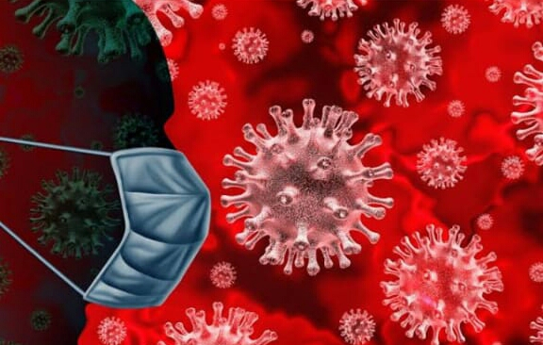
Cdc stand for (central for Disease control & prevention) nation's health protection agency is responding to a pandemic respiratory disease spreading from person to person caused by a new Corona virus.The disease has been name "Coronavirus disease "(abbreviated"covid-19").The Covid-19 Pandemic,also known as a coronavirus Pandemic,is ongoing Pandemic of Coronavirus disease 2019 (Covid-19) Caused by a Severe acute respiratory Syndrome Coronavirus 2 (SARS-COV-2). The outbreak was first identified in Wuhan,China,in December 2019.The World Health Organization declared the outbreak a public health emergency of international concern on 30 january,and a pandemic on 11 March.
Coronaviruses are a group of are related RNA viruses that cause diseases in mamals and birds.In humans,these viruses cause respiratory tract infection that can range from mild to lethal.

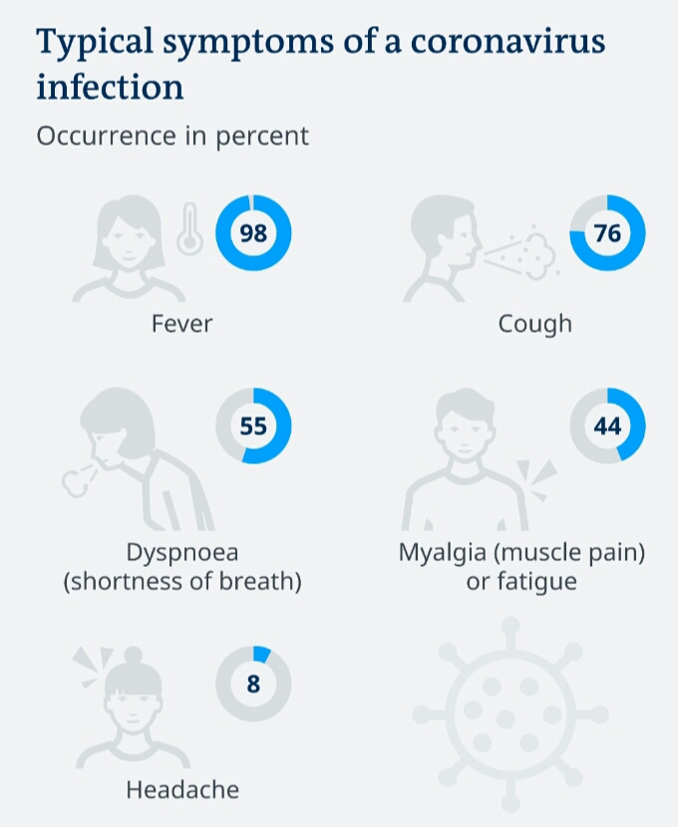

Mild illnesses include some cases of the Comon Cold also caused by the other viruses predominantly ,which more lethal varieties can cause SARS,MERS and COVID-19.
According to the World Health Organization there are no vaccines of corna virus.
This situation poses a serious public health risk.The federal government is working closely with state,local,tribal and territorial partners as well as public health partners,to respond to this situation.(https://www.edu.europa.eu).

As Pakistan is the developing country and 25% of population belongs to a poor family in our country. Most of the people are living below poverty line,therefore very much vulnerable to hanger and starvation. Due to Covid-19 lock down there were no economic activities,business and economic activities were closed.
That is why most of the daily wagers and laboured class sufferd badly.Million in pakistan would have straved if lock down was no lifted.
Due to this covid-19 this problem become more severe.In our country people are so unemployed that they cannot even fulfilltheir hunger.They do not serious about this disease.The people does not know have to save from Coronavirus.They are unaware that how to use masks, Gloves, sanitizer and save us our life from covid-19. So we decided to help them.

2.2 present situation:

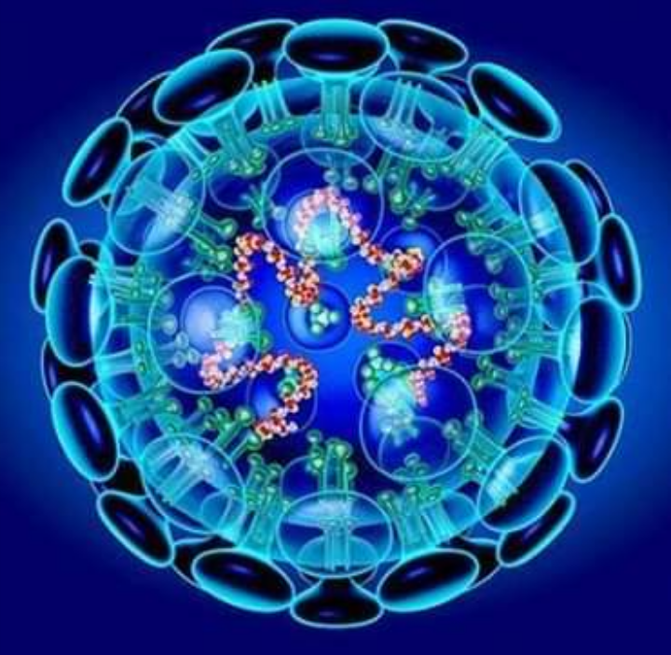
At the outset,we would point out that these days we are battling a disease like Corona virus which is very harmful disease.Corona virus spreads when an infected person coughs small droplets into the air. These can be breathed in,or cause an infection if you touch a surface they have landed on,and then touch your face with unwashed hands.The covid-19 pandemic in pakistan is the part of the ongoing worlwide pandemic of Corona virus disease 2019 (Covid-19) Caused by severe acute respiratory syndrom Coronavirus.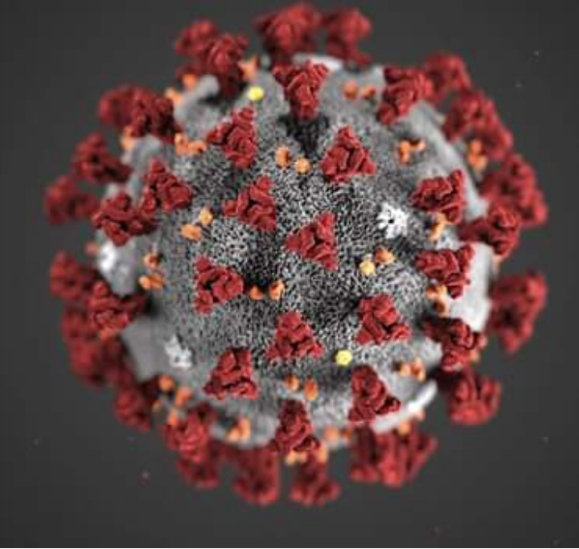

The virus was confermed to reach pakistan on 26 Feburary 2020,when a student in karachi tested positive upon returing from Iran.By 18 March Cases has been registered in all four provinces.Corona virus can effect anyone, but people with pre-existing health problems and older people are thought to be a greater risk of developing severe risk.
The disease has led to lockdown across the country which is causing a lot of hardship to the people.
The world Health Organization,and CDC and other authorities are constanting updating their pages with information about the best ways to prevent the spread coronavirus.paying close attentiom to close updates may have to take additional steps to protect you self and the people around you.
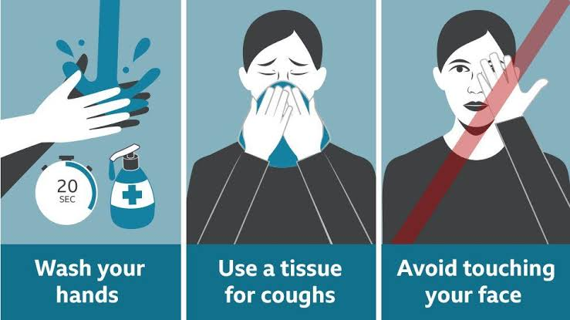

The first case of Corona virus was reported in Pakistan February 15 and Corona virus increased day by day.Since then the number of Corona virus patients has risen in pakistant 43,966. The number of recoveries is 12,489 and the number of deaths is 939.And there are still high risk of this disease.we should all pray to God to get rid of this dangerous disease like Corona virus as soon as possible.Ameen.(www.world meters.info).

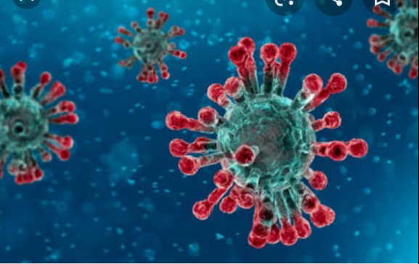

3. Justification of the project:

a.Importance of project activity:

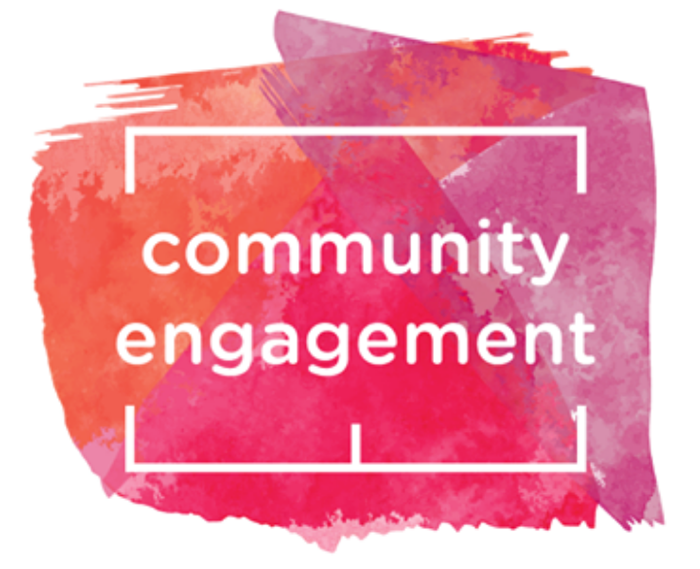

This is a big project because it helps the poor people.Now-a-days people are much worried due to Corona virus.so we decided to help them by financially support.Even in Pakistan there is very bad conditions of people.Most of the people in pakistan are belongs to a povertry.The economy of the pakistan is the 23rd largest in the world in term of purchasing power parity (ppp).
42nd largest in terms of nomial gross domestic product.poverty in pakustan has fallen dramatically ,independent bodies supported estimate of a considerable fall in the statistics by the 2007-8 fiscal year,when it was estimate that 17.2% total population lived below the poverty line.There is a solution to poverty in pakistan but people are little doing about it.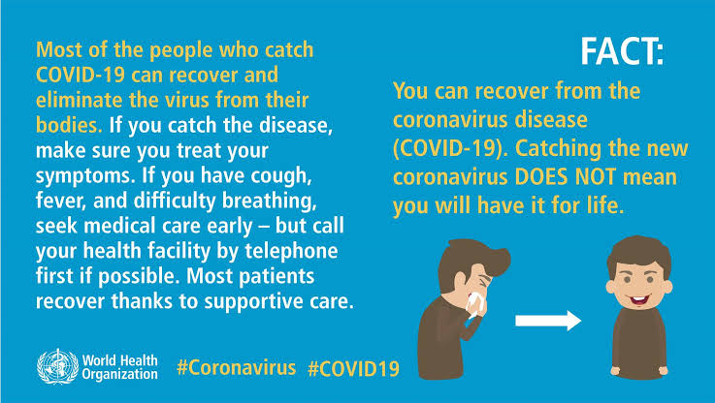

If we financially help them then,they fulfill their needs.However people does not serious about this disease,so we decided to aware people through survey and print outs.And also we provide self made santizer.Our this work helps the poor and needy people in a current situation.(en.wikipedia.org).

practical implications (who will get benefits of the activity)?

First of all,we were help a two poor families by a financially support.In our project every group member(Anam,Ayesha,Maheen,sidra) help a two famlies.we were distribute a rashan in our pockets money and parents help. In this step two poor families are benefited.secondly,we distribute hard copies of preventive measure about covid-19. Beacuse people does not know prevention measures about coronavirus.
And also guide people how to save their lives.This step help the people to understand this disease and so that,they can protect himself and his families.Thirdly
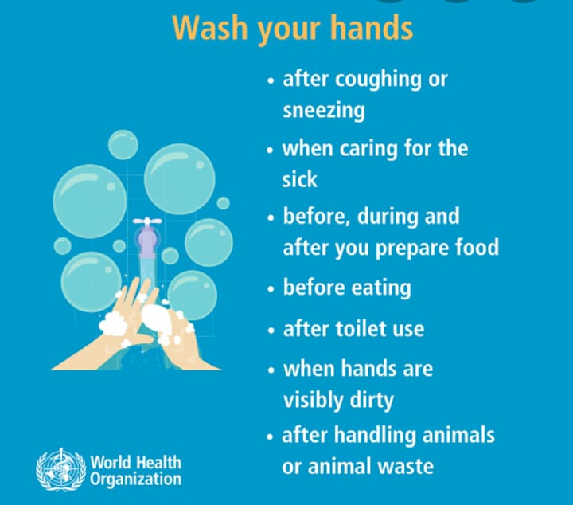

we were divide a self made sanitizer and guide people to use sanitizer and save himself and others in this disease.
Every person in our group (Anam,Ayesha,Maheen,sidra) divide the hand made sanitizer in their niehbourhood and tell how we use a sanitizer, mask, gloves.(en.wikipedia.org).

4.Objectives of the project:
By looking the current situation our project objectives are as follows:
- To help Community through financially support.
- Every person(Anam,Ayesha,mheen,sidra) helps the two poor houses.
- To tell Community about Corona virus.By distribute charts in public.
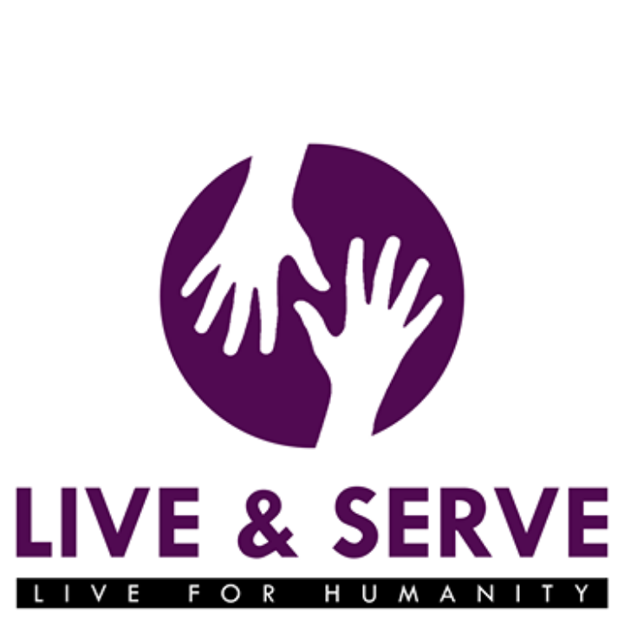

- By guide the Community,how to save him self and others?
- To tell Community wash your hands properly.
- To tell them,how to make self made sanitizer?
- By guiding,how to use sanitizer.

5.Plan ofaction:

a.How will do this activity:
In our group every person work equally.In first step we were help two houses in our neighborhood by financially support.we were decide to help a two families which are unable to tolerate their experience because they are unemployed.The second step is that to awear peoples by prints out prevention tips against Corona virus.

Anam Muneer:

Our group of every member work equally in our project.so after given my task,i observed my nearby people.After observation,I met two such families who are spending their lives in a bitterful condition.They have no proper mean of earning. The reason for unemployment is that the person who support their family working in a shop,due to a lock down (apedemic covid -19) all working places are closed.
I was decided to financially support those families by distributing 10kg flour and 5kg rice in both families.
The other step of my project is that I was guide people how we save from covid-19 . People do not know how to save from Corona virus.So I was decided to guide them how to take precautions and save from this apedemic.In this regard,I was distribute 200 hard copies of prevention tips about covid-19 in my neighborhood and public.
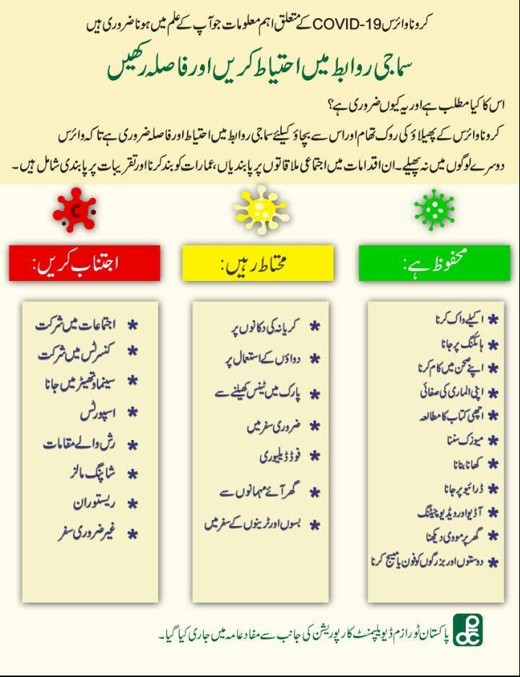

And I was also decided to distribute a sanitizer in my neighborhood and also guide a people how to make a sanitizer

(Anam Muneer,2020,BMAF19BM042, department of mathematics,uos bhakkar campus).

2. Ayesha Ashraf:

According to our group project,first of all I was observed such a two poor families in neighborhood areas.One of them is labour's house and the other is widow house.Due to lock down they are unemployed.So I was decided to help those families by financially support.I was distributed 5kg flour and 3 kg sugar in each house by pocket money and father's help.I also observed that people are unaware how to save us from covid-19 .I was decided to help them by prints out prevention tips against Corona virus.And I was distribute 200 copies of prevention tips in neighborhood areas and public.
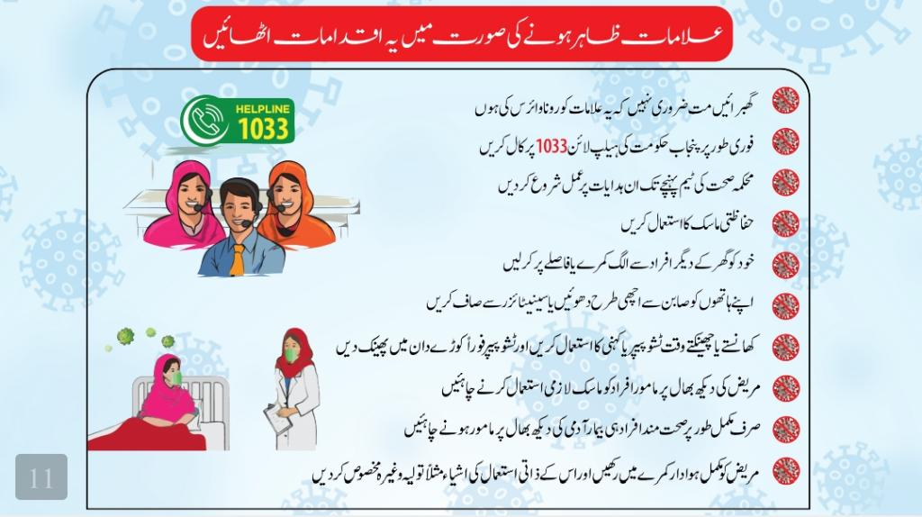

I was distribute home made .I told them how to use masks,and sanitizer.(Ayesha Ashraf ,2020 ,BMAF19BM052, department of mathematics,uos bhakkar campus).

3. Maheen Zahra:

According to our project,I was also chose two families who are spending their lives in a bitterful condition in my neighborhood area.
They have no proper mean of earning.Due to a lock down, they are unemploymed.
So I was decided to help those families by financiall support.One of them is rickshaw puller's house and other is labour's house.I was give 5kg rice and 3kg ghee in each house.

The other step of my project is that I was guide people how we save from covid-19 . People do not know how to save from Corona virus.
So I was decided to guide them how to take precautions and save from this apedemic.
In this regard,I was distribute 200 hard copies of prevention tips about covid-19 in my neighborhood and public.
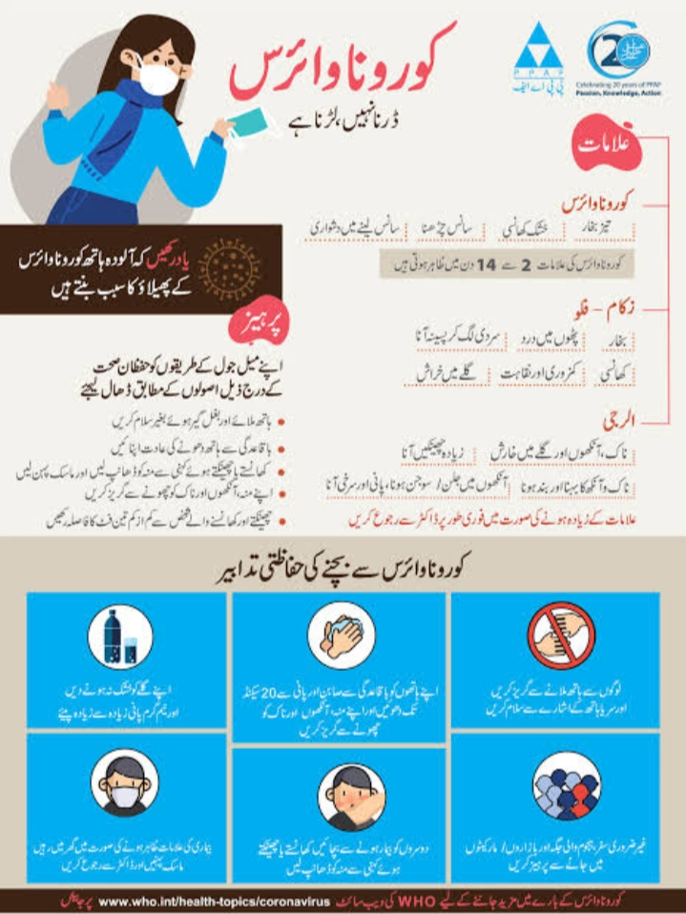
I was also decided to distribute a sanitizer in my neighborhood and also guide a people how to make a sanitizer.(Maheen Zahra,2020, BMAF19BM039,department of mathematics,uos Bhakkar campus).

4. Sidra:

According to our project,I was also chose two families,I will help two houses in my neighborhood. The house I was help have no one to help them because they are both widows and have no source of income.I was help these two houses for a thousand rupees.I was distribute rashan in these two houses which includes 2kg flour,2kg rice and1kg sugar in each house.In addition,I was look into the saftey of the Corona virus.I will take some pictures of Corona virus protection and print out and distribute them as well as people how to avoid Corona virus.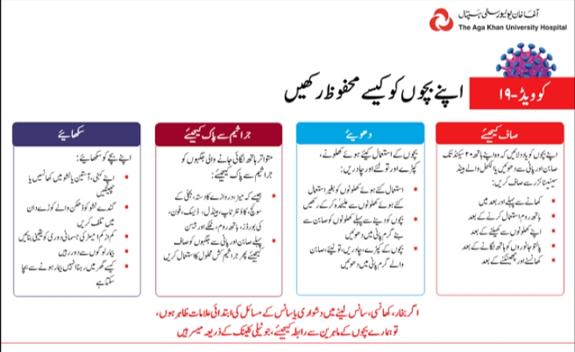

And I was make a sanitizer myself and distribute as many pictures as I can about the protection against the virus to people .I was also told them how make sanitizer ,how it is used.(sidra, BMAF19BM025,2020, department of mathematics,uos bhakkar campus).

b.Needed Rescorses and source ofGeneration (financial,Human resources etc:
We were help people at our own expenses and our parents will helps us.we were take some pictures safety about Corona virus and then distribute these pictures in apublic.Our brothers were help us in this work.(Anam Muneer,2020,BMAF19BM942, department of mathematics,uos bhakkar campus).
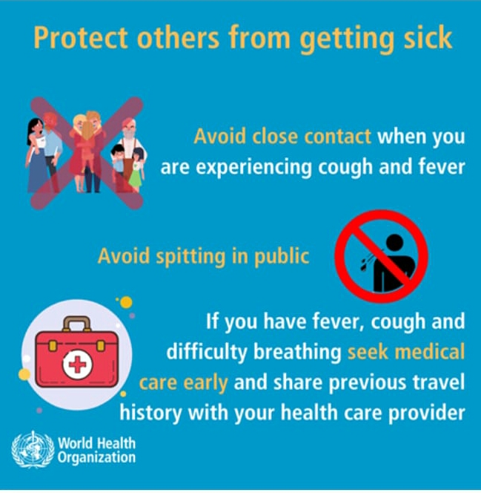

c.Each person roll in the project:
In this project, Everyone were play a very important role.Every one is working equally.Everyone in the group were contribute a same amount.In group each member tells the people about safety about Corona virus and distribute sanitizer.Everyone is working very hard.(Ayesha Ashraf, BMAF19BM052, 202,department of mathematics,uos bhakkar campus).

d.Proposed duration of project:
This project is not a small project that will be completed in a day or two.It is a big project and our group were completed this project in a month.(Maheen Zahra,2020, BMAF19BM039, department of
mathematics,uos bhakkar campus).

6.How will you evaluate your project in a possible outcome:
In a few days we will go these houses and ask them if what we have helped them you have benefited you so that we can evaluate our project.whether this project was successful. This project will remains a very successful.Our small efforts has helped many people.And we were do this honestly and diligently.(Sidra,BMAF19BM025,2020,department of mathematics,uos bhakkar campus).
7. References:
- (https://www.edu.europa.eu).
- (Google.com).
- (en.wikipedia.org).
- (Anam Muneer ,BMAF19BM042, 2020,department of mathematics, uos bhakkar campus).
- (Ayesha Ashraf ,BMAF19BM052, 2020,department of mathematics ,uos Bhakkar campus).
- (Maheen Zahra ,BMAF19BM039, 2020,department of mathematics,uos Bhakkar campus).
- (sidra, BMAF19BM025,2020, department of mathematics,uos bhakkar campus).

Anna Morton say
"I have a responsibility as a citizen to my community.It is both a responsibility and a privilege, because as I work to make my community a better place,I receive intrinsic benefits as well."
God willings

