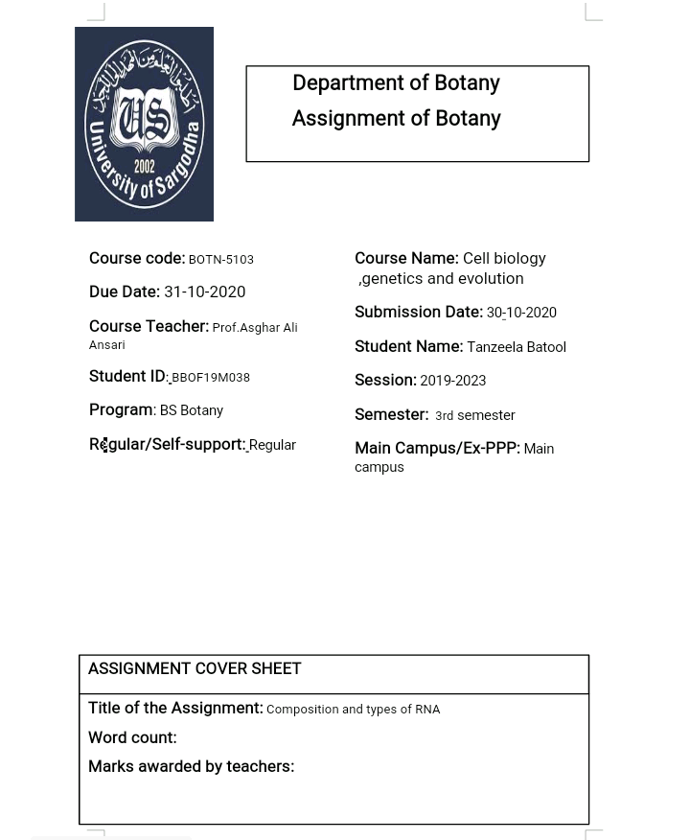

RNA (Ribonucleic Acid)

INTRODUCTION
Ribonucleic acid (RNA) is a polymeric molecule essential in various biological roles in coding, decoding, regulation and expression of genes. RNA and DNA are nucleic acids. Along with lipids, proteins, and carbohydrates, nucleic acids constitute one of the four major macromolecules essential for all known forms of life. Like DNA, RNA is assembled as a chain of nucleotides, but unlike DNA, RNA is found in nature as a single strand folded onto itself, rather than a paired double strand.
HISTORY
Nucleic acids were discovered in 1868 by Friedrich Miescher, who called the material 'nuclein' since it was found in the nucleus.It was later discovered that prokaryotic cells, which do not have a nucleus, also contain nucleic acids. The role of RNA in protein synthesis was suspected already in 1939.Severo Ochoa won the 1959 Nobel Prize in Medicine (shared with Arthur Kornberg) after he discovered an enzyme that can synthesize RNA in the laboratory. Ironically, the enzyme discovered by Ochoa (polynucleotide phosphorylase) was later shown to be responsible for RNA degradation, not RNA synthesis.
The sequence of the 77 nucleotides of a yeast tRNA was found by Robert W. Holley in 1965, winning Holley the 1968 Nobel Prize in Medicine (shared with Har Gobind Khorana and Marshall Nirenberg).
In 1967, Carl Woese hypothesized that RNA might be catalytic and suggested that the earliest forms of life (self-replicating molecules) could have relied on RNA both to carry genetic information and to catalyze biochemical reactions—an RNA world.
During the early 1970s, retroviruses and reverse transcriptase were discovered, showing for the first time that enzymes could copy RNA into DNA (the opposite of the usual route for transmission of genetic information). For this work, David Baltimore, Renato Dulbecco and Howard Temin were awarded a Nobel Prize in 1975. In 1976, Walter Fiers and his team determined the first complete nucleotide sequence of an RNA virus genome, that of bacteriophage MS2.
In 1977, introns and RNA splicing were discovered in both mammalian viruses and in cellular genes, resulting in a 1993 Nobel to Philip Sharp and Richard Roberts. Catalytic RNA molecules (ribozymes) were discovered in the early 1980s, leading to a 1989 Nobel award to Thomas Cech and Sidney Altman. In 1990 it was found in petunia that introduced genes can silence similar genes of the plant's own, now known to be a result of RNA interference.
At about the same time, 22 long RNAs, now called microRNAs, were found to have a role in the development of C. elegans.Studies on RNA interference gleaned a Nobel Prize for Andrew Fire and Craig Mello in 2006, and another Nobel was awarded for studies on transcription of RNA to Roger Kornberg in the same year. The discovery of gene regulatory RNAs has led to attempts to develop drugs made of RNA, such as siRNA, to silence genes.

COMPOSITION(structure) OF RNA
Each nucleotide in RNA contains a ribose sugar, with carbons numbered 1' through 5'. A base is attached to the 1' position, in general, adenine (A), cytosine (C), guanine (G), or uracil (U). Adenine and guanine are purines(having two carbon rings), cytosine and uracil are pyrimidines(having one carbon ring). A phosphate group is attached to the 3' position of one ribose and the 5' position of the next. The phosphate groups have a negative charge each, making RNA a charged molecule (polyanion). The bases form hydrogen bonds between cytosine and guanine, between adenine and uracil and between guanine and uracil.However, other interactions are possible, such as a group of adenine bases binding to each other in a bulge, or the GNRA tetraloop that has a guanine–adenine base-pair.

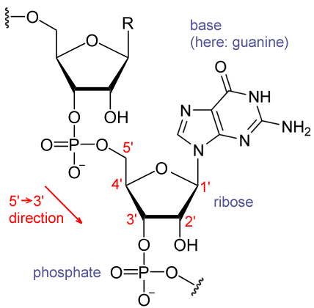
Structure of a fragment of an RNA
An important structural component of RNA that distinguishes it from DNA is the presence of a hydroxyl group at the 2' position of the ribose sugar. The presence of this functional group causes the helix to mostly take the A-form geometry, although in single strand dinucleotide contexts, RNA can rarely also adopt the B-form most commonly observed in DNA.The A-form geometry results in a very deep and narrow major groove and a shallow and wide minor groove.A second consequence of the presence of the 2'-hydroxyl group is that in conformationally flexible regions of an RNA molecule (that is, not involved in formation of a double helix), it can chemically attack the adjacent phosphodiester bond to cleave the backbone.
RNA is transcribed with only four bases (adenine, cytosine, guanine and uracil),but these bases and attached sugars can be modified in numerous ways as the RNAs mature. Pseudouridine (Ψ), in which the linkage between uracil and ribose is changed from a C–N bond to a C–C bond, and ribothymidine (T) are found in various places (the most notable ones being in the TΨC loop of (RNA). Another notable modified base is hypoxanthine, a deaminated adenine base whose nucleoside is called inosine (I). Inosine plays a key role in the wobble hypothesis of the genetic code.^{[16]}
There are more than 100 others naturally occurring modified nucleosides.The greatest structural diversity of modifications can be found in tRNA, while pseudouridine and nucleosides with 2'-O-methylribose often present in rRNA are the most common.The specific roles of many of these modifications in RNA are not fully understood. However, it is notable that, in ribosomal RNA, many of the post-transcriptional modifications occur in highly functional regions, such as the peptidyl transferase center and the subunit interface, implying that they are important for normal function.
The functional form of single-stranded RNA molecules, just like proteins, frequently requires a specific tertiary structure. The scaffold for this structure is provided by secondary structural elements that are hydrogen bonds within the molecule. This leads to several recognizable "domains" of secondary structure like hairpin loops, bulges, and internal loops. Since RNA is charged, metal ions such as Mg²⁺ are needed to stabilize many secondary and tertiary structures.
The naturally occurring enantiomer of RNA is D-RNA composed of D-ribonucleotides. All chirality centers are located in the D-ribose. By the use of L-ribose or rather L-ribonucleotides, L-RNA can be synthesized. L-RNA is much more stable against degradation by RNase. Like other structured biopolymers such as proteins, one can define topology of a folded RNA molecule. This is often done based on arrangement of intra-chain contacts within a folded RNA, termed as circuit topology.
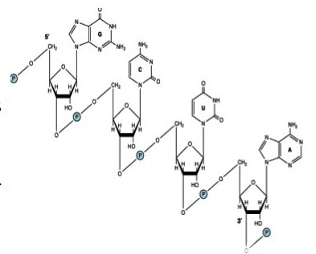

TYPES OF RIBONUCLEIC ACID (RNA)
In all prokaryotic and eukaryotic organisms,three main classes of RNA molecules exist that are explained below.
RNAs involved in protein synthesis
Type | Abbr. | Function | Distribution
Messenger RNA | mRNA | Codes for protein | All organisms
Signal recognition particle RNA | 7SL RNA or SRP RNA | Membrane integration | All organisms
Transfer-messenger RNA | tmRNA | Rescuing stalled ribosomes | Bacteria
Ribosomal RNA | rRNA | Translation | All organisms
Transfer RNA | tRNA | Translation | All organisms

Messenger RNA(mRNA)

Messenger RNA (mRNA) is a molecule of RNA encoding a chemical "blueprint" for a protein product. mRNA is transcribed from a DNA template, and carries coding information to the sites of protein synthesis, the ribosomes. Here, the nucleic acid polymer is translated into a polymer of amino acids: a protein. In mRNA as in DNA, genetic information is encoded in the sequence of nucleotides arranged into codons consisting of three bases each. Each codon encodes for a specific amino acid, except the stop codons that terminate protein synthesis. This process requires two other types of RNA: transfer RNA (tRNA) mediates recognition of the codon and provides the corresponding amino acid, while ribosomal RNA (rRNA) is the central component of the ribosome's protein manufacturing machinery.It comprises only 5% of the RNA in the cell. Most heterogenous in size and base sequence. mRNA genes are the genes that encode only for proteins but this encoding has an RNA intermediate. The DNA is firstly transcribed into mRNA and subsequently translated into a protein product. So, the mRNA genes are the genes that encode for mRNA in order to synthesize proteins.
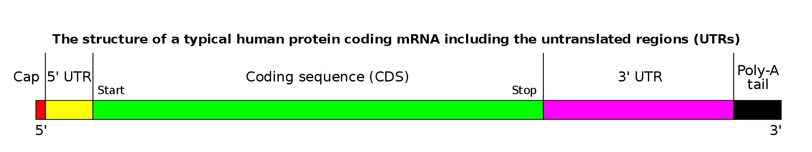
RIBOSOMAL RNA(rRNA)
Ribosomal ribonucleic acid (rRNA) is the RNA component of the ribosome, the organelle that is the site of protein synthesis in all living cells. Ribosomal RNA provides a mechanism for decoding mRNA into amino acids and interacts with tRNAs during translation by providing peptidyl transferase activity. The tRNAs bring the necessary amino acids corresponding to the appropriate mRNA codon.
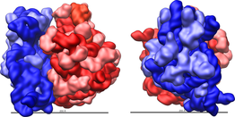
Three-dimensional views of the ribosome, showing rRNA in dark blue (small subunit) and dark red (large subunit). Lighter colors represent ribosomal proteins
TRANSFER RNA(tRNA)
Transfer RNA (tRNA) is a small RNA molecule (usually about 73-95 nucleotides) that transfers a specific active amino acid to a growing polypeptide chain at the ribosomal site of protein synthesis during translation. It has a 3' terminal site for amino acid attachment. This covalent linkage is catalyzed by an aminoacyl tRNA synthetase. It also contains a three base region called the anticodon that can base pair to the corresponding three base codon region on mRNA. Each type of tRNA molecule can be attached to only one type of amino acid, but because the genetic code contains multiple codons that specify the same amino acid, tRNA molecules bearing different anticodons may also carry the same amino acid.
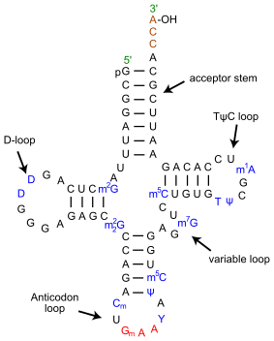
Secondary cloverleaf structure of tRNA from yeast.

RNAs involved in post-transcriptional modification or DNA replication
Type | Abbr. | Function | Distribution
Small nuclear RNA | snRNA | Splicing and other functions | Eukaryotes and archaea
Small nucleolar RNA | snoRNA | Nucleotide modification of RNAs | Eukaryotes and archaea
SmY RNA | SmY | mRNA trans-splicing | Nematodes
Small Cajal body-specific RNA | scaRNA | Type of snoRNA; Nucleotide modification of RNAs
Guide RNA | gRNA | mRNA nucleotide modification | Kinetoplastid mitochondria
Ribonuclease P | RNase P | tRNA maturation | All organisms
Ribonuclease MRP | RNase MRP | rRNA maturation, DNA replication | Eukaryotes
Y RNA |  | RNA processing, DNA replication | Animals
Telomerase RNA |  | Telomere synthesis | Most eukaryotes

Small nuclear ribonucleic acid (snRNA)
Small nuclear ribonucleic acid (snRNA) is a class of small RNA molecules that are found within the nucleus of eukaryotic cells. They are transcribed by RNA polymerase II or RNA polymerase III and are involved in a variety of important processes such as RNA splicing (removal of introns from hnRNA), regulation of transcription factors (7SK RNA) or RNA polymerase II (B2 RNA), and maintaining the telomeres. They are always associated with specific proteins, and the complexes are referred to as small nuclear ribonucleoproteins (snRNP) or sometimes as snurps. These elements are rich in uridine content.

Small nucleolar RNAs (snoRNAs)
Small nucleolar RNAs (snoRNAs) are a class of small RNA molecules that primarily guide chemical modifications of other RNAs, mainly ribosomal RNAs, transfer RNAs and small nuclear RNAs. There are two main classes of snoRNA, the C/D box snoRNAs which are associated with methylation, and the H/ACA box snoRNAs which are associated with pseudouridylation. snoRNAs are commonly referred to as guide RNAs but should not be confused with the guide RNAs that direct RNA editing in trypanosomes.
After transcription, nascent rRNA molecules (termed pre-rRNA) are required to undergo a series of processing steps in order to generate the mature rRNA molecule. Prior to cleavage by exo- and endonucleases the pre-rRNA undergoes a complex pattern of nucleoside modifications. These include methylations and pseudouridylations, guided by snoRNAs. Methylation is the attachment or substitution of a methyl group onto various substrates. The rRNA of humans contain approximately 115 methyl group modifications. The majority of these are 2'O-ribose-methylations ( where the methyl group is attached to the ribose group). Pseudouridylation is the conversion (isomerisation) of the nucleoside uridine to a different isomeric form pseudouridine(Ψ). Mature human rRNAs contain approximately 95 Ψ modifications. Each snoRNA molecule acts as a guide for only one (or two) individual modifications in a target RNA. In order to carry out modification, each snoRNA associates with at least four protein molecules in an RNA/protein complex referred to as a small nucleolar ribonucleoprotein (snoRNP). The proteins associated with each RNA depend on the type of snoRNA molecule (see snoRNA guide families below). The snoRNA molecule contains an antisense element (a stretch of 10-20 nucleotides) which are base complementary to the sequence surrounding the base (nucleotide) targeted for modification in the pre-RNA molecule. This enables the snoRNP to recognise and bind to the target RNA. Once the snoRNP has bound to the target site the associated proteins are in the correct physical location to catalyse the chemical modification of the target base.

Small interfering RNA (siRNA)
Small interfering RNA (siRNA), sometimes known as short interfering RNA or silencing RNA, is a class of double-stranded RNA molecules, 20-25 nucleotides in length, that play a variety of roles in biology. Most notably, siRNA is involved in the RNA interference (RNAi) pathway, where it interferes with the expression of a specific gene. In addition to their role in the RNAi pathway, siRNAs also act in RNAi-related pathways, e.g., as an antiviral mechanism or in shaping the chromatin structure of a genome; the complexity of these pathways is only now being elucidated. siRNAs were first discovered by David Baulcombe's group at the Sainsbury Laboratory in Norwich, England, as part of post-transcriptional gene silencing (PTGS) in plants.

Telomerase RNA
Telomerase RNA component, also known as TERC, is an RNA gene found in eukaryotes, that is a component of telomerase used to extend telomeres. Telomerase RNAs differ greatly in sequence and structure between vertebrates, ciliates and yeasts, but they share a 5' pseudoknot structure close to the template sequence. The vertebrate telomerase RNAs have a 3' H/ACA snoRNA-like domain.

MULTIPLE CHOICE QUESTIONS(MCQS)
- Which of the following rRNA molecules have peptidyl transferase activity in prokaryotes?
a) 23S rRNA
b) 28S rRNA
c) 5S rRNA
d) 18S rRNA
- Name the secondary structure of tRNA?
a) Cloverleaf
b) L-shaped
c) Duplex
d) Triple Helix
- Which of the following RNA molecule convert information stored in the nucleic acid to protein?
a) mRNA
b) snRNA
c) rRNA
d) tRNA
- Nucleotides in RNA are joined by:
a) 3’5’ phosphodiester bond
b) 3’4’ phosphodiester bond
c) 3’2’ phosphodiester bond
d) 3’6’ phosphodiester bond
- The most abundant type of RNA in the cell is
a) rRNA
b) mRNA
c) tRNA
d) hnRNA
- Ribose sugar in RNA is
a) D-ribose
b) L-ribose
c) Both L and D form
d) none
- RNA is primarily seen in
a) Nucleus
b) Cytoplasm
c) RER
d) SER
- Anticodon is present in
a) DNA
b) tRNA
c) rRNA
d) mRNA
- A single strand of mRNA attached to complex of ribosomes is called
a) Okazaki fragments
b) polymer
c) polysome
d) polypeptide
- Which of the following purine bases is present in RNA?
a) Uracil
b) Thymine
c) Cytosine
d) Guanine

