APA Format Citation Guide

This is a complete guide to APA (American Psychological Association) in-text and reference list citations. This easy-to-use, comprehensive guide makes citing any source easy.

Who created it?
The American Psychological Association is an organization created for individuals in the psychology field. With close to 118,000 members, they provide educational opportunities, funding, guidance, and research information for everything psychology-related. They also have numerous high-quality databases, peer-reviewed journals, and books that revolve around mental health.
The American Psychological Association is also credited with creating their own specific citation and reference style. Today, this format is used by individuals not only in the psychology field, but many other subject areas as well. Education, economics, business, and social sciences also use APA style quite frequently.

The evolution of this style
APA style is currently in its 6th edition, which was released in 2009. In previous versions of APA format, researchers and scholars were required to include the date that an electronic resource was accessed. In addition, names of databases were included, and only the name of the city was included in the publication information.
Now, it is no longer required to include the date of access as well as the name of the database in an APA citation or reference. The full location, including the city AND state (or the city and country if it’s an international publisher) is included instead.
In 2013, the APA released a revised manual just for electronic resources. This was released due to the increase in the amount of technological advances and resources.

Core Components of an APA Reference:

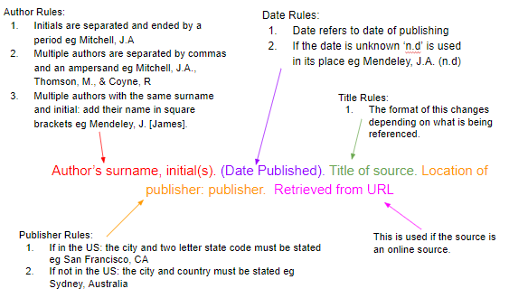

1. APA Referencing Basics: Reference List
A reference list is a complete list of references used in a piece of writing including the author name, date of publication, title and more. An APA reference list must:
- Be on a new page at the end of the document
- Be centred
- Be alphabetically by name of first author (or title if the author isn’t known, in this case a, an and the should be ignored)
  - If there are multiple works by the same author these are ordered by date, if the works are in the same year they are ordered alphabetically by the title and are allocated a letter (a,b,c etc) after the date
- Contain full references for all in-text references used

2. APA Referencing Basics: In-Text Citation
In-text references must be included following the use of a quote or paraphrase taken from another piece of work.
In-text citations are citations within the main body of the text and refer to a direct quote or paraphrase. They correspond to a reference in the main reference list. These citations include the surname of the author and date of publication only. Using an example author James Mitchell, this takes the form:
Mitchell (2017) states… Or …(Mitchell, 2017).
The structure of this changes depending on whether a direct quote or parenthetical used:
- Direct Quote: The citation must follow the quote directly and contain a page number after the date, for example (Mitchell, 2017, p.104). This rule holds for all of the variations listed.
- Parenthetical: The page number is not needed.

Two Authors:
The surname of both authors is stated with either ‘and’ or an ampersand between. For example:
Mitchell and Smith (2017) state… Or …(Mitchell & Smith, 2017).

Three, Four or Five Authors:
For the first cite, all names should be listed:
Mitchell, Smith, and Thomson (2017) state… Or …(Mitchell, Smith, & Thomson, 2017).
Further cites can be shorted to the first author’s name followed by et al:
Mitchell et al (2017) state… Or …(Mitchell et al, 2017).

Six or More Authors:
Only the first author’s surname should be stated followed by et al, see the above example.

No Authors:
If the author is unknown, the first few words of the reference should be used. This is usually the title of the source.
If this is the title of a book, periodical, brochure or report, is should be italicised. For example:
(A guide to citation, 2017).
If this is the title of an article, chapter or web page, it should be in quotation marks. For example:
(“APA Citation”, 2017).

Citing Authors With Multiple Works From One Year:
Works should be cited with a, b, c etc following the date. These letters are assigned within the reference list, which is sorted alphabetically by the surname of the first author. For example:
(Mitchell, 2017a) Or (Mitchell, 2017b).

Citing Multiple Works in One Parenthesis:
If these works are by the same author, the surname is stated once followed by the dates in order chronologically. For instance:
Mitchell (2007, 2013, 2017) Or (Mitchell, 2007, 2013, 2017)
If these works are by multiple authors then the references are ordered alphabetically by the first author separated by a semicolon as follows:
(Mitchell & Smith 2017; Thomson, Coyne, & Davis, 2015).

Citing a Group or Organisation:
For the first cite, the full name of the group must be used. Subsequently this can be shortened. For example:
First cite: (International Citation Association, 2015)
Further Cites: (Citation Association, 2015)

Citing a Secondary Source:
In this situation the original author and date should be stated first followed by ‘as cited in’ followed by the author and date of the secondary source. For example:
Lorde (1980) as cited in Mitchell (2017) Or (Lorde, 1980, as cited in Mitchell, 2017)

3. How to Cite Different Source Types
- In-text citation doesn’t vary depending on source type, unless the author is unknown.
- Reference list citations are highly variable depending on the source.

How to Cite a Book (Title, not chapter) in APA Format
Book referencing is the most basic style; it matches the template above, minus the URL section. So the basic format of a book reference is as follows:
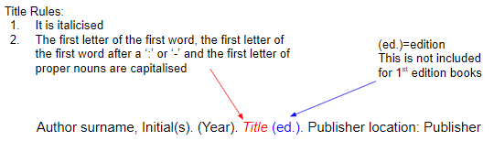

Book referencing examples:

Mitchell, J.A., Thomson, M., & Coyne, R.P. (2017). A guide to citation. London, England: My Publisher
Jones, A.F & Wang, L. (2011). Spectacular creatures: The Amazon rainforest (2nd ed.). San Jose, Costa Rica: My Publisher

How to Cite an Edited Book in APA Format
This reference format is very similar to the book format apart from one extra inclusion: (Ed(s)). The basic format is as follows:
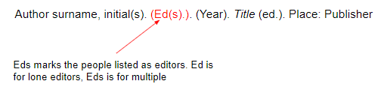

Edited book example:
Williams, S.T. (Ed.). (2015). Referencing: A guide to citation rules (3rd ed.). New York, NY: My Publisher

How to Cite a Chapter in an Edited Book in APA Format
Edited books are collations of chapters written by different authors. To reference a single chapter, a different format is needed. The basic structure is as follows:
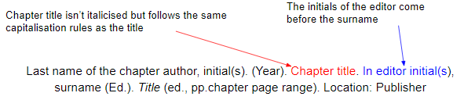

Edited book chapter example:
In the following example, B.N. Troy is the author of the chapter and S.T. Williams is the editor.
Troy, B.N. (2015). APA citation rules. In S.T, Williams (Ed.). A guide to citation rules (2nd ed., pp. 50-95). New York, NY: Publishers.

How to Cite an E-Book in APA Format
An E-Book reference is the same as a book reference expect the publisher is swapped for a URL. The basic structure is as follows:
Author surname, initial(s) (Ed(s).*). (Year). Title (ed.*). Retrieved from URL
*optional.

E-Book example:
Mitchell, J.A., Thomson, M., & Coyne, R.P. (2017). A guide to citation. Retrieved from https://www.mendeley.com/reference-management/reference-manager

How to Cite an E-Book Chapter in APA Format
This follows the same structure as an edited book chapter reference except the publisher is exchanged for a URL. The structure is as follows:
Last name of the chapter author, initial(s). (Year). Chapter title. In editor initial(s), surname (Ed.). Title (ed., pp.chapter page range). Retrieved from URL

E-Book chapter example:
Troy, B.N. (2015). APA citation rules. In S.T, Williams (Ed.). A guide to citation rules (2nd ed., pp. 50-95). Retrieved from https://www.mendeley.com/reference-management/reference-manager

How to Cite a Journal Article in Print or Online in APA Format
Articles differ from book citations in that the publisher and publisher location are not included. For journal articles, these are replaced with the journal title, volume number, issue number and page number. The basic structure is:
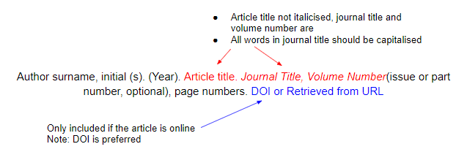

Journal Article Examples:
Mitchell, J.A. (2017). Citation: Why is it so important. Mendeley Journal, 67(2), 81-95
Mitchell, J.A. (2017). Citation: Why is it so important. Mendeley Journal, 67(2), 81-95. Retrieved from https://www.mendeley.com/reference-management/reference-manager

How to Cite a Newspaper Articles in Print or Online in APA Format
The basic structure is as follows:
Author surname, initial(s). (Year, Month Day). Title. Title of Newspaper, column/section, p. or pp. Retrieved from URL*
**Only include if the article is online.
Note: the date includes the year, month and date.

Newspaper Articles Example:
Mitchell, J.A. (2017). Changes to citation formats shake the research world. The Mendeley Telegraph, Research News, pp.9. Retrieved from https://www.mendeley.com/reference-management/reference-manager

How to Cite Magazine Articles in Print or Online in APA Format
The basic structure is as follows:
Author surname, initial(s). (Year, month day). Title. Title of the Magazine, pp.

Magazine Article Example:
Mitchell, J.A. (2017). How citation changed the research world. The Mendeley, pp. 26-28

How to Cite Non-Print Material in APA Format

How to Cite an Image in APA Format
The basic format to cite an image is:
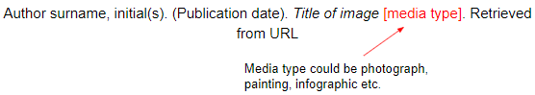

Image Example:
Millais, J.E. (1851-1852). Ophelia [painting]. Retrieved from www.tate.org.uk/art/artworks/millais-ophelia-n01506

How to Cite a Film in APA Format
The basic format of a film citation is:
Producer surname, initial (Producer), & Director surname, initial (Director). (Year of Release). Title of film [Motion Picture]. Country of Origin: Studio.

Film Example:
Hitchcock, A. (Producer), & Hitchcock, A. (1954) Rear window. United States of America: Paramount Pictures.

How to Cite a TV Programme in APA Format
The basic format is as follows:
Writer surname, initial(s) (Writer), & Director surname, initial(s) (Director). (Year of Release). Episode title [Television series episode]. In Executive producer surname, initial(s) (Executive Producer), TV series name. City, State of original channel: Network, Studio or Distributor

TV Programme Example:
Catlin, M., and Walley-Beckett, Moire (Writers), & Johnson, R (Director). (2010). Fly [Television series episode]. In Schnauz, T. (Executive Producer). Breaking bad. Culver City, CA: Sony Pictures Television

How to Cite a Song in APA Format
The basic format to cite a song in APA format is as follows:
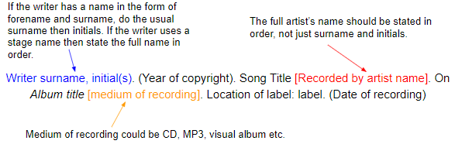

Song Example:
Beyonce, Diplo, MNEK, Koenig, E., Haynie, E., Tillman, J., and Rhoden, S.M. (2016) Hold up [Recorded by Beyonce]. On Lemonade [visual album]. New York, NY: Parkwood Records (August 16)

How to Cite a Website in APA Format
When citing a website, the basic structure is as follows:
Author surname, initial(s). (Year, month day). Title. Retrieved from URL

Website example:
Mitchell, J.A. (2017, May 21). How and when to reference. Retrieved from https://www.howandwhentoreference.com.

