The Polymerase Chain Reaction
It is hard to exaggerate the impact of the polymerase chain reaction. PCR, the quick, easy method for generating unlimited copies of any fragment of DNA, is one of those scientific developments that actually deserves timeworn superlatives like "revolutionary" and "breakthrough.“
From the daily practicalities of medical diagnosis to the theoretical framework of systematics, from courts of law to field studies of animal behavior, PCR takes analysis of tiny amounts of genetic material-even damaged genetic material-to a new level of precision and reliability.
"PCR is the most important new scientific technology to come along in the last hundred years,"
WHAT IS PCR?
PCR is an exponentially progressing synthesis of the defined target DNA sequences .
It was invented in 1983 by Dr. Kary Mullis, for which he received the Nobel Prize in Chemistry in 1993.
Why polymerase?
It is called “polymerase” because the only enzyme used in this reaction is DNA polymerase.
Why chain?
It is called “chain” because the products of the first reaction become substrates of the following one, and so on.
The central scientific fact that makes PCR so useful is this: The genetic material of each living organism-plant or animal, bacterium or virus-possesses sequences of its nucleotide building blocks (usually DNA, sometimes RNA) that are uniquely and specifically present only in its own species.
Indeed, complex organisms such as human beings possess DNA sequences that are uniquely and specifically present only in particular individuals.
These unique variations make it possible to trace genetic material back to its origin, identifying with precision at least what species of organism it came from, and often which particular member of that species.
PCR (polymerase chain reaction) is a method to analyze a short sequence of DNA (or RNA) even in samples containing only minute quantities of DNA or RNA.
PCR is used to reproduce (amplify) selected sections of DNA or RNA.
Previously, amplification of DNA involved cloning the segments of interest into vectors for expression in bacteria, and took weeks.
But now, with PCR done in test tubes, it takes only a few hours. PCR is highly efficient so that untold numbers of copies can be made of the DNA.
Moreover, PCR uses the same molecules that nature uses for copying DNA:
TERMS USED IN PCR
- DNA deoxyribonucleic acid; the chemical substance of our genes.
- RNA ribonucleic acid; the chemical substance that make up the working copies of genes (mRNA), among other things
- Nucleic acids a chemical term that covers both DNA and RNA; nucleic acids are molecules consisting of long chains of nucleotides linked together
- Nucleotides the building blocks of DNA; they comprise the four bases adenine, thymine, cytosine and guanine (A, T, C,G; in RNA thymine is replaced by uracil [U]), a sugar and at least one phosphate group; without the phosphate group these building blocks are referred to as nucleosides
- Sequence the order of the nucleotides in DNA (DNA sequence) or RNA (RNA sequence
- Primer a short DNA fragment with a defined sequence that serves as an extension point for polymerases
- Polymerases enzymes that link individual nucleotides together to form long DNA or RNA chains
- Hybridisation (annealing) the joining of two complementary DNA (or RNA) strands to form a double strand
- Complementary DNA The building blocks of DNA and RNA form specific pairings. Two strands whose building blocks form a sequence of perfect pairings are able to form a stable double strand and are referred to as complementary strands .

COMPONENTS IN PCR
Two "primers", short single-stranded DNA sequences that are synthesized to correspond to the beginning and ending of the DNA stretch to be copied;
An enzyme called polymerase that moves along the segment of DNA, reading its code and assembling a copy; and
A template of DNA building blocks that the polymerase needs to make that copy.

SOURCES OF DNA
- Blood
- Buccal cells
- Cultured cells (plant and animal)
- Bacteria
- Biopsies
- Forensic samples i.e. body fluids, hair follicles, bone & teeth roots
DNA ISOLATION AND PURIFICATION/EXTRACTION
DNA isolation is a routine procedure to collect DNA for subsequent molecular analysis.
There are three basic steps in a DNA extraction
- Cell disruption:- This is commonly achieved by grinding
or sonicating the sample. Removing membrane lipids by adding a detergent.
- Isolation of DNA:- Removing proteins by adding a protease.
- Precipitating the DNA :-usually ice-cold ethanol or isopropanol is used. Since DNA is insoluble in these alcohols, it will aggregate together, giving a pellet upon centrifugation.
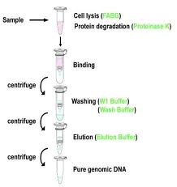

PCR PRINCIPLE
Three major steps are involved in a PCR. These three steps are repeated for 30 or 40 cycles.The cycles are done on an automated cycler, a device which rapidly heats and cools the test tubes containing the reaction mixture.
Each step -- denatauration (alteration of structure), annealing (joining), and extension -- takes place at a different temperature:
Steps in pcr principle
Denaturation: At 94 C (201.2 F), the double-stranded DNA melts and opens into two pieces of single-stranded DNA.
Annealing: At medium temperatures, around 54 C (129.2 F), the primers pair up (anneal) with the single-stranded "template" (The template is the sequence of DNA to be copied.) On the small length of double-stranded DNA (the joined primer and template), the polymerase attaches and starts copying the template.
Extension: At 72 C (161.6 F), the polymerase works best, and DNA building blocks complementary to the template are coupled to the primer, making a double stranded DNA molecule. 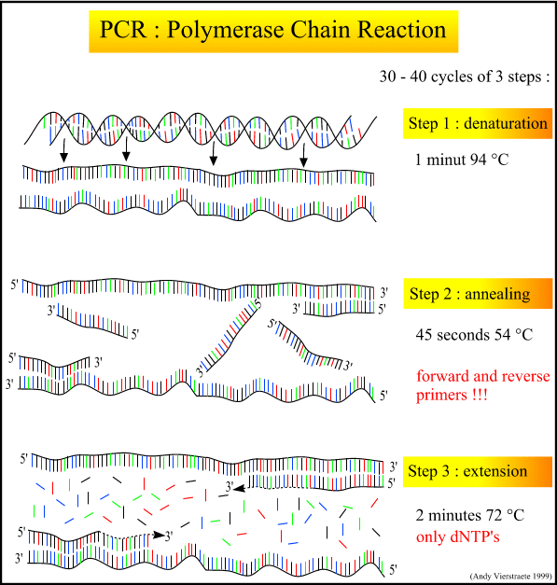

Types of PCR

    - QUALITATIVE PCR
    - QUANTITATIVE PCR

QUALITATIVE PCR
When PCR is used only for detecting a specific DNA segment, the method is referred to as Qualitative PCR. In many cases specific genes are copied in this way, e.g.in order to identify pathological changes.
The first gene identified by PCR was the gene responsible for sickle cell anemia.
PCR can of course be used to detect not only human genes but also genes of bacteria and viruses.
One of the most important medical applications of the classical PCR method is therefore the detection of pathogens.
Only Qualitative PCR can determine whether an infection has been eradicated,whether it is chronic (and might therefore progress unnoticed)and whether the individual has been reinfected with a different but related pathogen.Many viruses contain RNA rather than DNA. In such cases the viral genome has to be transcribed before PCR is performed, and RT-PCR is therefore used.
Sometimes it is also necessary to detect pathogens outside the body. Fortunately, the PCR method can detect the DNA of microorganisms in any sample, whether of body fluids, foodstuffs or drinking water. PCR is therefore used in all these areas. One of the most urgent problems PCR is helping to solve is to determine if donated blood is contaminated. Blood banks are one of the major transmission sources of hepatitis C, for example, and sometimes of HIV.
Quantitative PCR
Quantitative PCR provides additional information about detection of DNA.
It indicates not just whether a specific DNA segment is present in a sample, but also how much of it is there. This information is required in a number of applications ranging from medical diagnostic testing through target searches to basic research.
Quantitative PCR is used, for example, to help search for and evaluate targets, i.e. the sites in the body at which new drugs can act.
PROBLEMS/PRECAUTIONS……….
Of course, some technical problems can arise with PCR. The most important is contamination of the sample with extraneous genetic material that could generate numerous copies of irrelevant DNA. The result will often simply be useless, but sometimes can lead to erroneous conclusions.
Laboratories take special precautions against the accidental introduction of even a few molecules of a contaminant-especially amplified DNA from previous experiments. Preventing contamination is a special challenge in human applications, such as medicine or the law, where someone's life may literally hang in the balance.
Applications of PCR

Human Health and the Human Genome Project
PCR has very quickly become an essential tool for improving human health and human life. Medical research and clinical medicine are profiting from PCR mainly in two areas: detection of infectious disease organisms, and detection of variations and mutations in genes, especially human genes.
The method is especially useful for searching out disease organisms that are difficult or impossible to culture, such as many kinds of bacteria, fungi, and viruses, because it can generate analyzable quantities of the organism's genetic material for identification. It can, for example, detect the AIDS virus sooner during the first few weeks after infection than the standard ELISA test.
PCR can also be more accurate than standard tests. It is making a difference, for example, in a painful, serious, and often stubborn misfortune of childhood, the middle ear infection known as otitis media. The technique has detected bacterial DNA in children's middle ear fluid, signaling an active infection even when culture methods failed to detect it.
Lyme disease, the painful joint inflammation caused by bacteria transmitted through tick bites, is usually diagnosed on the basis of symptom patterns. But PCR can zero in on the disease organism's DNA contained in joint fluid, permitting speedy treatment that can prevent serious complications.
The technique even saves the lives of babies before they are born: doctors have used it for examining fetal DNA to learn whether the blood groups of mother and fetus are incompatible. This condition often leads to severe disability and even death of the fetus, but can be treated successfully in the womb with enough advance warning-thanks to PCR.
Many of the new genetic tests are the result of the Human Genome Project, which is to sequence all the DNA in typical human cells. ("Sequence" means to determine the precise order of the four different nucleotides that make up any strand of DNA.)
DNA sequencing reveals crucial variations in the nucleotides that constitute genes. These mutational changes produce disease and even death by forcing the genes to produce abnormal proteins, or sometimes no proteins at all. DNA sequencing involves first isolating and duplicating DNA segments for nucleotide analysis. Thus PCR is an essential tool for the Human Genome Project because it can quickly and easily generate an unlimited amount of any piece of DNA for this kind of study.
PCR and the Law
The technique's unparallelled ability to identify and copy the tiniest amounts of even old and damaged DNA has proved exceptionally valuable in the law, especially the criminal law. PCR is an indispensable adjunct to forensic DNA typing-commonly called DNA fingerprinting.
To type DNA, for example DNA extracted from blood found on a murder suspect's clothes, scientists study a handful of sites on the DNA where variation among individuals is typical. This helps them determine the likelihood that the sample matches the DNA of a specific person, for example a stabbing victim.
Other Applications Of PCR
BASIC RESEARCH
- Mutation screening
- Drug discovery
- Classification of organisms
- Genotyping
- Molecular Archaeology
- Molecular Epidemiology
- Molecular Ecology
- Bioinformatics
- Genomic cloning
- Site-directed mutagenesis
- Gene expression studies
APPLIED RESEARCH
- Genetic matching
- Detection of pathogens
- Pre-natal diagnosis
- DNA fingerprinting
- Gene therapy
Conclusion
The speed and ease of use, sensitivity, specificity and robustness of PCR has revolutionised molecular biology and made PCR the most widely used and powerful technique with great spectrum of research and diagnostic applications.
References
Mullis KB, Faloona FA: Specific synthesis of DNA in vitro via a polymerase-catalyzed chain reaction. Methods Enzymol 155: 335–350, 1987
Higuchi R, Dollinger G, Walsh PS, Griffith R: Simultaneous amplification and detection of specific DNA sequences. Bio/Technology 10: 413–417, 1992
Wilfingseder D, Stoiber H: Quantifizierung von PCR-Produktmengen durch real-time PCRVerfahren.
Antibiotika Monitor, Heft 1/2/2002
Reidhaar-Olson JF, Hammer J: The impact of genomics tools on target discovery. Curr Drug Discovery, April 2001
Brock TD: Life at high temperatures. Bacteriology 303: Procaryotic Microbiology, 1994
Mullis KB: The polymerase chain reaction. Nobel Lecture, December 8, 1993
Kary Mullis Website: http://www.karymullis.com
Deutsches Hepatitis C Forum e.V. Homepage – Qualitativer HCV-RNA Nachweis:
Tabitha M. Powledge

