Experiment no#8
Objective:
To measure the loss through gate valve related to the flow rate and calculating loss coefficient related to velocity head.
Apparatus:
The Cussons Hydraulic Bench, water reservoir and circulating pump, drainage tray etc.
Theory:
The Cussons Hydraulic Bench consists of a steel frame carrying equipment upon two platforms and an instrument panel. At the lower level is the water reservoir and circulating pump; at the upper level, the frame forms a cradle for the drainage tray/working surface. A bucket for measuring water flow is suspended below the drainage tray. The instrument panel includes a pressure gage and pump control valve. The hydraulic bench is shown schematically in Figure 1.
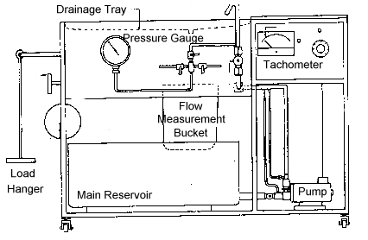
Figure 1. Cussons P6112 Hydraulics Bench Fitted with Variable Speed Unit
Water is drawn from the main reservoir by the centrifugal pump and delivered via a plastic flexible hose to the control valve mounted on the front panel. From this point the water is delivered to the test panel using another section of flexible hose. After use, the water is discharged into the drainage tray, passing into the bucket of the measuring apparatus which is carried on a beam. The free end of the beam is designed for use with a hanger carrying masses of a known value. Flow rates can be measured by timing the accumulation of water in the bucket with a stop watch. The measurement bucket is emptied using a drain plug at its base. When measurement of the water flow rate is complete, the water is emptied back into the main reservoir.
The pump is a high-speed centrifugal type. The motor normally operates at 5000 rpm with a maximum flow rate of 45 liters/min. The maximum head produced is 14 m. A controller is connected to the motor which allows the speed to vary between 0 and 5000 rpm. Speed is indicated by means of an analog tachometer.
The Pipe Bends and Fitting Apparatus enables friction losses in various types of pipe fittings to be determined experimentally. The apparatus consists of a test length of pipe work (pipe i.d. = 0.794 in) fitted to a vertical panel. The fittings include a pipe union, globe valve, gate valve and pipe bends of different forms. Immediately before and after each fitting are manometer tapings fitted with stopcocks. Mounted into the center of the panel are 4 manometer tubes which can be connected by means of flexible rubber tubes to the manometer tapings on either side of the fitting being tested. The difference in manometer heights will indicate the loss in head caused by the fitting. The test apparatus is shown schematically in Figure 2.
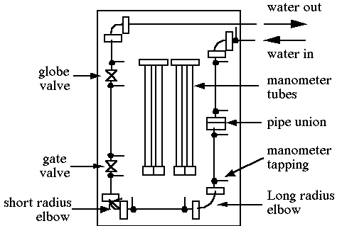
Figure 2. Pipe Bends and Fittings Apparatus
Flow Rate Measurement
The water discharged from the test apparatus falls into the drainage tray and flows into the measuring bucket. The following steps summarize the bucket/stopwatch flow rate measurement process.
1. Ensure that the rubber ball valve in the base of the bucket is open. The valve is operated by rotation of a steel disc at the end of the valve crankshaft.
2. Add appropriate masses to the weigh beam.
3. Using a stop watch, measure the elapsed time between closing the valve and accumulation of a convenient quantity of water in the bucket as indicated by tipping of the weigh beam.
Care should be taken that the bucket does not overflow at high flow rates. Open the drain valve as soon as the stop watch has been stopped. For the most accurate measurements, the timing should be made between two mass values. For example, the stopwatch could be started when the weigh bar, holding a 5 kg mass, first tips. A second weight would then be added to the weigh bar (10 kg, for instance) and the stopwatch stopped when the weigh bar tips a second time. The mass flow rate is then determined by
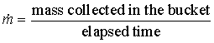 (7)
Alternatively, a rotameter may be installed in series with the Pipe Bends and Fitting Apparatus allowing direct measurement of the flow rate.
Analysis
As shown in equation 6, minor head losses are expressed as functions of the velocity squared. Constants in this expression may be grouped together such that the equation may be written as
₍₈₎
where k2 = K/2g
Minor loss coefficients can be determined through a curve fit of the experimental data, using a power equation form. The constant resulting from the curve fit procedure would then be used to evaluate the minor loss coefficient. The best value for K is obtained by curve fitting the experimental data with a power equation in which the exponent is set equal to 2
Procedure:

Calculations:
Sr. No. | Mass Flow rate | K₂ | h_{m}
1.
2.
3.
Conclusion:

