Agriculture: Dr. Amjed Ali
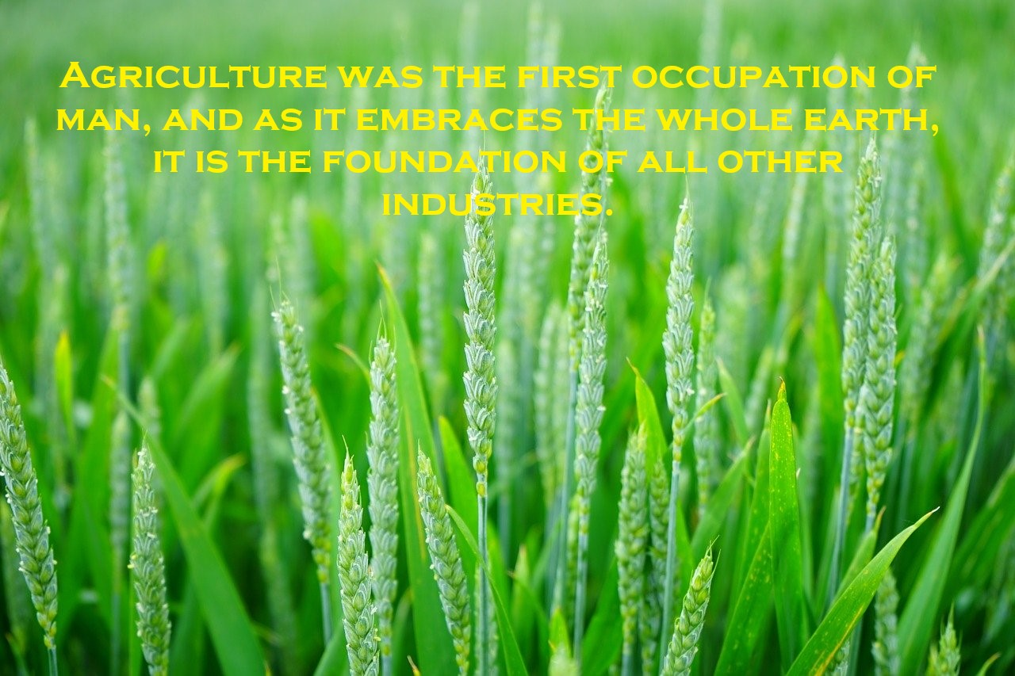
The word “Agriculture” is derived from two Latin words, Ager (or Agri) and colere (or cultura). Ager means field or land and colere means cultivation. Simply Agriculture means cultivation of field, agriculture means the cultivation of the soil, which includes several operations such as ploughing, planking, sowing of crops, harvesting of crops and feeding of animals etc. broadly speaking Agriculture can be defined as, a science or an art or an industry which makes use of soil for the production of plants, rearing of animals and birds which are directly or indirectly useful for maintaining the human life.
OR
Activity of man, primarily aimed for cultivating of soil, producing crops, and raising live stock.
Important of Agriculture:
Agriculture has a great importance in over populated world. Without giving the importance to agriculture, it is impossible to feed the people of the world and man cannot live without food. Agriculture plays a very vital role for economy of Pakistan and its development. It is the major source of food of huge population of Pakistan.
Agriculture holds great significance for our country. Pakistan has great potential of agriculture and at the time of independence Pakistan was mainly an agricultural country. In Pakistan, 43.7% of labor force is employed in agriculture sector. Agriculture sector is the single largest component of GDP in Pakistan. Its contribution is 19.3% to Pakistan’s GDP (Economic Survey of Pakistan 2019-20). Agriculture is still the largest sector of the economy of Pakistan in terms of labour participation and as such livelihood of the majority of the population directly or indirectly depends on it. However, during the last few decades, its contribution to GDP has gradually decreased to 19.3 percent however there is a lot of potential in the sector to increase its share in GDP through increased productivity utilization of latest agricultural technologies.
The important crops (wheat, rice, sugarcane, maize and cotton) account for 21.73 percent in the value addition of agriculture sector and 4.20 percent in GDP.
Wheat accounts for 8.7 percent to value addition in agriculture and 1.7 percent to GDP.
Being a main food as well as cash crop, rice holds an important place in the agriculture of Pakistan. After wheat, it is the second main staple food crop and second major exportable commodity after cotton. It contributes about 3.1 percent of value added in agriculture and 0.6 percent in GDP.
In Pakistan, after wheat and rice, Maize is the third important cereal crop. It contributes 2.9 percent to value addition in agriculture and 0.6 percent to GDP
Being a major cash crop of Pakistan, cotton is considered the backbone of the economy. It contributes about 0.8 percent to GDP and 4.1 percent of total value addition in agriculture.
Sugarcane is high value cash crop that has significance for sugar and sugar related industries in Pakistan. It contributes about 0.6 percent to GDP and 2.9 percent of the total value addition in agriculture.

The importance of agriculture is briefly discussed below.
- Provision of basic Necessities of life;
The three basic necessities of mankind are food, cloth and shelter. People depend on a wide range of agricultural products in almost all aspects of life, e.g. nutrition is a key determinant of human health, provider of energy-fuel-wood and medicinal plants. Agriculture is the only field which provides us with all three necessities, as described below.
- Food
We know that all of the food stuffs which to eat and to keep our selves alive are the production of agriculture such as milk, meat, seeds, roots, shoots, flowers and fruits.
- Cloth
Cloths of all major kinds are made from such agriculture products as cotton, wool, jute and natural silk.
- Shelter
Tree-trunks, wood and leaves have been sheltering mankind from ages. Even now wood is the basic material used in our houses.
- Raw materials for local industries / Development of Industrial Sector
Agriculture provides raw material for local industries such as textile, sugar, paper, oil, wool, and jute mills. Other industries that can be cited in this connection are cigarette, leather, flour mills, dairy, poultry, rice and fruits industry.
- Employment/ Increase in Per Capita Income
Agriculture provides employment to a large number of people. It has been estimated that about 70 per cent of our population is engaged directly or indirectly in Agriculture.
- Foreign exchange earnings / Economic Development
The major products which earn foreign exchange (80%) are cotton, Rice, raw wool, yarn, hides or skins. The important products which earn foreign exchange are footwear, leather goods, sports goods, garments and carpets which consume most of the raw materials obtained from agriculture. Agriculture is considered the backbone of Pakistan's economy, which relies heavily on its major crops. Pakistan's principal natural resources are arable land and water.
- State income/ Source of National Income
Major income of our Government comes from agriculture sector in the form of land revenue, water rates and taxes.
- Cleaning of surrounding air
Agriculture is a key to healthy biosphere. It plays an important role in cleaning of atmosphere, as plants take CO₂ and gives out almost same quantity of oxygen for our use. A young tree absorbs about 13 pounds CO₂ in a year. A tree having one-ton weight uses about 1.5 ton CO₂ and releases more than 1-ton oxygen. Ten to 50 percent expenses to keep the house cool can be saved by planting trees.
Plants also act as vegetative sound barrier. Planting of shrubs or hedges along the boundary wall of house can minimize noise pollution by absorbing sound.

