Middle and Long Distance Running
These races are usually 800 meters, 1500 meters, 5000 meters, and 10000 meters. Athletes participating in these races not only concentrate on running faster, but also on maintaining a high constant speed. Such running races are designed to test the athletes’ strength and endurance.
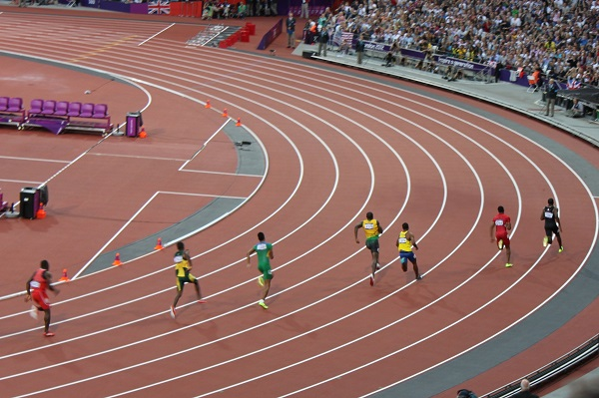

Running − Participating Countries
Running races are held throughout the world. Member federations of IAAF, the international regulating body of Athletics, organize athletic championships throughout the world. Though Americans and African athletes have been more successful in Running competitions, many Asian countries also participate in various international competitions.
Many of the world’s male sprinting champions are from the United States and Jamaica. The middle and long distance runners of Kenya and North Africa performed well in the recent Olympics, however runners from Great Brittan and USA dominated many of the previous Olympics. Russian women athletes give a tough competition to North African in the 1500 meter races.
East and North Africans are considered to be more athletic and good at running longer distances than their counterparts. Athletes from Kenya, Ethiopia, Tanzania, Uganda, Morocco and Algeria enjoyed success in long distance competitions of 5000 meters.
Chinese women athletes are also ranked high in long distance 10000 meter running along with Ethiopian athletes. Most prominent long distance male runners are from Kenya and Ethiopia. Recently athletes of Bahrain, Qatar, Saudi Arabia, and UAE won many medals in Asian Championships.

Running - Playing Environment

Track Design
Running competitions are held either on Outdoor Tracks or Indoor Tracks.
- Outdoor Tracks − Running races can be conducted both indoors and outdoors. In international competitions, outdoor tracks are oval shaped and they encompass the field used for various field events.
- Indoor Tracks − World indoor athletic championships are held in indoor tracks. The indoor track is also an oval shaped track with measurements similar to that of outdoors, but it has a 60-meter straight track across the length of the oval. This is used for the 60-meter sprint race.
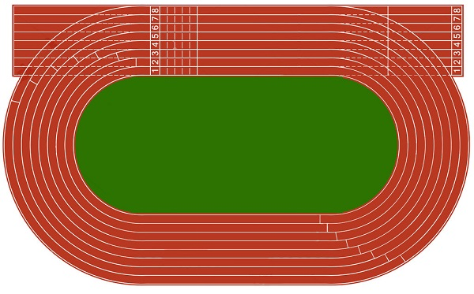

Types of Racing in 400 m Track
The oval track is a 400-meter track with parallel lanes. For the 100-meters sprint races runners run in straight lanes, for the 200-meter sprint races runners run at the bend of the track for 100 meters and the other 100 meters in a straight line. For 400 meters race, runners run around the track and complete a circle.
Athletes participating in the 800-meter race run around the track twice, and in 1500 meter race they run around the track three times and have to cover 300 meters more or another three fourths of the track to finish the race.

Running − Equipment
Running doesn’t require anything more than your ambition to participate in official competitions. You need good shoes and clothes that adhere to the rules of the sport.
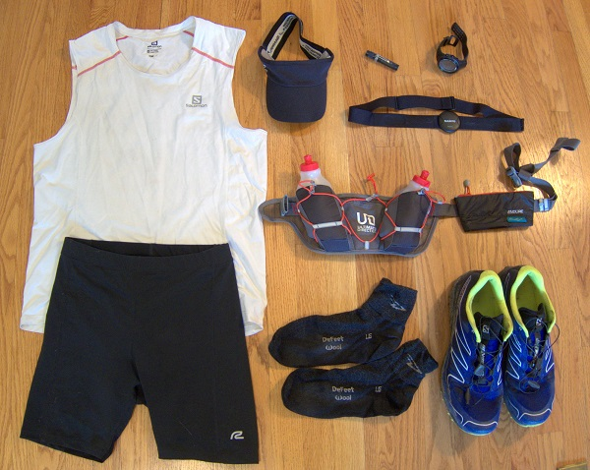
Shoes − Shoes used in professional running races are different from the ones used for walking and marathons. They don’t have heels and have eleven crampons. The crampons cannot be more than 11 mm in length.
Clothes − Male runners wear jerseys and shorts, while women runners wear tank tops and shorts. Runners also wear comfortable socks and shoe cushions.

Running - Terms
Before knowing the rules and the procedure for racing, let’s get familiar with some common terms used in this sport.
- Starting Blocks − Starting blocks are provided at the starting points in most sprint races. These blocks have sensors to record starting time and pressure. They provide grip and help athletes to push themselves at the start.
- False Start − Once the starting signal is given, players usually take more than 0.1 seconds to respond to it and start running. A player who reacts before 0.1 seconds is disqualified.
- Starting lines − Starting lines are 50 mm wide lines in white that indicate the starting point in a race. In a straight 100-meter race, the lines are all straight; in the 200 meter and 400 meter race the lines are staggered or curved so that each athlete runs equal distances to finish the race.
- Finish line − The finish line is a 50 mm wide line marked across the track. It usually is a straight line perpendicular to the sides of the track and is at the straight part of the track. If it is at the curved part of the track, it is marked along the radius.
- Break lines − Break lines are 50 mm wide arced lines and indicate the end of a bend. Small cones or prisms of any color other than white are sometimes placed on the lines separating lanes before the break lines start.
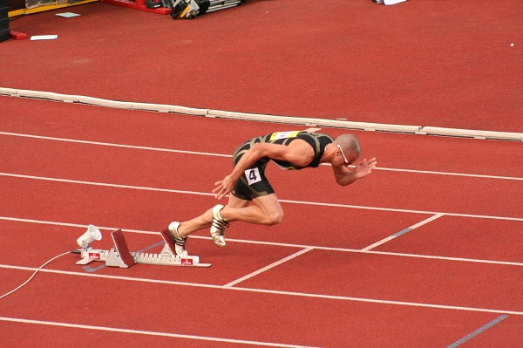

Running - How to Play?
Before the tournament starts, players’ positions, the number of heats, and the number of rounds are decided by the organizing committee.

Getting Ready
In sprints athletes take crouch position and in longer races, athletes should start the race from standing position. Here no starting blocks are used. They take respective positions in the lane before the starting line, when they hear on your marks call.
During sprint races, the ‘set’ position is taken on the next call, firmly placing feet on starting blocks and taking crouch position. For longer races, there is no ‘set’ call as they start their race in standing position. For the 800-meter race, athletes start from staggered starting points. For the 1500-meter race, athletes make a bunched start in standing position.
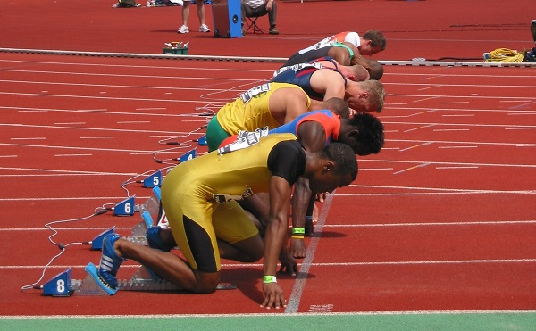

A Quick Glimpse of the Sport
Here’s how a typical race proceeds −
- Runners occupy respective positions in call.
- They start once they hear the starting gunshot.
- They run in their respective lanes along the race track.
- The race finishes when any part of the athletes’ body crosses the vertical plane of the finish line.

Winning a Race
- Each race is divided into various rounds and each round may be held in many heats to accommodate all athletes.
- The contesting athletes’ records and past achievements are considered while dividing athletes among heats. It is done so that the most successful athletes reach the finals.
- Though athletes might be randomly placed in the first round, athletes who advance by place and time are recorded. These records are considered while seeding them in heats in subsequent rounds.
- Usually two to three top performers from each heat participate in the subsequent races.
- The one who reaches the finish line first in the final is the winner.

Running - Rules
The runners should abide by the following rules in order to complete a race −
- Sprinters should run in designated lanes and cannot cross lanes, throughout the race.
- In races with bunched starts, athletes can break inside. In 800-meter race, they start from staggered positions and can break inside after the first bend.
- In longer races of 1500 meters, 5000 meters, and 10000 meters, athletes can break inside after the start.
- Sprinters shouldn’t step on white lines that mark their lanes throughout the race.
- Sensors are placed in the starting pistol and at the blocks. In case of a false start, the athlete is disqualified.
- Before giving the ‘set’ command or before firing the starter gun, athletes cannot touch the other side of the start line with their hands or feet.
- Athletes should not obstruct other athletes during the race.
- If an athlete is obstructed, the referee may order the race to be held again, or he may ask the athlete to take part in the next round.
- Athletes may leave the track voluntarily before the race ends, but they cannot come back to the track else they will be disqualified.
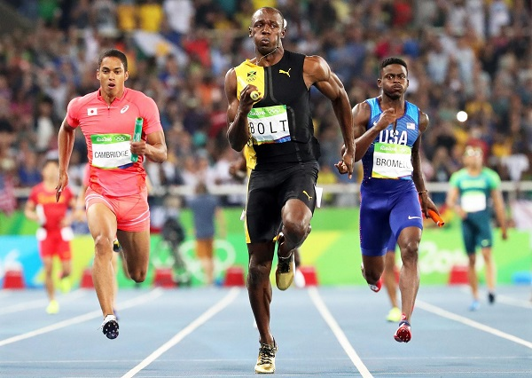

Running - Champions
Running races are an indispensable part of all Athletic championships. They are also a part of Olympic since the ancient times. Many racing tournaments are held globally. Some of them are as follows −
- IAAF World Championships
- IAAF World Indoor Championships
- Regional Championships (Pan- American, African, Asian, European Games)
- Olympics

Middle distance race
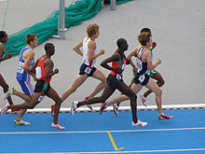
2008 World Junior Championships in Athletics - 1500 metres event
Middle distance race event is longer than sprints, up to 3000 metres. The standard middle distances are the 800 metres, 1500 metres and the mile run, while the 3000 metres may also be classified as a middle distance event. The 880 yard run, or half mile, was the forebear to the 800 m distance and it has its roots in competitions in the United Kingdom in the 1830s. The 1500 m came about as a result of running three laps of a 500 m track, which was commonplace in continental Europe in the 20th century.
Middle-distance running events are track races longer than sprints, up to 3000 metres. The standard middle distances are the 800 metres, 1500 metres and mile run, although the 3000 metres may also be classified as a middle-distance event. The 1500 m came about as a result of running ​3 ³⁄₄ laps of a 400 m outdoor track or ​7 ¹⁄₂ laps of a 200 m indoor track, which were commonplace in continental Europe in the 20th century.

800 metres
Athletics
800 metres
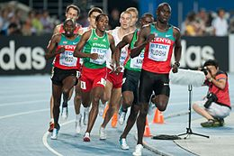
Men's 800 metres final in Daegu 2011.
World records
Men | David Rudisha 1:40.91 (2012)
Women | Jarmila Kratochvílová 1:53.28 (1983)
Olympic records
Men | David Rudisha 1:40.91 (2012)
Women | Nadezhda Olizarenko 1:53.43 (1980)
Championship records
Men | Donavan Brazier 1:42.34 (2019)
Women | Jarmila Kratochvílová 1:53.28 (1983)
The 800 metres, or 800 meters (US spelling), is a common track running event. It is the shortest common middle-distance running event. The 800 metres is run over two laps of the track (400-metre track) and has been an Olympic event since the first games in 1896. During indoor track season the event is usually run on a 200-metre track, therefore requiring four laps.
The event was derived from the imperial measurement of a half a mile (880 yards), a traditional English racing distance. Imperial racing distances were common in the United States. American high schools (in the name of the NFHS) were the last to convert to metric distances in 1980, following the NCAA's conversion in 1976. Countries associated to the English system converted to metric distances after the 1966 Commonwealth Games. 800 m is 4.67 m less than half a mile.
The event combines aerobic endurance with anaerobic conditioning and sprint speed. Both the aerobic and anaerobic systems are being taxed to a high extent, thus the 800-metre athlete is required to combine training between both systems.
Runners in this event are often fast enough to compete in the 400 metres or the 4 × 400 metres relay^{[1]} but only Alberto Juantorena and Jarmila Kratochvílová have won major international titles at 400 m and 800 m. If they are so inclined, 400 m runners are usually encouraged to run the 200 metres while 800 m runners are encouraged to run the 1500 metres or long distance events.

Training
800m runners have training plans that include both speed and endurance work, in order to improve both the aerobic and anaerobic energy systems, as both of these are used in the race. Almost all 800m athletes' training will be on the track during the outdoor season (Summer), and will mostly consist of repetitions of distances between 200m and 1000m. Coaches have varying opinions on training during Winter; some argue the athlete should continue to do 800m training and racing on indoor tracks, whereas others argue that cross-country running is more beneficial as it develops strength and endurance. 800-metre runners tend to include at least one longer run per week in their training schedule, but this may be more depending on their standard. For junior athletes these may be 2–4 miles (3–6 km), however for senior athletes these may be 5–7 miles (8–11 km). Sebastian Coe ran around 60-70 (95–110 km) miles per week at his peak, whereas Steve Ovett ran 100–120 miles (160–190 km). It is worth noting that the training of these two athletes was aimed at the 1500m and mile as well as the 800m. The higher an athlete's standard, the more likely they are to do "strength and conditioning" training, which may include weight training, circuit training, or plyometrics.

Race tactics
The 800 m event is also known for its tactical racing techniques. Because the 800 m event is the shortest middle distance event that has all the runners converge on lane one, positioning on the cut-in and the position of the pack is critical to the outcome of the race. It is commonly believed that getting the first or second position early in the race is advantageous as these positions are not usually caught up in the pack. Olympic champions Dave Wottle, Kelly Holmes and others have defied that logic by running a more evenly paced race, lagging behind the pack and kicking past the slowing early leaders. Often the winner of 800 m races at high levels are not determined by the strongest runner but instead by the athlete with the best positioning near the end of the race. This leads to a high probability of an upset. Competitive races tend to put the athletes in different lanes. Sometimes the race will begin on a "waterfall" start, making the starting line much more crowded and making it difficult to have a good start. This is common in youth running, but unlikely anywhere else.
Two common tactics for the 800 metres are running a negative split or a positive split between laps. The positive split is widely considered to be the more effective strategy, but on occasion experienced runners have been known to use a negative split to their advantage. A positive split is achieved by running the first lap faster than the second lap, and a negative split is achieved by the opposite, running the second lap faster than the first. The current world record holder, David Rudisha, runs using a positive split strategy. In his 2012 Olympic race, he ran his first lap in 49.28 seconds and his second lap in 51.63 seconds. Theoretically, an even split is the most effective strategy, but it is nearly impossible to achieve due to the race's length.

Running - Rules

The runners should abide by the following rules in order to complete a race −
- Sprinters should run in designated lanes and cannot cross lanes, throughout the race.
- In races with bunched starts, athletes can break inside. In 800-meter race, they start from staggered positions and can break inside after the first bend.
- In longer races of 1500 meters, 5000 meters, and 10000 meters, athletes can break inside after the start.
- Sprinters shouldn’t step on white lines that mark their lanes throughout the race.
- Sensors are placed in the starting pistol and at the blocks. In case of a false start, the athlete is disqualified.
- Before giving the ‘set’ command or before firing the starter gun, athletes cannot touch the other side of the start line with their hands or feet.
- Athletes should not obstruct other athletes during the race.
- If an athlete is obstructed, the referee may order the race to be held again, or he may ask the athlete to take part in the next round.
- Athletes may leave the track voluntarily before the race ends, but they cannot come back to the track else they will be disqualified.

1500 metres

Jump to navigationJump to search
Athletics
1500 metres
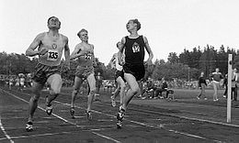
Olavi Salsola, Olavi Salonen and Olavi Vuorisalo (The three Olavis) break the 1,500 m world record in 1957 in Turku, Finland.
World records
Men | Hicham El Guerrouj (MAR) 3:26.00 (1998)
Women | Genzebe Dibaba (ETH) 3:50.07 (2015)
Olympic records
Men | Noah Ngeny (KEN) 3:32.07 (2000)
Women | Paula Ivan (ROM) 3:53.96 (1988)
Championship records
Men | Hicham El Guerrouj (MAR) 3:27.65 (1999)
Women | Sifan Hassan (NED) 3:51.95 (2019)
The 1500 metres or 1,500-metre run (typically pronounced 'fifteen-hundred metres') is the foremost middle distance track event in athletics. The distance has been contested at the Summer Olympics since 1896 and the World Championships in Athletics since 1983. It is equivalent to 1.5 kilometers or approximately ​¹⁵⁄₁₆ miles.
The demands of the race are similar to that of the 800 metres, but with a slightly higher emphasis on aerobic endurance and a slightly lower sprint speed requirement. The 1500 metre race is predominantly aerobic, but anaerobic conditioning is also required.
Each lap run during the world-record race run by Hicham El Guerrouj of Morocco in 1998 in Rome, Italy averaged just under 55 seconds (or under 13.8 seconds per 100 metres). 1,500 metres is three and three-quarter laps around a 400-metre track. During the 1970s and 1980s this race was dominated by British runners, along with an occasional Finn, American, or New Zealander, but through the 1990s many African runners began to win Olympic medals in this race, especially runners from Kenya, Morocco and Algeria.
In the Modern Olympic Games, the men's 1,500-metre race has been contested from the beginning, and at every Olympic Games since. The first winner, in 1896, was Edwin Flack of Australia, who also won the first gold medal in the 800-metre race. The women's 1,500-metre race was first added to the Summer Olympics in 1972, and the winner of the first gold medal was Lyudmila Bragina of the Soviet Union. During the Olympic Games of 1972 through 2008, the women's 1,500-metre race has been won by three Soviets plus one Russian, one Italian, one Romanian, one Briton, one Kenyan, and two Algerians. The 2012 Olympic results are still undecided as a result of multiple doping cases. The best women's times for the race were controversially set by Chinese runners, all set in the same race on just two dates 4 years apart at the Chinese National Games. At least one of those top Chinese athletes has admitted to being part of a doping program. The women's record was finally surpassed by Genzebe Dibaba of Ethiopia in 2015.
In American high schools, the mile run (which is 1609.344 metres in length) and the 1,600-metre run, also colloquially referred to as "metric mile", are more frequently run than the 1,500-metre run, since US customary units are better-known in America. Which distance is used depends on which state the high school is in, and, for convenience, national rankings are standardized by converting all 1,600-metre run times to their mile run equivalents.

Long-distance running
"Long-distance track event" redirects here. For the speed skating events, see long track speed skating.
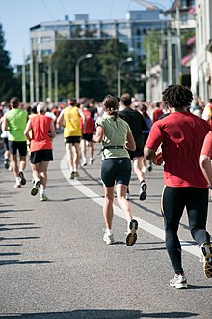
A group of amateur runners in a long-distance race in Switzerland.
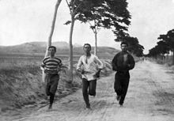
Burton Holmes' photograph entitled "1896: Three athletes in training for the marathon at the Olympic Games in Athens".
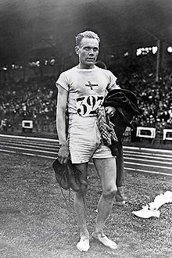
Paavo Nurmi, also known as the "Flying Finn", at the 1924 Summer Olympics in Paris; at the time, he won Olympic gold in the 5,000-meter long-distance running.
Long-distance running, or endurance running, is a form of continuous running over distances of at least 3 kilometres (1.8 miles). Physiologically, it is largely aerobic in nature and requires stamina as well as mental strength.
Among mammals, humans are well adapted for running significant distances, and particularly so among primates. The endurance running hypothesis suggests that running endurance in the genus Homo arose because travelling over large areas improved scavenging opportunities and allowed persistence hunting. The capacity for endurance running is also found in migratory ungulates and a limited number of terrestrial carnivores, such as bears, dogs, wolves and hyenas.
In modern human society, long-distance running has multiple purposes people may engage in it for physical exercise, for recreation, as a means of travel, for economic reasons, or for cultural reasons. Long-distance running can also be used as a means to improve cardiovascular health. Running improves aerobic fitness by increasing the activity of enzymes and hormones that stimulate the muscles and the heart to work more efficiently. Endurance running is often a component of physical military training and has been so historically. Professional running is most commonly found in the field of sports, although in pre-industrial times foot messengers would run to deliver information to distant locations. Long-distance running as a form of tradition or ceremony is known among the Hopi and Tarahumara people, among others. Distance running can also serve as a bonding exercise for family, friends, colleagues, and has even been associated with nation-building. The social element of distance running has been linked with improved performance.
In the sport of athletics, long-distance events are defined as races covering three kilometres (1.86 miles) and above. The three most common types are track running, road running and cross country running, all of which are defined by their terrain – all-weather tracks, roads and natural terrain, respectively. Typical long-distance track races range from 3000 metres to 10,000 metres (6.2 miles), cross country races usually cover 5 to 12 km (3 to 7½ miles), while road races can be significantly longer, reaching 100 kilometres (60 miles) and beyond. In collegiate cross country races in the United States, men race 8,000 or 10,000 meters, depending on their division, whereas women race 6,000 meters. The Summer Olympics features three long-distance running events: the 5000 metres, 10,000 metres and marathon (42.195 kilometres, or 26 miles and 385 yards). Since the late 1980s, Kenyans, Moroccans and Ethiopians have dominated in major international long-distance competitions. The high altitude of these countries has been proven to help these runners achieve more success. Mountain air, combined with endurance training, can lead to an increase in red blood cells, allowing increased oxygen delivery via arteries. The majority of these East African successful runners come from three mountain districts that run along the Great Rift Valley.

Contents
- 1History
  - 1.1Prehistoric running
    - 1.1.1Hunting
  - 1.2Ancient history
    - 1.2.1Messengers
- 2Physiology of long-distance running
  - 2.1Factors
    - 2.1.1Aerobic capacity
    - 2.1.2Lactate threshold
    - 2.1.3Fuel
    - 2.1.4Thermoregulation and body fluid loss
  - 2.2Impact on health
- 3In sport
  - 3.1Running competitions
    - 3.1.1Track running
    - 3.1.2Road running
    - 3.1.3Cross country running
- 4Adventure running
- 5Ultra-long distance: extended events and achievements

History

Prehistoric running

Hunting
Anthropological observations of modern hunter-gatherer communities have provided accounts for long-distance running as a historic method for hunting among the San of the Kalahari, American Indians, and the Australian Aborigines. In this method, the hunter would run at a slow and steady pace between one hour and a few days, in an area where the animal has no place to hide. The animal, running in spurts, has to stop to pant in order to cool itself, but as the chase goes on it would not have enough time before it has to start running again, and after a while would collapse from exhaustion and heat. The body structure of a skeleton of a 12 years old Nariokatome boy is suggested to prove that early humans from 1.5 million years ago were eating more meat and less plants, and hunted by running down animals.

Ancient history
With developments in agriculture and culture, long-distance running took more and more purposes other than hunting: religious ceremonies, delivering messages for military and political purposes, and sport.

Messengers
Running messengers are reported from early Sumer, were named lasimu as military men as well as the king's officials who disseminated documents throughout the kingdom by running. Ancient Greece was famous for its running messengers, who were named hemerodromoi, meaning “day runners”. One of the most famous running messengers is Pheidippides, who according to the legend ran from Marathon to Athens to announce the victory of the Greek over the Persians in the Battle of Marathon in 490 B.C. He collapsed and died as he delivered the message “we won”. While there are debates around the accuracy of this historical legend, whether Pheidippides actually ran from Marathon to Athens or between other cities, how far this was, and if he was the one to deliver the victory message, the marathon running event of 26.2 miles / 42.195 km is based on this legend.

Physiology of long-distance running
Humans are considered among the best distance runners among all running animals: game animals are faster over short distances, but they have less endurance than humans. Unlike other primates whose bodies are suited to walk on four legs or climb trees, the human body has evolved into upright walking and running around 2-3 million years ago. The human body can endure long-distance running through the following attributes:
- Bone and muscle structure: unlike quadruped mammals, which have their center of mass in front of the hind legs or limbs, in biped mammals including humans the center of mass lies right above the legs. This leads to different bone and muscular demands especially in the legs and pelvis.
- Dissipation of metabolic heat: humans’ ability to cool the body by sweating through the body surface provides many advantages over panting through the mouth or nose. These include a larger surface of evaporation and independence of the respiratory cycle.
One distinction between upright walking and running is energy consumption during locomotion. While walking, humans use about half the energy needed to run. Evolutionary biologists believe that the human ability to run over long-distances has helped meat-eating humans to compete with other carnivores. Persistence hunting is a method in which hunters use a combination of running, walking, and tracking to pursue prey to the point of exhaustion. While humans can sweat to reduce body heat, their quadrupedal prey would need to slow from a gallop in order to pant. The persistence hunt is still practised by hunter-gatherers in the central Kalahari Desert in Southern Africa, and David Attenborough's documentary The Life of Mammals (program 10, "Food For Thought") showed a bushman hunting a kudu antelope until it collapsed.^{[32]}

Factors

Aerobic capacity
One's aerobic capacity or VO₂Max is the ability to maximally take up and consume oxygen during exhaustive exercise. Long-distance runners typically perform at around 75–85 % of peak aerobic capacity, while short distance runners perform at closer to 100% of peak.
Aerobic capacity depends on the transportation of large amounts of blood to and from the lungs to reach all tissues. This in turn is dependent on having a high cardiac output, sufficient levels of hemoglobin in blood, and an optimal vascular system to distribute of blood.^{[34]} A 20 fold increase of local blood flow within skeletal muscle is necessary for endurance athletes, like marathon runners, to meet their muscles' oxygen demands at maximal exercise that are up to 50 times greater than at rest.
Elite long-distance runners often have larger hearts and decreased resting heart rates that enable them to achieve greater aerobic capacities. Increased dimensions of the heart enable an individual to achieve a greater stroke volume. A concomitant decrease in stroke volume occurs with the initial increase in heart rate at the onset of exercise. Despite an increase in cardiac dimensions, a marathoner's aerobic capacity is confined to this capped and ever decreasing heart rate.
The amount of oxygen that blood can carry depends on blood volume, which increases during a race, and the amount of hemoglobin in blood.
Other physiological factors affecting a marathon runner's aerobic capacity include pulmonary diffusion, mitochondria enzyme activity, and capillary density.
A long-distance runner's running economy is their steady state requirement for oxygen at specific speeds and helps explain differences in performance for runners with very similar aerobic capacities. This is often measured by the volume of oxygen consumed, either in liters or milliliters, per kilogram of body weight per minute (L/kg/min or mL/kg/min). As of 2016 the physiological basis for this was uncertain, but it seemed to depend on the cumulative years of running, and reaches a cap that longer individual training sessions cannot overcome.

Lactate threshold
A long-distance runner's velocity at the lactate threshold is strongly correlated to their performance. Lactate threshold is the cross over point between predominantly aerobic energy usage and anaerobic energy usage and is considered a good indicator of the body's ability to efficiently process and transfer chemical energy into mechanical energy. For most runners, the aerobic zone doesn't begin until around 120 heart beats per minute. Lactate threshold training involves tempo workouts that are meant to build strength and speed, rather than improve the cardiovascular system's efficiency in absorbing and transporting oxygen. By running at your lactate threshold, your body will become more efficient at clearing lactic acid and reusing it to fuel your muscles. Uncertainty exists in regards to how lactate threshold affects endurance performance.

Fuel
In order to sustain high intensity running, a marathon runner must obtain sufficient glycogen stores. Glycogen can be found in the skeletal muscles or liver. With low levels of glycogen stores at the onset of the marathon, premature depletion of these stores can reduce performance or even prevent completion of the race. ATP production via aerobic pathways can further be limited by glycogen depletion. Free Fatty Acids serve as a sparing mechanism for glycogen stores. The artificial elevation of these fatty acids along with endurance training demonstrate a marathon runner's ability to sustain higher intensities for longer periods of time. The prolonged sustenance of running intensity is attributed to a high turnover rate of fatty acids that allows the runner to preserve glycogen stores later into the race.
Long-distance runners generally practice carbohydrate loading in their training and race preparation.

Thermoregulation and body fluid loss
The maintenance of core body temperature is crucial to a marathon runner's performance and health. An inability to reduce rising core body temperature can lead to hyperthermia. In order to reduce bodily heat, the metabolically produced heat needs to be removed from the body via sweating, which in turn requires re-hydration to compensate for. Replacement of fluid is limited but can help keep the body's internal temperatures cooler. Fluid replacement is physiologically challenging during exercise of this intensity due to the inefficient emptying of the stomach. Partial fluid replacement can serve to avoid a marathon runner's body over heating but not enough to keep pace with the loss of fluid via sweat evaporation. Environmental factors can especially complicate heat regulation.

Impact on health
The impact of long-distance running on human health is generally positive. Various organs and systems in the human body are improved: bone mineral density is increased, cholesterol is lowered. However, beyond a certain point, negative consequences might occur. Male runners who run more than 40 miles (64 kilometers) per week face reduced testosterone levels, although they are still in the normal range. Running a marathon lowers testosterone levels by 50% in men, and more than doubles cortisol levels for 24 hours. Low testosterone is thought to be a physiological adaptation to the sport, as excess muscle caused may be shed through lower testosterone, yielding a more efficient runner. Veteran, lifelong endurance athletes have been found to have more heart scarring than controls groups, but replication studies and larger studies should be done to firmly establish the link, which may or may not be causal. Some studies find that running more than 20 miles (32 kilometers) per week yields no lower risk for all-cause mortality than non-runners, however these studies are in conflict with large studies that show longer lifespans for any increase in exercise volume.
The effectiveness of shoe inserts has been contested. Memory foam and similar shoe inserts may be comfortable, but they can make foot muscles weaker in the long term. Running shoes with special features, or lack thereof in the case of minimalist designs, do not prevent injury. Rather, comfortable shoes and standard running styles are safer.

In sport
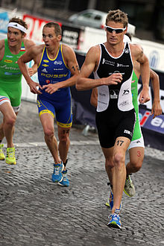
Men in the 10 km run section of the 2011 Grand Prix de Triathlon in Paris.
Many sporting activities feature significant levels of running under prolonged periods of play, especially during ball sports like association football and rugby league. However, continuous endurance running is exclusively found in racing sports. Most of these are individual sports, although team and relay forms also exist.
The most prominent long-distance running sports are grouped within the sport of athletics, where running competitions are held on strictly defined courses and the fastest runner to complete the distance wins. The foremost types are long-distance track running, road running and cross-country running. Both track and road races are usually timed, while cross country races are not always timed and typically only the placing is of importance. Other less popular variants such as fell running, trail running, mountain running and tower running combine the challenge of distance with a significant incline or change of elevation as part of the course.
Multisport races frequently include endurance running. Triathlon, as defined by the International Triathlon Union, may feature running sections ranging from five kilometres (3.1 mi) to the marathon distance (42.195 kilometres, or 26 miles and 385 yards), depending on the race type. The related sport of duathlon is a combination of cycling and distance running. Previous versions of the modern pentathlon incorporated a three or four kilometre (1.9–2.5 mi) run, but changes to the official rules in 2008 meant the running sections are now divided into three separate legs of one kilometre each (0.6 mi).
Depending on the rules and terrain, navigation sports such as foot orienteering and rogaining may contain periods of endurance running within the competition. Variants of adventure racing may also combine navigational skills and endurance running in this manner.

Running competitions

Track running
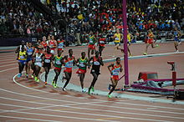
Runners turning the bend in the men's 10,000 metres final at the 2012 Summer Olympics.
Main articles: 5000 metres; 10,000 metres; One hour run; and track and field
The history of long-distance track running events are tied into the track and field stadia where they are held. Oval circuits allow athletes to cover long distances in a confined area. Early tracks were usually on flattened earth or were simply marked areas of grass. The style of running tracks became refined during the 20th century: the oval running tracks were standardised to 400 metres in distance and cinder tracks were replaced by synthetic all-weather running track of asphalt and rubber from the mid-1960s onwards. It was not until the 1912 Stockholm Olympics that the standard long-distance track events of 5000 metres and 10,000 metres were introduced.
- The 5000 metres is a premier event that requires tactics and superior aerobic conditioning. Training for such an event may consist of a total of 60–200 kilometers (40–120 miles) a week, although training regimens vary greatly. The 5000 is often a popular entry-level race for beginning runners.
  - The world record for men is 12:37.35 (an average of 23.76 km/h) by Kenenisa Bekele of Ethiopia in Hengelo, Netherlands on 31 May 2004
  - The world record for women is 14:11.15 (an average of 21.14 km/h) by Tirunesh Dibaba of Ethiopia in Oslo, Norway on 6 June 2008
- The 10,000 metres is the longest standard track event. Most of those running such races also compete in road races and cross country running events.
  - The world record for men is 26:17.53 (22.83 km/h) by Kenenisa Bekele of Ethiopia set in 2005
  - The world record for women is 29:17.45 (20.48 km/h) by Almaz Ayana of Ethiopia set on 12 August 2016
- The one hour run is an endurance race that is rarely contested, except in pursuit of world records.
- The 20,000 metres is also rarely contested, most world records in the 20,000 metres have been set while in a one-hour run race.

Road running[edit]
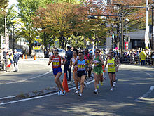
Women runners on a closed-off-road at the 2009 Yokohama Marathon.
Main articles: Road running and Marathon race
Long-distance road running competitions are mainly conducted on courses of paved or tarmac roads, although major events often finish on the track of a main stadium. In addition to being a common recreational sport, the elite level of the sport – particularly marathon races – are one of the most popular aspects of athletics. Road racing events can be of virtually any distance, but the most common and well known are the marathon, half marathon and 10 km run.
The sport of road running finds its roots in the activities of footmen: male servants who ran alongside the carriages of aristocrats around the 18th century, and who also ran errands over distances for their masters. Foot racing competitions evolved from wagers between aristocrats, who pitted their footman against that of another aristocrat in order to determine a winner. The sport became professionalised as footmen were hired specifically on their athletic ability and began to devote their lives to training for the gambling events. The amateur sports movement in the late 19th century marginalised competitions based on the professional, gambling model. The 1896 Summer Olympics saw the birth of the modern marathon and the event led to the growth of road running competitions through annual public events such as the Boston Marathon (first held in 1897) and the Lake Biwa Marathon and Fukuoka Marathons, which were established in the 1940s. The 1970s running boom in the United States made road running a common pastime and also increased its popularity at the elite level.
The marathon is the only road running event featured at the IAAF World Championships in Athletics and the Summer Olympics, although there is also the IAAF World Half Marathon Championships held every two years. The marathon is also the only road running event featured at the IPC Athletics World Championships and the Summer Paralympics. The World Marathon Majors series includes the six most prestigious marathon competitions at the elite level – the Berlin, Boston, Chicago, London, Tokyo, and New York City marathons. The Tokyo Marathon was most recently added to the World Marathon Majors in 2012 (See also: List of marathon races)
Ekiden contests – which originated in Japan and remain very popular there – are a relay race variation on the marathon, being in contrast to the typically individual sport of road running.

Cross country running
Main articles: Cross country running, Trail running, Fell running, and Mountain running
Cross country running is the most naturalistic form of long-distance running in athletics as competitions take place on open-air courses over surfaces such as grass, woodland trails, earth or mountains. In contrast to the relatively flat courses in track and road races, cross country usually incorporates obstacles such as muddy sections, logs and mounds of earth. As a result of these factors, weather can play an integral role in the racing conditions. Cross country is both an individual and team sport, as runners are judged on an individual basis and a points scoring method is used for teams. Competitions are typically races of 4 km (2.5 mi) or more which are usually held in autumn and winter. Cross country's most successful athletes often compete in long-distance track and road events as well.
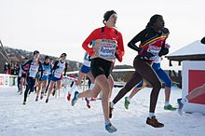
Women racing on snow in the 2012 European Cross Country Championships
The history of the sport is linked with the game of paper chase, or hare and hounds, where a group of runners would cover long distances to chase a leading runner, who left a trail of paper to follow. The Crick Run in England in 1838 was the first recorded instance of an organised cross country competition. The sport gained popularity in British, then American schools in the 19th century and culminated in the creation of the first International Cross Country Championships in 1903. The annual IAAF World Cross Country Championships was inaugurated in 1973 and this remains the highest level of competition for the sport. A number of continental cross country competitions are held, with championships taking place in Africa, Asia, Europe, Oceania, North America and South America. The sport has retained its status at the scholastic level, particularly in the United Kingdom and United States. At the professional level, the foremost competitions come under the banner of the IAAF Cross Country Permit Meetings.
While cross country competitions are no longer held at the Olympics, having featured in the athletics programme from 1912–1924, it has been present as one of the events within the modern pentathlon competition since the 1912 Summer Olympics.
Fell running, trail running and mountain running can all be considered variations on traditional cross country which incorporate significant uphill and/or downhill sections as an additional challenge to the course.

Adventure running
The term adventure running is loosely defined and can be used to describe any form of long-distance running in a natural setting, regardless of the running surface. It may include river crossing, scrambling, snow, extreme high or low temperatures, and high altitudes. It has both competitive and non-competitive forms, the latter being for individual recreation or social experience. As a result, courses are often set in scenic locations and feature obstacles designed to give participants a sense of achievement. It bears similarities to running sections of adventure racing.

Ultra-long distance: extended events and achievements
Main articles: Ultramarathon and Multiday races
A number of events, records and achievements exist for long-distance running, outside the context of track and field sports events. These include multiday races, ultramarathons, and long-distance races in extreme conditions or measuring hundreds or thousands of miles.
Beyond these, records and stand-alone achievements, rather than regular events, exist for individuals who have achieved running goals of a unique nature, such as running across or around continents (see lists of runners: America, Australia) or running around the world.
- Fastpacking
- Middle-distance running
- Running economy
- VO₂max
- Neurobiological effects of physical exercise
- Paceband
- Rarámuri people

