Endomembranous system and vasicular trafficking
GENERAL INTRODUCTION
OUTLINES:
- Vesicular trafficking includes all the communication pathways mediated by vesicles; as well as the organelles that send or receive vesicles.
- There are two main roads in this trafficking road map.
- Secretory pathway
- Importing pathway
SECRETORY PATHWAY:
- The pathway starts in the endoplasmic reticulum that sends vesicles to the Golgi apparatus, which in turn send vesicles targeted to the plasma membrane (Exocytosis).
- This pathway release molecules to the extracellular space, and also carries molecules to the plasma membrane.
IMPORTING PATHWAY:
- This pathway begins at the plasma membrane where vesicles and other large components are originated by membrane invagination (Endocytosis).
- These vesicles fuse with endosomes, which end up becoming lysosome.
- lysosomes degrade the endocytic molecules, both those form from the extracellular space and those forming the membrane of the vesicles.
- It is a degradation pathway.
There are many other communication pathways mediated by vesicles so that it looks like that all the organelles are connected through vesicles between each other. this has not been produced yet. However there is this rule saying that the communication by vesicles between two organelles used to be “Bidirectional”.
For example:
The endoplasmic reticulum sends vesicles to the Golgi apparatus which in turn sends vesicles back to the endoplasmic reticulum.
There are organelles, such as Mitochondria, Chloroplasts and Peroxisomes which are not the part of vesicular traffic because they do not frequently send or receive vesicles.
However, these organelles communicate with other organelles by other mechanisms.
BRIEF INTRODUCTION OF ORGANELLES INVOLVED IN
VESICULAR TRAFFICKING

ENDOPLASMIC RETICULUM:
The system comprises endoplasmic reticulum which is a membranous synthesis and is a transport organelle that is a extension of nuclear envelope. Endoplasmic reticulum forms a continue sheet enclosing a single internal space. This space is called “ER Lumen” and is also referred to as the ER cisternal space. The lumen takes up about 10% of entire cell volume. Its membrane allows molecules to selectively transferred between lumen and cytoplasm. It also provides channel between nucleus and the cytoplasm. ER has a central role on producing, processing and transporting “Biochemical compounds” for use inside and outside of the cell.
Its membrane is the side of production of all transmembrane proteins and lipids for most of cell organelles including ER itself, the Golgi apparatus, lysosomes, endosomes, mitochondria, peroxisomes, secretory vesicles and plasma membrane. Almost all of the proteins that will exit the cell, those staying in lumen of ER, Golgi apparatus or lysosome are originally delivered from endoplasmic reticulum. Some temporary proteins in lumen of ER can change their location and are transported but few constantly remain in lumen and are known as ER resident proteins.ER resident proteins are made up of specialized retention signal made up of specific sequence of amino acid that enable them to be retained by the organelle.
An example of such proteins is:
CHAPERON PROTEIN known as BIP which identifies other proteins that have been improperly built or processed and sent to their final destination.
SMOOTH ENDOPLASMIC RETICULUM (FUNCTION):
Also called transitional ER because they contain ER exit sites from which transport vesicles carrying newly synthesized proteins and lipids bud off for transport to processes, including synthesis of lipids, metabolism of carbohydrates, detoxification of drugs an poisons.
Enzymes of SER are vital to the synthesis of lipids and steroids (sex hormones of vertebrates and steroid hormones of adrenal glands). SER performing carbohydrates metabolism cells are abundant in liver cells.
ROUGH ENDOPLASMIC RETICULUM (FUNCTION):
Many types of cells export protein produced by ribosomes attached to the rough ER. The ribosome assemble amino acid into protein units,, which are carried into RER for further adjustments. These proteins may be transmembrane proteins, which become embedded in the membrane of endoplasmic reticulum OR water soluble proteins which are able to pass through the membrane into lumen, then those retained proteins are folded into correct three dimensional conformation. Chemicals such as carbohydrates or sugars are added, then ER either transport the completed protein called Secretory proteins to the areas of cell where they are needed OR they are sent to Golgi bodies for further processing or modification.

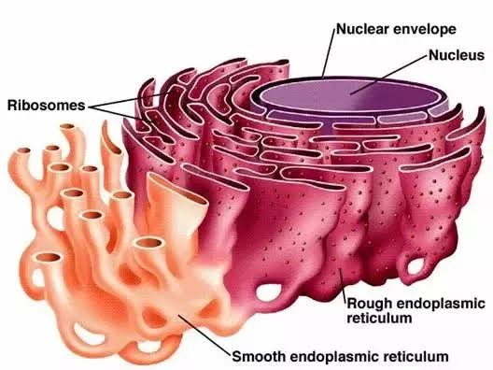

GOLGI APPARATUS:
Golgi apparatus is the stack of sacs called cisternae. Its main function is protein modification. The section of apparatus which receives the vesicles from ER is known as Cis-face while the opposite end is called Trans-face where modified compounds leave. Trans-face is usually facing the plasma membrane where most of the modifies are sent. Vesicles sent off by ER containing proteins are further altered at Golgi apparatus and then prepared for secretion from the cell or transport to other parts of the cell.
- Modification and synthesis of carbohydrate portion of glycoproteins is common in protein processing.
- The Golgi apparatus removes and substitutes various sugar monomers, producing a large variety of Oligosaccharides.
- In addition to modifying proteins the Golgi also manufactures macromolecules itself.
- In plants Golgi apparatus produce pectin and other polysaccharides need by plant structure.
- Once modification is completed, the Golgi apparatus sorts the products of its processing and send them to various parts of cell.
- Molecular identification labels or tags are added by Golgi enzymes to help in their transport.
- After this, Golgi apparatus sends off its products by budding vesicles from its Trans-face.
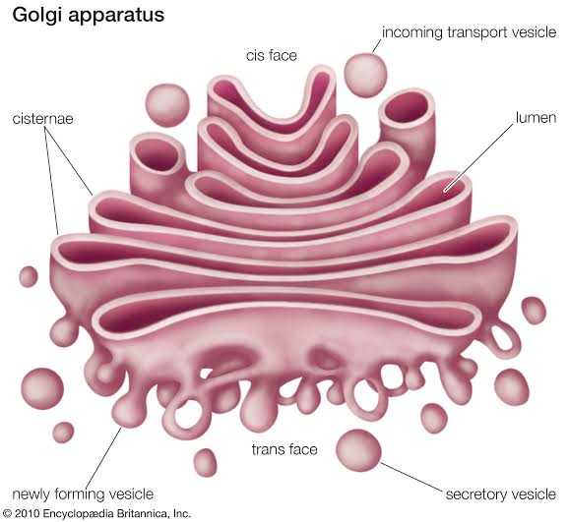
VACUOLES:
These are membrane bound sacs larger then vesicles. In plant cells vacuoles cover 30-90% of total cell volume.

VESICLES:
These are small membrane bound transport unit that can transfer molecules between different compartments.
Endoplasmic reticulum Golgi apparatus 3-Various locations

Clathrin-coated COPI-coated COPII-coated
CLATHRIN-coated: Transport substances between Golgi apparatus and plasma membrane.
COPI-coated & COPII-coated: Frequently used between ER & Golgi apparatus. i.e.
COPI coats vesicles transporting from cis-Golgi back to the RER and between Golgi compartments. This type of transport is called as Retrograde(Backward) transport.
COPII coats vesicles transporting proteins from the RER to the cis-Golgi.

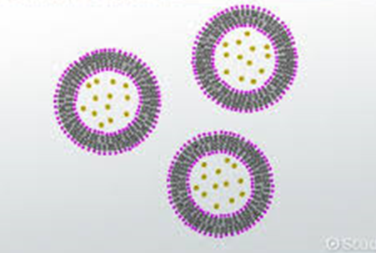
VESICLES

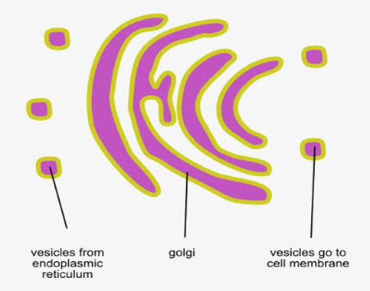
MECHANISM OF TRANSPORT

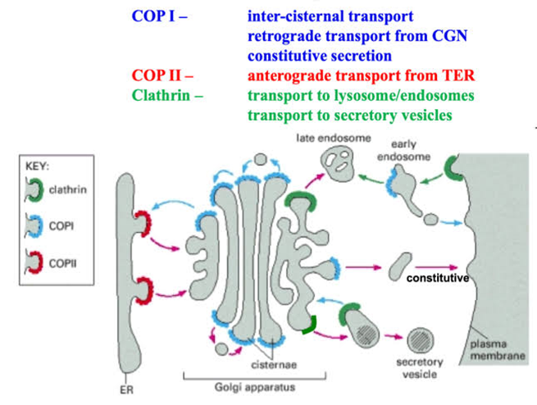
ROLE OF
- CLATHRIN
- COPI
- COPII
The vesicles (60 nm in diameter) are of three types :
- Transitional vesicles :
These are small membrane limited vesicles which are thought to form as blebs from the transitional ER to migrate and converge to cis face of Golgi, where they coalesce to form new cisternae.
- Secretory vesicles:
These are varied-sized membrane-limited vesicles which discharge from margins of cisternae of Golgi. They, often, occur between the maturing face of Golgi and the plasma membrane.
- Clathrin-coated vesicles;
These are spherical protuberances, about 50 µm in diameter and with a rough surface. They are found at the periphery of the organelle, usually at the ends of single tubules, and are morphologically quite distinct from the secretory vesicles. The clathrin-coated vesicles are known to play a role in intra-cellular traffic of membranes and of secretory products, i.e., between ER and Golgi, as well as, between GELR region and the endosomal and lysosomal compartments.
The GERL Region :
Golgi apparatus is a differentiated portion of the endomembrane system found in both animal and plant cells. This membranous component is spatially and temporally related to the endoplasmic reticulum (ER) on one side and by way of secretory vesicles, may fuse with specific portions of the plasma membrane. To the trans face of Golgi is associated the trans-reticular Golgi TGN (=trans Golgi-network) or GERL (=Golgi + smooth ER + lysosomal) in which acid phosphatase enzyme (a characteristic lysosomal enzyme) makes its first appearance. GERL is found to be involved in the origin of primary lysosomes and of melanin granules ; in the processing, condensing and packaging of secretory material in endocrine and exocrine cells; and in lipid metabolism. GERL is also a region of sorting of cellular secretory proteins.
TUBULES:
In Golgi apparatus a complex array of associated vesicles and anastomosing tubules (30 to 50 nm diameter) surround the dictyosome and radiate from it. In fact, the peripheral area of dictyosome is fenestrated (lace-like) in structure.
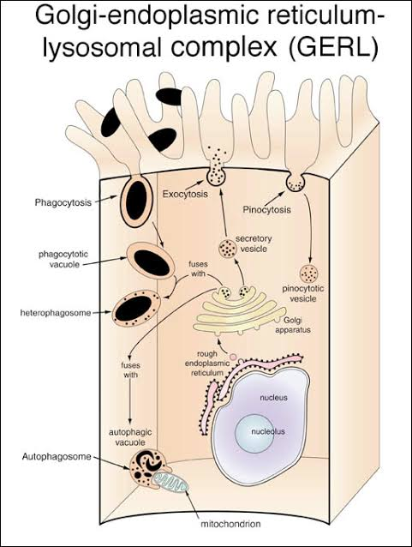

LYSOSOMES:
The lysosomes (Gr., lyso=digestive + soma=body) are tiny membrane-bound vesicles involved in intracellular digestion.
The biogenesis (origin) of the lysosomes requires the synthesis of specialized lysosomal hydrolases and membrane proteins. Both classes of proteins are synthesized in the ER and transported through the Golgi apparatus, then transported from the trans Golgi network to an intermediate compartment (an endolysosome) by means of transport vesicles (which are coated by clathrin protein) The lysosomal enzymes are glycoproteins, containing N-linked oligosaccharides that are processed in a unique way in the cis Golgi so that their mannose residues are phosphorylated. These mannose 6-phosphate (M6P) groups are recognized by M6P-receptors (which are transmembrane proteins) in the trans Golgi network that segregates the hydrolases and helps to package them into budding clathrin-coated vesicles which quickly lose their coats. These transport vesicles containing the M6P-receptors act as shuttles that move the receptors back and forth between the trans Golgi network and endolysosomes. The low pH in the endolysosome dissociates the lysosomal hydrolases from this receptor, making the transport of the hydrolases unidirectional.
FUNCTIONS OF LYSOSOMES:
The important functions of lysosomes are as follows:
- Digestion of large extracellular particles.
The lysosomes digest the food contents of the phagosomes or pinosomes. The lysosomes of leucocytes enable the latter to devour the foreign proteins, bacteria and viruses.
- Digestion of intracellular substances.
During the starvation, the lysosomes digest the stored food contents, viz., proteins, lipids and carbohydrates (glycogen) of the cytoplasm and supply to the cell necessary amount of energy.
- Autolysis
In certain pathological conditions the lysosomes start to digest the various organelles of the cells and this process is known as autolysis or cellular autophagy. When a cell dies, the lysosome membrane ruptures and enzymes are liberated. These enzymes digest the dead cells. In the process of metamorphosis of amphibians and \tunicates many embryonic tissues, e.g., gills, fins, tail, etc., are digested by the lysosomes and utilized by the other cells.
- Extracellular digestion.
The lysosomes of certain cells such as sperms discharge their enzymes outside the cell during the process of fertilization. The lysosomal enzymes digest the limiting membranes of the ovum and form penetration.

LYSOSOME IN CELL

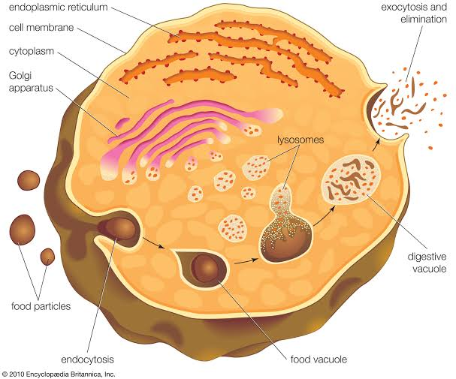

SECRETORY PATHWAY
Cells routinely import and export large molecules across the plasma membrane. Macromolecules are secreted out from the cell by Exocytosis
Macromolecules are ingested into the cell from outside through Phagocytosis and Endocytosis.
EXOCYTOSIS:
It is also called Emeiocytosis and Cell vomiting. In all eukaryotic cells, secretory vesicles are continually carrying new plasma membrane and cellular secretions such as proteins, lipids and carbohydrates (e.g., cellulose) from the Golgi apparatus to the plasma membrane or to cell exterior by the process of exocytosis. The proteins to be secreted are synthesized on the rough endoplasmic reticulum (RER). They pass into the lumen of the ER, glycosidated and are transported to the Golgi apparatus by ER-derived transport vesicles.
In the Golgi apparatus the proteins are modified, concentrated, further glycosidated, sorted and finally packaged into vesicles that pinch off from trans Golgi tubules and migrate to plasma membrane to fuse with it and release the secretion to cell’s exterior.
In contrast, small molecules to be secreted (e.g., histamine by the mast cells) are actively transported from the cytosol (where they are synthesized on the free ribosomes) into preformed vesicles, where they are complexed to specific macromolecules (e.g. a network of proteoglycans, in case of histamine)^{[1]} so that, they can be stored at high concentration without generating an excessive osmotic gradient.
During exocytosis the vesicle membrane is incorporated into the plasma membrane. The amount of secretory vesicle membrane that is temporarily added to the plasma membrane can be enormous : in a pancreatic acinar cell discharging digestive enzymes, about 900 µm2 of vesicle membrane is inserted into the apical plasma membrane (whose area is only 30 µm3) when the cell is stimulated to secrete.
Examination of cells following secretion using electron microscopy demonstrate increase presence of partially empty vesicles following secretion. This suggested that during the secretory process, only a portion of the vesicular content is able to exit the cell. This could only be possible if the vesicles where to temporarily establish continuity with the cell plasms membrane, expel a portion of its contents, then detach, receive, and withdraw into the cytosol (endocytose). In this way, the secretory vesicle could be used for subsequent rounds of exocytosis and endocytosis, until completely empty of its contents.

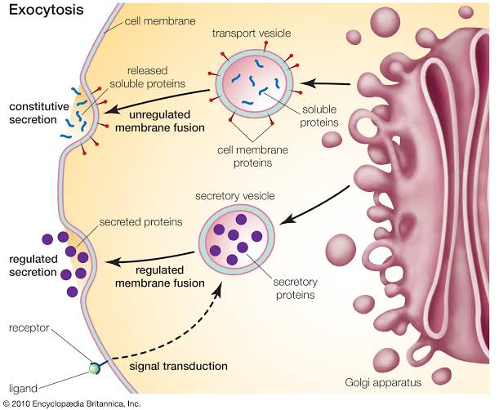

STEPS IN VESICULAR TRAFFICKING^{[5]}
There are five steps to exocytosis:
• Vesicle trafficking:
In this first step the vesicle containing the waste product or chemical transmitter is transported through the cytoplasm towards the part of the cell from which it will be eliminated.
• Vesicle tethering:
As vesicle approaches the cell membrane, it is secured and pulled towards the part of the cell from which it will be eliminated.
• Vesicle docking:
In this step the vesicle comes in contact with the cell membrane, where it begins to chemically and physically merge with the proteins in the cell membrane.
• Vesicle priming:
In those cells where chemical transmitters are being released, this step involves the chemical preparations for the last step of exocytosis.
• Vesicle fusion:
In this last step, the proteins forming the walls of the vesicles merge with the cell membrane and reach, pushing the vesicle contents (waste products or chemical transmitters) out of the cell. This step is the primary mechanism for the increase in the size of the cell’s plasma membrane.

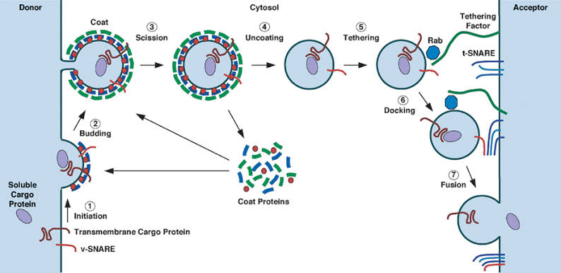

IMPORTING PATHWAYS
ENDOCYTOSIS:
In endocytosis, small regions of the plasma membrane fold inwards or invaginate, until it has formed new intracellular membrane limited vesicles. In eukaryotes, the following two types of endocytosis can occur : pinocytosis and receptor-mediated endocytosis.
2- PHAGOCYTOSIS:
Phagocytosis. Sometimes the large-sized solid food or foreign particles are taken in by the cell through the plasma membrane. The process of ingestion of large-sized solid substances (e.g., bacteria and parts of broken cells) by the cell is known as phagocytosis (Gr., phagein=to eat, kytos=cell or hollow vessel).
Occurrence of phagocytosis:
The process of phagocytosis occurs in most protozoans and certain cells of multicellular organisms. In multicellular organisms such as mammals, the phagocytosis occurs very actively in granular leucocytes and in the cells of mesoblastic origin. The cells of the mesoblastic origin are collectively known as the cells of macrophagic or reticuloendothelial system. The cells of macrophagic system are histiocytes of the connective tissue, the reticular cells of the hemopoietic organs (bone marrow, lymph nodes and spleen) and the endothelial cells which form the lining of capillary sinusoid of the liver, adrenal gland and hypophysis. The cells of macrophagic system can ingest bacteria, Protozoa, cell debris or even colloidal particles by the process of phagocytosis.
Process of phagocytosis.
In phagocytosis, first the target particle is bound, to the specific receptors on the cell’s surface (process is called adsorption),then the plasma membrane expands along the surface of the particle and eventually engulfs it. Vesicle formed by phagocytosis is called phagosome and it is typically 1 to 2 µm or larger in diameter, much larger than those formed during pinocytosis and receptor-mediated endocytosis. The phagosomes migrate to the interior of the cell and fuse with the pre-existing lysosomes (to form phagolysosome). The food is digested by the hydrolytic enzymes (acid hydrolase) of the lysosomes and the digested food is ultimately diffused to the surrounding cytoplasm. In addition to the normal set of lysosomal hydrolases, macrophage’s lysosomes contain enzymes that generate hydrogen peroxide (H2O2) and other toxic chemicals that aid in the killing of the bacteria.
The undigested food is expelled from the plasma membrane by the process of ephagy or egestion. In macrophages, the undigested parts of ingested material such as the cell walls of micro-organisms, accumulate within lysosomes as residual bodies. Accumulation of residual bodies may be one reason why macrophages have a very short life time (i.e., less than a few days).
Kinds of phagocytosis.
According to the physical and chemical nature of foreign substance following types of phagocytosis have been recognized:
- Ultraphagocytosis or Colloidopexy:
The process in which plasma membrane ingests smaller colloidal particles is known as colloidopexy or ultraphagocytosis, e.g. leucocytes and the macrophagic cells of mammals.
- Chromopexy:
When the cell ingests colloidal chromogen particles phagocytotically the process is known as chromopexy, e.g., some mesoblastic cells.
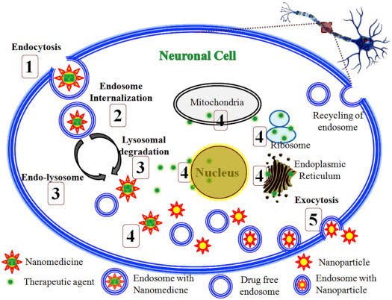
- Pinocytosis.
Pinocytosis (Gr. pinein = to drink ‘cell drinking’) is the non-specific uptake of small droplets of extracellular fluid by endocytic vesicles or pinosomes, having diameter of about 0.1 µm to 0.2 µm. Any material dissolved in the extracellular fluid is internalized in proportion to its concentration in the fluid. The process of pinocytosis was first of all observed by Edward in Amoeba and by Lewis (1931) in the cultured cells.
The light microscopy has shown that in Amoeba tiny pinocytic channels are continually being formed at the cell surface by invagination of the plasma membrane. From the inner end of each channel small vacuoles or pinosomes are pinched off, and these move towards the center of the cell, where they fuse with primary lysosomes, to form food vacuoles. Ultimately, ingested contents are digested, small breakdown products such as sugars and amino acids diffuse to cytosol.
Micropinocytosis:
Electron microscopic observations have been made on the pinocytotic process at sub-cellular or sub-microscopic level in the cells. The pinocytosis which occurs at submicroscopic level is known as micropinocytosis. In the process of micropinocytosis, the plasma membrane invaginates to from small vesicles of 650 Aº diameter. These closed vesicles are not coated by clathrin protein and they move across the cytoplasm of endothelial cells (which line the blood capillaries) to fuse with opposite plasma membrane discharging their contents. This is called transcytosis. Such transcellular passage of fluids is also found to occur in other types of cells such as Schawn and Satellite cells of nerve ganglion, macrophages, muscle cells and reticular cells, etc., but in them vesicles are coated by clathrin.^{[2]}
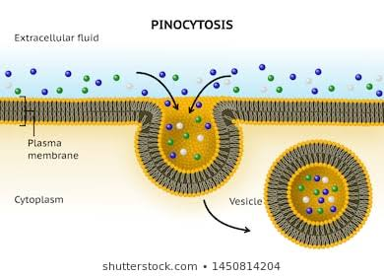
- Receptor-mediated endocytosis.
In this type of endocytosis, a specific receptor on the surface of the plasma membrane “recognizes” an extracellular macromolecule and binds with it. The substance bound with the receptor is called the ligand.
Examples of ligands may include:
Viruses, Small proteins (e.g., Insulin, Vitellogenin, Immunoglobin, Transferrin, etc.), Vitamin B12, Cholesterol containing LDL( low density lipoprotein), Oligosaccharide etc. The region of plasma membrane containing the receptor-ligand complex undergoes endocytosis. The whole process of receptor mediated endocytosis, includes the following events :
- Interaction of ligands and cell surface receptors:
The macromolecules (ligands) bind to complementary cell-surface receptors. There are more than 25 different types of receptors which are involved in receptor-mediated endocytosis of different types of molecules. Such a receptor is a transmembrane protein which contains two specific binding sites : (1) Ligand-binding site at the external surface of plasma membrane. (2) Coated-pit binding site at the inner or cytosolic face of the plasma membrane.
- Formation of coated-pits and coated-vesicles:
The endocytic cycle begins at specialized regions of the plasma membrane, called coated-pits. Coated-pits are depressions of plasma membrane having a coat of bristle-like structure towards their cytosolic side.
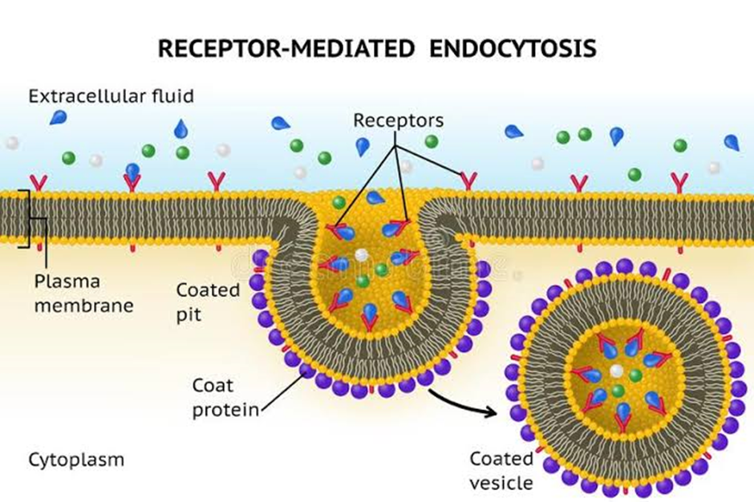
Functions of coated pits (clathrin dependent): The ligand-loaded receptors diffuse into these coated-pits. A coated-pit may accommodate about 1000 receptors of assorted variety. In fact, coated-pits serve as molecular filters and selective concentrating devices, since, they tend to collect certain receptors and leave others. They increase the efficiency of internalization of a particular ligand more than 1000-fold and also carry minor components of extracellular fluid. The life-time of each coated-pit is quite short—within a minute or so of being formed, it invaginates into the cell and pinches off to form the coated-vesicles. The coat of coated pits and coated vesicles is made up of protein, called clathrin and certain other proteins. A molecule of clathrin is composed of three large polypeptide chains and three smaller polypeptide chains, all of which together form a three-legged structure, called triskelion. A number of triskelions assemble into a basket-like network of hexagons and pentagons on the cytoplasmic surface of the membranes.
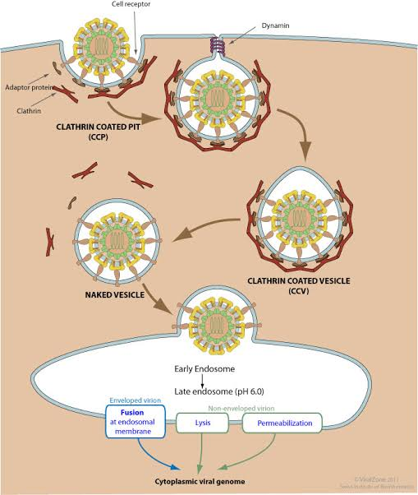
- Fusion of endocytic vesicle and endosome:
Once a coated vesicle is formed, the clathrin and associated proteins dissociate from the vesicle membrane and return to the plasma membrane to form a new coated-pit. The resultant endocytic vesicle gets fused with pre-existing endosomes and ultimately its contents are utilized by the cell.
Endosome or Receptosome. Recently it has been found that in the cells exists a complex set of heterogeneous membrane bound tubes and vesicles, called endosome, which extends from the periphery of the cell to the perinuclear region, where it lies quite close to Golgi apparatus. Thus, endosomes may be of two types:
- Peripheral endosomes just beneath the plasma membrane.
- Perinuclear or Internal endosomes.
The interior of the endosome is acidic (pH 5-6) due to the presence of ATP-driven proton (H+) pumps in its membrane that pumps H+ ions into the lumen from the cytosol. Endosomes lack in degradative enzymes. Thus, via receptor-mediated coated-vesicles, the ligands are delivered to the peripheral endosomes which slowly move inward to become perinuclear endosomes. These perinuclear endosomes are converted into endolysosomes and then into lysosomes due to following three activities:
- The fusion of transport vesicles from the Golgi apparatus. Transport vesicles capture a cargo of molecules, e.g., proteins, from the lumen of one compartment as they pinch off from its membrane and then discharge that cargo into another compartment as they fuse with it. Thus, in such vesicular transport, the transported proteins do not cross any membrane and they are transferred from lumen to lumen.
- Continuous membrane retrieval.
- Increased acidification.
The endosomal compartment also acts as the main sorting station in the endocytic pathway. The acidic environment of the endosome causes dissociation of ligands from their receptors. Such ligands are destined for destruction in the lysosomes along with the other non-membrane-bound contents of the endosome. The receptor-proteins are either returned to the same plasma membrane domain from which they come or they go to lysosomes and are degraded.
Example of receptor-mediated endocytosis:
Most animal cells are found to have a regulatory pathway for the uptake of cholesterol. Most cholesterol is transported in the blood in the form of particles of low density proteins or LDL. Each of these large spherical particles (22 nm in diameter) contains a core of about 1500 cholesteryl ester molecules surrounded by a lipid monolayer and also contains a single large protein molecule (apoprotein). When the cell needs cholesterol for membrane synthesis, it synthesizes receptor proteins for LDL particles and inserts them into its plasma membrane. The human LDL receptor is a single-pass transmembrane glycoprotein which is composed of about 840 amino acid residues, only 50 of which stick out from cytoplasmic side of plasma membrane to form the coated-protein-binding site.
The LDL - binding site of the receptor is exposed to cell surface. The LDL receptors move laterally within lipid bilayer, until they become associated to the newly formed coated-pits. Since coated-pits constantly pinch off to form coated vesicles, the LDL particles are bound to receptors in the coated-pits and are rapidly internalized. After shedding their clathrin-coats the endocytic vesicles deliver their contents to endosomes. In endosomes, the LDL particles and their receptors are separated from each other ; the receptors are returned to the plasma membrane, while LDL ends up in the lysosomes.
In the lysosomes, the cholesteryl esters in the LDL particles are hydrolyzed to free cholesterol molecules, which thereby become available to the cell for new membrane synthesis. If too much free cholesterol accumulates in a cell, this stops cell’s own cholesterol synthesis and the synthesis of LDL-receptor proteins, so that less amount of cholesterol is made and less amount of it is taken up by the cell
Energy utilisation by phagocytosis and endocytosis:
Unlike pinocytosis, which is a constitutive process that occurs continuously, the phagocytosis is a triggered process in which activated receptors transmit signals to the cell interior to initiate the response. Both phagocytosis and pinocytosis are active mechanisms in the sense that the cell requires energy for their operation. During phagocytosis by leukocytes oxygen consumption, glucose uptake and glycogen breakdown all increase significantly. The mechanism of endocytosis is found to involve the contraction of microfilaments of actin and myosin present in the peripheral cytoplasm (ectoplasm) which causes the plasma membrane to invaginate and to form the endocytic vacuole (pinosomes/phagosome). Involvement of actin microfilaments is demonstrated by the action of the drug cytochalasin B which inhibits endocytosis and disorganizes actin microfilaments.
Membrane fusion during exocytosis and endocytosis. Both exocytosis and endocytosis involve the fusion of initially separate regions of lipid bilayer and occur in at least two steps : first the two bilayers come into close apposition, it is called bilayer adherence, and then they fuse together (This is called bilayer joining). Both of these steps are believed to be mediated by some types of specific proteins, called fusogenic proteins.
MODIFICATIONS NECESSARY FOR TRANSPORT:
The cell surface of certain cells performs various physiological activities such as absorption, secretion, transportation, etc. To perform such specialized functions certain modifications are inevitable in the plasma membrane of such cells. Such cell surface differentiations may include microvilli, invagination, basement membrane and many types of cell-to-cell interconnections or junctions.
- Invaginations:
The bases (inner ends) of certain cells, such as the cells of the kidney, perform active transportation and contain many invaginations or infoldings of the plasma membrane. At the base of these folds, there develops a septa and, thus, narrow compartments of basal cytoplasm are formed. These infoldings contain many mitochondria. These mitochondria along with the enzymes of plasma membrane possibly provide energy rich compound, viz., ATP to the plasma membrane for the active transportation of solutes.
- Microvilli:
Microvilli are finger-like, slender projections of plasma membrane which are found in mesothelial cells, hepatic cells, epithelial cells of intestine (striated border), uriniferous tubules (brush border), gall bladder, uterus, growing oocyte and yolk sac. Microvilli increase the effective surface of absorption. For example, a single epithelial cell of intestine may have as many as 3000 microvilli and in a square millimeter of intestine there may be 200,000,000. These microvilli are 0.6 to 0.8 µm long and 0.1 µm in diameter. The narrow spaces between the microvilli form a kind of sieve through which substances may pass during the process of absorption. Within the cytoplasmic core of a microvillus fine microfilaments are observed which in the underlying cytoplasm form a terminal web. The microfilaments contain actin
and are attached to the tips of the microvilli by α-actinin their function is to produce contraction of microvilli.
- Basement Membrane:
The interface between all epithelia and underlying connective tissue is marked by a non-cellular structure called basement membrane. This membrane comprises two basic layers :
- Basal lamia which is in contact with the epithelial basal plasma membrane and is composed of fine feltwork of fibrils of collagen of Type IV that are embedded in an amorphous matrix. It is secreted by the epithelial cells.
- Reticular layer exists just beneath the basal lamina and is composed of fine reticular fibers of reticulin protein. The reticular fibers are embedded in a ground substance. The reticular layer is synthesized by underlying connective tissue into which it is merged. The basement membrane provides structural support for epithelia and may constitute an important barrier to the passage of materials between the epithelial and connective tissue compartments.
- Tight Junctions (Zonula Occludens):
The cells of both vertebrate and invertebrate animals display junctions that are designed to prevent or reduce the flow of even small molecules between the lateral surfaces of adjacent cells. Such junctions are particularly characteristics of epithelial tissues. In higher animals these are termed tight junctions and in invertebrates these are called septate junctions.
- Desmosomes:
Desmosomes are abundantly found in tissues that have to withstand severe mechanical stress, such as skin epithelia, bladder, cardiac muscle, the neck of uterus and vagina. Their presence in such tissues allows the tissues to function as elastic sheets without the individual cells being torn one from another.

DIAGRAMMATIC MECHANISM OF VESICULAR TRAFFICKING:

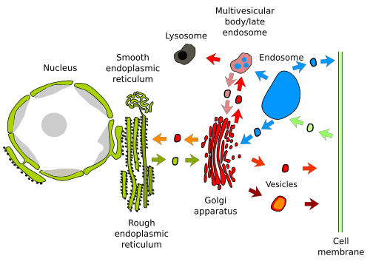
OR
