Project Report (Group No. 4)
BS Mathematics 2nd semester
Course Name:
Citizenship education and community Engagement
Title:
Report
Submission date
8-june-2020 At 9:00 p.m.
Group Members:
Laiba Bano (Group leader)
Roll No. BMAF19BM035
Rabia Farooq
Roll No. BMAF19BM032
Aniqa Raza
Roll No. BMAF19BM007
Areeba Rasool
Roll No. BMAF19BM003
Ayesha
Roll No. BMAF19BM006
Submitted to:
Mam Mehlah Jabeen
Session:
2019-23

University of Sargodha sub campus
Bhakkar

1.Title of project:
Rescue the community in COVID-19 condition
2.Introduction:
Rescue 1122 (Urdu: 1122 پنجاب ایمرجنسی‎) is an emergency service that serves Punjab Province in Pakistan. The service is accessed by calling 1122 from any phone. It was established under the 2006 Punjab Emergency Service Act to provide management of emergencies such as fire, rescue and emergency medical services. The Punjab Emergency Council and District Emergency Boards have been constituted to ensure management and prevention of emergencies and to recommend measures for mitigation of hazards endangering public safety. Dr Rizwan Naseer is the current Director General of Rescue 1122 Pakistan.
After the success of the Lahore Pilot Project launched in 2004, Rescue 1122 is operational in all Districts of Punjab with a population of over 110 million and providing technical assistance to other Provinces of Pakistan. Rescue 1122 includes Emergency Ambulance, Rescue & Fire services and a Community Safety program.
The District Emergency Officer is responsible for the day-to-day operational management and administration of the Service in the Districts in close coordination with the District Administration. The office of the Director General is mainly responsible for the overall monitoring to ensure uniformity and quality, training, planning, research and development through the Provincial Monitoring Cell. The management is currently working to improve its services. In March 2013, Emergency Rescue Service Rawalpindi received 14 new fully equipped ambulances.
Presently, Rescue 1122 is representing a model of integrated emergency services in the world. It offers emergency, fire, rescue, disaster management, water rescue, animal rescue and community safety services under one umbrella.
"Introduction of Rescue 1122". rescue.gov.pk. Retrieved August 1, 2017.
2.1. Background:
In more advanced developing countries, establishing ambulance transport systems is more feasible, but still requires considerable expertise and planning. Prior to 2004, Pakistan did not have an organized emergency medical system. In that year, Rescue 1122 was launched as a professional pre-hospital emergency service, and it has managed to achieve an average response time of 7 minutes, comparable to that of developed nations. Some of the critical factors in its success included local manufacture of vehicles, training instructors to certify emergency medical technicians, adopting training materials to the local context, and branching out to include fire and rescue service response under a united command structure.
Waseem Hanniya, Naseer, Rizwan ,Razzak,Junid Abdul (June 1,2011) http://emj.bmj.com/content/emermed/28/6/513.full.pdf
2.2. Present Situation:
In Pakistan:
The Message of the Director General Punjab Emergency Service Dr Rizwan Naseer on UN Global Road Safety Week( 10 May 2020)
https://www.youtube.com/watch?v=kx98yb0laUQ&feature=youtu.be (YouTube channel Rescue 1122)
Rescuers are performing their duties at inside Expo Corona Hospital in Hall 1 and Hall 3 to take care of Corona positive patients.
Hats off to all Frontline Fighters of COVID-19
Rescue Officers with staff at Expo Corona Triage Center are also performing 24/7 duties to facilitate COVID-19 patients.(9 May 2020)
Mr. Zeeshan Assistant Commissioner Model Town visited Lahore Expo Triage Center and discussed in detail with Rescue Officers Sir Ahsan and Dr. Ali about the arrangements for the patients of Expo Corona Hall Number 1. He appreciated the organized set up by the Rescue Team at Expo Center and ensured to provide administrative support to the team during this pandemic (6 May 2020)
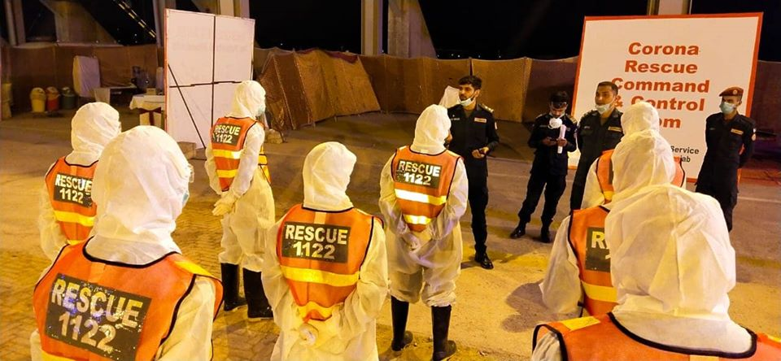
https://www.facebook.com/rescue1122official/ (Rescue official Page)
In Bhakkar:
All Rescue 1122 services are closed due to corona virus. Corona helpline 080099000 in Bhakkar. Tahir Mahmood as a District Emergency Services doing his job very well. Now they only serves the corona patient.
https://www.facebook.com/rescue1122official/(Rescue Mohafiz Bhakkar)
3.Justification of project:
a. Important of project activity:
First Aid knowledge is invaluable for both you as the individual and for your community. It enables you to assist persons who become injured in the event of an accident or emergency situation until help arrives. First Aid skills can be applied in the home, the workplace or in public locations, therefore the more First Aid certified people there are in a community the safer that community becomes. Becoming First Aid certified not only benefits you as an individual but it extends to your family, friends, co-workers and even the community as a whole. As unpleasant as it is to talk about, accidents and emergency situations are not completely preventable or unavoidable.
If an accident happens in the workplace, in your home or in a public space, being a helpless witness to an emergency situation can potentially worsen the situation.
This is why it is very important for as many people as possible to have at least a basic knowledge of First Aid. In its most basic form, First Aid is the initial assistance given to a victim of injury or illness. Basic First Aid knowledge is comprised of relatively simple techniques and procedures that can be performed with limited equipment and is typically carried out until professional medical assistance arrives
laiba Bano BMAF19BM035,(2020)
b. Practical Implication:(Who will get benefit of this project?)
1. It allows those trained with the potentially lifesaving ability to assist an injured or ill person during a variety of emergency situations.
In situations such as someone ingests a harmful substance, suffers from a heart attack, a seizure or stroke, is involved in a motor vehicle accident or is caught in a natural disaster, a person trained and knowledgeable in even the very basics of First Aid can be of extreme importance in assisting the injured person(s) until emergency responders arrive. The more people that are First Aid trained and knowledgeable the more the community as a whole benefit.
2. Knowledge in First Aid benefits the individuals themselves regardless of whether an emergency affects them directly or involves people they live and work with. First Aid can and often lessens the severity of an emergency in a given time and place.
3. While everyone can benefit from First Aid knowledge and training it is an even greater benefit to those working or living with individuals who require ongoing special attention or treatment such as children, persons with physical or mental disabilities, persons with chronic illness, persons with disorders such as epilepsy, the elderly, persons involved in recreational activities such as swimming or people working in dangerous environments such as a factory or construction site.
laiba Bano BMAF19BM035, (2020)
4.Objectives:
To provide participants with the knowledge to administer First Aid care and treatment in the workplace or in personal situations. How we provide First Aid adults, children & babies in a wide range of emergency situations
Our main objectives are given below:
We will aware our neighborhood about
- emergency numbers
Country Emergency Numbers:
Dial 112 or 911 from a mobile phone with GSM coverage anywhere in the world and your call will be automatically directed to that country’s emergency number. (https://www.abcpublications.com.au)
- First aid basics
- Aware community through pamphlet
- Give basic training to public about rescue
- How ladies rescue their children in absence of male person.
- How people rescue their lives in Pandemic condition.
- Awareness through social media
(laiba Bano BMAF19BM035,(2020) ,
5. Plan of action
a. How will you do this project activity?

1.Going to community Institute:
First of all, I will visit the Rescue office 1122. Tell them my project .in this regard, In Bhakkar ,Mr. Asif Murawat give training to people.I will contact him and become a part of community service.
2. Get First Aid training:
I will visit recue 1122 office and get training of first aid from them. Mr. Asif Murawat is performs his duty in this regard.I will meet him and avail myself.
3.Print out a Pamphlet of basic first aid in lock down condition:
Pamphlet regarding treatment of first aid will be developed by group leader Laiba Bano on MS Word . I will print it out, distribute it among people and paste it on the walls of shops etc. So people will aware about that.
.4.Visit our neighborhood and train them:
Each member of group will visits his own neighborhood and teach them about first Aid treatment. I will visit my own neighbourhood and tell them about basics of first aid in lock down situation. The reason behind is that during lock down hospital is close for common person and public transport is also stop in this regard. So, i will tell them about basics, how they will rescue their beloved at home? It is specially for women who are not well educated, at the absence of male how can they give their children first aid
5.Tell neighbours about First Aid basics:
- How to stock your home first aid kit?
- Peroxide or alcohol to clean cuts
- Prevent common injuries in the home
- First aid is essential for your car and purse.

6.Aware neighbour about emergency numbers:
First Aid & Emergencies
CALL 911 NOW IF YOU ARE HAVING:
- Chest pain
- Sudden weakness or Numbness
- Difficulty Breathing
I will also aware people about emergency numbers of doctors, recue, fire brigade. In any situation they will dial given number.
laiba Bano BMAF19BM035, (2020),
Tell people about first aid basic
In a present situation, whole world is effected by COVID-19. According to my project title my plan of action is rescue the community in COVID-19. In present situation people cannot go to hospital or clinic due to lockdown. So, I went to give them awareness that how they can rescue themselves at home. If they get any infection, how they can treat themselves. If they get any cut at any part of body how they bandage themselves.
(Rabia Farooq, Bs math, (2020)
b. Needed resources & the source of generation (financial, human resources etc.)
Financial Resources:
Every member of group will contribute and print out pamphlet.I will contribute my own pocket money.
Human Resources:
I need help of Rescue 1122 in this regard. They will traine me and then I will play a vital role in awareness of society.
laiba Bano BMAF19BM035, (2020),
.c.Each person’s role in the project
Group work:
Awreness through social media:
I (laiba Bano, BMAF19BM035) make a page on facebook,name “First Aid Traning”. All group members joined that group and now we post there about first aid basic.
Page link is given below:-
Fisrt Aid Traning:
(Rabia Farooq, BMAF19BM032) send message to rescue officers “Sir Bilal Rana”. He send her voice message and told all tranning of first aid basics, all group members listen it and ten aware their neighbourhood.
https://www.facebook.com/First-Aid-basics-107653677649331/?modal=admin_todo_tour
Make Pumphlet:
I (laiba bano,BMAF19BM035) made a pumphlet and other group members search it. Every member of group individuialy prnted it out and share with neighbours, pasted on street walls.
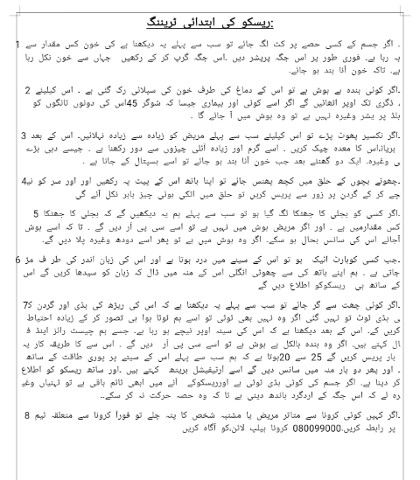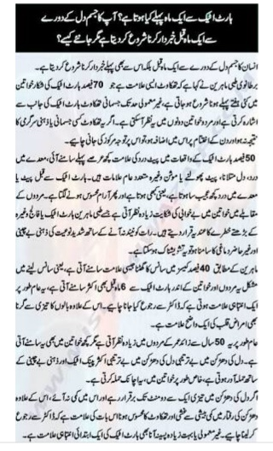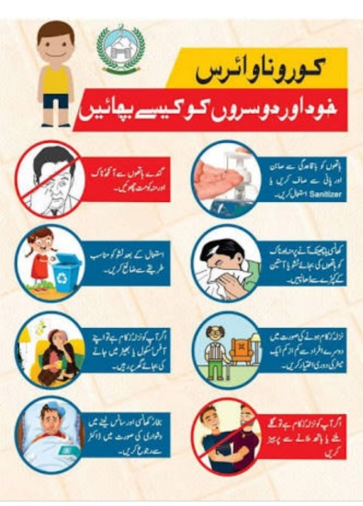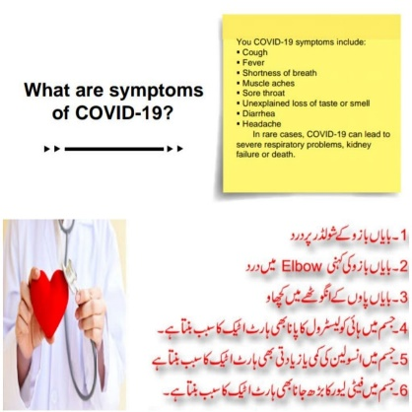

Individual work :
Laiba Bano, BMAF19BM035:

cording to my project title name “Rescue the community in COVID-19 condition”.
Rescue training:
I already taken rescue training from “Sir Asif Murawat” in TEVTA (Bhakkar). He told me about first aid basics treatment. I also awarded a certificate which is given below:
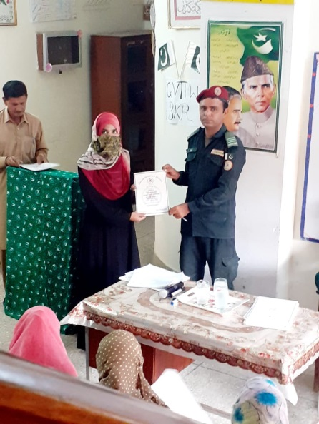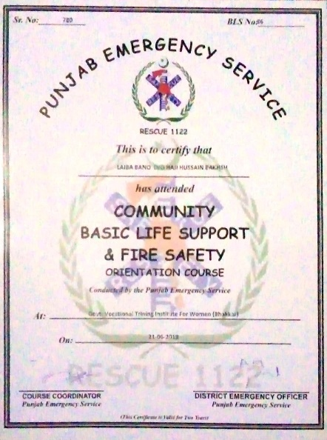

Tried to Community service as a volunteer:
First of all, I called Bhakkar Rescue and said that if you are doing any community service, put me in it as a volunteer. I met Bilal who said that Sir Asif used to do community service in schools, colleges and rural areas of Bhakkar but all the services have been shut down due to the corona virus. "At this critical juncture, we all have to not only take care of ourselves, but also protect society by building social distance," he added. His number is
+923338053888.I also posted a request on the "Rescue Muhafiz Bhakkar" Facebook official page. The answer was given by Dr. Tahir Mahmood, District Emergency Officer.
Screenshot are given below:
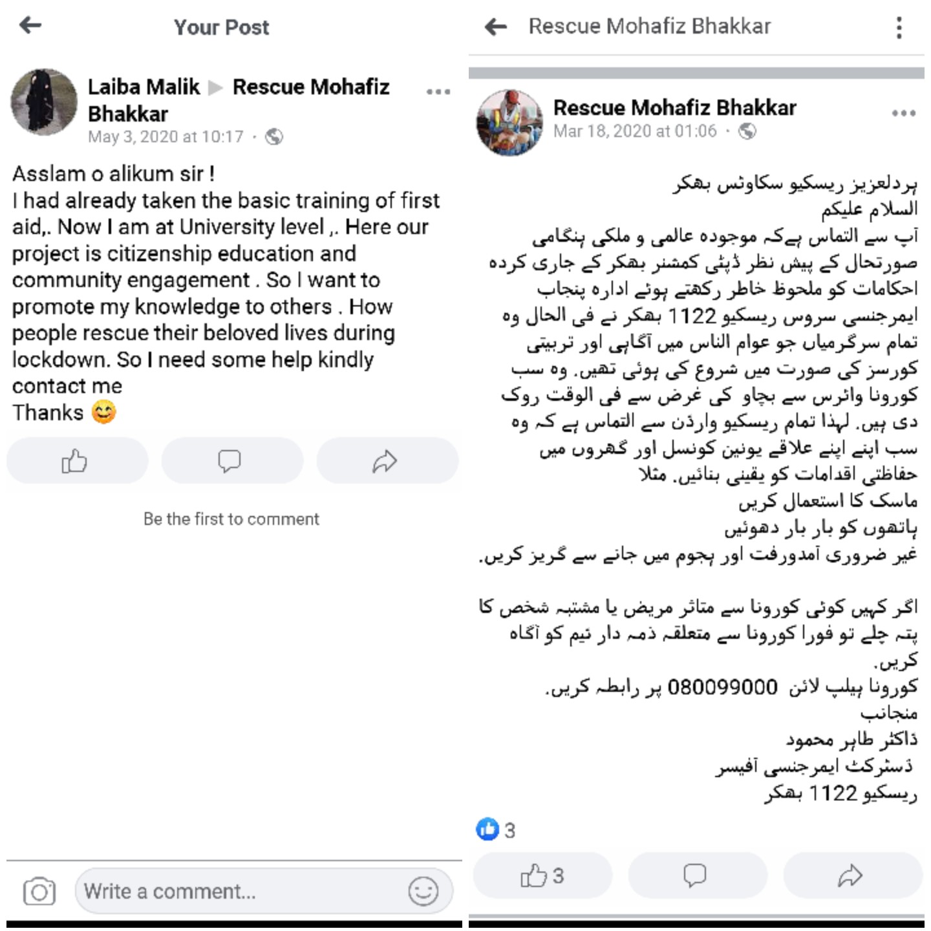
Community service as my own way:
So, I started this campaign in my area. For this I chose four houses in my area. I visited these homes and gave them initial rescue training on how to save the lives of their loved ones in this critical situation. I told them about how to make first aid kit, what you do in emergency situation like nose bleeding, heart attack, cut, and electric shock. I also told them about some emergency numbers of rescue and corona rescue.
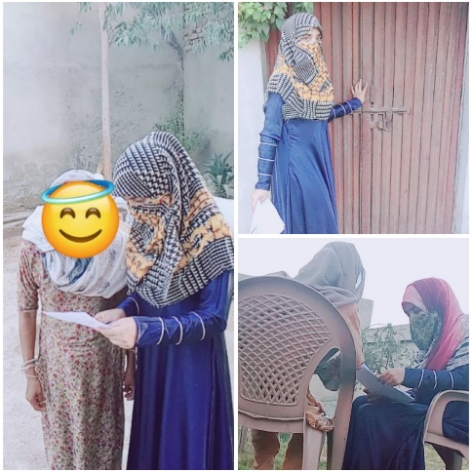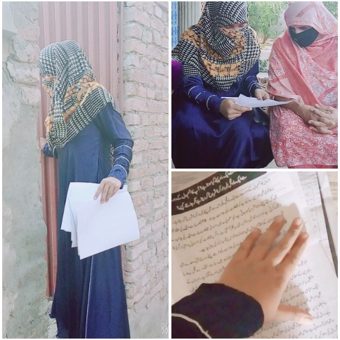

Commitment to my nation by pledge:
I have committed to my nation’s safety by pledging, I promote safety against COVID19.As it is our part of project to aware people with rescue training in COVID 19 condition. So, firstly I committed myself to my nation than I give awareness to other people.
My certificate is: -
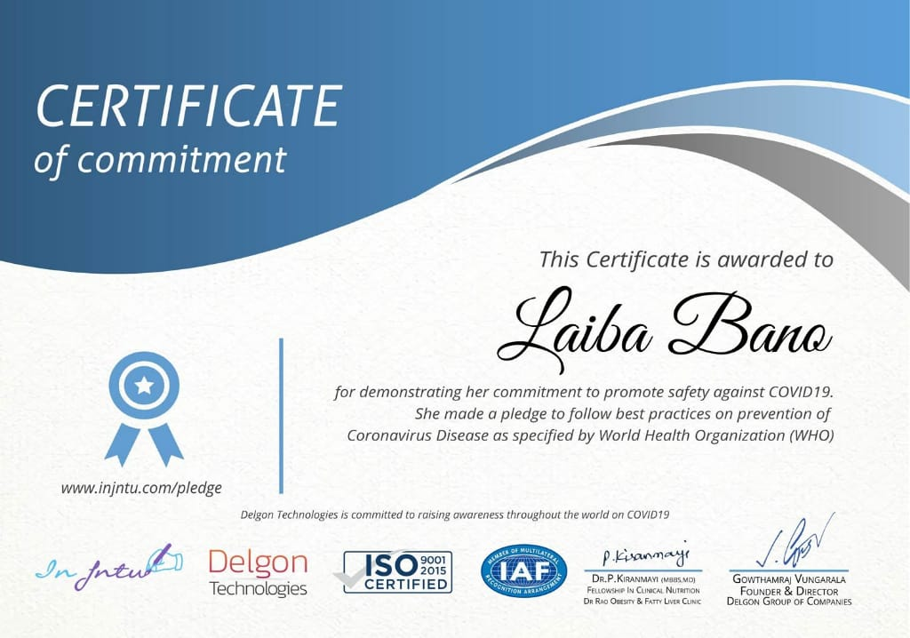
Awareness through Pamphlet (Brother Mudassir Malik Help):
I made a pamphlet on MS word. It contained some precautionary measures and information about rescue. Printed out. Divide it among the street children. I pasted it on the street walls and on the gates of houses with my brother help. When I went to the neighbors' house for information, I also gave it to them.
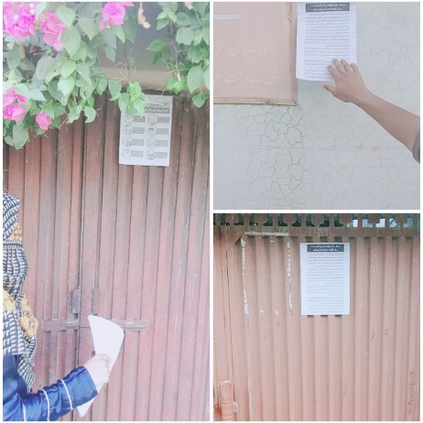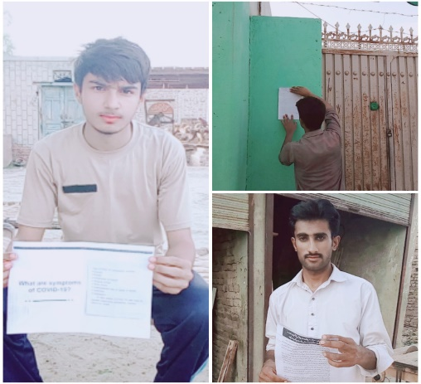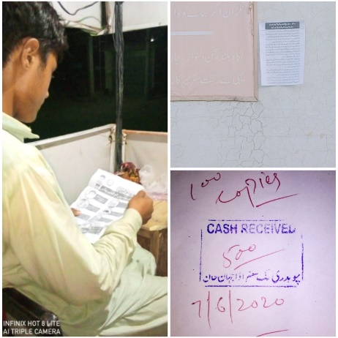
___________________________________________________________________________

Aniqa Raza, BMAF19BM007:

According to project, I decided to help people in pandemic situation of COVID-19. I choose more than three houses in my neighborhood to guide them about "how to rescue in this situation". The reason for the project is that, due to lockdown people avoid to go to hospital and clinics. So, I went to them and guided them about the first aid basics.
The project was distributed in some steps. In the first step we gathered valid information from trusted resources, about cure and treatment of small wounds and diseases which can be cured at home.
In the next step we tried to find out the best of conveying information to people. As we know picture and colorful images are more understandable rather than text form. Pictorial form can convey exact meaning in easiest way.
So,i created charts and pamphlet in soft form and then converted them to hard copies. After that the most important step of project is the distribution of pamphlet and charts and give awareness with the help of my brother and Couzin
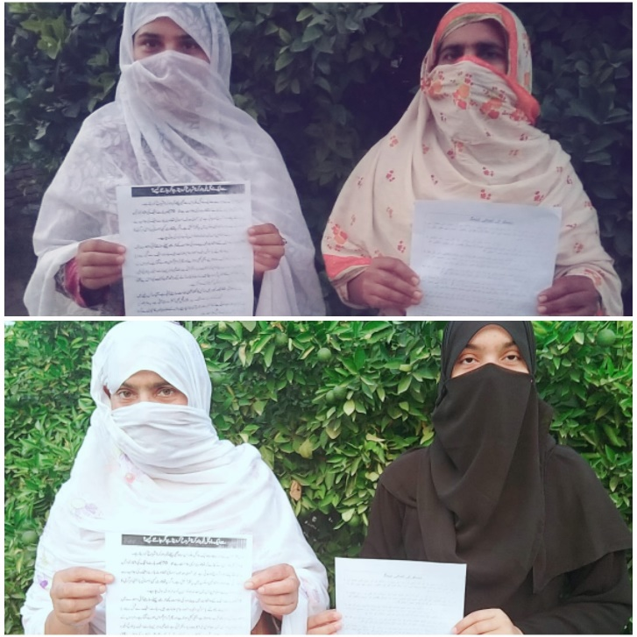
My brother: (Muhammad Raza)
My brother helped me a lot in this project. I made a pamphlet of first aid training on MS word; my brother went out Bazar and printed out pamphlets. He also distributed these pamphlets among their friends and the shopkeeper and paste it on the wall of area.
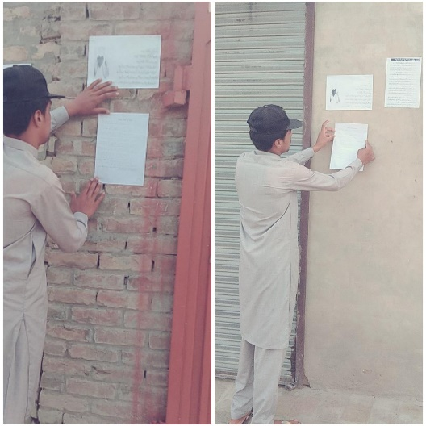

My cousin: (shaher bano)
I did this project activity with the help of my cousin. She helped me a lot in this project. I visited my neighborhood with my cousin and told them about first aid treatment. I told them what they can do when any emergency situations such as electric shock, nose bleeding, injuries, burn, bites and string occur. I also aware them about emergency number. I did this task affectionately and gave my best to achieve the goal of our project
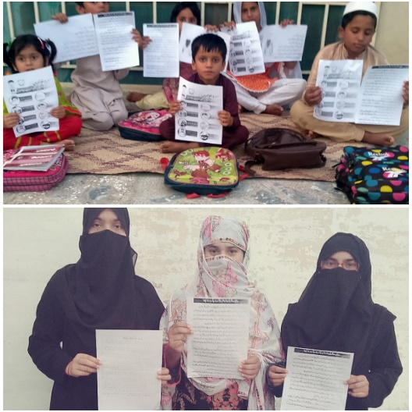

Ayesha Arif, BMAF19BM006:

According to our project, first step is to gathered right information about the current/treatment of wounds, injuries or other emergency situations. For this purpose, I got first aid training from different U-tube channels and videos. I did this activity with the help of two persons.
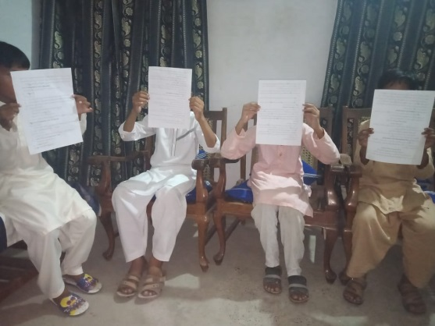
My Brother: (Huzaifa Arif)
My brother helped me a lot in this project. I made a pamphlet of first aid training on MS Word, my brother went to bazaar and printed out pamphlets. He also distributed these pamphlets among his friends, shopkeepers and also pasted it on the walls of our area.
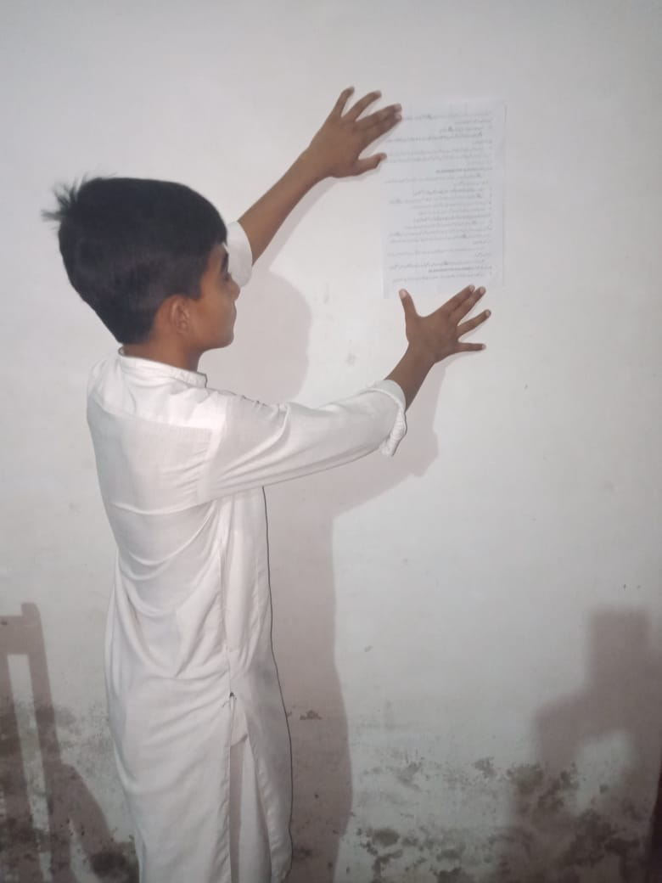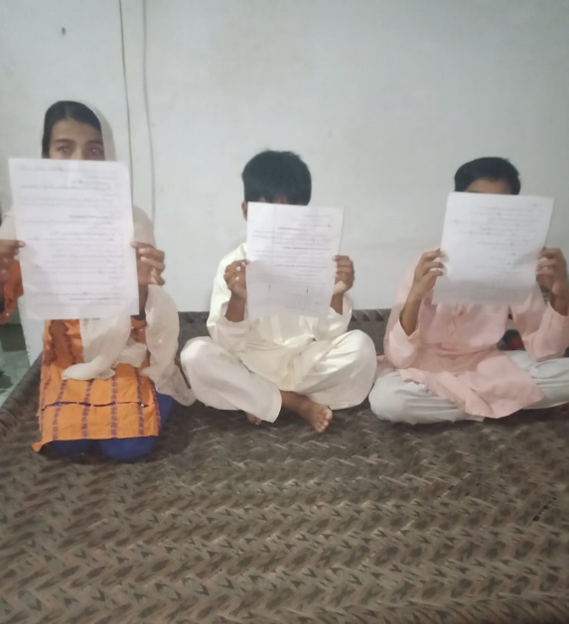
My Sister: (Nimra Arif)
I did this project activity with the help of my sister She helped me a lot in this project. I visited my neighborhood with my sister and told them about first aid treatment. I also told them how they can handle the emergency situations at home. I told them what they can do when any emergency situation such as electric shock, nose bleeding, injuries, burns, bites and strings occurs. I also aware them about emergency numbers of doctors, fire brigade and rescue. I also gave them pamphlets so that they can easily understand.
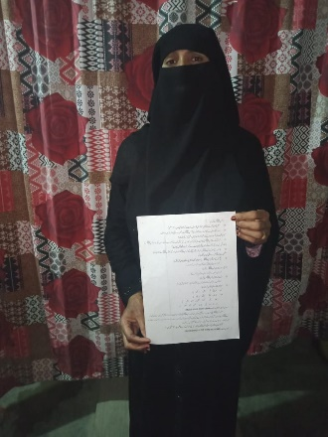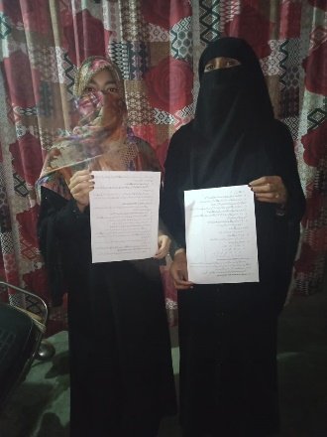
I did this task affectionately and gave my best to achieve the goal of project

Rabia Farooq, BMAF19BM032:

I decided to perform the activity of awareness about rescue in my area. First, step is to gathered right information about the cure/treatment of wound or injuries or other emergency situations. For this purpose, I connected Sir Bilal Ahmar Rana, who work in rescue office. He gave me an information about first aid training.
I did this activity with the help of two persons
My brother (Rana Mudassir): -
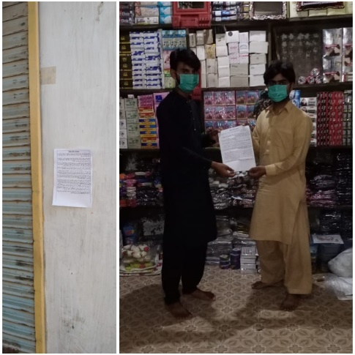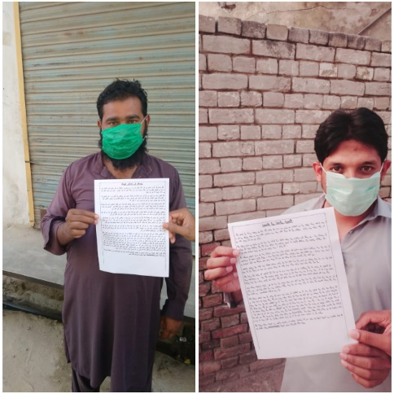
My brother helped me a lot in this project. I made a pamphlet of first Aid training on Ms. Word. My brother went to the bazar and printed out pamphlet. He also distributed this pamphlet among their friends and the shopkeepers and pasted it on the walls.

My sister (Ayesha Farooq): -
I did the project activity with the help of my younger sister. She helped me a lot in this project. I visited my neighborhood with my sister and told them about first aid treatment and also told them that how they handle the emergency situation such as electric shock, nose bleeding, injuries, heart attack symptoms and bandage occurs etc. I also aware them about emergency numbers of doctors and rescue. I also gave them pamphlet so, that they can easily understand.
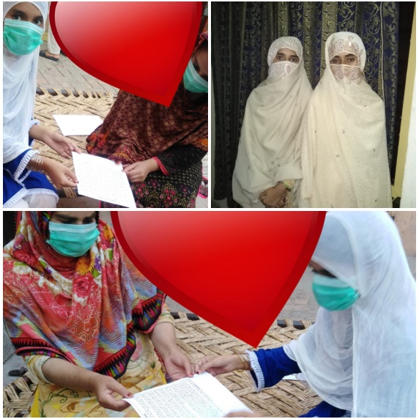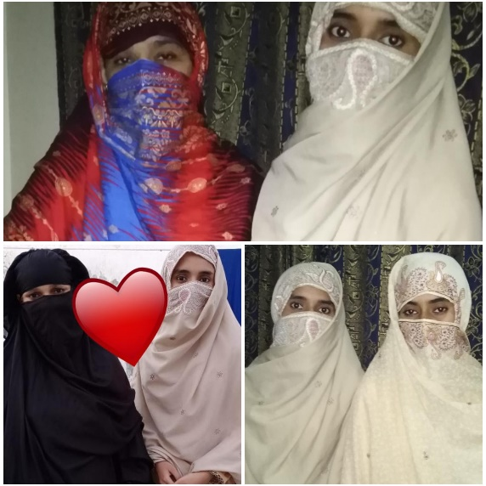

I message to “Sir Bilal Ahmar Rana” on what’s app. He works in rescue office. He gave me information about first aid basics. He told me about medical emergency and traffic accident. He also told me bout head injury, heart attack symptoms, electric shocks, nose bleeding and bandages through what’s app voice recording. I send this recording to my group members.
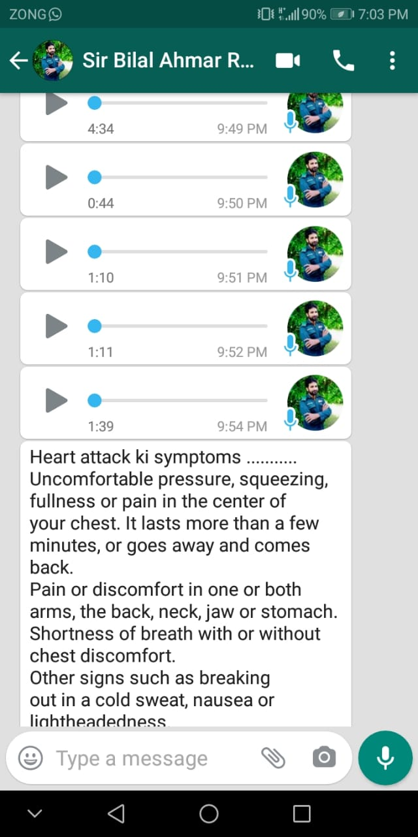
I did this task affectionately and gave my best to archive the goal of project.

Areeba Rasool, BMAF19BM003:

I did this activity with the help of two persons
My Mother
First of all, she guided how I should do this activity. She helped me in finding uneducated families. She also went with me when I made a survey in my area.
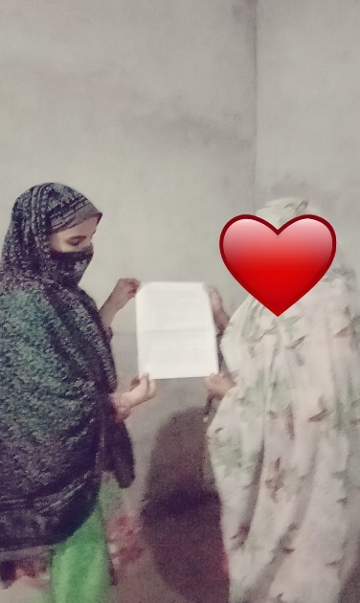
My Cousin brother:
My cousin brother helped me a lot in this project. First of all, he went to bazaar 3km away from our chak and printed out pamphlets. He also provided pamphlets to shopkeepers and neighbors.
First off all I went to two Mohalla’s of our chalk (56M/L). I gave information about the first aid basics. I told them that they rescue themselves in COVID_19 situation. I told them what they can do when any emergency situation such as electric shock, bleeding, heart attack etc. occur. I also aware them about emergency numbers of doctors and rescue team. I also provide them pamphlets to aware them about more knowledge of first aid.
I did this task affectionately and gave my best to achieve the goal of our project.

d.Proposed duration of the project
It took a couple of week, Allhamdullilah we did it proper way.
6. How will you evaluate your project for possible outcomes?
How Save time:
It is time saving for those who cannot go to training center due to lack of time.
Increase Awareness:
Those people who did not know about the first aid, will know it and they will save lives.
Helpful in lockdown:
In lockdown people cannot go to hospital of little bit emergency situation. Due to this they will handle tiny emergencies at home and saves their beloved lives.
laiba Bano BMAF19BM035, (2020),
References:

- "Introduction of Rescue 1122". rescue.gov.pk. Retrieved August 1, 2017.Wekipedia, Rescue official website
- Waseem Hanniya, Naseer, Rizwan ,Razzak,Junid Abdul (June 1,2011) http://emj.bmj.com/content/emermed/28/6/513.full.pdf

- https://www.youtube.com/watch?v=kx98yb0laUQ&feature=youtu.be (YouTube channel Rescue 1122)
- https://www.facebook.com/rescue1122official/ (Rescue official Page)
- https://www.facebook.com/rescue1122official/(Rescue Mohafiz Bhakkar
- laiba Bano BMAF19BM035, BS Math (2020), Bs Mathematics, Department of Mathematics, University of Sargodha sub campus Bhakkar)
- (Rabia Farooq, BMAF19BM032, Bs Math, (2020) Department of Mathematics, University of Sargodha sub campus Bhakkar)
- Areeba Rasool, BMAF19BM003, BS Math (2020) Department of Mathematics, University of Sargodha sub campus Bhakkar
- Ayesha Arif, BMAF19BM006, Bs Math (2020) Department of Mathematics, University of Sargodha sub campus Bhakkar
- Aniqa Raza, BMAF19BM007, BS Math (2020) Department of Mathematics, University of Sargodha sub campus Bhakkar.
- https://www.facebook.com/First-Aid-basics-107653677649331/?modal=admin_todo_tour

