Some useful Definitions:

Allocation Model:
The purpose of solving problem involving the allocation scarce resources, this category of problem is referring to as allocation type problems and any method or model employed to solve allocation type is called an allocation model.
Objective function:
Objective function is a mathematical equation which describes the production output target that corresponds to the maximization of profits with respect to production.
Constraints:
Mathematical programming method or sometimes referred to as technique of constraint optimization.
Optimal solution:
The set of feasible solution one sometime or more than one is the best solution in the sense that achieve the high degree of stated goal such a solution is referred to as the optimal solution.

Q:-
An electronic company manufacture integrated circuit for radios, televisions and videos for a particular month it has available at least 1250 units of materials not more than 850 man-hours. The demand and selling price of each the above products are given in the following table.
Products | Unit of material | Man-hours | Selling Price(Rs)
Radio | 3 | 2 | 2,500
Television | 11 | 9 | 14,500
Video | 16 | 7 | 12,000
Formulate the problem as an LP model to determine a production schedule for maximizing income.
Solution:

The selling price of each of the products is our objective function(objective function is a mathematical equation which describes the production output target that corresponds to the maximization of profits with respect to production). And these three products (radio, TV, video)for a particular month that at least 1250 units not more than 850 man-hours, these are our constraints.
We have to give(objective function) maximize is;
max z= 2500x1+14500x2+12000x3
Constraints:
(Subject to) s/t: 3x1+11x2+16x3>_1250
2x1+9x2+7x3<_850

Consider the following LP formulations using graphical approach:
- max Z = 12x1+3x2
s/t:
x1+x2<_900
4x1+x2>_1200
x1+2x2>_100
with x1,x2>_0
Solution:
Let x1 and x2 represent the coordinate axes in the plane. Firstly, we observe that any point (x1, x2) in the plane which satisfy the condition x1>_0 and x2>_0 lie in the quadrants. Now we draw the graph of the constraints by converting in equalities.
According to first constraints:
(0, 900) (900, 0) --------(1)
According to second constraints:
(0, 1200) (300, 0) --------(2)
According to third constraints:
(0, 50) (100, 0)
With x1, x2>_0

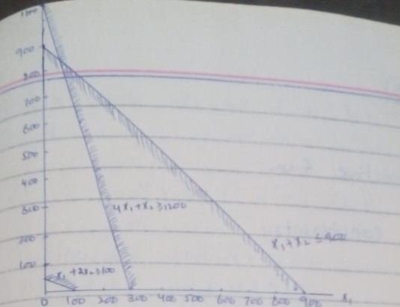

These constraints we solve the graphically, the first two constraints make the feasible region but the third constraints do not meet the other two constraints, so we can say that this formulation is redundant. Because (the redundant are those constraints if a remove from the whole equation these could not be any region after finding the solution).
Example:
Max Z = 12x1+4x2.
S/t: 25x1+ 3x2<_300
5x1 + 2x2<_400
2x2<_150
X1 + X2<_120
With x1, x2 >_0
Solution:
Let x1 and x2 represent the coordinate axes in the plane. Firstly, we observe that any point (x1, x2) in the plane which satisfy the condition x1>_0 and x2>_0 lie in the quadrants. Now we draw the graph of the constraints by converting in equalities.

According to first constraint:
(0, 100) (12, 0) -------(1)
According to second constraint:
(0, 200) (80, 0) ------------(2)
According to third constraints:
X2 = (75) -------(3)
According to fourth constraint:
(0, 120) (120,0) ---------(4)

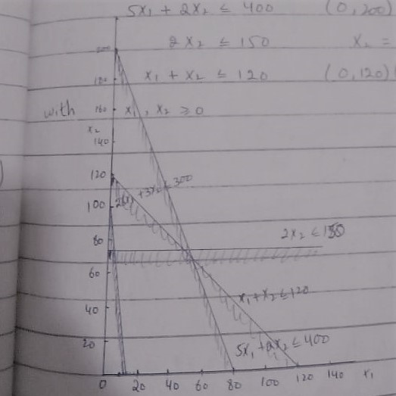

These constraints are graphically representing. All the constraints meet with other constraints. we can say that this formulation is alternative optimal solution.
Feasible solution:
Set of values of decision variables satisfying all constraints of a linear programming problem is called solution to that problem. Any solution which also satisfies the known negativity restriction of the problem is called feasible solution.
Optimal feasible solution:
Any feasible solution which maximizes or minimizes the objective function is called an optimal feasible solution.
Feasible Region:
The common region determined by all constraints and non- negativity restriction of a LP problem is called feasible region.
Corner point:
A corner point of a feasible region is a point in the feasible region that is the intersection of two boundary lines.

