Maintaining homeostasis
Biological systems like those of your body are constantly being pushed away from their balance points. For instance, when you exercise, your muscles increase heat production, nudging your body temperature upward. Similarly, when you drink a glass of fruit juice, your blood glucose goes up. Homeostasis depends on the ability of your body to detect and oppose these changes.
Maintenance of homeostasis usually involves negative feedback loops. These loops act to oppose the stimulus, or cue, that triggers them. For example, if your body temperature is too high, a negative feedback loop will act to bring it back down towards the set point, or target value, of 98.6\,^\circ\text F98.6∘F98, point, 6, degrees, start text, F, end text/ 37.0\,^\circ\text C37.0∘C37, point, 0, degrees, start text, C, end text.
How does this work? First, high temperature will be detected by sensors—primarily nerve cells with endings in your skin and brain—and relayed to a temperature-regulatory control center in your brain. The control center will process the information and activate effectors—such as the sweat glands—whose job is to oppose the stimulus by bringing body temperature down.
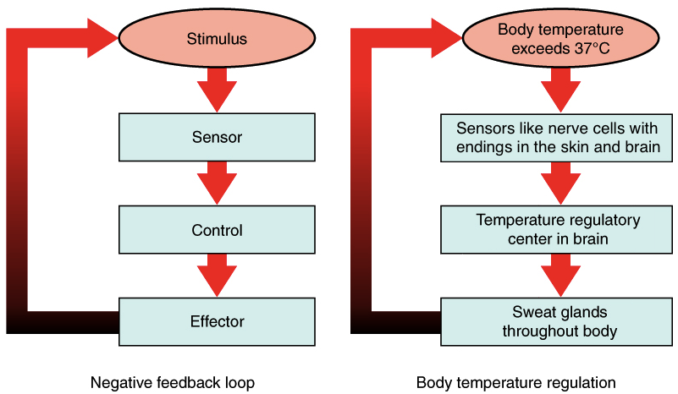
(a) A negative feedback loop has four basic parts: A stimulus, sensor, control, and effector. (b) Body temperature is regulated by negative feedback. The stimulus is when the body temperature exceeds 37 degrees Celsius, the sensors are the nerve cells with endings in the skin and brain, the control is the temperature regulatory center in the brain, and the effector is the sweat glands throughout the body.
Image credit: modified from Homeostasis: Figure 1 by OpenStax College, Anatomy & Physiology, CC BY 4.0
Of course, body temperature doesn't just swing above its target value—it can also drop below this value. In general, homeostatic circuits usually involve at least two negative feedback loops:
- One is activated when a parameter—like body temperature—is above the set point and is designed to bring it back down.
- One is activated when the parameter is below the set point and is designed to bring it back up.
To make this idea more concrete, let's take a closer look at the opposing feedback loops that control body temperature.

Homeostatic responses in temperature regulation
If you get either too hot or too cold, sensors in the periphery and the brain tell the temperature regulation center of your brain—in a region called the hypothalamus—that your temperature has strayed from its set point.
For instance, if you’ve been exercising hard, your body temperature can rise above its set point, and you’ll need to activate mechanisms that cool you down. Blood flow to your skin increases to speed up heat loss into your surroundings, and you might also start sweating so the evaporation of sweat from your skin can help you cool off. Heavy breathing can also increase heat loss.
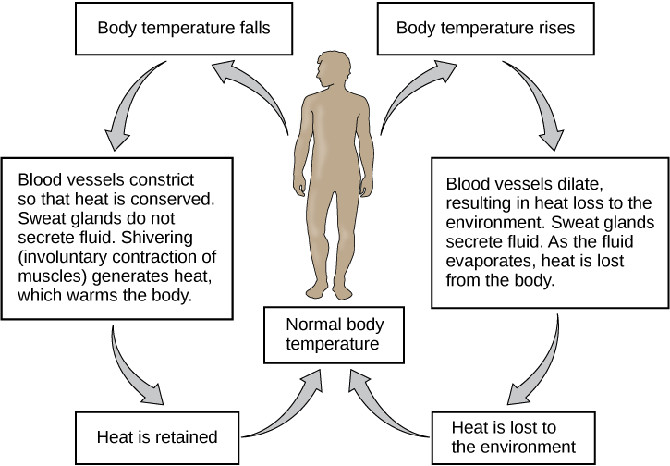
Image showing temperature regulation in response to signals from the nervous system. When the body temperature falls, the blood vessels constrict, sweat glands don't produce sweat, and shivering generates heat to warm the body. This causes heat to be retained the the body temperature to return to normal.
When the body temperature is too high, the blood vessels dilate, sweat glands secrete fluid, and heat is lost from the body. As heat is lost to the environment, the body temperature returns to normal.
Image credit: Homeostasis: Figure 4 by OpenStax College, Biology, CC BY 4.0
On the other hand, if you’re sitting in a cold room and aren’t dressed warmly, the temperature center in the brain will need to trigger responses that help warm you up. The blood flow to your skin decreases, and you might start shivering so that your muscles generate more heat. You may also get goose bumps—so that the hair on your body stands on end and traps a layer of air near your skin—and increase the release of hormones that act to increase heat production.
[Can homeostatic responses affect behavior?]
Notably, the set point is not always rigidly fixed and may be a moving target. For instance, body temperature varies over a 24-hour period, from highest in the late afternoon to lowest in the early morning.^22squared Fever also involves a temporary increase in the temperature set point so that heat-generating responses are activated at temperatures higher than the normal set point.^33cubed

Disruptions to feedback disrupt homeostasis.
Homeostasis depends on negative feedback loops. So, anything that interferes with the feedback mechanisms can—and usually will!—disrupt homeostasis. In the case of the human body, this may lead to disease.
Diabetes, for example, is a disease caused by a broken feedback loop involving the hormone insulin. The broken feedback loop makes it difficult or impossible for the body to bring high blood sugar down to a healthy level.
To appreciate how diabetes occurs, let's take a quick look at the basics of blood sugar regulation. In a healthy person, blood sugar levels are controlled by two hormones: insulin and glucagon.
Insulin decreases the concentration of glucose in the blood. After you eat a meal, your blood glucose levels rise, triggering the secretion of insulin from β cells in the pancreas. Insulin acts as a signal that triggers cells of the body, such as fat and muscle cells, to take up glucose for use as fuel. Insulin also causes glucose to be converted into glycogen—a storage molecule—in the liver. Both processes pull sugar out of the blood, bringing blood sugar levels down, reducing insulin secretion, and returning the whole system to homeostasis.
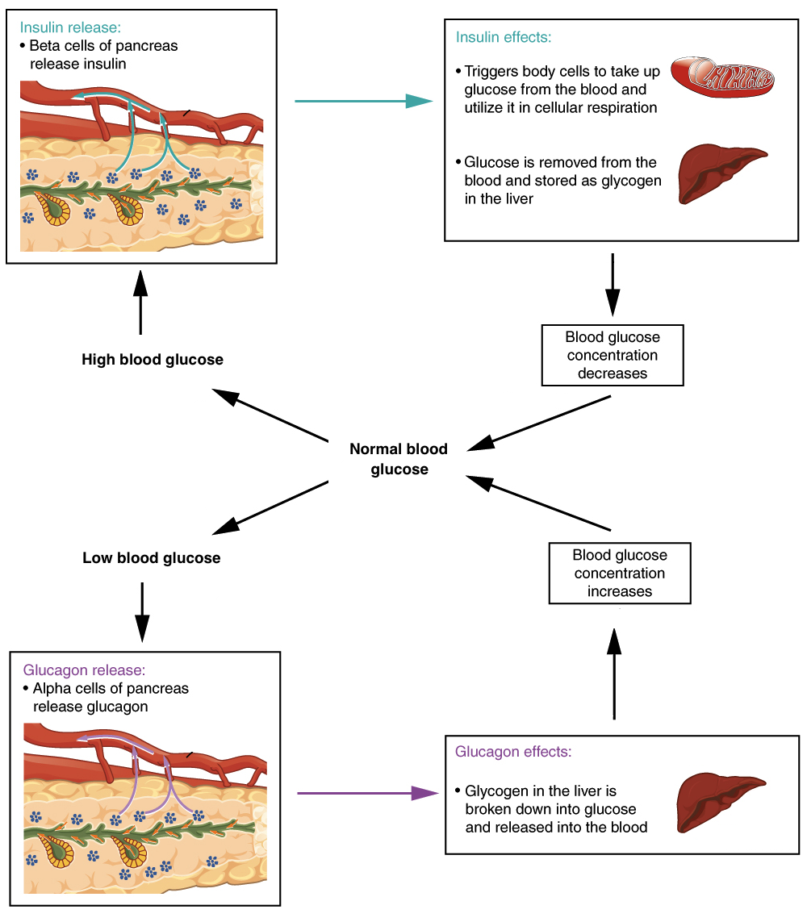
If blood glucose concentration rises above the normal range, insulin is released, which stimulates body cells to remove glucose from the blood. If blood glucose concentration drops below this range, glucagon is released, which stimulates body cells to release glucose into the blood.
Image credit: modified from The endocrine pancreas: Figure 2 by OpenStax College, Anatomy & Physiology, CC BY 4.0
Glucagon does the opposite: it increases the concentration of glucose in the blood. If you haven’t eaten for a while, your blood glucose levels fall, triggering the release of glucagon from another group of pancreatic cells, the α cells. Glucagon acts on the liver, causing glycogen to be broken down into glucose and released into the bloodstream, causing blood sugar levels to go back up. This reduces glucagon secretion and brings the system back to homeostasis.
Diabetes happens when a person's pancreas can't make enough insulin, or when cells in the body stop responding to insulin, or both. Under these conditions, body cells don't take up glucose readily, so blood sugar levels remain high for a long period of time after a meal. This is for two reasons:
- Muscle and fat cells don't get enough glucose, or fuel. This can make people feel tired and even cause muscle and fat tissues to waste away.
- High blood sugar causes symptoms like increased urination, thirst, and even dehydration. Over time, it can lead to more serious complications.^{4,5}4,5start superscript, 4, comma, 5, end superscript

Positive feedback loops
Homeostatic circuits usually involve negative feedback loops. The hallmark of a negative feedback loop is that it counteracts a change, bringing the value of a parameter—such as temperature or blood sugar—back towards it set point.
Some biological systems, however, use positive feedback loops. Unlike negative feedback loops, positive feedback loops amplify the starting signal. Positive feedback loops are usually found in processes that need to be pushed to completion, not when the status quo needs to be maintained.
A positive feedback loop comes into play during childbirth. In childbirth, the baby's head presses on the cervix—the bottom of the uterus, through which the baby must emerge—and activates neurons to the brain. The neurons send a signal that leads to release of the hormone oxytocin from the pituitary gland.
Oxytocin increases uterine contractions, and thus pressure on the cervix. This causes the release of even more oxytocin and produces even stronger contractions. This positive feedback loop continues until the baby is born.
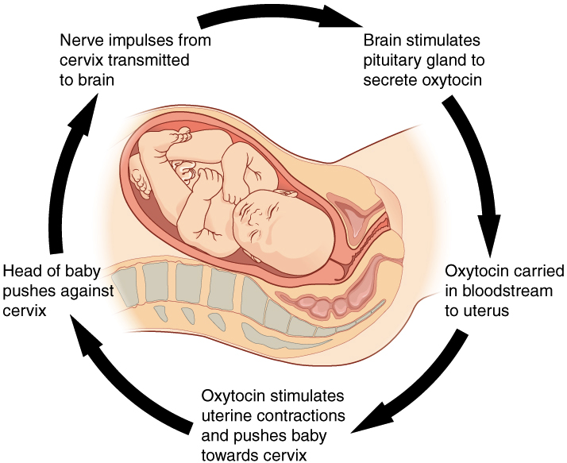
Normal childbirth is driven by a positive feedback loop. A positive feedback loop results in a change in the body’s status, rather than a return to homeostasis. The feedback loop includes (the loops is drawn clockwise): * Nerve impulses from the cervix being transmitted to the brain * The brain stimulates the pituitary gland to secrete oxytocin * Oxytocin carried in bloodstream to uterus * Oxytocin stimulates uterine contractions and pushes baby toward cervix * Head of baby pushes against cervix * and so on in a loop!
Image credit: Homeostasis: Figure 2 by OpenStax College, Anatomy &

