Market Structures
What is market?
Market is set of all actual & potential buyers & sellers of any particular product irrespective of place.
What is a Market Structure?
Market structure is that particular environment in which market operates or buyers & sellers trade.
What are determinants of market structure?
- Number of buyers & sellers
Large, small, few, single etc
- Nature of product
Homogenous/same or heterogeneous/differentiated
- Degree of mobility of factors of production
Freedom to enter & exit the market (free or restricted)
- Degree of information
Information about prices, quality, features, outlets, substitutes, etc (complete or incomplete)
Types of Market Structures:
- Perfect Competition
- Monopoly
- Monopolistic Competition
- Oligopoly
- Duopoly
- Perfect Competition:
- Features of Perfect Competition:
- Number of buyers & sellers: Large number of buyers & sellers
- Nature of Product: Homogeneous product
- Degree of mobility of factors of production: Free entry & exit
- Degree of information: Complete information is available
- Price Determination under perfect competition
Due to large number of buyers & sellers a single individual either on demand side or supply side cannot influence/control the price. Therefore the prices are determined by market demand & supply as follows:
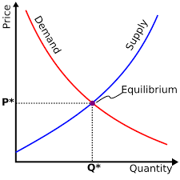
The only option available with the firms is to decide the quantity of goods to be sold at price fixed by market. So the demand curve faced by an individual perfectly competitive firm is horizontal. The firms are considered as price takers in this case.
Price, AR & MR curves
As explained in the table shown below a perfectly competitive firm faces same horizontal AR, MR & Price curves as firm has no control over prices so the only option is to alter the quantity to be produced and supplied.
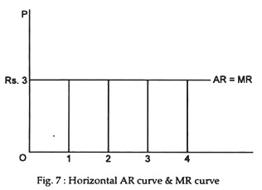

P | Q | TR=P*Q | MR | AR=TR/Q
3 | 1 | 3 | 3 | 3
3 | 2 | 6 | 3 | 3
3 | 3 | 9 | 3 | 3
3 | 4 | 12 | 3 | 3
3 | 5 | 15 | 3 | 3

- Output determination by an individual firm
In order to determine the optimal level of output firm needs to compare the MC & MR. the optimal conditions for output determination are as follows:
F.O.C MC=MR
S.O.C MC cuts MR from Below or slope of MC > slope of MR
The above conditions can be explained with the help pf following figure:

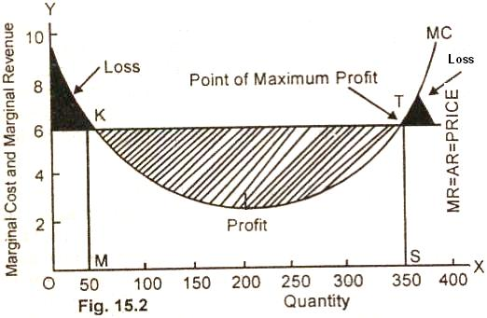
The following points are significant to note:
- From origin to the point K (where MC cuts MR) MC˃MR i.e. production in this stage will not be beneficial as the plant is underutilized so loss is indicated by shaded area (black). Due to loss firm will not decide the production in this situation.
- At point K, MC=MR so the firm has the option to stop production at this point. However, as the firm has started production so the profits are to be generated after this point so firm will not stop production and continue.
- From point K to point T, MC lies below MR i.e. MC<MR indicating that each additional unit produced will generate profit and leads to increase in total profit so firm will continue the production. (some people get confused that why firm is not stopping production where the gap is maximum. The answer is that the above graph is showing marginal analysis i.e. analysis for each additional unit of output.)
- At Point T, again MC=MR so firm has the option to stop production.
- After point T, MC˃MR so production in this stage will not be beneficial as the additional units will cause loss.
- So firm will determine that output will be produced till point T where MC=MR and MC cuts MR from below.
So Graphically output determination under perfect competition is as follows:
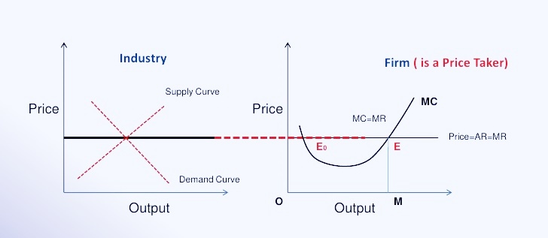
The perfectly competitive firm will produce M units of output.

B. Monopoly:
- Features of Monopoly:
- Number of buyers & sellers: Single Buyer
- Nature of the Product: Unique product having no close substitute
- Degree of mobility of factors of production: Restricted Entry & Exit
- Degree of information: Incomplete information is available
- Reasons for existence of Monopoly
- Complete control over entire supply of raw material
When one company exerts sole control over a resource that is necessary for the production of a specific product, the market may become a monopoly. For example, the only medication deemed acceptable to treat a disease comes from a particular ingredient X, and knowledge of this ingredient X is owned by a single family owned company. The company can, therefore, be said to have a monopoly over ingredient X that is needed to cure the disease because it is the only company that can produce a product deemed acceptable.
- Natural Monopoly
Economies of scale may also be the reason as some business are profitable only on large scale by a single firm. A market may also become a monopoly simply because it may be more cost-effective for one company to serve the whole market than to have several smaller firms in competition with one another. A company with virtually unlimited economies of scale is referred to as a natural monopoly. Such firms become monopolies due to their position and size, which makes it impossible for new entrants in the market to compete price-wise. Natural monopolies are common in industries with high fixed costs and low marginal costs of operation.
- Government rules regulations can create monopoly through govt franchises etc
In certain instances, a monopoly may be explicitly created by the government if it grants a single company, whether private or government-owned, the right to conduct business in a particular market. For example, when a national railways transportation service is created by the government, in most cases they are granted a monopoly on the operation of passenger trains in the country. As a result, other firms are only able to offer passenger train services with the cooperation and/or permission of the government-owned provider.
Sometimes to ensure consistent delivery of a product or service that has a very high up-front cost the government creates monopoly. An example is electric and water utilities. It's very expensive to build new electric plants or dams, so it makes economic sense to allow monopolies to control prices to pay for these costs
- Copy rights, patents etc
Extending intellectual property protection to a company in the form of patents and copyrights is yet another way in which monopolies are created. When a government does this, it is in fact giving a single company an exclusive right to provide a particular product / service to the market. Patents and copyrights work in providing owners of intellectual property with the right to act as an exclusive provider of a new product for a specific length of time. This creates a temporary monopoly in the market with regards to new products and services.
- Why monopolies are bad for an Economy
Monopolies restrict free trade and prevent the market from setting prices. That creates the following four adverse effects:
- Price fixing: Since monopolies are lone providers, they can set any price they choose. That's called price-fixing. They can do this regardless of demand because they know consumers have no choice. It's especially true when there is inelastic demand for goods and services. That's when people don't have a lot of flexibility.
- Declining product quality: Not only can monopolies raise prices, but they also can supply inferior products. Monopolies aware of the fact that there no other alternative available to the people may compromise quality of the product in some cases/areas.
- Loss of innovation: Monopolies lose any incentive to innovate or provide "new and improved" products. Competition is the cause of innovation. As Monopoly lacks competition so innovation is lost. A 2017 study by the National Bureau of Economic Research found that U.S. businesses have invested less than expected since 2000 due to a decline in competition.﻿
- Inflation: Monopolies create inflation. Since they can set any prices they want, they will raise costs for consumers. It's called cost-push inflation.
- Price Determination under Monopoly
Due to single seller the monopoly firm has complete control over price. So the monopoly firm is price maker. However, in order to increase demand monopoly firm needs to decrease the prices of its product. Therefore, the demand curve faced by a monopoly firm is negatively sloped.

AR & MR curves
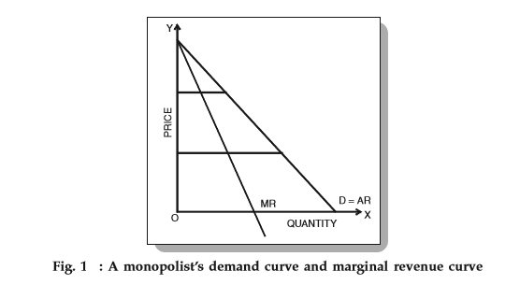

As the firm must reduce the price of the product to increase its demand so the above curves are downward sloping. Further, MR curve lies Below AR Curve because as price is being reduced to sell additional units so marginal revenue i.e. revenue from sale of each additional unit is also decreasing.
- Output determination
In order to determine the optimal level of output firm needs to compare the MC & MR. as taught earlier output will be produced till point where the following conditions are fulfilled:
F.O.C MC=MR
S.O.C MC cuts MR from Below or slope of MC > slope of MR
Graphically output determination under Monopoly is as follows:
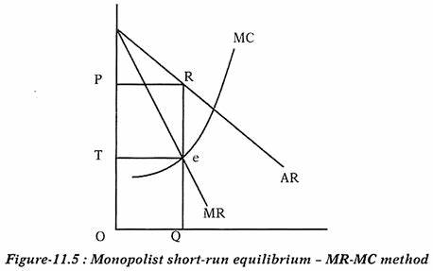

As shown in the above graph output will be produced till point e where conditions of optimality are fulfilled.

- Cases of profit & Loss in Perfect Competition in short run:
During short run a firm may face profit or loss due to certain fixed factors and limitations. These cases are graphically discussed below:
https://www.youtube.com/watch?v=V81gQroEszI
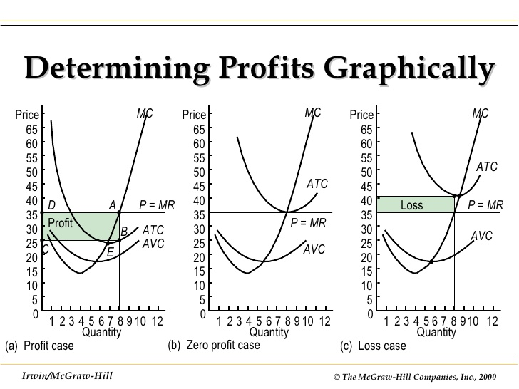
- Case of profit
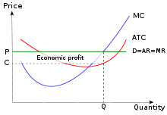
- Case of No profit no loss

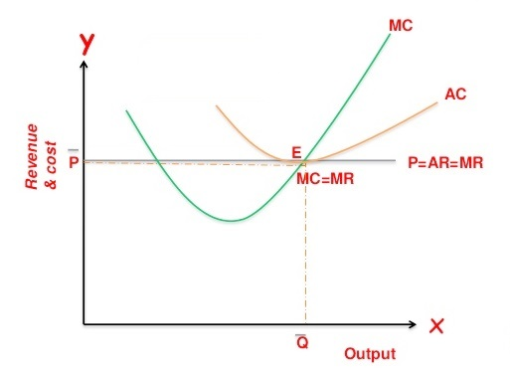

- Case of loss

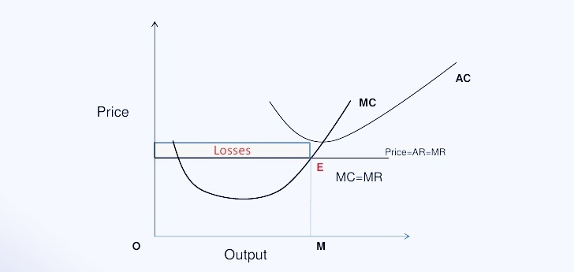

Monopoly Cases of profit & Loss in short run:
During short run a firm may face profit or loss due to certain fixed factors and limitations. These cases are graphically discussed below:

- Case of profit

- Case of No profit no loss

- Case of loss

