Exercise # 13
VIRAL DISEASES IN PLANTS
Viruses are very small obligate parasites and submicroscopic infectious entities. They are made up of nucleic acid (RNA or DNA) and protein coat. They are meso-biotic and replicate only in living host. There are two types of symptoms exhibited by plant viruses, these are:
External symptoms: Hypertrophy, hyperplasia, stunting, spots and lesions on leaves.
Internal Symptoms: Biochemical changes, and production of “inclusion bodies” which are amorphous, granular or crystalline structures formed invirus-infected cell.
Most common virus symptoms are chlorosis, necrosis and enation. Chlorosis is yellowing of green tissues due to death of chlorophyll or it is failure of chlorophyll formation,while necrosis is death of tissues due to plant pathogen infection.Enation is the abnormal outgrowth of host tissues or eruption from a plant surface caused by infection of some viruses;indeed, it means small leaf.
Other virus symptoms include mosaic, mottling and ring spots.Mosaic is a condition produced due to the infection of virus in which light green or yellow color patches get intermingled with normal green colour ofthe leaves; mottling is irregular pattern of indistinct light and dark areasproduced due to virus infection on the leaves; and ringspots are appearance of necrotic or chlorotic ringson the leaves and sometimes also on the fruit and stem.
Materials

Diseased samples of above mentioned diseases.
Procedure
- Visit fields having viral infections and collect diseased samples. Study the above mentioned symptoms in depth.
- Study the symptom differences among mosaic, mottle and flecking.
- Cut the cross section of infected tissues and observe the inclusion bodies.
- Preserve the samples and mount them on your practical mannual.
- Conduct the pot experiment under green house conditions and produce any of the above symptom on the healthy plants through rubbing or grafting.

Questions
- What is the name of the procedure used for virus transmission other than rubbing or grafting?
Through insect-vector
- Which phanerogamic parasite is used for virus transmission?
Cuscuta spp. also known as dodder is used for virus transmission.
- Write down the complete name of ELISA?
It is Enzyme linked immune sorbent assay.
- Explain whether ELISA is a serological or molecular virus detection test?
It is serological detection test.
- What is the purpose of carborandum powder?
This powder causes abrasion on the surface of leaves and cause injuries, so is used for mechanical inoculation of viruses.

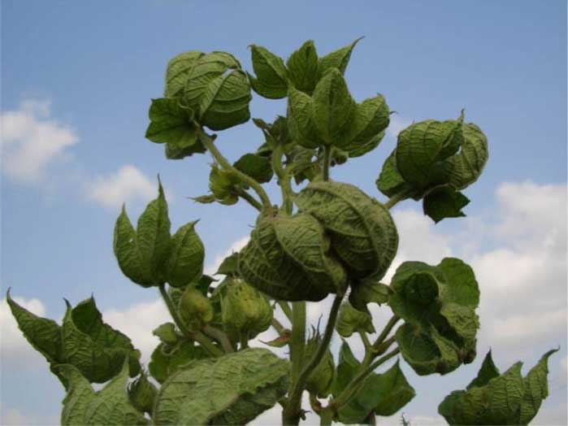
Cotton Leaf Curl Virus
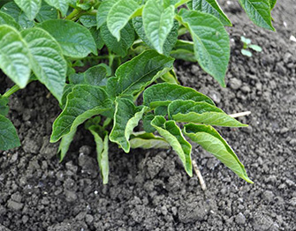
Potato Leaf Roll Virus
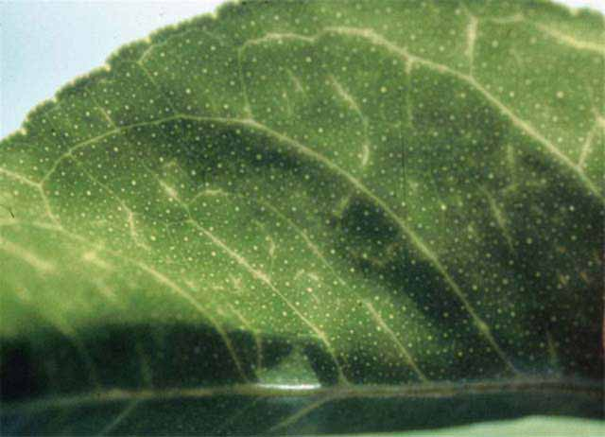
Citrus Tristeza Virus

