The Road to Mecca represents a most interesting & exceedingly interior pilgrimage tale of Leopold Weiss, born in 1900 in what is today Lvov, Ukraine (previously Lemberg in Galicia, then part of the Austro-Hungarian Empire), descendent of a long line of rabbis. The book is in fact the autobiography of Muhammad Asad and the story of this most radical transformation is quite stunning, a conversion of faith enmeshed in a long pattern of travel & work as a journalist by the erstwhile Weiss, whose rather affluent family moved to Vienna when Leopold was still fairly young.
Curiously, his grandfather wanted Leopold's dad to follow his path as a rabbi, though he chose to become a lawyer with a distinctly secular stance. Meanwhile, it was hoped that Leopold would complete his university degree in Vienna & become a lawyer like his own father, the source of another familial disappointment, as Leonard failed to complete his studies, dropping out to become a journalist, over time based primarily in the Middle East & the Arabian Peninsula & working for the Frankfurter Zeitung & other newspapers.
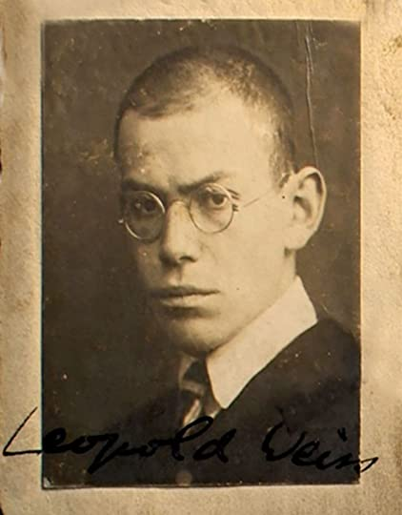
Leopold's many constructive encounters while seeking something "more meaningful" in life, include a brief stint in Berlin with early filmmaker F.W. Murnau (Nosferatu based on Bram Stoker's Dracula), explorations by camel & train across Syria & Iraq and time with members of the House of Saud, including King Abd al-Aziz ibn Saud in what became Saudi Arabia. Over time, the outsider who had once attended Hebrew school, though more for its cultural content, while even developing a fluency in Aramaic, experiences a gradual but rather complete transformation.
There is also a memorable intersection involving a discussion of theology with a Jesuit priest on a ship bound for Egypt & Turkey and another with the chairman of the Zionist Committee of Action in Palestine, where although of Jewish origin, the author feels a "strong objection to Zionism", taking issue with the Balfour Declaration of 1917 and stating his opposition with Dr. Chaim Weismann, attempting to point out that long before the Hebrews came to the area as "conquerors to Palestine, there were many Semitic & non-Semitic tribes settled there--including the Amorites, Edomites, Philistines, Moabites & Hittites, with the descendants of many of these peoples still resident in the area."
Gradually, the man who began life as Leopold Weiss experiences a metamorphosis, converting to Islam & becoming in the process Mohammad Asad. In time, some began to refer to him as "a Jewish Lawrence of Arabia".
Islam did not seem so much a religion in the popular sense of the word as, rather, a way of life; not so much a system of theology as a programme of personal & social behavior based on the consciousness of God. Nowhere in the Koran could I find any reference to a need for "salvation" or a mention of original or inherited sin; sin meant no more than a lapse from the innate, positive qualities with which God was said to have endowed every human being. There was also no trace of any dualism in the consideration of man's nature: body & soul seem to be taken as one integral whole.
I found Asad's commentary on the Crusades of considerable interest, calling this a "defining moment for western civilization, a wave of intoxication that brought tribes & classes together, providing a shared cultural awareness + a sense of unity but also causing intellectual damage--the poisoning of the western mind." Reading about the transformation of Leopold Weiss in becoming Mohammad Asad from an author who has such a keen sense of Islamic history and cultures made The Road to Mecca a fascinating book. Asad indicates that he decided to become a Muslim "not because I lived among them so long; rather I decided to live among them because I had embraced Islam." Asad goes on to comment...
Throughout the years I have spent in the Middle East--as a sympathetic outsider from 1922 to 1926 and then as a Muslim sharing the aims & hopes of the Islamic community ever since--I have witnessed the steady encroachment of Muslim cultural life & political independence + European public opinion that labels any resistance to this incursion as xenophobia. The West's main argument is always that the political disruption & Western intervention is not merely aimed at protecting "legitimate" Western interests but also at securing progress for the indigenous peoples themselves.
This was of course before WWII & the discovery of oil further changed the dynamics of that intervention, eventually leading to independence for many of the countries where Mohammad Asad lived. The author later spent time as a compiler of Muslim history, writing books on the nature of the Koran & Islam, still later serving as Pakistan's Ambassador to the United Nations when that country became independent, splitting from the Indian subcontinent in 1947. I can not begin to capture the many roads that Asad traveled in The Road to Mecca but the book is extremely thoughtful, quite personally revealing & very well-written.
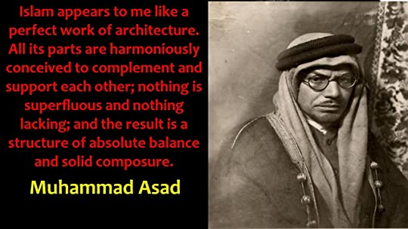
Curiously, at some point I thought of the intriguing novel by Kurban Said, Ali & Nino, a novel that featured a Jewish fellow in Azerbaijan who converts to Islam, marrying a Georgian Christian woman, a book that was first published in Vienna just before the outbreak of WWII. And yes, Asad does make it to Mecca and speaks candidly about his experiences there.
It may be that someone who was raised a Jew within a Christian landscape prior to WWI & perhaps survived WWII & the Holocaust because he changed both his residence & his identity is particularly empowered to provide insight into Islam, a quality that someone who has known no other faith can not. The sister & father of the former Leopold Weiss, among many other Jews living in Vienna at the time of the Anschluss or the German annexation of Austria, perished in the Holocaust, along with countless others.
I recommend this book highly to anyone interested in Islamic history or in reading about a unique search for personal identity. *Interspersed are many black & white photographs which add context to Asad's story. **The first photo image is of Leopold Weiss as a young man, the second after his transformation to Muhammad Asad.

