FSQM L # 25-26. COMMON CONTAMINANTS OF PLASTIC FOOD PACKAGING MATERIALS
Charlotte Wagner (October 9, 2012)
https://www.foodpackagingforum.org/food-packaging-health/food-packaging-materials/plastics/common-contaminants (22-04-2020)
- Biocides  - Biomonitoring  - Bioplastics  - Bisphenol A  - Bisphenol S  - Can coatings  - Chemical Risk Assessment  - Chronic disease  - Developmental exposures  - Endocrine disruptors  - Epigenetics  - EU Parliament Report on FCMs  - FACET exposure tool | Food Packaging Materials  - Ceramics  - Glass  - Metal  - Paper and board  - Plastics  - Printing inks  - Wax  - Wood  - Melamine  - Micro plastics | - Migration  - Migration modeling  - Mineral oil hydrocarbons  - Mixture Toxicity  - Nanomaterials  - Non-intentionally added substances (NIAS)  - Per- and polyfluoroalkyl substances (PFASs)  - Phthalates  - Plastic recycling  - Regulation on Food Packaging  - Silicones  - Threshold of Toxicological Concern  - UV filters in food packaging

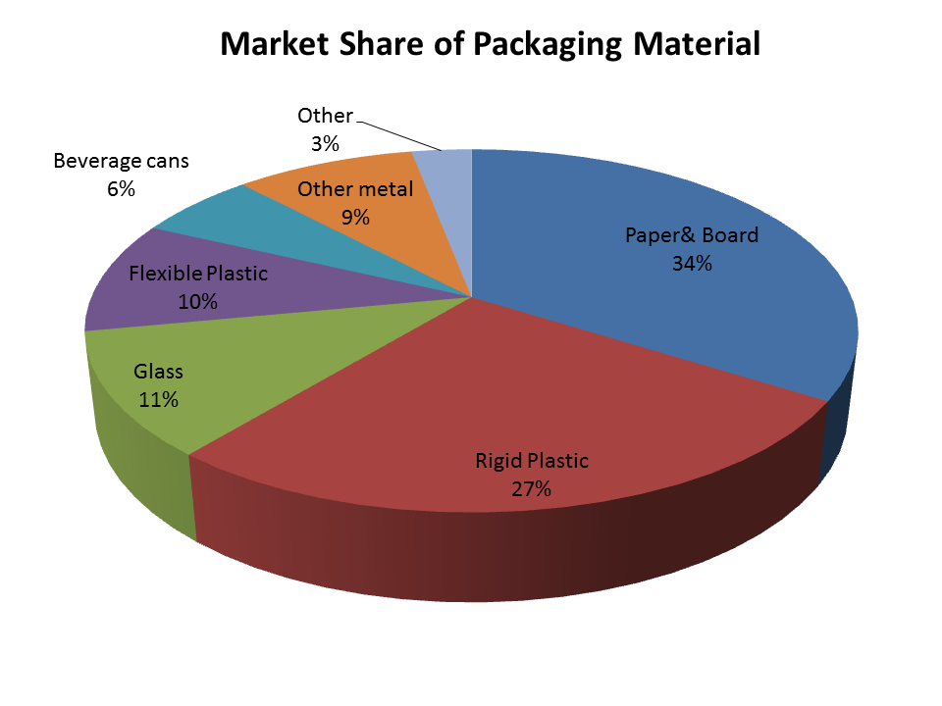
PLASTICS AS FOOD PACKAGING
Plastic Foil | PET (polyethylene terephthalate) | - Formaldehyde [1]  - Acetaldehyde [1]  - Antimony [2]  - UV Stabilizers [3]  - Polybrominated Dimethylesters (PBDE) [4] | Joghurt cup lids
 | PE | - Polyolefin oligomeric saturated hydrocarbons (POSH) [5]  - Nonylphenol [6] | Freezer bags, frozen poultry and ham bags, prepackaged fresh produce, food storage containers [7, 8]
 | PVC | - Vinyl chloride [9]  - Organo tins [10]  - Adipates [11]  - Plasticiser [11, 12]  - nonylphenol [13] | Shrink foil, shrink foil prepackaged meat, cheese, fruit and vegetables [8]
 | HDPE | - Antimony [4]  - Polybrominated Dimethylesters (PBDE) [11] | Milk, dairy products [8]
 | Cellulose | - Triacetin [14] | Meat packaging [8]
Plastic Bottle | PET (polyethylene terephthalate) | - Formaldehyde [1]  - Acetaldehyde [1]  - Antimony [4, 15]  - UV Stabilizers [3]  - Adipates [16]  - Phthalates [16]  - Polybrominated Dimethylesters (PBDE) [4] | Soft drinks, CSD** (single use) [8]
 | PC (polycarbonate) | - Bisphenol A [14, 17]  - Antimony [4]  - Polybrominated dimethylethers (PBDE) [2, 4]  - 4-nonylphenol [17] | Repeated use water bottles, baby feeding bottles [14]
 | PVC (polyvinylchloride) | - Vinyl chloride [9]  - Plasticiser [12]  - Organo tins [10]  - Nonylphenol [4, 18, 19] | Water and soft drink bottles (single use)[14]
Plastic Trays and Inserts | PVC (polyvinylchloride) | - Vinyl chloride [9]  - Plasticiser [12]  - Organo tins [10]  - Plasticiser [11, 12]  - Nonylphenol [18, 19], | Chocolate box inserts, food trays, biscuit tins[14]
 | PS (polystyrene) | - Styrene [20] (found for cups)  - Styrene trimers [21]  - Polybrominated dimethylesters (PBDE) [4] | Yoghurt, dairy product, honey, syrup and ice cream, marmalade and jam tubs and containers;trays for prepackaged meat and fruit[14]
Plastic Trays (Oven Proof) | PET (polyethylene terephthalate) | - Formaldehyde [1, 15]  - Acetaldehyde [1, 15]  - Antimony [4]  - UV Stabilizers [3] | oven proof or microwavable food
Plastic Cups | PP (polypropylene) | - Polyolefin oligomeric saturated hydrocarbons (POSH) [5]  - Erucamide, oleamide [7]  - Antioxidants [7]  - Phthalates [7]
 | PS (Polystyrene) | - Styrene [20]  - Styrene trimers [21]  - Polybrominated dimethylesters PBDE [4] | Vending cups [14]
Plastic Pouches | Aluminium | - Aluminium [8]
 | PP (polypropylene) | - Polyolefin oligomeric saturated hydrocarbons (POSH) [5]  - Erucamide, oleamide [7]  - Antioxidants [7] | Crisps, biscuits, snack foods, sugar, grains and vegetables[14]
 | PET | - Formaldehyde [1, 15]  - Acetaldehyde [1, 15]  - Antimony [15]  - UV Stabilizers [3] | Boil in the bag food [8]
Glass | Glass Container  Coated Metal Closure | - Phthalates [1-3]  - Epoxidised soy bean oil (ESBO) [1, 2]  - Lead [4] | Glass bottles, yoghurt jars, vegetable and fruit jars
Ceramics | Glazed Ceramic | - Heavy metals (Lead and Cadmium) [1] | Kitchen Ware
Metal | Steel Coated with tin (tinplate)  Coated tin,  steel or Aluminum | - Tin [1]  - Iron [1]  - Bisphenol A diglycidyl ether (BADGE) [2]  - Bisphenol A [3]  - Fungicide [4]  - Aluminium [5]  - Tin [1]  - Iron [1] | White fruit cans [1]  Soft drink and beer cans, fish and pâté cans [1, 6]

FOOD PACKAGING - PAPER
Food Packaging | Food Contact Material* | Typical Migrants | Typical uses
Paper | Paper (recycled and/or printed) | - Printing inks (including benzophenones) [1]  - Mineral oils [2]  - Anthraquinone [3] | Dry food packaging such as flower, sugar [1]
 | PE (polyethylene) coating | - Polyolefin oligomeric saturated hydrocarbons (POSH) [4]
 | Non-stick coating | - Perfluorinated compounds [5, 6]
Carton Board | Carton (recycled and/or printed) | - Printing inks (including benzophenones) [1]  - Mineral oils [2]  - Phthalates [7]  - Anthraquinone[3] | Rice cartons, muesli and cereal cartons, infant formula [1]
 | PE (polyethylene) | - Polyolefin oligomeric saturated hydrocarbons (POSH) [4]  - UV stabiliser [8] | Beverage cartons, frozen food cartons, baby formula [9]
 | Aluminium | - Aluminium [10] | Snacks, cough drops
 | PP (polypropylene) | - Polyolefin oligomeric saturated hydrocarbons (POSH) [4]  - Erucamide, oleamide [9]  - Antioxidants (BHT) [9,11]  - Benzophenone [12] | Bag in box [9]

PRINTING INK
Substance name | CAS | Application | Regulation | Health Effect
4,4’‐bis (dimethylamino)-benzophenone | 90-94-8 | Printing ink for paper and board [1] | Not regulated in the EU, not registered with OECD | No studies on health effects available
4,4’‐bis(diethylamino)‐benzophenone (DEAB) | 90-93-7 | Printing ink for paper and board [1] | Not regulated in the EU, not registered with OECD, authorized in Switzerland (Swiss ordinance 817.023.21, Section B | No studies on health effects available
Dibutyl phthalate | 84-74-2 | Plasticizer in ink for PE [2] | Authorized as an additive in the EU SML = 0.3mg/kg-d, registered with OECD | Reproductive toxicant (embryotoxicity and impaired fertility (see assessment), undifferentiated gonads in frogs [3], reproductive tract malformations in rats and rabbits [4])
Dicyclohexyl phthalate | 84-61-7 | Plasticizer in ink for PE [2] | Not regulated in the EU, authorized in Switzerland (Swiss ordinance 817.023.21, Section B) | Endocrine disruptor, centribular cell hypertrophy in rat [5]
Triphenylphosphate | 115-86-6 | Printing ink for paper and board [6] | Not regulated in the EU, registered with OECD, authorized in Switzerland (Swiss ordinance 817.023.21, Section B | Low acute toxicity (see OECD report)
Di(2-ethylhexyl)phthalate (DEHP) | 117-81-7 | Plasticizer in ink for PE [2] | EPA LOAEL 19mg/kg-d, SML =1.5mg/kg-d, group 00032 SML =60mg/kg-d, only to be used in repeated use articles in contact with non-fatty food and concentrations below 0.1%, OECD registered | Light skin and eye irritation, hepatoxin, kidney toxin, testicular toxicity (see OECD report), testicular toxicity [7], male reproductive tract malformations in rats and rabbits [4], reduced fertility (EFSA Opinion)
4-methyl-benzophenone | 134-84-9 | Printing ink for paper and board [6] | Not authorized by EU or FDA, authorized in Switzerland (Swiss ordinance 817.023.21, Section B | No studies on health effects available
Benzophenone | 119-61-9 | Photosensitizer in printing inks [8, 9] | Approved as a food additive (9.1) (legislation: (EU) No 10/2011 (SML = 0.6 mg/kg), registered with OECD, FDA approved as food additive, authorized in Switzerland (Swiss ordinance 817.023.21, Section B | Classified as a 2B carcinogen by IARC (Monograph), Hepatoxin in two generations study in rats, estrogenic potency (see EFSA report), estrogenic and androgenic activity in hormone responsive reporter assay [10]
Methyl 2-benzoylbenzoate | 606-28-0 | Printing ink for paper and board [6] | Not regulated in the EU, authorized in Switzerland (Swiss ordinance 817.023.21, Section B (currently under reevaluation)) | No studies on health effects available
1-Hydroxycyclohexyl phenyl ketone | 947-19-3 | Printing ink for paper and board [6] | Not regulated in the EU, registered with OECD, authorized in Switzerland (Swiss ordinance 817.023.21, Section B | Cytotoxic [11]
4-Phenylbenzophenone | 2128-93-0 | Printing ink for paper and board [6] | Not regulated in the EU, authorized in Switzerland (Swiss ordinance 817.023.21, Section B (currently under reevaluation)) | No studies on health effects available
2-Isopropylthioxanthone (2-ITX) | 5495-84-1 | Photoinitiator in printing inks on drinking cartons [12] | Not regulated in the EU, authorized in Switzerland (Swiss ordinance 817.023.21, Section B | No studies on health effects available
Ethyl 4-dimethylaminobenzoate | 10287-53-3 | Printing ink for paper and board [6] | Not regulated in the EU, authorized in Switzerland (Swiss ordinance 817.023.21, Section B (currently under reevaluation)) | No studies on health effects available
2-ethylhexyl-4-dimethylaminobenzoate | 21245-02-3 | Printing ink for paper and board [6] | Not authorized by EU or FDA, authorized in Switzerland (Swiss ordinance 817.023.21, Section B (currently under reevaluation)) | Antagonist effect in Yeast two hybrid assay EC50 (+S9^{d})and in MDA-kb2 cell transcriptional-activation assay [13, 14]
2,2-Dimethoxy-2-phenylacetophenone | 24650-42-8 | Printing ink for paper and board [6] | Not regulated in the EU, authorized in Switzerland (Swiss ordinance 817.023.21, Section B) | Binds with rat estrogen receptors [15]
4-(4-Methylphenylthio)benzophenone | 83846-85-9 | Printing ink for paper and board [6] | Not regulated in the EU, authorized in Switzerland (Swiss ordinance 817.023.21, Section B) | No studies on health effects available

Threshold values defined by different research groups and regulatory agencies during the development of the TTC and ToR concepts.
Approach | Threshold groups | Threshold values | Reference
General ToR | All chemicals | 0.1 ppm in the diet | Frawley, 1969 [1]
ToR | Non-carcinogens | 1.5 ug/person/day | US FDA [5, 6]
Decision tree approach | Cramer class I  Cramer class II  Cramer class III | 1800 ug /person/day  540 ug/person/day  90 ug/person/day | Munro, 1996 [8]
ToR, tiered approach | Level 1  Level 2  Level 3 | 1.5 ug/person/day  15 ug/person/day  30-45 ug/person/day | Cheeseman, 1999 [9]
TTC | Cramer classes I-III  Organophosphates and Carbamates  Genotoxic compounds | according to [8]  18 ug/person/day  0.15ug/person/day | Kroes, 2004 [10]
TTC | Cramer classes I-III  Organophosphates and Carbamates  Structural alerts for Genotoxicity | according to [8]  according to [10]  according to [10] | Scientific Opinion EFSA, 2012 [12]
Adjusted for Body Weight | Cramer class I  Cramer class II  Cramer class III  Organophosphates and Carbamates  Structural alerts for Genotoxicity | 30 ug/kg bw/day  9.0 ug/kg bw/day  1.5 ug/kg bw/day  0.3 ug/kg bw/day  0.0025 ug/kg bw/day | Scientific Opinion EFSA, 2012 [12]
- Rulis, A. (1986). “De minimis and threshold of regulation.” In: Food Protection Technology. C.W. Felix, ed. Lewis Publishers, pp 29-37.
- Munro I.C. et al. (1996). “Correlation of structural class with no-observed-effect levels: a proposal for establishing a threshold of concern.” Food Chem Toxicol 34:829-67.
- Cramer, G. et al. (1978). “Estimation of toxic hazard – a decision tree approach.” Food Cosmet Toxicol 16:255-76.
- Kroes, R. et al. (2000). “Threshold of toxicological concern for chemical substances present in the diet: a practical tool for assessing the need for toxicity testing.” Food Chem Toxicol 38:255-312.
- Kroes, R. et al. (2004). “Structure-based thresholds of toxicological concern (TTC): guidance for application to substances present at low levels in the diet.” Food Chem Toxicol 42:65-83.10.
- EFSA (2012). “Scientific Opinion on exploring options for providing advice about possible human health risks based on the concept of Threshold of Toxicological Concern (TTC).” EFSA Journal 2012;10(7):2750.
- EC (2000). “Commission Regulation (EC) No 1565/2000 of 18 July 2000 laying down the measures necessary for the adoption of an evaluation programme in application of Regulation (EC) No 2232/96 of the European Parliament and of the Council.”
- Munro IC et al. (1999). “A procedure for the safety evaluation of flavouring substances. Joint FAO/WHO Expert Committee on Food Additives.” Food Chem Toxicol 37:207-32.
- Koster, S. et al. (2011). “Application of the TTC concept to unknown substances found in analysis of foods.” Food Chem Toxicol 49:1643-60.
- EFSA (2012). “Scientific Opinion on evaluation of the toxicological relevance of pesticide metabolites for dietary risk assessment.”

Threshold Classes and corresponding threshold values
Classification | TTC (µg/person/d) | Reference
Cramer class I | 1800 | Munro 1996 [2]*
Cramer class II | 540 | Munro 1996 [2]*
Cramer class III | 90 | Munro 1996 [2]*
Organophosphates and carbamates | 18 | Kroes 2004 [5]*
Carcinogens | 1.5 | TOR rule, Rulis [1]**
Genotoxic substances (without aflatoxin-like, azoxy- or N-nitroso compounds) | 0.15 | Kroes 2004[5]**

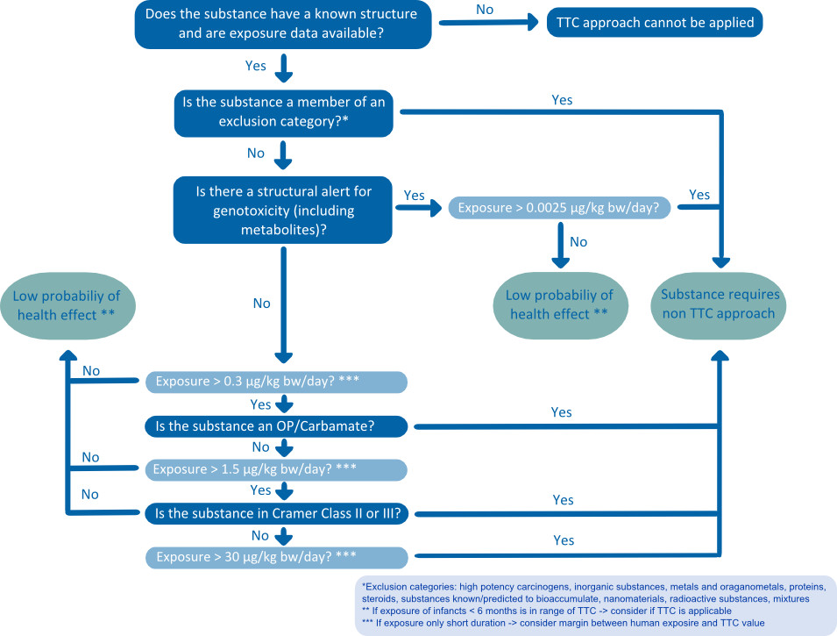

References
1. Mutsuga, M., et al., Survey of formaldehyde, acetaldehyde and oligomers in polyethylene terephthalate food-packaging materials. Food Addit Contam, 2005. 22(8):783-789.
2. Andra, S.S. and K.C. Makris, Thyroid Disrupting Chemicals in Plastic Additives and Thyroid Health. Journal of Environmental Science and Health, Part C, 2012. 30(2):107-151.
3. Begley, T.H., et al., Migration of a UV stabilizer from polyethylene terephthalate (PET) into food simulants. Food Addit Contam, 2004. 21(10):1007-1014.
4. Andra, S.S., et al., Co-leaching of brominated compounds and antimony from bottled water.Environment International, 2012. 38(1):45-53.
5. Biedermann-Brem, S., et al., Migration of polyolefin oligomeric saturated hydrocarbons (POSH) into food. Food Additives & Contaminants: Part A, 2012. 29(3):449-460.
6. Alfirevic, M., et al., Presence of nonylphenols in plastic films and their migration into food simulants. Acta Chimica Slovenica, 2011. 58(1):127-133.
7. Kawamura, Y., et al., Determination of additives in food contact polypropylene. Journal of the Food Hygienic Society of Japan, 2000. 41(2):154-161.
8. Crompton, T.R., Additive migration from plastics into foods. A guide for analytical chemists. 2007, Shawbury, Shrewsbury, Shropshire, UK: Smithers Rapra Technology Limited
9. Benfenati, E., et al., Migration of vinyl chloride into PVC-bottled drinking-water assessed by gas chromatography-mass spectrometry. Food Chem Toxicol, 1991. 29(2):131-134.
10. Papaspyrou, S.D., et al., Determination of migration of n-butyltins and n-octyltins to food simulants by gas chromatography–mass spectrometry. Appl Organometal Chem, 2007. 21:412–424.
11. Goulas, A.E., A. Kokkinos, and M.G. Kontominas, Effect of gamma-radiation on migration behaviour of dioctyladipate and acetyltributylcitrate plasticizers from food-grade PVC and PVDC/PVC films into olive oil. Z Lebensm Unters Forsch, 1995. 201(1):74-78.
12. Petersen, J.H. and L.K. Jensen, Phthalates and food-contact materials: enforcing the 2008 European Union plastics legislation. Food Additives & Contaminants: Part A, 2010. 27(11):1608-1616.
13. Votavova, L., et al., Migration of Nonylphenols from Polymer Packaging Materials into Food Simulants. Czech Journal of Food Sciences, 2009. 27(4):293-299.
14. Sendón García, R., et al., Revision of analytical strategies to evaluate different migrants from food packaging materials. Trends in Food Science &amp; Technology, 2006. 17(7):354-366.
15. Bach, C., et al., Chemical compounds and toxicological assessments of drinking water stored in polyethylene terephthalate (PET) bottles: A source of controversy reviewed. Water Res, 2012. 46(3):571-583.
16. Schmid, P., et al., Does the reuse of PET bottles during solar water disinfection pose a health risk due to the migration of plasticisers and other chemicals into the water? Water Res, 2008. 42(20):5054-5060.
17. Guart, A., et al., Migration of plasticizers phthalates, bisphenol A and alkylphenols from plastic containers and evaluation of risk. Food Additives & Contaminants: Part A: Chemistry, Analysis, Control, Exposure & Risk Assessment, 2011. 28(5):676-685.
18. Bradley, E., Nonylphenol in food contact plastics and migration into foods, F.S. Agency, Editor 2010
19. Inoue, K., et al., Migration of 4-nonylphenol from polyvinyl chloride food packaging films into food simulants and foods. Food Addit Contam, 2001. 18(2):157-164.
20. Ahmad, M. and A.S. Bajahlan, Leaching of styrene and other aromatic compounds in drinking water from PS bottles. J Environ Sci (China), 2007. 19(4):421-426.
21. Choi, J.O., et al., Migration of styrene monomer, dimers and trimers from polystyrene to food simulants. Food Addit Contam, 2005. 22(7):693-699.
GLASS
References
1. Gartner, S., et al., Analysis and migration of phthalates in infant food packed in recycled paperboard. J. Agric. Food Chem. , 2009. 57(22):10675-10681.
2. Pedersen, G.A., et al., Migration of epoxidized soybean oil (ESBO) and phthalates from twist closures into food and enforcement of the overall migration limit. Food Addit Contam Part A Chem Anal Control Expo Risk Assess, 2008. 25(4):503-510.
3. Petersen, J.H. and L.K. Jensen, Phthalates and food-contact materials: enforcing the 2008 European Union plastics legislation. Food Additives & Contaminants: Part A, 2010. 27(11):1608-1616.
4. Shotyk, W. and M. Krachler, Lead in bottled waters: Contamination from glass and comparison with pristine groundwater. Environ. Sci. Technol., 2007. 41(10):3508-3513.
5. Bopp, K., B. Kuch, and M. Roth, Hormonelle Aktivität in natürlichen Mineralwässern? Deutsche Lebensmittel-Rundschau, 2011. 106(September 2010):489-499.
CERAMICS
Reference
1. Gonzalez-Soto, E., et al., Migration of lead and cadmium from ceramic materials used in food preparation. Bull Environ Contam Toxicol, 2000. 65(5): p. 598-603
METALS
References
1. Page, B., M. Edwards, and N. May, Metal Packaging, in Food and Beverage Packaging Technology. 2011, Wiley-Blackwell. p. 107-135.
2. Hammarling, L., et al., Migration of bisphenol-A diglycidyl ether (BADGE) and its reaction products in canned foods. Food Addit Contam, 2000. 17(11):937-943.
3. Goodson, A., W. Summerfield, and I. Cooper, Survey of bisphenol A and bisphenol F in canned foods. Food Addit Contam, 2002. 19(8):796-802.
4. Coelhan, M., J.T. Yu, and A.L. Roberts, Presence of the biocide ortho-phenylphenol in canned soft drinks in the United States and Germany. Food Chemistry, 2009. 112(2):515-519.
5. Müller, M., M. Anke, and H. Illing-Günther, Aluminium in foodstuffs. Food Chemistry, 1998. 61(4):419-428.
6. Sendón García, R., et al., Revision of analytical strategies to evaluate different migrants from food packaging materials. Trends in Food Science &amp; Technology, 2006. 17(7):354-366.
PAPERS AND CARD BOARD
References
1. Bradley, E.L., et al. (2012). “Printing ink compounds in foods: Uk survey results.“ Food Additives and Contaminants: Part B:1-11.
2. Biedermann, M., Grob K. (2010). “Is recycled newspaper suitable for food contact materials? Technical grade mineral oils from printing inks.“ Eur Food Res Technol 230:785-796.
3. BfR (2013). “Bfr streicht anthrachinon aus den bfr-empfehlungen für lebensmittelverpackungen“. Webpage of the BfR.
4. Biedermann-Brem, S., et al. (2012). “Migration of polyolefin oligomeric saturated hydrocarbons (posh) into food.“ Food Additives & Contaminants: Part A 29:449-460.
5. Trier, X., et al. (2011). “Polyfluorinated surfactants (pfs) in paper and board coatings for food packaging.“ Environmental Science and Pollution Research:1-13.
6. Trier, X., et al. (2011). “Structural isomers of polyfluorinated di- and tri-alkylated phosphate ester surfactants present in industrial blends and in microwave popcorn bags.“ Environmental Science and Pollution Research:1-11.
7. Gartner, S., et al. (2009). “Analysis and migration of phthalates in infant food packed in recycled paperboard.“ J Agric Food Chem 57:10675-10681.
8. Sanches-Silva, A., et al. (2008). “Development of a multimethod for the determination of photoinitiators in beverage packaging.“ Journal of Food Science 73:C92-C99.
9. Kawamura, Y., et al. (2000). “Determination of additives in food contact polypropylene.“ Journal of the Food Hygienic Society of Japan 41:154-161.
10. Page, B., et al. 2011. Metal packaging. In: Food and beverage packaging technology:Wiley-Blackwell, 107-135.
11. Sanches-Silva, A., et al. (2007). “Determination of butylated hydroxytoluene in food samples by high-performance liquid chromatography with ultralviolet detection and gas chromatography/mass spectrometry.” Journal of Aoac International 90:277-283.
12. Pastorelli, S., et al. (2008). “Study of the migration of benzophenone from printed paperboard packages to cakes through different plastic films.“ Eur Food Res Technol 227:1585-1590.

