Complexometric titrations: new reagents and concepts to overcome old limitation.

Introduction
Titrimetry is a general and powerful method which is used to quantify a wide range of analytes. The high accuracy of the results and the maturity of the procedure have made it a routine method in various fields such as environmental moni- toring, bioanalytical chemistry and clinic analysis. Compared
with quantitative instrumental measurements that depend on a readout using methods such as ion chromatography, ICP-MS or AAS, titrimetry is the simplest and most accurate method because it relies on an exhaustive consumption of the analyte at the end point. Today, titrimetry can be easily automated, and commercially available standardized reagents provide more convenience to the end users. These key advantages have

made titrimetric methods an indispensible part of analytical

Department of Inorganic and Analytical Chemistry, University of Geneva, Quai Ernest-Ansermet 30, CH-1211 Geneva, Switzerland. E-mail: eric.bakker@unige.ch
chemistry, even with the arrival and establishment of newer instrumental techniques.

Published on 27 May 2016. Downloaded by UNIVERSITE DE GENEVE on 06/07/2016 13:51:12.
Jingying Zhai
Jingying Zhai is currently a PhD candidate in Prof. Eric Bakker’s research group at the University of Geneva. Having worked on optical sensors for glucose and hydrogen peroxide, she received her Master’s degree from Nanjing University in 2013. Her research interests include ion- selective optical and electro- chemical nanosensors, novel complexometric titration methods and reagents based on ion-exchange principles.

Eric Bakker
Eric Bakker is a professor of analytical chemistry at the Uni- versity of Geneva. He received his PhD from the Swiss Federal Institute of Technology in Zurich (ETHZ), Switzerland and spent
14 years in the United States and 3 years in Australia before accepting his current position. His research interests are electro- analytical and optical sensors, analytical applications of extrac- tion principles, desalination approaches, and environmental analysis.

Complexometric titration (complexometry or chelatometry) is one of the classical titrimetric methods developed for the rapid and quantitative chemical analysis of metal ions. The ions of interest are titrated with the chelator of choice through a coordination complexation reaction and rapidly form stable monodentate or multidentate complexes. The chelator is sometimes called the complexing reagent or, more simply, the titrant. The end point can be identified by using a metallo- chromic indicating dye, which shows a color change, or by using other instrumental indicators, such as ion-selective electrodes.
Published on 27 May 2016. Downloaded by UNIVERSITE DE GENEVE on 06/07/2016 13:51:12.
The earliest example of this type of titration reaction is the determination of cyanide ion concentration by using silver nitrate, proposed by the German chemist Justus Liebig in the 1850s.¹ In 1945, Schwarzenbach, who has made a significant contribution to this field, formally introduced the complexo- metric titration method to quantify metal ions, mainly using EDTA as the chelator.² The discovery of EDTA dramatically pushed the field forward. Since 1950, the concept of complexo- metric titration has spread all over the world, for example to measure water hardness.³ A comprehensive theory of com- plexometry was put forward by Schwarzenbach in his book, published 10 years after the introduction of the method.^{4,5} Almost at the same time, various indicating dyes started to appear for visualizing the end point by the naked eye or by spectrophotometric instrumentation. Murexide and Eriochrome Black T were established as indicators for water hardness.^{6,7} A number of researchers including Reilley, Hildeb- rand, Patton, Reeder and Tsien contributed to the synthesis of new indicators to improve their selectivity.^{8–11} Powerful instru- mental analysis methods such as potentiometry, conductome- try, thermometry, coulometry and chronopotentiometry were also developed to provide improved choices for quantitative analyses.^{12–19} Although EDTA has always been the most widely recognized chelator in complexometric titration, good chela- tors and indicators as well as new concepts have been con- tinuously emerging. In addition, various titration protocols have been developed.^{20,21} This review summarizes the most recent developments on complexometric titration reagents and methods.

Chelators
  - The classical chelator EDTA
Chelators are today widely applied in the chemical industry, therapy, agriculture, biochemistry and other fields. Most chela- tors contain N, O or S atoms in their molecular structure to provide lone-paired electrons available for coordination.^{4,22,23} Functional groups such as carboxylates, amines, hydroxyls and sulfhydryls are very commonly found. One of the structurally simple monodentate ligands is ammonia. It is able to strongly coordinate with metals including Cu²⁺, Ni²⁺, Co³⁺, and Ag⁺ and is useful to extract or dissolve metals.^{23,24} However, it is not suited for use as a chelator in complexometric titrations because ammonia only exhibits one bond that can be used to
coordinate the analyte. The resulting stepwise formation of metal complexes makes it diﬃcult to observe the end point. Cyanide suﬀers from the same drawback.^{23,24}
It has therefore been proposed early on that for a reagent to
act as a chelator in complexometric titrations,⁴ (i) the reaction should be kinetically fast, (ii) it should proceed stoichio- metrically, and (iii) the change in free energy must be suﬃciently large.
The introduction of EDTA was a revolution in the field
of complexometric titrations because it fulfills the above- mentioned conditions. As shown in Fig. 1, EDTA exhibits multiple coordinating groups and forms 1 : 1 metal–chelator complexes. EDTA is able to form complexes with various metal ions. Since its introduction, a large number of elements have been measured with this method. Early pioneering studies have been done by Schwarzenbach and co-workers.^{4,25–28} EDTA has been used to analyze almost half of the elements in the periodic table while its derivatives such as diethylene triamine pentaacetic acid (DTPA) and ethylene glycol tetraacetic acid (EGTA) provide similar usage.^{4,29–37} EDTA and its derivatives belong to the aminopolycarboxylic acid family. It is able to dis-
sociate into several protonation states. The eﬀective formation constant of the metal–EDTA complexes therefore depends on pH, which makes titrations with EDTA pH dependent. Because EDTA and its derivatives exhibit high binding constants to many metals ions, they lack tunable selectivity and often require the use of masking reagents.^{4,23}
The total amount of Ca²⁺ and Mg²⁺ is normally titrated with EDTA at pH 10 while Ca²⁺ alone is titrated at pH 13 upon masking the Mg²⁺ ions with OH⁻.^{38–41} Recently, EDTA titration was demonstrated by Kaneta and co-workers in microfluidic paper-based analytical devices.⁴² This paper-based device con- tains various amounts of known EDTA and a small amount of indicator. The device is able to rapidly and quantitatively determine the Ca²⁺ and Mg²⁺ in mineral water, river water and seawater samples.
As an eﬀective chelator, EDTA can also be used to remove the toxic transition metals such as Pb²⁺, Ni²⁺, Hg²⁺, Cd²⁺ and As³⁺ from wastewater, contaminated soil and lake water.^{43–45}
Unfortunately, many chelators are not biodegradable and will persist in the environment.^{46,47} Therefore, recyclable/ separable EDTA-functionalized compounds or materials have also been reported for these applications, such as EDTA bonded polymers, particles or natural materials.^{43,48}

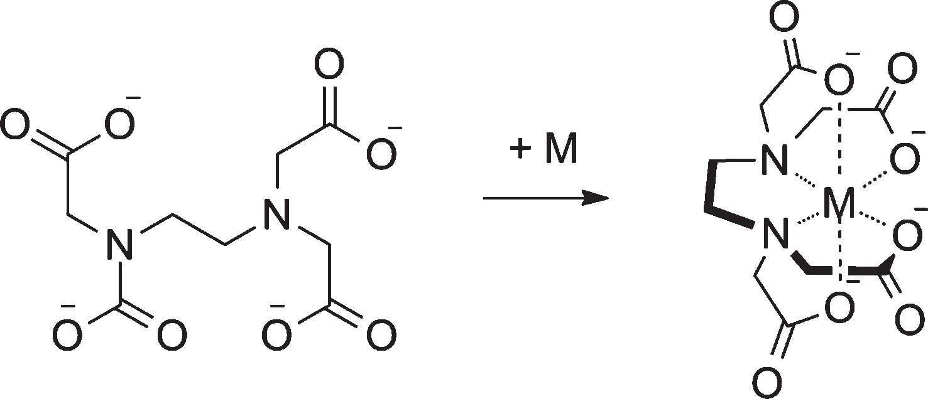

Fig. 1 Chemical structure of fully deprotonated EDTA and its com- plexation with a metal ion M in 1 : 1 stoichiometry.

Stark and co-workers reported that EDTA-like chelator modified nanomagnets can remove Cd²⁺, Pb²⁺ and Cu²⁺ from contaminated water.⁴³ In a very short time, the concentrations of transition metal ions may decrease to the μg L⁻¹ range, which is often acceptable. The nanomagnets must be separ- ated from the treated water.
Until today, 95% of the publications in the complexometric titration area are still based on EDTA and its derivatives. EDTA as an important conventional chelator has also been used medicinally for the treatment of human intoxication with heavy metals. For this type of medical treatment, three other commonly used chelators also exist, including British Anti- Lewisite (BAL), dimercaptosuccinic acid (DMSA) and dimer- captopropane sulfonate (DMPS).⁴⁹ These pharmaceutical chelators can in principle equally be used in titrations.

  - Extractants based on diglycoamides
Diglycolamides as a new class of extractants for actinide and lanthanides ions have been extensively studied during the past
few decades.⁵⁰ Separation, recycling and storage of these long-
methyldiglycolamide (TMDGA), N,N,N′,N′-tetraethyldiglycol- amide (TEDGA), and N,N,N′,N′-tetrapropyldiglycolamide (TPDGA) can be used as complexing agents for Pu(_{IV}) and Am(_{III}).⁵³ As neutral complexing reagents, these diglycolamines display high aﬃnity to Pu(_{IV}) and Am(_{III}) and form more stable complexes with Pu(_{IV}) and Am(_{III}) than EDTA in highly con- centrated HNO₃ solution.
Water insoluble diglycolamides with long alkyl chains can be dissolved in solvents to perform liquid–liquid extraction of actinides and lanthanides.^{50,54} Many groups have studied the synthesis and characteristics of diﬀerent diglycolamide extrac- tants. Among these extractants, N,N,N′,N′-tetraoctyl diglycol- amide (TODGA) was found to be a promising extractant for trivalent actinides.^{55,56} The metal ions will be extracted into
the solvent together with a counteranion (NO₃⁻) in highly con- centrated HNO₃ solution or its salt. If the concentration of the counteranion (NO₃⁻) is not suﬃciently high, the extractants cannot function properly. The extraction process can also be based on ion exchange. Naganawa and co-workers reported on the role of the hydrophobic counteranions (TFPB⁻) in the
extraction of lanthanides( ⁵⁷

III) with TODGA. The metal ions

lived radioactive elements from high level waste generated from nuclear fuel are very important for the environment and human health. Diglycolamides and their analogs (see Fig. 2) were found to be very eﬀective and selective for the extraction of trivalent actinides compared with other extractants such as malomide and octyl-( phenyl)-N,N-diisobutyl carbamoyl methyl phosphine oxide (CMPO) based extractants.^{51,52}
The lipophilicity of diglycolamide compounds can be tuned with diﬀerent alkyl chains on N atoms. Sasaki and co-workers reported that water soluble diglycolamines N,N,N′,N′-tetra-
may be exchanged into the solvent by the counter ion of TFPB⁻. The introduction of an ion exchanger improves the extraction ability and selectivity with a low background of ionic strength. On the other hand, without addition of a hydrophobic cationic exchanger, dissolving the extractant into the ionic liquid can also result in a high extraction eﬃciency for lanthanides, still based on the cation-exchange mechanism.^{58,59} Diglycolamide-functionalized specific ionic
liquids with functional groups attached to the cationic part of the ionic liquid showed high extraction eﬃciency to actinides

and lanthanides.^{59–61} Verboom and co-workers also reported
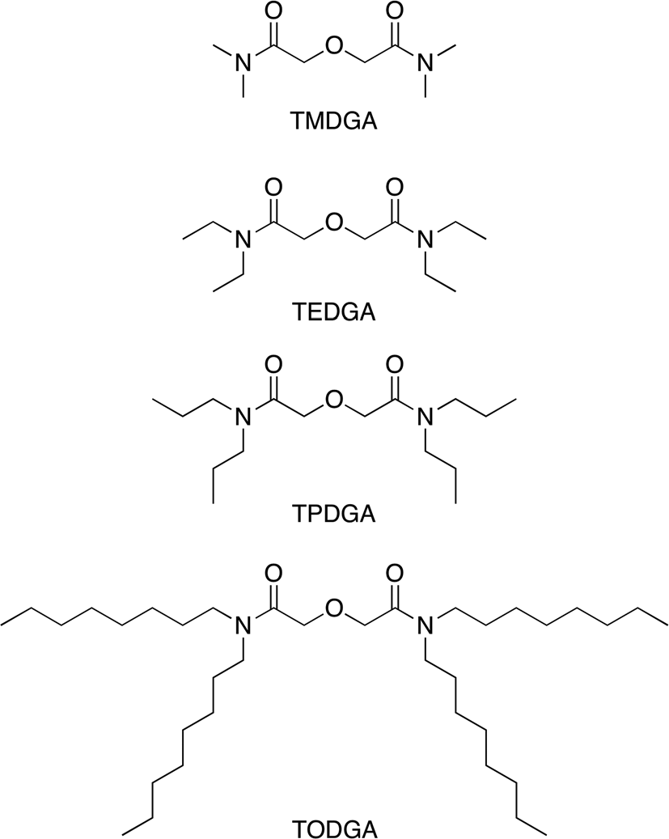
on a series of new ligands based on diglycolamides that have three functional groups at C-pivot and trialkylphenyl platforms.⁶² These ligands also showed high aﬃnity for Am(_{III}) and Eu(_{III}) with a 1 : 1 metal to ligand stoichiometry. In general, ligands based on diglycoamide with various plat- forms have demonstrated satisfactory extraction performance.
The water soluble diglycoamide based compounds are promising chelators for the titration and extraction of acti- nides and lanthanides in homogeneous titrations. However, for the use of hydrophobic titrants/extractants, the extraction system should best contain an ion exchanger, which is further explained below with the nanospheres.
  - Ion selective nanospheres as a new generation of chelators
Conventional titration reactions occur directly in the aqueous sample. Recently, Bakker and co-workers proposed ion selec- tive nanospheres as a novel class of complexometric titration reagents, which moved the titration process from the homo- geneous to the heterogeneous phase.^{63–65} One key advantage of using this new toolbox is that the titration reagents no longer need to be water soluble. Other lipophilic chelators

Fig. 2 Structural formulae of the diglycolamide based ligands for acti- nide and lanthanide ions extraction.
Published on 27 May 2016. Downloaded by UNIVERSITE DE GENEVE on 06/07/2016 13:51:12.
with high selectivity and high aﬃnity to the analyte can be used, such as ionophores for Pb²⁺, Ca²⁺, Cu²⁺, Na⁺, K⁺ and

Cl⁻.^{66–68} These classical ionophores have originally been intro- duced as active reagents in ion selective electrode membranes for many decades. As shown in Fig. 3, the chelating nano- spheres for calcium or lead titration contain a lipophilic calcium ionophore II or lead ionophore IV and a cation exchanger in the core of emulsified organic nanodroplets, which is made of the surfactant Pluronic F-127 and a plastici- zer.⁶³ Based on the principle of ion exchange, the analyte calcium or lead readily exchanges into the nanospheres for the original counter ions (K⁺ or Na⁺, which would only inter- ference at extremely high concentration) of the ion exchanger. Every Ca²⁺ or Pb²⁺ exchanges with two monovalent counter ions so that the core of the nanospheres remains neutral. In the chelating nanospheres the ionophore is chosen at molar excess compared to the ion exchanger. It is therefore the ion-exchanger that defines the extraction capacity, not the ionophore, and various ion–ionophore stoichiometries can be tolerated.
Fig. 4 shows a comparison of titrations eﬀected with calcium selective nanospheres and the chelator EDTA.⁶³ Because the calcium ionophore exhibits no protonatable groups, it was not necessary to control the sample pH during

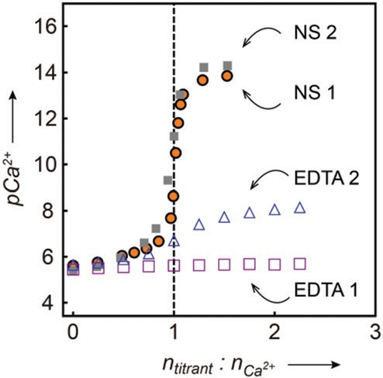

Fig. 4 Comparison of calcium selective emulsion with EDTA as com- plexing agents for the potentiometric titrations of 4 µM calcium. NS 1: titration in non-buﬀered water by calcium selective emulsion; NS 2: titration in 1 mM pH 7.0 Tris-HCl by emulsion; EDTA 1: titration in non- buﬀered water by EDTA; EDTA 2: titration in 1 mM pH 7.0 Tris-HCl by EDTA. The dashed vertical line marks the end point.

the titration: titrations with the calcium selective nanospheres showed an almost indistinguishable behavior in pH 7.0 buﬀered solution than in unbuﬀered water. The titration curves were nearly identical, with sharp transitions at the end- point. Titrations with EDTA did not show a visible endpoint in

unbuﬀered water and the transition was not easily observable
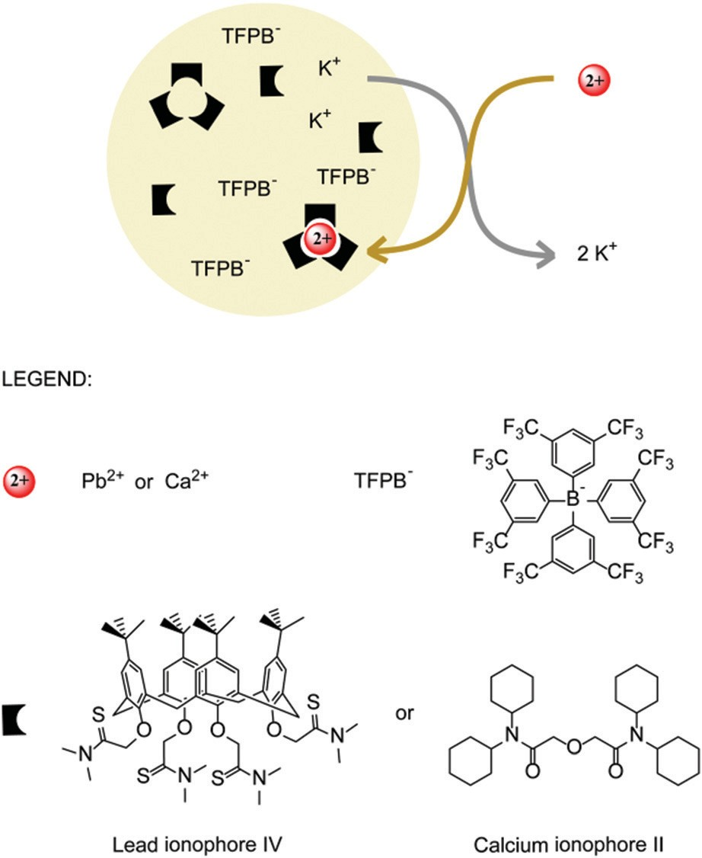
in samples buﬀered at pH 7.0. As established, EDTA titrations of calcium must be performed above pH 10.
The chelating nanospheres exhibit attractive versatility. By simply replacing the ionophore in the nanospheres, it is possible to create a palette of reagents of diﬀerent selectivities. A potential limitation is that the nanospheres tend to co- agulate at high concentration, resulting in undesirable light scattering if the end point is observed by optical methods. This method is still young and emulsion based titrations for
monovalent metal ions such as Na⁺ and K⁺ still remain to be demonstrated.

Published on 27 May 2016. Downloaded by UNIVERSITE DE GENEVE on 06/07/2016 13:51:12.

Fig. 3 Ion-selective emulsions containing nanospheres as the com- plexing agent and structures of the compounds used to form nano- spheres. The nanosphere core is made of dodecyl 2-nitrophenyl ether (D-NPOE) and the hydrophobic sub-structure of Pluronic F-127. The complexation reaction comprises (1) the ion exchange between the target ion (Ca²⁺ or Pb²⁺) in aqueous phase and the counter ion of R⁻ (K⁺) in the organic phase and (2) the complexation reaction between the target ion and the receptor, which lowers the solvation energy for the target ion and provides the driving force for its uptake into the nanospheres.

Coulometric titration
Coulometric conversion has also been considered to directly generate titrants for the purpose of eﬀecting titrations. This principle works on the basis of Faraday’s law, which defines a direct relationship between the charge passing through the electrode and the molar amount of analyte that has reacted. A quantitative release of titrant can be achieved through precise manipulation of current and duration, if there are no cross-reactions.
Reilley and Porterfield reported earlier on a general method for the coulometric generation of EDTA, where EDTA was indirectly released upon the reduction of mercuric–EDTA. This method has been successfully demonstrated to measure calcium, copper, zinc and lead ions.¹² By applying an appropri- ate potential or current, the direct release of non-redox active ions was demonstrated. The released ions served directly as the titrant and were also used to determine the end point of the titration. Compared with traditional volumetric titrations,

this method is able to accurately release the titrant without requiring standardized stock solution. In addition, the sample is not diluted during the titration and the sample volume can remain quite limited. However, the lack of selectivity and the limited options of reagents are yet to be improved, and the use of mercury is often no longer acceptable today.
Published on 27 May 2016. Downloaded by UNIVERSITE DE GENEVE on 06/07/2016 13:51:12.
More recently, the introduction by our group of ion selective membranes to achieve coulometric titration was aimed to over- come the above mentioned limitations.⁶⁹ Calcium and barium ions (titrant ions) were chosen as initial examples. When a constant current and duration was applied across the ion selective membrane, Ca²⁺ or Ba²⁺ was released from the membrane to the sample solution with high selectivity and accuracy. A second ion selective electrode was used as the end point indicator. As above, the amount of released titrant ions could be accurately calculated using Faraday’s law.
Bakker and co-workers subsequently introduced the concept of thin layer coulometric titration (Fig. 5).⁷⁰ By apply- ing a constant potential, Ca²⁺ was electrochemically injected into a thin sample layer through transport across a calcium selective membrane (calcium pump). The free calcium ion activity in the thin layer was measured by another set of poten- tiometric ion-selective electrodes placed opposite the pumping electrode, only spaced by the thin layer gap. Calcium EDTA titration was demonstrated in the range of 0.25–0.75 mM with a precision of 3%, whereas the coulometric readout gave a range of 0.02–0.12 mM and a precision of 2%. This method requires only a very small amount of sample and is suitable for in situ measurements. Moreover, it is potentially calibration free owing to the coulometric mode. For the latter to be true, the selectivity of the ionophore has to be high (which it nor- mally is) and any non-Faradaic processes during the coulo- metric release must be negligible.

Indicators
  - Metallochromic dye based indicators
An end point detection by the naked eye is sometimes thought to be the most convenient way to visualize the titration end point, and metallochromic indicators can be applied for this purpose. As an indicator, it should also fulfill key criteria that include a high sensitivity to exhibit a drastic change at the end point, a high selectivity to obtain accurate results, and a suﬃciently stable complex with the metal of interest. In the early days, Murexide and Eriochrome Black T were the classical dye indicators for Ca²⁺, Mg²⁺ as well as other metal ions.^{4,6,7} However, these dyes are not very selective and can only be used
in a narrow range of pH.
The development of colorimetric/fluorescent metal sensors has gradually drawn people’s attention to their wider appli- cations in biochemical and environmental sciences. In the pursuit of highly selective and sensitive metal ion sensors, a great number of specially designed molecules have emerged where many have proven to be good candidates as indicators for complexometric titration. The fluorophore/chromophore

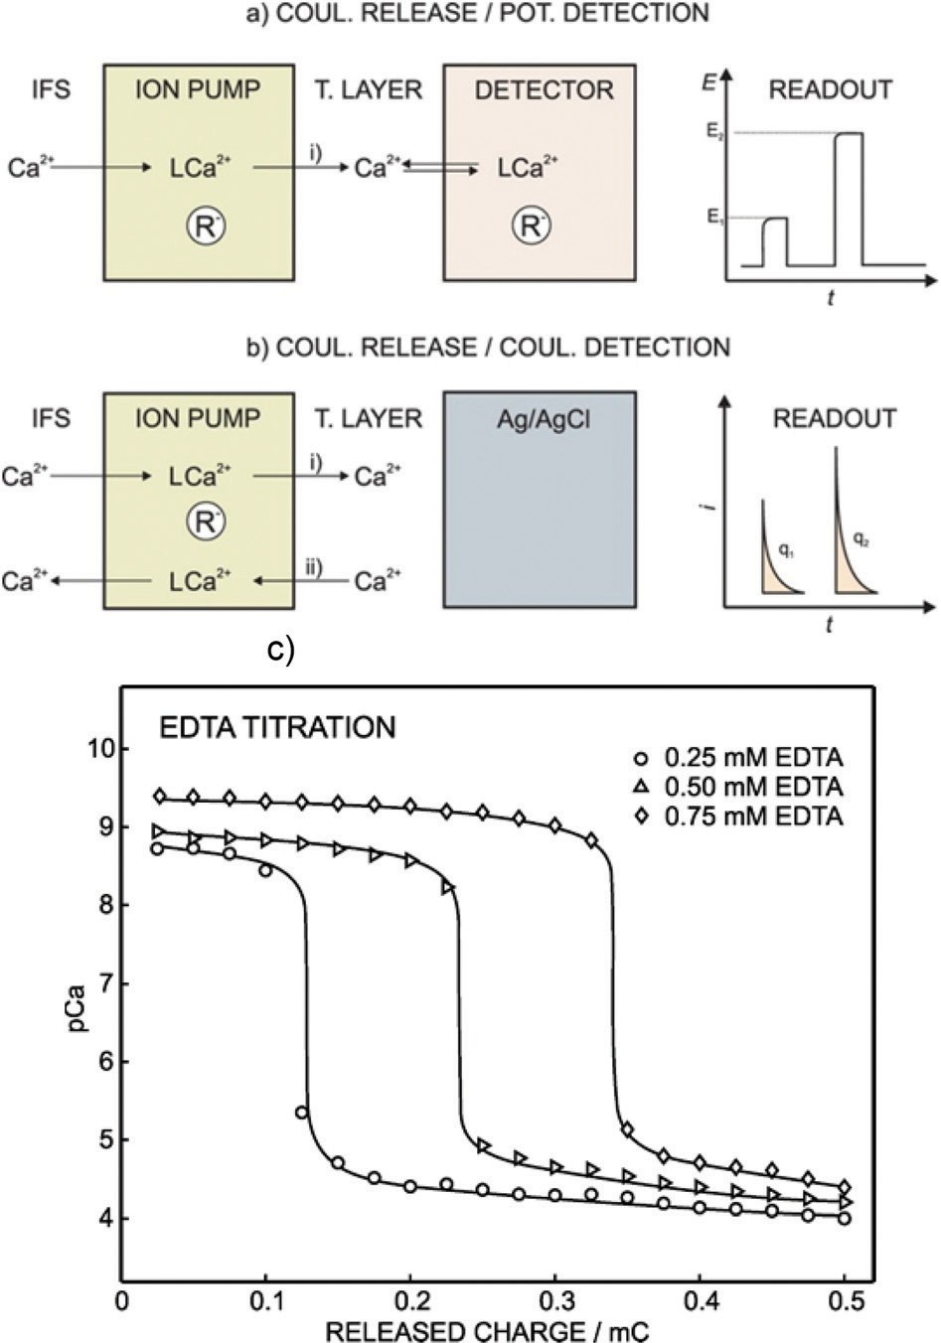

Fig. 5 Illustration of the coulometric release concept (labeled as ion pump) in a thin layer sample. (a) Flat sheet conﬁguration with potentio- metric readout (detector). E1 and E2 correspond to two diﬀerent signals as a consequence of diﬀerent excitation times. (b) Tubular conﬁguration with a coulometric readout. The Ag/AgCl served as the working elec- trode. The integrated charges q1 and q2 correspond to two diﬀerent signals obtained at two excitation times. IFS, internal ﬁlling solution; R⁻, cation exchanger; L, ionophore. (c) Complexometric titration by using the calcium pump plus potentiometric detection for three EDTA con- centrations (0.25, 0.50, and 0.75 mM). Solid lines correspond to the cal- culated concentrations from equilibrium theory. Flat sheet conﬁguration indicates that the membrane of the working electrode (calcium pump) uses a ﬂat porous polypropylene sheet. Tubular conﬁguration means that the working electrode is a silver/silver chloride wire placed inside a hollow ﬁber doped with the lipophilic cocktail.

was usually modified with metal chelating groups and the metal binding would induce a change of the optical signal. Rhodamine, porphyrin, BODIPY, fluorescein, spiropyran, coumarin, dansyl derivatives and many others have been used as fluorophore/chromophore^{71–76} and dipicolylamine, glucosamine, or Gly-His as the receptor.^{74,77,78} pH response sometimes accompanies the metal response because of proto- natable groups on the fluorophore/chromophore and also on the metal chelating groups.
Mártinez-Máñez, Rurack and co-workers designed a series of metal triggered dye formation systems for the highly selec- tive determination of Hg²⁺.⁷⁹ The squaraine derivatives were passivated first by a chemical addition reaction with thiols

(spectroscopic inhibitor) that switch oﬀ the colorimetric and fluorescence properties of the indicator. When the target ions are present, they react with the thiols and release the indicator to induce the optical signal recovery shown in Fig. 6. From the passivated state (colorless) to the activated state (blue), the indicators generated dramatic changes in the optical signals, thereby improving sensitivity. The color change was observed
within a few seconds, making the compounds potential indi- cators for the titration of mercury ions. Fluorescent titration demonstrated that the indicator may detect less than 2 ppb of Hg²⁺ in solution. The indicator with a hydrophobic side chain was adsorbed onto powered silica and subsequently coated onto a polyethyleneterephthalate film. This film served to analyze Hg²⁺ and could easily be reused after washing with the thiol inhibitor.
Reymond and co-workers reported new types of fluorescent sensors for Cu²⁺ which are pH independent and exhibit a high selectivity.⁸⁰ These sensors were quinacridone (fluorophore) derivatives functionalized with a ethylenediamine group (binding site). The ethylenediamines were attached to each nitrogen atom of the symmetrical quinacridone via a linker. The presence of Cu²⁺ induced the quenching of the fluo- rescence by formation of the macrocyclic metal–chelator complex, which brought the complex and the fluorophore closer to each other. To overcome the pH dependence, the authors modified the chemical structures of the indicator. By making the linker suﬃciently long, the protonation/deprotona-
tion of the chelating groups was found to no longer influence
the fluorescence of the fluorophore. At the same time, the long linker did not aﬀect the ability of the metal to coordinate with the two ethylenediamine groups and to cause fluorescence quenching. The sensors showed good selectivity to copper and were independent of pH in the range from 2 to 10. The fluo- rescent titration showed a 1 : 1 stoichiometry of the complex.
Recently, our group has introduced emulsion based ion exchange nanospheres (discussed above) to serve also as optical indicators for complexometric titrations.⁶⁵ The indicat- ing nanospheres contained a lipophilic pH sensitive dye (chro- moionophore), an ion exchanger and an ionophore. For cationic analytes, the working principle of the indicating nanospheres is the exchange between the analyte and the H⁺
released from the chromoionophore. The color of the indicating nanospheres changes because the chromoiono- phore transitions from the protonated state to the deproto- nated state. To serve as an indicator, the metal indicator complex should generally be 10 to 100 times less stable than the metal chelator complex so that the chelator can eﬀectively displace the metal ion from the indicator complex. This is eﬀectively achieved here with the same chelator/ionophore, since the eﬀective aﬃnity between the metal and the receptor is dictated by ion-exchange, which is weakened by the presence of the lipophilic pH indicator. The chromoionophore-based indicating nanospheres may work in a wide pH range and even at very acidic pH. Unfortunately, however, the transitions become rather diﬃcult to identify with increasing pH because the chromoionophore becomes more easily deprotonated at high pH.
To overcome this pH dependence, cationic solvatochromic dye based indicating nanospheres were recently introduced. The solvatochromic dye is not sensitive to pH and changes color with the solvent environment.⁶⁴ In the emulsion based titration, a large amount of the chelating nanospheres and a much smaller amount of indicating nanospheres are mixed together, and the sample solution was gradually added. Here, the indicating nanospheres only function as the indicator to show the color change at the endpoint. Only when the chelat- ing nanospheres become saturated at the endpoint, the cat- ionic solvatochromic dye in the indicating nanospheres will be exchanged from the nanosphere core to the outside solution by the analyte (Fig. 7). Owing to the diﬀerent polarity between
the nanosphere core and aqueous solution, the color of the
solution will change. Essentially the same sharp titration curves were obtained at pH 5.5 and pH 9, which suggest that this concept can eﬃciently overcome the challenge of pH dependence in such titrations (Fig. 8).
  - Instrument-based indicators
While the metallochromic indicators discussed above can directly visualize the end point by a color change, sometimes appropriate indicating dyes are not easily found and instru- mental methods are needed to identify the end point.
Potentiometry by ion selective electrodes is likely the most widely applied electrochemical indicator. An ion selective elec-

trode can not only measure the activity of the ions but also act
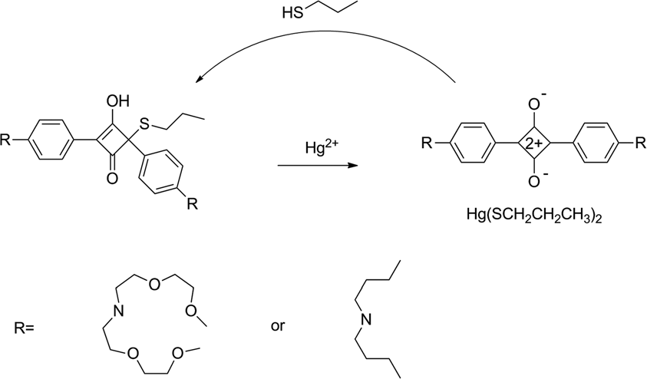
as the end point indicator to visualize the so-called free activity of the analyte. In potentiometry, the observed signal, the electromotive force, is related to the analyte activity according to the Nernst equation. With the appropriate selectivity, a large change in the signal is usually observed at the end point.
Pretsch and co-workers suggested ways to improve the detection limits and sensitivity of potentiometric titrations, with lead(_{II}) as an example.⁸¹ By changing the sensing com- ponents of the membrane and adjusting the flux of the primary ion, the detection limit of the titration could be improved by several orders of magnitude, and lower concen-

Fig. 6 The analytical reverse reaction between squaraine derivatives and Hg²⁺.
Published on 27 May 2016. Downloaded by UNIVERSITE DE GENEVE on 06/07/2016 13:51:12.
trations of lead could be titrated. To obtain lower detection limits of the lead selective electrode, a metal chelator, nitrilo-

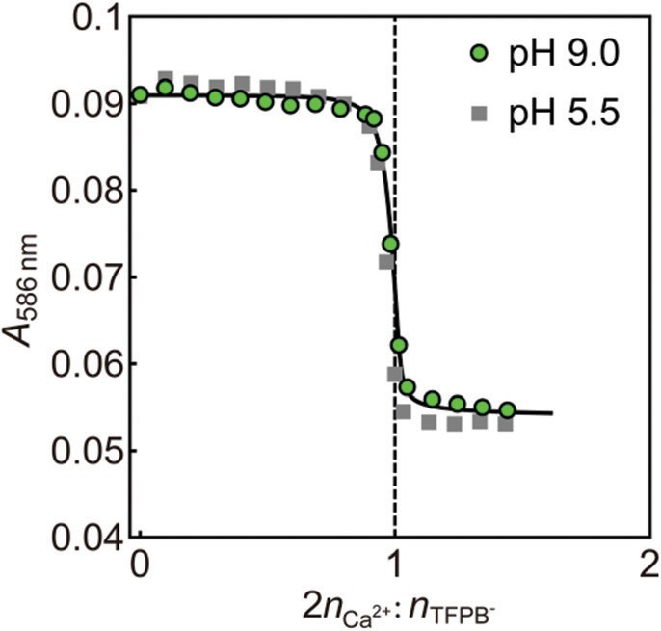

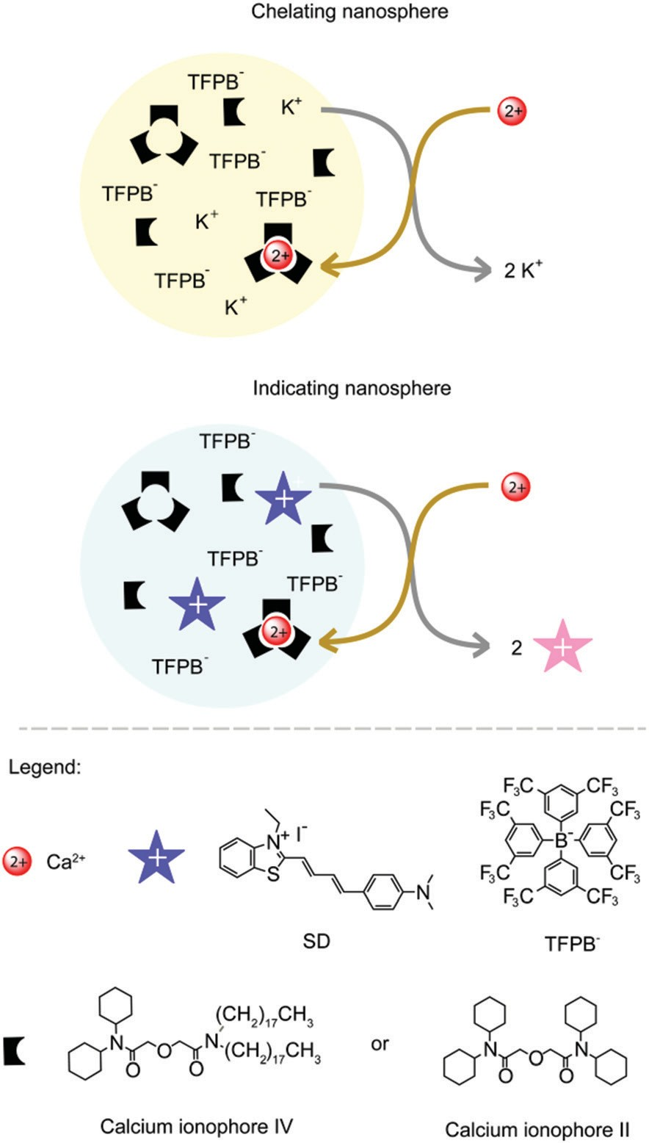
Fig. 8 Optical reverse titration curves for calcium using solvatochromic dye SD based optical nanospheres as the indicator at the indicated pH values. End point indicator: SD-based and Ca²⁺-selective; pH 9.0: 10⁻³ M Tris-H₂SO₄; pH 5.5: 10⁻³ M MES-NaOH; the dashed vertical line indicates the expected end point. Fitting parameters: V_{T} = 2 ml, [TFPB⁻]^{is}
= 3.29 × 10^{−6.15} M, V_{is} = 1.5 µL, [TFPB⁻]^{cs} = 2.35 × 10⁻⁵ M, V_{cs} = 8 µL,

[Ca2+]titrant = 10−3 M, Kcs
^{2þ} ^{þ}Ca ’;SD
Ca^{2þ} ;Jþ
½J^{þ}]aq ¼ 10^{—7}M, K^{is}
½SD^{þ}]aq ¼ 10^{—5:5}M.

Fig. 7 Schematic illustration of ion selective nanospheres as chelators and indicators in the complexometric titration of calcium. Chelating nanospheres contain calcium ionophore II and a cation exchanger. Indi- cating nanospheres contain calcium ionophore IV, a cation exchanger and the solvatochromic dye SD.
universal method that measures the change of temperature with the added volume of titrant during a volumetric titra- tion.⁸³ Since heat change is one of the general characteristics of most reactions, a thermometric titration is suited for a wide range of reactions such as acid/base, precipitation, coordi- nation and redox titrations.^{83–87} Some factors such as light scattering, absorption inducing surface blocking, color change or overlay, will influence the optical or potentiometric signal but have no significant influence on a thermometric titration. Thermometric titration has been successfully applied to monitor sulfate, total alkalinity, and chlorinity in seawater,⁸⁵ and a wide range of metal ions such Ca²⁺, Mg²⁺, Fe²⁺, and Pb²⁺.^{83,84,87} The first thermometric titration research work was

on acid and base neutralization and was reported by Bell and
Cowell in 1913.⁸⁸ Jordan successfully applied thermometric titration to estimate the heat produced by the complex formed

triacetic acid (NTA) or EDTA, acting as a metal buﬀer at low concentrations was added to the inner solution of the ion selective electrode to keep the concentration of lead low and stable. In this particular case, the net Pb²⁺ flux was directed from the sample to the inner solution. With a significant inward flux, the ion selective electrode may show a super- Nernstian response slope to the analyte, thereby improving the
Published on 27 May 2016. Downloaded by UNIVERSITE DE GENEVE on 06/07/2016 13:51:12.
sensitivity of the titration quite dramatically.
Daniele and co-workers used amperometry to detect the endpoint of Ca²⁺ and Mg²⁺ titrations with EDTA.⁸² A platinum disc microelectrode was used to reduce the H⁺ to H₂ in non- buﬀered sample solutions. A second wave in the linear scan voltammogram was observed after the end point due to excess EDTA. The precision of the method was found to be satisfac- tory, the relative standard deviation being not larger than 2% for at least three replicates. Besides electrochemical methods, thermometric titration has been found to be an attractive
between divalent metal ions and EDTA.⁸⁹ For example, both Ca²⁺ and Mg²⁺ could be determined by thermometric titration even if the formation constants diﬀer by less than 2 orders of magnitude.^{84,87} By comparison, the metallochromic indicator Eriochrome Black T is not suﬃciently selective to separate Ca²⁺ and Mg²⁺ at the same time and requires masking reagents or pH control.^{4,6} In addition, diﬀerent dynamic characteristics may also help separate the analytes by monitoring their release of heat in order to obtain a higher selectivity. A key disadvantage of this method is the relatively high detection limit compared with other instrumental indicators. The reason is that one requires a suﬃciently large quantity of reaction substrate to observe a detectable tempera- ture variance. The development of dedicated instruments encouraged the widespread use of this method. Recently, Barin and co-workers introduced a very simple and inexpensive setup for simultaneous enthalpimetric analysis by using an

infrared camera as a detector to monitor the temperature and disposable microplates to process the enthalpimetric analysis.⁹⁰ The noncontact and nondestructive infrared thermal imaging technique provided rapid signal acquisition with very good quantitative results. Even if some limitations for this new method remain, such as not being suitable for low reaction rate reactions, it still shows potential to be applied in a range of important applications.
Published on 27 May 2016. Downloaded by UNIVERSITE DE GENEVE on 06/07/2016 13:51:12.

Conclusion
The introduction of EDTA has made complexometric titrations a well-known analytical technique. However, the drawbacks of EDTA have until recently not been overcome. As summarized in this work, the advent of new titration reagents and end point indicators has injected a new vitality into the field and has also raised more issues to be resolved in further work.
Recent new concepts of chelators and indicators based on heterogeneous reactions involving emulsion based reagents show very promising characteristics for complexometric titration. Here, ion selective nanospheres really are multi- component nanoscale solvent reactors that act in analogy to traditional chelators and indicators and extend the usage of lipophilic ionophores and other non-water-soluble com- pounds. This approach exhibits a high selectivity and sensi- tivity to a range of analytes, does not have to limit itself to a unique 1 : 1 complex stoichiometry, and is largely pH inde- pendent. Simply changing one or more of the components in the droplets, the nanospheres can be extended to other ions. This concept is highly suitable for titrating low con- centrations of analyte. High analyte concentrations are more problematic, since nanosphere coagulation normally results in light scattering that interferes with an optical endpoint detection.
Thin layer coulometric titrations based on ion selective membranes consume only a very small amount of sample. With a highly selective release of the titrant, only the analyte of interest is consumed or converted, which is very attractive for in situ analysis. Direct probes that give the same result as volumetric titrations, but without the hassle of sampling, splitting into aliquots, standardization of reagents, and volumetric delivery are potentially very attractive for a range of applications.
A number of receptors or ionophores have been reported and applied in diﬀerent fields. However, there are not a suﬃcient number of receptors of quality for anions, and highly selective and pH independent receptors are still very much needed.
Universal methods are also very popular, such as thermo- metric titrations, which measure the temperature change to indicate the end point. It is suitable for almost all reactions and is not limited to complexation, but to obtain observable measurable temperature changes, it requires a relatively large concentration of substrate.

Conﬂict of interest
The authors declare no competing financial interest.

Acknowledgements
The authors thank the Swiss National Science Foundation (SNSF) and the University of Geneva for financial support. Jingying Zhai gratefully acknowledges the support from the China Scholarship Council.

References
- J. Liebig and J. Liebigs, Ann. Chem., 1851, 77, 102–105.
- G. Schwarzenbach, E. Kampitsch and R. Steiner, Helv. Chim. Acta, 1945, 28, 1133–1143.
- M. C. Yappert and D. B. DuPré, J. Chem. Educ., 1997, 74, 1422.
- G. Schwarzenbach and H. Flaschka, Complexometric titra- tions, London, 1969.
- H. Ackermann, J. E. Prue and G. Schwarzenbach, Nature, 1949, 163, 723–724.
- H. J. Gitelman, C. Hurt and L. Lutwak, Anal. Biochem., 1966, 14, 106–120.
- R. A. C. Lima, S. R. B. Santos, R. S. Costa, G. P. S. Marcone,
R. S. Honorato, V. B. Nascimento and M. C. U. Araujo, Anal. Chim. Acta, 2004, 518, 25–30.
- J. Patton and W. Reeder, Anal. Chem., 1956, 28, 1026–1028.
- G. P. Hildebrand and C. N. Reilley, Anal. Chem., 1957, 29, 258–264.
10 R. Y. Tsien, Biochemistry, 1980, 19, 2396–2404.
- G. Grynkiewicz, M. Poenie and R. Y. Tsien, J. Biol. Chem., 1985, 260, 3440–3450.
- C. N. Reilley and W. W. Porterfield, Anal. Chem., 1956, 28, 443–447.
- C. N. Reilley and R. W. Schmid, Anal. Chem., 1958, 30, 947– 953.
14 J. T. Stock, Anal. Chem., 1976, 48, 1R–9R.
15 C. N. Reilley, Anal. Chem., 1960, 32, 185–193.
- K. R. Williams, V. Y. Young and B. J. Killian, J. Chem. Educ., 2011, 88, 315–316.
- K. Granholm, T. Sokalski, A. Lewenstam and A. Ivaska,
Anal. Chim. Acta, 2015, 888, 36–43.
18 Y. Ni and Y. Wu, Anal. Chim. Acta, 1997, 354, 233–240.
- D. Wilson, S. Alegret and M. d. Valle, Electroanalysis, 2015,
27, 336–342.
- M. D. DeGrandpre, T. R. Martz, R. D. Hart, D. M. Elison,
A. Zhang and A. G. Bahnson, Anal. Chem., 2011, 83, 9217– 9220.
- C. Maccà, L. Soldà and M. Zancato, Anal. Chim. Acta, 2002,
470, 277–288.
- C. N. Reilley and A. Vavoulis, Anal. Chem., 1959, 31, 243– 248.

- C. N. Reilley, R. W. Schmid and F. S. Sadek, J. Chem. Educ., 1959, 36, 555–564.
Published on 27 May 2016. Downloaded by UNIVERSITE DE GENEVE on 06/07/2016 13:51:12.
- A. E. Martell and S. Chaberek, Anal. Chem., 1954, 26, 1692– 1696.
- E. J. Wheelwright, F. H. Spedding and G. Schwarzenbach,
J. Am. Chem. Soc., 1953, 75, 4196–4201.
- G. Schwarzenbach and E. Freitag, Helv. Chim. Acta, 1951,
34, 1503–1508.
- G. Schwarzenbach, W. Biedermann and F. Bangerter, Helv. Chim. Acta, 1946, 29, 811–818.
- G. Schwarzenbach, Helv. Chim. Acta, 1946, 29, 1338.
- Y. Ni and Z. Peng, Anal. Chim. Acta, 1995, 304, 217–222.
- C. Maccà, L. Soldà, G. Favaro and P. Pastore, Talanta, 2007,
72, 655–662.
- J. Gao, Y. Guo, S. Wang, T. Deng, Y.-W. Chen and N. Belzile,
J. Chem., 2013, 2013, 1–4.
32 W. Xian-ke, Analyst, 1990, 115, 1611–1612.
33 M. Vlasák, Z. Luxemburková, V. Sychra and M. Suchánek,
Accredit. Qual. Assur., 2013, 18, 491–499.
34 S. G. Novick, J. Chem. Educ., 1997, 74, 1463.
- S.-P. Yang and R.-Y. Tsai, J. Chem. Educ., 2006, 83, 906.
- M. Romero, V. Guidi, A. Ibarrolaza and C. Castells, J. Chem. Educ., 2009, 86, 1091.
- P.-L. Fabre and O. Reynes, J. Chem. Educ., 2010, 87, 836– 837.
- J. S. Fritz, J. P. Sickafoose and M. A. Schmitt, Anal. Chem., 1969, 41, 1954–1958.
- M. C. Yappert and D. B. DuPré, J. Chem. Educ., 1997, 74, 1422–1423.
- H. V. Malmstadt and T. P. Hadjiioannou, Anal. Chim. Acta, 1958, 19, 563–569.
41 P. G. McCormick, J. Chem. Educ., 1973, 50, 136–137.
- S. Karita and T. Kaneta, Anal. Chim. Acta, 2016, 924, 60–67.
- F. M. Koehler, M. Rossier, M. Waelle, E. K. Athanassiou,
L. K. Limbach, R. N. Grass, D. Günther and W. J. Stark,
Chem. Commun., 2009, 4862–4864.
- E. Vassileva, B. Varimezova and K. Hadjiivanov, Anal. Chim. Acta, 1996, 336, 141–150.
- C. Chen, T. Tian, M. K. Wang and G. Wang, Geoderma, 2016, 275, 74–81.
- M. Bucheli-Witschel and T. Egli, FEMS Microbiol. Rev., 2001, 25, 69–106.
- B. Nowack, Environ. Sci. Technol., 2002, 36, 4009–4016.
- M. A. Rahman, M.-S. Won and Y.-B. Shim, Anal. Chem., 2003, 75, 1123–1129.
49 M. E. Sears, Sci. World J., 2013, 2013, 1–13.
- S. A. Ansari, P. Pathak, P. K. Mohapatra and V. K. Manchanda, Chem. Rev., 2012, 112, 1751–1772.
- S. A. Ansari, P. Pathak, P. K. Mohapatra and
V. K. Manchanda, Sep. Purif. Rev., 2011, 40, 43–76.
- H. Narita, T. Yaita, K. Tamura and S. Tachimori, J. Radio- anal. Nucl. Chem., 1999, 239, 381–384.
- Y. Sasaki, H. Suzuki, Y. Sugo, T. Kimura and G. R. Choppin,
Chem. Lett., 2006, 35, 256–257.
- Y. Sasaki, Y. Sugo, S. Suzuki and S. Tachimori, Solvent Extr. Ion Exch., 2001, 19, 91–103.
- G. Modolo, H. Asp, C. Schreinemachers and H. Vijgen,
Solvent Extr. Ion Exch., 2007, 25, 703–721.
- S. A. Ansari, P. N. Pathak, V. K. Manchanda, M. Husain,
A. K. Prasad and V. S. Parmar, Solvent Extr. Ion Exch., 2005,
23, 463–479.
- H. Suzuki, H. Naganawa and S. Tachimori, Phys. Chem. Chem. Phys., 2003, 5, 726–733.
- K. Shimojo, K. Kurahashi and H. Naganawa, Dalton Trans., 2008, 5083–5088.
- P. K. Mohapatra, Chem. Prod. Process Model., 2015, 10, 135– 145.
- P. K. Mohapatra, A. Sengupta, M. Iqbal, J. Huskens and W. Verboom, Chem. – Eur. J., 2013, 19, 3230–3238.
- A. Sengupta, P. K. Mohapatra, R. M. Kadam, D. Manna,
T. K. Ghanty, M. Iqbal, J. Huskens and W. Verboom, RSC Adv., 2014, 4, 46613–46623.
- D. Jańczewski, D. N. Reinhoudt, W. Verboom, C. Hill,
C. Allignol and M.-T. Duchesne, New J. Chem., 2008, 32, 490–495.
- J. Zhai, X. Xie and E. Bakker, Chem. Commun., 2014, 50, 12659–12661.
- J. Zhai, X. Xie and E. Bakker, Anal. Chem., 2015, 87, 12318– 12323.
- J. Zhai, X. Xie and E. Bakker, Anal. Chem., 2015, 87, 2827– 2831.
- J. D. Rodriguez, T. D. Vaden and J. M. Lisy, J. Am. Chem. Soc., 2009, 131, 17277–17285.
- E. Bakker, P. Bühlmann and E. Pretsch, Chem. Rev., 1997,
97, 3083–3132.
- P. Bühlmann, E. Pretsch and E. Bakker, Chem. Rev., 1998,
98, 1593–1688.
- V. Bhakthavatsalam, A. Shvarev and E. Bakker, Analyst, 2006, 131, 895–900.
- M. G. Afshar, G. A. Crespo and E. Bakker, Anal. Chem., 2015, 87, 10125–10130.
- D. B. Papkovsky, G. V. Ponomarev and O. S. Wolfbeis, Spec- trochim. Acta, Part A, 1996, 52, 1629–1638.
- R. Sheng, P. Wang, Y. Gao, Y. Wu, W. Liu, J. Ma, H. Li and S. Wu, Org. Lett., 2008, 10, 5015–5018.
- S. B. Maity, S. Banerjee, K. Sunwoo, J. S. Kim and P. K. Bharadwaj, Inorg. Chem., 2015, 54, 3929–3936.
- Y. Zheng, X. Cao, J. Orbulescu, V. Konka,
F. M. Andreopoulos, S. M. Pham and R. M. Leblanc, Anal. Chem., 2003, 75, 1706–1712.
75 R. D. Hancock, Chem. Soc. Rev., 2013, 42, 1500–1524.
- J. D. Winkler, K. Deshayes and B. Shao, J. Am. Chem. Soc., 1989, 111, 769–770.
- J. Hatai and S. Bandyopadhyay, Chem. Commun., 2014, 50, 64–66.
- A. Mitra, A. K. Mittal and C. P. Rao, Chem. Commun., 2011,
47, 2565–2567.
- J. V. Ros-Lis, M. D. Marcos, R. Mártinez-Máñez, K. Rurack and J. Soto, Angew. Chem., Int. Ed., 2005, 44, 4405– 4407.
- G. Klein, D. Kaufmann, S. Schürch and J.-L. Reymond,
Chem. Commun., 2001, 561–562.

- S. Peper, A. Ceresa, E. Bakker and E. Pretsch, Anal. Chem., 2001, 73, 3768–3775.
- M. A. Baldo, S. Daniele, C. Bragato and G. A. Mazzocchin,
Analyst, 1999, 124, 1059–1063.
83 S. T. Zenchelsky, Anal. Chem., 1960, 32, 289–292.
- R. H. Callicott and P. W. Carr, Clin. Chem., 1976, 22, 1084– 1088.
- F. J. Millero, S. R. Schrager and L. D. Hansen, Limnol. Oceanogr., 1974, 19, 711–715.
86 W. L. Everson, Anal. Chem., 1971, 43, 201–205.
- H. Yoshida, T. Hattori, H. Arai and M. Taga, Anal. Chim. Acta, 1983, 152, 257–263.
- J. M. Bell and C. F. Cowell, J. Am. Chem. Soc., 1913, 35, 49–54.
- J. Jordan and T. G. Alleman, Anal. Chem., 1957, 29, 9–13.
- J. S. Barin, B. Tischer, A. S. Oliveira, R. Wagner,
A. B. Costa and E. M. M. Flores, Anal. Chem., 2015, 87, 12065–12070.

Published on 27 May 2016. Downloaded by UNIVERSITE DE GENEVE on 06/07/2016 13:51:12.

This journal is © The Royal Society of Chemistry 2016 Analyst, 2016, 141, 4252–4261 | 4261

View publication stats

