Defects In Solids
Solids are formed from many small crystals. However, during the process of crystallization, the defect in solids occurs due to the fast or moderate rate of formation of crystals. Defects, in general, are defined as those in which there will be irregularities in the arrangements of constituent particles. On the basis of irregular arrangement, the defect may be a point or line defect.
In an ideal crystal when there are any irregularities of arrangement around any point or any atom in the crystal then it is said to be deviation point defect. Likewise, when there is any deviation of arrangement in the entire row of lattice points of crystals then such type of defect will be line defect. We will learn about all the defects in solids in this lesson.
Table of Content
- Types of Defects in Solids
- Stoichiometric Defect
- Schottky Defect
- Frenkel Defect
- Impurity Defects
- Non-stoichiometric Defects
- Metal Deficiency Defect
Types of Defects in Solids
As we know, according to the third law of thermodynamics, at absolute 0k temperature any substance will be perfectly crystalline but on increasing temperature defects in solids are created which are classified into the following three types:-
- Stoichiometric defects
- Non-Stoichiometric defects
- Impurity Defect
Stoichiometric Defects
The defect in which stoichiometry of the compound remains the same as shown by their chemical formula. It is also called as intrinsic or thermodynamic defects. These are further classified into two types;
- Vacancy Defect: (Vacant sites in the lattice)
- Interstitial Defect: (Constituents particles move to the interstitial site of the lattice).
Both vacancy and interstitial defect are only for the non-ionic solids. For ionic solids which maintain the neutrality of the crystal are shown by Frenkel and Schottky defects.
Schottky Defects
This defect occurs due to the missing of the same number of cations and anions from the lattice site. These type of defect is shown by this substance which having high co-ordination number.
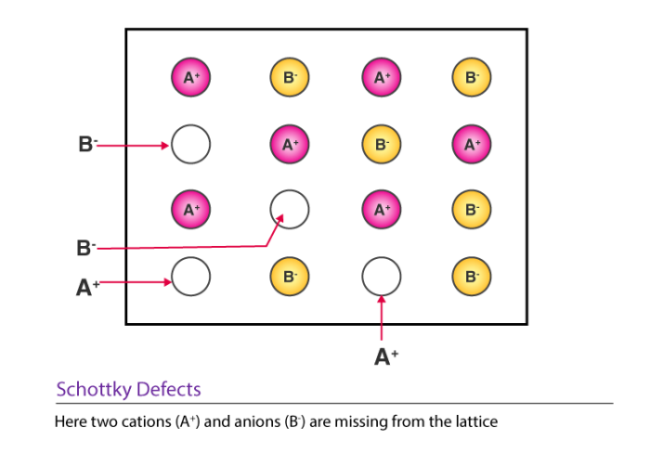
Schottky defect generally occurs in ionic compounds in which the radius ratio of cation and anion [r⁺/r–] is not far below unity. It is a kind of vacancy defect where an equal number of cations and anions are missing but maintain the neutrality of the crystal. The density of such type of crystal decreases. Due to the presence of ions this crystal can conduct electricity at a small extent. Examples:- NaCl , CsCl , KCl , AgBr etc.
Frenkel Defect
In this type of defect, some cations are missing from their lattice site and occupy the interstitial site of the lattice. This type of defect is shown by those substances which have low co-ordination number. The closeness of like charges tends to increase the dielectric constant of crystal.
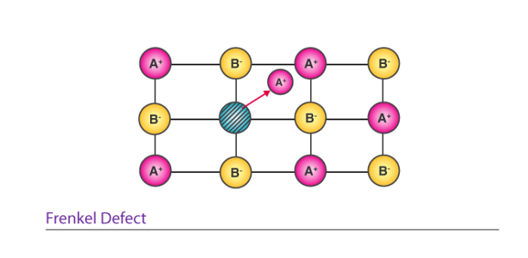
Frenkel defect is a kind of dislocation defect or interstitial defect in which the smaller ion generally cation dislocate from their position to occupy the interstitial site of the lattice or crystal. The density of these types of crystals remains the same because there is no movement of ion outside the crystal. This defect is exhibited in those ionic compound in which the radius ratio[r⁺/r–] is low. Example: ZnS , AgBr , AgI , AgCl
Note: AgBr shows both Frenkel and Schottky defect.
Impurity Defects
In the molten state, NACL contains a small amount of SrCl₂ in the form of impurity in the crystal. Due to the presence of SrCl₂ some site of Na+ ion is occupied by Sr²⁺. For maintaining the neutrality of the crystal one Sr²⁺ replaces two ions of Na+ and remaining one site of Na+ will be vacant. Example: CdCl₂ and AgCl.
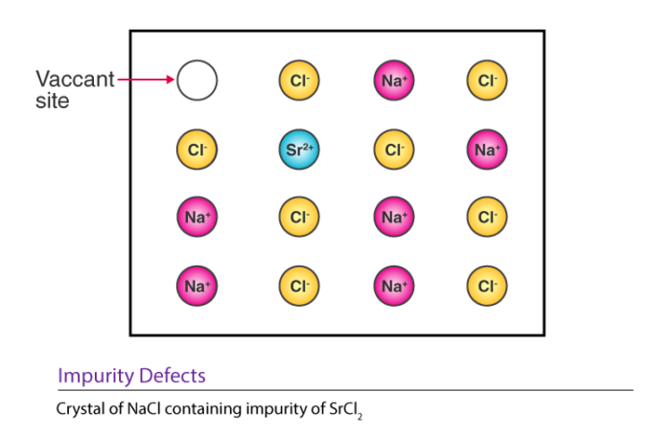Non- stoichiometric Defects
This defect is shown by compound of D block elements of the periodic table. These defects are classified as metal excess defects which are again of two types. They are as follows;
Metal excess defect due to anionic vacancy
When a compound having excess metal ion if an anion is absent from the lattice site there it creates a void while is there occupied by an electron. This type of defect is shown by alkali metal halides like NaCl, KCl, LiCl.
When alkali metal halides are heated in an atmosphere of vapour of the alkali metal, anion vacancies are created. This anion is then diffuse to the surface of the crystal and combine with newly generated metal cations. The electron is lost by the metal atom is then diffuses the crystal and occupy the anionic vacancy site and form F-centres inside the crystal. These F-centres give different colours like NaCl gives a yellow colour. KCl gives a violet colour and HCl gives pink colour.
Metal excess defect due to the presence of interstitial cation:
When an excess positive ion is located in the interstitial site. This type of defect is shown by ZnO. When ZnO is heated it loses oxygen reversibly. The excess Zn2+ ions are occupied in the interstitial sites for maintaining the neutrality, electrons are enclosed in the neighbouring interstitial sites. On heating, ZnO turns yellow colour by losing oxygen.
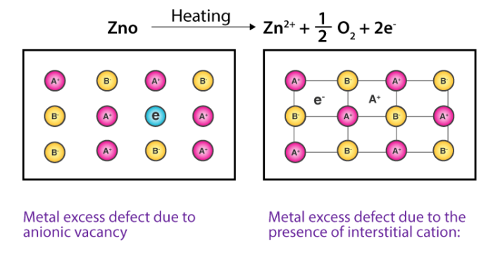
Metal Deficiency Defect
In this defect, some cations are missing from the lattice site and for maintaining its electrical neutrality another remaining cation increase their valency. For example, FeO which is found with a composition of Fe_{0.95} O. It may actually range from Fe_{0.93}O to Fe_{0.96}O.
In the crystal of FeO, some Fe²⁺ cations are missing and the loss of positive charge is made up by the presence of the required number of Fe⁺³ ions.
