Interview and survey on Thesis
In this class of thesis we required the survey and interview process on their selected thesis . From which later on selected and move to next stage. We basically want to know and check that the student should go and met with different people regarding their idea and how much the students seriously investigate their idea from the people , and some history related etc in audio form or visual form and written as well as a process and which will later on help in the making of thesis sculptures and in jury process

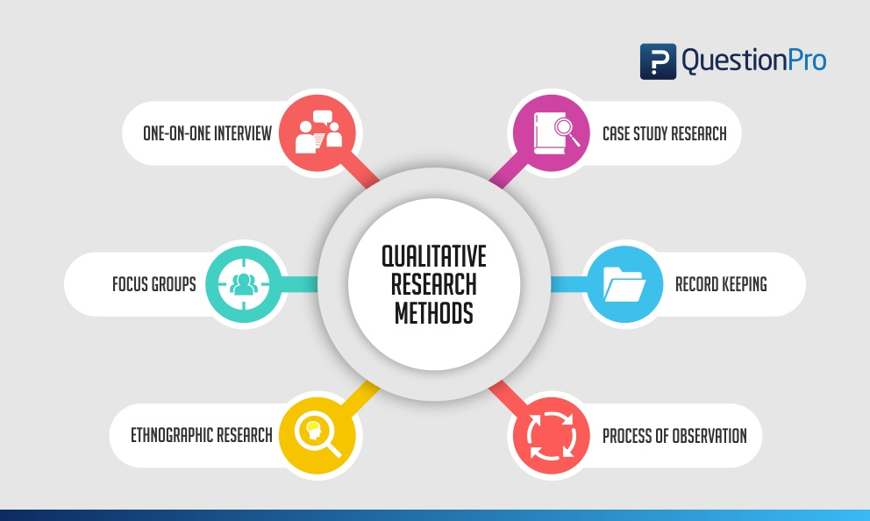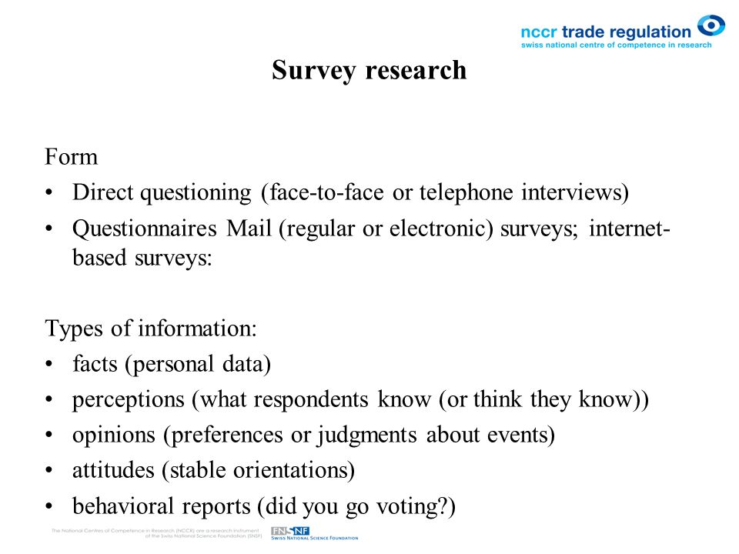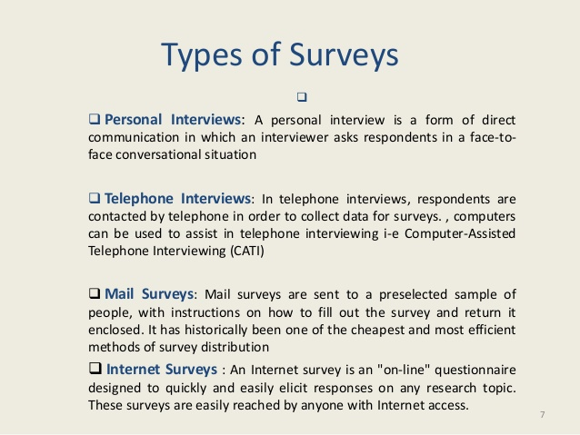

Qualitative Research Design 2019 – Definition & Techniques
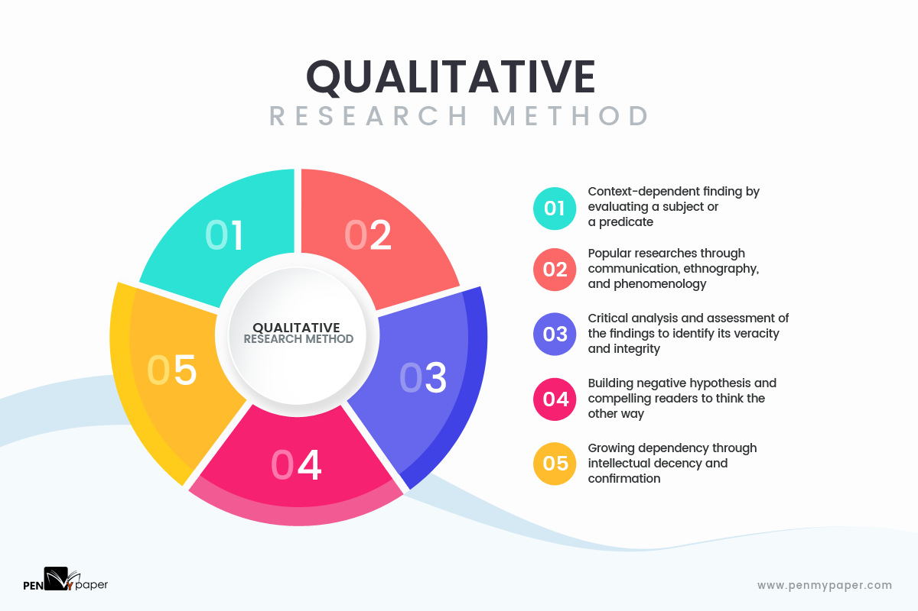May 17, 2019
“Recently, I submitted a paper that required qualitative researching. I was so unaware of the tools and techniques that I had no choice left than seeking expert assistance. Lucky that my consultant came up with something high-class!” – John Mayo, Harvard Business School (MBA)
The quoted text is from a management student, who had experienced the worst phases while executing qualitative research and failed fatally. That doesn’t mean the technique is tough, rather it conveys a message, asking the students to learn the research method. And, you are just at the place!
Here, you will be guided through all the nitty-gritty of qualitative research, starting from definition, classifications, to approach and tools. Know what differentiates academic writing and before another assignment comes up, take a close quick look at the details. Time to score better and rank higher.

Do you know what does qualitative research mean?
Sinking deeper naturally and gaining some realistic gen is termed as Qualitative research. Where else do you get to apprehend a social phenomenon, so well, that too in their natural backdrop! The qualitative practice is best known to give a true-to-life analyzing essence, where all the WHYs are answered but not the WHATs. Rather than embracing some factual answers, the qualitative system focuses on human beings and their palpable experiences. Through multi-stage inquiry, scholars squeeze out the sensible riposte from the interviewee. Knowledge is subjective, here.
Major focus areas aren’t only individuals in qualitative research, it also emphasizes societies, cultures, languages, and communications. This particular practice is mostly used to understand the meaning of people’s lives. Like, you may wish to know how and why an MBA people escaped to live his dream. In order to identify the transparency and authenticity in the responses, the researchers maintain a certain level of neutrality in the engagement. It actually preserves the trustworthiness and rigor in the relationship.

‘Qualitative research is science’ – truth or myth?
The aspect of “good science” can be maintained in qualitative research if conducted with a credible qualitative study. Professionals believe the practices used in this research shifts from the standard quantitative methods. So, the conventional belief of external and internal validity does not apply here. But there are distinct approaches that largely influences the integrity of qualitative information. Here, a list of related aspects has been mentioned; try to address them in your analysis.
- Milieu (backdrop): Qualitative findings are mostly context-dependent and that’s the cardinal principle of this methodology. A careful representation is essential to value the concerned situations, characters, and time
- Veracity (truth): To highlight the authenticity of the findings, a researcher must talk about his or her personal connections with the context and the participants. There’re three key activities that must be taken into account on this consideration – prolonged engagement, persistent observation, triangulation.
- Intellectual uprightness: Negative hypotheses are developed for retaining intellectual integrity in the paper. This doesn’t fit the prototype of a perfect research methodology, because here, negative evidence compels the audience to think other-way-round while believing the original and sensible data. Participant checks and Self-reflexive journals are two unique techniques used for challenging the bias.
- Transference: It is a rather analogous thought to the conventional quantitative method, where a database is provided with an insight that anyone wishes to make a transfer in their context of interest are always allowed.
- Confirmability: A peer reviewer or an auditor is appointed in qualitative research who evaluates the researching procedure, collected data, interpretations, and recommendations to ensure internal coherence and rationalism.
- Dependency: Reliance generates with the audit team as they assess and evaluate to affirm that all data are true and consistent.

Qualitative research practices: Tools & Techniques
For amateur researchers, a qualitative study is one methodology of analyzing and finding data. But the reality speaks of its multiple varieties. Each has a distinct style and approach to inquiry with a single motive of identifying the cause to an effect. Check the significant ones in the dropdown list.
- Phenomenological: This technique completely concerns to interviews, surveys, observations and more like that. The underlying purpose is to recognize the subject’s experience at/about a particular event in order to project your description of the event, phenomena or activity. Unlike others, you don’t have to write a strong hypothesis at the very beginning.
- Ethnography: Professionals consider this as the most significant qualitative research technique, and hence, it’s a familiar term among the scholars. Ethnography is the most critical method, as here, researchers fuses into the participant’s environment and remains engrossed, even for years, just to apprehend its culture, root, goal, motivation, and more.
- Narrative Model: You must have heard about storytelling, where byte by byte are weaved together to form something big and interesting. Well, this approach is exactly the same. In the narrative model, only one or two participants are inquired. The scholars conduct a self-research through books and other sources to collect data and create a cohesive story.
- Case Study: This is quite a popular technique in quantitative research, but a few years back, Harvard Business School introduced this in the qualitative system. It entails a deep understanding of a fact or an event or an entity through multiple sources and building up an explanation based on that assembled information.
- Grounded Theory: Particularly this technique is an extended leg of Phenomenological study. Where the later portray the essence of an event, the former is known to state the theory behind the activity. Primary interviews and globally-known documents are used in the process of building theories and hypothesis.

Critical qualitative topic? Seek help from mavens!
Students, like you, who are new and inexperienced, often, fail to identify the suitable technique to be followed in qualitative research. It happens when you aren’t quite affable with this holistic research practice. Consulting with PenMyPaper experts will certainly ease the task on your favor. Here, experts are exceptionally knowledgeable and have dealt with multiple projects in the past. Submit your requirements and get a high-quality research paper.

