What is Perspective?
Perspective is the way to draw three-dimensional objects on a two-dimensional surface by giving the right impression of their height, width, depth, and position in relation to each other.
In other words, perspective is a technique that simulates on a two-dimensional surface, such as a sheet of paper or a canvas, what the human eye sees.
Linear perspective is effective for representing parallel lines, such as walls of a room, buildings, a row of telephone poles, fences, etc. It is also used to add figures or objects when drawing.
Linear perspective is used to create what we see in a realistic way but it is also essential when drawing from imagination.
Atmospheric perspective refers to the effect of the atmosphere on far away objects and therefore it is used in landscape painting.

Linear Perspective
Each drawing that uses linear perspective will have a horizon line that may be visible or invisible in the final drawing.
In each linear perspective drawing or painting, there will be at least one vanishing point.
A vanishing point is a dot on the horizon line. Lines, which are parallel in reality, will meet in a vanishing point when drawn in perspective. To the human eye, although they are parallel, they seem to meet at a great distance.
The most common types of perspective are perspective with one vanishing point, two vanishing points and three vanishing points.

One-Point Perspective
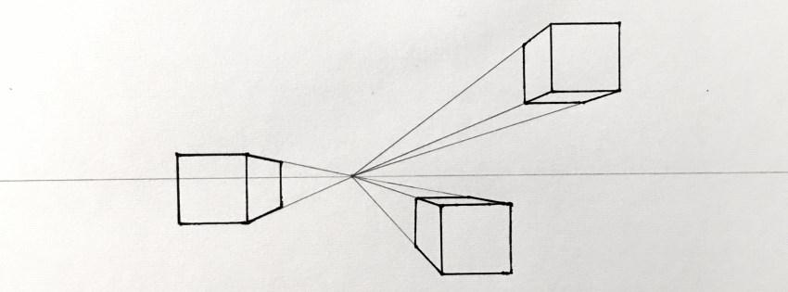 Boxes in 1-point perspective
One point perspective is used for drawing objects that are in front of the observer and in reality their width lines are parallel to the horizon and their height lines are perpendicular to the horizon (for example, a table in front of the observer).
Therefore:
- ALL lines representing HEIGHT will be parallel to each other and perpendicular to the horizon line.
- ALL lines representing WIDTH will be parallel to each other and to the horizon line.
- Lines that in reality are parallel and represent DEPTH will NOT be parallel when drawing; they will meet at the same vanishing point on the horizon.
Among other things, one point perspective is suitable for cases such as a wall or a building facing the observer or in cases where there are roads, railroad tracks, a row of electricity poles, fences, a corridor etc.

How to Start?
Start by drawing a horizon line and one vanishing point.
We only use the vanishing point, but having a horizon line helps as a guideline to draw other parallel width lines.
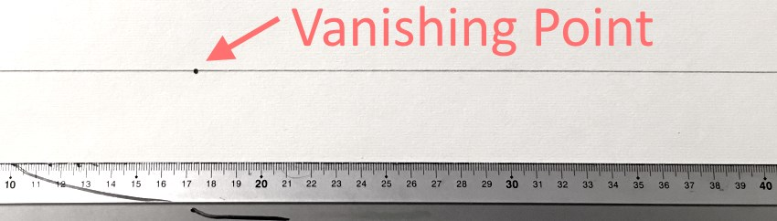
Next, draw a rectangle.
Remember:
In one point perspective, ALL width lines are parallel to the horizon and ALL height lines are perpendicular to the horizon.
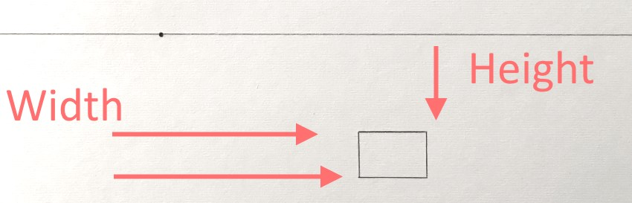
Now draw depth lines from the rectangle's vertices.
ALL depth lines will meet at the vanishing point:
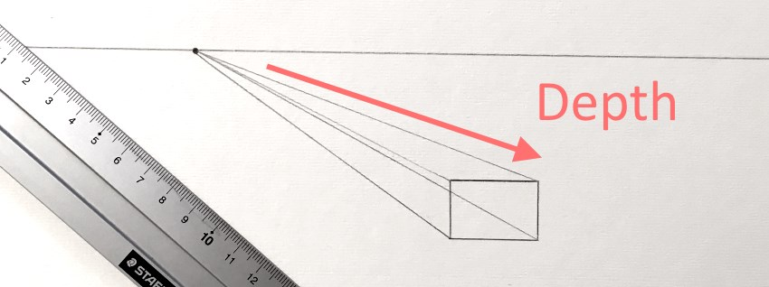
Finish drawing a box in perspective:
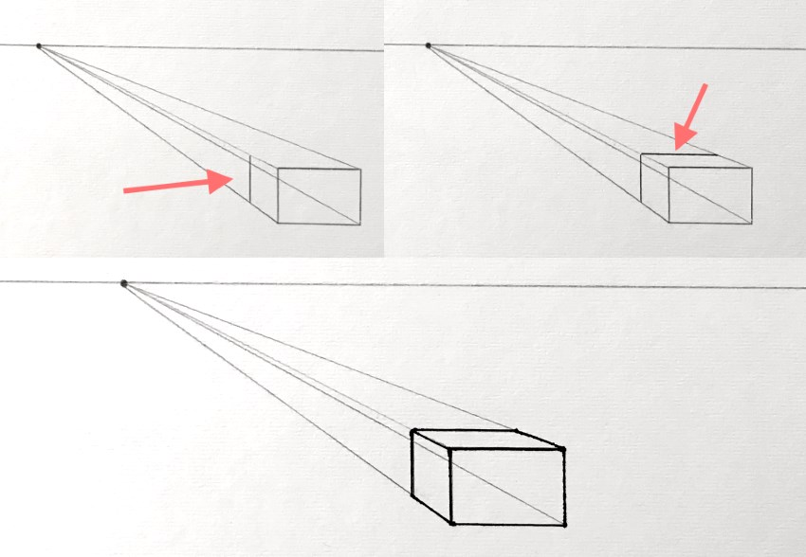
Exercise:
Create cubes and boxes above, on and below the horizon line. Draw more boxes, close to and far from the vanishing point to see different effects.
Exercise 2:
Try a more complicated object. A chair is a good candidate. Here is an example of a chair in one-point perspective and another in two-point perspective (which we will cover later):
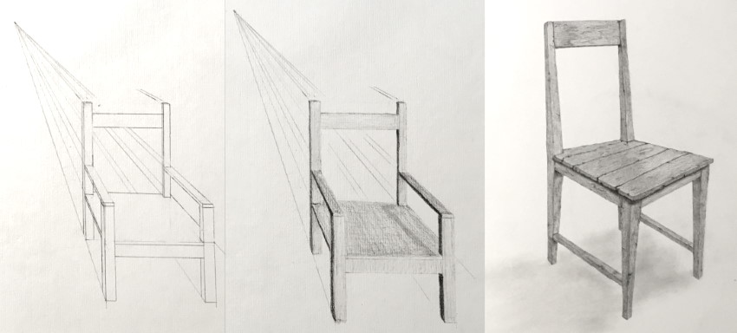
Good to know:
Objects above the horizon line will be objects we need to look up to see, like planes, birds etc.
Objects below the horizon line will be objects we see from above. For example, looking down from an airplane or a tall building. Or, just looking at objects on the floor, down at an angle.
Objects on the horizon, are when we are in front of the horizon line, but they can be higher on the horizon line, center to it or lower, depending on the angle we look at them:
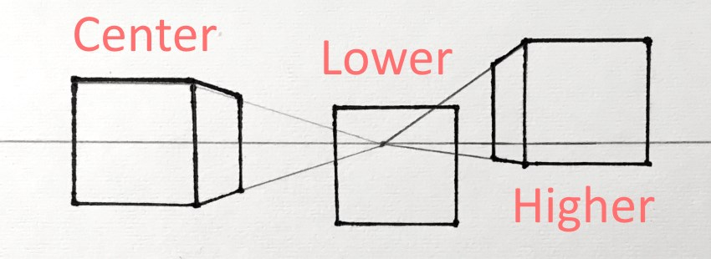

Where to Draw the Horizon Line?
When drawing or painting, the horizon-line's placement has a significant effect on the outcome.
Artists can use their "artistic license" to build different compositions with different horizon line placement.
In general:
- When the horizon line is at the center of the painting, it will translate as eye level when looking forward.
- When the horizon line is low on the drawing surface, it will usually look as if the viewer is looking above the horizon line, looking up.
- When the horizon line is high on the drawing surface, it translates as looking at an angle below the horizon line, looking down.
Different horizon line placements on my paintings:
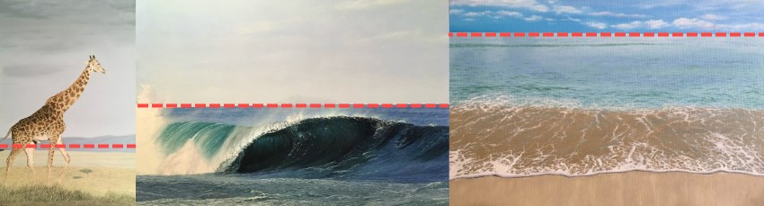

How to draw a Room in One-Point Perspective
Draw a horizon line with one vanishing point.
Then, draw a back wall (a rectangle).
Remember, all lines that in reality are parallel to the horizon line will be parallel to it in one point perspective.
Height line will be perpendicular to the horizon.
Depth lines, on the other hand, will be drawn from the vanishing point. So, we will create some lines to represent walls.
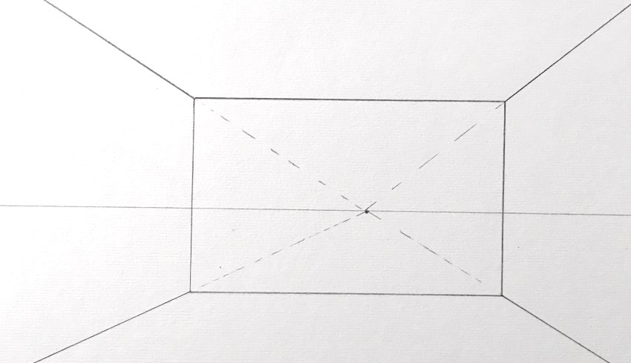
We can use the full size of the paper or, like in this case, we will border the front of the room.
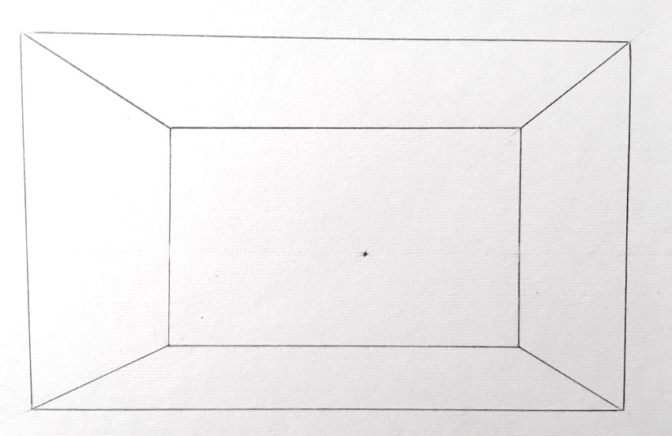
For a window, the height lines are perpendicular to the horizon and the depth lines are exiting from the vanishing point.
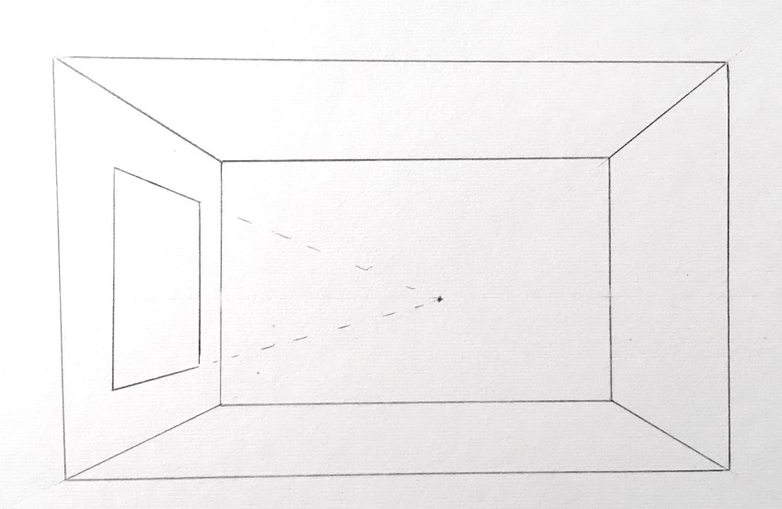
Drawing a cupboard is like drawing a box in perspective.
Start by creating the bottom plane (that way, the cupboard is on the floor and not hoovering). Then, build the back plane and complete the cupboard.
Remember to erase the lines that should not be seen in the final rendering.
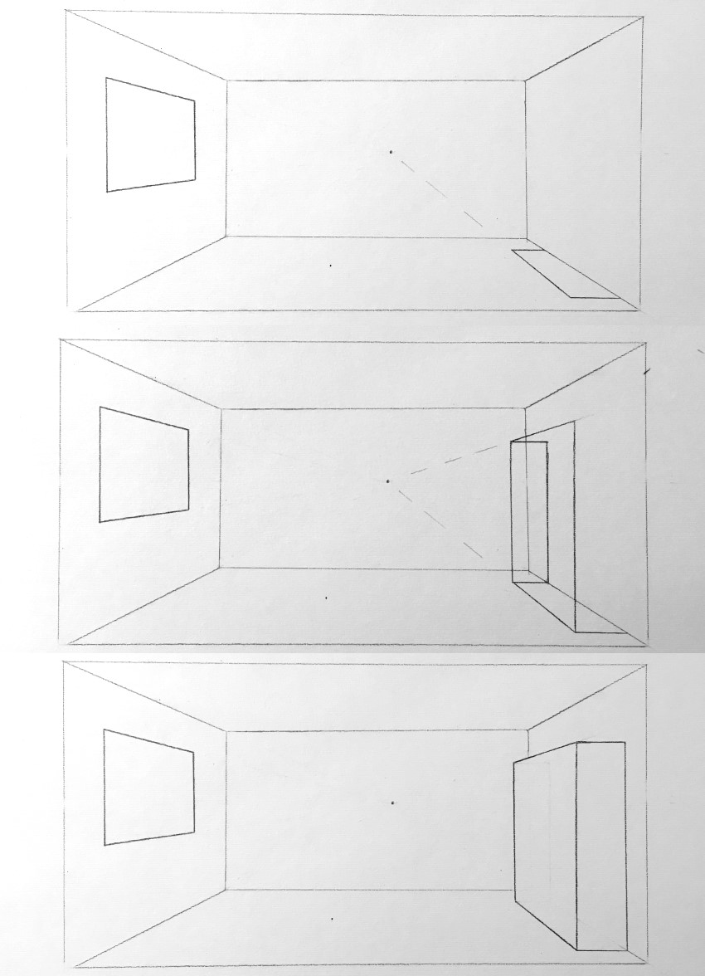
Exercise:
Create different rooms from imagination (like a kitchen, living room, bedroom, etc.) and fill them with furniture like a television set, pictures, bed, sound-system, refrigerator and so on.
Exercise 2:
Look at some reference images for a room and try to recreate it in one-point perspective.
Example for drawing stage:
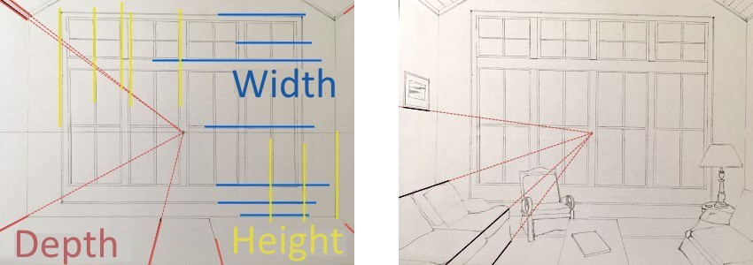
Result:
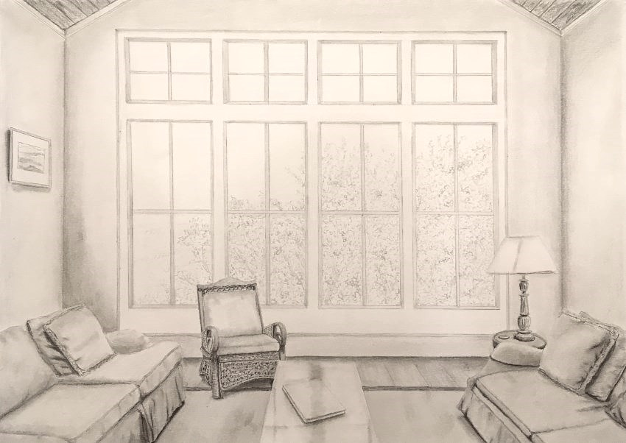
Important:
For a more realistic result (like in the example above), remove any traces of lines in the final render. There are no lines in nature!
More on that can be found on my guide for realistic drawing basics.
Keep in mind:
It is recommended to use drawing pencils and a ruler when drawing in linear perspective. A technical pen can also be used.
A list for my recommended drawing-pencils and supply: Pencil drawing supply review.
For recommended drawing pens, visit my technical pens review.
Tip:
In perspective drawing, there is an extensive usage of guidelines. These guidelines will not appear in the finished drawing. Therefore, it is advisable not to apply pressure to the drawing-pencil so that these lines can be easily erased later.
Remember:
When there are several objects at different angles in the space of the room, they may use different vanishing points.

How to Add Figures in Perspective
The horizon line will be at eye level.
Mountains or other objects might hide the horizon line. In that case, one can hold a brush or a pencil horizontally, in front of the eyes, in order to know where the horizon line is.
People of the same height as the observer, will be drawn when their eyes are on the horizon line.
People, who are taller or shorter than the observer, will be drawn when their eyes are slightly above or below the horizon.
Although the eyes of distant people will be on the horizon line, the people themselves will be smaller; therefore, their feet will be drawn higher on the drawing surface.
Finding the height of the first figure can be done by placing it near a doorway or any other object that the relation between it and the figure's height is known.
Finding the height of one figure in the painting will make it easy to find the height of the other figures in relation to it.
Figures of the same height and same distance from the observer, regardless of their position on the width axis, will be drawn in the same size.
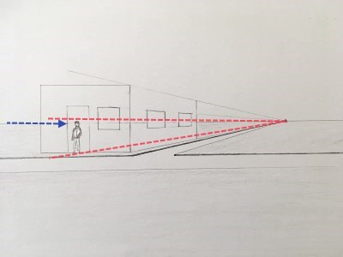 Eyes on the horizon line

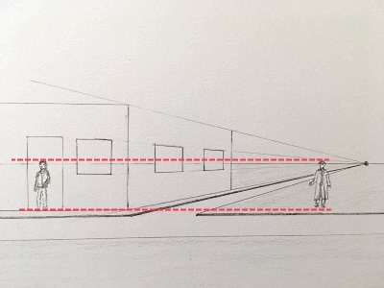 Horizontal guidelines
A figure of the same height but farther from the observer will be smaller in the painting.
Once finding the height of the far figure, by drawing lines from the vanishing point, it can be moved to the right or left using horizontal guidelines.
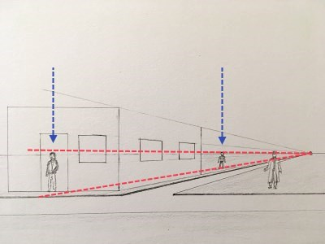 Finding the height of a figure

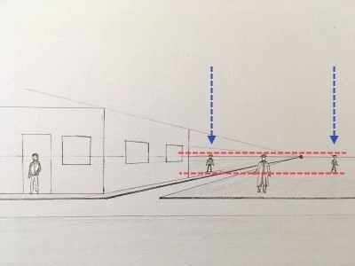 Moving figure to the right
Result:
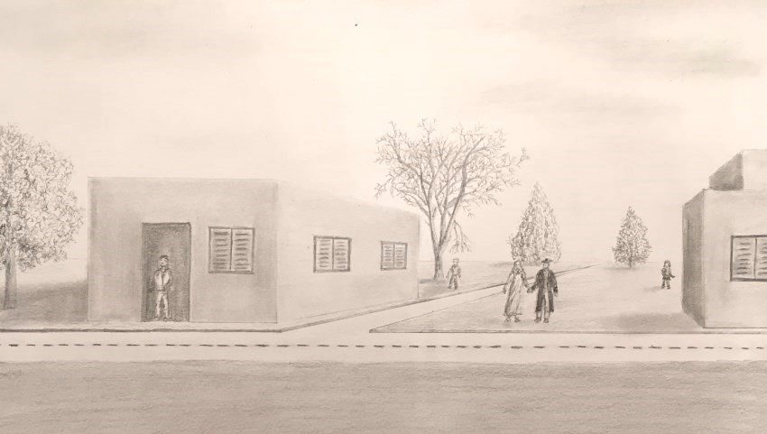 Street with figures in perspective

How to Find the Center of a Quadrilateral in Perspective
To find the center of ANY quadrilateral (square, rectangle, trapezoid...) in perspective, two diagonals from the vertices should be drawn.
The encounter between the two diagonals is the center.
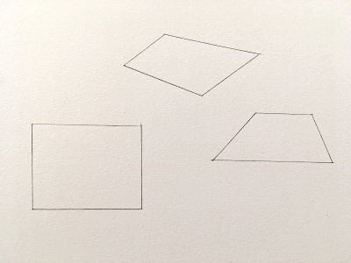 Quadrilaterals drawing

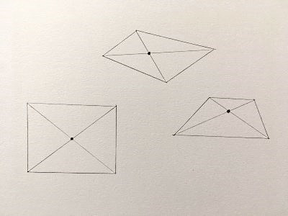 Finding the center
In one-point perspective, when there is a need for a row of poles such as lighting poles, telephone poles, fences and so on, they will be positioned within two lines from the vanishing point.
To draw the poles at an equal distance from each other, the nearest and furthest poles should be drawn first.
Then two diagonals are drawn between them. The point where the diagonals meet is the center point, which is the midpoint to add another pole in perspective.
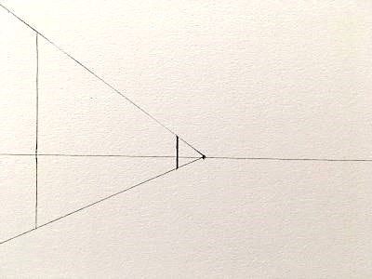 Near and far poles

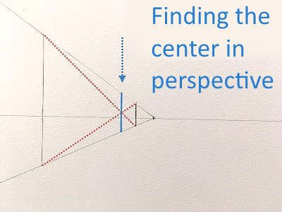 Finding the midpoint
After finding the midpoint for a new pole, two new quadrilaterals are created and two new midpoints for poles can be found and so on.
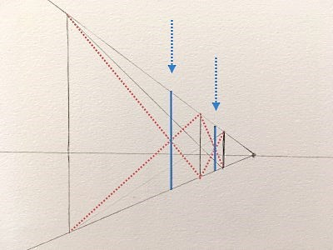 Adding poles

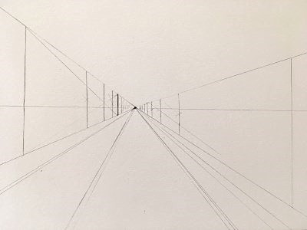 Continue drawing in perspective
Result:
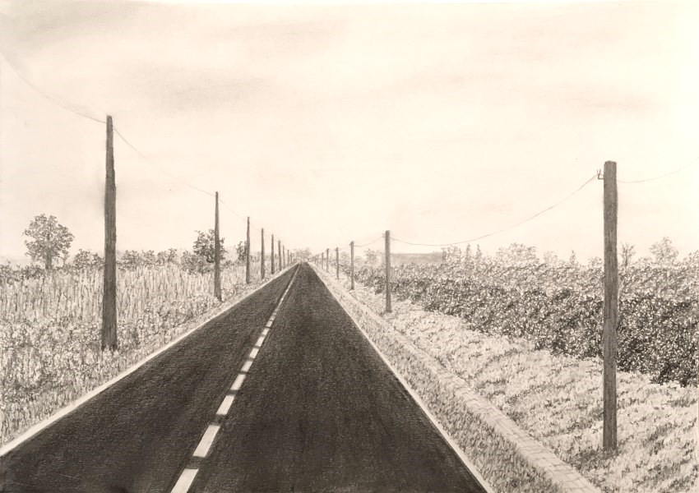 Road and telephone poles in perspective
Keep in mind:
The same process (of finding the midpoint) is used to find the midpoint of windows, window shutters, cupboard doors, drawer handles and so on.

How to draw tiles in perspective
As always in one-point perspective, a horizon line and a vanishing point are drawn.
Between two lines from the vanishing point, a rectangle (or square) in perspective is drawn.
Drawing two diagonals from the rectangle vertices to find its center point.
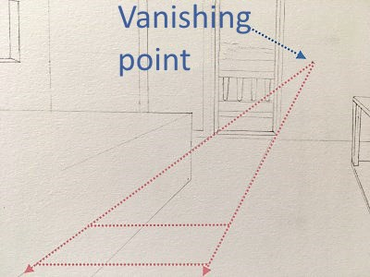 A rectangle in perspective

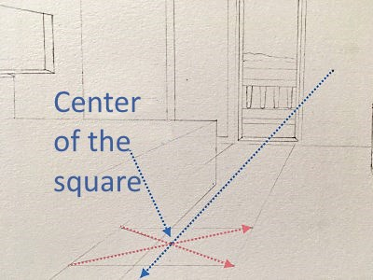 Finding the center point
From the vanishing point, a third line is drawn through the middle of the rectangle, which divides it into two equal rectangles.
Then, a line is drawn from one of the rectangle's vertices through the middle of its far side.
The place where this line meets with the continuation of the rectangle right side is the depth of the rectangle adjacent to it in perspective.
Continue in the same way until the column of tiles is completed.
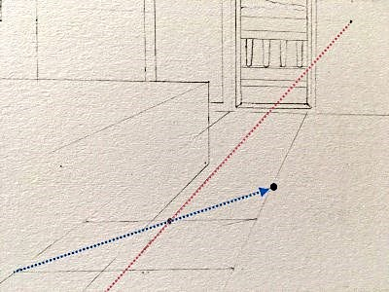 Finding next rectangle depth

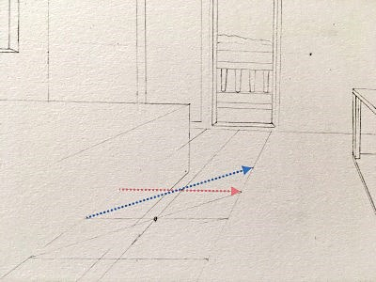 Finishing the column of tiles
In one-point perspective, the horizontal lines will not be affected by perspective and will be drawn parallel to the horizon.
Measuring the width of one tile with a ruler, no matter which one, can be used to mark the width of the tiles next to it, from the right and left sides, on the same horizontal line.
Through these points, lines from the vanishing point can be drawn, representing depth.
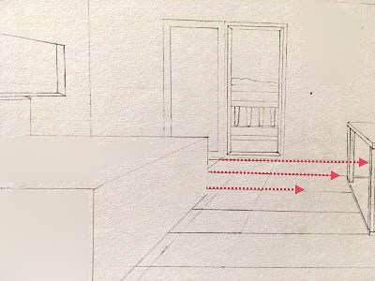 Drawing horizontal lines

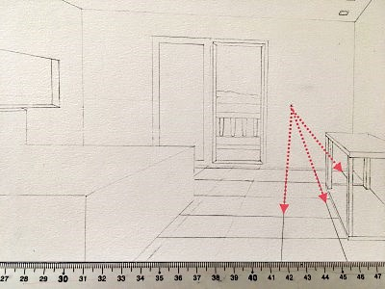 Adding depth lines
The door, in this case, has the width of two tiles.
Using the width of two tiles and the depth of two tiles as radius to figure out where the open door can be.
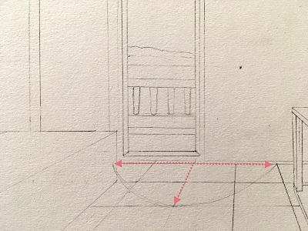 Two tiles as radius

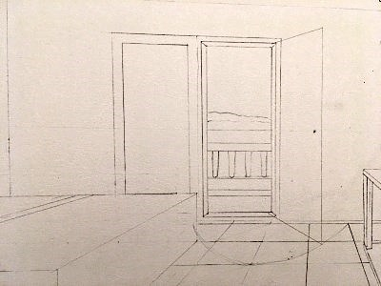 Choosing a door position
Result:
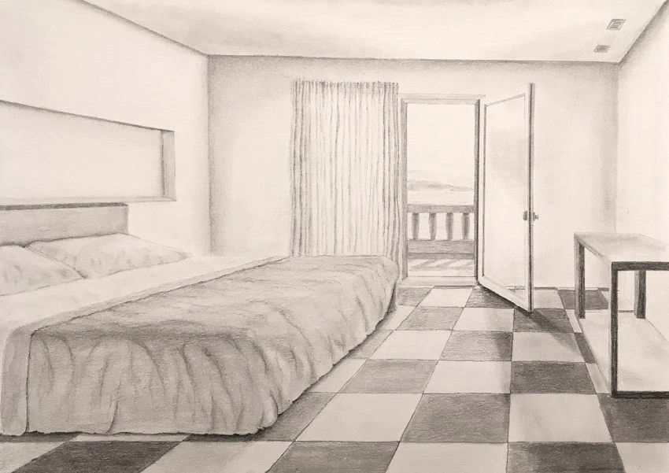 Tiles in perspective

