Most Common Grammar Mistakes
Understanding the 18 most common grammar mistakes can help you improve your writing. When you know which common grammatical errors to look for, it's easier to act as your own proofreader and editor.
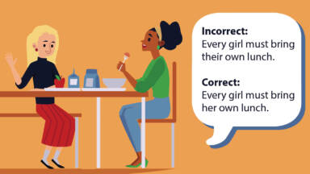
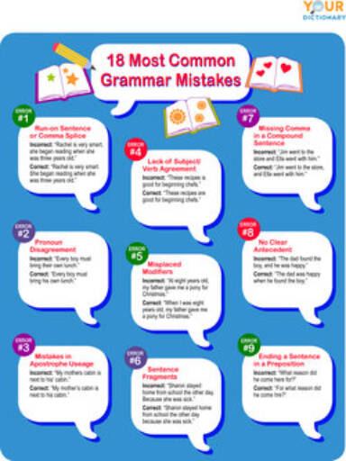

1. Run-on Sentence or Comma Splice
A run-on sentence is a sentence that joins two independent clauses without punctuation or the appropriate conjunction. A comma splice is similar to a run-on sentence, but it uses a comma to join two clauses that have no appropriate conjunction. Fixing a run-on sentence or a comma splice can be accomplished in one of five different ways.
Incorrect sentence: “Rachel is very smart, she began reading when she was three years old.”
- Solution 1: Separate the clauses into two sentences. “Rachel is very smart. She began reading when she was three years old.”
- Solution 2: Replace the comma with a semicolon. “Rachel is very smart; she began reading when she was three years old.”
- Solution 3: Replace the comma with a coordinating conjunction. “Rachel is very smart, for she began reading when she was three years old.”
- Solution 4: Replace the comma with a subordinating conjunction. “Rachel is very smart because she began reading when she was three years old.”
- Solution 5: Replace the comma with a semicolon and transitional word or phrase. “Rachel is very smart; as a result, she began reading when she was three years old.”

2. Pronoun Disagreement
Some of the most common grammar mistakes are pronoun errors. They occur when pronouns do not agree in number with the nouns to which they refer. If the noun is singular, the pronoun must be singular. If the noun is plural, the pronoun must be plural as well.
For example:
- Incorrect: “Every girl must bring their own lunch.”
- Correct: “Every girl must bring her own lunch.”
Pronoun errors are common in modern English, as writers try to avoid awkward phrasing or the implication of sexist language. Although this is an admirable goal, it is still important to learn the correct grammar and use it in more formal situations.

3. Mistakes in Apostrophe Usage
Apostrophes are used to show possession. However, you do not use an apostrophe after a possessive pronoun such as my, mine, our, ours, his, hers, its, their, or theirs.
For example:
- Incorrect: “My mothers cabin is next to his' cabin.”
- Correct: “My mother's cabin is next to his cabin.”
In the case of it's, the apostrophe is used only to indicate a contraction for “it is.”
For example:
- Incorrect: “Its a cold day for October.”
- Correct: “It's a cold day for October.”

4. Lack of Subject-Verb Agreement
Confusion over subject-verb agreement can be the source of many grammatical errors. When speaking or writing in the present tense, a sentence must have subjects and verbs that agree in number. If the subject is singular, the verb must be singular. If the subject is plural, the verb must be plural as well.
For example:
- Incorrect: “These recipes is good for beginning chefs.”
- Correct: “These recipes are good for beginning chefs.”

5. Misplaced Modifiers
To clearly communicate your ideas, you should place a modifier directly next to the word it is supposed to modify. The modifier should clearly refer to a specific word in the sentence. Misplaced modifiers can create confusion and ambiguity.
For example:
- Incorrect: “At eight years old, my father gave me a pony for Christmas.”
- Correct: “When I was eight years old, my father gave me a pony for Christmas.”

6. Sentence Fragments
Sentence fragments are also common grammar mistakes. A sentence needs to have a subject and a verb. A fragment often happens after another related idea has been expressed.
For example:
- Incorrect: “Sharon stayed home from school the other day. Because she was sick.”
- Correct: “Sharon stayed home from school the other day because she was sick.”

7. Missing Comma in a Compound Sentence
A compound sentence expresses two complete and related ideas, and it usually includes a conjunction to connect these two parts. There should be a comma before the conjunction to indicate the two ideas are related. If that’s missing, it’s a mistake readers will notice.
For example:
- Incorrect: “Jim went to the store and Ella went with him.”
- Correct: “Jim went to the store, and Ella went with him.”

8. No Clear Antecedent
An antecedent is a word that comes before a pronoun and helps the reader understand what the pronoun means. Generally, you can clear up this confusion by rearranging the wording.
For example:
- Incorrect: “The dad found the boy, and he was happy.”
- Correct: “The dad was happy when he found the boy.”

9. Ending a Sentence in a Preposition
Another common grammar mistake is ending a sentence with a preposition. A preposition, by its nature, indicates that another word will follow it. In casual conversation, this type of error is no big deal, but you should avoid this mistake in your writing.
For example:
- Incorrect: “What reason did he come here for?”
- Correct: “For what reason did he come here?”

10. Mixing Up Spellings
There are words that sound the same but have different spellings and meanings. If you mix these up, it can be an embarrassing mistake. These are a few of the most commonly confused words:
- “You’re” vs. “your”
- “To” vs. “two” vs. “too”
- “Weather” vs. “whether”
- “There” vs. “their”
For example:
- Incorrect: “There father went to school there.”
- Correct: “Their father went to school there.”

11. Mixing Up Similar Words
Sometimes, it’s not a matter of mixing up the spelling as much as an error in word choice. There are many words that sound similar but have different meanings and spellings. These include the following:
- “Affect” and “effect”
- “Except” and “accept”
- “Comprise” vs. “compose”
- “Further” vs. “farther”
For example:
- Incorrect: “The rain had a good affect on the farmer’s field.”
- Correct: “The rain had a good effect on the farmer’s field.”

12. Unnecessary Commas
While commas are important for clarity and give the reader a chance to pause in the sentence, it’s possible to use commas when you don’t need them. These unnecessary commas can be confusing to read, and they make writing look less professional. Before you use a comma, think about why you’re using it. If you aren’t sure it’s needed, double check by reviewing comma rules.
For example:
- Incorrect: “She had a stomach ache, because she ate too much ice cream.”
- Correct: “She had a stomach ache because she ate too much ice cream.”

13. Mixing Up Possessives and Plurals
People often get confused when adding an “s” to the end of a word. When do you need an apostrophe? In general, you use an apostrophe before an “s” to show possession or as a contraction, like “that’s” for “that is.” If you’re just trying to say something is plural, you don’t need the apostrophe. Like most rules in the English language, this has some variation. However, if you keep the general guidelines in mind, you’ll be correct most of the time.
For example:
- Incorrect: “The dogs dish was full of bone’s.”
- Correct: “The dog’s dish was full of bones.”

14. Mistakes With Well and Good
One of the most common grammatical errors is mixing up “well” and “good.” In general, “well” is an adverb, while “good” is an adjective. When you aren’t sure which one to use, simply ask yourself whether an adjective or an adverb is appropriate for the situation.
For example:
- Incorrect: “I am doing good in math.”
- Correct: “I am doing well in math.”

15. Comparisons That Are Incomplete
When you use a word that has a comparative aspect, you need to compare it to something else. These common grammatical errors may appear in advertisements or market slogans, but it does not work well in papers or other writing. If the word requires a comparison, you should always provide it.
For example:
- Incorrect: “My hair is smoother and softer.”
- Correct: “My hair is smoother and softer than it was a month ago.”

16. Mixing Up Adverbs and Adjectives
If you mix up adverbs and adjectives, this can be an embarrassing grammar mistake. This is the kind of error that can annoy a teacher or make the difference between a great grade on an essay and getting marked down. This happens most often with words that end in “-ly.”
For example:
- Incorrect: “Susan gave me a real nice bouquet of flowers.”
- Correct: “Susan gave me a really nice bouquet of flowers.”

17. Confusion Between Fewer and Less
Many people mix up “fewer” and “less.” If you’re talking about the amount of something, you need to decide whether the item is all one thing or a group of many things. If it’s a group of many smaller things, you should use “fewer.” If it’s one thing, you should use “less.”
For example:
- Incorrect: “The store was almost out of dog food. There were less cans on the shelves than there were yesterday.”
- Correct: “The store was almost out of dog food. There were fewer cans on the shelves than there were yesterday.”

18. Title Capitalization Problems
Knowing when to capitalize the words in a title can be very confusing. In general, you should capitalize the first and last words, all nouns and pronouns, all verbs, and all adjectives and adverbs. However, there are specific title capitalization rules depending on the style you are using.
For example:
- Incorrect: “Around the world in 80 days”
- Correct: “Around the World in 80 Days”

