- Definition
- History
- Objectives
- Ideal Properties
- Design
- Types
  - Stirred Tank Fermentor
  - Airlift Fermentor
  - Fluidized Bed Fermentors
  - Packed Bed Fermentor
  - Photo Fermentor

Definition of Fermentor
A Fermentor can define as a closed cylindrical vessel which supports the biochemical and chemical activity by the microorganisms to carry the conversion of raw material into a useful product.

History
Year of discovery | Name of the discoverer and their discovery
During 1914-15 | A fermentor was developed for the production of acetone by the scientist Chain Weizmann.
1930 | Large scale aerobic fermentor was developed.
1934 | In this year, aeration system, water and steam inlet flow was introduced in a fermentor by the scientists Strauch and Schmidt.
1944 | A fermentor was developed for the yeast production by the scientists De Beeze and Liebmann for the large scale production.
1950 | A fermentor was developed in India at Hindustan Antibiotic Ltd., Pune and named it as “Pilot fermentor”.

Objectives of Fermentor
The objectives include the production of metabolites, enzymes, microbial biomass and recombinant product.
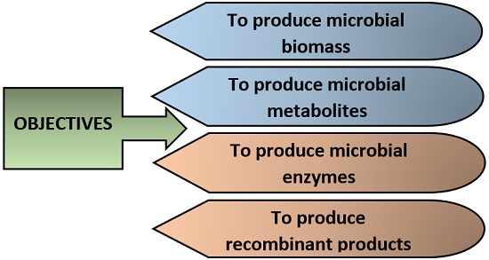

Ideal Properties of a fermentor
- A fermentor should be made of a good quality material that can withstand all the conditions inside the vessel.
- It should give high productivity.
- It should be able to handle the stream sterilization pressure.
- There should be all the control parameters that monitor the fermentation process like pH electrode, temperature probe etc.
- A material used in the fermentor should be cheap that could give satisfactory results.

Design of Fermentor
The basic design of fermentor includes:
- Basic elements
- Controlling elements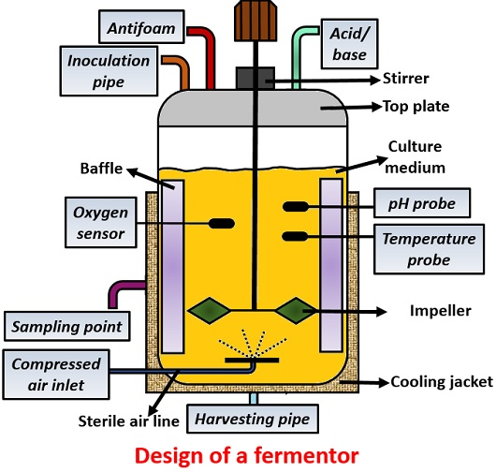

Basic Elements
Basic components are necessary for the construction of fermentor, which involves:
Top-plate: It is the cover that is generally made of stainless steel.
Inoculation pipe: Helps to port the inoculum inside the fermentor.
Drive motor: It drives the impeller shaft.
Impeller shaft: Holds the agitator centrally.
Impeller: Acts as an agitating device for mixing up the nutrients and microorganisms uniformly.
Stirrer: Mixes the gas bubbles throughout the liquid culture medium.
Baffle: Prevents the counterflow or vortex formation by breaking down the gas bubbles to improve aeration efficiency.
Sparger: It supplies oxygen into the culture medium through the perforated tubes.
Drain point: Withdraws cells or medium for the continuous fermentation.
Cooling jacket: It is fitted externally to the fermentation vessel which allows the passage of steam or cold water to balance the heat generated during the process.

Controlling Elements
Controlling elements contain elements that monitor the parameters that are necessary for product formation like (temperature, pH, acid, bases, oxygen supply, pressure etc.) which includes:
Pt-100: Monitors the temperature in the culture vessel.
Foam probe: It senses foam formation.
pH electrode: Monitors the pH in the culture vessel.
Oxygen sensor: Maintains the dissolved oxygen content level.
Heating pad: Provides heat to the medium.
Cold finger: It is a pipe that passes cold water inside a vessel to cool the contents.
Rotameter: Provides variable airflow into the culture vessel.
Pressure valve: Maintains the pressure.
Air pump: Supplies air throughout the medium.
Peristaltic pump: It pumps acid, base and antifoam into the medium.

Basic functions of a fermentor
- It should be reliable for long-term operation.
- A fermentor should be capable of being operated aseptically or should provide sterile conditions.
- The bioreactor provides adequate aeration and agitation for uniform mixing of the contents in the vessel.
- It should consume less power.
- A fermentor equipped with controlling probes that maintain the temperature, pH, oxygen level etc.
- It facilitates the passage of inoculum and media into the vessel.
- A bioreactor does not allow excessive evaporation loss.
- It minimizes the labour input for the operation, harvesting, cleaning and maintenance.

Types of Fermentor
A fermentor is mainly of 5 types, which includes:
- Stirred tank fermentor
- Airlift fermentor
- Fluidised bed fermentor
- Packed bed fermentor
- Photo fermentor
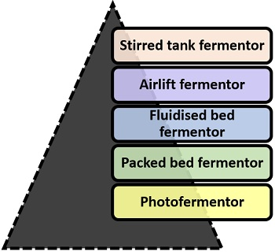

Stirred Tank Fermentor
It consists of:
- Motor driveshaft
- A variable number of impellers (more than one): The impellers have a 1/3rd diameter of the vessel.
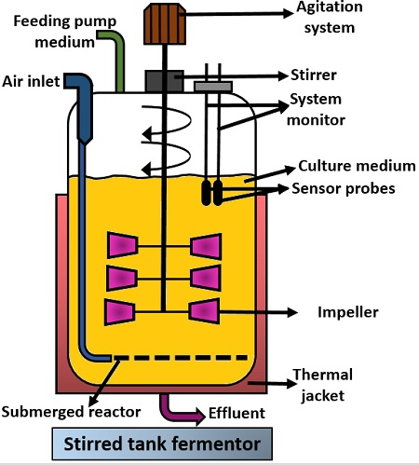
The height and diameter ratio of this bioreactor is between 3:5. Air passes into the culture medium through a single orifice from the tube attached externally. It enables better distribution of the contents throughout the vessel. Its basic functions include:
- Homogenization
- Suspension of solid material
- Aeration to the medium
- Heat exchange
In stirred tank fermentor, rotating stirrer and baffle found either at the top or the bottom. It mainly uses the batch process or fermentation.
Advantages:
- Easy to operate
- There is good temperature control
- Its construction is quite simple
- There is a low operating cost
- Easy to clean
- Don’t cause shear damage to the cells.
Disadvantages:
- Cannot use for immobilized cells or enzymes.
- It has low volumetric productivity.

Airlift Fermentor
It consists of a single container inside which a hollow tube is present. This hollow tube refers to “Draft tube”. There is a gas flow inlet present at the bottom of the fermentor allows the passage of oxygen. Gas flow inlet is attached with the perforated disc or tube that allows continuous distribution of air.
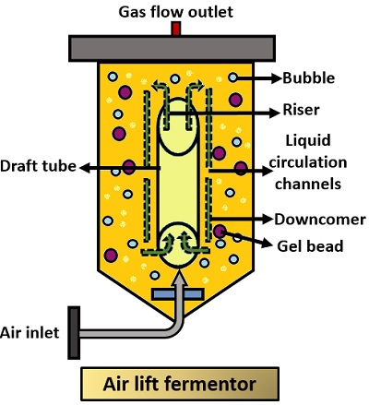
This type of bioreactor lacks the mechanical stirring arrangements for agitation. As from the name Airlift, it is clear that the airlifts the medium upwards. In this, there are internal liquid circulation channels which enable continuous circulatory motion of the medium. In this fermentation occurs at a fixed rate of volume and circulation.
Advantages:
- It ensures adequate mixing.
- Consumes less energy.
- It favours the growth of aerobic cultures.
- Construction is simple.
- It can use both free and immobilized cells and enzymes.
- Widely uses in SCP production.
- Avoids excessive heat generation.
Disadvantages:
- Mechanical stirring arrangements are absent.

Fluidized Bed Fermentor
The top portion of this bioreactor is more expanded. This expansion reduces the velocity of the fluid. Its bottom part is slightly narrow.
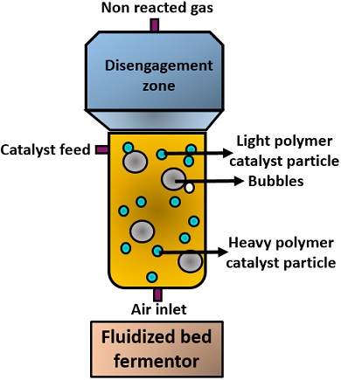
It designs in such a way where:
- Solid retains inside the vessel
- And, liquid flows out.
An adequate amount of gas introduces into the medium to form a suitable gas-liquid-solid fluidised bed. By using this kind of biofermentor one should note that the suspended particles should not be too light or too heavy and secondly, there should be continuous recycling of the medium for good bioprocessing.
Advantages:
- Mixes the contents uniformly
- Maintains the uniform temperature gradient
- It can be used for continuous operation
- Produces higher volumetric productivity.
- There is little or no clogging of particles.

Packed Bed Fermentor
It consists of:
- A cylindrical vessel
- Bed of solid matrix packed with biocatalysts
The solid matrix used for packed bed fermentor is generally:
- Porous or non-porous
- Highly compressible
- Rigid
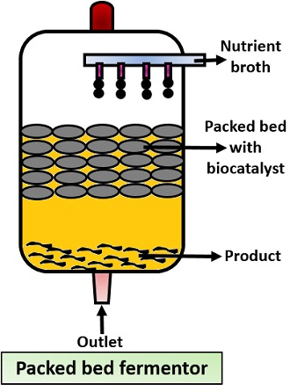
In this kind of biofermentor, a nutrient broth continuously flows over the immobilized biocatalyst. After that, a product releases into the fluid at the bottom of the culture vessel and finally removed. In this bioreactor, a flow of fluid can be upward and downward.
Advantages:
- Low operation cost
- Can be operated continuously
- Separation of the biocatalyst is easy
- It is widely used in wastewater engineering.
Disadvantages:
- There are undesired heat gradients
- Poor temperature control
- There is an alternation in the bed porosity
- Involves higher risk of particles clogging.

Photo Fermentor
This fermentor works under the principle of light energy that involves direct exposure to the sunlight or through some artificial illumination. It uses widely for the production of p-Carotene, astaxanthin etc.
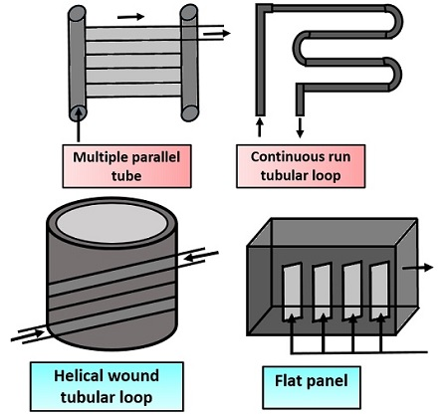
This type of bioreactor is basically made of glass or plastic. Photo fermentor consists of:
- A single container
- Number of tubes or panels
Tubes act as “Solar light receivers or trappers”. In this, culture transfers through solar trappers with the help of a centrifugal pump. Inside photo fermentor, adequate penetration of sunlight is maintained and after that, it is cooled when there is a rise in temperature. In this kind of biofermentor, the microorganisms used are microalgae and cyanobacteria. These microorganisms grow in the presence of solar light and then product forms during the night.
Advantages:
- Gives higher productivity
- Provides large surface and volume ratio
- There is better control of gas transfer
- Provides uniform temperature gradient.
Disadvantages:
- Expensive method to carry out
- There is technical difficulty in the process of sterilization.
A bioreactor or fermentor means bio: living organisms and reactor: which gives energy. Therefore it simply refers to the culture vessel where microorganisms utilize all the nutrients under optimum conditions inside a bioreactor. It performs bioconversion or modification of a compound into a biological and biochemical compound like antibiotics, enzymes, SCPs etc.

