Radio:
You might think "radio" is a gadget you listen to, but it also means something else. Radio means sending energy with waves. In other words, it's a method of transmitting electrical energy from one place to another without using any kind of direct, wired connection. That's why it's often called wireless. The equipment that sends out a radio wave is known as a transmitter; the radio wave sent by a transmitter whizzes through the air—maybe from one side of the world to the other—and completes its journey when it reaches a second piece of equipment called a receiver.
When you extend the antenna (aerial) on a radio receiver, it snatches some of the electromagnetic energy passing by. Tune the radio into a station and an electronic circuit inside the radio selects only the program you want from all those that are broadcasting.
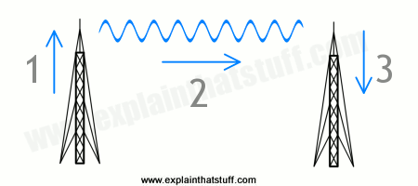
Artwork: How radio waves travel from a transmitter to a receiver. 1) Electrons rush up and down the transmitter, shooting out radio waves. 2) The radio waves travel through the air at the speed of light. 3) When the radio waves hit a receiver, they make electrons vibrate inside it, recreating the original signal. This process can happen between one powerful transmitter and many receivers—which is why thousands or millions of people can pick up the same radio signal at the same time.
How does this happen? The electromagnetic energy, which is a mixture of electricity and magnetism, travels past you in waves like those on the surface of the ocean. These are called radio waves. Like ocean waves, radio waves have a certain speed, length, and frequency. The speed is simply how fast the wave travels between two places. The wavelength is the distance between one crest (wave peak) and the next, while the frequency is the number of waves that arrive each second. Frequency is measured with a unit called hertz, so if seven waves arrive in a second, we call that seven hertz (7 Hz). If you've ever watched ocean waves rolling in to the beach, you'll know they travel with a speed of maybe one meter (three feet) per second or so. The wavelength of ocean waves tends to be tens of meters or feet, and the frequency is about one wave every few seconds.
When your radio sits on a bookshelf trying to catch waves coming into your home, it's a bit like you standing by the beach watching the breakers rolling in. Radio waves are much faster, longer, and more frequent than ocean waves, however. Their wavelength is typically hundreds of meters—so that's the distance between one wave crest and the next. But their frequency can be in the millions of hertz—so millions of these waves arrive each second. If the waves are hundreds of meters long, how can millions of them arrive so often? It's simple. Radio waves travel unbelievably fast—at the speed of light (300,000 km or 186,000 miles per second).
Television (TV):
The basic idea of television is "radio with pictures." In other words, where radio transmits a sound signal (the information being broadcast) through the air, television sends a picture signal as well. You probably know that these signals are carried by radio waves, invisible patterns of electricity and magnetism that race through the air at the speed of light (300,000 km or 186,000 miles per second). Think of the radio waves carrying information like the waves on the sea carrying surfers: the waves themselves aren't the information: the information surfs on top of the waves.
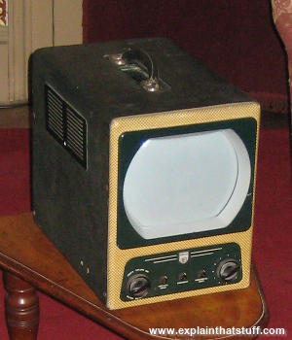
Photo: As radios became more portable, people started to realize tiny TVs could be too. This early example is an Ekco TMB272 from about 1955, which could be powered either by the usual domestic electricity supply or a 12-volt battery. Although sold as a portable, it was extremely heavy; even so, it found quite a niche market with TV companies such as the BBC, who used it as a monitor for outside broadcasts.
Television is really a three-part invention: the TV camera that turns a picture and sound into a signal; the TV transmitter that sends the signal through the air; and the TV receiver (the TV set in your home) that captures the signal and turns it back into picture and sound. TV creates moving pictures by repeatedly capturing still pictures and presenting these frames to your eyes so quickly that they seem to be moving. Think of TV as an electronic flick-book. The images are flickering on the screen so fast that they fuse together in your brain to make a moving picture (really, though they're really lots of still pictures displayed one after another).
When TV was first developed, all it could handle was black-and-white pictures; engineers struggled to figure out how to cope with color as well, which was a much more complex problem. Now the science of light tells us that any color can be made by combining a mixture of the three primary colors, red, green, and blue. So the secret of making color TV was to develop cameras that could capture separate red, green, and blue signals, transmission systems that could beam color signals through the air, and TV sets that could turn them back into a moving, multicolored image.
Telephone:
A telephone is not just the thing that sits on your table at home. It's a complete system: the handset at your end, the cable that runs into the wall, a whole collection of communication apparatus (copper cables, fiber-optics, microwave towers, and satellites) that carries telephone signals across country, some switching apparatus that makes sure calls get to the right place and a handset at the other end.
Let's think about a typical phone handset. At the top, there's a loudspeaker you press against your ear. At the bottom, there's a microphone you put near your mouth. Coming out of the handset, wrapped inside a single thick, coiled cable, are two pairs of copper wires. One pair is an output: it takes outgoing electrical signals from the microphone to the telephone system; the other pair is an input: it takes incoming signals from the telephone system to the loudspeaker.
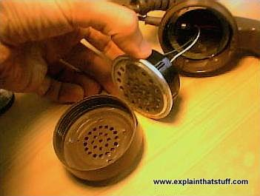
Photo: You can see the microphone really clearly when I unscrew the mouthpiece of this antique telephone. Note that the microphone is connected by just two wires: one carries electricity into the microphone; the other carries it back out again.
The loudspeaker and microphone work in similar but opposite ways. The microphone contains a flexible piece of plastic called a diaphragm with an iron coil attached to it and a magnet nearby. When you speak into the mouthpiece, the sound energy in your voice makes the diaphragm vibrate, moving the coil nearer to or further from the magnet. This generates an electric current in the coil that corresponds to the sound of your voice: if you talk loud, a big current is generated; if you talk softly, the current is smaller. You can think of a microphone as an energy converting device: it turns the sound energy in your voice into electrical energy. Something that converts energy from one form to another is called a transducer. The loudspeaker in a phone works in the opposite way: it takes an incoming electrical current and uses magnetism to convert the electrical energy back into sound energy you can hear. In some phones, the loudspeaker and microphone units are virtually identical, just wired up in opposite ways.
Camera:
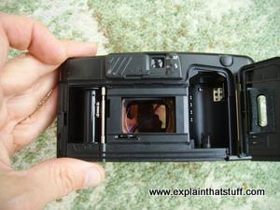
Photo: An old-style film camera from the late 1980s. The film loads in a spool on the right and winds across to another spool on the left, passing in front of the lens on the way. When you take a photo, the shutter lets light enter from the lens and expose the film. It's all very 19th-century compared to digital photography!
If you have an old-style camera, you'll know that it's useless without one vital piece of equipment: a film. A film is a long spool of flexible plastic coated with special chemicals (based on compounds of silver) that are sensitive to light. To stop light spoiling the film, it is wrapped up inside a tough, light-proof plastic cylinder—the thing you put in your camera.
When you want to take a photograph with a film camera, you have to press a button. This operates a mechanism called the shutter, which makes a hole (the aperture) open briefly at the front of the camera, allowing light to enter through the lens (a thick piece of glass or plastic mounted on the front). The light causes reactions to take place in the chemicals on the film, thus storing the picture in front of you.
This isn't quite the end of the process, however. When the film is full, you have to take it to a drugstore (chemist's) to have it developed. Usually, this involves placing the film into a huge automated developing machine. The machine opens up the film container, pulls out the film, and dips it in various other chemicals to make your photos appear. This process turns the film into a series of "negative" pictures—ghostly reverse versions of what you actually saw. In a negative, the black areas look light and vice-versa and all the colors look weird too because the negative stores them as their opposites. Once the machine has made the negatives, it uses them to make prints (finished versions) of your photos.
If you want to take only one or two photographs, all of this can be a bit of a nuisance. Most people have found themselves wasting photographs simply to "finish off the film." Often, you have to wait several days for your film to be developed and your prints (the finished photographs) returned to you. It's no wonder that digital photography has become very popular—because it solves all these problems at a stroke.

How digital cameras work
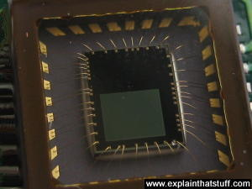
Photo: A typical image sensor. The green rectangle in the center (about the size of a fingernail) is the light-sensitive part; the gold wires coming off it connect it into the camera circuit.
Digital cameras look very much like ordinary film cameras but they work in a completely different way. When you press the button to take a photograph with a digital camera, an aperture opens at the front of the camera and light streams in through the lens. So far, it's just the same as a film camera. From this point on, however, everything is different. There is no film in a digital camera. Instead, there is a piece of electronic equipment that captures the incoming light rays and turns them into electrical signals. This light detector is one of two types, either a charge-coupled device (CCD) or a CMOS image sensor.
If you've ever looked at a television screen close up, you will have noticed that the picture is made up of millions of tiny colored dots or squares called pixels. Laptop LCD computer screens also make up their images using pixels, although they are often much too small to see. In a television or computer screen, electronic equipment switches all these colored pixels on and off very quickly. Light from the screen travels out to your eyes and your brain is fooled into see a large, moving picture.
In a digital camera, exactly the opposite happens. Light from the thing you are photographing zooms into the camera lens. This incoming "picture" hits the image sensor chip, which breaks it up into millions of pixels. The sensor measures the color and brightness of each pixel and stores it as a number. Your digital photograph is effectively an enormously long string of numbers describing the exact details of each pixel it contains. You can read more about how an image sensor produces a digital picture in our article on webcams.

