Experiment No#7
Objective:
To calculate the energy losses in bends and pipe fittings.
Theory:
Introduction
Energy losses in pipe flows are the result of friction between the fluid and the pipe walls and internal friction between fluid particles.
Minor (secondary) head losses occur at any location in a pipe system where streamlines are not straight! such as at pipe junctions, bends, valves, contractions, expansions and reservoir inlets and outlets. In this experiment! you will measure minor head losses through a pipe section that has several bends, transitions! and fittings as shown in figure

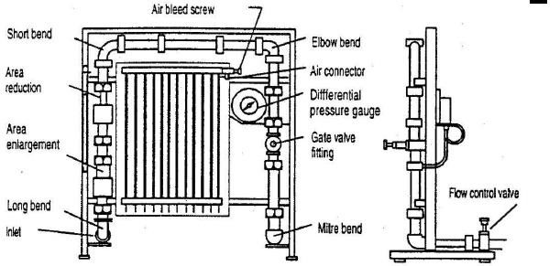

The energy balance between two points in a pipe can be described by the Bernoulli equation, given by,
𝑝1 𝑉12 𝑝2 𝑉22
+𝑧₁ + = +𝑧₂ ++ℎ_{𝐿}
𝛾 2𝑔 𝛾 2𝑔
where p_{i} is static pressure (in Pa), at point i, γ is specific weight of the fluid (in N/m³), z_{i} is the elevation (in meters), of point i, V_{i} is the fluid velocity (in m/s), at point i, g is the gravitational constant (in m/s²), and h_{L} is head loss (in meters), The term ^{𝑝𝑖} is referred to as the static head; z_{i} is the elevation head; and
𝛾
𝑉𝑖 𝑝𝑖
2𝑔 is the dynamic (or velocity), head. The summation of the static head and the elevation head, 𝛾 +𝑧𝑖 is referred to as the piezometric head.
The piezometric head is what is measured with the piezometer (manometer) board on the apparatus for this experiment.

Head loss, h_{L,} includes the sum of pipe friction losses, h_{f} and all minor losses.
ℎ_{𝐿} = ℎ_{𝑓} + ∑ ℎ_{𝑖}
𝑖=1,2,…𝑛
where h_{i} is the minor head loss (in meters) for the i^{th} component and
n is the number of components (fittings, bends, etc.). Pipe friction losses are expressed as the Darcy
Wisbech equation given by
𝐿 𝑉²
ℎ_{𝑓} = 𝑓
𝐷2𝑔
where f is a friction factor, L is the pipe length, and x is the pipe diameter. Pipe friction losses are assumed to be negligible in this experiment. Minor losses occur at any bend, transition, or fitting where the streamlines are not straight and are proportional to the #velocity head. for all components, head loss is given by
𝑉2
ℎ_{𝑖} = 𝐾_{𝑖}
2𝑔
where K_{i} is the loss coefficient (dimensionless) for the i^{th} component and
V is the fluid velocity as it travels through the pipe component. For the expansion and contraction, the V used in the above equation h_{i} is the velocity of the fluid in the smaller-diameter pipe.
Apparatus:
- Armfield Hydraulics Bench with Energy Losses apparatus
- Stopwatch
Procedure

Observations:
Sr# | Volume  (liter) | Time  (sec) | Flow rate  (m³/sec) | H₁  (m) | H2  (m) | H3  (m) | H4  (m) | H5  (m) | H6  (m) | H7  (m) | H8  (m)
1
2

Calculations:
Sr.# | Flow  Rate  (m³/s) | Velocity in small pipe  (m/s) | Velocity  Head  (m) |  | Difference Piezometer Head
 |  |  |  | 90º  Elbow  (H₁H₂) | 45º  Elbow  (H₃H₄) | Sudden enlargement  (H₅-H₆) | Sudden contraction  (H₆-H₇) | 90^{O} bend  (H₇-H₈)
1
2

Conclusion:

