Illustrate the historical character Mullah Nasruddin?

"Character Design Illustration"

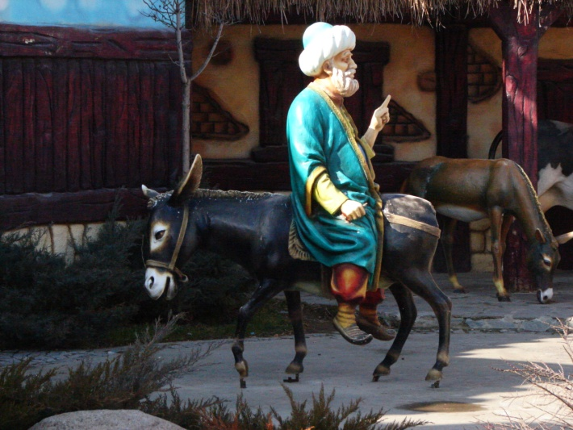

Mullah Nasruddin

In a small town somewhere in the Middle East lived Mulla Nasruddin, who was famous for being a bit funny.He reacted to the foolishness of his fellow men and to the challenges of daily life in a manner that people found strange. But most wise men agreed that under this foolishness was a keen perception that directs to the truth.

Illustrate or design a character of Mullah Nasrrudin by hand (manual) or by computer (Photoshop or Illustrator) follow by any style or technique (traditional and untraditional like caricature or cartoon).

Main principles of character design should be in consideration are outlined below:
- Read about the biography of the character in detail.
- First of all sketch your character with simple lines after the brainstorming about character personality.
- Create concept art after detailed understanding about your character personality.
- After approving concept art, finally, finish your character in full color design.

