T lymphocytes
T cells derive their letter designation from their site of maturation in the thymus. Like the B cell, the T cell expresses a unique antigen-binding receptor called the T-cell receptor. T-cell receptors only recognize processed pieces of antigen (typically peptides) bound to cell membrane proteins called major histocompatibility complex (MHC) molecules.
Major Histocompatibility Complex
The ability of MHC molecules to form complexes with antigen allows cells to decorate their surfaces with internal (foreign and self) proteins, exposing them to browsing T cells. MHC comes in two versions: class I MHC molecules, which are expressed by nearly all nucleated cells of vertebrate species, and class II MHC molecules, which are expressed by professional antigen-presenting cells and a few other cell types during inflammation.

STRUCTURE OF T CELL RECEPTOR
TCR proteins are members of the immunoglobulin superfamily of proteins. Like the antibody light chains, the TCR chains have two immunoglobulin-like domains, each of which contains an intra-chain disulfide bond spanning 60 to 75 amino acids. The Cα domain of the TCR differs from most immunoglobulin domains in that it possesses only a single β sheet, rather than a pair, and the remainder of the sequence is more variably folded. The amino-terminal (variable) domain in both chains exhibits marked sequence variation, but the sequences of the remainder of each chain are conserved (constant). Each of the TCR variable domains has three hyper variable regions, which appear to be equivalent to the complementarity-determining regions (CDRs) in immunoglobulin light and heavy chains. A fourth hyper variable region on the TCR chain does not appear to contact antigen, and its functional significance is therefore uncertain. At the C-terminal end of the constant domain, each TCR chain contains a short connecting sequence, in which a cysteine residue forms a disulfide link with the other chain of the heterodimer. C-terminal to this disulfide is a Tran’s membrane region of 21 or 22 amino acids, which anchors each chain in the plasma membrane. The Trans membrane domains of the TCR and chains are unusual in that they each contain positively charged amino acid residues that promote interaction with corresponding negatively charged residues on the chains of the signal transducing CD3 complex. Finally, like BCRs, each TCR chain contains only a very short cytoplasmic tail at the carboxyl-terminal end.
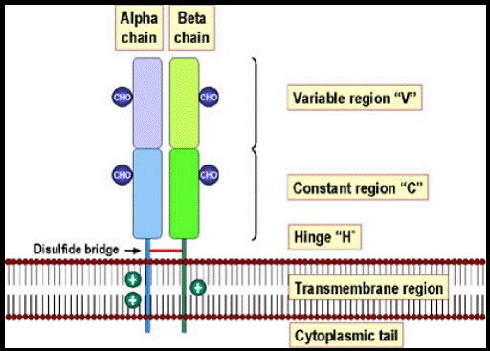
Function of T cell receptor
The T-cell receptor (TCR) plays a central role in adaptive immunity by mediating recognition of peptides presented by the major histocompatibility complex (MHC) on the surface of antigen presenting cells. Studies of the interaction between individual TCRs and their specific peptide MHC (PMHC) complexes continue to give insights into the biological functions of T cells, as well as information necessary for the design and safeguarding of TCR-based therapeutics. Production of soluble TCRs of high quality and in high yields is therefore needed for biophysical characterization of TCR interactions. Furthermore, soluble TCRs are useful as detection reagents when studying antigen presentation

T CELL ACTIVATION
CD4 and CD8 T cells leave the thymus and enter the circulation as resting cells in the G0 stage of the cell cycle. These naïve T cells are mature, but they have not yet encountered antigen. Their chromatin is condensed, they have very little cytoplasm, and they exhibit little transcriptional activity. However, they are mobile cells and recirculate continually among the blood, lymph, and secondary lymphoid tissues, including lymph nodes, browsing for antigen. It is estimated that each naïve T cell recirculates from blood through lymph nodes and back again every 12 to 24 hours. Because only about 1 in 105 naïve T cells is likely to be specific for any given antigen, this large-scale recirculation increases the chances that a T cell will encounter appropriate antigen.
If a naïve T cell does not bind any of the MHC-peptide complexes encountered as it browses the surfaces of stromal cells of a lymph node, it exits through the efferent lymphatic’s, ultimately draining into the thoracic duct and rejoining the blood. However, if a naïve T cell does encounter an APC expressing an MHC-peptide to which it can bind; it will initiate an activation program that produces a diverse array of cells that orchestrate efforts to clear infection. A successful T cell-APC interaction results in the stable organization of signaling molecules into an immune synapse. The TCR/ MHC-peptide complexes and co receptors are aggregated in the central part of this synapse (central supramolecular activating complex, or cSMAC) The co-receptors CD4 and CD8, which are found in the cSMAC, stabilize the interaction between TCR and MHC by binding MHC class II and MHC class I molecules, respectively. Interactions between adhesion molecules and their ligands (e.g., LFA-1/ICAM-1 and CD2/LFA-3) help to sustain the signals generated by allowing long-term cell interactions. These molecules are organized around the central aggregate, forming the peripheral or “p” SMAC.
However, even the increased functional avidity offered by co-receptors and adhesion molecules is still not sufficient to fully activate a T cell. Interactions between co-stimulatory receptors on T cells (e.g., CD28) and co-stimulatory ligands on dendritic cells (e.g., CD80/86) provide a second, required signal. A third set of signals, provided by local cytokines (Signal 3), directs T-cell differentiation into distinct effector cell types.

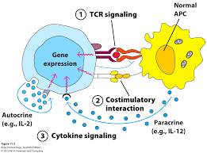
Three signals are required for activation of a naïve T cell.

The TCR/MHC-peptide interaction, along with CD4 and CD8 co-receptors and adhesion molecules, provide Signal 1. Co-stimulation by a separate set of molecules, including CD28 (or ICOS, not shown) provides Signal 2. Together, Signal 1 and Signal 2 initiate a signal transduction cascade that results in activation of transcription factors and cytokines (Signal 3) that direct T-cell proliferation (IL-2) and differentiation (polarizing cytokines). Cytokines can act in an Autocrine manner, by stimulating the same cells that produce them, or in a paracrine manner, by stimulating neighboring cells.

