Linear Correlation Coefficient
To find out the relation between two variables in a population, linear correlation formula is used. To see how the variables are connected we will use the linear correlation. Also known as “Pearson’s Correlation”, a linear correlation is denoted by r” and the value will be between -1 and 1.
The elements denote a strong relationship if the product is 1. Similarly, if the coefficient comes close to -1, it has a negative relation. If the Linear coefficient is zero means there is no relation between the data given.
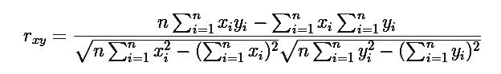
Where “n” is the number of observations, “x_{i}” and “y_{i} “are the variables.
Also Check: Correlation Coefficient Formulas

Solved Examples
Question 1: Calculate the linear correlation coefficient for the following data. X = 4, 8 ,12, 16 and Y = 5, 10, 15, 20.
Solution:
Given variables are,
X = 4, 8 ,12, 16 and Y = 5, 10, 15, 20
For finding the linear coefficient of these data, we need to first construct a table for the required values.
X | y | x² | y² | XY
4 | 5 | 16 | 25 | 20
8 | 10 | 64 | 100 | 80
12 | 15 | 144 | 225 | 180
16 | 20 | 256 | 400 | 320
Σ x = 40 | Σ y =50 | 480 | 750 | 600
According to the formula of linear correlation we have,
r(xy)=(4×600)−(40×50)4(480)−402√4(750)−502√

r(xy)=2400−20001920−1600√3000−2500√

r(xy)=400320√500√

r(xy)=40017.89×22.36

r(xy)=400400=1

Therefore, r(xy) = 1

