Topic: Cellular Metabolism
Cellular Metabolism:
Cellular metabolism is the set of chemical reactions that occur in living organisms in order to
maintain life.
These processes allow organism to grow and reproduce, maintain their structure and respond
to environmental changes. All cells in the body require energy for many of their processes.
- Energy comes into the body in the form of food stuffs.
- Carbohydrates, Protein and fats that we consume have chemical energy that we can utilize to make ATP.

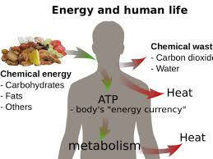

Energy:
ATP is a form of energy. Energy is stored in the chemical bonds of nutrient molecules. When
a bond is broken energy is released. And when bond is formed then energy is stored in the
Bond. All organisms need free energy for keeping themselves alive and functioning. All life
on planet earth is powered, directly or in directly, by solar energy. But no organism can make direct use of sunlight as a source of energy for metabolism. All can use chemical energy in the food such as sugar etc. The chloroplast of the plants captures light energy coming from the sun and convert it into chemical energy that gets stored in sugar and then in other organic molecules.
With the emergence of photosynthesis on earth, molecular oxygen began to accumulate slowly in the atmosphere. The presence of free oxygen made possible the evolution of respiration. Respiration releases great amount of energy, and couples some of this energy to the formation of adenosine triphosphate (ATP) molecules. ATP is a kind of link between Catabolism and Anabolism.

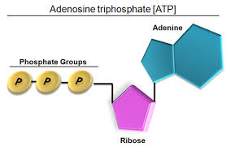
Photosynthetic Organism:
Photosynthetic organisms (higher land plants) use solar energy to Synthesize organic compounds, such as carbohydrates that cannot be formed without the input of energy. Energy stored in these molecules can be used later to power cellular processes and can serves as energy source for all forms of life. Because in photosynthesis light energy is converted into chemical energy in the form of ATP. This ATP is then utilizing by the chlorophyll for the reduction of co2.

Classification of Cellular Metabolism:
Cellular metabolism has two distinct divisions:
- Anabolism
- Catabolism

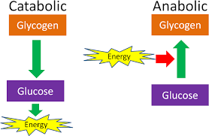

Anabolism
A constructive process during which larger molecules are built from smaller ones is called Anabolism. In anabolism condensation is usually involved. It is a metabolic process in which a cell uses energy to construct molecules such as enzymes and nucleic acid to perform other essential life functions.

Carbohydrates:
Carbohydrates are present in large amount in living organisms. They are found in all organisms and in almost all parts of the cell. There are three major classes of carbohydrates.
Monosaccharides:
These are simple sugars. They are sweet in taste, and are easily soluble in water and cannot by hydrolyzed into simple sugars. Glucose and fructose are simple sugars.
Disaccharides:
These are the combination of monosaccharides by the removal of water. Such as sucrose, lactose and maltose.
Polysaccharides:
These are most complex and the most abundant carbohydrates in nature. They are polymers of glucose. They are branched and tasteless. Such as starch, cellulose and glycogen.
Lipids
The lipids are heterogeneous group of compounds related to fatty acid. They are soluble in organic solvents like ether and carbon tetrachloride and are insoluble in water and polar Carbohydrates. Lipids include fats, oils, waxes, cholesterol etc. These are triglycerides.
Further modification produces:
- Phospholipids
- Glycolipids
- Lipoprotein
Protein:
Protein is made up of chain of amino acids. Protein is the most abundant organic compound to be found in cells and comprise 50% of total dry weight. As hormones proteins regulate metabolic process. The covalent bond that is formed is a peptide bond. Polypeptide contains 2-100 amino acids. And protein contains more than hundred amino acids. Proteins require additional modification to become functional.

Modification:
In protein modification occurs on four levels. The primary structure comprises the number of and sequences of amino acids in protein molecule. In secondary structure the polypeptide chain in protein molecule usually do not lie flat. They usually coil into helix. (alpha helix and beta plated sheet).
In tertiary structure, a polypeptide chain bends and folds upon itself form a globular structure. And forms 3D folding. In quaternary structure two or more 3-D proteins that act as a functional unit, i.e. Hemoglobin. IN protein shape determines function, and loss of shape leads to loss of function. Protein may by structural or functional. If structural it plays a role in cellular architecture such as collagen, actin and myosin. If it is functional, it plays a role in cell metabolism. such as Enzymes and antibodies.
Pathway
Anabolism is a building aspect of metabolism.
Polymerization is an anabolic pathway used to build macromolecules such as nucleic acid, protein and polysaccharides uses condensation reaction to join monomers. Larger molecules are form from smaller molecules using enzymes and cofactor.
Energy Source:
Anabolism is powered by catabolism where large molecules are broken down into smaller parts. Anabolic process is also powered by cleavage of ATP. Anabolism usually involves reduction and decreases entropy making it unfavorable without energy input.
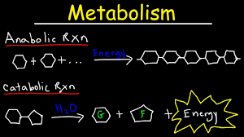

Anabolism is endergonic process, because these reactions require energy. Anabolism is usually synonymous with biosynthesis. The starting material is called precursor molecule, are joined together using the chemical energy made available from hydrolyzing ATP, and reducing the cofactors NAD+, NADP+, and FAD or performing favorable side reactions.
Cofactors:
The reducing agents NADH, NADPH, and FADH2, as well as metal ions act as cofactors at various steps in anabolic pathways. NADH, NADPH, and FADH2 act as electron carrier, while charged metal ions within enzymes stabilize charged functional groups on substrates.
Substrates:
Substrates for anabolism are mostly intermediates taken from catabolic pathways during periods of high energy charge in the cell.
Photosynthetic carbohydrate synthesis:
Photosynthetic carbohydrate synthesis in plants and certain bacteria is an anabolic process that produces glucose, cellulose, starch, lipids, and protein from co2.
It uses the energy produced from light driven reactions of photosynthesis, and creates the precursor to the large molecule via carbon assimilation in the photosynthetic carbon reduction cycle and Calvin cycle.
Amino acid biosynthesis:
Amino acids are formed from intermediates in the catabolic processes of glycolysis, the citric acid cycle or pentose phosphate pathway. From glycolysis, glucose 6-phosphate is a precursor for histidine; 3-phosphoglycerate is a precursor for glycine and cysteine; phosphoenolpyruvate combined with 3-phosphoglycerate derivative erythrose 4-phosphate,
Forms tryptophan, phenylalanine, and tyrosine; and pyruvate is a precursor for alanine, valine, leucine and isoleucine.
From the citric acid cycle, alpha ketoglutarate is converted into glutamate and subsequently glutamine, proline and arginine and oxaloacetate are converted into aspartate and subsequently asparagine, methionine, threonine and lysine.
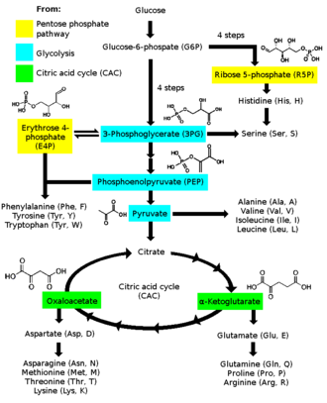
Glycogen storage:
During periods of high blood sugar, glucose 6-phosphate from glycolysis is diverted to the glycogen-storing pathway. It is changed to glucose-1-phosphate by phosphoglucomutase and then to UDP-glucose by UTP -glucose-1-phosphate uridyltransferase. Glycogen synthase adds this UDP- glucose to a glycogen chain.
Gluconeogenesis:
Glucagon is a catabolic hormone, but it also stimulates the anabolic process of gluconeogenesis by the liver, and to a lesser extent the kidney cortex and intestines, during starvation to prevent low blood sugar. It is the process of converting pyruvate into glucose. Pyruvate can come from background of glucose, lactate, amino acids, or glycerol.
The glycogenesis pathway has many reversible enzymatic processes in common with glycolysis, but it is not the process of glycolysis in reverse. It uses different irreversible enzymes to ensure the overall pathway runs in one direction only.
Regulation:
Anabolism operates with separate enzymes from catalyst, which undergo irreversible steps at some point in their pathways. This allows the cell to regulate the rate of production and prevent an infinite loop, also known as futile cycle from forming with catabolism.
Catabolism
It is the set of metabolic process that break down large molecules. This including breaking down and oxidizing food molecules. The purpose of catabolic reaction is to provide energy and component that are needed by anabolic reaction which build molecules. The exact nature of these catabolic reactions differs from organism to organism. The most common set of catabolic reactions in animals can be separated into three main stages.
First stage:
Large organic molecules, such as protein, polysaccharides or lipid are digested into their smaller components outside the cell.
Next these smaller molecules are taken up by cells and converted to smaller molecules, usually acetyl coenzyme A which releases some energy.
Finally, acetyl group on the CoA is oxidized to water and carbon dioxide in citric acid cycle and electron transport chain releasing energy that is stored by reducing the coenzyme (NAD+) into NADH.
Digestion:
Macromolecules such as starch, cellulose or proteins cannot be rapidly taken by cells and must be broken into their smaller units before they can be used in cell metabolism.
The digestive enzymes include protease that digest proteins into amino acids, as well as glycoside hydrolases that digest polysaccharides into simple sugar known as monosaccharides.
- Microbes simply secrete digestive enzymes into their surroundings.
- Animals only secrete these enzymes from specialized cells in their guts including stomach and pancreas and salivary glands.
- Amino acids or sugar released by these extracellular enzymes and then pumped into cells by active transport proteins.
Energy from organic compounds:
Carbohydrates catabolism is the breakdown of carbohydrates into smaller units.
Carbohydrates are usually taken into cells once they have been digested into monosaccharides
The major route of breakdown is glycolysis, where sugar such as glucose and fructose are converted into pyruvate and some ATP is generated. Pyruvate is an intermediate in several metabolic pathways, but the majority is converted to acetyl-coA through aerobic (with oxygen) glycolysis and fed into the citric acid cycle, the most important product is NADH, which, is made from NAD+ as the acetyl-CoA is oxidized.
This oxidation releases carbon dioxide as a waste product.
Anaerobic condition:
In anaerobic conditions, glycolysis produces lactate through the enzyme lactate dehydrogenase re-oxidizing NADH to NAD+ for re use in glycolysis.
An alternative route for glucose breakdown is the pentose phosphate pathway which reduces the coenzyme NADPH and produces pentose sugar such as ribose, the sugar component of nucleic acid.
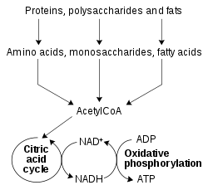

The balance between anabolism and catabolism is sensitive to ADP and ATP, otherwise known as energy charge of cell.
- High amount of ATP cause cells to favor the anabolic pathway and slow catabolic activity.
- Excess ADP slows anabolism and favors catabolism.
Metabolic disorder:
- Calcium metabolism disorder
- Acid base imbalance
- Metabolic brain disorder
Signs and Symptoms:
Symptoms that can occur with metabolic disorders are weight loss, jaundice and seizures.
Symptoms vary with the type of metabolic disorder.
Causes:
Inherited metabolic disorders are one cause of metabolic disorders and occur when a defective gene causes an enzyme deficiency.
Metabolic diseases can also occur when the liver or pancreas do not function properly.
Diagnosis:
Metabolic disorders can be present at birth, and many can be identified by routine screening.
If a metabolic disorder is not identified early, then it may be diagnosed later in life, when symptoms appear.
Specific blood and DNA tests can be done to diagnose genetic metabolic disorders.
Management:
Metabolic disorders can be treatable by nutrition management, especially if detected early.

