Course: Teaching of English Language

WRITING SKILLS

Content list
1: Language
Introduction
1.1Definition of Language:
1.2 Characteristics and Features of Language
1.3 Image

2: Communication
2.1 Definition
2.2 Types
2.3 categories
2.4 processes
2.5 channels
2.6 Barriers
2.7 images
2.8 Example

3: Sentence
3.1 Definition
3.2 Types
3.3 structures
3.4 Example
3.5 images
4: Written communication
4.1 introductions
4,2 Definition
4.3 Types
4.4 purposes
4.5 processes
4.6 Types of writing
4.7 Paragraph writing
4.8 Essay writing
4.9 Note taking
4.10 Letter Writing
4.11 CV writing
4.12 Report writing
Definition of Language:

- A system of communication consisting of sounds, words, and grammar, or the system of communication used by people in a particular country or type of work.
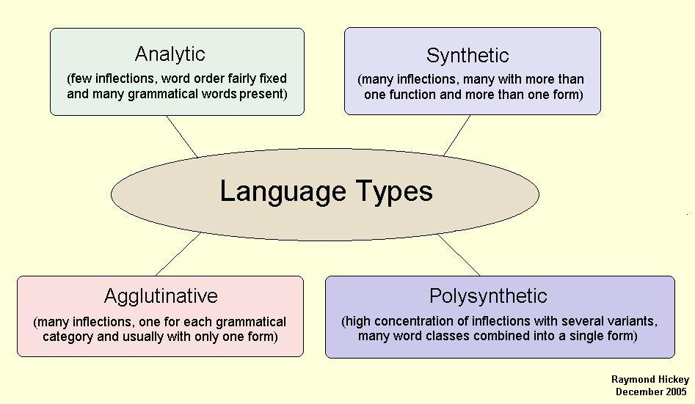

Characteristics and Features of Language
Language is, today, an inseparable part of human society. Human civilization has been possible only through language. It is through language only that humanity has come out of the Stone Age and has developed science, art and technology in a big way. Language is a means of communication, it is arbitrary, it is a system of systems. We know that Speech is primary while writing is secondary
Language is human so it differs from animal communication in several ways. Language can have scores of characteristics but the following are the most important ones: language is arbitrary, productive, creative, systematic, vocalic, social, non-instinctive and conventional. These characteristics of language set human language apart from animal communication. Some of these features may be part of animal communication; yet they do not form part of it in total.
Language is Arbitrary: Language is arbitrary in the sense that there is no inherent relation between the words of a language and their meanings or the ideas conveyed by them. There is no reason why a female adult human being be called a woman in English, aurat in Urdu, Zen in Persian and Famine in French. The choice of a word selected to mean a particular thing or idea is purely arbitrary but once a word is selected for a particular referent, it comes to stay as such. It may be noted that had language not been arbitrary, there would have been only one language in the world.
Language is Social: Language is a set of conventional communicative signals used by humans for communication in a community. Language in this sense is a possession of a social group, comprising an indispensable set of rules which permits its members to relate to each other, to interact with each other, to co-operate with each other; it is a social institution. Language exists in society; it is a means of nourishing and developing culture and establishing human relations.
Language is Symbolic: Language consists of various sound symbols and their graphological counterparts that are employed to denote some objects, occurrences or meaning. These symbols are arbitrarily chosen and conventionally accepted and employed. Words in a language are not mere signs or figures, but symbols of meaning. The intelligibility of a language depends on a correct interpretation of these symbols.
Language is Systematic: Although language is symbolic, yet its symbols are arranged in a particular system. All languages have their system of arrangements. Every language is a system of systems. All languages have phonological and grammatical systems, and within a system there are several sub-systems. For example, within the grammatical system we have morphological and syntactic systems, and within these two sub-systems we have systems such as those of plural, of mood, of aspect, of tense, etc.
Language is Vocal: Language is primarily made up of vocal sounds only produced by a physiological articulator mechanism in the human body. In the beginning, it appeared as vocal sounds only. Writing came much later, as an intelligent attempt to represent vocal sounds. Writing is only the graphic representation of the sounds of the language. So the linguists say that speech is primary.
Language is Non-instinctive, Conventional: No language was created in a day out of a mutually agreed upon formula by a group of humans. Language is the outcome of evolution and convention. Each generation transmits this convention on to the next. Like all human institutions languages also change and die, grow and expand. Every language then is a convention in a community. It is non-instinctive because it is acquired by human beings. No body gets a language in heritage; he acquires it because he an innate ability.
Language is Productive and Creative: Language has creativity and productivity. The structural elements of human language can be combined to produce new utterances, which neither the speaker nor his hearers may ever have made or heard before any, listener, yet which both sides understand without difficulty. Language changes according to the needs of society.
Finally, language has other characteristics such as Duality referring to the two systems of sound and meaning, Displacement which means the ability to talk across time and space, Humanness which means that animals cannot acquire it, Universality which refers to the equilibrium across humanity on linguistic grounds, Competence and Performance which means that language is innate and produced is society and furthermore, language is culturally transmitted. It is learnt by an individual from his elders, and is transmitted from one generation to another. Thus using J. Firth’s term, language is a ‘polysystametic’. It is also open to be studied from multifaceted angles.
INTRODUCATION

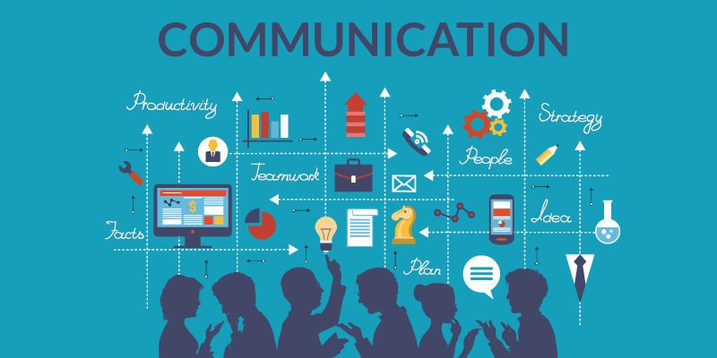

Definition of Communication
communication, The imparting or exchanging of information by speaking, writing, or using some other medium. …The successful conveying or sharing of ideas and feelings.

Oxford English Dictionary
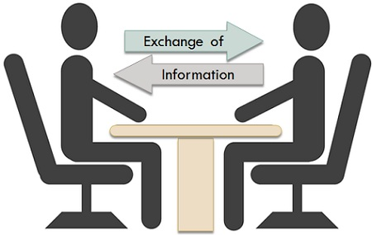

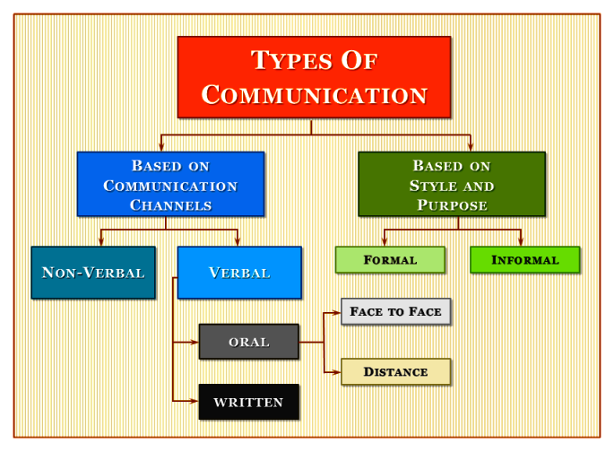

Categories of Communication

- The different categories of communication include:
- Spoken or Verbal Communication, which includes face-to-face, telephone, radio or television and other media.
- Non-Verbal Communication, covering body language, gestures, how we dress or act, where we stand, and even our scent. There are many subtle ways that we communicate (perhaps even unintentionally) with others. For example, the tone of voice can give clues to mood or emotional state, whilst hand signals or gestures can add to a spoken message.
- Written Communication: which includes letters, e-mails, social media, books, magazines, the Internet and other media? Until recent times, a relatively small number of writers and publishers were very powerful when it came to communicating the written word. Today, we can all write and publish our ideas online, which have led to an explosion of information and communication possibilities.
- Visualization: Graphs and chart maps logos and other visualization can all communicate messages

The Communication Process
A message or communication is sent by the sender through a communication channel to a receiver, or to multiple receivers.
The sender must encode the message (the information being conveyed) into a form that is appropriate to the communication channel, and the receiver(s) then decodes the message to understand its meaning and significance

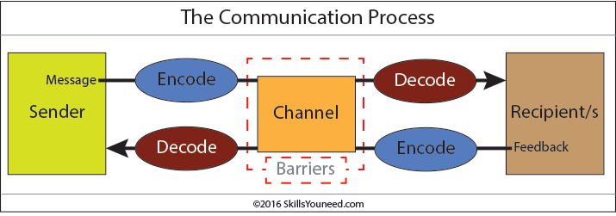

. Communication Channels
Communication channels are the term given to the way in which we communicate. It is therefore the method used to transmit our message to a recipient, or to receive a message from someone else.
There are multiple communication channels available to us today. These include face-to-face conversations, telephone calls, text messages, email, the Internet (including social media such as Facebook and Twitter), radio and TV, written letters, brochures and reports.
Choosing an appropriate communication channel is vital for effective communication. Each communication channel has different strengths and weaknesses.
For example, broadcasting news of an upcoming event via a written letter might convey the message clearly to one or two individuals. It will not, however, be a time- or cost-effective way to broadcast the message to a large number of people. On the other hand, conveying complex, technical information is easier via a printed document than a spoken message. The recipients are able to assimilate the information at their own pace and revisit anything that they do not fully understand.
Written communication is also useful as a way of recording what has been said, for example by taking minutes in a meeting.

Encoding Messages
All messages must be encoded into a form that can be conveyed by the communication channel chosen for the message.
We all do this every day when transferring abstract thoughts into spoken words or a written form. However, other communication channels require different forms of encoding, e.g. text written for a report will not work well if broadcast via a radio programmers, and the short, abbreviated text used in text messages would be inappropriate in a letter or in speech.
Complex data may be best communicated using a graph, chart or other visualization.
Effective communicators encode their messages so that they fit both the channel and the intended audience. They use appropriate language, conveying the information simply and clearly. They also anticipate and eliminate likely causes of confusion and misunderstanding. They are generally aware of the recipients’ experience in decoding similar communications.
Successful encoding of messages for the audience and channel is a vital skill in effective communication.

Decoding Messages
Once received, the recipient needs to decode the message. Successful decoding is also a vital communication skill.
People will decode and understand messages in different ways.
This will depend on their experience and understanding of the context of the message, how well they know the sender, their psychological state and how they feel, and the time and place of receipt. They may also be affected by any Barriers to Communication which might be present.
There are therefore a wide range of factors that will affect decoding and understanding.
Successful communicators understand how the message will be decoded, and anticipate and remove as many as possible of the potential sources of misunderstanding.

Feedback
The final part of a communication is feedback: the recipient lets the sender know that they have received and understood the message.
Recipients of messages are likely to provide feedback on how they have understood the messages through both verbal and non-verbal reactions. Effective communicators pay close attention to this feedback as it is the only way to assess whether the message has been understood as intended, and it allows any confusion to be corrected.
Barriers to Effective Communication
There are many barriers to communication and these may occur at any stage in the c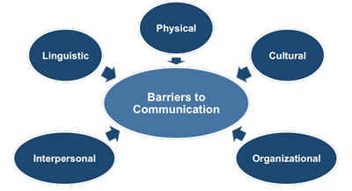
There are many barriers to communication and these may occur at any stage in the communication process. Barriers may lead to your message becoming distorted and you therefore risk wasting both time and/or money by causing confusion and misunderstanding.
Effective communication involves overcoming these barriers and conveying a clear and concise message.

Language Barriers
Language and linguistic ability may act as a barrier to communication.
- However, even when communicating in the same language, the terminology used in a message may act as a barrier if it is not fully understood by the receiver.
- For example, a message that includes a lot of specialist jargon and abbreviations will not be understood by a receiver who is not familiar with the terminology used.
Psychological Barriers
- The psychological state of the communicators will influence how the message is sent, received and perceived.
- For example:
- If someone is stressed they may be preoccupied by personal concerns and not as receptive to the message as if they were not stressed
Physiological Barriers:
Physiological barriers to communication may result from the receiver’s physical state.
For example, a receiver with reduced hearing may not fully grasp the content of a spoken conversation especially if there is significant background noise,
Physical Barriers
- An example of a physical barrier to communication is geographic distance between the sender and receiver(s).
- Communication is generally easier over shorter distances as more communication channels are available and less technology is required. The ideal communication is face-to-face.
- Although modern technology often helps to reduce the impact of physical barriers, the advantages and disadvantages of each communication channel should be understood so that an appropriate channel can be used to overcome the physical barriers
Systematic Barriers
- Systematic barriers to communication may exist in structures and organizations where there are inefficient or inappropriate information systems and communication channels, or where there is a lack of understanding of the roles and responsibilities for communication. In such organizations, people may be unclear of their role in the communication process and therefore not know what is expected of them.
Attitudinal Barriers
- Attitudinal barriers are behaviors or perceptions that prevent people from communicating effectively.
- Attitudinal barriers to communication may result from personality conflicts, poor management, and resistance to change or a lack of motivation. To be an effective receiver of messages you should attempt to overcome your own attitudinal barriers to help ensure more effective communication
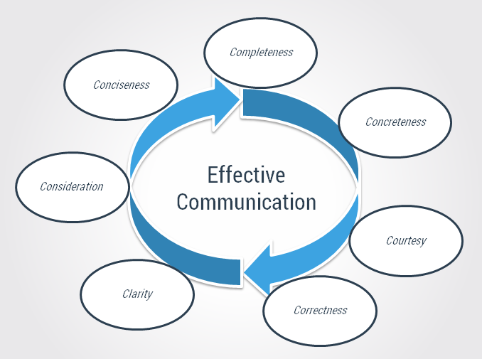
- To improve your overall communication skills you need to be aware of, and attempt to minimize, any barriers to communication that are present.
- By developing your emotional intelligence you will become more aware of how to communicate with others in the most appropriate and effective ways.
- Take our Interpersonal Skills Self-Assessment to find out your strengths and weakness.
Introduction of sentence:
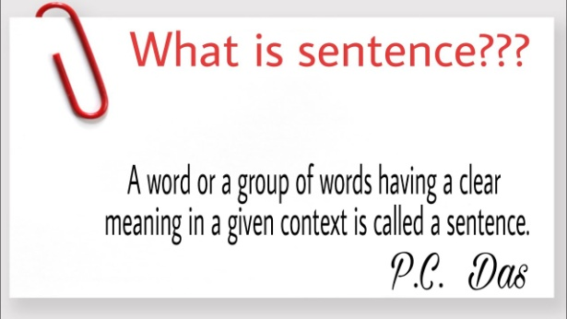

A sentence is the basic unit of language which expresses a complete thought. It does this by following the grammatical basic rules of sentence. For example: 'Angela is the cutest girl in the class'. A complete sentence has at least a subject and a main verb to state (declare) a complete though.
Types of sentence:
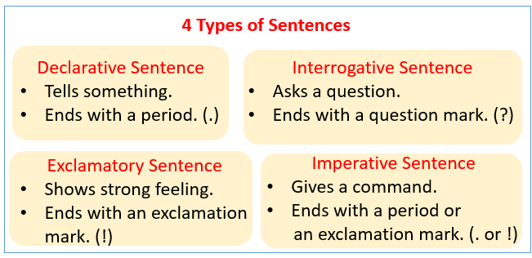

Declarative/Statement Sentences

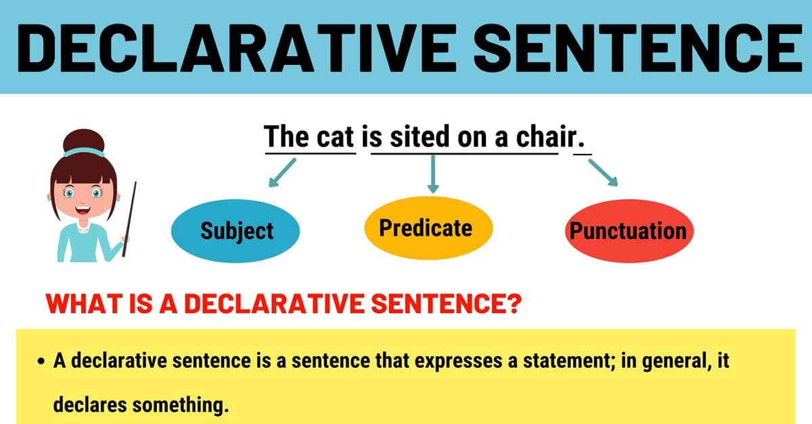
This type of structure helps in making statements and stating basic information. You can also express an opinion using them. It is the most common type among 4 types of sentences and is prevalent in most academic writings and verbal speech. Put a period when ending this type of the sentence.
Examples:
- Students failed to complete their essays on time.
- My wife loves eating cake in the morning.
- The developer needs new resources for completing a project.

Exclamatory/Exclamation Sentences

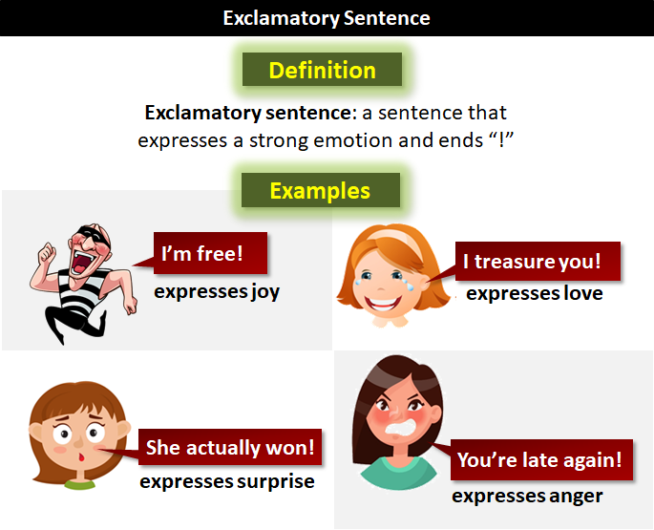
You use an exclamatory type to express deep emotions or feelings. It can either be disbelief or happiness, and it must be finished with an exclamation point. Rarely do you need to use this type in formal and highly objective writings.
Examples:
- I got an A in my research paper!
- That movie was exciting!
- I can’t believe how fast that car was moving.

Imperative/Command Sentence

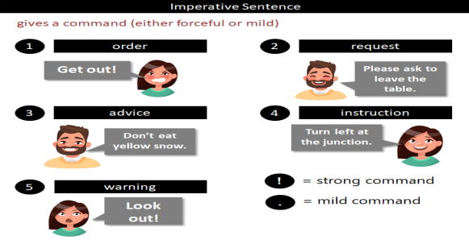
You use it when giving demand or instruction.. This can either be negative or positive depending on a message.
Examples:
- Do not stop!
- Never speak to me like that again.
- Please leave your shoes outside.

Interrogative/Question Sentences

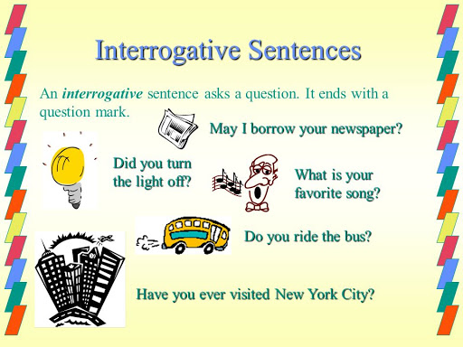
This type is simple to understand as it helps in asking a question. You use a question mark at its end. For framing your question, choose words like “why,” “what,” “when,” “where,” “do,” or “how.”
Examples:
- What time will you finish writing your English homework?
- What is an adverb?
- How often do you read this article?

The Four Sentence Structures
A sentence can consist of a single clause or several clauses. When a sentence is a single clause, it is called a simple sentence (and the clause is called an independent clause). A sentence must contain at least one independent clause. Below are the four types of sentence structure (with their independent clauses shaded:
- A Complex Sentence.
A complex sentence has an independent clause and at least one dependent clause. For example:
Diplomacy is the art of saying "nice doggie" until you can find a rock. (Actor Will Rogers, 1879-1935)
When you're on the Internet, nobody knows you're a dog. (Cartoonist Peter Steiner)
A Compound Sentence.
- A compound sentence has at least two independent clauses. For example:
  - Cry "Havoc," and let slip the dogs of war. (Playwright William Shakespeare, 1564-1616)
- A Simple Sentence.
- A simple sentence has just one independent clause. For example:
  - You can't surprise a man with a dog. (Screenwriter Cindy Chupack)
- A Compound-Complex Sentence.
- A compound-complex sentence has at least two independent clauses and at least one dependent clause. For example:
  - When a dog bites a man that is not news because it happens so often, but if a man bites a dog, that is news. (Editor John B Bogart)
Introduction:
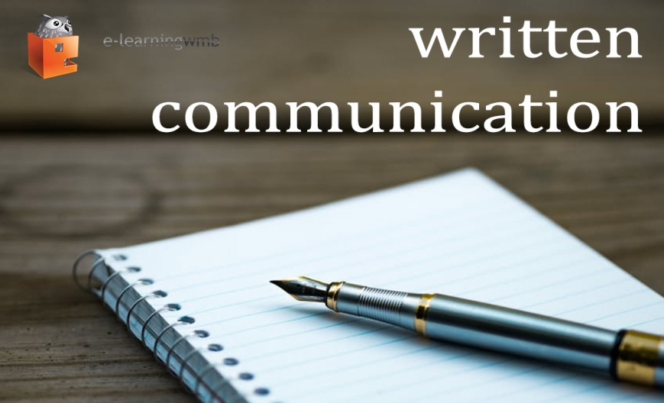
Writing is one of four skills in English that we must master to learn writing skill we must understand what writing itself. These are definition of writing according to some experts,

Meaning of writing skill?
Writing skills mean the writer is to write down their thoughts/ideas/opinions/facts/stories etc in a manner which makes their thoughts clear and comprehensible to the reader. Good writing needs to have good vocabulary, correct grammar and spellings along with perfect punctuation.

Definition:
According to Harmer (2001:79) writing is a form of communication to deliver though or to express feeling through written form.
Jonah (2006:14) argues that writing is a series of activities going on and involves several phases, the preparatory phase, and the content development and review, as well as revisions or improvements posts.

According to Gephardt and Dawn Rodriguez (1989: 1) Writing is one of the most important things you do in school. Good writing skills take big part to determine in the success, whether it writing a report, proposal or assignment in school.
From the definition above I can conclude that writing is person ability to communicate their, information, ideas and feeling to someone in the form of written, writing not only an activity arranging word into form of sentence. Moreover, when people write something they should organize sentence become interesting and coherence. 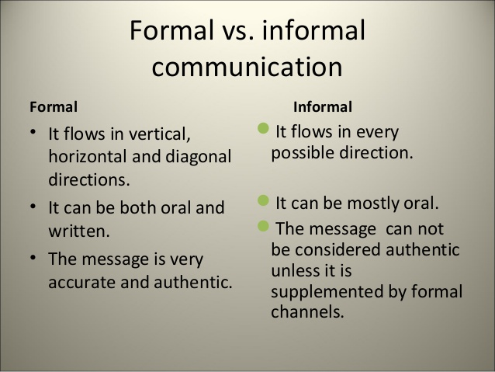
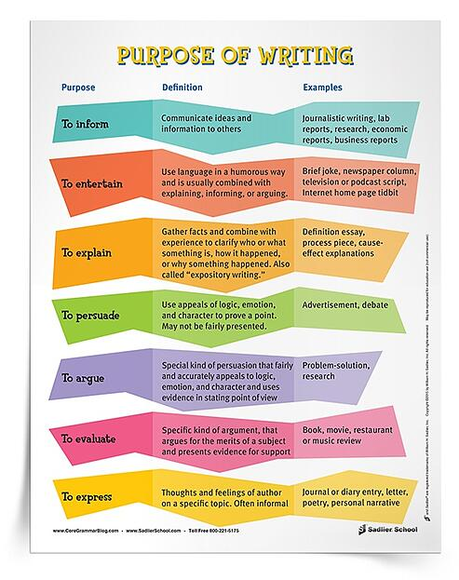

Why do we teach writing?
These are several reasons to teach writing, they are:
1. Reinforcement: This is arguably the most common reason why we teach writing. Typically course book exercises require students to WRITE answers as single words, phrases or sentences. The idea is that this usually reinforces grammar or provides evidence they have understood a text. This element of reinforcement is also true when used in conjunction with number three below. A lot of test preparation work requires students to write by, for example taking notes from a phone conversation and then writing a message using the information
2. Examination Practice: Most exams require students to give answers in writing. Some require essay-type answers. This is mainly due to the fact that writing is a very convenient and often accurate mode of assessment. Writing on the page is certainly easier to assess objectively than students' speaking.
3. Reference: Students take notes throughout our lessons so that they have something to revise and remember about what they had been learning before as guidance for them to get good score in the future.
4. Writing as Communication: Writing skills are an important part of communication. Good writing skills allow you to communicate your message with clarity and ease to a far larger audience than through face-to-face or telephone conversations.
5. In Academic development: writing exercises in school support development of critical thinking and problem-solving skills. Students also learn the writing process, from outline to finished product, which translates into other aspects of life and learning. For example, students can use planning and organizing, research and peer review to make research or scientific journal.

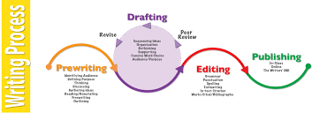
Barriers of writing
Noise:
It is a very common problem faced by everyone at their workplace. A writer actually requires a place that is surrounded with silence. When a writer is involved in his writing, his flow of thoughts travel in a direction to produce a coded message in his mind, whenever anybody interrupts the flow of thoughts is disturbed and he becomes disturbed. But a writer should be used to the noise factor because he cannot come across a place that is filled with utmost silence expect occasionally. He should concentrate in his work deeply. He should master the techniques of concentration by methods such as meditation, pranayam etc. He learns to focus on objects under any circumstances if he is involved in activities such as meditation.
Lack of effective tools:
Writer requires many tools for writing. Writers today require facilities like internet to gather information. Everybody is not lucky enough to own a PC and buy an internet connection at home. If he lacks digital facilities, then he can gather information from the books. He should store books that he buys or uses for academic purposes. A writer should also learn to make effective use of his tools. Even if he has an internet connection at home, he must know the techniques to search the desired results. He can make use of many search engines such as Google, yahoo, msn search etc. He must buy books that provide him the right information.
Training for writing:
Everybody is not lucky enough to imbibe training for effective writing. If a writer belongs to a wealthy background, his parents can assist and finance for him to learn various courses for writing. But even if he is not able to acquire any training he should train himself. He can gather information from various sources such as internet, books, libraries, friends etc. He can also activate his mind by following the therapies of meditation, spiritual techniques, yoga, etc.
Scope or motivation:
Sometimes a person may feel the urge to write something, but the people around him may not encourage him. They may tell him that he is not a good writer. In such situation, he should not follow the words of others but he should follow his own path. If he is urged he should take a step ahead. If he has not developed the necessary skills he can learn a lot by watching the other writers in the forum. He can learn the skills that are necessary for a writer.
Writer's block:
A writer consistently needs to think and ponder to write something. At a point of time when he or she is continuously delivering thoughts to pin down, he may come to a point where his mind becomes saturated. At this time, he cannot think further as his mind becomes blocked. To refresh his mind and start writing again he can use different techniques. He should quietly sit down in a room and read something that absorbs his mind. He should just sit down in a room alone and slowly start thinking and feel refreshed. He can also involve in spiritual activities such as meditation, yoga, or even recreational activities to make his mind fresh. A writer should remember that he should also become a good reader because it boosts his thinking capacity. I am writing this article because my mind had become saturated now and I am feeling fresh to present this article now
The Problem students have in writing
There are several problems that student have in writing such as:
1. Punctuations Mark: Most of student is confused to put punctuation mark in the right place, for example put comma in a paragraph they are very difficult to determine which part should be given a coma.
2. Plagiarism: The paper uses someone else’s ideas or words as if they were the student’s own. Plagiarism can take the form of cutting and pasting bits of the writings of others and using them in one’s paper without acknowledgement, turning in someone else’s writing as one’s own, or even turning in a paper of one’s own that was written for credit in a different class, without the permission of the instructor.
3. Incoherent writing: Incoherent means that each part of the writing appears it's not to be 'connected' and heading towards a single conclusion or goal. Incoherent writing appears because the writer has many main idea and thesis statement when they write text so that the texts do not have unclear purpose. Each idea is should be related in a way that helps build towards an overall controlling idea, conclusion or theme in the text in order to make the text become coherent and easy to understand.
4. Paragraph structure: Paragraph divisions appear random, or paragraphs lack topic sentences, or they address too many points, or they fail to link with the previous or following paragraphs in a logical way.
5. Grammatical errors: There are many students who do not understand the procedures of writing proper grammar it can be seen from student writing assignments that they collected are still many grammatical errors that cause students less interested in studying writing because in their minds grammar it's complicated. Moreover, students also have poor vocabulary that make student limited to make sentence or paragraph.
6. Topic choice: student confused to choose the topic in order to make a good writing so that students often choose the inappropriate topic with their study and it seem like their writing assignment look unrelated with the subject that they had been learn before.

Characteristic of academic writing
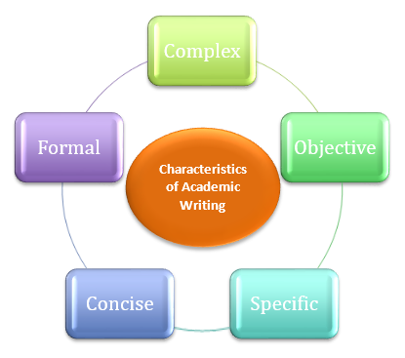

QUALITIES OF GOOD WRITING
- Clarity and focus: In good writing, everything makes sense and readers don’t get lost or have to reread passages to figure out what’s going on. Focused writing sticks with the plot or core idea without running off on too many tangents.
- Organization: A well organized piece of writing is not only clear; it’s presented in a way that is logical and aesthetically pleasing. You can tell non-linear stories or place your thesis at the end of an essay and get away with it as long as your scenes or ideas are well ordered.
- Ideas and themes: Is the topic of your paper relevant? Does your story come complete with themes? Can the reader visualize your poem? For a piece of writing to be considered well crafted, it has to contain clearly identifiable ideas and themes.
- Voice: This is what sets you apart from all other writers. It’s your unique way of stringing words together, formulating ideas, and relating scenes or images to the reader. In any piece of writing, the voice should be consistent and identifiable.
- Language (word choice): We writers can never underestimate or fail to appreciate our most valuable tools: words. Good writing includes precise and accurate word choices and well crafted sentences.
- Grammar and style: Many writers would wish this one away, but for a piece of writing to be considered good (let alone great), it has to follow the rules of grammar (and break those rules only when there’s a good reason). Style is also important in ensuring that a piece of writing is clear and consistent. Make sure you keep a grammar book and style guide handy.
- Credibility or believability: Nothing says bad writing like getting the facts wrong or misrepresenting oneself. In fiction, the story must be believable (even if it’s impossible), and in nonfiction, accurate research can make or break a writer
- Main Topic:

- 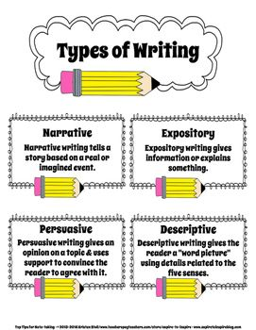

1. Expository
Expository writing explains or informs. It talks about a subject without giving opinions. Expository writing's main purpose is to explain. It is a subject-oriented writing style, in which authors focus on telling you about a given topic or subject without voicing their personal opinions. These types of essays or articles furnish you with relevant facts and figures but do not include their opinions. This is one of the most common types of writing. You always see it in textbooks and how-to articles. The author just tells you about a given subject, such as how to do something.
Key Points:
- Usually explains something in a process.
- Is often equipped with facts and figures.
- Is usually in a logical order and sequence.
When You Would Use Expository Writing:
- Textbook writing.
- How-to articles.
- Recipes.
- News stories (not including opinion or editorial pieces).
- Business, technical, or scientific writing.
- Example:
- The municipal government of Happyville unanimously approved the construction of sixty-two miles of bike trails in 2017. Made possible by a new tax levy, the bike trails are expected to help the city reach its sustainability and clean air goals while reducing traffic and congestion. Eighteen trailheads with restrooms and picnic areas have been planned at a variety of access points. The city expects construction to be complete in April 2021.
- Because this paragraph supplies the reader with facts and figures about its topic, the new bike trails, without offering the author’s opinion on it, it is expository.
Example:
Many people associate the taste of pumpkins with fall. In October, companies from Starbucks to McDonalds roll out their pumpkin-flavored lattes and desserts. Here is how to make an easy pumpkin pie using only five ingredients. First, make sure you have all of the ingredients.
This writing is expository because it is explaining. In this case, you can already tell that the piece will be about how to make a pumpkin pie.
Non-example:
Everyone knows that the best part about fall is all of the pumpkin-flavored desserts. Pumpkin pie is the best fall treat because it is not only delicious but also nutritious. Pumpkin is filled with vitamin A, which is essential for a healthy immune system and good vision.
This is not expository because several opinions are stated, such as “Pumpkin pie is the best fall treat…” Although this excerpt contains a fact about pumpkin containing vitamin A, that fact is used as evidence to support the opinion. These opinions make this an example of persuasive writing.

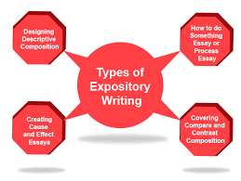

2. Descriptive
Descriptive writing focuses on communicating the details of a character, event, or place.
Descriptive writing's main purpose is to describe. It is a style of writing that focuses on describing a character, an event, or a place in great detail. It can be poetic when the author takes the time to be very specific in his or her descriptions.
Example:
In good descriptive writing, the author will not just say: “The vampire killed his lover.”
He or she will change the sentence, focusing on more details and descriptions, like: “The bloody, red-eyed vampire sunk his rust-colored teeth into the soft skin of his lover and ended her life."
Key Points:
It is often poetic in nature
It describes places, people, events, situations, or locations in a highly-detailed manner.
The author visualizes what he or she sees, hears, tastes, smells, and feels.
When You Would Use Descriptive Writing:
- Poetry
- Journal or diary writing
- Nature writing
Descriptive passages in fiction
Example;
The children pedaled leisurely down the Hapeville Bike Trail, their giggles and whoops reverberating through the warm spring air. Sweet-scented wildflowers brought an array of color to the gently undulating landscape, tempting the children to dismount now and then so they could lay down in the springy, soft grass.
Through description, this passage paints a vivid picture of a scene on the new bike trail.
Example:
The phone 6 is unexpectedly light. While size of its screen is bigger than those of the iphone that came before, it is thinner, and its smooth, rounded body is made of aluminum, stainless steel, and glass. The casing comes in whitish silver, gold, or a color the company calls “space gray,” the color of the lead of a pencil, with darker gray accents.
This is an example because it describes aspects of the phone. It includes details such as the size, weight, and material.
Non-example:
So you just brought home a shiny new Smartphone with a smooth glass screen the size of your palm. The first thing you will want to do when purchasing a new cell is buy a case. Cracking your screen is an awful feeling, and protection is inexpensive when you compare it to the costs of a new phone.
Even though this example uses adjectives, you can tell that this is not an example of descriptive writing because the purpose is not to describe the phone—it’s to persuade you to buy a case.
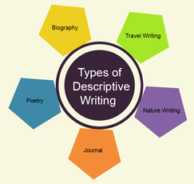

3. Persuasive:
Persuasive writing tries to bring other people around to your point of view.
Persuasive writing's main purpose is to convince. Unlike expository writing, persuasive writing contains the opinions and biases of the author. To convince others to agree with the author's point of view, persuasive writing contains justifications and reasons. It is often used in letters of complaint, advertisements or commercials, affiliate marketing pitches, cover letters, and newspaper opinion and editorial pieces.
Key Points:
- Persuasive writing is equipped with reasons, arguments, and justifications.
- In persuasive writing, the author takes a stand and asks you to agree with his or her point of view.
- It often asks for readers to do something about the situation (this is called a call-to-action).
When You Would Use Persuasive Writing:
- Opinion and editorial newspaper pieces.
- Advertisements.
- Reviews (of books, music, movie, restaurants, etc.).
- Letter of recommendation.
- Letter of complaint.
- Cover letters
Example:
Following the 2012 Olympic Games hosted in London, the UK Trade and Investment department reported a £9.9 billion boost to the economy. Although it is expensive to host the Olympics, if done right, they can provide real jobs and economic growth. This city should consider placing a bid to host the Olympics.
This is persuasive writing because the author has a belief—that “this city should consider placing a bid to host the Olympics”—and is trying to convince others to agree.
Non-example:
According to legend, the Olympics were founded by Hercules. Now almost 100 countries participate in the Games, with over two million people attending. So cities from Boston to Hamburg begin considering their bid to be a host city more than 10 years in advance.
All of these statements are facts. Therefore it’s expository. To be persuasive writing, you must have an opinion that you’re trying to persuade people of—then, of course, you will support that opinion with evidence.

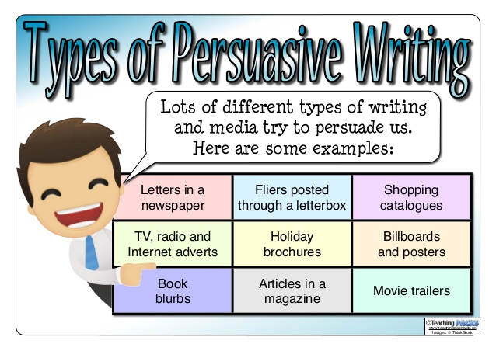

4. Narrative
A narrative tells a story. There will usually be characters and dialogue.
Narrative writing's main purpose is to tell a story. The author will create different characters and tell you what happens to them (sometimes the author writes from the point of view of one of the characters—this is known as first person narration). Novels, short stories, novellas, poetry, and biographies can all fall in the narrative writing style. Simply, narrative writing answers the question: “What happened then?”
Key Points:
- A person tells a story or event.
- Has characters and dialogue.
- Has definite and logical beginnings, intervals, and endings.
- Often have situations like actions, motivational events, and disputes or conflicts with their eventual solutions.
Examples of When You Would Use Persuasive Writing:
- Novels
- Short stories
- Novellas
- Poetry
- Autobiographies or biographies
- Anecdotes
- Oral histories

Example:
“I don’t think that’s a good idea,” said Jaclyn.
“You never used to be such a girl!” retorted Orin, pushing open the door.
Reluctantly, Jaclyn followed.
This is a narrative because it’s telling a story. There are different characters conversing, and a plot is unraveling.
Non-example:
Cutting Edge Haunted House holds the Guinness World Record for the largest haunted house on earth. It’s located in a district in Fort Worth, Texas known as "Hell's Half Acre" in a century-old abandoned meat-packing plant. The haunted house takes an hour to complete, winding through horrific scenes incorporating the factory's original meat-packing equipment.
While this would serve as a worthy setting for a story, it would need a plot before it could be called a narrative.
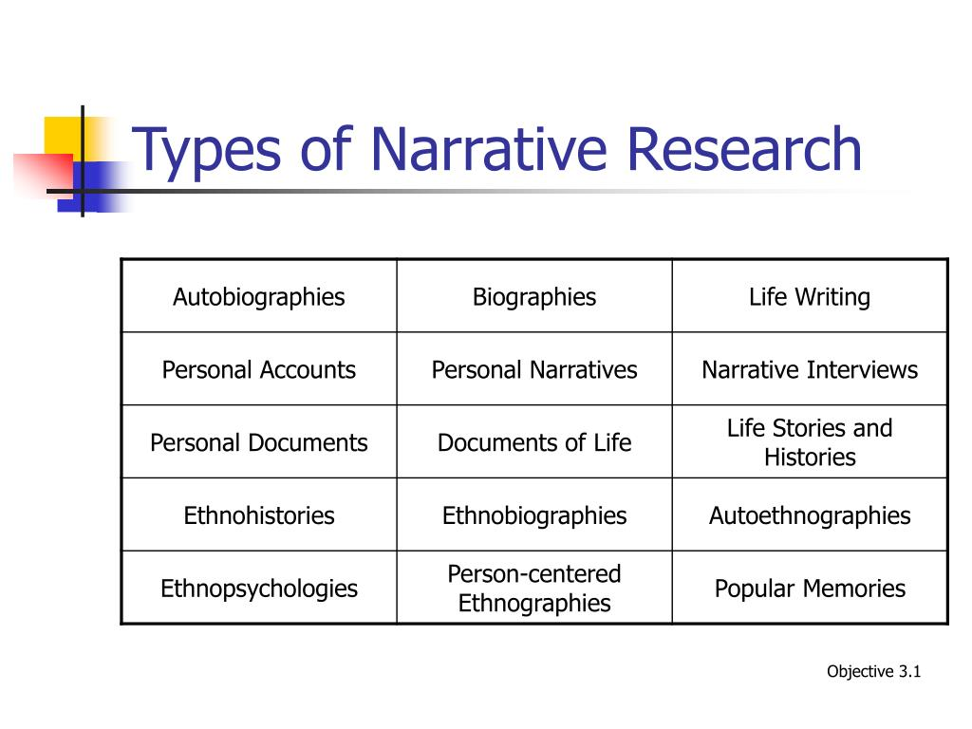

What is a Paragraph?
A paragraph is a component of fictional prose and non-fiction writings.
When writing essays, research papers, books, etc., new paragraphs are indented to show their beginnings. Each new paragraph begins with a new indentation
Paragraph definition
A paragraph is a unit of writing in a larger body of work. A paragraph expresses a particular topic or theme.
Types of paragraphs
There are four types of paragraphs that you need to know about: descriptive, narrative, expository, and persuasive. A quick search around the internet will yield other types, but to keep this simple, it's a good idea to consider just these four.
Descriptive paragraph:
This type of paragraph describes something and shows the reader what a thing or a person is like. The words chosen in the description often appeal to the five senses of touch, smell, sight, sound, and taste. Descriptive paragraphs can be artistic and may deviate from grammatical norms.
Narrative paragraph:
This type of paragraph tells a story. There's a sequence of action or there's a clear beginning, middle, and end to the paragraph.
Expository paragraph: This type of paragraph explains something or provides instruction. It could also describe a process and move the reader step by step through a method. This type of paragraph often requires research, but it's possible that the writer is able to rely on his or her own knowledge and expertise.
Persuasive paragraph:
This type of paragraph tries to get the reader to accept a particular point of view or understand the writer's position. This is the type of paragraph that many teachers focus on because it's useful when building an argument. It often requires the collection of facts and research.
The purpose of a paragraph: is to express a speaker’s thoughts on a particular point in a clear way that is unique and specific to that paragraph. In other words, paragraphs shouldn’t be mixing thoughts or ideas. When a new idea is introduced, generally, a writer will introduce a new paragraph.

10 Effective Paragraph Criteria

- Keep the paragraph on one topic.
- Include a topic sentence.
- Use supporting sentences that give details or facts about the topic.
- Include vivid words.
- Make sure it does not have run-on sentences.
- Include sentences that make sense and stick to the topic.
- Sentences should be in order and make sense.
- Write sentences that begin in different ways.
- Make sure the sentences flow.
- Be sure sentences are mechanically correct — spelling, punctuation, capitalization, indentation.
Introduction of Essay

An essay is generally a short piece of writing outlining the writer’s perspective or story. It is often considered synonymous with a story or a paper or an article. Essays can be formal as well as informal. Formal essays are generally academic in nature and tackle serious topics.

Types of Essays
The type of essay will depend on what the writer wants to convey to his reader. There are broadly four types of essays
Narrative Essays: This is when the writer is narrating an incident or story through the essay. So these are in the first person. The aim when writing narrative essays is to involve the reader in them as if they were right there when it was happening. So make them as vivid and real as possible. One way to make this possible is to follow the principle of ‘show, don’t tell’. So you must involve the reader in the story.
Descriptive Essays: Here the writer will describe a place, an object, an event or maybe even a memory. But it is not just plainly describing things. The writer must paint a picture through his words. One clever way to do that is to evoke the senses of the reader. Do not only rely on sight but also involve the other senses of smell, touch, sound etc.
A descriptive essay when done well will make the reader feel the emotions the writer was feeling at the moment.
Expository Essays: In such an essay a writer presents a balanced study of a topic. To write such an essay, the writer must have real and extensive knowledge about the subject. There is no scope for the writer’s feelings or emotions in an expository essay. It is completely based on facts, statistics, examples etc. There are sub-types here like contrast essays, cause and effect essays etc

Persuasive Essays: Here the purpose of the essay is to get the reader to your side of the argument. A persuasive essay is not just a presentation of facts but an attempt to convince the reader of the writer’s point of view. Both sides of the argument have to present in these essays.

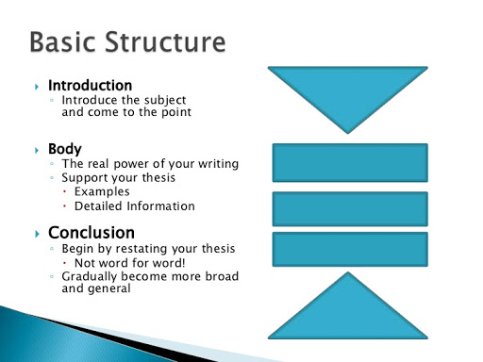
Note Taking

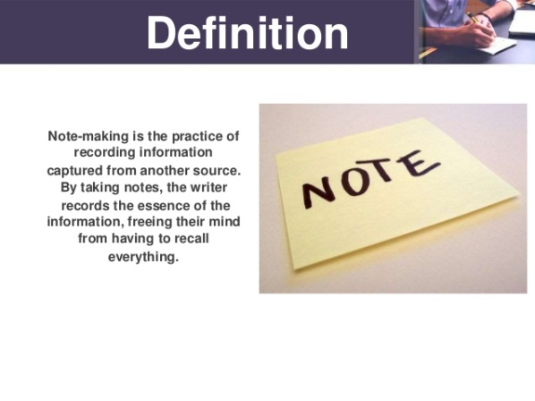
We will examine several different note-taking strategies below.
- Cornell Method. The Cornell Method for note-taking was created at Cornell University in the 1950's, and has been useful for many students in making their notes more organized. ...
- Outline Method. ...
- Charting Method. ...
- Sentence Method. ...
- Mind-Mapping Method.

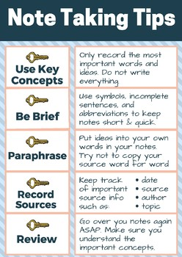
Introduction of letter writing

Letter Writing: A letter is a written message that can be handwritten or printed on paper. It is usually sent to the recipient via mail or post in an envelope, although this is not a requirement as such. Any such message that is transferred via post is a letter, a written conversation between two parties.
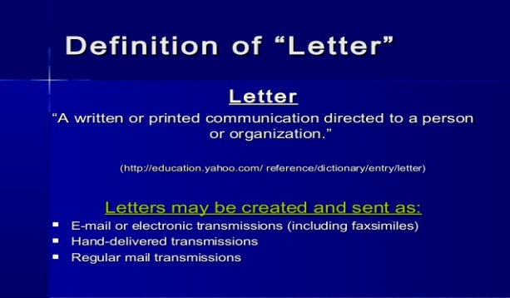

Types of Letters
Formal Letter: These letters follow a certain pattern and formality. They are strictly kept professional in nature, and directly address the issues concerned. Any type of business letter or letter to authorities falls within this given category.
Informal Letter: These are personal letters. They need not follow any set pattern or adhere to any formalities. They contain personal information or are a written conversation. Informal letters are generally written to friends, acquaintances, relatives etc.
- Business Letter: This letter is written among business correspondents, generally contains commercial information such as quotations, orders, complaints, claims, letters for collections etc. Such letters are always strictly formal and follow a structure and pattern of formalities.
- Official Letter: This type of letter is written to inform offices, branches, subordinates of official information. It usually relays official information like rules, regulations, procedures, events, or any other such information. Official letters are also formal in nature and follow certain structure and decorum.
- Social Letter: A personal letter written on the occasion of a special event is known as a social letter. Congratulatory letter, condolence letter, invitation letter etc are all social letters.
- Circular Letter: A letter that announces information to a large number of people is a circular letter. The same letter is circulated to a large group of people to correspond some important information like a change of address, change in management, the retirement of a partner etc.
- Employment Letters: Any letters with respect to the employment process, like joining letter, promotion letter, application letter etc.
Example of letter

What is a CV in writing?
Your CV, short for curriculum vitae, is a personal marketing document used to sell yourself to prospective employers. It should tell them about you, your professional history and your skills, abilities and achievements. ... A CV is required when applying for a job

How to write a CV

While your CV should be specific to your background and tailor to the job for which you're applying, there are several steps you can take to ensure you write an effective CV. Most CVs include the following information:
- Contact information
- Academic history
- Professional experience
- Qualifications and skills
- Awards and honors
- Publications
- Professional associations
- Grants and fellowships
- Licenses and certificates
- Volunteer work
- Personal information (optional)
- Hobbies and interests (optional)
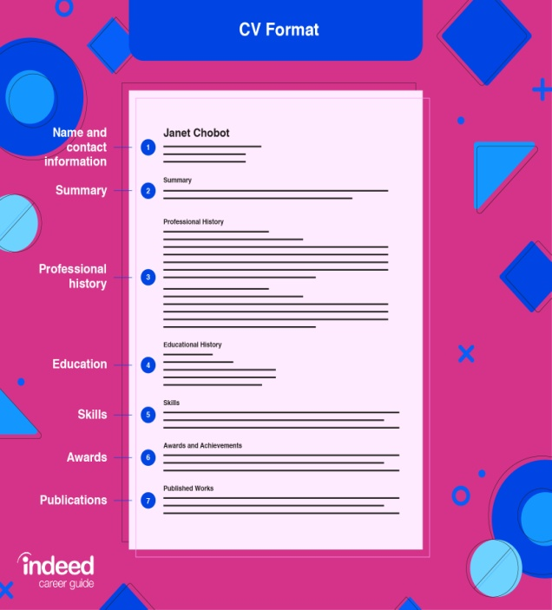
Here are seven steps for writing a simple CV:
- Include your contact information. This includes your full name, phone number and email address. Including your physical address is optional.
- Detail your academic history in reverse-chronological order. This can include your post-doctoral programs, graduate school, undergraduate school and high school. Only include your most recent two educational experiences. Dates attended is optional.
- Record your professional experience. List the company or organization, job title and dates employed starting with your most recent job. List your job duties, experience gained and achievements. Use numbers to measure your impact when possible.
- Include relevant skills and qualifications. This can be in a separate skills section. Reread the job description to highlight the most important skills employers are looking for. These can include both hard and soft skills that make you the best candidate for the job.
- List honors and awards. Use this section to outline your achievements in the field related to your application. Start with the award name followed by year awarded, the organization that gave you the award and details about the award such as how often the award is given, how many people receive it, etc.
- Include relevant publications and presentations. Include relevant citations of presentations, papers, studies, books or other publications important to your professional history. For publications, include authors, date published, summary, volume, page and DOI number. For presentations, include the title, date and location of presentation.
- List your professional associations and affiliations. This should include the name of the organization, geographic location or chapter and dates of active membership.

Introduction of Report Writing
Report Writing is a systematic writing process that requires skills, researches, and details.
The report writing process is generally a very time-consuming process and it requires a comprehensive research.
Report writing is utilizable for explaining matters or issues informing higher authorities to assist them taking a right decision in regards to the matters or issues.Main focus of the report writer is to make the whole-thing self explanatory to enlighten the readers about a matter or issue. Creativity doesn’t play a vital role in report writing.
Definition of report writing
The definition of report writing is creating an account or statement that describes in detail an event, situation or occurrence, usually as the result of observation or inquiry. The two most common forms of report writing are news report writing and academic report writing.
Types of report

Formal Report Writing
Formal Report Writing is much complicated and time-consuming. Generally, it demands an enormous research, references, lists, explanation, links and many other things.
These kinds of report writings are usually preferred for important matters, issues or incidents.. 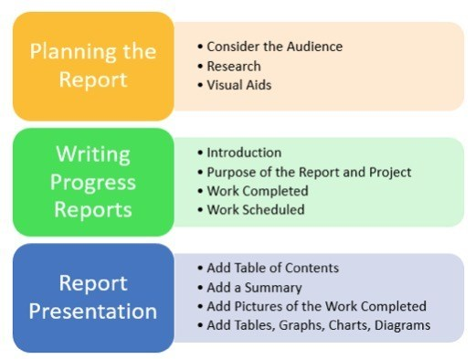

Informal Report Writing
Informal report writing is easier as compared to formal report writing. In this kind of writing, you needn’t to perform many researches.
You just need to focus on the basic things including – Introduction, Discussion & Recommendations.
This report writing has further few types, such as – Credit Report, Progress Report, Feasibility Report, Financial Report, Literary Report, Personal Evaluation and Sales Activity Report.
The purpose of mentioning the above mentioned information is to make you understand the process in an easier and better manner.

Report structure
A report is a well organized, well planned document that evaluates a subject or problem, and it may include:
- The systematic record of ordered events
- Simplification of the implication of events
- Assessment of the facts of research
- Discussion of the outcomes of a course of action
- References
- Conclusions

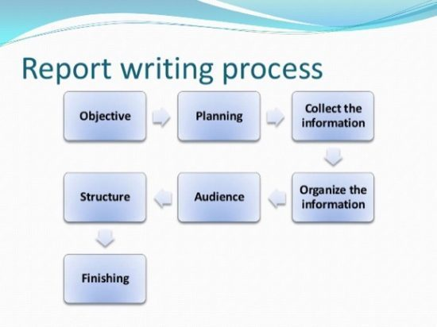
- Conculction
Students typically panic about academic writing because they feel they’ve nothing to say. This sense of mental blankness (writer’s block) is, paradoxically, caused by being aware of too many possible things you could say. If you avoid committing yourself to any particular approach, your mind is unable to form a coherent mental picture of the topic, so that it seems impossible to form a connected argument.
- It is forth language skill
- Process of writing is a natural set of steps that writers take to create a finished piece of work.
- It is a process of organizing ideas and creativity through text.
- The focus of process writing is on process, not on the end-product.
- It is useful for all skill levels, from children to published authors, to develop an authentic, creative work.
- It breaks the act of writing into manageable steps that can be taken over a period of time, rather than all at once.
- Process writing is a natural set of steps that writers take to create a finished piece of work.
- It is a process of organizing ideas and creativity through text.
- The focus of process writing is on process, not on the end-product.
- It is useful for all skill levels, from children to published authors, to develop an authentic, creative work.
- It breaks the act of writing into manageable steps that can be taken over a period of time, rather than all at once.
- The above steps do not exist in a linear way. Writers sometimes go back and forth among steps.
You have the authority to shape the writing process as it best fits YOU. It is a tool meant to serve your best interests, after all. 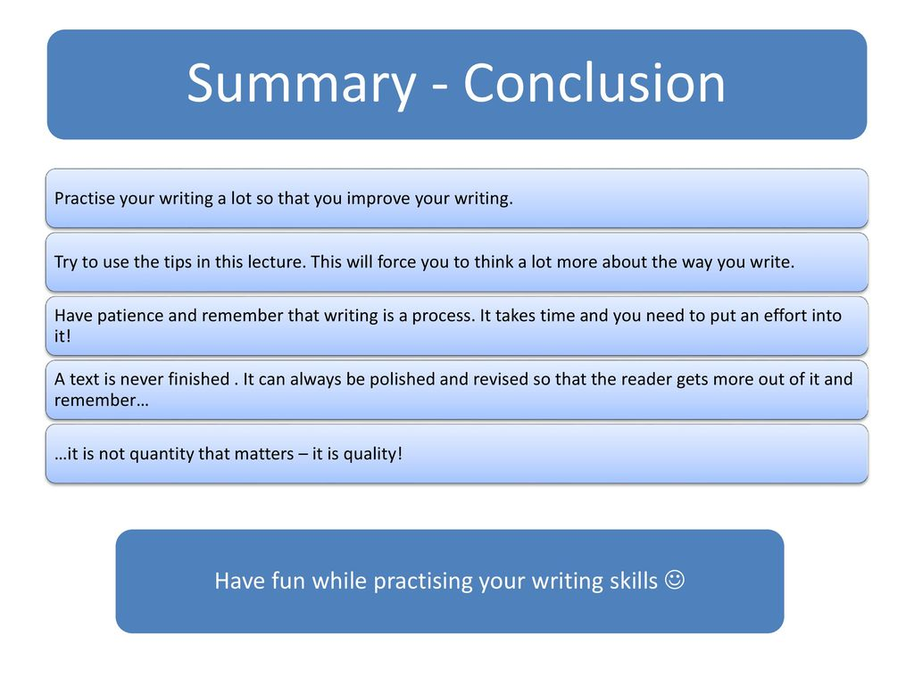

Reference:
1: https://dictionary.cambridge.org/dictionary/english/language
2:https://courses.lumenlearning.com/atd-tc3-management/chapter/different-types-of-communication/
3:https://www.toppr.com/guides/business-correspondence-and-reporting/communication/barriers-in-communication/
4:https://www.learngrammar.net/english-grammar/sentence-definition-n-types
5: https://www.learngrammar.net/english-grammar/sentence-definition-n-types
6: Oxford English Dictionary
7:https://owlcation.com/humanities/Four-Types-of-Writing
8:https://writingexplained.org/grammar-dictionary/paragraph
9:https://www.thoughtco.com/paragraph-composition-term-1691565
10;https://www.toppr.com/guides/english/writing/essay/
11:https://www.toppr.com/guides/english/writing/letter-writing/
12:https://www.indeed.com/career-advice/resumes-cover-letters/what-is-a-cv
13:https://techpatio.com/2017/guest-posts/report-writing-types

