What is sculpture?

مجسمہ بصری فنون کی شاخ ہے جو تین جہتوں میں کام کرتی ہے۔ یہ پلاسٹک آرٹس میں سے ایک ہے۔ پائیدار مجسمہ سازی کے عمل میں اصل میں پتھر ، دھات ، سیرامکس ، لکڑی اور دیگر مواد میں نقش و نگار (ماد ofی کی برطرفی) اور ماڈلنگ (مٹی کے طور پر مٹی کے اضافے) کا استعمال کیا جاتا تھا لیکن ، جدیدیت کے بعد سے ، ماد andوں کی تقریبا complete مکمل آزادی رہی ہے اور عمل مختلف قسم کے مواد کو ہٹانے کے ذریعہ کام کیا جاسکتا ہے جیسے نقش و نگار ، ویلڈنگ یا ماڈلنگ کے ذریعہ جمع ، یا مولڈ یا کاسٹ

تباہ کن ماد .وں میں فن کا کام کرنے سے پتھر کا مجسمہ کہیں بہتر رہتا ہے ، اور اکثر قدیم ثقافتوں سے رہنے والے کاموں (مٹی کے برتنوں کے علاوہ) کی اکثریت کی نمائندگی کرتا ہے ، حالانکہ لکڑی میں مجسمہ سازی کی متضاد روایات تقریبا entire ختم ہوچکی ہیں۔ تاہم ، بیشتر قدیم مجسمے کو روشن طریقے سے پینٹ کیا گیا تھا ، اور یہ کھو گیا ہے۔ [2]

متعدد ثقافتوں میں مذہبی عقیدت کا مجسمہ مرکزی حیثیت رکھتا ہے ، اور حالیہ صدیوں تک بڑے بڑے مجسمے ، جو نجی افراد کے ل too بہت مہنگے تھے ، وہ عام طور پر مذہب یا سیاست کا اظہار ہوتا تھا۔ وہ ثقافت جن کی مجسمے مقداروں سے زندہ رہ چکے ہیں ان میں قدیم بحیرہ روم ، ہندوستان اور چین کے علاوہ وسطی اور جنوبی امریکہ اور افریقہ کے بہت سے ثقافت شامل ہیں۔

قدیم یونان میں مجسمہ سازی کی مغربی روایت کا آغاز ہوا ، اور یونان کو کلاسیکی دور میں بڑے پیمانے پر شاہکار تیار کرتے دیکھا جاتا ہے۔ قرون وسطی کے دوران ، گوٹھک مجسمہ عیسائی مذہب کی اذیتوں اور جذبات کی نمائندگی کرتا تھا۔ نشا. ثانیہ میں کلاسیکی ماڈلز کی بحالی نے مشیلانجیلو کے ڈیوڈ جیسے مشہور مجسمے تیار کیے۔ جدیدیت کا مجسمہ تعمیراتی مجسمہ سازی کے ساتھ ہی روایتی عمل اور انسانی جسم کی عکاسی پر زور دیتا ہے ، اور بنی ہوئی چیزوں کو فنون لطیفہ کی پیش کش کے ساتھ پیش کرتا ہے۔

TYPES OF SCULPTURE

ایک بنیادی امتیاز گول میں مجسمے ، آزاد کھڑے مجسمے جیسے مجسمے ، کسی اور سطح سے (ممکنہ طور پر بیس پر) منسلک نہیں ہوتا ہے ، اور مختلف قسم کی راحت ، جو کم از کم جزوی طور پر کسی پس منظر کی سطح سے منسلک ہوتا ہے۔ . ریلیف اکثر دیوار سے پروجیکشن کی ڈگری کے ذریعہ کم یا باس ریلیف ، اعلی ریلیف ، اور بعض اوقات درمیانی راحت میں درجہ بندی کیا جاتا ہے۔ ڈوبی امداد - قدیم مصر تک محدود ایک تکنیک ہے۔ بڑے اعداد و شمار کے گروہوں اور بیانیے والے مضامین کے لئے راحت معمول کا مجسمہ وسیلہ ہے ، جو دور میں پورا کرنا مشکل ہے ، اور یہ معمولی تکنیک ہے جو دونوں طرح کی عمارتوں سے منسلک معماری کی مجسمہ سازی کے لئے استعمال ہوتی ہے ، اور چھوٹی سطح کی مجسمہ دیگر اشیاء کو سجانے کے لئے ، جیسا کہ زیادہ مٹی کے برتنوں ، دھاتی کاموں اور زیورات میں۔ ریلیف مجسمہ اسٹیل ، سیدھے سلیبس ، عام طور پر پتھر کی بھی سجاوٹ کرسکتا ہے ، اکثر اس میں لکھا ہوا لکھاوٹ بھی موجود ہے۔

ایک اور بنیادی امتیازی نقشہ تراشی کی تراکیب کے مابین ہے ، جو کسی موجودہ بلاک یا گانٹھ سے مواد کو ہٹا دیتے ہیں ، مثال کے طور پر پتھر یا لکڑی ، اور ماڈلنگ کی تکنیک جو مادی سے کام کو شکل دیتی ہیں یا تیار کرتی ہیں۔ کاسٹنگ ، اسٹیمپنگ اور مولڈنگ جیسی تکنیک کام کو تیار کرنے کے لئے ڈیزائن پر مشتمل انٹرمیڈیٹ میٹرکس کا استعمال کرتی ہیں۔ ان میں سے بہت ساری کاپیاں تیار کرنے کی اجازت دیتی ہیں۔

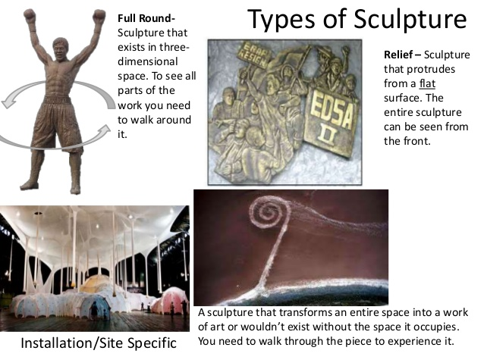
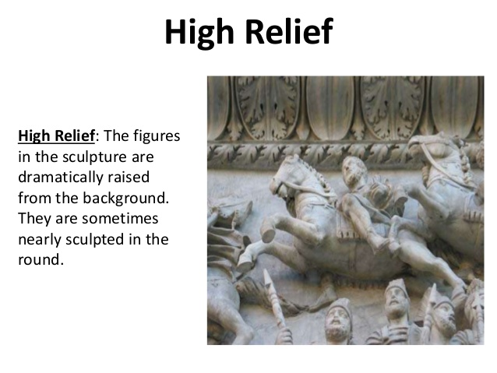
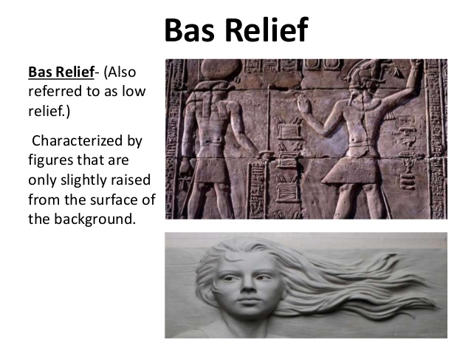
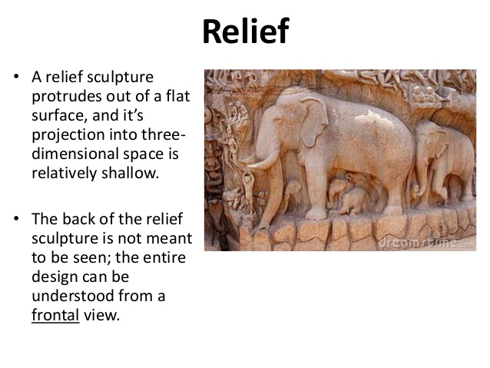

PROCESS HOW SCULPTURE BUILD
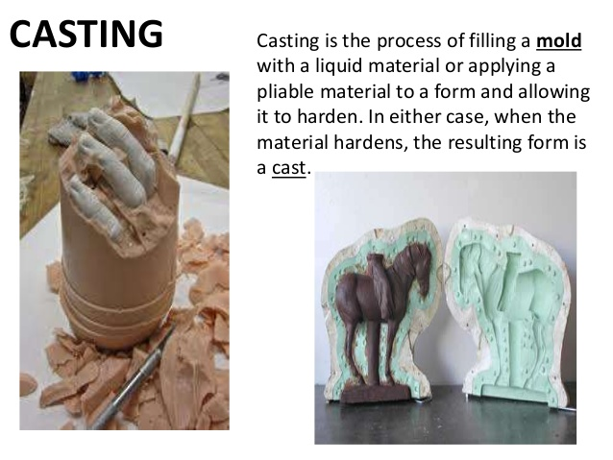

ROUND SCULPTURES

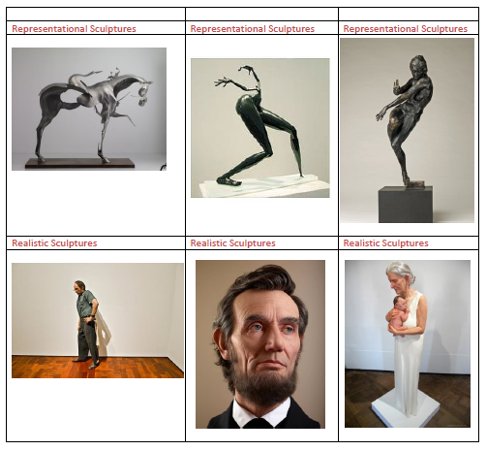

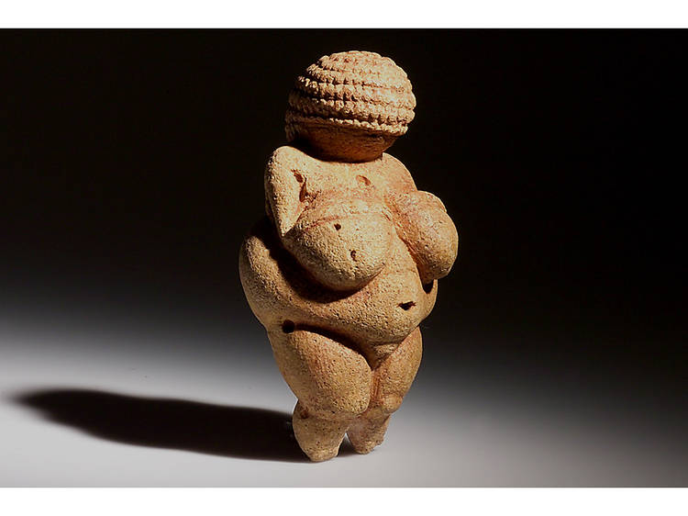

Venus of Willendorf, 28,000–25,000 BC
he ur sculpture of art history, this tiny figurine measuring just over four inches in height was discovered in Austria in 1908. Nobody knows what function it served, but guesswork has ranged from fertility goddess to masturbation aid. Some scholars suggest it may have been a self-portrait made by a woman. It’s the most famous of many such objects dating from the Old Stone Age.

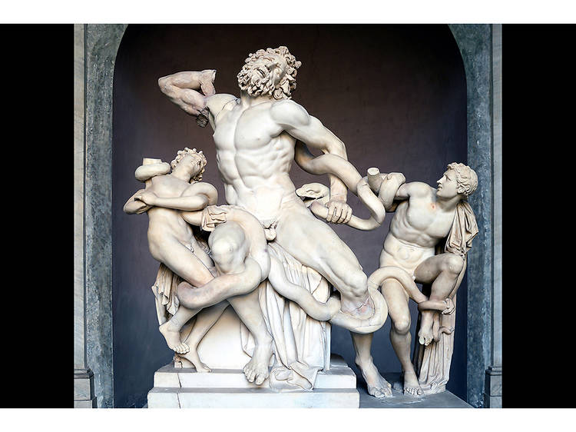

Laocoön and His Sons, Second Century BC
Perhaps the most famous sculpture of Roman antiquity, Laocoön and His Sons was originally unearthed in Rome in 1506 and moved to the Vatican, where it resides to this day. It is based on the myth of a Trojan priest killed along with his sons by sea serpents sent by the sea god Poseidon as retribution for Laocoön’s attempt to expose the ruse of the Trojan Horse. Originally installed in the palace of Emperor Titus, this life-size figurative grouping, attributed to a trio of Greek sculptors from the Island of Rhodes, is unrivaled as a study of human suffering.

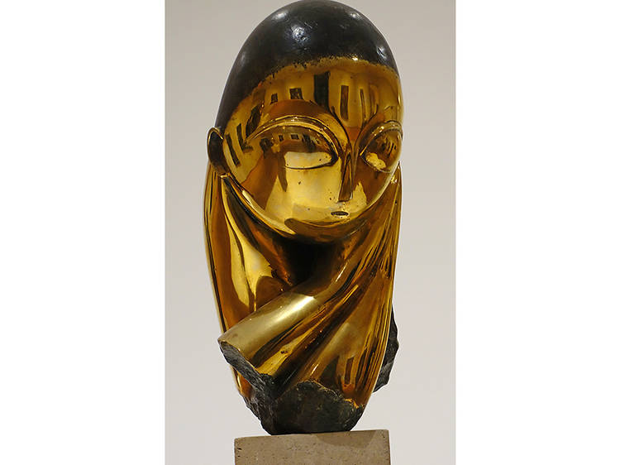

Gian Lorenzo Bernini, Ecstasy of Saint Teresa, 1647–52
Acknowledged as an originator of the High Roman Baroque style, Gian Lorenzo Bernini created this masterpiece for a chapel in the Church of Santa Maria della Vittoria. The Baroque was inextricably linked to the Counter-Reformation through which the Catholic Church tried to stem the tide of Protestantism surging across 17th-century Europe. Artworks like Bernini’s was part of the program to reaffirm Papal dogma, well served here by Bernini’s genius for imbuing religious scenes with dramatic narratives. Ecstasy is a case in point: Its subject—Saint Teresa of Ávila, a Spanish Carmelite nun and mystic who wrote of her encounter with an angel—is depicted just as the angel is about to plunge an arrow into her heart. Ecstasy’s erotic overtones are unmistakable, most obviously in the nun’s orgasmic expression and the writhing fabric wrapping both figures. An architect as all as an artist, Bernini also designed the setting of the Chapel in marble, stucco and paint.

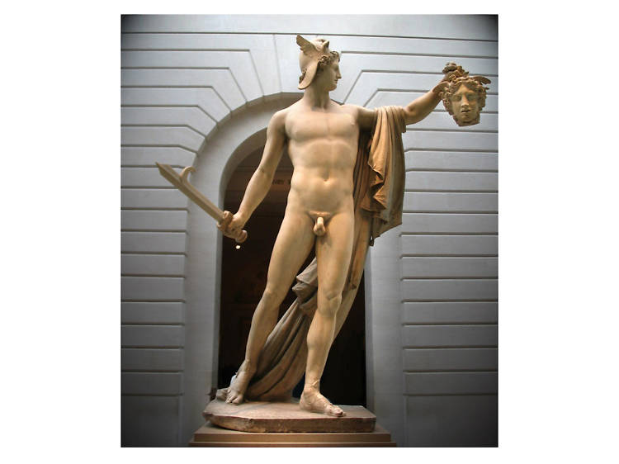

Antonio Canova, Perseus with the Head of Medusa, 1804–6
Italian artist Antonio Canova (1757–1822) is considered to be the greatest sculptor of the 18th-century. His work epitomized the Neo-Classical style, as you can see in his rendition in marble of the Greek mythical hero Perseus. Canova actually made two versions of the piece: One resides at the Vatican in Rome, while the other stands in the Metropolitan Museum of Art’s European Sculpture Court.

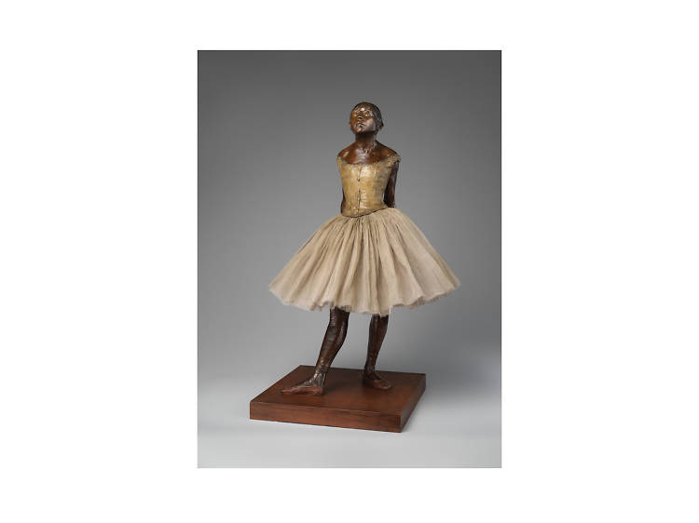

Edgar Degas, The Little Fourteen-Year-Old Dancer, 1881/1922
While Impressionist master Edgar Degas is best known as a painter, he also worked in sculpture, producing what was arguably the most radical effort of his oeuvre. Degas fashioned The Little Fourteen-Year-Old Dancer out of wax (from which subsequent bronze copies were cast after his death in 1917), but the fact that Degas dressed his eponymous subject in an actual ballet costume (complete with bodice, tutu and slippers) and wig of real hair caused a sensation when Dancer debuted at the Sixth Impressionist Exhibition of 1881 in Paris. Degas elected to cover most of his embellishments in wax to match the rest of girl’s features, but he kept the tutu, as well as a ribbon tying backing her hair, as they were, making the figure one of the first examples of found-object art. Dancer was the only sculpture that Degas exhibited in his lifetime; after his death, some 156 more examples were found languishing in his studio.

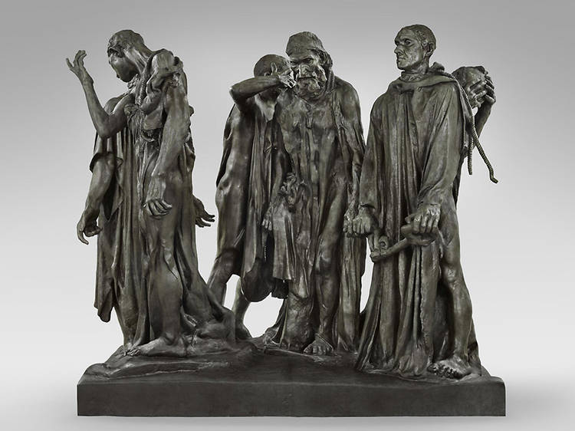

Auguste Rodin, The Burghers of Calais, 1894–85
While most people associate the great French sculptor Auguste Rodin with The Thinker, this ensemble commemorating an incident during the Hundred Years' War (1337–1453) between Britain and France is more important to the history of sculpture. Commissioned for a park in the city of Calais (where a year-long siege by the English in 1346 was lifted when six town elders offered themselves up for execution in exchange for sparing the population), The Burghers eschewed the format typical of monuments at the time: Instead of figures isolated or piled into a pyramid atop a tall pedestal, Rodin assembled his life-size subjects directly on the ground, level with the viewer. This radical move toward realism broke with the heroic treatment usually accorded such outdoor works. With The Burghers, Rodin took one of the first steps toward modern sculpture.

Antony Gormley, The Angel of the North, 1998
Winner of the prestigious Turner Prize in 1994, Antony Gormley is one of the most celebrated contemporary sculptors in the UK, but he’s also known the world over for his unique take on figurative art, one in which wide variations in scale and style are based, for the most part, on the same template: A cast of the artist’s own body. That’s true of this enormous winged monument located near the town of Gateshead in northeastern England. Sited along a major highway, Angel soars to 66 feet in height and spans 177 feet in width from wingtip to wingtip. According the Gormley, the work is meant as a sort of symbolic marker between Britain’s industrial past (the sculpture is located in the England’s coal country, the heart of the Industrial Revolution) and its post-industrial future.

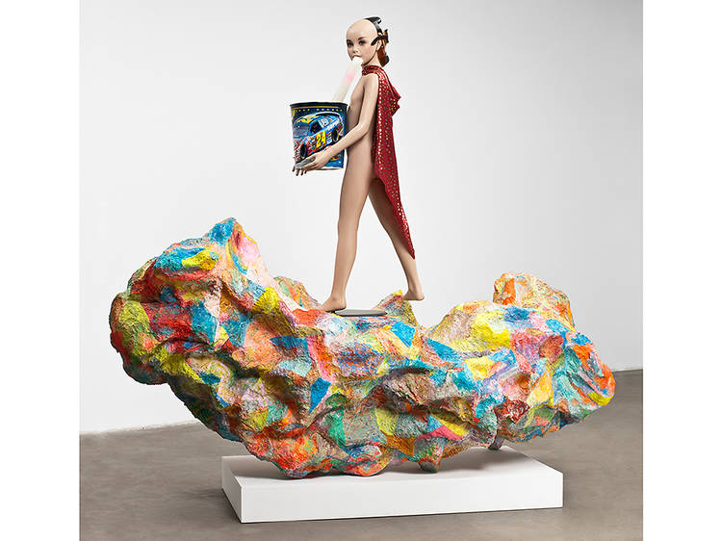

Rachel Harrison, Alexander the Great, 2007
Rachel Harrison’s work combines a consummate formalism with a knack for imbuing seemingly abstract elements with multiple meanings, including political ones. She fiercely questions monumentality and the masculine prerogative that goes with it. Harrison creates the bulk of her sculptures by stacking and arranging blocks or slabs of Styrofoam, before covering them in a combination of cement and painterly flourishes. The cherry on top is some sort of found object, either alone or in combination with others. A prime example is this mannequin atop an elongated, paint-splashed form. Wearing a cape, and a backwards-facing Abraham Lincoln mask, the work sends up the great man theory of history with its evocation of the Ancient World’s conqueror standing tall on a clown-colored rock.

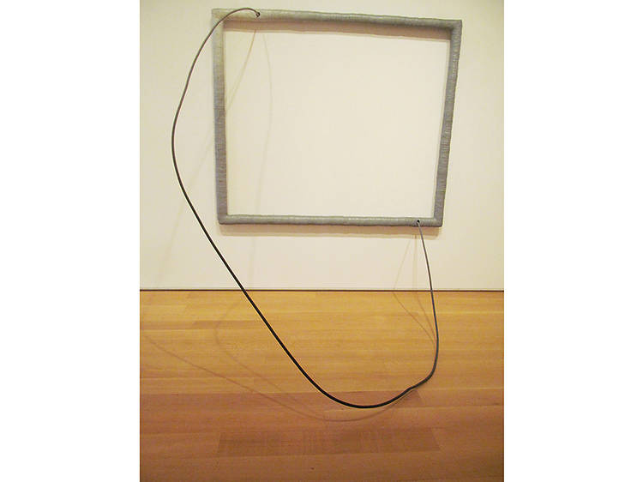

Eva Hesse, Hang Up, 1966
Like Benglis, Hesse was a woman artist who filtered Postminimalism through an arguably feminist prism. A Jew who fled Nazi Germany as a child, she explored organic forms, creating pieces in industrial fiberglass, latex and rope that evoked skin or flesh, genitals and other parts of the body. Given her background, it’s tempting to find an undercurrent of trauma or anxiety in works such as this one.

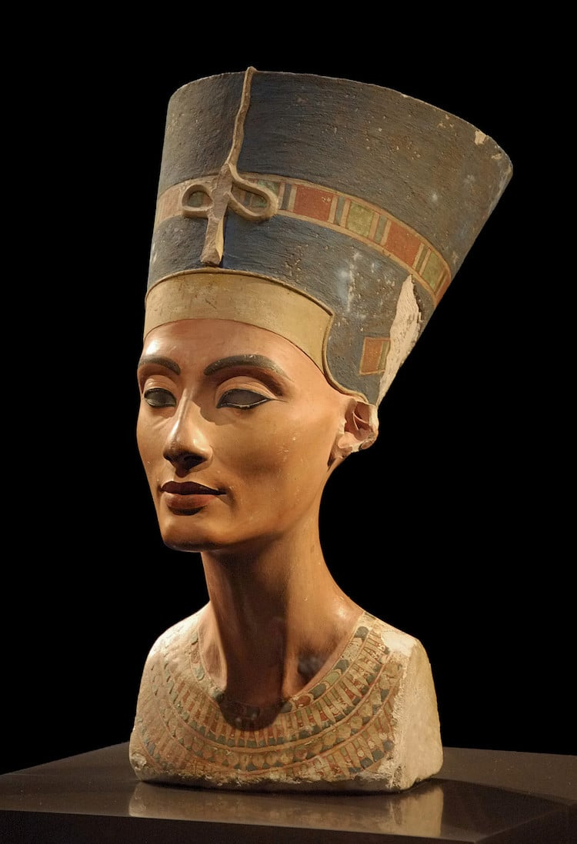

BUST OF NEFERTITI BY THUTMOSE (1345 BC)
This painted limestone bust, now in the Neues Museum in Berlin, is a beautiful portrait of Nefertiti, the Great Royal Wife of the Egyptian pharaoh Akhenaten. Found in the workshop of an artist named Thutmose, his iconic rendering made Nefertiti a symbol of ideal feminine beauty for centuries to come.

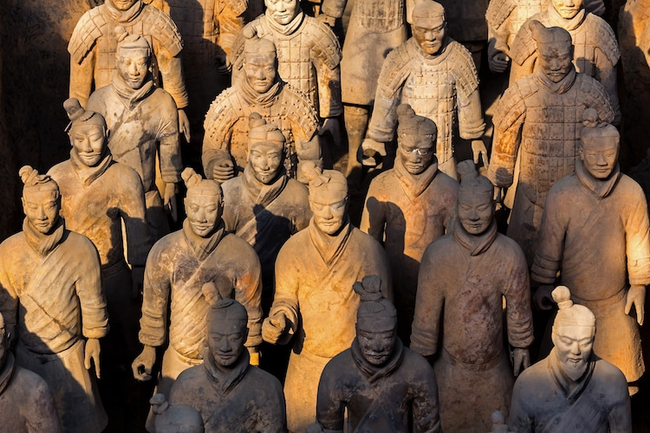

TERRACOTTA WARRIORS (LATE 3RD CENTURY BC)

This collection of sculptures in Xi’an, China depicts the army of Qin Shi Huang, the first Emperor of China. Counted among the terracotta figures are 8,000 soldiers, 130 chariots, and 670 horses. The figures are an incredible example of funerary art, created to guard to Emperor in the afterlife. They were only discovered in 1974 when farmers digging a well happened upon them in a location almost 1 mile from the Emperor’s tomb. Portions of the collection are often part of traveling exhibitions around the world and the mausoleum in Xi’an has been a World Heritage Site since 1987. The works have inspired everything from 3D sidewalk art to pizza dough sculptures.

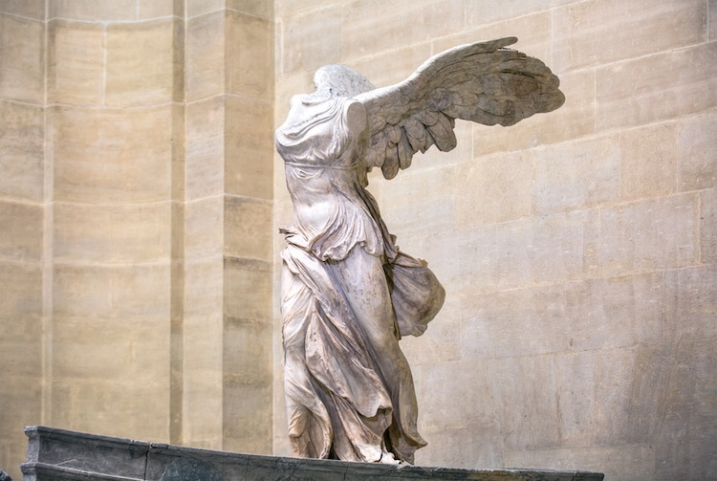

NIKE OF SAMOTHRACE (C.190 BC)
Located in the Louvre, the Winged Victory of Samothrace or Nike of Samothrace is an iconic example of Hellenistic Greek sculpture. Depicting Nike, the Greek goddess of victory, it is one of the few remaining Hellenistic sculptures that is a Greek original and not a later Roman copy. With her clothes clinging to her body, the goddess triumphantly moves forward as though on the prow of a ship leading troops to victory. One of the most famous sculptures in history, it would later influence Umberto Boccioni’s Unique Forms of Continuity in Space.
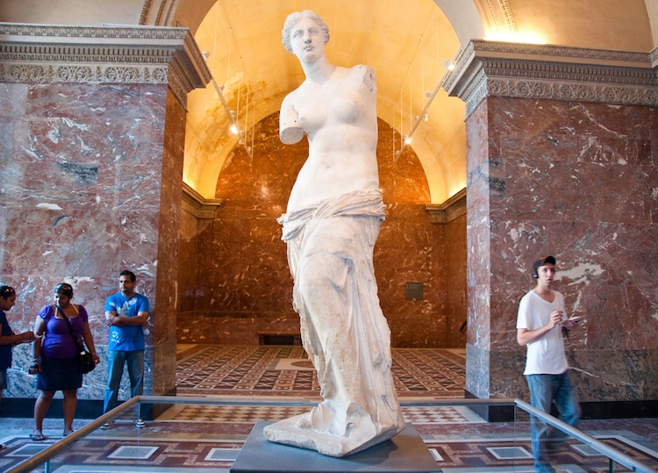

VENUS DE MILO (C.130 BC)
Also located in the Louvre, the Venus de Milo is also known as the Aphrodite of Milos and is thought to depict Aphrodite, the Greek goddess of love. The marble sculpture stands 6 feet 8 inches tall and is known for its missing arms. As any limbs were in peril of breaking off over time, it’s not uncommon for ancient sculpture to be missing their limbs. The world famous sculpture was found on the Greek island of Milos in 1820 by a peasant, who discovered it fractured into two pieces. The work has long influenced artists, including Dalí, who created the Venus de Milo with Drawers in 1936.
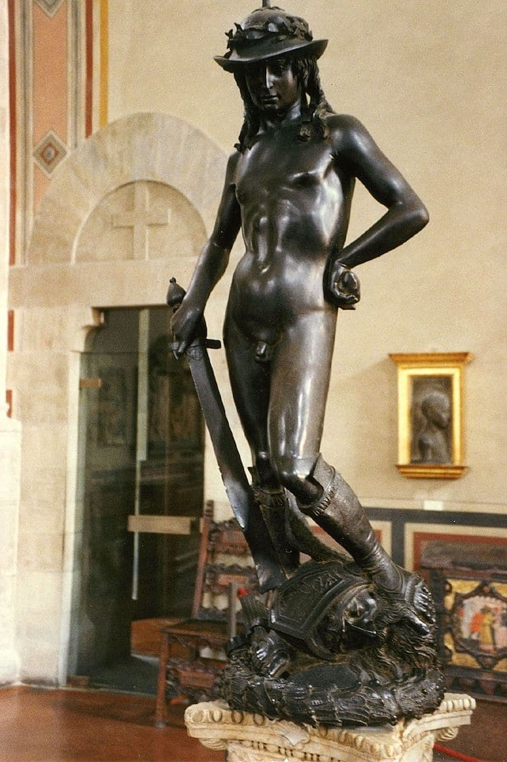

DAVID BY DONATELLO (1430-1440)
Almost 100 years before Michelangelo’s David, Italian Renaissance sculptor Dontaello created another iconic version of the Biblical tale. Cast in bronze, Donatello’s David is younger and more contemplative, having just slain Goliath. In fact, Donatello cleverly uses Goliath’s head and David’s sword as supports for the structure. The sculpture caused a scandal at the time, as David is nude except for his boots, and was considered so naturalistic it was disturbing. The early Renaissance sculpture has the distinction of being both the first unsupported bronze cast sculpture, as well as the first freestanding male nude since antiquity.

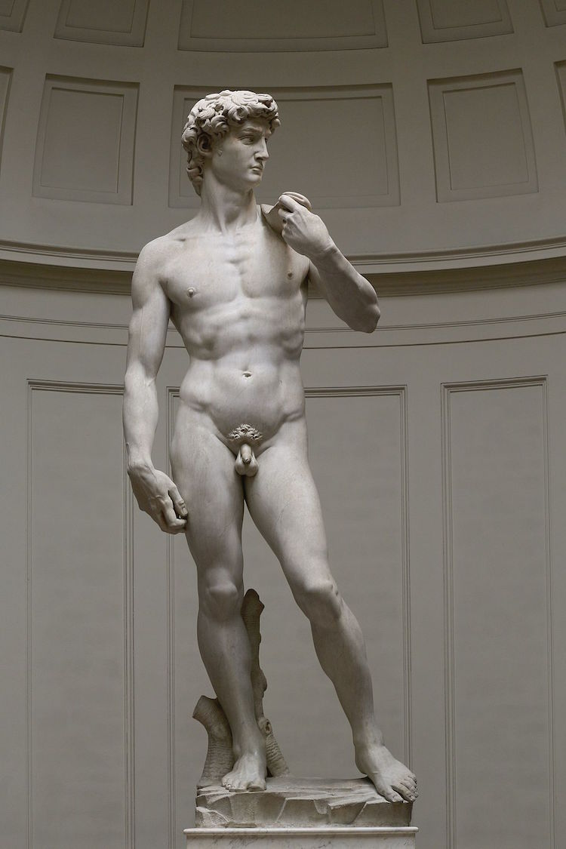

DAVID BY MICHELANGELO (1501-1504)
Originally commissioned for the roof of Florence’s cathedral, Michelangelo was only 26 years old when he won the job. One of the most iconic sculptures in history, Michelangelo’s oversized David is calm and collected, with his slingshot slung over his shoulder, confidently waiting to take on Goliath. Michelangelo’s skill is demonstrated in his attention to detail, from the bulging veins in David’s hand to the mastery of contrapposto in his pose.

STATUE OF LIBERTY, DESIGNED BY FRÉDÉRIC AUGUSTE BARTHOLDI AND BUILT BY GUSTAVE EIFFEL (1876-1886)
Known to symbolize freedom in the United States, the Statue of Liberty is a copper statue that was a gift from the French government and shows a robbed figure representing the Roman goddess Libertas. In her arms, she holds a tablet with the date of the US Declaration of Independence. The idea for the gift was dreamed up by Édouard René de Laboulaye, president of the French Anti-Slavery Society, to celebrate and honor the Union victory in the Civil War and the abolition of slavery. The green patina now associate with the celebrated sculpture only appeared after 1900 as the copper oxidized.

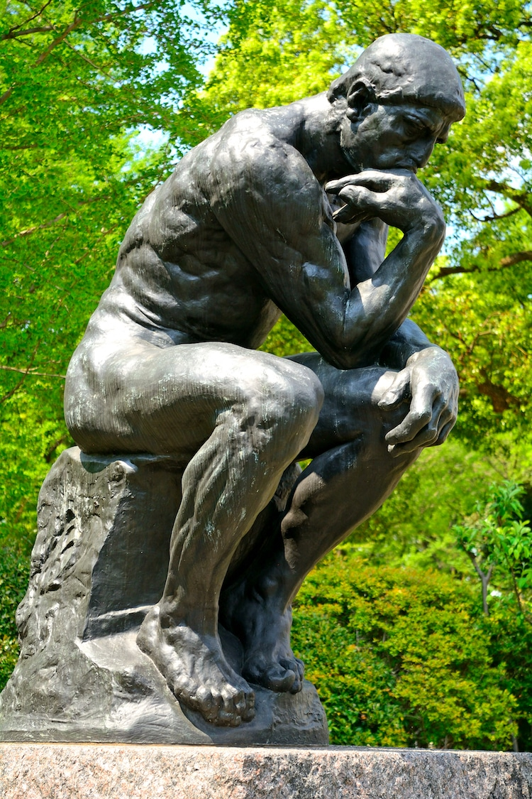

THE THINKER BY RODIN (1880, CAST IN 1904)
This masterpiece by French sculptor Auguste Rodin was originally titled The Poet and was actually meant to be part of a larger composition called The Gates of Hell. The Thinker was actually retitled by foundry workers who found similarities with Michelangelo’s sculpture Il Penseroso (The Thinker) and became an independent work of art. The celebrated sculpture has been cast multiple times, with 28 full figure castings, though many not made during Rodin’s lifetime. The Musée Rodin has the honor of displaying the first full-scale cast of this figure, often used to represent philosophy.

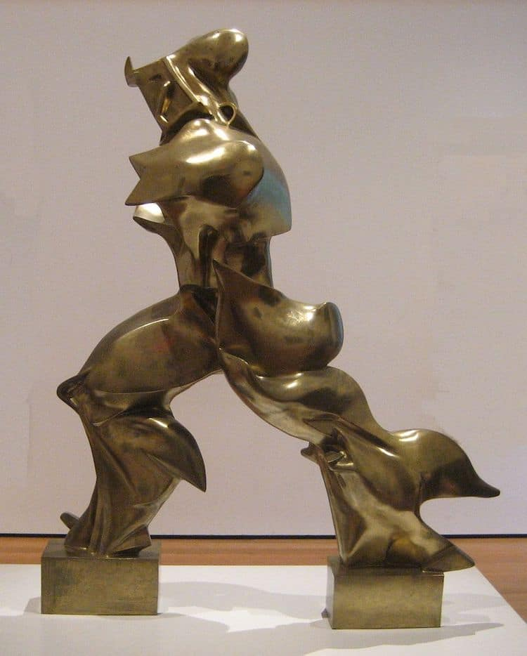

UNIQUE FORMS OF CONTINUITY IN SPACE BY UMBERTO BOCCIONI (1913, CAST IN 1931)
Though he died at 33, Italian artist Umberto Boccioni had an enormous impact on the art world. Helping shape the aesthetics of the Futurist movement, he was interested in the dynamism of form and deconstructing solid shapes. Now located in New York’s MoMA, his Unique Forms of Continuity in Space is the apex of his ideas. Suggesting a windswept movement, the sleek bronze at once embraces modern machinery, yet is also a nod to the ancient past. Bursting with energy, it fulfills Boccioni’s wish, “Let us fling open the figure and let it incorporate within itself whatever may surround it.”

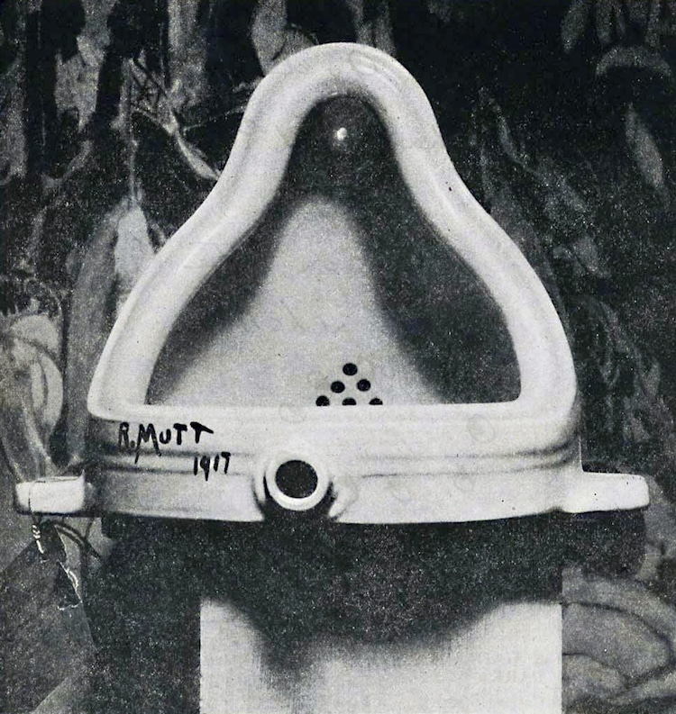

FOUNTAIN BY DUCHAMP (1917)
Marcel Duchamp turned the artwork on its ear with his readymade Fountain, a porcelain urinal. The Dada artist first submitted the work to the Society of Independent Artists for an exhibition in New York, but it was rejected. The original, then photographed by Alfred Stieglitz in this studio, is now lost, but Duchamp commissioned numerous replicas in the 1960s that still exist. With this groundbreaking work, Duchamp challenges us to think about whether or not traditional concepts of craftsmanship or aesthetics are important when considering something art.

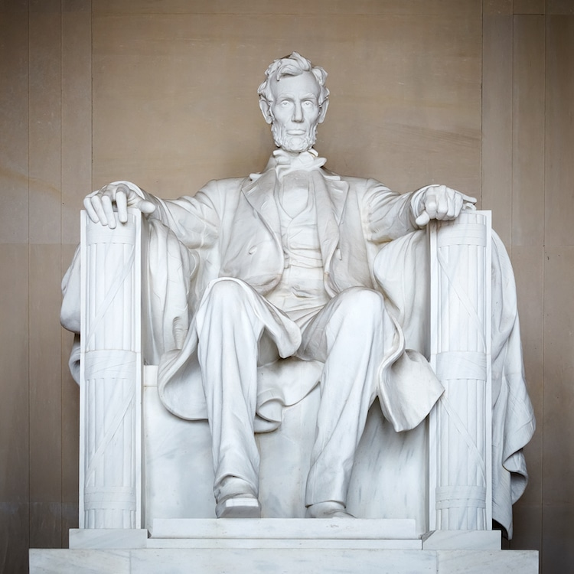

LINCOLN MEMORIAL, DESIGNED BY DANIEL CHESTER FRENCH & CARVED BY THE PICCIRILLI BROTHERS (1920)

Originally designed to be 10 feet tall, this marble sculpture of the 16th president of the United States was enlarged to 19 feet from head to foot. It depicts Lincoln in contemplation, sitting inside the majestic temple structure that forms the rest of the Lincoln Memorial. From the 1930s, the space has gained importance as a symbol of race relations in the United States.

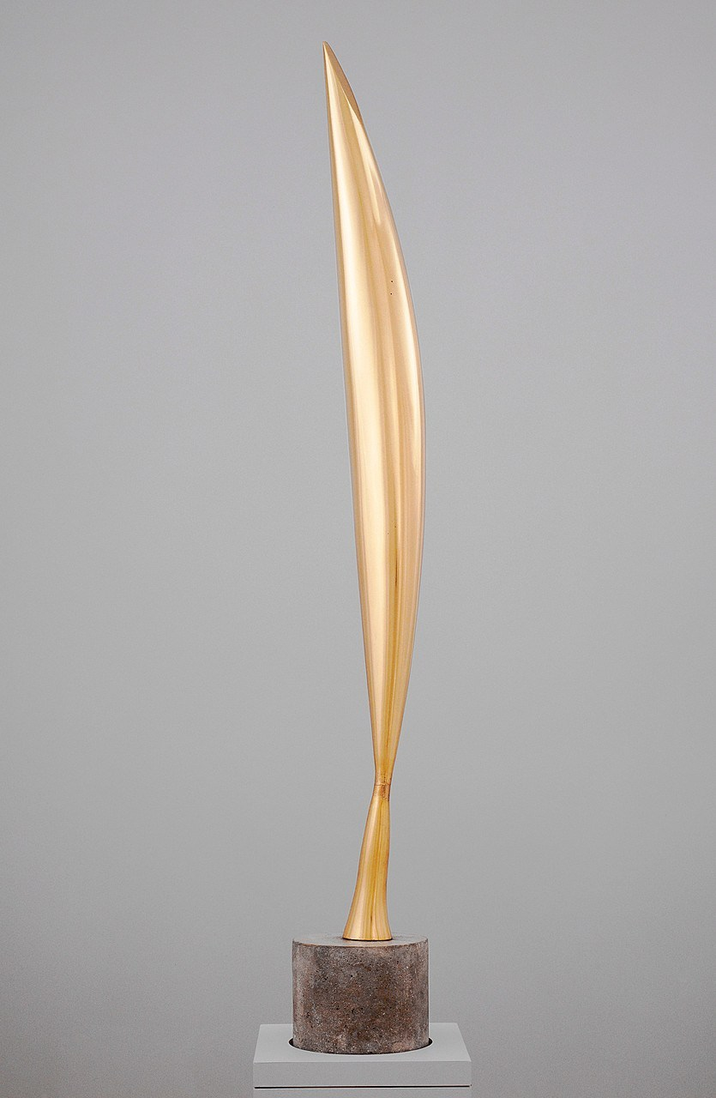

BIRD IN SPACE BY CONSTANTIN BRANCUSI (1923)

Bird in Space is a series of sculptures by Romanian artist Constantin Brancusi, the first being cast in 1923. Seven are made of marble and nine are cast in bronze. Rather than focus on a physical depiction of a bird, Brancusi wished to depict a feeling of movement. Stripping the animal of its wings and feathers, and elongating its beak and midsection, the sleek form emerges. A masterclass in symmetry and harmony, the sculpture set a record in 2005, when it was sold at auction for $23.5 million. At the time, it was a record high for a piece of sculpture. Currently, the original marble version is at the Metropolitan Museum of Art in New York.

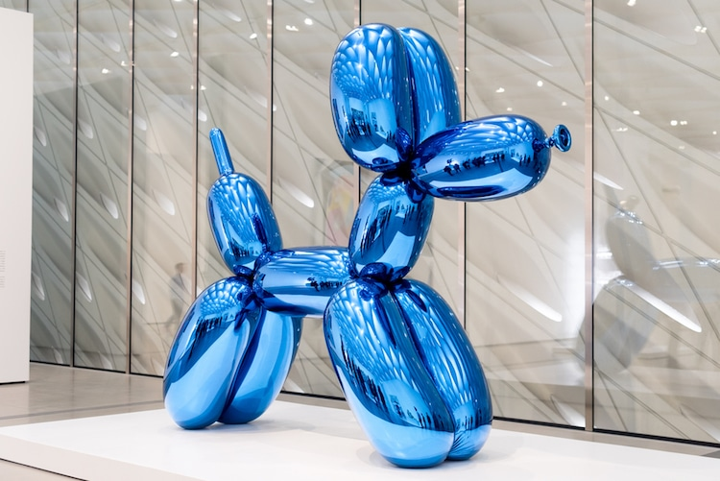

BALLOON DOG BY JEFF KOONS (1994-2000)
Love him or hate him, Jeff Koons is responsible for some of the most memorable art of the 20th century. In 2013, his Balloon Dog (Orange), made of stainless steel with a transparent coating, set a record for a living artist when it sold at Christie’s for $58.4 million in 2013. Part of a series that transforms a playful child’s party favor into a monumental sculpture, Koons also created other versions in blue, magenta, red, and yellow.
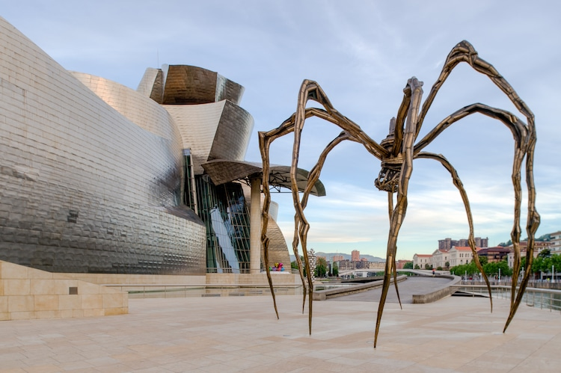

MAMAN BY LOUISE BOURGEOIS (1999, CAST IN 2001)
Standing over 30 feet high, Bourgeois’ Maman at the Guggenheim in Bilbao is a masterpiece that marries physical and psychological power. Impressive in its size, the large spidery sculpture is associated with the artist’s own mother, who worked repairing tapestries. We see the spider, protecting fiercely her sac of 26 marble eggs, provokes fear through her size, but vulnerability through the stilt-like legs, which could seemingly topple at any moment. The spider is a recurring theme in Bourgeois’ work, first featuring in drawings in 1947 and continuing throughout her career, including the 1996 sculpture Spider.
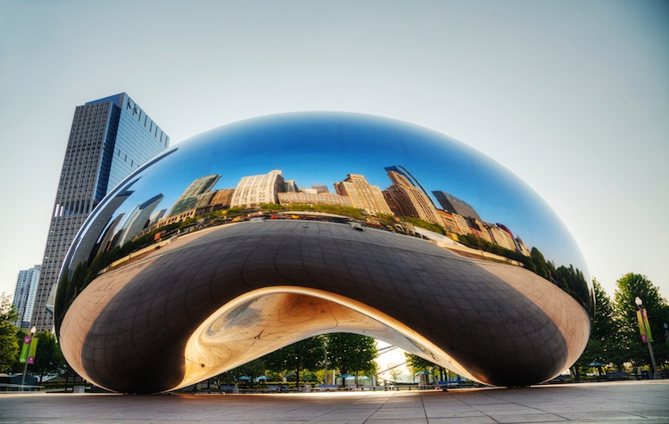

CLOUD GATE BY ANISH KAPOOR (2004)
When he’s not stirring controversy by exclusively licensing the blackest black paint on the planet, Anish Kapoor is known for his headline-making sculpture. One of his most well-known pieces, Cloud Gate in Chicago’s Millenium Park, was inspired by liquid mercury. Kapoor won the commission after submitting to a design contest, and though the design was controversial—many believed the seamless design was impossible to construct and upkeep—it’s now become a beloved part of the city.

KINETIC SCULPTURES

CONTEMPORARY SCULPTURES
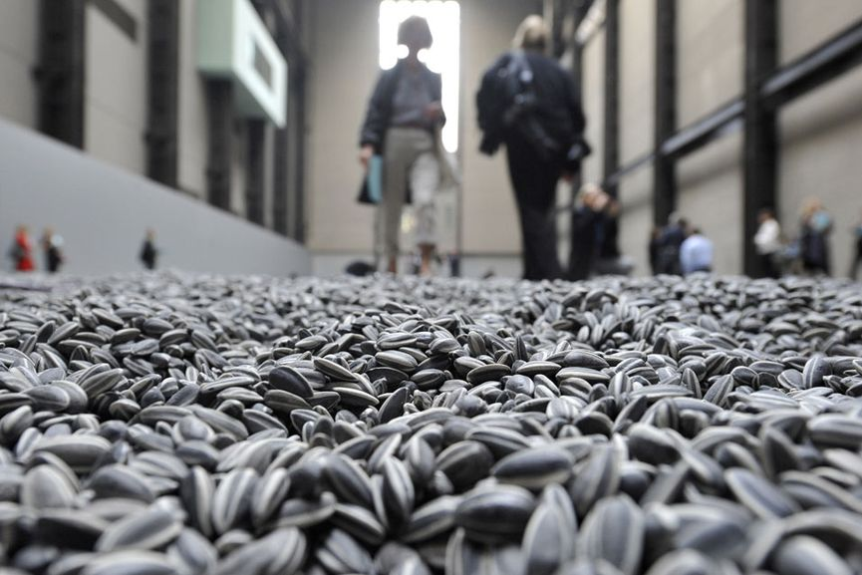

Ai Weiwei - The Dissident
One of the most controversial figures associated with installation art is certainly Ai Weiwei. Expanding the definition of art to include new forms of social engagement, his dramatic actions highlight the widening gap between the ideal and the real in Chinese society. Some of his most memorable pieces are the installation Remembering where he campaigned to bring justice to the victims of the 2008 earthquake in Sichuan, the installation Sunflower Seeds consisted of 100 million porcelain seeds made by 1600 artisans commenting on the mass production and consumption, and lately a controversial piece addressing the plight of Syrian immigrants.

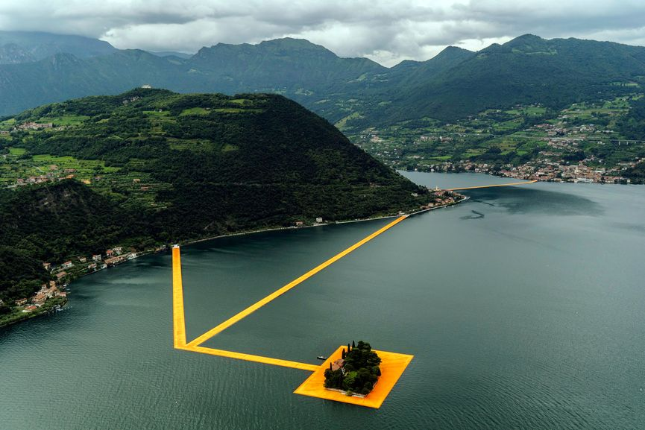

Christo - Enhancing the Genre of Land Art
Christo and his wife Jeanne-Claude enhanced the genre of land art, presenting a different approach to the environment and raising our expectations of it. Creating large-scale installations such as wrapping of the Reichstag in Berlin, Running Fence in Sonoma and The Gates in New York City’s Central Park, they have repeatedly rejected all theories that their projects contain any kind of deeper meaning other than their immediate aesthetic impact. After an artistic and personal relationship that lasted over fifty years, Jeanne-Claude died in 2009. Christo continued working, and this year, he created the most ambitious project ever. Conceived by the couple, but executed by Christo alone, Floating Piers was a monumental installation in Italy that consisted of 3 kilometers long runway that floats on water, allowing people to walk freely across it.

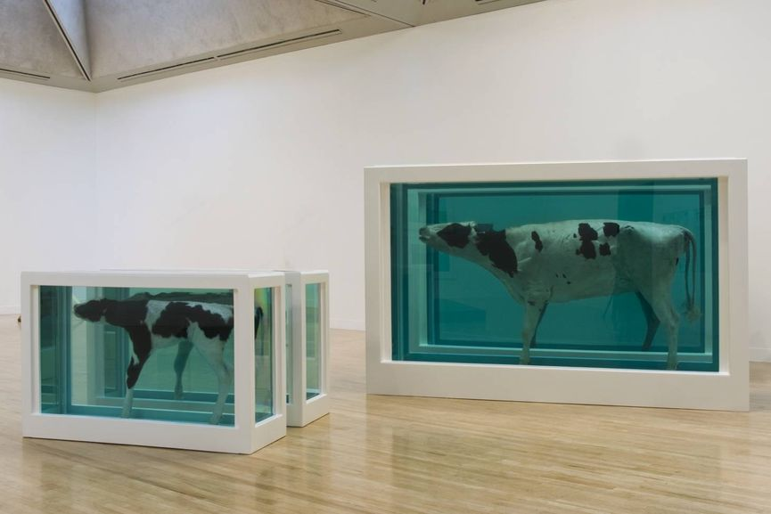

Damien Hirst - The Enfant Terrible
The wealthiest living British artist, Damien Hirst is a self-styled enfant terrible of contemporary art. Fusing any person’s biggest questions and concerns, his works explore the idea of death, how it fits into life, and how both of these interact with art. The piece A Thousand Years from 1991 that portrayed a dead cow’s head in a tank being consumed by maggots and flies, was the first of its kind, launching Hirst straight into the limelight of the artistic world of the 1990s. Involving an entire zoo of dead animals, his famous series Natural History included various preserved creatures placed in steel and glass tanks filled with formaldehyde solution. The piece from this series The Physical Impossible of Death in the Mind of Someone Living became representative of British art of the 20th century.

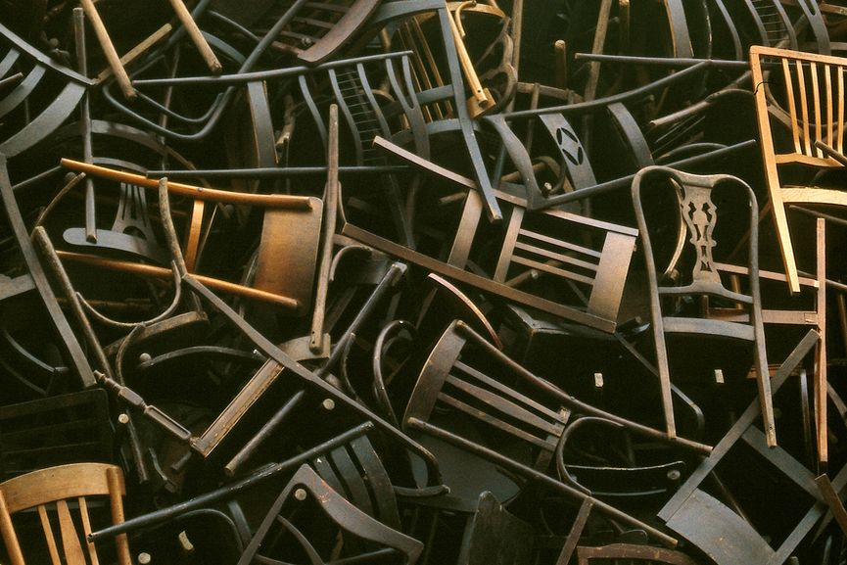

Doris Salcedo - Exploring Political and Mental Archeology
Sculptures and installations of Doris Salcedo function as political and mental archeology. Using domestic materials charged with different meanings, she depicts burdens and conflicts with precise economical means. Researching Columbia’s recent political history, her early sculptures such as La Casa Vuida combined domestic furniture with textiles and clothing directly linked to personal and political tragedy. Recently, her works became increasingly installation-based, turning the gallery space into vertiginous environments charged with politics and history. The piece Noviembre 6 y 7 from 2002 commemorating the seventeenth anniversary of the violent seizing of the Supreme Court in Bogota involved wooden chairs that were slowly lowered against the facade of the new Palace of Justice building. This created “an act of memory” that re-inhabited the space of forgetting.

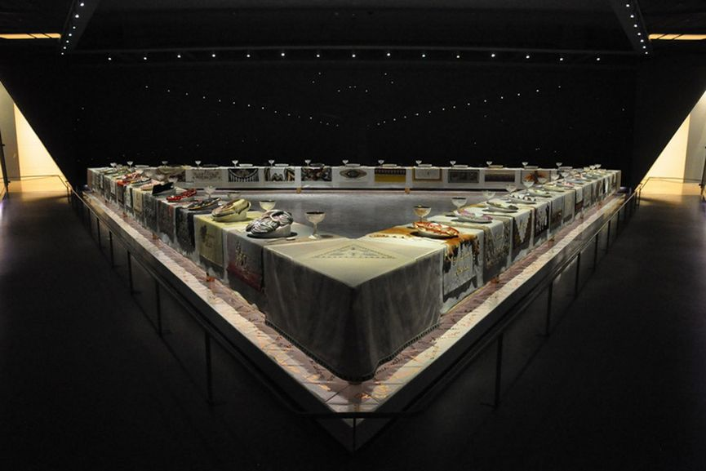

Judy Chicago - The Pioneer of the Feminist Movement
An American artist, art educator and writer, Judy Chicago is best known for her large collaborative art installation pieces which examine the role of women in history and culture. As one of the pioneers of the Feminist Art Movement in the 1970s, she called attention to women’s roles as artists and aimed to alter the conditions under which art was produced and received. As an attempt to redress women’s traditional underrepresentation in the visual arts, she placed the female subject in the center of her practice. Her most celebrated piece The Dinner Party from 1979 celebrated the achievements of women throughout history, featuring explicit vaginal imagery. She also employed “domestic” and “feminine” arts such as needlework and embroidery, introducing them to the world of high art.

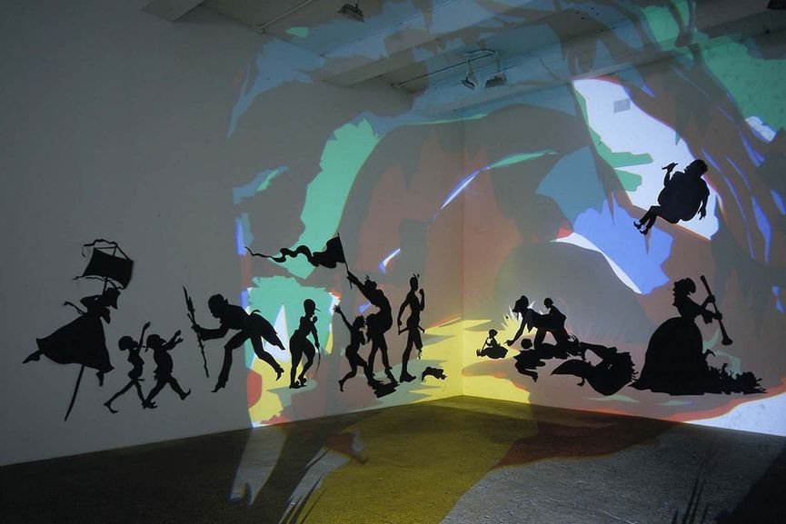

Kara Walker - Exploring the History of Racism
An African-American installation and conceptual artist, Kara Walker has been exploring the history of the American South with her wall-sized cut paper silhouettes. Exploring and illustrating histories of racism, these vignettes are drawn from various sources such as historical novels or slave testimonials. Using imagery of mammies, pickninnies, sambos and other racial stereotypes, these silhouettes present a powerful metaphor which she describes as something that “says a lot with very little information”. She invites the public to explore the origins of racial inequality, but also the vast social and economic inequalities that persist in America. Relying on humor and viewer interaction, her works are deeply engaging.

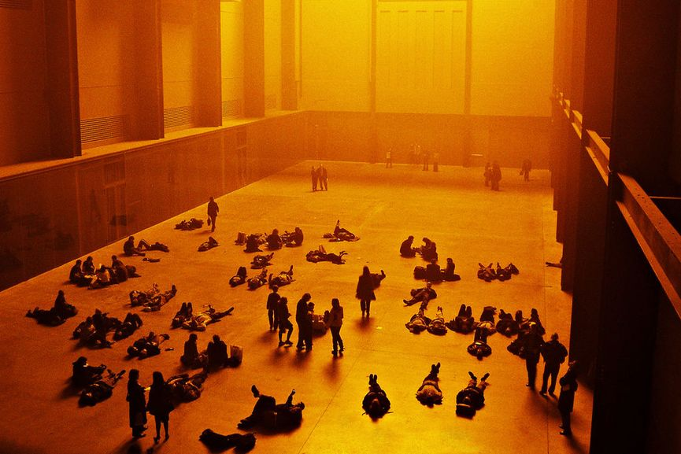

Olafur Eliasson - Taking Responsibility
Working with the purpose of turning thinking into doing, the art of Olafur Eliasson is relevant to the individual as well as the public. Concerned with the environment and its safety, he uses natural elements such as light, water, air temperature and fog with makeshift technical devices to transform museum galleries and public areas into immersive environments. One of his most famous works is The Weather Project from 2008 when Eliasson installed a giant artificial sun inside the Tate Modern. Among his famous art installations created outdoors, the project Green River included dying the rivers of Moss, Los Angeles, Bremen, Tokyo, and Stockholm with nontoxic powder to remind their inhabitants of its fluidity. “It is not just about decorating the world… but about taking responsibility,” Olafur Eliasson said of his practice in a 2009 TED Talk

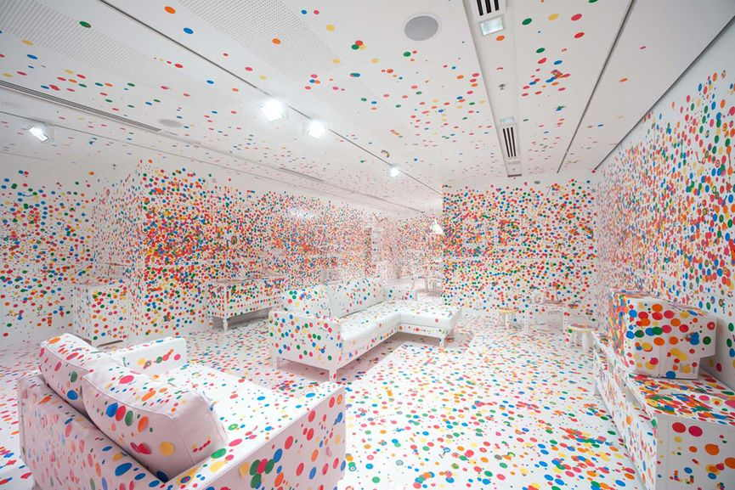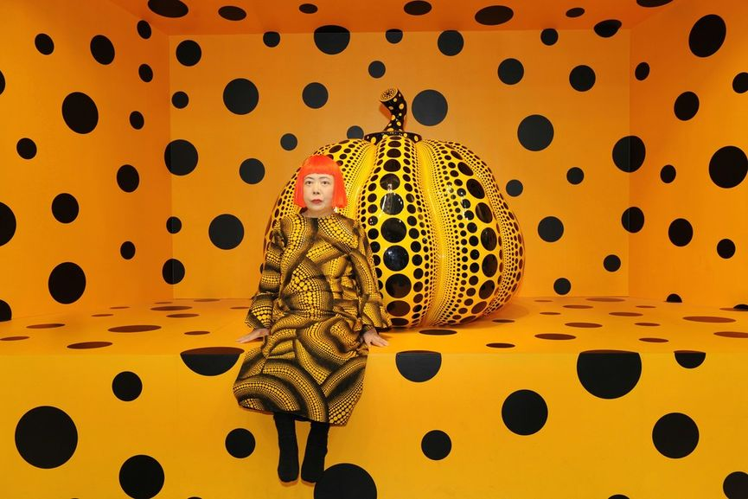

Yayoi Kusama - Creating an Immersive Sensory Experience
A famous provocative avant-garde artist from Japan, Yayoi Kusama is one of the most prominent figures in her country’s present-day culture. Becoming active in New York avant-garde circles during the formative years of Pop Art and Minimalism, her practice was seminal to the development of assemblage, environmental art, performative practices, and later, installation art. In the mid-1960s, she began developing her interests in the optics and interactive elements of mirrors, electric lights, sound and kinetics. Becoming famous for her provocative happenings and exhibitions, her extraordinary artistic endeavors spans various media and continues to appeal to the imagination and the senses. She has lived voluntarily in a psychiatric institution since 1977, traveling often to her studio in Tokyo. Much of her practice has been marked with obsessiveness and the struggle with her psychological trauma.

PAKISTANI SCULPTURES
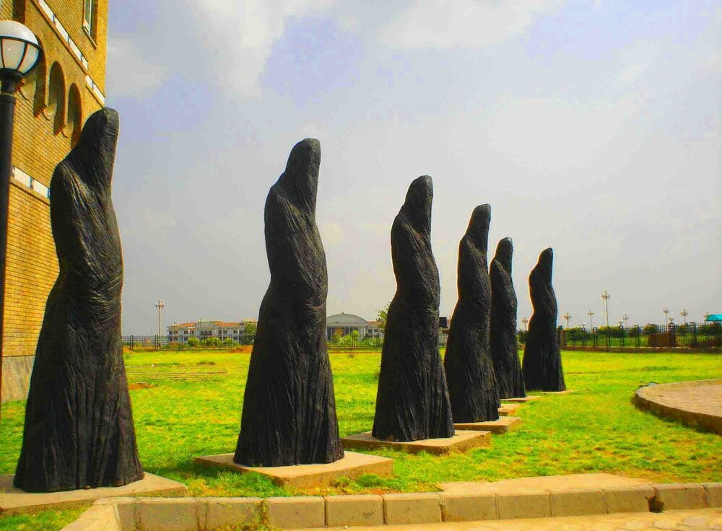
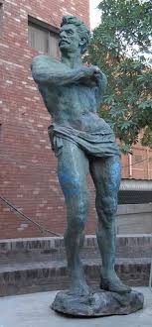
Jamil Baloch
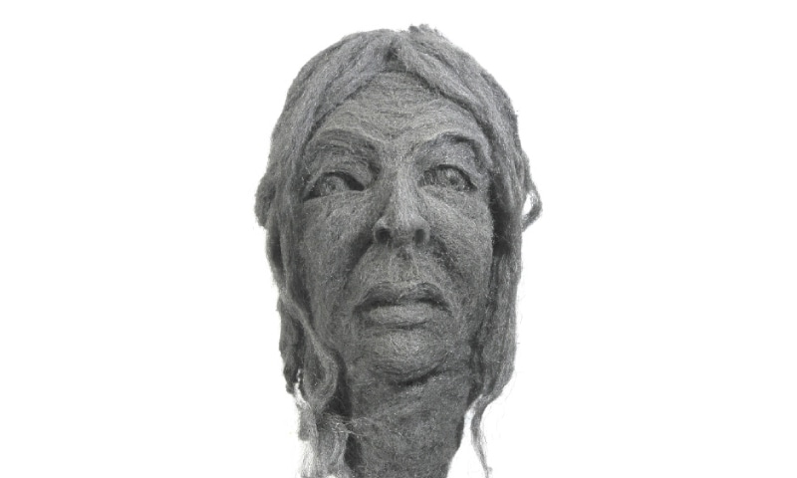
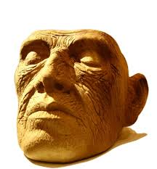
Imran Hunzai

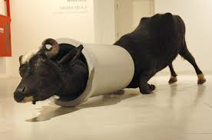
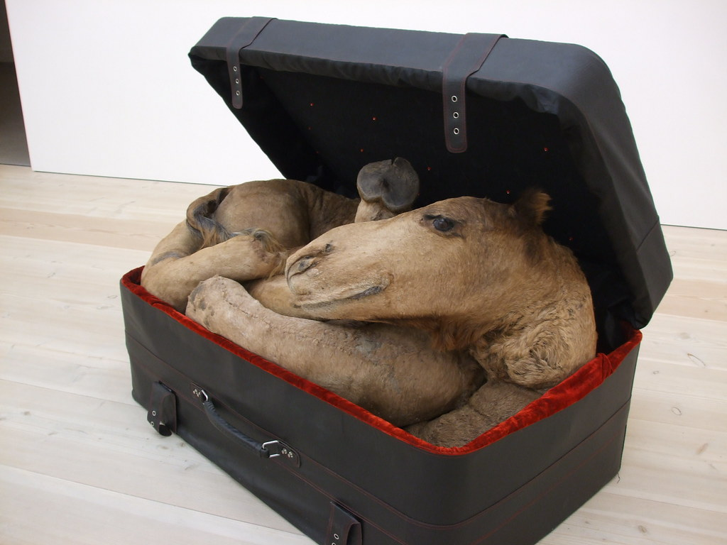
Huma Mulji

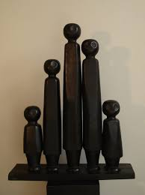
Abdur Jabbar Gul

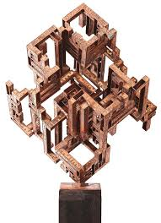
Amin Gulgee
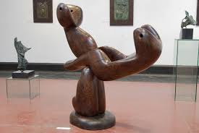
Shahid Sajjad

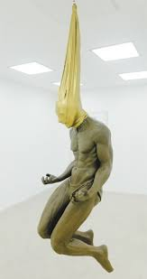
Saud Baloch
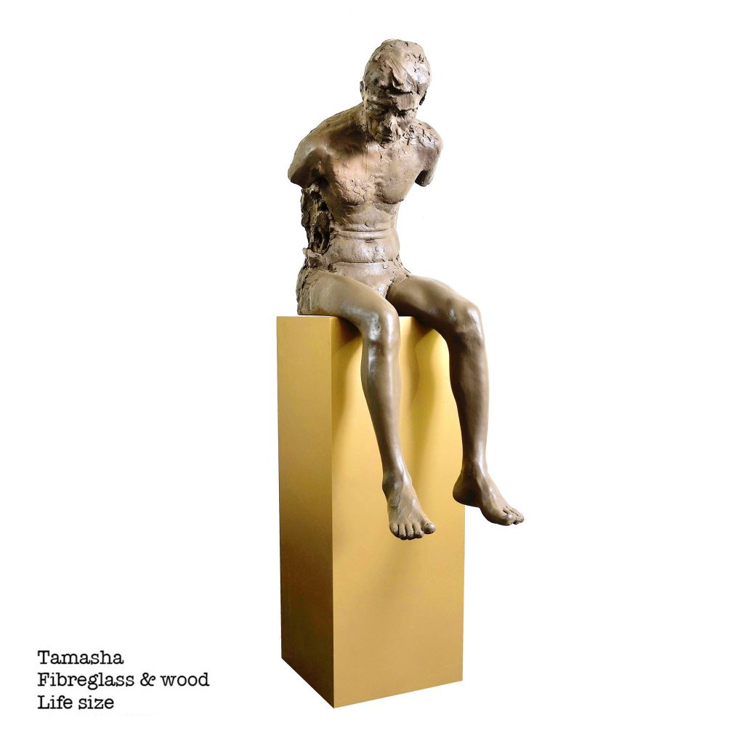
Saud Baloch
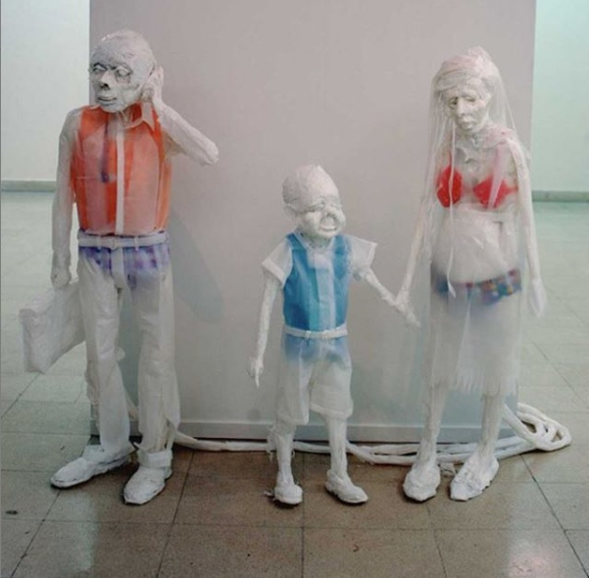
Khalil Chistee
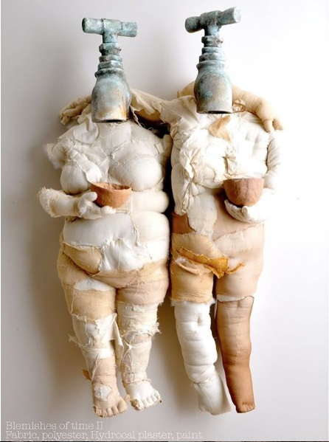
Ruby Chishtee

