TOPIC
APOPTOSI AND GAP
JUNCTION

Apoptosis:
(Programmed cell death)
(LIFE CANNOT EXIST WITHOUT CELLULAR DEATH)

Introduction:
- The word “Apoptosis” comes from the ancient Geek, meaning the
“falling of petals from a flower”
OR
“Of leaves from a tree in autumn”
- In humans the rate of cell growth and cell death is balanced to maintain the weight of the body.
- Apoptosis, or programmed cell death, is a highly regulated process that allows a cell to self – degrade in order for the body to eliminate unwanted or dysfunctional cells. During apoptosis, the genome of cell with disintegrate into smaller apoptotic bodies.
- Between 50 and 70 billion cells die each day due to apoptosis in the average human adult. For an average child between ages of 8 and 14, approximately 20 billion to 30 billion die each day.
History:
German scientist Carl Vogt was first to describe the principle of apoptosis in 1842. In 1845, anatomist, walther flemming delivered a more precise description of the process of programmed cell death.
- Kerr received the Paul Ehrlich and Lud Wig Darmstaedter prize on march 14, 2000, for this description of apoptosis. He shared the prize with Botson biologist Robert Horvitz.
- Apoptosis has since been recognized and accepted as a distinctive and important mode of “programmed” cell death, which involves the genetically determined elimination of cells.
- Apoptosis is essential to embryonic development and maintenance of homeostasis in multicellular organisms. In humans, for example, the rate of cell growth and cell death is balanced to maintain the weight of body. During fetal development, cell death helps sculpt body shape and making the right neuronal connections.
- Tissue homeostasis mainly depends on the balance between cell proliferation and cell death. Programmed cell death or apoptosis is an intrinsic death program that occurs in various physiological and pathological situations.
- Apoptosis or self-destruction is necessary for normal development and homeostasis of multicellular organisms.
- Apoptosis play a major role in many diseases like cancer,
- AIDS and
- Neurodegenerative disorders.
Cell death:
Cell die by one of two mechanisms-
- -Necrosis - Death by injury
- -Apoptosis - Death by suicide
- Apoptosis and necrosis have different characteristics.

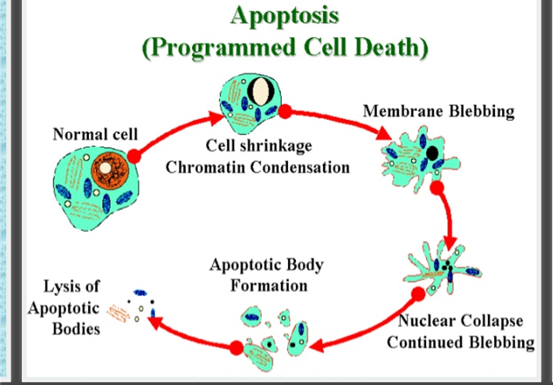
Types of cell death:
Cell death occur via several processes
- Apoptosis
- Necrosis
- Autophagy
- Oncosis
- Entosis
- Pyroptosis

Apoptosis (physiological cell death):
- Functional form of cell death
- Occurs under physiological conditions
- Energy (ATP) dependent
- Cell shrinks and pulls away from its neighbours.
- Nucleus ruptures
- Induced by physiological stimuli (lack of growth factor, changes in hormonal environment)
- No inflammation follows apoptosis
Necrosis (Pathological cell death):
- Accidental form of cell death
- Seen under pathological death
- No energy requirement
- Cell swelling in a defining features
- Entire cell balloons and ruptures
- Induced by cell non-physiological disturbances lytic viruses, hypothermia, hypoxia, ischaemia, metabolic poisons
- Necrosis is followed by inflammation.
Need for apoptosis:
Apoptosis is needed for proper development.
Examples;
- The reabsorption of tadpole tail.
- The formation of fingers and toes of the cells.
- The formation of proper connections between neurons in the brain.
Apoptosis is needed to destroy cells
Examples;
- Cell infected with virus.
- Cell with DNA damage
- Cancer cells.

Reasons of apoptosis:
- Withdrawal of positive signals
Examples:
- Growth factors for neurons.
- Interleukit-2 (IL-2)
- Receipt of negative signals:
Examples:
- Damage to DNA with in the cell
- Death activators
- Tumor necrosis in factor alpha (TNF- alpha)
- Lymphotoxin (TNF-beta)
- Fas ligand (FasL)
Inducers of apoptosis:
- TNF family
- Growth factor withdrawl
- Calcium
- Oncogenes
- Nutrient deprivation
- Toxins
- UV radiation
- Gamma radiation
Important in normal physiology:
- Development: Immune system maturation,
Morphogenesis, neural development.
- Adult: Immune privilege, DNA damage and wound repair,
- Excess apoptosis
- Neurodegenerative diseases
- Deficient apoptosis
- Cancer
- Autoimmunity
- In embryo
During embryonic development, help to digit formation.
Lack of apoptosis in humans can lead to webbed fingers called “Syndactly”

Apoptosis; Morphological changes
- Cell shrinkage
- Organelle reduction
- Mitochondrial leakage
- Chromatin condensation
- Nuclear fragmentation
- Membrane blebbing and changes
Apoptosis: Biochemical changes:
Characteristic biochemical changes in the cells undergoing
apoptosis;
- Chromosomal DNA cleaved into fragments
- Change in the plasma membrane – phosphatidylserine in the outer leaflet
- Loss of electrical potential across the inner membrane of the mitochondria
- Relocation of cytochrome c from intermembrane of mitochondria to the cystol.
Caspases:
- Caspases stands for Cysteine Aspartate-Specific Protease.
- Caspases have the characteristics of high specificity for substrates containing Asp, and use a Cys for catalyzing peptide bond cleavage.
- Synthesized in the cell as precursors named procaspase.
- Caspase are the major executioners in apoptosis.

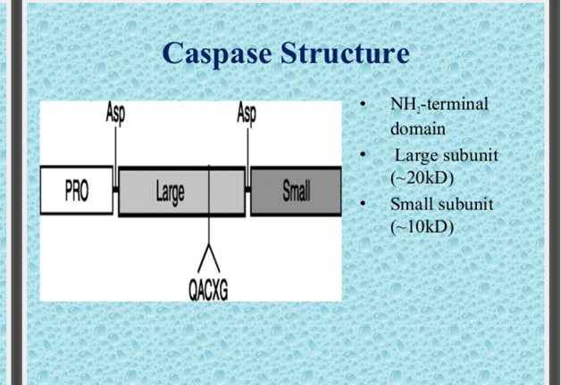

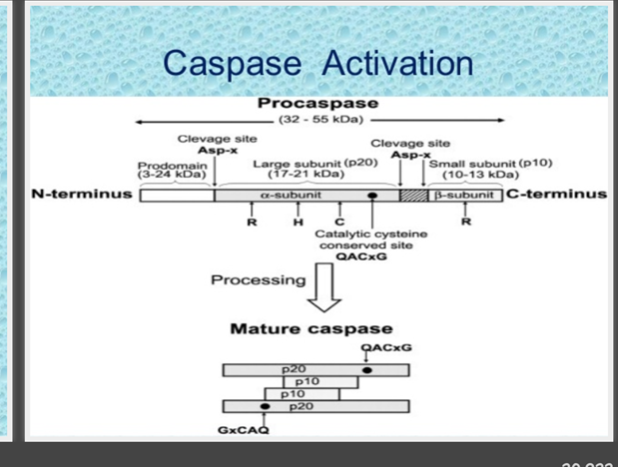

Caspases role in apoptosis:
- Cut of contact with surrounding cells.
- Reorganize cytoskeleton.
- Shut don DNA replication and repair.
- Interrupt splicing.
- Destroy nuclear structure.
- Induce cell to display signals making it for phagocytosis.
- Disintegrate cells into apoptotic bodies.

Intrinsic pathway:
- Initiated from within cell.
- Activated in response to signals such as DNA damage, loss of cell survival factors, cell stress.
- Hinges on balance between pro and anti apoptotic signals of Bcl-2 family.
- Apaf-1, cytochrome-c, ATP (apoptosome) activate procaspase-9 complex.
- Pro apoptotic proteins released which activate caspase proteases.

Extrinsic pathway:
- Begins out side the cell.
- Activation of death receptors ( Fas-R, TNF-R, DR-3, DRY/DR5) by death ligands ( Fas-L, TNF-alpha, Apo3L, Apo2L) play major role.
- Death induced signaling complex (DISC) activated.
- On DISC activation same effector pathway on imtrinsic pathway is adopted.

Disorders where apoptosis is inhibited
(decreased apoptosis, increase in cell servival)
- CANCER:
Colorectal cancer
Glioma
Lymphoid malignamcies
Liver
Neuroblastoma
Prostate cancer
- AUTOIMMUNE DISORDERS:
Mysthenia gravis
Systemic lupus eryrhmatous
- INFLAMATORY DUSEASE:
Bronchial asthma
Inflammatory bowel disease
Pulmonary inflammation
- VIRAL INFECTIONS:
Herpes viruses
Poxviruses
Adeno viruses
Baculovirus
Cowpox
Disorders where apoptosis is excessive increased in cell death:
(Means hyperactive apoptosis)
- AIDS
CD4 + cells
T-lymphocytes
- Neurodegenerative disorders
Alzheimer’s disease
Epilepsy
Parkinson’s disease
Amyotrophic lateral sclerosis
Cerebellar degeneration
Apoptosis: Role in disease cancer:
- Apoptosis eliminate damaged cells ( damage => mutation =>) cancer.
- Tumor suppressor P53 controls senescence and apoptosis response to damage.
- Most cancer cells are defective in apoptotic response (damaged, mutant cells survive)
- High levels of anti apoptotic proteins
OR
- Low levels of pro apoptotic proteins ===> CANCER

Gap Junction

Gap junctions are essential to the function of multicellular animals, which require a high degree of coordination between cells. In vertebrates, gap junctions comprise connexins and currently 21 connexins are known in humans. The functions of gap junctions are highly diverse and include exchange of metabolites and electrical signals between cells, as well as functions, which are apparently unrelated to intercellular communication. Given the diversity of gap junction physiology, regulation of gap junction activity is complex. The structure of the various connexins is known to some extent; and structural rearrangements and intramolecular interactions are important for regulation of channel function. Intercellular coupling is further regulated by the number and activity of channels present in gap junctional plaques. The number of connexins in cell-cell channels is regulated by controlling transcription, translation, trafficking, and degradation; and all of these processes are under strict control. Once in the membrane, channel activity is determined by the conductive properties of the connexin involved, which can be regulated by voltage and chemical gating, as well as a large number of posttranslational modifications. The aim of the present article is to review our current knowledge on the structure, regulation, function, and pharmacology of gap junctions. This will be supported by examples of how different connexins and their regulation act in concert to achieve appropriate physiological control, and how disturbances of connexin function can lead to disease.
Gap junctions are integral membrane proteins that enable the direct cytoplasmic exchange of ions and low molecular weight metabolites between adjacent cells. These connections are essential in many aspects of animal physiology including propagation of electrical signals and coordination of cell signaling by transfer of second messengers. The proteins that form gap junctions differ between vertebrates and no vertebrates. In vertebrates, gap junctions are formed by connexins, whereas the gap junction proteins of no vertebrate animals are termed in nexins (517). Connexins share structural features with in nexins though there is no amino acid sequence homology between the two. Proteins with amino acid sequence homology to in nexins have been identified in vertebrates (500). These proteins, called pan nexins, are able to form intercellular channels when overexpressed, but studies show that native pan nexins are likely glycosylated in their extracellular domains and do not form cell-cell channels (507). Therefore, it is suggested that they act as hemi channels (114).
The aim of this article is solely to review our current knowledge of connexins. A simple search on PubMed on “gap junction OR connexin” yields more than 15,000 hits. This shows that a huge amount of scientific work has been conducted in this field, and obviously it is impossible to cover every detail in this article. The article aims to cover the basic principles of connexin structure, how connexin expression, transcription, turnover, and trafficking are regulated, as well as how mature gap junction channels are affected by gating and posttranslational modification. Finally, some insight to the physiological function of gap junctions and their involvement in various diseases is given, along with a status of experimental pharmacological treatments targeting gap junctions.
Basic properties of Connexins:

Connexins structure:

Gap junctions are formed by the apposition of Connexins from adjacent cells, where each Connexins is formed by six connexin proteins. There are 21 different connexin genes in the human genome and 20 in mice. Connexins are tetra span transmembrane (TM) domain proteins with intracellular N- and C-termini. Two extracellular loops (E1 and E2) provide continuity between TM domains TM1-TM2 and TM3-TM4, while the region between TM2 and TM3 (the “cytoplasmic loop;” CL) is located in the intracellular space. Connexins are expressed in all tissues except differentiated skeletal muscle, erythrocytes, and mature sperm cells. Each of the Connexins can form gap junctions by themselves; however, studies have demonstrated that many cells coexpress more than one connexin isoform, giving rise to heteromeric connexons (more than two different connexins in a connexon) and heterotypic channels (a gap junction channel with different connexons), conferring further diversity in their composition and function. Connexins are named based on their predicted molecular weight (e.g., Cx43 is ~43 KD in size) and this nomenclature continues to be widely used. Of note, this nomenclature does give rise to confusion in some cases where homologous connexins have different names (i.e., molecular weights) in different species (Table 1; h-human; m-mouse). In the present review, we have adapted to the nomenclature decided upon at the International Gap Junction Meeting in Denmark 2007. Non-human connexins are named after their human ortholog when differing, but to ease the linking to the original literature the species dependent name is given in parenthesis. For example, mouse Cx30.2 is referred to as Cx31.9 (mCx30.2).

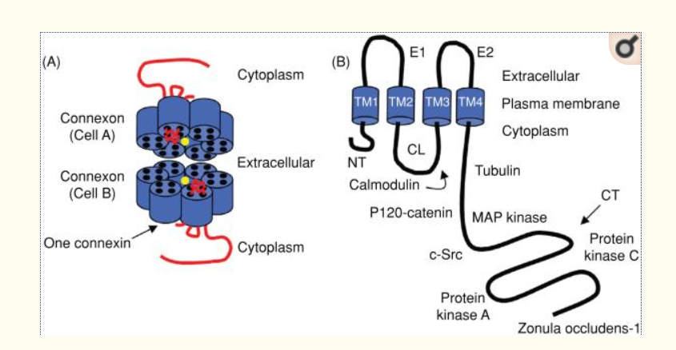

Model of a Cx43 gap junction channel and monomer. (A) The channel pore location has been indicated by the yellow circle. (B) The Cx43 monomer with protein partners. The abbreviations are as follows: NT, N-terminus; CL, cytoplasmic loop; CT, C-terminus; E1 and E2, extracellular loops 1 and 2; TM1-4, transmembrane segments 1-4.
Connexins can be divided into five subgroups (α, β, γ, δ, or ε) with respect to their extent of sequence identity and length of the CL. Connexins are then abbreviated with “GJ” for gap junction and numbered according to the order of discovery. For example, Cx43 was the first connexin of the α-group (GJα1) and Cx32 was the first connexin of the β-group (GJβ1).
Many studies have aimed at characterizing the high-order structure of the gap junction channel. Early work showed that a connexin hemi channel has 6-fold symmetry, with a pore in the center (413, 699). The initial observations were confirmed and expanded by several authors [e.g., references (275, 276, and 683)]. A major step forward came from the work of Unger et al. (698). These authors used electron crystallography to solve the three-dimensional structure of gap junction channels formed by Cx43 subunits. The assembled gap junction channels were observed at a resolution of 7.5 Å in the membrane plane and 21 Å in the vertical direction. The study clearly showed the electron densities corresponding to 24 TM domains in α-helical order. As shown, they are organized as six repeats of four TM domains (labeled A-D), consistent with the notion that a connexon is formed by the oligomerization of six connexins, each with four TM domains. The images further revealed that the pore narrows from 40 to 15 Å at the boundary with the extracellular gap. This narrowing [initially proposed by the low-angle x-ray diffraction analysis of Makowski et al. (413), as well as data of Unwin and Zampighi (699)] is due to the tilting of the channel-lining TM domain (labeled “C” in the right panel of). Whether this structure corresponds to that of an open or a closed channel remains to be determined. The data of Unger et al. further showed that the C α-helix extends beyond the putative boundary of the bilayer and into the cytoplasm. If the “C” domain corresponds to the third TM domain this may suggest that the second half of the CL is also a α-helix, which conforms part of the vestibule of the pore. The latter would be consistent with observations of this domain using NMR (155) and with the functional mapping of this area (620). Unger et al. provided a fundamental framework for understanding the gap junction pore from a structural point of view. However, it is worth noting that the investigators needed to truncate the carboxyl terminus of Cx43 to improve the diffraction quality of the two-dimensional crystals. Hence, with the exception of a small fragment of the CL, intracellular regions were not characterized within this structure.
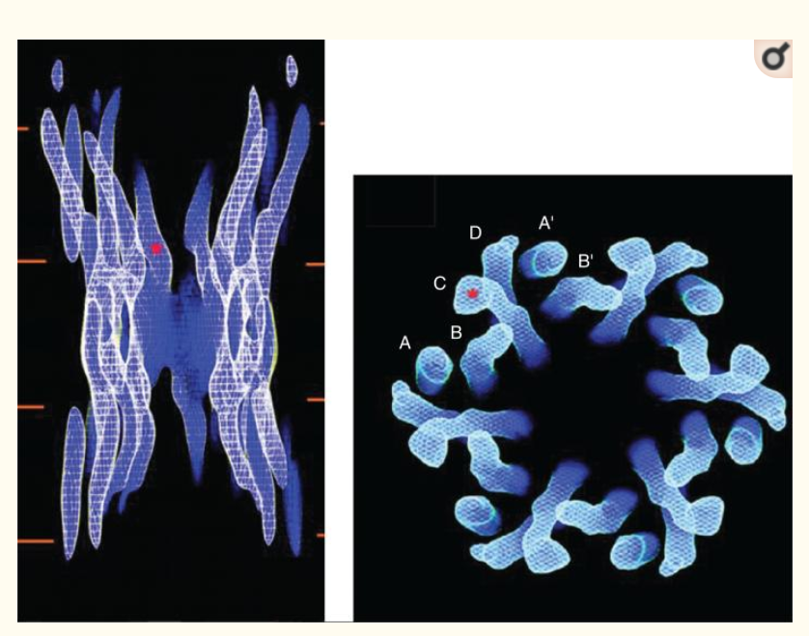
Cx43 channel structure obtained by electron crystallography. The panel on the left shows a side view of the entire channel. The red lines represent the lipid bilayers. The red asterisk indicates the point at which the pore diameter is estimated to be the smallest. The panel on the right is a view from the cytoplasmic side. The channel is formed by six repeats of four identifiable densities (A-D), each density corresponding to one transmembrane domain. Modified, with permission, from Unger VM, Kumar NM, Gilula NB, Yeager M. Science 283: 1176-1180, 1999 (698). Reprinted, with permission, from AAAS.
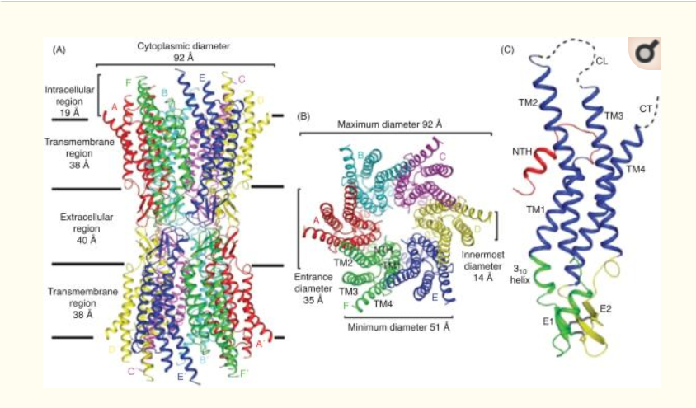

Structure of the Cx26 gap junction channel and Cx26 promoter in ribbon representation. (A) Side view of the Cx26 gap junction channel. (B) Top view of the Cx26 gap junction channel showing the arrangement of the transmembrane helices TM1 to TM4. (C) Side view of the Cx26 promoter. Color code: red, NT; blue, TM1-TM4; green, E1; yellow, E2; gray, disulphide bonds; dashed lines, CL and CT, which were not visible in the map. E1 and E2 are the loops connecting TM1 and TM2, and TM3 and TM4, respectively. Modified, with permission, from Maeda et al. 2009 (409).
Structural analysis using x-ray crystallography has recently provided the gap junction field with the highest resolution of a gap junction channel (409). At a resolution of 3.5 Å, the overall structure of the Cx26 channel was determined as follows; length of the channel, approximately 155 Å ; the extracellular gap, approximately 40 Å; the outer diameter of the channel at the cytoplasmic end, approximately 90 Å, which decreases to approximately 50 Å in the extracellular portion; the inner diameter of the channel, approximately 40 Å at the channel entrance, and narrows to approximately 14 Å around the midpoint of the membrane region (Fig. 3A/B). The channel, which includes the 24 TM spanning domains, contains approximately 60% α-helical structure. The Cx26 monomer is a four-helical bundle in which each pair of adjacent helices is antiparallel (Fig. 3C). TM1 and TM2 face the luminal side of the pore; however, the TM2 and the cytoplasmic half of the TM1 are not exposed to the lumen because they are covered by a short α-helix from the N-terminus. TM3 and TM4 are on the outside of the channel facing the lipid environment. The extracellular loop E1 contains a 3₁₀ helix at the beginning and a short α-helix in its carboxyl-terminal half. E2, together with E1, form a short antiparallel β-sheet. Six conserved cysteine residues, three in each loop, form intramolecular disulphide bonds between E1 and E2. The intermolecular interactions between two adjoining connexons involve both the E1 and E2 domains and numerous hydrogen bonds and salt bridges help create a tight seal that isolates the channel interior to form the connection between adjacent cells. Similar to Cx43 structure (698), the CL and cytoplasmic tail (CT) domains were not visualized in the Cx26 electron density map. This led the authors to suggest that the channel is in an open conformation, since no obstructions through the pore were identified combined with their crystallization conditions.
Although, neither crystallographic technique was able to address the structure of the CT or CL because of the dynamic nature of these domains, these same characteristics that interfere with crystallographic techniques make NMR an ideal tool for studying them. Previous NMR studies have focused on identifying regions of structural order and binding between the CT and CL of Cx43 because these domains play a fundamental role in gap junction regulation (155, 274, and 647). For example, the CT may mediate pH gating in a “particle-receptor” interaction, modeled after the “ball-and-chain” mechanism of voltage-dependent inactivation (Fig. 4A) (332). A direct pH-dependent interaction between a soluble version of the Cx43CT (S255-I382) and a peptide corresponding to the second half of the CL (D119-K144) (155) was identified. This interaction was dependent on the CL peptide forming a α-helical structure in response to the acidification (Fig. 4B). It was proposed that the second half of the CL acts as the “receptor” for the CT domain (155, 606). In a separate study, the soluble version of the CT domain was identified by NMR as being highly flexible and predominately disordered in structure (Fig. 4C) (648). Moreover, changes in the pH of the solvent caused dimerization of the Cx43CT (649), which may be a relevant step in the regulation of Cx43 by intracellular factors such as low ph.
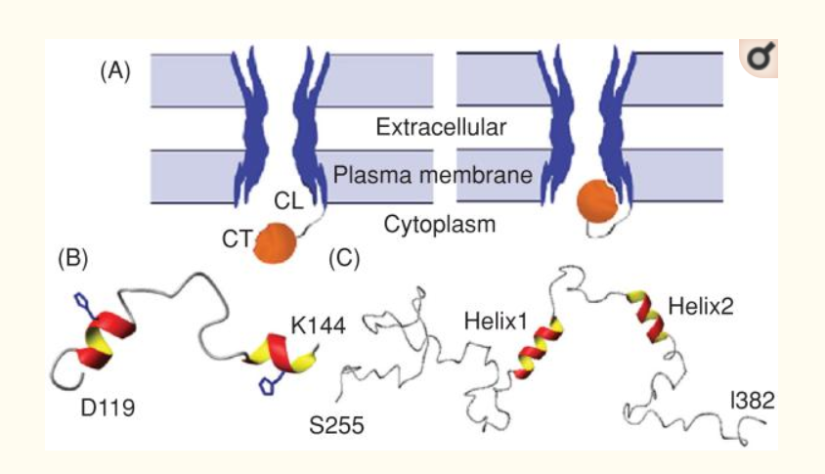

Ball-and-chain” model of Cx43 regulation. (A) Under normal conditions, the gate [cytoplasmic tail (CT)] is away from the pore. Under the appropriate stimulus, the gate swings toward the mouth of the channel, binds to a receptor [cytoplasmic loop (CL)] affiliated with the pore, and closes the channel. Lowest energy structure of the (B) Cx43CL and (C) Cx43CT domains; α-helices colored red and yellow. Figure is modified, with permission, from Delmar M, Coombs W, Sorgen P, Duffy HS, Taffet SM, Structural bases for the chemical regulation of Connexin43 channels, Cardiovasc.Res., 2003, 62(2): 268-275, (138) by permission of Oxford University Press, Duffy et al. 2002 (155), and Sorgen et al. 2004 (648), with permission.

Connexin structure during gap junction regulation:
Although there have been some spectacular successes in solving the structures of integral membrane proteins by x-ray crystallography, especially for the gap junction proteins, these structures only provide a snapshot of the protein in a single conformation. Electron crystallography, cryo-electron microscopy, and atomic force microscopy (AFM) offer alternative, albeit lower resolution, approaches to membrane protein structure determination that are not dependent on the generation of three-dimensional crystals. Over the past few years, the Sosinsky and Lal laboratories have taken advantage of these non-x-ray crystallographic methods to provide novel insight into how chemical mediators of gap junction regulation (e.g., Ca²⁺ and pH) affect the structure of Cx43 and Cx26 channels and hemi channels.
The Sosinsky laboratory used AFM to image the conformational changes of the cytoplasmic and extracellular surfaces of native Cx26 gap junction plaques in response to changes in calcium concentration .Calcium has long been postulated to play a crucial role in the gating of the gap junction intercellular communication by decreasing or suppressing electrical coupling .In the absence of calcium, the cytoplasmic surface formed a hexametric pore (2.8 nm inner diameter) protruding 1.7 nm from the membrane bilayer and exhibited a high degree of structural flexibility. Similar to the cytoplasmic surface, the extracellular connexon surface formed a hexametric pore exhibiting an inner diameter of 1.5 nm and protruded 1.6 nm from the lipid bilayer .When the extracellular hemi channel surface was imaged in the presence of calcium (0.5 mmol/L), the entrance narrowed significantly as evident in the reduced pore size (from 1.5 to 0.6 nm).The conformational change was fully reversible and specific amongst other divalent cations tested (e.g., magnesium). The conformational change did not alter the height nor cause a rotation of the extracellular domains. Calcium also had a profound, but different effect on the cytoplasmic surface, inducing the formation of micro domains and an increase in the plaque height. However, the cytoplasmic surface appeared too flexible to be imaged at sufficiently high resolution to assign structural changes. These observations, together with the differences in intracellular and extracellular hemi channel sensitivity to calcium concentrations (intracellular, μmol/L range; extracellular, mmol/L range), support the idea that a different gating mechanism for channel closure exists at the extracellular surface from the one that occurs at the cytoplasmic surface.

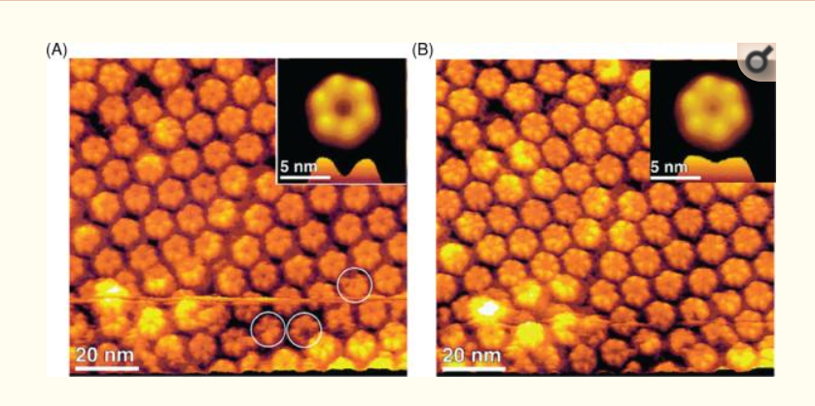

Conformational changes in Cx26 hemi channels observed in low and high calcium buffers by atomic force microscopy (AFM). (A) AFM topography showing the extracellular connexon surface imaged in a calcium-free buffer solution. Individual connexons exhibit defects in the number of subunits, as indicated by the circles. (B) Same connexon surface imaged in (A), but in the presence of 0.5 mmol/L calcium. The channel diameter has changed significantly as seen in the correlation averaged top view (inset) and the profile at the bottom of the inset. All images were displayed as relief tilted by 5°.

Permeability of gap junction channels:

Traditionally, gap junctions have been characterized as nonspecific pores between cells passing molecules up to 1 kDa in molecular mass, and expectation was that the pore diameter would be the primary selectivity determinant among the different connexin isoforms. Since then, a variety of approaches have been used to investigate permeability properties of connexin channels. Studies involving measurement of unitary conductance, ion selectivity, and permeability to fluorescent tracers of various sizes, charges, and chemistries, have revealed a wide variety of pore properties. No atomic ions are large enough to be excluded and homotypic gap junctions of Cx43, Cx40, Cx37, and Cx45 shows similar selectivity to monovalent cations (e.g., K⁺ and Na⁺) (32, 716, 717, 733); however, the charge selectivity’s range from a slight anion preference (Cx32) to a high cation selectivity (Cx40 and Cx43) (32,667,733). The electrophysiological properties of macroscopic coupling are determined by the biophysical properties of the underlying channels. Channel behavior is complex usually with a main open state, as well as states of lower conductance. The unitary conductance of gap junction channels depends on the connexin isotypes; Cx36 channels display a unitary conductance of 14 PS (674), whereas Cx37 form channels with a very high electrical conductance of 300 PS (718). The conductance of cell-to-cell channels can in most cases be calculated from the conductance of the individual hemi channels under the assumption that the channels work as two resistors in series.

The initial use of a range of fluorescent tracers and uncharged molecules to study gap junction permeation provided significant information regarding the pore diameter limitation of Cx channels (suggested ranking: Cx43>Cx32>Cx26>Cx37>Cx46 and Cx43>Cx40) (248). Though, fluorescent tracers became useful to report the existence and extent of junctional communication (e.g., use of Lucifer Yellow), they provide limited information regarding the nature of the permeability pathway itself. Important as the use of no biologic tracers have been in the estimation of pore diameters, these tracers convey little information on the ability of connexins to transfer biological molecules such as metabolites and second messengers. Although the literature on permeation of biological molecules is limited, important efforts have focused on the characterization of the permeability of connexin channels to endogenous cytoplasmic molecules. This is not a simple task due to the existence of more than 20 connexin isoforms, with different pore properties, that can almost all form heterogenic channels. Additionally, permeability properties of a given channel are expected to be modulated by reversible posttranslational modification (e.g., phosphorylation, see section on posttranslational modifications) or protein-protein interactions. Each answer will therefore be specific to a particular structural and biochemical channel, at a specific time. Measuring the flux of biological molecules poses many problems that make a reliable quantification difficult. Often the molecules in question are subject to cellular metabolism and in the case of second messengers, the messengers can affect coupling by activation of downstream cascades. In both cases, transfer can be grossly over or underestimated. Recent reviews summarize extensive information regarding the permeation by cytoplasmic molecules through connexin channels (248, 249). As previously established, most of the studied gap junction channels (homomeric Cx26, Cx32, and Cx43 and heteromeric Cx26/Cx30 or Cx32) are permeable to second messengers and metabolites, such as ATP or ADP, Ca²⁺, cAMP, IP₃, glutamate, glutathione, and of interest to siRNA. However, connexin isoforms can influence the gap junctional permeability. For example, Cx43 channels have a 100- to 300-fold higher selectivity for ATP over those of Cx32, while glutamate, glutathione, and ADP show a 10- to 20-fold preferential permeability through Cx43 channels, whereas adenosine is 10-fold more permeable through Cx32 (219). These studies demonstrate the differences in intercellular transfer of natural permeants among the different connexins. However, the physical basis of this selectivity remains unclear, as there are no evident correlations between metabolite properties and their permeability through different connexin channels.

Compatibility of connexin types in channel formation:

Connexins are somewhat promiscuous in the sense that different connexins can combine to form channels with unique properties. Channels with diverse connexin content are classified on the basis of how the connexins are mixed. Individual Connexins (hemi channels) are termed chromomeric when they contain only one connexin type and heterogenic if they contain different connexins. When identical connexons form cell-cell channels they are termed homotypic. In some cases, cells with connexons of different connexin composition form channels, which are then termed heterotypic. This gives rise to four possible combinations of homo/heteromeric and homo/heterotypic channels. Given the 21 connexins in humans and the fact that connexons contain six connexins, this leads to an explosion of possible combinations. However, not all connexins are compatible in forming functional channels and secondly not all combinations of connexins are expressed in the same or neighboring cells.

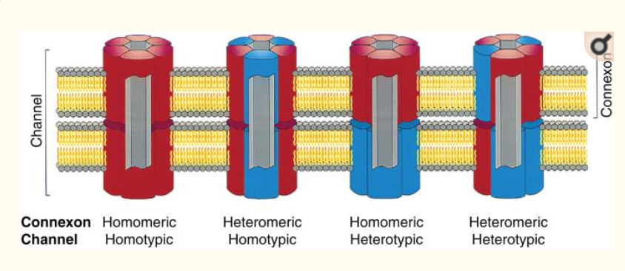

Possible channels formed by multiple connexins. The figure shows gap junctional channels of different composition. Homeric connexons are formed by a single connexin type whereas connexons containing more than one connexin type is heteromeric. When connexons of the same composition form a cell-cell channel it is homotypic and if the connexons differ in composition it is heterotypic. Reprinted from Cell, 84(3), Kumar NM, Gilula NB, The gap junction communication channel, 381-8, Copyright [1996], (338) with permission from Elsevier.
Heterotypic combinations of homomeric channels have been studied extensively and are physiologically relevant when cells expressing different connexins couple. Connexin of the α- and β-groups are more likely to form channels with other members of their own group. For example, in the group, Cx37 forms heterotypic channels with Cx40 (747) and Cx43 (64), but not with theβconnexins Cx26 and Cx32 (747). On the other hand, Cx37 does not form channels with the α-connexins Cx46 and Cx50 (747), so any given combination of interest needs to be tested. A more exhaustive review of possible combinations can be found in reference (763). The functional properties of heterotypic channels are often similar to that expected of two connexons in series and will be dealt with in the section on voltage gating.
Coexpression of different connexins occurs in many cell types as, for example, in the skin, where Cx31, Cx26, Cx43, Cx32, Cx40, Cx30, and Cx45 are expressed at the protein level (144). The study of heteromeric channels is complicated because even if coexpression results in channels/coupling with altered properties, it is difficult to prove that connexins actually incorporate into the same channel. Conversely, even if heteromeric channels are formed, they will exist together with homomeric channels. The relative proportions of hetero- and homomeric connexons will be determined by the probability of hetero- and homomeric oligomerization. In the atrium of the heart, Cx40 and Cx43 are coexpressed and studies show that they most likely form heteromeric channels (256, 702). However, the alterations in macroscopic coupling properties can largely be described by the behavior of homo- and heterotypic channels and it has been concluded that the heteromeric channels are of little importance (702). In contrast, coexpression of Cx40 and Cx43 significantly increases the sensitivity to pH-dependent gating (233). Furthermore, it has been shown that the CTs of Cx40 and Cx43 can interact with each other and with each other’s CL, suggesting that interactions within connexins in heteromeric channels are responsible for the shift in pH dependence (57).
Gap junctions may also be degraded by autophagy, and annular gap junctions sequestrated by double membrane structures have been reported (516). Such structures are found in cardiac cells, where some Cx43 colocalizes with the autophagosomal marker LC3. The association of both Cx43 and LC3 with lipid rafts is increased in heart failure, suggesting that autophagy plays a role in degrading Cx43 in this condition (268). Autophagy also degrades Cx43 and Cx50 in normal rat kidney (NRK) cells during starvation. Intracellular connexins were found to be enclosed in a structure containing LC3 and colocalized with p62, a protein that targets ubiquitinated proteins for autophagy. Furthermore, knockdown of Atg5, which is required for autophagy, prevented starvation induced connexin degradation (379).
Instead of being degraded, some internalized connexin may be recycled back to the plasmamembrane, as suggested by the colocalization of internalized Cx43 with rab4 and rab11, which are markers of recycling endosomes (215). This phenomenon may be particularly important during mitosis, where Cx43 is endocytosed and recycled to the plasmamembrane in the final stages of mitosis (48).
Gap junction:
Gap junctions are a specialized intercellular connection between a multitudes of animal cell-types. They directly connect the cytoplasm of two cells, which allows various molecules, ions and electrical impulses to directly pass through a regulated gate between cells.
One gap junction channel is composed of two connexons (or hemi channels), which connect across the intercellular space. Gap junctions are analogous to the plasmodesmata that join plant cells.
Gap junctions occur in virtually all tissues of the body, with the exception of adult fully developed skeletal muscle and mobile cell types such as sperm or erythrocytes. Gap junctions, however, are not found in simpler organisms such as sponges and slime molds.
A gap junction may also be called a nexus or macula communicants. While a phase has some similarities to a gap junction, by modern definition the two are different.
Structure:
In vertebrates, gap junction hemi channels are primarily homo- or hetero-hexamers of connexin proteins. Invertebrate gap junctions comprise proteins from the innexin family. Innexins have no significant sequence homology with connexins. Though differing in sequence to connexins, innexins are similar enough to connexins to state that innexins form gap junctions in vivo in the same way connexins do. The recently characterized pannexin family, which was originally thought to form inter-cellular channels (with an amino acid sequence similar to innexins), in fact functions as a single-membrane channel that communicates with the extracellular environment, and has been shown to pass calcium and ATP.
At gap junctions, the intercellular space is between 2 and 4 nm and unit connexons in the membrane of each cell are aligned with one another.
Gap junction channels formed from two identical hemi channels are called homotypic, while those with differing hemi channels are heterotypic. In turn, hemi channels of uniform connexin composition are called homomeric, while those with differing connexins are heteromeric. Channel composition is thought to influence the function of gap junction channels.
Before innexins and pannexins were well characterized, the genes coding for connexin gap junction channels were classified in one of three groups, based on gene mapping and sequence similarity: A, B and C (for example, GJA1, GJC1). However, connexin genes do not code directly for the expression of gap junction channels; genes can produce only the proteins that make up gap junction channels. An alternative naming system based on this protein's molecular weight is also popular (for example: connexin43=GJA1, connexin30.3=GJB4)
Level of organization:

- DNA to RNA to Connexin protein.
- One connexin protein has four transmembrane domains
- 6 Connexins create one Connexon (hemi channel). When different connexins join together to form one connexon, it is called a heteromeric connexon
- Two hemi channels, joined together across a cell membrane comprise a Gap Junction channel.
When two identical connexons come together to form a Gap junction channel, it is called a homotypic GJ channel. When one homomeric connexon and one heteromeric connexon come together, it is called a heterotypic gap junction channel. When two heteromeric connexons join, it is also called a heterotypic Gap Junction channel.
- Several gap junction channels (hundreds) assemble within a macromolecular complex called a gap junction plaque.

Gap junctions and the "bystander effect":

Cell death:
The "bystander effect" with its connotations of the innocent bystander being killed is also mediated by gap junctions. When cells are compromised due to disease or injury and start to die messages are transmitted to neighboring cells connected to the dying cell by gap junctions. This can cause the otherwise unaffected healthy bystander cells to also die. The bystander effect is, therefore, important to consider in diseased cells, which opened an avenue for more funding and a flourish of research. Later the bystander effect was also researched with regard to cells damaged by radiation or mechanical injury and therefore wound healing. Disease also seems to have an effect on the ability of gap junctions to fulfill their roles in wound healing.

Tissue restructuring:

While there has been a tendency to focus on the bystander effect in disease due to the possibility of therapeutic avenues there is evidence that there is a more central role in normal development of tissues. Death of some cells and their surrounding matrix may be required for a tissue to reach its final configuration and gap junctions also appear essential to this process. There are also more complex studies that try and combine our understanding of the simultaneous roles of gap junctions in both wound healing and tissue development.

Areas of electrical coupling:

Gap junctions electrically and chemically couple cells throughout the body of most animals. Electrical coupling can be relatively fast acting. Tissues in this section have well known functions observed to be coordinated by gap junctions with inter-cellular signaling happening in time frames of micro-seconds or less.

Heart:

Gap junctions are particularly important in cardiac muscle: the signal to contract is passed efficiently through gap junctions, allowing the heart muscle cells to contract in unison. Gap junctions are expressed in virtually all tissues of the body, with the exception of adult fully developed skeletal muscle and mobile cell types such as sperm or erythrocytes. Several human genetic disorders are associated with mutations in gap junction genes. Many of those affect the skin because this tissue is heavily dependent upon gap junction communication for the regulation of differentiation and proliferation. Cardiac gap junctions can pharmacologically be opened with rotigaptide.

Neurons:

A gap junction located in neurons is often referred to as an electrical synapse. The electrical synapse was discovered using electrical measurements before the gap junction structure was described. Electrical synapses are present throughout the central nervous system and have been studied specifically in the neocortex, hippocampus, vestibular nucleus, thalamic reticular nucleus, locus coeruleus, inferior olivary nucleus, mesencephalic nucleus of the trigeminal nerve, ventral tegmental area, olfactory bulb, retina and spinal cord of vertebrates.
There has been some observation of weak neuron to glial cell coupling in the locus coeruleus, and in the cerebellum between Purkinje neurons and Bergmann glial cells. It appears that astrocytes are coupled by gap junctions, both to other astrocytes and to oligodendrocytes. Moreover, mutations in the gap junction genes Cx43 and Cx56.6 cause white matter degeneration similar to that observed in Pelizaeus–Merzbacher disease and multiple sclerosis.
Connexin proteins expressed in neuronal gap junctions include:
- mCX36
- mCX57
- mCX45
with mRNAs for at least five other connexins (mCx26, mCx30.2, mCx32, mCx43, mCx47) detected but without immunocytochemical evidence for the corresponding protein within ultrastructurally-defined gap junctions. Those mRNAs appear to be down-regulated or destroyed by micro interfering RNAs (miRNAs ) that are cell-type and cell-lineage specific.

Retina:

Neurons within the retina show extensive coupling, both within populations of one cell type, and between different cell types.

