Lecture 10: Understanding Light
Subject: Foundation Drawing-II
Class: BS Fine Arts 2nd
Instructor: Ms. Nadia Abbasi

When shading, you are essentially reproducing the value of light as it interacts with a form. Understanding light is crucial in order to create a convincing portrait.
I’m going to use a sphere with one main light source as an example because the light is more predictable.
In the arranged still life the light source is coming from the top left. The area facing the light is the light side and the area facing away from the light is the shadow side
The transition zone is referred to as the terminator.
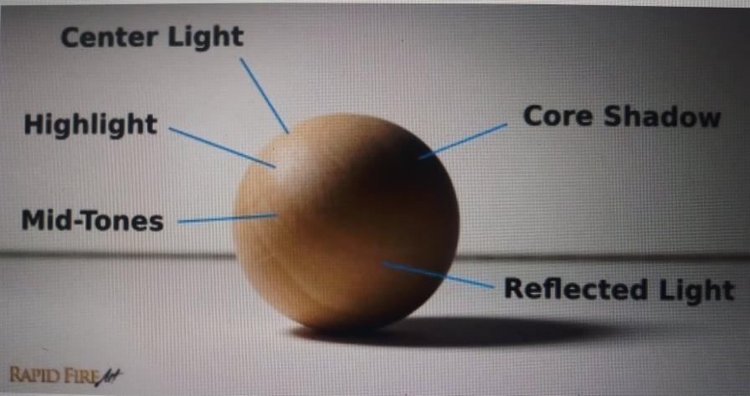

The side facing the light consists of the core light, highlight and mid-tones.
- Core Light: The area on the surface of a form that faces the light source directly. It is darker than the highlight.
- Highlight: A reflection of the light source on the form. The highlight is the lightest area and will appear in different places depending on your viewing angle. At certain angles, the highlight will not exist in your line of sight. On glossy surface, it will be very defined, while appearing soft on matte surfaces.
- Mid-Tones: Mid- tones are the darkest values on the light side, and are lighter than the core shadow. These areas are not facing the light directly. Mid-tones appear darker and darker as they approach the shadow side, as the surface of the form starts facing away from the light. The side facing away from the light consists of the core shadow and reflected light.
- Core Shadow: the core shadow or form shadow is a dark strip that appears after the terminator. The appearance of the core shadow can be affected by reflections or multiple light source. In our still life the core shadow is less prominent on the left side due to reflections from the white table.
- Reflected Light: objects are not only lit by light sources, but also by reflected light.
That’s why shadows are rarely ever black. Light bounces off different surfaces such as walls or even dust particles in the air, creating reflections. These reflection can vary in color and value.

