HTML Comment Tags
Comment tags are used to insert comments in the HTML source code. You can add comments to your HTML source by using the following syntax:
<!-- Write your comments here -->
Notice that there is an exclamation point (!) in the opening tag, but not in the closing tag.

Colors
HTML colors are specified using predefined color names, or RGB, HEX, HSL, RGBA, HSLA values.

Color Names:
In HTML, a color can be specified by using a color name:
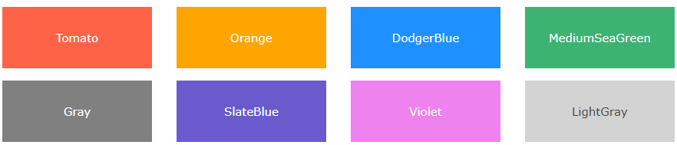

RGB Colors:
In HTML, a color can be specified as an RGB value, using this formula:
rgb(red, green, blue)
Each parameter (red, green, and blue) defines the intensity of the color between 0 and 255. For example, rgb(255, 0, 0) is displayed as red.
Black -> rgb(0, 0, 0) White -> rgb(255, 255, 255)

RGBA Value:
RGBA color values are an extension of RGB color values with an alpha channel - which specifies the opacity for a color. An RGBA color value is specified with:
rgba(red, green, blue, alpha)
The alpha parameter is a number between 0.0 (fully transparent) and 1.0 (not transparent at all): Experiment by mixing the RGBA values below:

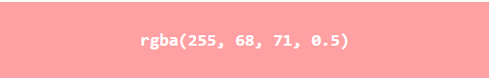

HEX Colors:
In HTML, a color can be specified using a hexadecimal value in the form of #rrggbb. Where rr (red), gg (green) and bb (blue) are hexadecimal values between 00 and ff (same as decimal 0-255).
For example, #ff0000 is displayed as red, because red is set to its highest value (ff) and the others are set to the lowest value (00). Experiment by mixing the HEX values below:

HTML Links (Hyperlinks)
HTML links are hyperlinks You can click on a link and jump to another document. When you move the mouse over a link, the mouse arrow will turn into a little hand.
Note: A link does not have to be text. It can be an image or any other HTML element.
Hyperlinks are defined with the HTML <a> tag:
<a href="url">link text</a>

The target Attribute
The target attribute specifies where to open the linked document.
The target attribute can have one of the following values:
- _blank - Opens the linked document in a new window or tab
- _self - Opens the linked document in the same window/tab as it was clicked (this is default)
- _parent - Opens the linked document in the parent frame
- _top - Opens the linked document in the full body of the window
- framename - Opens the linked document in a named frame

