fao.org

CHAPTER 4 WAX
Contents - Previous - Next
4.1 Introduction
The word wax describes a large variety of substances of plant and animal origin, as well as man-made products which are mostly petroleum derivatives. However, natural waxes are not single substances, but a mixture of various long-chain fatty acids and a variety of other constituents, depending on their origin. Each wax therefore has unique physical and chemical characteristics which are exploited in a multitude of applications. In particular, wax from the honeybee has an extremely wide spectrum of useful applications and occupies a very special position among waxes.
Young bees in the hive, after feeding the young brood with royal jelly, take part in the construction of the hive. Engorged with honey and resting suspended for 24 hours together with many other bees in the same position, 8 wax glands on the underside of the abdomens of the young bees secret small wax platelets. These are scraped off by the bee, chewed and masticated into pliable pieces with the addition of saliva and a variety of enzymes. Once chewed, attached to the comb and re-chewed several times, they finally form part of this architectural masterpiece, a comb of hexagonal cells, a 20 g structure which can support 1000 g of honey. Wax is used to cap the ripened honey and when mixed with some propolis, also protects the brood from infections and desiccation. Together with propolis, wax is also employed for sealing cracks and covering foreign objects in the hive. The wax collected by the beekeeper is that which is used in comb construction. Frame hive beekeeping produces wax almost exclusively from the cap and top part of the honey cells.
For centuries, beeswax was appreciated as the best material for making candles. Before the advent of cheap petroleum-based waxes, tallow (rendered animal fat) was used for cheap candles and for the adulteration of beeswax. Ancient jewellers and artisans knew how to form delicate objects from wax and cast them later in precious metals. Colours of ancient wall paintings and icons contain beeswax which has remained unchanged for more than 2000 years (Birshtein et al., 1976). The wrappings of Egyptian mummies contained beeswax (Benson et al., 1978) and beeswax has long found use in medicinal practices and in creams and lotions. Of all the primary bee products it has been, and remains, the most versatile and most widely used material.
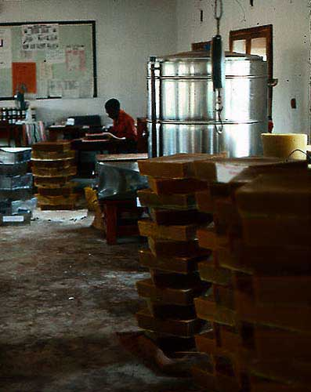
Figure 4.1 : Wax processed from traditional beekeeping at the honey factory in Kabompo, NW Province, Zambia.

Other waxes derived from plants and animals (data from Brown, 1981 and Tulloch, 1970) include:
Carnauba is obtained from the leaves of Copernicia cerifuga, a palm tree found in Brazil It melts at 83-86°C.
Ouricuri is also obtained from the leaves of a palm tree found in tropical America, but it is of lower quality than Carnauba wax. It melts at 84°C.
Candelilla is obtained from a reed-like plant found in Mexico and California. It melts at 70⁰C and has a yellowish colour.
Esparto is obtained from esparto grass as a by-product of the artisanal paper industry. It produces a high gloss finish with very little rubbing. It melts at 73⁰C.
Sugarcane Wax is a by-product of sugar refining. It melts at 78 to 80⁰C.
Ozokerite is a mineral wax. It is mined.
Ceresin is a mixture of purified ozokerite and paraffin wax.
Ghedda is the general name applied to waxes from the Asian Apis species.
Spermaceti is a very high quality wax obtained from the head of sperm whales. Since there is an international agreement restricting the hunting of these animals, no more spermaceti wax should be used or traded. In most recipes spermaceti can be replaced with beeswax. Synthetic substitutes exist as well.
Shellac with a melting point of 74-78⁰C, shellac is secreted by the Lac insect (Laccifer lacca, Coccoidea) in Asia, and is used for electrical insulation, seals and certain polishes.
Chinese insect wax is produced by Coccus ceriferus and Brahmaea japomca (Coccoidea). It melts at 82-84⁰C. Other wax producing Coccoidea are Icerva purchasi and Dactylopius coccus whose waxes melt at 78⁰C and 99-101 ⁰C, respectively.
Other wax producing Coccoidea are Icerva purchasi and Dactylopius coccus whose waxes have melting points at 78⁰C and 99-100⁰C, respectively.
Many reviews of wax have been published of which some of the more comprehensive are by Bull (1977) Walker (1983a) and Coggshall and Morse (1984), Hepburn (1986) and Crane (1990). An international market review for beeswax was conducted by the International Trade Centre of UNCTADIGATT (ITC, 1978).
Many bee species produce wax but unless otherwise mentioned, only the wax of the honeybee species Apis mellifera will be referred to in this bulletin. Wax from other honeybee species (ghedda wax) is very similar, but has characteristics sufficiently different for it not to be used by the cosmetic industry. Even the wax produced by A. mellifera is not always the same. Thus, the cosmetic industry generally prefers beeswax from Africa.
4.2 Physical characteristics of beeswax
Virgin beeswax, immediately after being secreted, elaborated and formed into comb, is white (see Figure 4.2). It becomes darker with use inside the hive as pollen, silk and larval debris are inadvertently incorporated. Rendered, but untreated beeswax comes in varying shades of yellow. Pure white beeswax on the market has always been bleached.
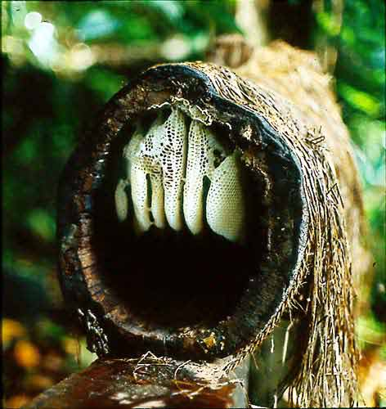
Figure 4.2 : Newly constructed white comb in a traditional log hive.

The melting point of beeswax is not constant since the composition varies slightly with its origin. Various pharmacopoeias give a range of 61-66⁰C or more commonly, 62-65 ⁰C. Its relative density at 15 ⁰C is 0.958 - 0.970 g/cm³ and its electrical resistance ranges from 5x10¹² to 20x10¹² Ohm m (Crane, 1990). Its thermal conductivity coefficient is 2.5 x d10⁻³ Jcm/s°Ccm². The saponification value of beeswax is 85-100 (Smith, 1951).
Beeswax is an inert material with high plasticity at a relatively low temperature (around 32 ⁰C). By contrast, at this temperature most plant waxes are much harder and of crystalline structure. Beeswax is also insoluble in water and resistant to many acids, but is soluble in most organic solvents such as ether, benzine, benzol, chloroform, turpentine oil and after warming, in alcohol and fatty oils.
Ghedda waxes from the Asian honeybee species are described as softer and more plastic, but do not have a significantly different melting point (Warth, 1956). The melting point of wax from three Meliponid (stingless bee) species ranged between 64.6 and 66.5 ⁰C (Smith, 1951 and Phadke et al., 1969). Bumble bee wax has a much lower melting point at 30-40⁰C and bumble bees therefore mix their wax with pollen in order to improve its structural strength (Alford, 1975). Other insect waxes are normally used for protective body coatings, rather than for structural purposes. They are therefore very different in their composition as well as their physical characteristics and they have much higher melting points.
4.3 The composition of beeswax
Pure beeswax from Apis mellifera consists of at least 284 different compounds. Not all have been completely identified but over 111 are volatile (Tulloch, 1980). At least 48 compounds were found to contribute to the aroma of beeswax (Ferber and Nursten, 1977). Quantitatively, the major compounds are saturated and unsaturated monoesters, diesters, saturated and unsaturated hydrocarbons, free acids and hydroxy polyesters. Table 4.1 lists the proportion of compounds as presented by Tulloch (1980).
There are 21 major compounds, each making up more than 1 % of the pure unfractionated wax. Together they account for 56% of the wax. The other 44% of diverse minor compounds probably account for beeswax's characteristic plasticity and low melting point (Tulloch, 1980).
Table 4.1:
Composition of beeswax (after Tulloch, 1980). Major compounds are those forming more than 1% of the fraction. The number in brackets indicates the number of compounds making up at least 1 % of the unfractionated, pure wax. The number of minor compounds, those with less than 1% of the fraction, is only an estimate.
Description | % of fraction | Number of components in fractoin
 |  | Major | Minor
Hydrocarbons | 14 | 10 (5) | 66
Monoesters | 35 | 10 (7) | 10
Diesters | 14 | 6 (5) | 24
Triesters | 3 | 5 | 20
Hydroxy monoesters | 4 | 6 (1) | 20
Hydroxy polyesters | 8 | 5 | 20
Acid esters | 1 | 7 | 20
Acid polyesters | 2 | 5 | 20
Free acids | 12 | 8 (3) | 10
Free alcohols | 1 | 5 | ?
Unidentified | 6 | 7 | ?
TOTAL | 100 | 74 | > 210
The ratio of ester values to acids, a character used by the various pharmacopoeias to describe pure beeswax is changed significantly by prolonged or excessive heating. At 100⁰C for 24 hours the ratio of ester to acid is changed beyond the limits set for pure beeswax.Longer heating or higher temperatures lead to greater degradation and loss of hydrocarbons (Tulloch, 1980). These changes also influence the physical characteristics of the wax. Thus, excessive heating during rendering or further processing changes the wax structurally and alters the beneficial characteristics of many of its minor compounds, not only the aromatic and volatile compounds.
Bleaching destroys at least the aromatic compounds of wax. Bleached wax no longer has the pleasant and typical aroma of wax and it can be assumed that it also lacks many of the other minor compounds.
Various plant growth promoting substances, such as myricil alcohol (Weng et al., N-1979), triacontanol (Devakumar et al., 1986), gibberellin GA₃ (Shen and Zhao, 1986) and a rape oil steroid (Jiang, 1986) have been detected in and isolated from beeswax. Kurstjens et al., (1990) describe at least 11 proteins in the freshly secreted wax scales of A. mellifera capensis worker bees and 13 proteins in the wax combs of A. m. scutellata and A. m. capensis.
The composition of wax from Asian honeybee species is much simpler and contains fewer compounds in different proportions (Phadke et al., 1969, 1971; Phadke and Nair, 1970, 1973 and Narayana, 1970). These ghedda waxes therefore cannot be used as substitutes for Apis mellifera wax in certain recipes. Since little is known about which compounds or mixtures cause the beneficial medicinal and dermatological effects of beeswax, no conclusions can be drawn from the composition data alone. Ghedda waxes are used locally in many of the same ways as Apis mellifera wax is used in other parts of the world. Meliponid waxes, which are less like honeybee wax than Ghedda wax, have been used by Amerindians for many of the same purposes, as honeybee waxes (Posey, 1978).
Beeswax is considered safe for human consumption and has been approved as an ingredient in human food in the USA (USA, 1978). It is inert, i.e. it does not interact with the human digestive system at all and passes through the body unaltered. However, substances dissolved or encapsulated in wax are slowly released. This property is exploited in many medicinal preparations (see 4.5.10). At the same time these properties can create a problem when wax is stored near toxic chemicals and pesticides or after treatment with various drugs inside the hive. Any fat soluble toxins can be absorbed and then released much later when the wax is consumed as food, used in cosmetics or given to bees in the form of foundation sheets.
4.4 The physiological effects of wax
Most of the effects of beeswax are described in the section on applications (section 4.5). Because it is inert, beeswax has no direct effect on humans or larger animals. However, its indirect effects can be very strong.
If mixed with medicinal drugs or poisonous baits, wax preserves the active materials longer and releases them slowly. It can be used to create thin non-corrosive, non-allergenic protective films on many surfaces from metals to fruits and human skin. Thus it protects against external damage such as corrosion and abrasion as well as against moisture loss. It is a good electric insulator and, when saponified with borax, allows the mixture of very stable and smooth emulsions for cosmetics. Even in small concentrations it improves other formulations in the same way.
A very small anti-inflammatory and antioxidant activity can be observed in beeswax due possibly to some inclusions of propolis or other minor ingredients.
4.5 The uses of wax today
In the past, beeswax had a wide range of uses. Though in many cases beeswax can be replaced with cheaper, synthetic waxes, its very special characteristics, medicinal benefits, plasticity and aroma ensure its continuing use. Many of these characteristics cannot be achieved with artificial waxes. The trend for more natural products in cosmetics may also increase its use. Presently, there is a scarcity of beeswax in industrialized countries, at least seasonally.
In industrialized countries, most nationally produced wax is used by beekeepers for foundation sheets. Approximately one third of imported wax is used for cosmetics, one third for pharmaceutical preparations one fifth for candles and the rest for other, minor uses (ITC, 1978).
In developing countries with traditional beekeeping methods, wax is often wasted. If it is rendered, most is subsequently exported and only relatively small proportions are used by local manufacturers. This, however, depends very much on the local industry. There are many possibilities for good quality products in local emerging markets and in import substitution. Adj are (1984) listed over 150 uses of beeswax as described also in an old 1954 edition of " The Hive and the Honeybee"
A few examples from the wide range of products in which beeswax can be included, together with a few recipes for small or home-based industrial production are described below. There are many types of synthetic waxes available today, often with superior characteristics for special applications Apart from price and availability however, beeswax has preferred characteristics in a wide range of applications and conditions. There are very few products which consist only of beeswax or in which only beeswax can be used, but the value or characteristics of most other products are enhanced or complemented by its inclusion.
4.5.1 In beekeeping
In countries with frame hive beekeeping, the majority of locally produced beeswax is consumed by beekeepers for the making of wax foundations - the patterned sheets of wax which are given to the bees as a guide for construction of their combs. Bees will not accept foundation made of synthetic waxes such as paraffin wax. Small quantities of paraffin wax mixed with beeswax may be accepted by the bees. Using such mixed foundation sheets, however, is a severe breach of good beekeeping practices, since it will adulterate all wax rendered from such combs. Non-frame beekeepers use melted wax or strips of smooth wax sheets as guides for bees to start their combs on. Each beekeeper can easily make the strips by dipping wet boards into melted wax (see Figure 4. 3a and 4.4 top right). Patterned sheets are usually made by specialized manufacturers, since the pattern imprinting requires special roller presses. Such presses, until recently, were very expensive, ranging from hand operated roller presses at about US$ 800 each to complete manufacturing lines costing many tens of thousands of dollars (see Figure 4.3 and 4.4). However, since at least 1989 inexpensive presses with moulded plastic rollers have been available for a fraction of the price of metal rollers in Brazil (see Cylindros Alveolador in Annex 1 and Figure 4. 3d). These plastic rollers do not last as long as steel rollers, but they are much cheaper to buy.
In order to reduce damage during hive management and honey extraction in centrifugal extractors, foundation sheets are reinforced with wire either by the beekeeper (frame per frame) or by the manufacturer who embeds the wire into the foundation sheet (see Figure 4.4). Sheets come in different sizes to fit the various sizes of frames. Standardized frame hive equipment within one country and preferably also in neighbouring countries will make manufacturing easier and more economical. Sheets should always fit the whole width of the frame, otherwise bees will not attach the comb to the frame. This weakens the comb and thus defies the main purpose of the frame. It also reduces the surface area for brood and honey storage by more than 5 %. In most countries foundation sheets are traded by manufacturers against raw wax with a mark-up for labour and equipment cost. Many manufacturers are also suppliers of beekeeping equipment, but also beekeeping cooperatives or large beekeepers sometimes make foundation sheets.
Fledgling beekeeping operations in countries with no tradition of beekeeping always have problems making their own wax foundation, since not enough beeswax is produced. Materials have to be imported or beekeeping started as a topbar operation. It takes a fairly stable frame hive beekeeping industry, i.e. one that is not growing too fast, to supply all foundation needs to its beekeepers because wax production from this type of beekeeping is low (1-2% in weight of honey production as compared to 10-15 % in topbar and traditional beekeeping).
Bottom board and side wall scrapings which contain large percentages of propolis can be processed into cheap wood preservatives (see recipes 4.11.10) particularly for hive equipment, or may be used by beekeepers for baiting swarm traps. However, these scrapings should never be mixed with other beeswax, since they destroy its quality for other uses.
a)  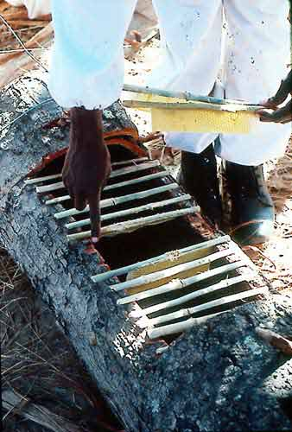 | b)  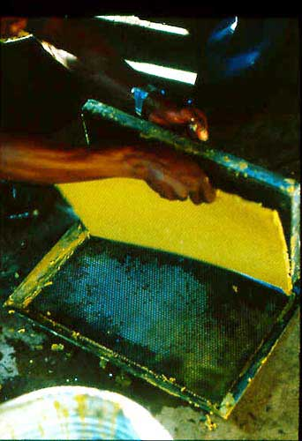
c)  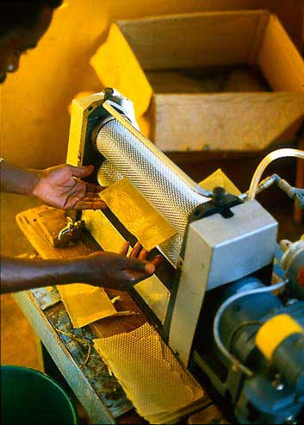 | d)  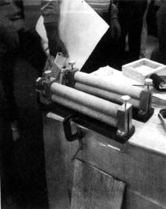
Fig 4.3 a) Melted wax starter strips from unpatterned wax sheets for topbar hives.
b) Simple foundation press for single sheets requires more practice and nore wax per sheet; can also be made from gypsum (plaster) using commercial foundation to prepare the plaster moulds.
c) Motorised foundation rollers with moist.
d) Hand-operated, low cost, plastic foundation rollers

a)  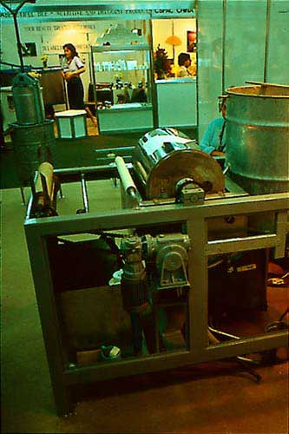 | b)  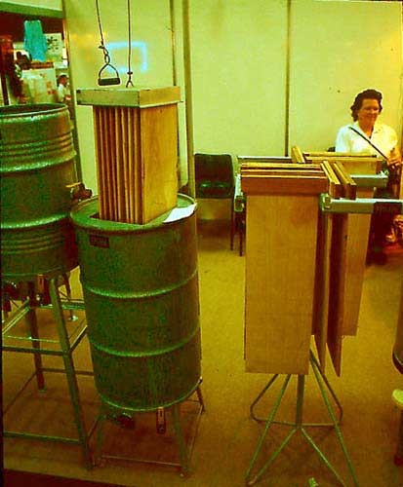
c) 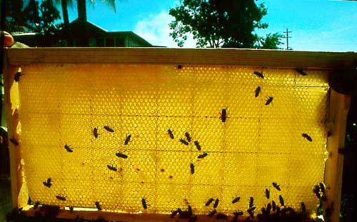
Figure 4.4: Top left: Medium size set up for the production of continuous wax sheets with a cooled drum rotating through a liquid wax bath. Top right: Rack and liquid wax bath for the production of multiple wax sheets by hand-dipping moist, wooden boards into the molten wax. Bottom: Wired frame with wired foundation sheet. All Langstroth and Dadant size frames should have at least four horizontal wires. Vertical wires can be embedded into the wax sheet by some manufacturers, but either of the wiring methods is usually sufficient.

4.5.2 For candle making
Beeswax, next to the cheaper tallow, was the major raw material for candles until the development of cheaper petroleum products such as paraffin wax, which was introduced during the last century. Since beeswax has a higher melting point than most paraffin waxes (most of which melt between 480 and 68⁰C) beeswax candles remain straight at higher ambient temperatures. If wick size is correctly proportioned with respect to the diameter of the candle, they are less likely to drip than candles made from other materials. Waxes with a melting point above 88⁰C do not perform well during burning. The Roman Catholic church requires that its ceremonial candles are made with at least 51 % pure beeswax. A detailed description of candle making is given in the recipe in section 4.11.2.
4.5.3 For metal castings and modelling
Because of its plasticity, beeswax is easily formed and carved. It maintains its shape well even over very long periods of time as proven by wax sculptures found in ancient Egyptian graves. Its relatively low melting point permits easy and complete removal from casting moulds. The hollow space left in these moulds can then be filled with molten metal. Already in ancient times whether in Asia, the Americas or Europe, craftsmen using this V lost wax method, sculpted small, solid metal figures, jewellery, large hollow sculptures and more recently also bells. Until today, different mixtures of beeswax and other waxes are used to create special forms and surfaces for jewellery and artistic sculptures.
No special preparations are necessary to use beeswax in these applications and in an indirect way, the resulting sculptures or jewellery may be considered a value added product from beekeeping. However far fetched this analogy may be, the lost wax technique is a craft in its own right and requires careful study. It may be undertaken using highly refined plasters like in dentistry, temperature controlled ovens and gas torches, but it is also possible on a very simple level using locally available clays and home-built furnaces. Both are beyond any simple descriptions that can be provided here, but Feinberg (1983) gives details for small-scale manufacturers.
The sculptures of Madam Tussaud's in London are widely known and copied in many countries. In the museum, famous people are copied in wax and dressed as life-sized figures. A mixture of three parts beeswax and one part of a harder wax are used (Sargant, 1971). Modelling in wax, or ceroplasty is a well developed art used also for scientific models in important collections around the world (Olschki, 1977). During the last century, wax flower modelling was apparently popular in Europe. A bibliography on wax modellers, collections and history has been published by Pyke (1973) and a handbook on sculpting with wax and plaster by Miller (1974).
4.5.4 In cosmetics
The unique characteristics of beeswax give a certain solidity to emulsified solutions, facilitate the formation of stable emulsions and increase the water holding capacity of ointments and creams. These and other characteristics, which only beeswax combines in one substance, make beeswax irreplaceable in the cosmetics industry. Though the desired effects can often be achieved with as little as 1 to 3 % beeswax (Coggshall and Morse, 1984) final proportions are also determined by the relatively high cost of beeswax.
Beeswax not only improves the appearance and consistency of creams and lotions but is also a preferred ingredient for lipsticks, because it contributes to sheen, consistency and colour stabilization. Other cosmetic applications are found in cold creams (8-12% beeswax content by weight), deodorants (up to 35 %), depilatories (hair removers, up to 50%), hair creams (5-10%), hair conditioners (1-3%), mascara (6-12%), rouge (10-15%), eye shadows (6-20%) and others.
Since ancient times, the basic recipe for creams and ointments has consisted of a mixture of beeswax and oil in various proportions according to the desired consistency. Traditionally, vegetable oils were used but they become rancid and limit the period for which such creams can be used. Today, most plant oils have been replaced by mineral oils such as liquid paraffin or preservatives are added. Selective use of vegetable oils from olives, corn, peanuts, jojoba, cacao, palms, coconuts and others still continues, since many of their beneficial effects cannot be provided by synthetic mineral oils.
In order to mix the otherwise incompatible beeswax and oils with water, all of which are essential ingredients of any cream or lotion, an emulsifier has to be added. Borax is the classic emulsifier, available in most pharmacies. Today's "high-chemistry" cosmetics use a large array of other synthetic emulsifiers. The chemical process on which the emulsification is based is the saponification of the acids in beeswax, i.e. the result is technically a soap. The associated cleansing effect is exploited in so-called cleansing creams, which are very much like simple skin creams.
To remove the free acids from beeswax so that it no longer needs an emulsifier and can be easily mixed with pigments and mineral products, a special process was developed and patented (Brand, 1989). The free acids are removed through reaction with glycidol at 80-120⁰C in the presence of a basic catalyst.
Recipes for cosmetics, including preparations of depilatory waxes, are presented in Chapter 9.
4.5.5 Food processing
Beeswax has been used in a variety of products and processes from packaging to processing and preservation. It has also been used as a separation agent in the confectionary industry (Ribot, 1960) and in cigarette filters (Noznickli and Likwoh, 1967). Many of these applications could be accomplished with other, cheaper waxes. Since most of these processes involve large scale and complicated production procedures, they are not described here -
A common, simple and small scale application for beeswax is the protection of containers against the effects of acids from fruit juices or honey. Steel drums for storage and shipment of honey have to be treated to prevent corrosion and dissolution of iron. The treatment may involve an expensive food grade paint, a plastic liner made from a food grade plastic film or a thin coat of beeswax.
4.5.6 Industrial technologv
A patent by Enger (1976) describes a material for encapsulating electrical and electronic apparatus for use in high moisture or chemically active environinents. One example consisted of at least 50% (ideally 70% by weight) of silicone, mixed with a fluorocarbon (20% tetrafluorethylene and a natural animal or mineral wax (10% beeswax) and, if necessary, an inert filler. After polymerization or fluorethylene vulcanization with a catalyst and/or heat, the inert product becomes impermeable to ions and fluid.
Another patent describes the preparation of a material for embedding or electrically insulating circuits of high and ultra-high frequency. The mixture of 10-30% ceresin wax, 55-65 % beeswax and 15-25 % ethylcellulose has a high melting point, is very hard at high temperatures, very strong when cold and can be remelted (Franklin, 1951).
A patent for an anti-corrosion rust inhibitor describes the incorporation of one or more different waxes, including beeswax. These waxes are mixed with crystalline polyethylene and polystyrene then heated to more than 200⁰C. The residue is removed and after adding liquid paraffin, it is boiled until it is homogeneous. The transparent, creamy liquid not only lubricates saws, just as pure beeswax would do, but protects iron, copper, brass, aluminum, chrome and nickel surfaces (limori, 1975). Other effective coatings contain beeswax; one such is composed of 90% mineral jelly and 10% beeswax (Sanyal and Roy, 1967).
In other formulations, beeswax may be used as a binder, particularly if lubricant characteristics are required (Bera et al., 1971) or if mixtures have to be ingested (see 4.5.10). Pure beeswax was once used for lubricating wire rods during high pressure continuous extrusion of wire (Fuchs, 1970). Beeswax has also been used to decrease viscosity and improve slip casting properties when casting glass under pressure (Bezborodov, 1968). For agricultural pest control, beeswax has been an ingredient of slow release pellets of pyrethrum pesticides (Ahmed et al., 1976). Waxing of the threads on pipes was reported to prevent joints from corroding or locking and simultaneously made them waterproof (Brown, 1981).
4.5.7 Textiles
Textiles and papers can be waterproofed with various products containing beeswax and a French patent is referred to in section 4.11.8. Emulsions containing beeswax for leather treatment have been described in many publications and a basic recipe is provided in section 4.11.7.
Batik is a traditional method of colouring cloth, adaptable to both small and large scale production for artistic and commercial applications. It is based on the principle that wax will protect areas which are not supposed to be stained by the dye in which the cloth will be immersed. By multiple applications, very complex, multi-coloured designs can be achieved (see Figure 4.5). This technique was refined in several Asian countries and is now used around the world. Today, because of its high cost, beeswax has been largely replaced by cheaper alternatives. The wax is used in its pure form and needs no processing before application. Various books about batik have been published in different languages and can often be found in local bookstores.
a)
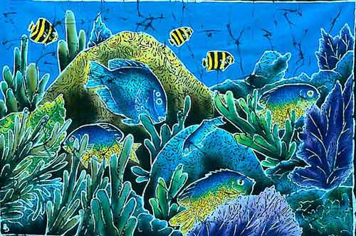
b)
Figure 4.5 : Batiks from Sri Lanka (top) and Barbados (bottom), both Very popular with tourists, form the basis of a small but profitable local industry.
4.5.8 Varnishes and polishes
A patent was recently registered for a varnish made from dammar resin and beeswax to be used for paintings and for art restoration (Krzyzynski, 1988).
Other recipes for varnishes, sometimes also including propolis are given in section 4.11. If propolis is included, the suitability of the locally available material should be tested. Knopf and Ogait (1961) reported that propolis containing a large percentage of balsam (which has non-drying properties) adversely affected the quality of the varnish. Propolis from different places can exhibit considerable variation in balsam content.
Detailed discussions and recipes for preparations with synthetic wax are presented by Jones (1977) who also lists reasons such as the formation of soft, easily marred films and a lack of availability, why natural beeswax is increasingly being replaced by other waxes in polishes.
4.5.9 Printing
In the old art of etching or engraving, beeswax was used as a protective surface coating. Wax was applied to a heated metal plate. The excess drained off while the remaining wax solidified into a thin film through which the design was drawn. The application of concentrated nitric acid or a mixture (1:8 by volume) of concentrated hydrochloric and nitric acids for a few minutes etched away the exposed metal and left the engraved part ready for negative printing. Today, a liquid asphalt is normally used instead. A US patent (Hughes, 1960) uses beeswax as part of a liquid protective coating for plastic lithography plates and also for automobiles.
Glass can be etched with hydrofluoric acid after protecting those areas with beeswax which are to remain clear.
All of the acids mentioned are highly toxic and corrosive. Special precautions are required to avoid contact with clothing, skin and eyes.
Various inks, pens, markers and even carbon paper often contain small amounts of beeswax (Polishchuk and Denisova, 1970). One patent (Morishita et al., 1978) for typewriter ink includes a recipe of 1 part Japan wax or beeswax, 1 part Hitaide resin 503, S parts fluorescent granules (pigment) and 0.02 part Emulgen PP 150 (an emulsifier).
4.5.10 Medicine
As a coating for drugs or pills, beeswax facilitates ingestion but retards dissolution of the enclosed compounds until they reach the digestive tract. Beeswax can also be prepared as a mixture with the drug and then functions as a time release mechanism, releasing the drug over a longer period of time.
One such suppository base (a substance which allows slow release of another substance) has been developed on the basis of 5% beeswax, 5% palmitic acid and 90% of Nubon, a semi-synthetic hydrogenated vegetable oil (El-Sabbagh et al., 1988). This was used initially with chloramphenicol. In another preparation, beeswax alone served as the carrier for the drug. On an experimental basis nalidixic acid suspended in beeswax remained longer in the blood of tested animals after oral application than when the acid was administered directly (Lee and Lee, 1987). With another drug, the antihistamine chlorpheniramine maleate, various mixtures of glyceryl monostearate, stearic acid, lactose and higher proportions of beeswax had been successfully tested as a base. Many more examples can be found in pharmaceutical and medical literature. Each drug application requires its own specific modifications of the rudimentary base formulation.
Chewing dark comb (but not the old, black brood comb) without honey, brood or bee-bread is known to be effective against colds. A study by Maksimova-Todorova et al., (1985) has shown that even the wax fractions of propolis have antiviral activities. Older combs contain among many other things a good portion of propolis.
Beeswax can be used to fill capsules with equal amounts of drugs or other ingredients of various granule sizes. The granules of drugs are made adhesive by coating them with molten wax (about 90g molten wax for 3kg of granules), fat or glycerol, by spraying with liquid paraffin or by mixing them with powdered wax or fat and heating. After thorough mixing the hard capsules are pressed with their open end into an evenly spread layer of the mixture (Iwamoto et al., 1965). This process can also be adapted to making pills with pollen.
A mixture of equal parts melted beeswax and honey is recommended for treating cracked hooves of animals. It should be applied after the cracks have been thoroughly cleaned.
4.5.11 Others
Other products in which beeswax provides some improvement and in which it is a traditional ingredient, include grafting wax, crayons, floor and furniture polish, general purpose varnish, sealing wax, corrosion prevention, protective car polishes and sewing thread
- especially for sail and shoe making.
Again, in many of these products, beeswax can be replaced by cheaper synthetic waxes. The recipes in section 4.11 may be considered as general guidelines for the manufacture of any of the described products, using either beeswax or other available waxes. The special characteristics derived from the use of beeswax may be of importance in some particular conditions and may bring a better price for the product.
The fact that plant growth stimulators have been isolated from beeswax favours it over synthetic substitutes for use as a grafting wax. An Indian study on A. cerana wax suggests that its triacontanol content may be an economical alternative source for this plant growth stimulator (Devakumar et al., 1986).
Many other applications for beeswax, in cosmetics and pharmaceuticals may benefit also from the presence of minor components which have not yet been thoroughly investigated.
4.6 Wax collection and processing
There are several ways of collecting beeswax. Morse (1965) has experimented with the idea of producing beeswax directly from clustered bees with a caged queen and no foundation. Comb building was prevented by exposing clusters to continuous daylight and wax scales were collected below the cluster. This may be suitable for certain experimental requirements, but is not economically feasible with the current prices of wax.
More commonly in frame hive beekeeping, wax is rendered from the cappings removed during honey extraction. This produces a very high quality, light coloured wax. Light coloured broken combs provide the next quality of wax, whereas old black brood combs yield the smallest proportion and lowest quality of wax. Scrapings from side walls and the bottom board contain very high proportions of propolis and should not be mixed with better quality waxes. They can be used in swarm traps, for hive wood treatments, or in other preservatives for wood (see recipes in section 4.11.10).
In areas with traditional and topbar hive beekeeping, different qualities of wax can be produced by separating new white honey combs from darker ones or from those with portions of brood. Since whole combs are harvested and crushed or pressed, the proportion of wax per kilogramme of honey (10-15%) is much higher than with frame hive beekeeping, where the yield is only 1-2%.
Before processing, all comb or wax pieces should be washed thoroughly to remove honey and other debris. Crane (1990) even suggests soaking combs in water for several hours, or up to two days for older brood combs. The first wash, if done with small amounts of water can be used for beer brewing or if no infectious diseases are present for refeeding to the bees.
Several methods of rendering wax are possible and may be adapted to various circumstances. Wax can be separated in solar wax melters, by boiling in water then filtering, or by using steam or boiling water and special presses. If soft water or rain water is not available for these processes, hard water (high calacium content) may be used, but 0.1 % of vinegar should be added to it (Crane, 1990). The different methods are described in further detail in many beekeeping publications, for both small scale, low investment processing and for larger scale operations (Clauss, 1982; Adjare, 1984 and 1990; Coggshall and Morse, 1984; Hepburn, 1986; Gentry, 1988; Graham, 1992 etc).
Wax should never be heated above 85 ⁰C. If wax is heated directly (without water) or above 85 ⁰C discolouration occurs. Therefore wax always needs to be processed in water or in a water bath. Wax should not be processed in unprotected steel, iron or copper containers, since it will discolour from reaction with these metals. Direct exposure of wax to hot steam results in partial saponification.
The residues from wax rendering contain sufficient nutrients to be used as poultry food or be turned into good compost. A Polish study measured a crude protein content of 22.12% When added at 4% to the rations of laying hens instead of green forage meal, the residue maintained all growth and health characteristics and improved egg yolk colour (Faruga et al., 1975). With some precautions, the residue can also be included in diets for rearing wax moth larvae (see 8.10.7).
4.7 Buying
A buyer should make sure wax has been stored for a few weeks after processing in water, since newly cleaned wax may contain up to 20% by weight of water. Much of this water will be lost during the first few weeks of storage. Unpleasant surprises found inside larger blocks of wax may be rocks or other heavy materials.
Beeswax should have its characteristic yellow colour and sweet aroma when bought as rendered beeswax. The grey coloured layer at the bottom of inadequately cleaned wax cakes is mostly debris. It should be scraped off and may be reprocessed to extract more wax.
Wax cleaned in a solar wax extractor can sometimes be less aromatic and will be much whiter, almost the pale white colour of paraffin wax. The aroma of beeswax can be destroyed by overheating and chemical bleaching. Dark coloured beeswax has either been inadequately cleaned or has been processed in unsuitable containers made of iron, copper, brass, nickel, zinc (galvanized steel) or their alloys. The latter discolouration can only be reversed with a special metal binding (chelating) process. White (1966) described using approximately 1.9 g of the sodium salt of ethylene-diamine tetra-acetic acid (EDTA) in a litre of soft (rain) water to process approximately 400 g of wax. The mixture was boiled at 100⁰C for one hour, stirring continuously in a stainless steel, glass or aluminum container. After cooling, the bottom layer was scraped off while the clean part was remelted in clean water and cooled.
Adulteration with other waxes is difficult to detect without chemical analyses and physical tests, some of which are described in 4.9.
4.8 Storage
Beeswax should only be stored in its rendered, clean form. Before rendering, it will quickly be attacked by wax moths, which are able to destroy large quantities of wax in short periods of time (see Figure 4.6). Clean wax in large blocks is not attacked by wax moths. The honey guide of Africa (Indicator minor) is uniquely adapted to digesting wax with an intestinal flora of Micrococcus cerolyticus and the yeast Candida albicans (Friedman et al., 1957). However, the honey guide rarely consumes or steals large amounts of wax while it may destroy wax foundation sheets.
Storage should be in cool dry places and never in the same room with any kind of pesticide. Wax will slowly crystallize over time and as a consequence become harder, but this process is reversible without any damage, just as with crystallized honey. The white bloom, i.e. dust, that sometimes appears on the outside of a wax cake or candle consists of small wax crystals. When melted or pressed with the rest of the wax it reverts to normal beeswax without any residues or impurities. Wax can be stored for very long periods of time without losing its major characteristics as items from Egyptian graves more than 2000 years old have shown.
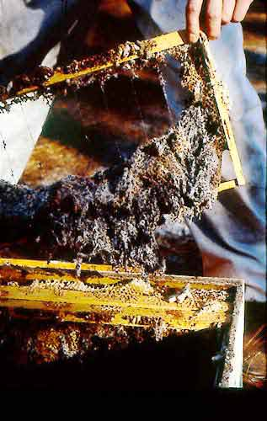 Figure 4.6: Wax comb destroyed by wax moths before it was rendered into clean wax.
The storage requirements of products made with beeswax are affected by the added ingredients. Polishes containing only mineral or non-vegetable oils can last for years, but cosmetic emulsions, which are mixtures of water and oil have a very limited shelf-life ranging from a few weeks to a few months (and longer if refrigerated). Unless some alcohols, propolis or other preservatives are added, emulsions are an excellent environment for microorganisms to flourish. Clean ingredients, a clean working environment and proper storage are very important to maintain the quality of products and prolong their storage life.
4.9 Quality control
Beeswax, when sold in solid blocks should always both be clean and have the colour and odour characteristics described in section 4.7. Though adulteration is easy (usually with cheap paraffin waxes), its detection is only possible with chemical tests, but it will very likely be detected by any larger buyer long before it reaches an industrial user. Adulteration renders the whole batch useless for most purposes and constitutes a considerable loss to the buyer. Therefore, such practices usually result in a buyer ceasing to buy from the supplier and possibly from the country from which the wax came.
Quality standards for wax are set in most countries according to their pharmacopoeias. A few industries like the Japanese cosmetic industry but also the American Wax Importers and Refiners Association specify their own limits (see ITC, 1978). In addition, for each industrial product in which beeswax is being used, there are other industry standards to be observed. These have to be obtained from the respective industry representations or trade publications. Such standards may vary considerably from country to country and manufacturer to manufacturer.
To detect adulteration, a number of tests may have to be conducted. The simplest is to determine the melting point, by measuring the temperature at which the first liquid wax appears during very slow heating. It should be between 61 and 66⁰C or preferably between 62 and 65 ⁰C. However, values within this range are not a guarantee of purity.
Determining the saponification cloud point is an officially accepted, sensitive method for determining adulteration. The method is limited to detecting quantities greater than 1 % of high melting (80-85 ⁰C) paraffin waxes, or more than 6% of low melting (50-55 ⁰C) paraffins. The test measures the amount of hydrocarbons which saponify (turn into soap) in a specific amount of ethanol and give a clear solution. If the solution becomes clear at or below 65 ⁰C, the wax is probably unadulterated with paraffin. If it is adulterated, the solution will turn clear only at a higher temperature. Some of the details of this test are described by Tulloch (1973) for the American Wax Importers and Refiners Association and in section 4.11.15. The saponification cloud point is not suited to detect adulteration with carnauba wax, but gas liquid chromatography (GLC) can detect the 6% of free C₃₂ alcohol (an alcohol molecule with 32 carbon atoms) contained in Carnauba wax. Beeswax only contains very little (Tulloch, 1980).
Tulloch (1980) also suggests that GLC can be used to detect adulteration of beeswax with as little as 1 % of petroleum hydrocarbons from low melting paraffins, but not for detecting low levels of high melting paraffin waxes.
Pharmacopoeia list ester values from 66 to 82 but most beeswaxes range between 72 and 80. Tulloch (1980) suggests values of 70 to 80 are most typical. Acid values range from 16.8 to 24 and ratios between ester and acid values are fairly stable and narrow, mostly between 3 3 and 4.2. The ratios can change after excessive heating and can exceed 4.2 with heating to 100 ⁰C for only 24 hours, while the ester and acid values might remain within set limits. Ester and acid values in waxes from other Apis species may be significantly different (Ikuta, 1931 and Phadke et al., 1969).
In Africa, adulteration of beeswax with dark and sticky Trigona (Meliponidae) wax has been reported (Smith, 1951). Such wax is of little value in most industrial and beekeeping applications, since the resins are difficult to remove.
For standard testing methods, references can be obtained from Crane (1990), ITC (1978), Apimondia, pharmacopoeias and industry associations.

