Department of Zoology
Mid Term Assignment

Course Code: Zol-606
Course Title: Introduction to Biotechnology
Course Teacher: Dr. Sajida Batool
Student Name: Zarsha Hassan
Student ID: BZOF16M038
Program: BS
Session: 2016-2020
Semester: 8th
Regular/ Self-Support: Regular
Main Campus/ Ex-PPP: Main Campus
Assignment Title: Introduction To Factors Affecting Bioreactor Design
Words Count: 3585

INTRODUCTION
Bioreactor: As name indicates that bioreaction is the combination of two words one is bio and other one is reactor. It means that it is related to the life or living thing or a reaction is carried out by the living things. So if we try to define the word bioreactor it will be that “ an appratus in which a reaction or a biotransformation is carried through the living things, these could be enzymes, cells, parts of cells etc”. Bioreactor is the container or vessel or a cylinder in which biochemical reaction is performed. Bioreactors are of different type depending upon the reaction which is to be carried in the industries. Bioreactors are available in different ranges like with ltter capacity to several cubes meter. Bioreactors are aslo different on the basis of their structure from simle to complex. It depends on the nature of activity which is to be performed. While designing the framework of a bioreactors one thing is kept to the mind which is the yield production capability which environment needs for the daily routine purposes. That could be the things of bakeries or wines. Bioreactors are aslo different on the basis of their structure from simle to complex. It depends on the nature of activity which is to be performed. While designing the framework of a bioreactors one thing is kept to the mind which is the yield production capability which environment needs for the daily routine purposes As we can produce biomass, metabolites, cell and tissue culturing, to check the food qualities etc.
General structure of bioreactors
Their designs differ from simple to complex. Mostly they are consists of wires, complex pipes, metal rods and fittings. The activity of a bioreactor depends upon the the mode of action on which it is working (Pandey et al, 2008). The mode of action of bioractor is classified as batch process in which reaction is carried out in the patches or in a doscontinuous manner. It is semi closes appratus in which at the start of reaction reactants or raw materials are added from the top and products are collected from the bottom. Fed batch process, this mode is also called semi_continuous mechanism. It is used in food industries and medical labs and pharmaceutical companies (Schaechter & Lederberg, 2004.. In Continuous process the fresh raw material is added to the container or batch when the growth rate of microbs is exponential. And products can be withdraw continously frpm the outlet.
TYPES OF BIOREACTORS
There is a vast variety of bioreactors. Some of which are as follow.
There are two types depending upon the availbility of microbes. These microbes may be prokaryotes like E.coli or bacterias (Cinar et al, 2003).
- Suspended growth bioreactor
- Biofilm bioreactors
- SUSPENDED GROWTH BIOREACTORS
In this type the microbes are freely moving in the suspended growth bioreactor. This type of bioreactors has no fixation for the microbes. Bioreactors are aslo different on the basis of their structure from simle to complex (Bhattacharyya et al., 2008). It depends on the nature of activity which is to be performed. While designing the framework of a bioreactors one thing is kept to the mind which is the yield production capability which environment needs for the daily routine purposes (Cinar et al., 2003).
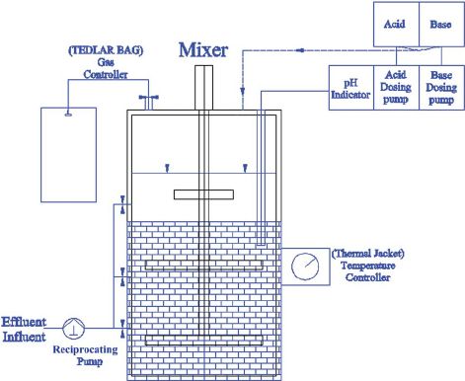
Figure:1 suspended growth bioreactor.
Few types of suspended growth bioractors are as follow
Stirred tank reactor
Bioreactors intended for the very productive articulation of the organic properties of the living organism or cells should accomplish ideal communications between the living cells and the way of life media (Schaechter & Lederberg, 2004). In a firmly controlled condition they need to give productive methods for blending, mass and warmth move between the various stages. Current reactor advancements, new kinds of bioreactors are continually being created so as to enhance and improve the yield of products (Dochain, 2008).
Due to its variety and adaptability the precisely STR is considered as the pillar for the industry. In common almost three kinds of fermentor or tanks that are used on the large scale of industries (Dunn, 2003).
- Non blendind and vaccumed about 70&
- Non blended and non vaccumed about 10%
- Blended and vaccumed about 20%
These bioreactors are designed for different purposes as for the biotransformation of traditonal item i.e wines, cheese and beer non blended and non vaccumed fermentors are used. But the microbs grow in the blended and vaccumed bioreactors produce the high yield of products very efficiently (Nag, 2008).
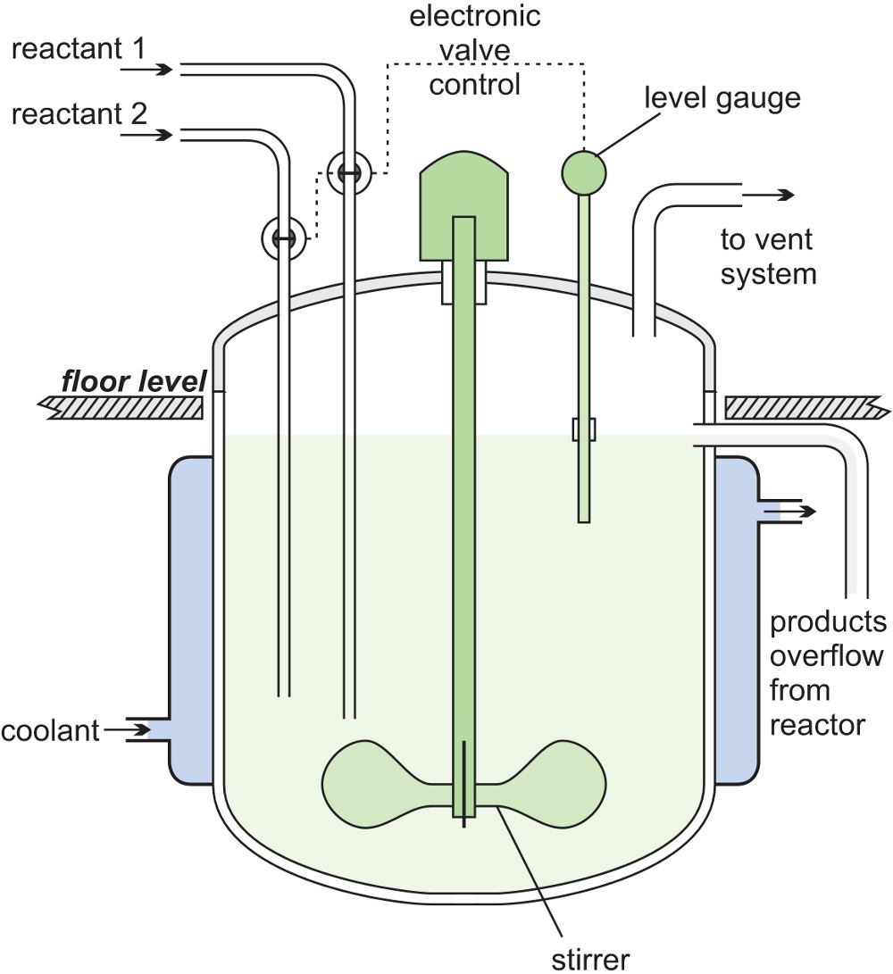
Figure:2 stirred tank bioreactor
Bioreactor also known as fermenters. This size ranges from less than 1 liter to more then 1500 liters. It may be the size of a test tube (Nag, 2008).
Continuous stirred bioreactors
They are design to carry the metabolic activities as a continuous process. Biosubstances, which are the combination of media with microbes are added from the top and products is continuously being drained. Bioreactors are aslo different on the basis of their structure from simle to complex (Binod et al, 2008). It depends on the nature of activity which is to be performed. While designing the framework of a bioreactors one thing is kept to the mind which is the yield production capability which environment needs for the daily routine purposes (Laska & Cooney, 1999).
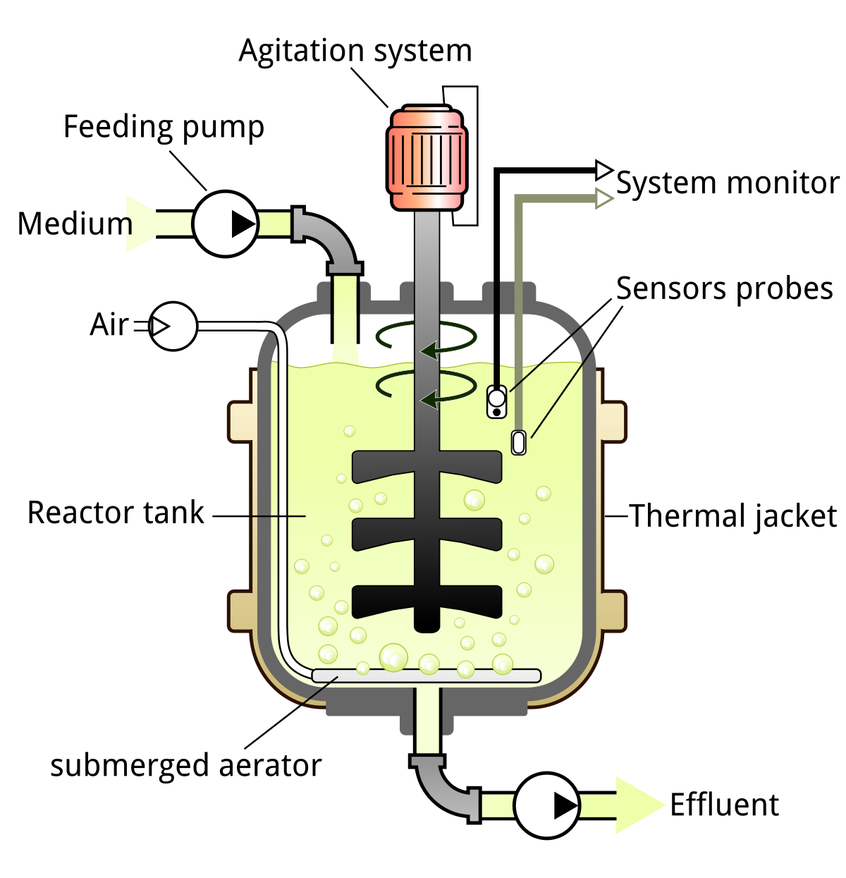
Figure: 3 Continuous stirred bioreactor.
Piston / Plug Flow / Tube Bioreactor
This reactor is horizontal tube like from left to right. One side is inlet and the other side is outlet. Microbes and food is added through inlet. In this reactor three phases are observed (Meuwly et al, 2007).
- Lag phase
- Product formation = zero
- Microbes growth = not increasing
- Substrate concentration = high
- Exponential growth
- Product formation = start forming
- Microbes growth = increasing
- Substrate concentration = decreasing
- Death phase
- Product formation = maximum
- Microbes growth = start decreasing
- Substrate concentration = almost consumed
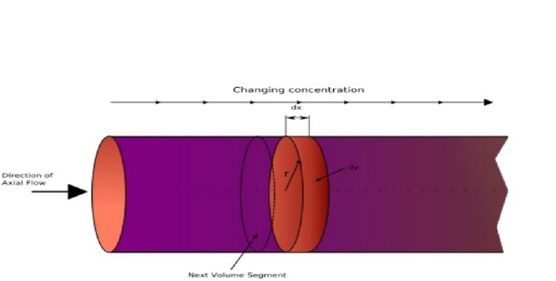
Figure: 4 Piston/ plug bioreactor.
Bioreactors are aslo different on the basis of their structure from simle to complex (Wang et al, 1992a,b). It depends on the nature of activity which is to be performed. While designing the framework of a bioreactors one thing is kept to the mind which is the yield production capability which environment needs for the daily routine purposes (Allen & Bhatia, 2002).
2. BIOFILM BIO REACTORS
In this bioreactor the microbes are coated on the sheets and are placed inside the bioreactors. These sheets have fixed microbes over them. Biofilm bioreactors are used for the purification of water. As the microbes used in the biofilm bioreactors do not secret harmful chemical and absorb the toxicants (Beg. et al. (2001). Water passes through the biofilm bioreactors from one side and collected from the bottom. During this passage microbes absorb all the toxicants from the water and make the water drinkable.
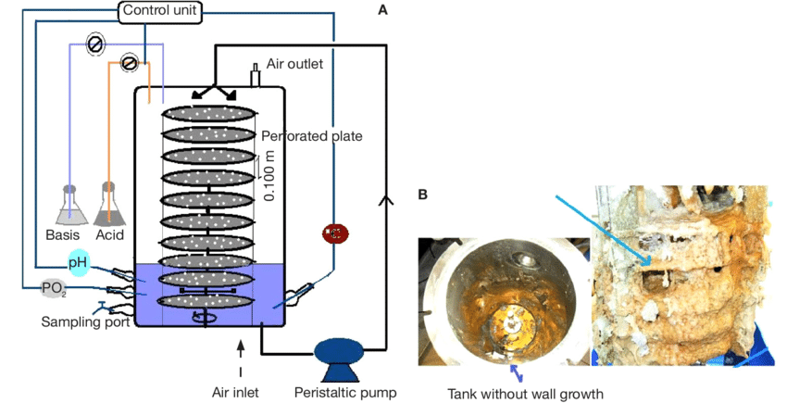
Figure:4 Biofilm Bioreactors used in filtration plants.
There are further few types of biofilm bio reactors.
Packed bed bioreactor
The Packed Bed Bioreactors (PBRs) ordinarily comprise of a pressed bed that bolsters the cells on or inside bearers and a store that is utilized to re-flow the oxygenated supplement medium through the bed (Perry & Wang, 1989; Chiou et al, 1991). Two significant setups are conceivable, with the pressed bed compartment found either outside to, or inside, the repository of the medium. A regular methodology in creating PBRs is to initially utilize a little scope model bed to recognize the ideal pressing grid for the cell line of intrigue (Degaleesan, 2001; Kantarcia et al, 2005). An ideal grid is one that gives the essential mix of cell connection, expansion and profitability. This framework is then used to improve the operational parameters (for example pressed bed tallness and volume, medium perfusion rate, and so forth.) of the PBR through perfusion tries that are for the most part performed at lab scale (Luo et al, 1999). This is very complex bioractor in its design to understand by a normal mind. So do not try to understand its beyond your capability. No doubt it performs fundamental funtion in biotecnology but its technology is so complex (Kantarci et al, 2005). Bioreactors are aslo different on the basis of their structure from simle to complex. It depends on the nature of activity which is to be performed. While designing the framework of a bioreactors one thing is kept to the mind which is the yield production capability which environment needs for the daily routine purposes.
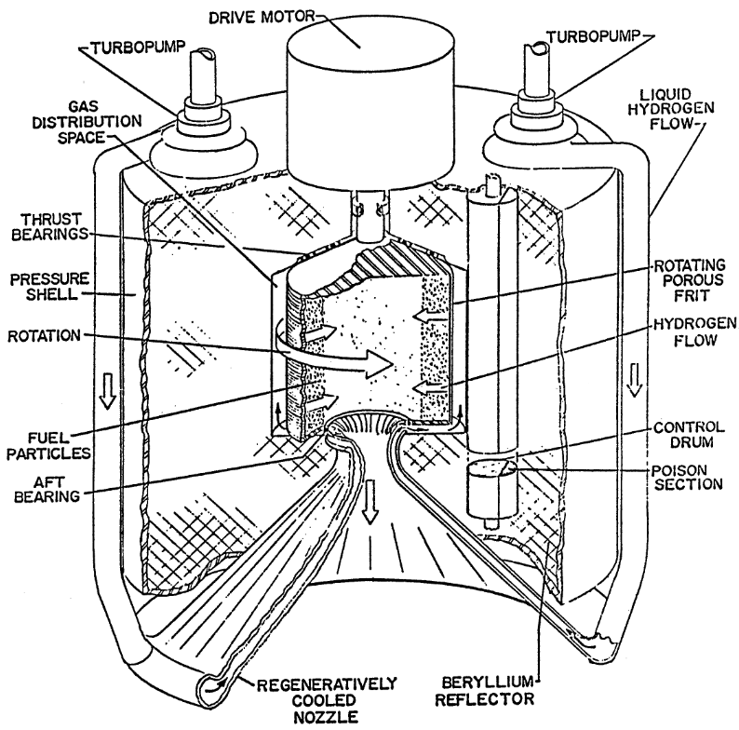
Figure: 5 Packed bed Bioreactor.
Microbes grow with film or cellulose sheet (Bandino et al, 2001). Microbes are in controlled environment and cause the bioconversion for example the acetic acid is converted to the less acidic form. Sheets are closely packed so therefore it allows the maximun conversion. Action of water to sheets allows the more furified result in the filtration plant (Garcia-Ochoa & Gomez (2009).
Fluidized bed bioreactor
Microbes are coated on the beads that are not fixed in the reactorsand move to the different places from one side to the others. When air enters from the inlet hole is cause the movement of the beads then beads flow from on place to the other through water present in it. Microbes are attached to the surface of beads. And the surface of beads is not stationary and circulates in the water and purify the warter (Meng et al, 2009). Bed is not packed fluidized. Bioreactors are aslo different on the basis of their structure from simle to complex. It depends on the nature of activity which is to be performed. While designing the framework of a bioreactors one thing is kept to the mind which is the yield production capability which environment needs for the daily routine purposes (Gerlach et al, 2008). Their designs differ from simple to complex. Mostly they are consists of wires, complex pipes, metal rods and fittings. The activity of a bioreactor depends upon the the mode of action on which it is working (Wang et al, 2010).
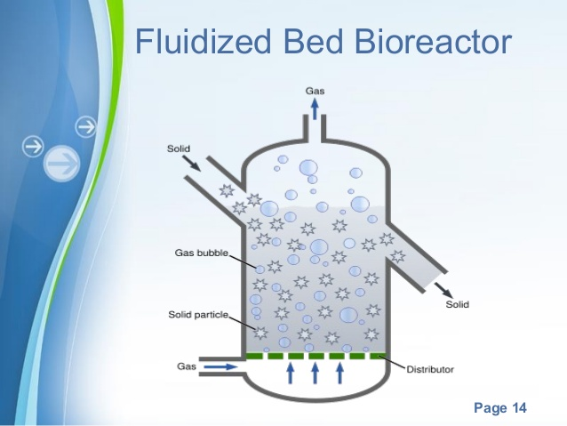
Figure:6 flluidided bed bioreactor.
FACTORS AFFECTIND THE DESIGN OF BIOREACTOR
Numerous elements add to the structure of a bioreactor.
Durand (2003) revealed that contrasted with lowered aging, the strong media utilized in strong state aging containing lesser water yet a significant gas stage present among the particles. This element is critical as a result of the poor hot air conductivity contrasted to water ( Seye. et al. (2014). Another point is the wide assortment of lattices utilized in strong state maturation, which shift as far as organization, size, mechanical opposition, porousness and water-retention limit. Every one of these elements can influence the reactor structure furthermore, the system to control the key parameters (Pandey et al, 2008). (To be sure, with lowered maturation, it very well may be thought of an estimate that all the media formed usually by water.
With lowered maturation, the trouble for the most part experienced is identified with impediments at the degree of oxygen move limit, which relies on the shape also, size of the reactor and the tumult/air circulation framework utilized. To portray this exchange, a parameter, that has been characterized (Wang et al, 2010). It can be considered as a "comparability unvarying", which implies that its worth communicates the limit of the gear to move oxygen autonomous of the volume of the reactor and, as such, comprises a significant parameter utilized in scale-up concentrates in lowered aging (Durand, 2003). With strong state Fermentation, other than oxygen move, which can be a restricting variable for certain plans, the issues are progressively intricate and influence the control of three significant parameters, for example temperature, pH and water substance of the strong medium. There are too different elements influencing the bioreactor structure, to be specific (Xu et al, 2011).: the morphology of the organism (the nearness or not of a septum in the hyphae) and, identified with this, its protection from mechanical unsettling, the need or not of having a sterile procedure filamentous organisms are morphologically intricate microorganisms, showing distinctive auxiliary structures for an amazing duration cycles. The fundamental vegetative structure of development comprises of rounded fibers known as hyphae that begin from the germination of a solitary conceptive conium or then again a bit of mycelium (Huang & McDonald, 2009). As the hyphae keep on develop, they branch every now and again and more than once to shape a mass of hyphal fibers alluded to as a mycelium (Collins et al., 1998). At the point when developed in lowered culture, these parasites display diverse morphological structures, running from scattered myceliam fibers to thickly intertwined myceliam masses alluded to as pellets, though condition, as the end purpose of the organisms' formative cycle, is once in a while accomplished during lowered development, halfway because of moderately great supplement accessibility and halfway to the physical idea of the hyphal divider Each parasitic species is likewise remarkable in its anatomical, morphological and physiological improvement (Abbott, 2003). Hence, for contagious aging, the exact physiological conditions and right stage of improvement must be set up to accomplish the maximal item arrangement. A regular methodology in creating PBRs is to initially utilize a little scope model bed to recognize the ideal pressing grid for the cell line of intrigue (Degaleesan, 2001; Kantarcia et al, 2005). An ideal grid is one that gives the essential mix of cell connection, expansion and profitability. This framework is then used to improve the operational parameters (for example pressed bed tallness and volume, medium perfusion rate, and so forth.) of the PBR through perfusion tries that are for the most part performed at lab scale (Luo et al, 1999). This is very complex bioractor in its design to understand by a normal mind. At the end of the day, controlling the type of these microorganisms is a main problem that needs incredible consideration so as to make ideal utilization of their potential creation limits during their improvement as indicated by the structure of bioreactor structured.

REFERENCES
- Bancroft, G. N., Sikavitsas, V. I., & Mikos, A. G. (2003). Design of a flow perfusion bioreactor system for bone tissue-engineering applications. Tissue engineering, 9(3), 549-554.
- Ahamed, A., & Vermette, P. (2008). Culture-based strategies to enhance cellulase enzyme production from Trichoderma reesei RUT-C30 in bioreactor culture conditions. Biochemical Engineering Journal, 40(3), 399-407.
- Ahamed, A., & Vermette, P. (2010). Effect of mechanical agitation on the production of cellulases by Trichoderma reesei RUT-C30 in a draft-tube airlift bioreactor. Biochemical Engineering Journal, 49(3), 379-387.
- Allen, J. W., Hassanein, T., & Bhatia, S. N. (2001). Advances in bioartificial liver devices. Hepatology, 34(3), 447-455.
- Babitha, S., Carvahlo, J. C., Soccol, C. R., & Pandey, A. (2008). Effect of light on growth, pigment production and culture morphology of Monascus purpureus in solid-state fermentation. World Journal of Microbiology and Biotechnology, 24(11), 2671-2675.
- Badino Jr, A. C., Facciotti, M. C. R., & Schmidell, W. (2001). Volumetric oxygen transfer coefficients (kLa) in batch cultivations involving non-Newtonian broths. Biochemical engineering journal, 8(2), 111-119.
- Van Bergeijk, S. A., Salas-Leiton, E., & Cañavate, J. P. (2010). Low and variable productivity and low efficiency of mass cultures of the haptophyte Isochrysis aff. galbana (T-iso) in outdoor tubular photobioreactors. Aquacultural engineering, 43(1), 14-23.
- Belghith, H., Ellouz-Chaabouni, S., & Gargouri, A. (2001). Biostoning of denims by Penicillium occitanis (Pol6) cellulases. Journal of biotechnology, 89(2-3), 257-262.
- Bhattacharyya, B. C., Banerjee, S., & Ghosh, T. K. (2008). Bioreactors: functions in fermentation processes. Advances in Fermentation Technology, 172-201.
- Blánquez, P., Caminal, G., Sarra, M., Vicent, M. T., & Gabarrell, X. (2002). Olive Oil Mill Waste Waters Decoloration and Detoxification in a Bioreactor by the White Rot Fungus Phanerochaeteflavido‐alba. Biotechnology progress, 18(3), 660-662.
- Blánquez, P., Casas, N., Font, X., Gabarrell, X., Sarrà, M., Caminal, G., & Vicent, T. (2004). Mechanism of textile metal dye biotransformation by Trametes versicolor. Water research, 38(8), 2166-2172.
- Spier, M. R., Vandenberghe, L. P. S., Medeiros, A. B. P., & Soccol, C. R. (2011). Application of different types of bioreactors in bioprocesses. Bioreactors: design, properties and applications. Nova Science Publishers Inc: New York, 55-90.
- Brozzoli, V., Crognale, S., Sampedro, I., Federici, F., D’annibale, A., & Petruccioli, M. (2009). Assessment of olive-mill wastewater as a growth medium for lipase production by Candida cylindracea in bench-top reactor. Bioresource technology, 100(13), 3395-3402.
- Spier, M. R., Vandenberghe, L. P. S., Medeiros, A. B. P., & Soccol, C. R. (2011). Application of different types of bioreactors in bioprocesses. Bioreactors: design, properties and applications. Nova Science Publishers Inc: New York, 55-90.
- Cartwright, T. (1994). Animal cells as bioreactors (Vol. 11). Cambridge University Press.
- Collins, P. C., Miller, W. M., & Papoutsakis, E. T. (1998). Stirred culture of peripheral and cord blood hematopoietic cells offers advantages over traditional static systems for clinically relevant applications. Biotechnology and bioengineering, 59(5), 534-543.
- Chaudhuri, J., & Al-Rubeai, M. (2005). Bioreactors for tissue engineering. Springer, The Netherlands.
- del Carmen Chavez-Parga, M., Gonzalez-Ortega, O., Negrete, M. D. L. L. X., Vallarino, I. G., Alatorre, G. G., & Escamilla-Silva, E. M. (2008). Kinetic of the gibberellic acid and bikaverin production in an airlift bioreactor. Process Biochemistry, 43(8), 855-860.
- Chèze-Lange, H., Beunard, D., Dhulster, P., Guillochon, D., Cazé, A. M., Morcellet, M., ... & Junter, G. A. (2002). Production of microbial alginate in a membrane bioreactor. Enzyme and microbial technology, 30(5), 656-661.
- Chen, H. B., Kao, P. M., Huang, H. C., Shieh, C. J., Chen, C. I., & Liu, Y. C. (2010). Effects of using various bioreactors on chitinolytic enzymes production by Paenibacillus taichungensis. Biochemical engineering journal, 49(3), 337-342.
- Cheng-Wu, Z., Zmora, O., Kopel, R., & Richmond, A. (2001). An industrial-size flat plate glass reactor for mass production of Nannochloropsis sp.(Eustigmatophyceae). Aquaculture, 195(1-2), 35-49.
- Couto, S. R., & Toca-Herrera, J. L. (2007). Laccase production at reactor scale by filamentous fungi. Biotechnology advances, 25(6), 558-569.
- Chiou, T. W., Murakami, S., Wang, D. I., & Wu, W. T. (1991). A fiber‐bed bioreactor for anchorage‐dependent animal cell cultures: Part I. Bioreactor design and operations. Biotechnology and bioengineering, 37(8), 755-761.
- Christiansen, G. S., Danes, B., Allen, L., & Leinfelder, P. J. (1953). A culture chamber for the continuous biochemical and morphological study of living cells in tissue culture. Experimental cell research, 5(1), 10-15.
- Xu, C. P., Kim, S. W., Hwang, H. J., & Yun, J. W. (2006). Production of exopolysaccharides by submerged culture of an enthomopathogenic fungus, Paecilomyces tenuipes C240 in stirred-tank and airlift reactors. Bioresource technology, 97(5), 770-777.
- Cinar, A., Parulekar, S. J., Undey, C., & Birol, G. (2003). Batch fermentation: modeling: monitoring, and control. CRC press.
- De Bartolo, L., Jarosch‐Von Schweder, G., Haverich, A., & Bader, A. (2000). A novel full‐scale flat membrane bioreactor utilizing porcine hepatocytes: cell viability and tissue‐specific functions. Biotechnology progress, 16(1), 102-108.
- Degaleesan, S., Dudukovic, M., & Pan, Y. (2001). Experimental study of gas‐induced liquid‐flow structures in bubble columns. AIChE journal, 47(9), 1913-1931.
- Dempsey, M. J. (1994). Biofilms and fluidized bed fermentation. International biodeterioration & biodegradation, 34(3-4), 237-244.
- Dochain, D. (2008). Automatic control of bioprocesses. USA: Editorial John Wiley & Sons.
- Couto, S. R., Sanromán, M. A., & Guebitz, G. M. (2005). Influence of redox mediators and metal ions on synthetic acid dye decolourization by crude laccase from Trametes hirsuta. Chemosphere, 58(4), 417-422.
- Doran, P. M. (1995). Bioprocess engineering principles. Elsevier.
- Dunn, I. J., Heinzle, E., Ingham, J., & Prenosil, J. E. (2003). Biological reaction engineering. John Wiley & Sons.
- Dunn, I. J., Heinzle, E., Ingham, J., & Prenosil, J. E. (2003). Biological reaction engineering. John Wiley & Sons.
- Durand, A. Bioreactor designs for solid state fermentation Biochemical Engineering Journal, 2003, 13, 113–125.
- Delvigne, F., Aldric, J. M., Destain, J., & Thonart, P. (2008). Improvement of xylanase production by Penicillium canescens 10-10c in solid-state fermentation. Biotechnologie, Agronomie, Société et Environnement.
- Bakri, Y., Jacques, P., & Thonart, P. (2003). Xylanase production by Penicillium canescens 10–10c in solid-state fermentation. In Biotechnology for Fuels and Chemicals (pp. 737-748). Humana Press, Totowa, NJ.
- Barrios-González, J. (2012). Solid-state fermentation: physiology of solid medium, its molecular basis and applications. Process Biochemistry, 47(2), 175-185.
- Bellon-Maurel, V., Orliac, O., & Christen, P. (2003). Sensors and measurements in solid state fermentation: a review. Process Biochemistry, 38(6), 881-896.
- Durand, A. (2003). Bioreactor designs for solid state fermentation. Biochemical Engineering Journal, 13(2-3), 113-125.
- Gaspar, A., Cossch, T., Roques, C., & Thonart, P. (1997). Study on the production of a xylanolytic complex frompenicillium canescens 10-10c. Applied biochemistry and biotechnology, 67(1-2), 45.
- Harman, G. E., Howell, C. R., Viterbo, A., Chet, I., & Lorito, M. (2004). Trichoderma species—opportunistic, avirulent plant symbionts. Nature reviews microbiology, 2(1), 43-56.
- Cooney, J. M., Lauren, D. R., Jensen, D. J., & Perry-Meyer, L. J. (1997). Effect of Harvest Time, Temperature, Light, and Spore Inoculum Concentration on 6-n-Pentyl-2 H-pyran-2-one Production by Trichoderma spp. Journal of Agricultural and Food Chemistry, 45(7), 2802-2806.
- Mo, H., Zhang, X., & Li, Z. (2004). Control of gas phase for enhanced cellulase production by Penicillium decumbens in solid-state culture. Process Biochemistry, 39(10), 1293-1297.
- Park, Y., Kang, S., Lee, J., Hong, S. L., & Kim, S. (2002). Xylanase production in solid state fermentation by Aspergillus niger mutant using statistical experimental designs. Applied microbiology and biotechnology, 58(6), 761-766.

