TOPIC:Extra Cellular Matrix;and various types of extra cellular matrix proteins

Table of Contents:
- Definition…………………
- Summary…………………
- Types…………………….
  - Glycosaminoglycan’s………………..
  - Fibrous Proteins………………………..
  - Specialised extracellular matrix or basal lamina………………….
- ECM and Disease…………………………………………………….

- Definition:
The extracellular matrix has some specialised functions such as, strength, filtration, adhesion etc. The macromolecules that constitute the extracellular matrix are mainly secreted locally by the cells. In most of the connective tissues the macromolecules are secreted by fibroblast (Fig. 4.9). In some specialised connective tissues, such as cartilage and bone, they are secreted by chondroblasts and osteoblasts, respectively.
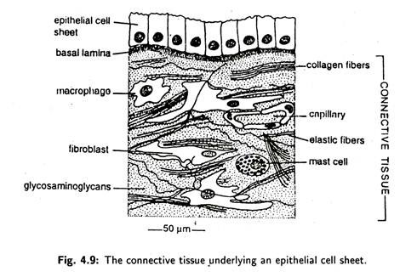
The extracellular space is more or less synonymous of intercellular space which is a space between the membranes of two cells and have a width between 200-300 A for closely applied cells. It is also true that in some tissues, the extracellular space and its matrix is a part of an organised structure such as basement membrane or connective tissue stroma.

Summary of the Extracellular Matrix:

The extracellular matrix is not solid and amorphous but contains numerous aqueous pores, and like other polysaccharide networks (Laurent, 1995; Ogston, 1995), it acts as a sieve through which water and polar molecules can easily diffuse when the extracellular matrix is hydrated (Kamiya et al., 1962, 1963Kamiya et al., 1962Kamiya et al., 1963). The extracellular matrix becomes limiting to water movement when it is dehydrated, and evaporation is the driving force for water movement (Tazawa and Okazaki, 1997). The average sizes of pores in semidehydrated extracellular matrices were originally estimated to be approximately 3–5 nm in diameter (Carpita et al., 1979; Miller, 1980a; Carpita, 1982), whereas those in hydrated extracellular matrices were estimated to be approximately twice as large (Tepfer and Taylor, 1981; Baron-Epel et al., 1988a; Shepherd and Goodwin, 1989; Meiners et al., 1991a; McCann and Roberts, 1991). Therefore, when the extracellular matrix is hydrated, its permeability is typically greater than that of the plasma membrane and can be ignored as a first approximation when measuring the permeation of solutes into or out of the cell.
The original experiments to determine pore size of the extracellular matrix were done in 100–300 mol/m³ solutions that contained solutes that were either small enough to pass through the extracellular matrix and plasmolyze the cell or were too large to pass through the extracellular matrix and caused it to crinkle (cytorhysis). Either way, the 0.1- to 0.3-M solutions dehydrated the extracellular matrix during the experiment and thus provided a minimum estimate of the average pore size (Carpita et al., 1979

- Types of Extracellular Matrix:

The extracellular matrix is made of three main types of extracellular macromolecules:
(i)
Polysaccharide glycosaminoglycan’s (commonly known as mucopolysaccharides) or GAGs which are usually linked covalently to proteins in the form of proteoglycans.
(ii)
Fibrous proteins of two functional types:
- Mainly structural (e.g., collagen and elastin)
- Mainly adhesive (e.g., fibronectin and laminin);

(iii)
Specialised extracellular matrix or basal lamina

(i).Glycosaminoglycan:

It is a long, un-branched linear polysaccharide chains and consists of repeating disaccharide units in which one of two sugars is always either N-acetyl glucosamine or N-acetylgalactosamine. Hence it is named glycosaminoglycan.
The second sugar of glycosaminoglycan is a uronic acid. In most of the cases, the amino sugar is sulfated. Due to presence of large numbers of carboxyl and sulfate group on most of their sugar residues, glycosaminoglycan’s are highly acidic and negatively charged.

There are four main classes of glycosaminoglycan’s:

(i) Hyaluronic acid,
(ii) Chondroitin sulfate and dermatan sulfate,
(iii) Heparan sulfate and heparin, and
(iv) Keratan sulfate.

(ii) Fibrous Protein:
- Structural Proteins:
Collagen:
The major fibre-forming structural proteins of the extracellular matrix are collagens. The fibrillar collagens are generally rope-like, triple- stranded helical molecules that aggregate into long cable-like fibrils in the extracellular space.
It is a hydrophobic protein. This protein is found in all multicellular animals and is secreted mainly by connective tissue cells. The basic molecular unit of collagen is tropocollagen or pro-collagen which is 300 nm in length and 1.5 nm wide. It is made of three polypeptide chains that are coiled together to form a triple helical structure.
The major portion of three polypeptide chains of tropocollagen called a-chain (about 1.000 amino acid long) has an a-helix organisation with short non-helical segments of 16-25 residues at both ends that are called tclopeptides.
The amino acid composition of the polypeptide chain of collagen is very simple; they have a large amount of proline and many of the proline and lysine residues are hydroxylated. So far, about 20 distinct a-chains of collagen have been identified. These are encoded by separate genes.
Different combination, and permutations of these genes are expressed in different tissues. So, various combinations of the 20 types of a-chain will theoretically constitute more than thousand types of collagen molecules.
So far, about five isotypes of collagen based on slight differences (Table 4.2) in the organisation of the polypeptide and association with other molecules—such as polysaccharide and glycoprotein—have been found.
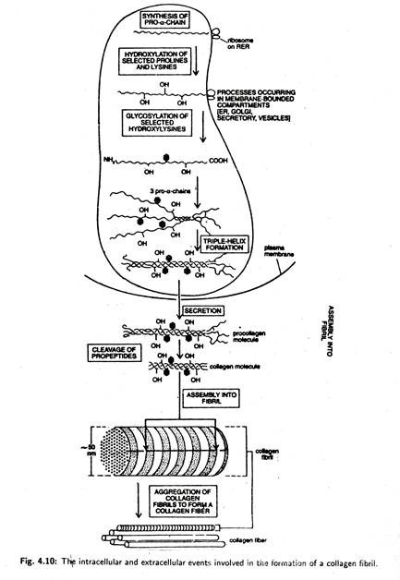

Glycine is the smallest amino acid regularly spaced at every third residue throughout the central region of the a-chain. In the lumen of the endoplasmic reticulum, proline and lysine are hydroxylated to form hydroxyproline and hydroxyserine, respectively. Each pro a-chain has an extra non-helical segment at their amino—and carboxyl terminal ends.
The extra segment is called telopeptides. Each pro α-chains then combines with other two pro a-chain and forms a triple stranded helical molecule called the pro-collagen or tropocollagen.

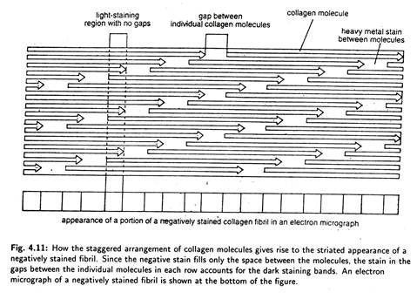

Elastin:

Elastin is a fibrillar cross-linked, random-coil, hydrophobic, non-glycosylated protein that gives the elasticity of the tissues—such as skin, blood vessels and lungs—in order to function. This protein is rich in proline and glycine and contains little amount of hydroxyproline and hydroxyserine.
It is secreted into the extracellular space and forms an extensive cross-linked network of fibres and sheets that can stretch and recoil like a rubber band and imparts the elasticity to the extracellular matrix. Elastin fibre also contains a glycoprotein which is distributed as micro-fibrils on the elastin fibre surface.

B. Adhesive Fibrous Protein:
The extracellular matrix contains several adhesive fibrous glycoproteins that bind to both cells and other matrix macromolecules and, ultimately, help cells stick to the extracellular matrix. Fibronectin and laminin are the examples of best characterised large adhesive glycoproteins in the extracellular matrix.
Fibronectin:

Fibronectin is a glycoprotein. It is made of two polypeptide chains which are similar but not identical. The two polypeptides are joined by two disulfide bonds near the carboxyl terminus. Each chain is folded into a series of globular domains joined by a flexible polypeptide segments.
Individual domains are specialised for binding to a particular molecule or to a cell. For example, one domain binds to collagen, another to heparin, another to specific receptors on the surface of various types of cells, and so on. In this way fibronectin builds up the close organisation of the matrix and help cells attach to it.
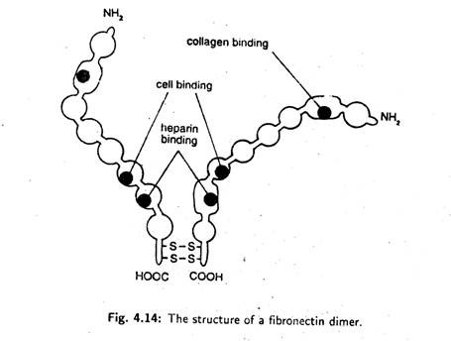

Fibronectin occurs in three forms:
1. A Soluble Dineric Form:
Called plasma fibronectin—which circulates in the blood and other body fluid. The main function of this fibronectin is to enhance blood clotting, wound healing and phagocytosis.
2. Oligomers of Fibronectin:
Called cell-surface fibronectin—which are occasionally found to attach on the cell surface and helps cell to cell attachment.
3. Highly Insoluble Fibrillar Fibronectin:
Called matrix fibronectin—which help cell adhere to the matrix.

Lamina:

Laminin is an adhesive glycoprotein. It is secreted specially by epithelial cells. This protein is a major part of all basal laminae. It binds the epithelial cells to type IV collagen of basal Lamina. Laminin is composed of three multi-domain polypeptide chains, such as A chain, B₁ chain and B₂ chain.

It has a rather peculiar asymmetric cross-shaped structure with an extended long arm ending with a large domain at one pole and three short arms having two globular domains in each arm at the opposite end.
In the middle portion both B₁ and B₂ chains make a double helical configuration around the straight central A chain. Three chains are held together by disulfide bond. Each chain is made of more than 1,500 amino acid residues. Laminin has high-affinity binding sites for other components of the basal lamina.
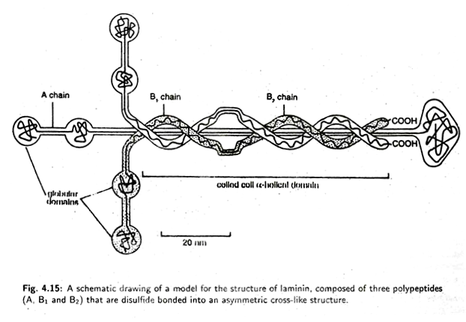

(iii) Specialised Extracellular Matrix Basal Laminae:

Basal lamina is a continuous thin mat or sheet like specialised extracellular structure that underlies all epithelial cells. Individual muscle cells, fat cells, Schwann cells are wrapped by basal lamina. It is actually linked to the plasma membranes of different types of cell by specific receptors.
The basal lamina separate these cells from the connective tissue. In the glomerulus of the kidney, the basal lamina lie between two cell sheets and forms a porous filter that allows water, ions and small molecules in blood to cross into the urinary space while retaining protein and cells in the blood.
Basal lamina is also able to determine cell polarity, influence cell metabolism, organise the proteins in neighbouring plasma membrane, induces cell differentiation and also facilitate cell migration.
The macromolecules that comprise the basal lamina are synthesised by the cells that sit on it. The precise composition of basal lamina varies from tissue to tissue but, in general, it is made of huge quantity of type IV collagen, together with proteoglycan —primarily heparan sulfate and some glycoproteins like laminin and enlactin.
In cross-sectional view, most of the basal lamina consists of two distinct layers—an electron-lucent layer, i.e., lamina lucida or rara, which remains in close contact with plasma membrane of the epithelial cells that sit on it; and an electron-dense layer, or lamina densa, that is present just below the lamina lucida.
In some cases, a third layer, i.e., lamina reticular is also found below the lamina densa and connects the underlying connective tissue (Fig. 4.16). It is made of collagen fibrils. Lamina lucida and lamina densa are unitedly called basal lamina. Lamina reticularis plus basal lamina constitute the basement membrane.

Diagram:
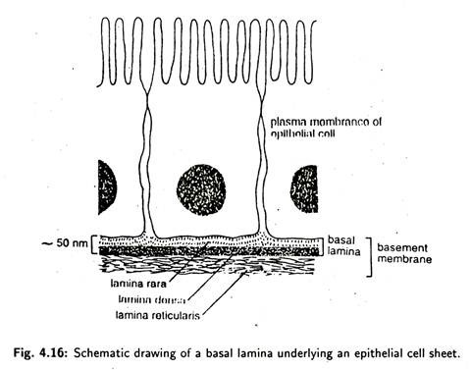

ECM and Disease:
Degradation of the extracellular matrix is required for the
tissue remodeling associated with various physiological and pathological
processes such as morphogenesis, angiogenesis, tissue repair cirrhosis, arthritis and metastasis. Matrix metalloproteases are the major proteases involved in extracellular matrix degradation.

