1 | Meaning of biomechanics | 03
2 | Definition of biomechanics | 03
3 | Examples | 03
4 | Significance of biomechanics | 03
5 | Functions of biomechanics | 05
6 | Conclusion | 08
7 | References | 09
Table of Content

SPORTS BIO-MECHANICS
- Definition of Bio-Mechanics:
“ Bio-Mechanics is the study of forces and their effects on living organism / system.”
It has two parts to define Bio-Mechanics:
- BIO: Knowledge of life
- Mechanics: Branch of physics that deals with forces and their effects on objects.
- Definitions of Sports bio-mechanics:
“ The study of forces and their effects on living organism / system in the area of sports and exercise.”
“ Sports bio-mechanics is a quantitative based study and analysis of professional athletes and sports activities in general. It can simply be described as the physics of sports.”
Example:
- Qualitative Analysis of Kicking techniques
- Qualitative Analysis of movement of arms, legs, hips, feet, knee and shoulders.
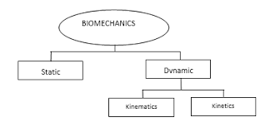
- Significance of Sports bio-mechanics:
Helps in improving Techniques Utilizing the various innovative techniques of Biomechanical Principles in practice and Sports helps To improve various error detections, improves skills, develop and strengthen qualitative and quantitative analysis with proper and selected tools and equipments. Design new equipment as biomechanics is the main part in the students’ overall sports performance; it also helps to develop and design structure of equipments, Shoes and sports clothes design, sports tools facilities like single plate Photography, Automatic Tracking System, Electro goniometry, Accelerometer, Pressure Measurement, Ground structure, surface structure and lab activities etc in proper way.
According to sports type and place, sports equipments also are used as per the principles of biomechanics in physical Education and Sports. Increase in sports performance utilizing various new techniques of biomechanical principles in the Physical Education can help to enhance performance of students in the several sports. With several models of scientific quantitative analysis like force-motion, force-time, inertia, motion, coordination, continuum, segmental interaction and balance performance of player in terms of speed, time, and accuracy in sports can be improved. Under the proper Guidance of biomechanical techniques students who have such training show better result in comparison to those who don’t have proper guidance. Prevention of Injuries Applying the innovative principles of it, player’s injury risk can be reduced by maintaining proper care about cause, diagnosis, cure and rehabilitate them. In the qualitative type of analysis techniques to prevent and recover injuries also provided accordingly.
Muscles improvement by following the biomechanical principles, various muscle groups and tissue structure can be improved in well condition. Actions such as kicking football by legs, throwing and Catching Ball, Jumping Long, lifting weight etc helps to maintain the elasticity in the muscles and build Biceps and Triceps, building joints that leads to strengthen the physical endurance. Improve internal organ system with the help of several structured approach and techniques of biomechanics in sports assist to keep internal body organ system properly because in the qualitative analysis there are various moves useful related to health of several internal organ systems. Working of all joints, function properly if the physical exercise is done accordingly.
There are some points to show the significance of Bio-mechanics in sports:
- Improves performance in sports.
- Development of improved sports performance.
- Helps in understand human body.
- Create confidence in sportsperson.
- Prevents sports injuries.
- Helps in research work.
- Improves in training techniques.
- Increases the popularity of sports.

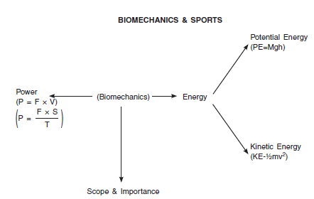
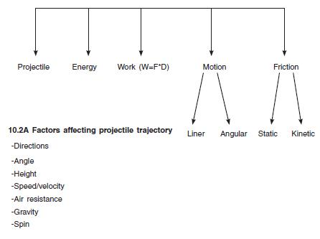
- Functions of Sports bio-mechanics:
There are major four functions of sports bio-mechanics:
- Technique Improvement
- Equipment Improvement
- Training Improvement
- Injury Improvement
- Technique Improvement
The most common method for improving performance in many sports is to improve an athlete's technique. This is highlighted here as one motivation for studying biomechanics, and it is probably what you thought of when asked how a biomechanics goes about trying to improve an athlete's performance.
The application of biomechanics to improve technique may occur in two ways: Teachers and coaches may use their knowledge of mechanics to correct actions of a student or athlete in order to improve the execution of a skill, or a biomechanics researcher may discover a new and more effective technique for performing a sport skill. In the first instance, teachers and coaches use qualitative biomechanical analysis methods in their everyday teaching and coaching to effect changes in technique. In the second instance, a biomechanics researcher uses quantitative biomechanical analysis methods to discover new techniques, which then must be communicated to the teachers and coaches who will implement them.
For example: Let's look at a simple example of the first case. As a coach, suppose you observe that your gymnast is having difficulty completing a double somersault in the floor exercise. You might suggest three things to the gymnast to help her successfully complete the stunt: (1) jump higher, (2) tuck tighter, and (3) swing her arms more vigorously before takeoff.
- Equipment Improvement
There are many examples of energy storage and return in sports equipment. Vaulting poles, diving boards, trampolines, ice hockey sticks, tennis racquets and other pieces of equipment are successful examples of energy storage and return. In all of these cases, performance in the sport is highly dependent on the energy stored in the equipment. The extra energy returned by the diving board increases a diver’s height and flight time allowing the diver to perform more complex dives. The extra energy stored in a hockey stick allows the athlete to shoot the puck faster. In these sports, the objective is to maximize the energy returned, to ensure it occurs in the right location, at the right time and with the right frequency.
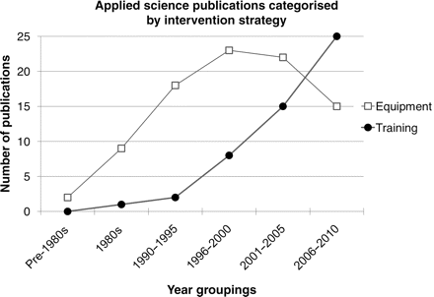
- Training Improvement
When coaches understand how forces work on muscles and affect motion in sports, they have a clear advantage over those who lack this knowledge and its applications. Athletes who know the basic concepts have a rationale for learning the correct way to execute skills. Knowing the reason behind learning a challenging technique gives them more motivation to master it. The key to success is finding effective instructional cues that help the athlete achieve correct mechanical technique. Coaches with a command of mental training tools and sports training principles can help athletes make amazing things happen on the field. Anatomy and physiology lay the foundation for biomechanics and kinesiology, areas of study about human movement. With a command of these areas, coaches can:
- Analyze sport movements
- Select the best training exercises
- Reduce or prevent injuries
- Design or choose the sport equipment that best matches athletes' personal needs
- Maximize economy and efficiency of movements
- Injury Prevention
Experiencing an injury in any sport is impossible to avoid, but it has been found new ways that may be able to reduce the amount of occurrences. The studies are led by analyzing biomechanics, which is designed to simplify the way we understand the motion of the human body.
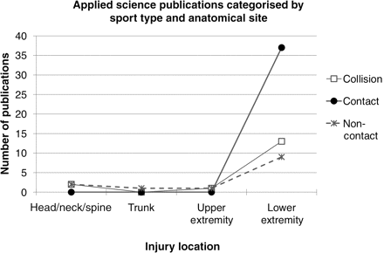

- Conclusion:
This study concludes that role of biomechanics in physical education and sports play a crucial role in this field. Physical educators teach a wide variety of human movements, and biomechanics provides a rationale critical for evaluating technique and prescribing intervention to help young people improve. In sports and exercise, biomechanics refers to the study of human movements, including the interaction between the athlete, sport equipment and the exercise environment. Athletes are always trying to find ways to get faster, higher and stronger with minimal injuries.
Biomechanics has a unique place in the field of Health Education, Physical Education and Sports. It helps to Trainers and coaches to improve the Physical performance of students with the various biomechanical techniques of different games. Its application in the life of person especially to Students, Sportsmen and Practitioners is noteworthy for Physical, Mental and Social Development. To put it simply, applying Biomechanical Principles in the Physical Exercise and Sports plays an important role in improving physical performance, Injury Mechanism, Equipment development, developing internal organ system well, etc stated above. Hope present study may provide detailed information of Biomechanical Application in Physical Education and Sports.

6. References:
Apply biomechanics to improve techniques. (n.d.). Retrieved April 24, 2020, from https://us.humankinetics.com/blogs/excerpt/apply-biomechanics-to-improve-techniques
Fukuzumi, S. I., Hirasawa, N., & Azuma, M. (2019). 2F3-7 Usability and Quality in Use. The Japanese Journal of Ergonomics, 55(Supplement). doi: 10.5100/jje.55.2f3-7
http://www.asbweb.org/conferences/2010/abstracts/525.pdf
Knudson, D. (1970, January 1). Applying Biomechanics in Physical Education. Retrieved April 24, 2020, from https://link.springer.com/chapter/10.1007/978-1-4757-5298-4_9
McBain, K., Shrier, I., Shultz, R., Meeuwisse, W. H., Klügl, M., Garza, D., & Matheson, G. O. (2012, March 1). Prevention of sports injury I: a systematic review of applied biomechanics and physiology outcomes research. Retrieved April 24, 2020, from https://bjsm.bmj.com/content/46/3/169
Rogers, P. (2019, September 22). Biomechanics Studies the Interplay of Mechanics and Bodies. Retrieved April 24, 2020, from https://www.verywellfit.com/understanding-biomechanics-3498389
Sports biomechanics. (2019, October 2). Retrieved April 24, 2020, from https://en.wikipedia.org/wiki/Sports_biomechanics
Sport Biomechanics: The Rules of Sport Technique. (n.d.). Retrieved April 24, 2020, from https://www.sports-training-adviser.com/sportbiomechanics.html

