Ismail Gulgee
Born:25October1926
Died: 16 December 2007
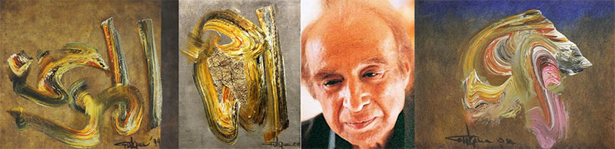

Biography
Recreating the Islamic calligraphy with a unique abstract and gestural interpretation, and portraying the members of Afghan Royal Family and people of elite classes, the Pakistani artist, Ismail Gulgee, is celebrated as a globally famous Pakistani painter, whose Arabic calligraphy inspired abstract paintings and portrait paintings are highly admired in Islamic states and the rest of the world as well. He was born on October 25, 1926, in Peshawar, Pakistan. Without receiving any formal education in painting, the self-taught Gulgee began to paint while studying hydraulics in the US. In 1950, he held his first exhibition in Stockholm, where he worked briefly as a design engineer. After his higher studies, Gulgee came to Pakistan and held another solo exhibition in Warsak, near Peshawar, where he was involved in a dam construction project on the Kabul River. A gifted portraitist, he enjoyed regular state patronage and elite commissions throughout his career. In 1957, Afghanistan’s King Zahir Shah commissioned Gulgee to paint his portrait, and subsequently invited him to Kabul to complete another 151 portraits of members of the royal family. Famous as “the court painter of Pakistan”, Gulgee continued to paint both Pakistani and foreign dignitaries including US presidents Jimmy Carter and George HW Bush, King Faisal of Saudi Arabia, King Hussein of Jordan and Farah Pahlavi, Empress of Iran.
Very few people took Gulgee’s artistic inclination seriously. He recalls a meeting with the Aga Khan in the 50s when the spiritual leader of the Ismaili community to which Gulgee belongs told him, “An artist brings glory to himself, but what your country needs is engineers.” Gulgee who was at that time working in Stockholm as a design engineer, nevertheless held his first exhibition of paintings in the Swedish city soon after. He was still concentrating on realistic portraits in oil when he moved to Pakistan to wrok as a builder of dams in various parts of the country. His first big break and a milestone in Gulgee’s artistic revolution came at this time when King Zahir Shah of Afghanistan visited Pakistan and was so pleased by a portrait done by Gulgee that he invited him to Kabul. Stone and marble and lapis lazuli were still some months away but in Kabul the artist began to produce prolifically and impressively a range of portraits and sketches that earned him the reputation of being one of Pakistan’s most talented young artists. His portraits were realistic and strong and his abstracts were not completely bold but the free-flowing style was unmistakably his. And undoubtedly exceptionally good. In 1959, an exhibition of Gulgee’s work, 151 in all was held in Kabul. Gulgee is known for his uncanny talent of creating the most faithful portraits of the great personalities of our age in blue lapis lazuli. Seeing them from a distance you would think that you look at a big photograph in bluishblack, but at a closer look you discover that the picture is formed from thousands of minute pieces of lapis lazuli that are put together in such a way that they are almost invisibly connected. Thus the picture made of dark blue stones with hundreds of different shades appears as whole as though it were a finely executed painting on canvas.
In 1960, Gulgee received his first extended exposure to abstract expressionism through an exhibition of American painter Elaine Hamilton in Karachi. Gulgee adapted action painting's energy and gesture to a Pakistani context, using virtuoso brushwork to produce large, free flowing calligraphic abstractions that captured the mystical dance of Sufi dervishes. In later decades, he embraced decoration, embellishing his canvases with gold and silver leaf, pieces of mirror and vibrant constellations of dots. In the late 1960s, Gulgee began experimenting with sculpture, securing numerous commissions for large-scale bronze works of Koranic verses and Islamic symbols, such as the sculpture he executed for Islamabad’s Shah Faisal mosque in 1986. Though he had a high public profile across the Muslim world, he exhibited infrequently at home, citing lack of proper exhibition venues for his large scale work. A rare solo show at Karachi’s Indus Gallery in 1988 was followed six years later by an important retrospective at the National Assembly in Islamabad. Eager to ensure his artistic legacy, in 2000, he inaugurated the Gulgee Museum near his home in Karachi. His paintings were bright and full of color, but the paint was put on with great sensitivity, and paintings vibrate with intense feeling. Areas sing with luminous, thin color; thick blobs of paint pulsate with fiberglass tears, the brush swirls strong and free. The total effect used to be very free, yet considered and well thought out. They work enormously well, because it was all orchestrated with great care and concentration. On the evening of 19 December 2007, Gulgee was found murdered along with his wife Zarin Gulgee and his maid. He was buried in Karachi on December 20, 2007.
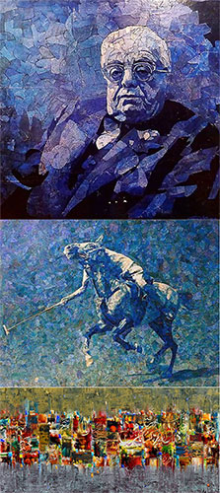
Text Reference:
Excerpts from the article Ismail Gulgee: The Gestural Interpreter of Islamic Calligraphy (book) Gulgee published by Ferozsons in 2000, pg. 23.

Awards
- President’s Medal for Pride of Performance, Government of Pakistan, 1970
- Sitara-e-Imtiaz, 1982
- Quaid-e-Azam Award, 1988
- Hilal-e-Imtiaz, 1995

Articles
- Ismail Gulgee: The Gestural Interpreter of Islamic Calligraphy
- Ismail Gulgee
- Ismail Gulgee, a pride for the nation?
- Faces of Pakistan: Ismail Gulgee
- Ismail Gulgee ‘A Towering Artist from the Subcontinent’
- Ismail Gulgee: An insight into life of Pakistan’s great painter Part 1, Part 2
- Gulgee painting auction sets record at Bonham’s
- Bonhams: Art on the rise

Books
- Gulgee
- Ismail Gulgee
- Pakistani Painters

Videos
- Gulgee: A Legend in Calligraphy, Painting, Sculptures
- Fauzia Khan interviews Painter Gulgee
- Gulgee
- Gulgee

