What is Agile methodology? Examples, when to use, advantages & disadvantages
Agile software development methodology is an process for developing software (like other software development methodologies – Waterfall model, V-Model, Iterative model etc.)
However, Agile methodology differs significantly from other methodologies. In English, Agile means ‘ability to move quickly and easily’ and responding swiftly to change – this is a key aspect of Agile software development as well.

Brief overview of Agile Methodology
- In traditional software development methodologies like Waterfall model, a project can take several months or years to complete and the customer may not get to see the end product until the completion of the project.
- At a high level, non-Agile projects allocate extensive periods of time for Requirements gathering, design, development, testing and User Acceptance Testing, before finally deploying the project.
- In contrast to this, Agile projects have Sprints or iterations which are shorter in duration (Sprints/iterations can vary from 2 weeks to 2 months) during which pre-determined features are developed and delivered.
- Agile projects can have one or more iterations and deliver the complete product at the end of the final iteration.

Example of Agile software development
Example: Adobe is working on project to come up with a competing product for Microsoft Word, that provides all the features provided by Microsoft Word and any other features requested by the marketing team. The final product needs to be ready in 10 months of time. Let us see how this project is executed in traditional and Agile methodologies.
In traditional Waterfall model –
- At a high level, the project teams would spend 15% of their time on gathering requirements and analysis (1.5 months)
- 20% of their time on design (2 months)
- 40% on coding (4 months) and unit testing
- 20% on System and Integration testing (2 months).
- At the end of this cycle, the project may also have 2 weeks of User Acceptance testing by marketing teams.
- In this approach, the customer does not get to see the end product until the end of the project, when it becomes too late to make significant changes.
The image below shows how these activities align with the project schedule in traditional software development.
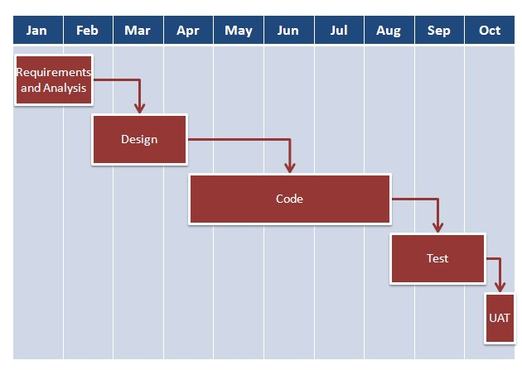
With Agile development methodology –
- In the Agile methodology, each project is broken up into several ‘Iterations’.
- All Iterations should be of the same time duration (between 2 to 8 weeks).
- At the end of each iteration, a working product should be delivered.
- In simple terms, in the Agile approach the project will be broken up into 10 releases (assuming each iteration is set to last 4 weeks).
- Rather than spending 1.5 months on requirements gathering, in Agile software development, the team will decide the basic core features that are required in the product and decide which of these features can be developed in the first iteration.
- Any remaining features that cannot be delivered in the first iteration will be taken up in the next iteration or subsequent iterations, based on priority.
- At the end of the first iterations, the team will deliver a working software with the features that were finalized for that iteration.
- There will be 10 iterations and at the end of each iteration the customer is delivered a working software that is incrementally enhanced and updated with the features that were shortlisted for that iteration.
The iteration cycle of an Agile project is shown in the image below.
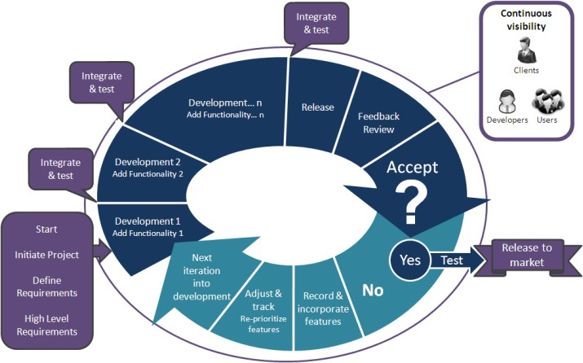
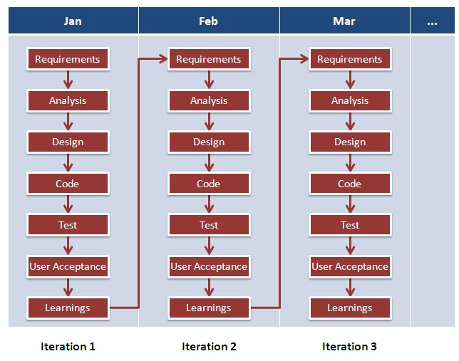
This approach allows the customer to interact and work with functioning software at the end of each iteration and provide feedback on it. This approach allows teams to take up changes more easily and make course corrections if needed. In the Agile approach, software is developed and released incrementally in the iterations. An example of how software may evolve through iterations is shown in the image below.
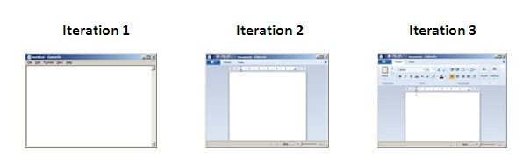
Agile methodology gives more importance to collaboration within the team, collaboration with the customer, responding to change and delivering working software.

