ANTIMALARIAL Drugs

Introduction:
Antimalarial agents are drugs used for the treatment or prophylaxis of malaria. Malaria is caused by four species of Plasmodium, such as Plasmodium falciparum, P. malariae, P. ovale, and P. vivax. Three of which produces the mild forms of malaria by destroying red blood cells in peripheral capillaries and thus, causing anaemia. The bouts of fever correspond to the reproductive cycle of the parasite. However, the most dangerous is the P. falciparum. In this case, the infected red blood cells become sticky and form lumps in the capillaries of the deep organs of the body and cause microcirculatory arrest. This disease still affects about 200 millions people and causes at least 2 million deaths per year.
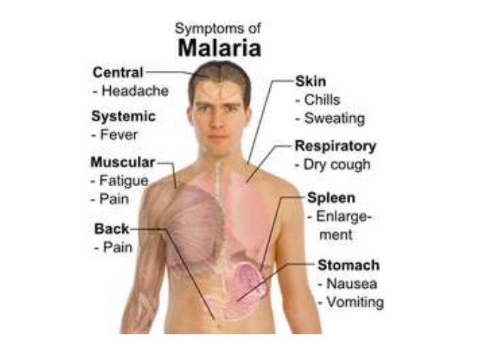
Lifecycle of plasmodium:
- Drugs acting at different stages:
The different stages of the reproductive cycle of the malarial parasite and the drugs acting at different stages of this cycle are given below:
• Stage-I: No drug is effective in this stage.
• Stage-II: Primaquine and pyrimethamine can block at this stage.
• Stage-III: Primaquine can only prevent because fever occurs at this stage.
• Stage-IV: Chloroquine, amodiaquine, santoquine, proguanil.
• Stage-V: Primaquine only.

- Phases of life cycle
Two important phases of the parasite life cycle are the following:
1. Asexual cycle—occurs in the infected host.
2. Sexual cycle—occurs in the mosquito.
After the insect bite, the parasite forms rapidly. They leave the circulation and localize in the hepatocytes whereby they transform, multiply, and develop into tissue schizonts. The primary asymptomatic tissue stage lasts for 15 days and the tissue schizonts rupture, each releasing thousands of merozites. The released merozites invade more erythrocytes to continue the cycle’s synchronous rupture of erythrocytes to continue the cycle. Synchronous rupture of erythrocytes and release of merozytes into the circulation leads to febrile pattern attacks on day 1 and 3; hence, the designation is ‘tertian malaria’. Some erythrocyte parasites differentiate into several forms known as gametophytes. After infecting human blood, female mosquito ingests them. Then the exﬂagellation of male gametocyte is followed by the male gametogenesis and the fertilization of the female gametocytes in the insect’s guts. The resulting zygote, which develops as an oocyte in the gut wall, eventually gives rise to infective sporozoite, which invades the salivary glands of the mosquito. The insect then can infect another human by taking a blood meal.
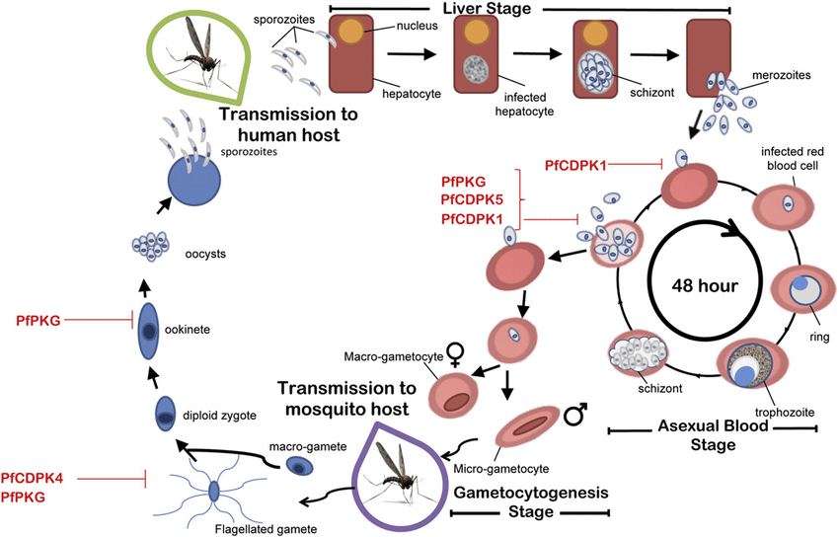

Classification of Antimalarial agents
Anti malarial drugs can be classified according to anti malarial activity and according to structure.
- According to anti malarial activity:
- Tissue schizonticides for causal prophylaxis: These drugs act on the primary tissue forms of the plasmodia which after growth within the liver, initiate the erythrocytic stage. By blocking this stage, further development of the infection can be theoretically prevented. Pyrimethamine and Primaquine have this activity. However since it is impossible to predict the infection before clinical symptoms begin, this mode of therapy is more theoretical than practical.
- Tissue schizonticides for preventing relapse: These drugs act on the hypnozoites of P. vivax and P. ovale in the liver that cause relapse of symptoms on reactivation. Primaquine is the prototype drug; pyrimethamine also has such activity.
- Blood schizonticides: These drugs act on the blood forms of the parasite and thereby terminate clinical attacks of malaria. These are the most important drugs in anti malarial chemotherapy. These include chloroquine, quinine, mefloquine, halofantrine, pyrimethamine, sulfadoxine, sulfones, tetracyclines etc.
- Gametocytocides: These drugs destroy the sexual forms of the parasite in the blood and thereby prevent transmission of the infection to the mosquito. Chloroquine and quinine have gametocytocidal activity against P. vivax and P. malariae, but not against P. falciparum. Primaquine has gametocytocidal activity against all plasmodia, including P. falciparum.
- Sporontocides: These drugs prevent the development of oocysts in the mosquito and thus ablate the transmission. Primaquine and chloroguanide have this action.
Thus in effect, treatment of malaria would include a blood schizonticide, a gametocytocide and a tissue schizonticide (in case of P. vivax and P. ovale). A combination of chloroquine and primaquine is thus needed in ALL cases of malaria.
- According to the structure:
- Aryl amino alcohols: Quinine, quinidine (cinchona alkaloids), mefloquine, halofantrine.
- 4-aminoquinolines: Chloroquine, amodiaquine.
- Folate synthesis inhibitors:
Type 1 – competitive inhibitors of dihydropteroate synthase – sulphones, sulphonamides;
Type 2 – inhibit dihydrofolate reductase – biguanides like proguanil and chloroproguanil; diaminopyrimidine like pyrimethamine
- 8-aminoquinolines: Primaquine
- Antimicrobials: Tetracycline, doxycycline, clindamycin, azithromycin, fluoroquinolones
- Peroxides: Artemisinin (Qinghaosu) derivatives and analogues – artemether, arteether, artesunate, artelinic acid
- Naphthoquinones: Atovaquone
- Iron chelating agents: Desferrioxamine
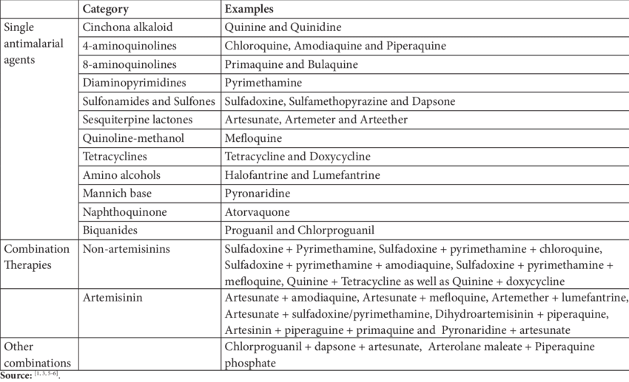

Drug profile of antimalarial agents
- 4-Substituted Quinolines
Mode of Action:
Three different mechanism of actions are suggested for these drugs:
DNA interaction: The mechanism of action for quinine is that the drug gets intercalated into the DNA of the parasite. It is based on the fact that the concentration required for the inhibition of nucleic acid synthesis is signiﬁcantly higher than that necessary for the inhibition of the plasmodium parasite. Ferriprotoporphyrin IX: The plasmodium parasite utilizes host haemoglobin as a source of amino acid. On digestion of the haemoglobin, the haem is released as ferriprotoporphyrins IX and it produces haemolysis of the erythrocyte parasites. Therefore, ferriprotoporphyrin that is released is converted into nontoxic products and they, in turn, to haemozoites by the polymerase enzyme. The steps involved in the conversion to haemozoites are inhibited by the chloroquine. Weak base hypothesis: The 4-substituted quinolines have weak base and because of this pKa they are thought to accumulate in a location, which is acidic (parasite lysozome pH 4.8–5.2). As the extracellular ﬂuid of the parasite is at pH 7.4, the weak base will move towards a more acidic pH of lysosome. Once the acid–base reaction occurs, elevating the pH in the lysozome, that in turn reduces the parasite’s ability to digest haemoglobin, thus reducing the availability of amino acids.
- Chloroquine
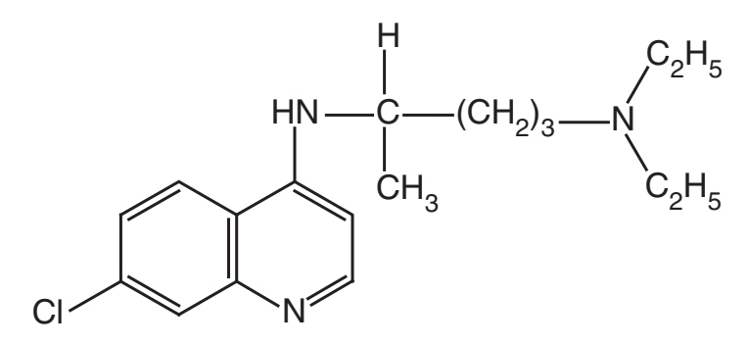
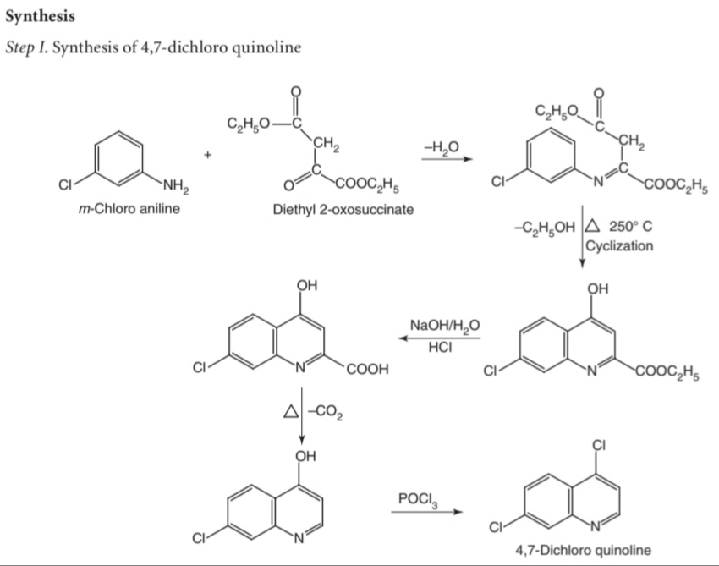
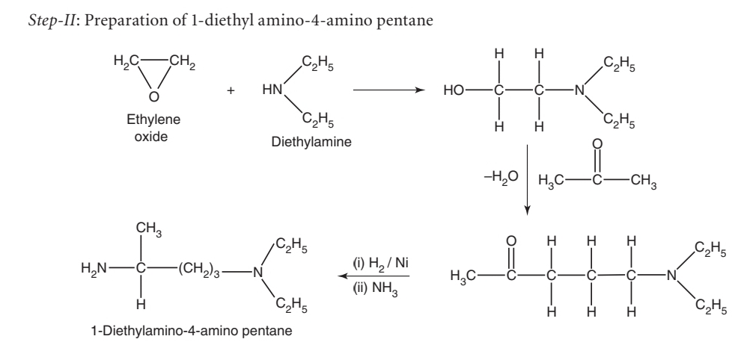
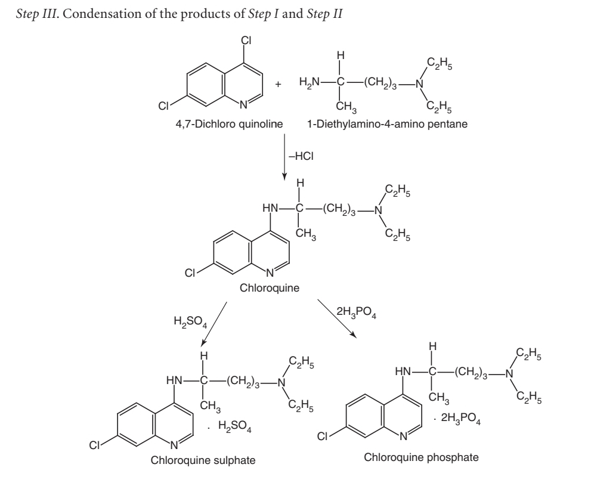
- Metabolism:
The drug is metabolized by N-dealkylation through CYP2D6, and CYP3A4 isoenzymes. It has been reported that the level of metabolism correlates closely with degree of resistance.
- Properties and uses:
Chloroquine exists as white or almost white crystalline powder, soluble in water and in methanol, very slightly soluble in ethanol. It is mainly used as an antimalarial. Chloroquine also has antihistaminic and anti inflammatory properties. It is used to treat hepatic amoebiasis, rheumatoid arthritis, discoid lupus erythematosus, cutanea tards, solar urticaria, and polymorphous light eruptions. Chloroquine and other 4-amino quinolines are not effective against exoerythrocytic parasites. It is an example for poor selective toxicity. Adverse reactions include retinopathy, haemolysis in patients with glucose-6-phosphate dehydrogenase deﬁciency (same mutation that confers resistance against malaria), muscular weakness, exacerbation of psoriasis and porphyria, and impaired liver function.
- Dose:
The recommended dose as a prophylactic and a suppressive is 500 mg once per week. As a therapeutic the dose , initially, is 1 g followed by 500 mg in 6 h, and 500 mg on the 2nd and 3rd day.
- Dosage forms:
Chloroquine sulphate injection I.P., B.P., Chloroquine sulphate tablets I.P., B.P.

- Hydroxy chloroquine 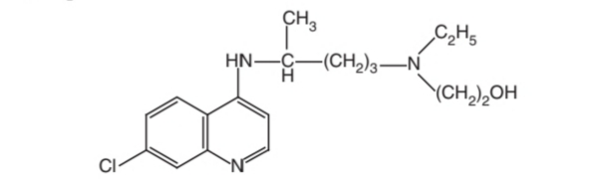

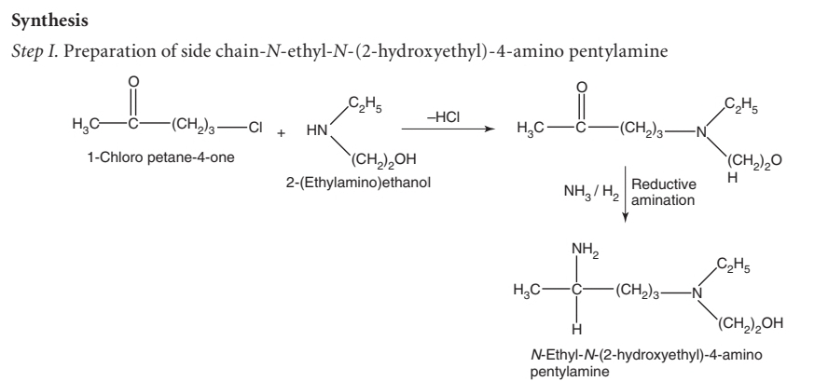

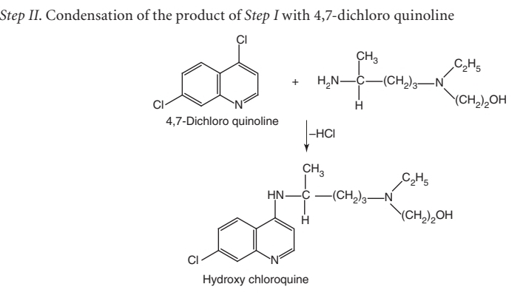
- Properties and uses:
Hydroxychloroquine is a white or almost white crystalline powder, soluble in water, practically insoluble in ethanol and in ether. It is equivalent to the chloroquine, but it is less toxic and used in the place of chloroquine against normally sensitive strains. It is mainly used as an antimalarial. It is also used for the treatment of rheumatoid arthritis and lupus erythematoses.
- Dose:
In P. falciparum infections, the dose is 1.25 g in a single dose or in two divided doses at 6 h intervals; in rheumatoid arthritis, 400 mg daily; in lupus erythematosus, 200 to 400 mg 1 or 2 times daily.
- Dosage forms:
Hydroxychloroquine tablets B.P.
Structure –Activity relationship
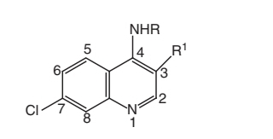
- At C-4 position, the dialkylaminoalkyl side chain has 2-5 carbon atoms between the nitrogen atoms, particularly the 4-diethylaminomethyl butyl amino side chain that is optimal for activity, as in chloroquine and quinacrine.
- The substitution of a hydroxyl group on one of the ethyl groups on the tertiary amine (hydroxy quinoline), reduces toxicity.
- Incorporation of an aromatic ring in the side chain (e.g. amodiaquine) gives a compound with reduced toxicity and activity.
- The tertiary amine in the side chain is important.
- The introduction of an unsaturated bond in the side chain was not detrimental to activity
- The 7-chloro group in the quinoline nucleus is optimal, the methyl group in position 3 reduces activity, and an additional methyl group in position 8 abolishes activity.
- The D-isomer of chloroquine is less toxic than its L-isomer.

- 8-Aminoquinolines
Mode of action:
While the mechanism of action of the 8-amino quinolines is unknown, it is known that primaquine can generate reactive oxygen species via an autoxidation of the 8-amino quinoline group with the formation of radical anion. As a result, cell destructive oxidants, such as hydrogen peroxide, super oxide, and hydroxyl radical can be formed.
- Primaquine
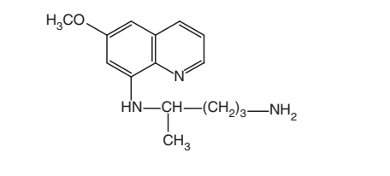
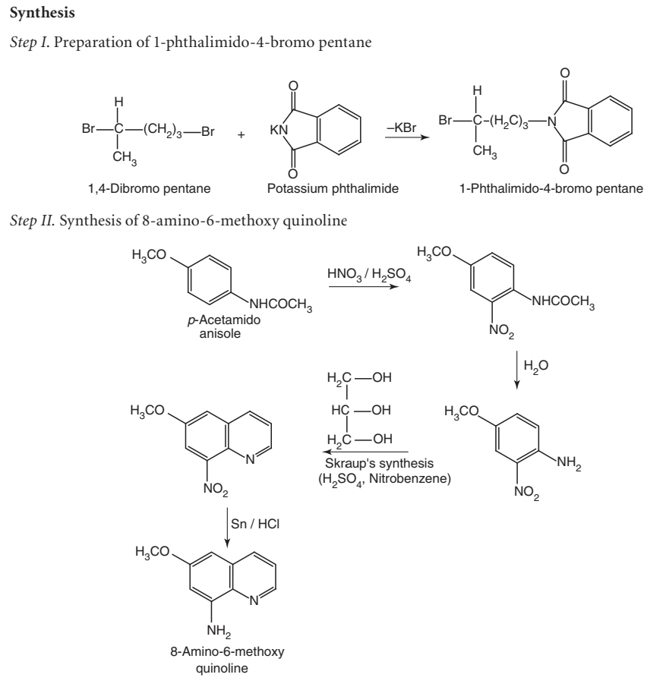

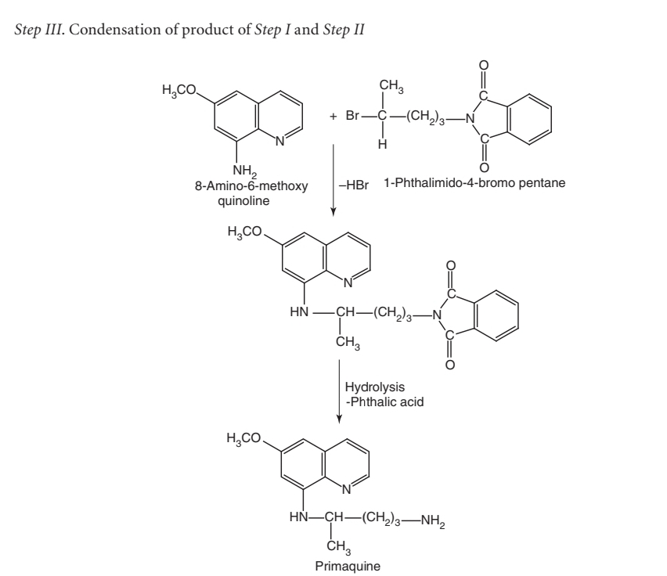
- Metabolism:
Primaquine is totally metabolized by CYP3A4 with primary metabolites having carboxy primaquine. Trace amounts of N-acetyl primaquine, aromatic hydroxylated products, and conjugation metabolites are seen.
- Properties and uses:
Primaquine is a crystalline powder, soluble in water, and practically insoluble in alcohol. In vitro and in vivo studies indicate that the stereochemistry at the asymmetric carbon is not important for antimalarial activity. These appears to be less toxicity with the levorotatory isomer, but this is dose–dependent, and may not be of much importance as the doses used to treat exoerythrocytic P. vivax malaria. It is extensively used for the radical cure of relapsing vivax malaria, but it is not normally employed either for arresting the severe attacks of the disease or for the suppressive therapy. It invariably kills gametocytes of all the species, or inhibits their growth and development in the mosquito. It fails to produce any signiﬁcant effect on other erythrocytic stages, and hence, it must not be employed alone for the treatment of malaria.
- Dose:
The recommended dose for administration is 17.5–26.3 mg (10–15 mg of base) once daily for 14 days. seen.
- Acridine Derivatives
- Quinacrine

- Mode of action:
Quinacrine acts at many sites within the cell, including intercalation of DNA strands, succinic dehydrogenase, mitochondrial electron transport, and cholinesterase. It may be tumerogenic and mutagenic and has been used as a sclerosing agent. Because it is an acridine dye, quinacrine can cause yellow discolouration of the skin and urine.
- Properties and uses:
It acts as a schizontocidal and now it is not used as an antimalarial agent. It is used in the treatment of leishmaniasis and some tape worm infestations.
- a . Biguanides
Mode of action:
Biguanides inhibit dihydrofolate reductase enzyme and interfere in the folic acid metabolism. This leads to inhibition of the nuclear division in malarial parasites.
- Proguanil HCL

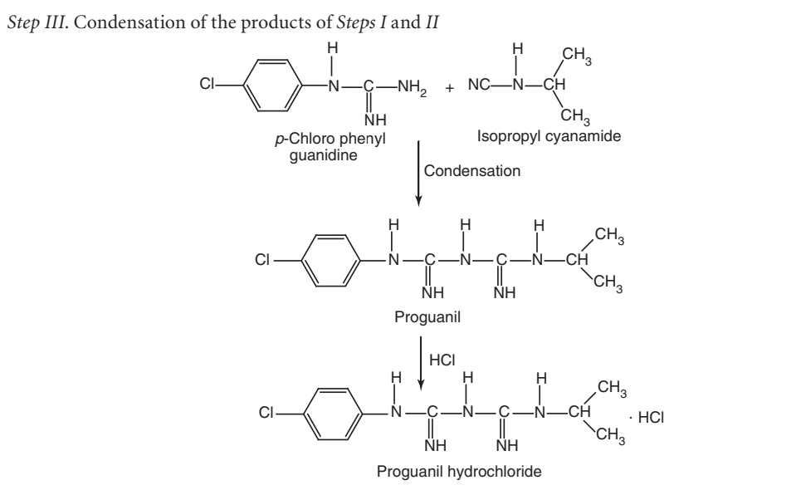
- Metabolism:
Proguanil is a prodrug, which is metabolized in the liver to diaminotriazine (cycloguanil) that acts as a dihydrofolate reductase inhibitor of Plasmodium species and inhibits DNA synthesis.
- Properties and uses:
Proguanil hydrochloride is a white crystalline powder, slightly soluble in water, sparingly soluble in ethanol, and practically insoluble in methylene chloride. It is used mainly for prophylactic treatment of malaria.
- Dose:
The recommended dose as a prophylactic and a suppressant is 100 to 200 mg per day in nonimmune subjects; 300 mg/week or 200 mg twice/week in semi-immune subjects. In the case of acute vivax malaria, initial loading dose is 300 g–600 mg followed by 300 mg per day for 5–10 days. For the treatment of falciparum malaria, the dose is 300 mg two times daily for 5 days.
4) b. Diaminopyrimidines
- Mode of Action:
It inhibits the reduction of folic acid and dihydrofolic acid to the active tetrahydrofolate coenzyme form.
- Pyrimethamine

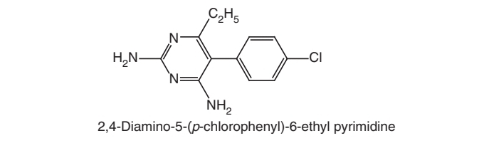
- Properties and uses:
Pyrimethamine exists as a white crystalline powder or colourless crystals, practically insoluble in water, and slightly soluble in alcohol. Pyrimethamine inhibits the reduction of folic acid and dihydrofolic acid to the active tetrahydrofolate coenzyme form. It ﬁnds its extensive use as a suppressive prophylactic for the prevention of severe attacks due to P. falciparum and P. vivax. It is also used in the treatment of taxoplasmosis and as an immuno suppressive agent.
- Dose:
The administered dose as a suppressive is 25 mg once a week, as a therapeutic 50–75 mg once a day for two days when used alone, otherwise 25 mg.
- Dosage forms:
Pyrimethamine tablets I.P., B.P.

- Trimethoprim
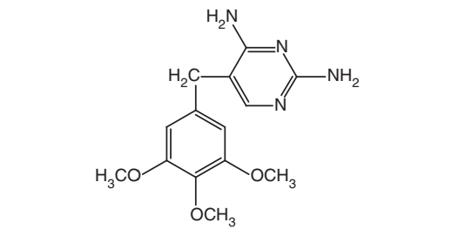
- Properties and uses:
Trimethoprim exists as a white or yellowish-white powder, very slightly soluble in water, and slightly soluble in ethanol. It is a potent inhibitor of dihydrofolate reductase. It has been employed in conjugation with sulphamethopyrazine in the treatment of chloroquine-resistant malaria. It has also been used in conjugation with sulphonamides in the treatment of bacterial infections. Trimethoprim is an antibacterial, effective against malarial parasite.
- Dose:
The administered dose is 1.5 g with 1 g of sulphametopyrazine per day for 3 days.
- Dosage forms:
Co-trimoxazole intravenous infusion B.P., Co-trimoxazole oral suspension B.P., Paediatric co-trimoxazole oral suspension B.P., Co-trimoxazole tablets dispersible B.P., Co-trimoxazole tablets paediatric B.P., Co-trimoxazole tablets B.P., Trimethoprim oral suspension B.P., Trimethoprim tablets B.P.
- Sulphones and sulphonamides

- Mode of action:
They only act against the erythrocytic stages of malaria parasite. The sulphadoxine interferes with the parasites ability to synthesize folic acid. Sulphonamides block the incorporation of pamino benzoicacid (PABA) to form dihydropteroic acid. PABA is the central part of the folate structure. Sulphonamides exhibit signiﬁ cant toxicity because humans do not synthesize the vitamin folic acid. There are severe to fatal occurrences of erythema multiform, Stevens-Johnson syndrome, toxic epidermal necrolysis, and serum sickness syndromes attributed to the sulphadoxine
- Micellaneous

- Halofantrine
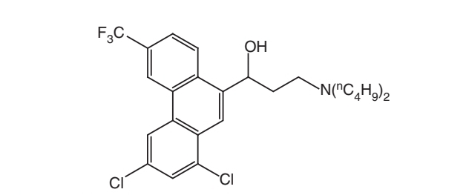
- Artemether
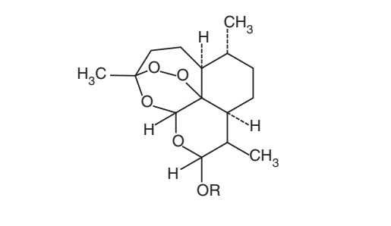
- Artesunate
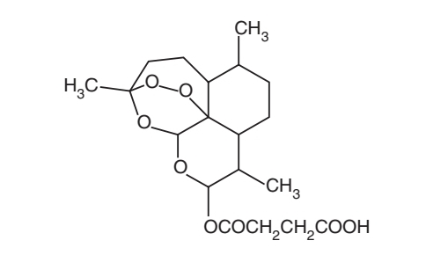
- Mefloquine
