EFFECTIVE SENSORY EVALUATION
Some parameters must be controlled for effective sensory evaluation
Climate Control
Climate Control Sensory facility particularly evaluation and discussion areas should be odor free and temperature controlled. There should be excellent arrangements for proper ventilation. The use of disposable filters in the ventilation system pipes is encouraged. Odor transfer from the food preparation area can be minimized with slightly positive pressure in these areas. Overall these should be noise interruption free.
Odor Control
The testing area must be kept free from odors. Although it is very difficult to attain, an air temperature and humidity control system with activated carbon filters could be helpful in odor control. As suggested earlier, a slight positive air pressure in the evaluation area is recommended to decrease invasion of air from the preparation room and other areas.
Lighting
Overall illumination of the laboratory should be with luminous uplighters as these are comparable to daylight in brightness and do not produce too much heat. Colored lights are usually optional in testing facilities to disguise color variations among the food products e.g. minced meat has tendency to change color and develop odor during the storage.
Time of the Day
Sensory tests should preferably be performed in the morning or afternoon. However, trained panelist can do this job any time. Preferably try to avoid tests after meals by better results.
Carriers
These are required for some food products to form a base for the food being tested e.g. cream fillings in pastries. In sensory evaluation, the main goal is to make the test more sensitive to find out product differences. However, use of carriers minimizes assessor’s capability to distinguish difference due to alterations in the flavor, texture and mouthfeel characteristics. Hence, carrier are not desirable in some situations due to decrease in test sensitivity for perceiving sensual variations.
Serving Temperature
In sensory evaluation, samples should be served at temperature these are usually consumed e.g. soup should be served hot and carbonated drinks must be cold. However, in case of trained sensory panel temperature sometimes vary from normal eating temperatures. Liquid milk can be served warm or cold depending upon the objectives of the evaluation. International Dairy Federation recommends a temperature of 16°C for liquid milk and 20°C for reconstituted powdered milk.
Sample Size
It depends upon the test objective however sample should be sufficient (about 30 g or adequate for 2-3 sips) for the overall assessment of the product. In consumer tests, this quantity is usually doubled.
Serving Containers
It depends upon the circumstances and protocol established in sensory facilities. Sometimes it is economical and time saving to use disposable containers and sometimes dishes can be washed if number of samples are limited and sufficient time is available. Additionally, in some testing facilities, use of disposable dishes is discouraged due to environmental and financial restrictions.
Sensory Evaluation Methods
Sensory evaluation plays significant role in quality control and marketing of the products. It is frequently used in food industries for new product development and recipe modification of the products. It is carried out to find out differences among the products, nature of difference and possible acceptance or rejection of products on the basis of differences. Sensory characteristics of food products can be assessed by using discriminatory, difference, descriptive and affective methods.
Types of tests
1. DIFFERENCE TESTING
a. Paired Comparison Test
In this case, each evaluator is provided with two coded samples and the task is to select the sample with the highest concentration of a pre-defined descriptor such as sweetness. This test is only meant for a detectable difference and did not specify the degree of difference.
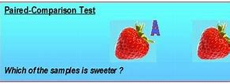
b. Triangle test
It can also be used for screening panelists who are able to perceive a difference. . In triangle testing, each assessors gets three coded samples, two are identical and one is different. The task is to pick out the unusual sample. If the judge isolates the odd sample correctly, then the evaluator can be further proceeded for scaling test. If not, they are disregarded

c. Duo-Trio Test
In this case, 3 samples are provided to the judge; one is reference (labeled R) and other two are coded. One coded sample is a duplicate of reference and other one is dissimilar. The assessor is enquired to isolate the odd sample. This test is mostly used with strong flavor products due to less tasting required.
d. Multiple Comparisons Test
This is just like paired comparisons test. In this case, a reference sample (labeled R) is presented to the evaluator with numerous coded samples and each one is compared with the reference sample on the basis of a specific attribute.
2. Descriptive Testing
SCORING METHODS
These tests are also called as scaling methods and are used to find out the intensity of some traits. The assessor uses a structured or unstructured scale to express his/her decision. Scaling methods are helpful in establishing the size, intensity and direction of the differences for a particular trait; hence these tests should be executed by the skilled or trained personal.
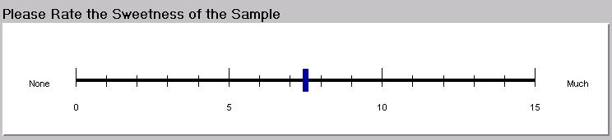
3. Affective Testing
Hedonic scale
These tests are mostly used to establish the consumer acceptability or preference for a particular product through liking and disliking. Affective tests are employed in the food industry to determine liking and disliking of consumer, preference of one product over another and consumers intention to use a product. The most commonly used hedonic scales are 7-point hedonic scale and 9-point hedonic scale with expressions stretching from dislike extremely to like extremely. By using hedonic scale, the evaluator can compare the acceptability of numerous products. 9-point hedonic scale is most commonly used in English speaking countries as well as in Pakistan.
