Citizenship Education and Community . Development
Project Report
Submitted to: Ma’am Mehlah Jabeen
Submitted by: Group 2
- Tehreem Irtaza Raza
- Aaiza Maryum
- Shagufta Bashir
- Zia-ullah
- Maria Ali
Submission Date: 7-June-2020
Program: BS-Botany (2nd)
Session: 2019-2023

Projects:
- Marks, gloves, sanitizers and flour distribution.
- Plantation
- Support PM program of ehsas relief fund

Marks, Gloves, Sanitizers and Flour distribution:
- Introduction:
- Background of the problem:
COVID-19 is the infection brought about by the new corona infection that developed in China in December 2019.COVID-19 side effects incorporates hack, fever, brevity of breath, muscle hurts, sore throat, unexplained loss of taste or smell , looseness of the bowels and migraine . COVID-19 can be extreme and a few cases have cause demise. The new corona infection can be spread from individual to individual .It is determined to have a research facility test. Avoidance includes visit hand washing, hacking into the curve of your elbow, remaining at home, when you are wiped out then wears a material face covering (mask).If you can't rehearse social separating. (http://covid.gov.im)
- Present situation:
The continuous COVID-19 emergency has gravely influenced the everyday breadwinners and the poor areas of society. For the individuals who procure on everyday schedule, it has gotten practically close to make a decent living. They can't go out and work because of lockdown that has been forced by the legislature .A day by day breadwinner neglects to raise his family's costs. Things have more regrettable and more awful, white collar class individuals have come to neediness and the needy individuals have started to ask. About 1800 cases have been accounted for in all pieces of Pakistan with 25 passings announced and the numbers are expanding. (Tehreem Irtaza Raza, BBTF19BM032)

- Justification of the project:
- Importance of project activity:
Due to corona, the national and economic situation has deteriorated. People do not have enough information about the disease to protect themselves and their families. This COVID-19 is killing thousands of people all over the world. It not only kills people, but also the economy of a state. Scientists are unable to combat this epidemic. Only preventions can control its spread. And for this, public awareness regarding the epidemic is of primary importance. So this project was helped public in controlling the epidemic. (covid.gov.pk)
- Practical Implications (Who will get benefits to the activity?):
We were gave awareness practically to the people by distributing masks (handmade), sanitizers and gloves. Gloves and masks may not be the most common cause, but some were benefited. And because of the lockdown people, who Work on a daily basis, is affected. They can't afford their families, and many families have nothing to eat. That is why we have decided to distribute the flour among the poor. With the help of this, people will be able to spend a few days in lockdown without work, so we are hopeful that public will get benefit through this project. (Tehreem Irtaza Raza, BBTF19BM032)
- Objectives of the Activity:
- To meet the basic needs of needy individuals. Moreover, to beat the poverty in lockdown.
- To spare individuals from SARS - CoV-2 (corona).
- To mindful individuals from the plague.
- To motivate the people to play their role.
- To make each and every citizen responsible.

- Plan of action:

- How were you done this activity?
We were completed our project through these steps;
- Members of my group and I (Tehreem, Aaiza and Shagufta) were distribute masks (handmade), sanitizers and gloves, in their respective areas, to people and children.
- We decided to distribute the flour among the needy people.
- And our group member Maria was distributed flour in her respected area.
- My group members and I (Tehreem, Aaiza and Zia-ullah) were helped these poor people at our own expense. And we were distributed the flour to the needy people living in the city. Because the people who live in the village have their own wheat and flour.
- So we were distributed the flour among the people of the city. The three of us was raised some money out of our own pockets and bought and distributed the flour.
- We were collect money at one place. As I live in the city, my group members (Aaiza and Zia-ullah) were sent me their own money through easy paisa.
- Then I was bought the flour and distributed the flour in the city.

- Needed resources and the source of generation (financial and human resources):
- To accomplish the project masks, sanitizer and gloves distribution three people were needed, so our group members (Tehreem, Aaiza and Shagufta) were accomplished it. All the resources were generated by us to meet needs.
- To accomplish the project flour distribution three people were needed, so our group members (Tehreem, Aaiza, Maria and Zia-ullah) were accomplished it.
- And for the flour distribution our parents were helped us financially.

- Each person’s role in the project:

For the project of Masks, sanitizers and gloves distribution:

Group member 1: Tehreem Irtaza Raza
- I was made 256 masks by myself.
- I took cloth for the masks from the NGO Tehreem Foundation.
- I was distributed it in my neighborhood with the help of my mother and brother.
- My mother helped me in this way that they went with me in my neighborhood to distribute masks and gloves.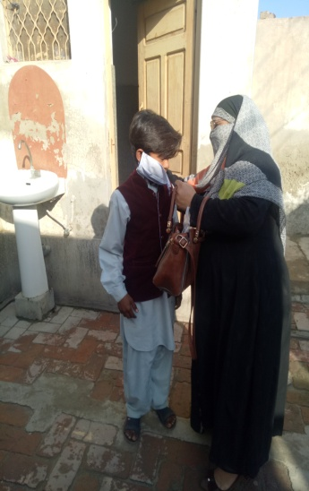 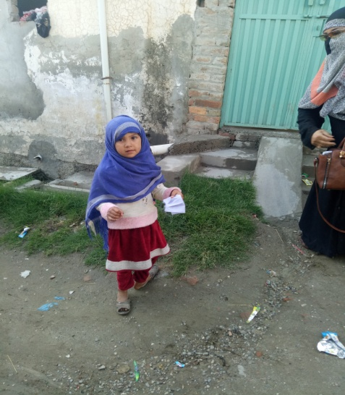
- My mother and I were gone to every house in our neighborhood.
- And we were distributed masks to all houses in our neighborhood. 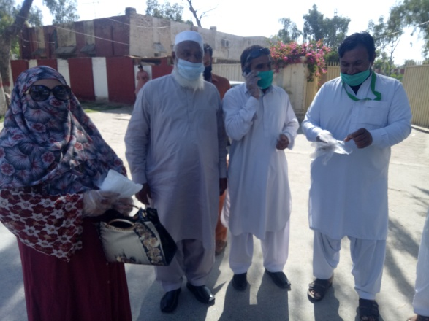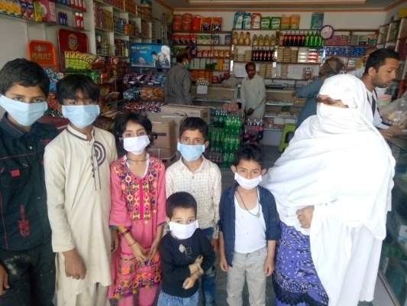 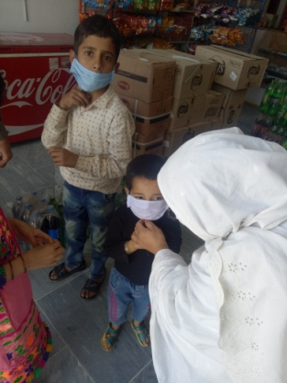
- My brother was gone to market and he was distributed masks to the people who were came market for purchasing or buying anything like vegetables, fruits, medicines and other essential things.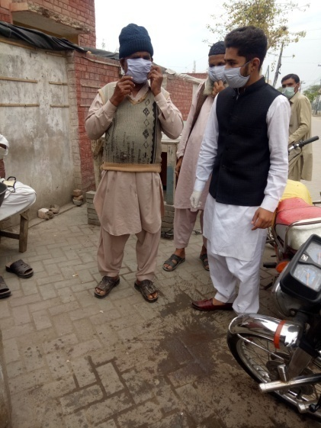 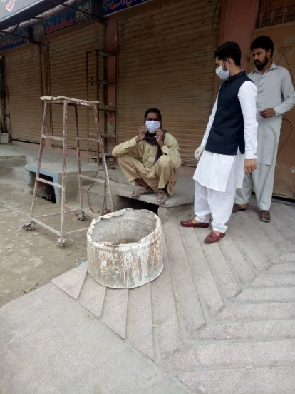
- And he was distributed marks to every person who were came market or present in market for any purpose.
- I was bought gloves from the medical store with the help of my brother and with the help of my mother.
- My mother was distributed all these gloves.(Tehreem Irtaza Raza BBTF19BM032)

Group member 2: Aaiza Maryum
- I was made masks by myself and distributed it to the children of my neighborhood with the help of my elder sister 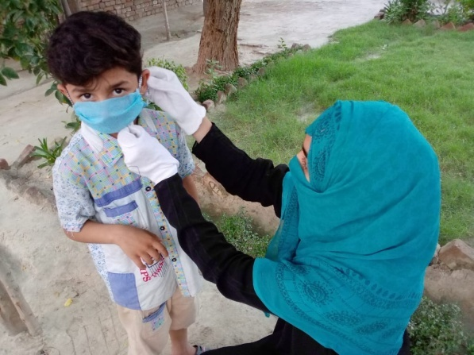 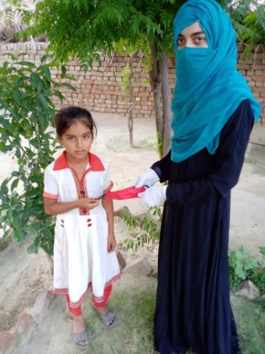
- I was sanitized the hands of children of my neighborhood.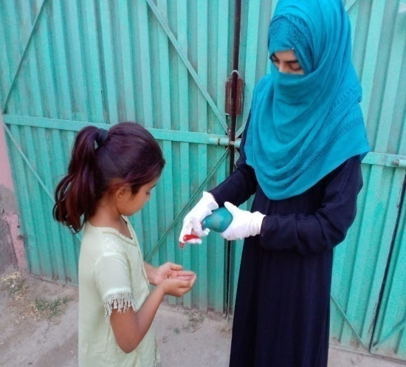 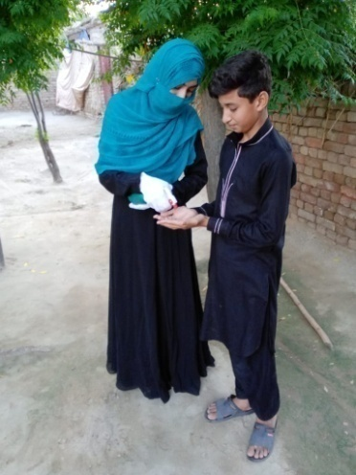
- I also gave awareness to children about the corona viruses, safety measurement and also about social distancing at my home.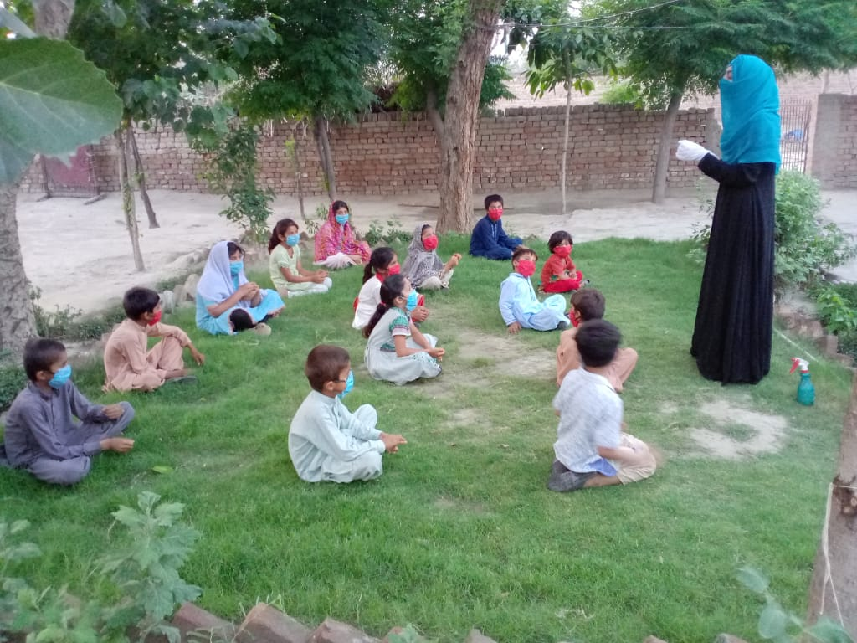

Group member 3: Shagufta Bashir
- I was bought masks and sanitizers from the market with the help of my uncle.
- My uncle gone to market and he was purchased masks and sanitizers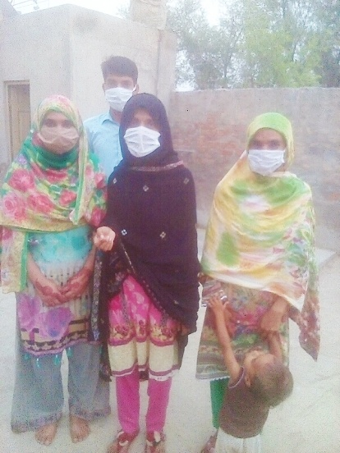 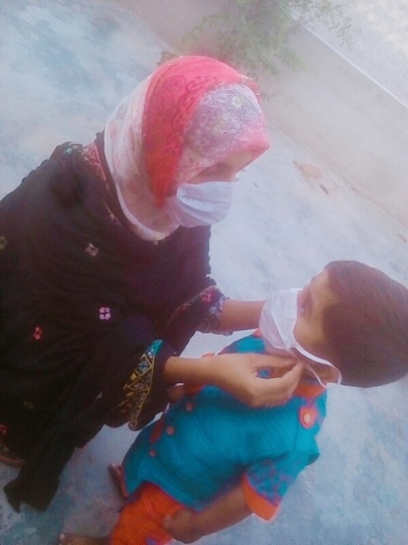
- And I was distributed masks.
- And sanitized children of my related area with the help of my sister.(ShaguftaBashirBBTF19BM055)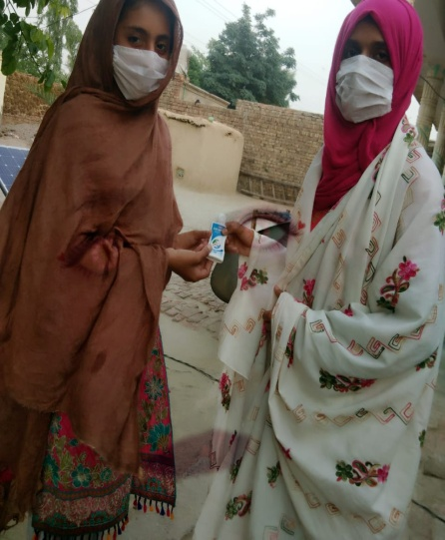 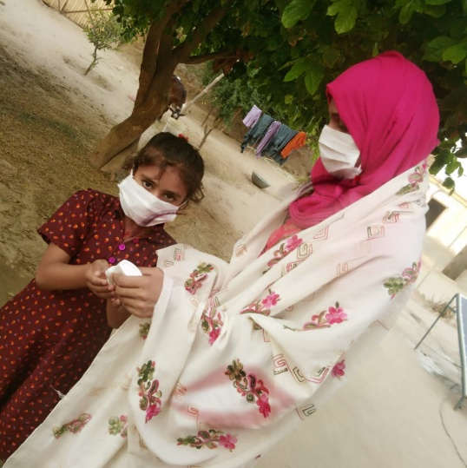 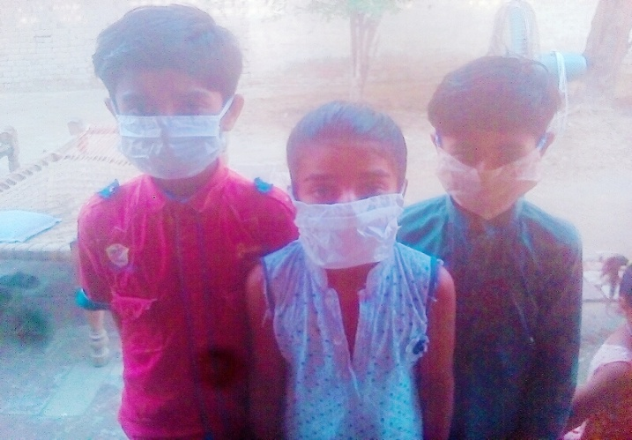

For the project of Flour distribution:

Group member 1: Aaiza Maryum
- I was sent my contribution to Tehreem Irtaza, as she lives in city therefore she was purchase flour and distributed it in city needy people, through easy paisa with the help of my brother.
- My brother was gone to city Bhakkar to send my contribution to Tehreem Irtaza Raza.
- I sent 2,000 rupees as contribution.
- I was contributed this money for the flour distribution from my pocket money.(Aaiza Maryum BBTF19BM023)

Group member 2: Zia-ullah
- I was sent my contribution to Tehreem Irtaza through easy paisa by my own self.
- I was gone to the shop of easy paisa in Bhakkar to sent contribution to our group leader Tehreem Irtaza Raza.
- I contributed 2,000 rupees from my pocket money. (Zia-ullah BBTF19BM002)

Group member 3: Tehreem Irtaza Raza

- First of all, I was taken the money that was send by my 2 group members out of the easy paisa shop.
- I was gone to easy paisa shop with the help of my brother.
- Then I was purchased flour with the help of my brother from market.
- And he was distributed it to the needy people of my neighborhood.
- I contributed 2,000 rupees. 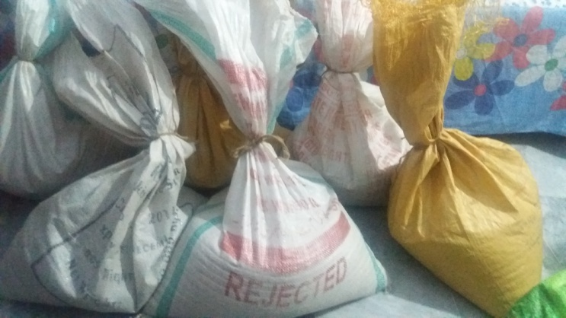
- I was used my pocket money for this entire project.
- I was made 6 bags of floor of 20 kg for the one needy family.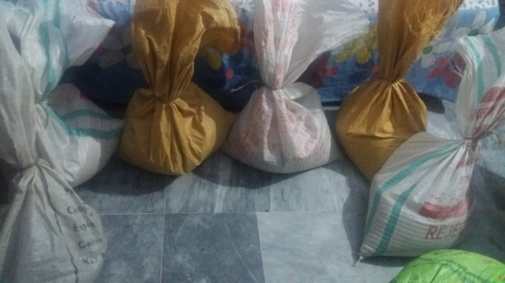 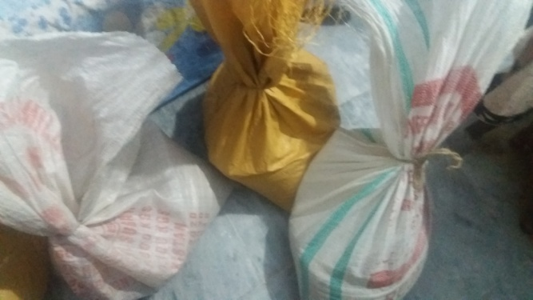
- I was also gave a bag of 32 kg of flour in my village, because that family is too needy and poor.
- And my mother was also helped me financially.(Tehreem Irtaza Raza BBTF19BM032)

Group Member 4: Maria Ali
- I was gave a bag of flour 0f 50 kg to a deserving people. 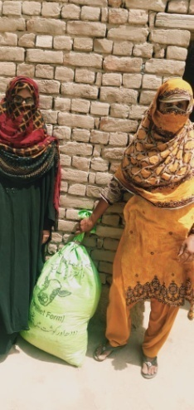 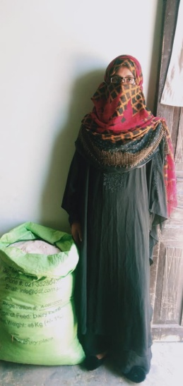
- I have found out that widow has 2 children deserves that flour. So I was gave it to her.(Maria Ali BBTF19BM050)

- Purposed duration of the activity:
Minimum twenty (20) days were required to complete the task. But lockdown and article-144 can hinder the path. So, we were accomplished the project in 25 days before 30-06-2020. (Group 5 BS-Botany 2nd)
- How will you evaluate your project from possible outcomes?
We were received better outcomes. About our project of marks, gloves and sanitizer distribution, we all group members were gone to that people who were given masks. We found out that Mask has benefited them a lot.
We were asked them that how masks, sanitizers and gloves help them to save their lives from the COVID-19. They were said that when they go outside, with the help of masks they not only protected from corona viruses as well as they were protected from many other types of germs which infect a normal and healthy person. They told us that by gloves and sanitizer they were also protected themselves from corona viruses and other germs. From our project of flour distribution needy people show very positive outcomes. They said that this flour helped them in the days of lockdown in this serious condition. And the daily wagers which are not able to afford the expenses of their family they said that by your flour distribution we were benefited, by this our household expenses become low. And they said that something is better than nothing. By their saying, they ensured that they were benefited by our effort and our project. (Group 5 BS-Botany (2nd)

Plantation:

- Introduction:
- Background of the problem:
Plantation agriculture is more than 400 years old and contributes to the regional and national economics in many tropical countries. The main environmental issues related to plantation agriculture with perennial crops, including soil erosion, soil fertility decline, pollution, carbon sequestration and biodiversity. Soil erosion and soil fertility decline are of concern in some areas, but in most plantations these are being checked by cover crops and inorganic fertilizers applications. Few studies have been conducted on the issue of carbon sequestration under perennial plantation cropping.
Reduction in reforestation yield much greater benefits for a reduction in CO₂ emission than expending plantation agriculture. The biggest threat to diversity is the loss of habitat through expansion of plantation area. The biggest and main point of crop destruction is environmental aspects. (https://www.researchgate.net/)
- Present situation:
Soil erosion, soil fertility decline, pollution, carbon sequestration and biodiversity because of all these problems the earth and the living organism which is present on earth, has been facing many difficulties. Pollution is increase day by day.
And the traffic pollution is also a big problem of this era. By pollution, ozone layer is affected and day by day this layer becomes thinner and thinner. Deforestation is also a major cause. (https://www.researchgate.net/)
- Justification of the project:
- Importance of project activity:
Likely the absolute most significant factor a ranch has on the nearby condition is where the estate is built up. In the event that characteristic backwoods is cleared for planted woods, at that point a decrease in biodiversity and loss of natural surroundings will result.
- Trees emit oxygen that we have to relax.
- Trees decrease the measure of tempest water spillover, which lessens disintegration and contamination in our conduits and may diminish the impacts of flooding.
- Numerous types of natural life rely upon trees for living space.
- Trees give food,
- Give insurance,
- Provide home for some fowls and warm blooded creatures.

On the off chance that a manor is set up on surrendered horticultural land, or profoundly debased land, it can bring about an expansion in both living space and biodiversity. The tree species utilized in a ranch is additionally a significant factor. (Tehreem Irtaza Raza BBTF19BM032)

- Practical Implications (Who will get benefits to the activity?):
We were planted in different places where there are few trees or no trees. And plants were planted in places where they can be look after. Due to our project many people, animals and environment were got benefits. We are going to overcome the worldwide problem by plantation, so we are hopeful that public was got benefit through this project. And we whole as a nation were got benefit. (Zia-ullah BBTF19BM002 and Tehreem Irtaza Raza BBTF19BM032).
- Objectives of the Activity:

- The primary point of set up green society is to be a solid world.
- Environment Security.
- Plantation to most extreme tree to assurance nature in whole world. The objective of the general public is to plant trees equivalent to total populace.
- To make a contamination free earth.
- To makes ecological mindfulness, among the individuals
- To mindful support and teach the individuals for estate the trees and about security nature.
- Distribution the trees liberated from cost and open spot, similar to class, school, films rail and bus stop, advertise and so on.
- To put forth best attempts for making world greenery.

- Plan of action:

- How will you do this activity?
We were completed our project through these steps;
- We were gone to a place where there are fewer plants.
- And where these plants will be look after.
- And we were chosen plants that are more beneficial to the environment and to the people. And then we were planted plants.
- And we will protect these plants until they will become strong.

- Needed resources and the source of generation (financial and human resources):
To accomplish this project Plantation I and my group member were accomplished this project.
Both of us were financially supported by our family (parents and Brother).
- Group member 1: Tehreem Irtaza Raza
- I was financially supported by my mother and by my pocket money.
- And my father was helped me in plantation. (Tehreem Irtaza Raza BBTF19BM032)
- Group member 2: Zia-ullah
- I was financially supported by my brother and from my pocket money.

Each person’s role in the project:

Group member 1: Zia-ullah

- I was planted many plants by my own self.
- I was bought 100 plants.
- 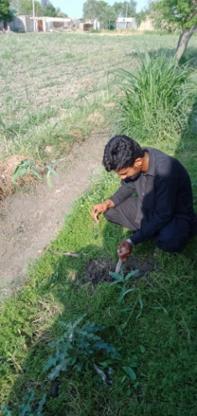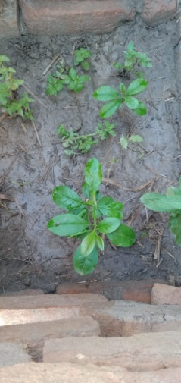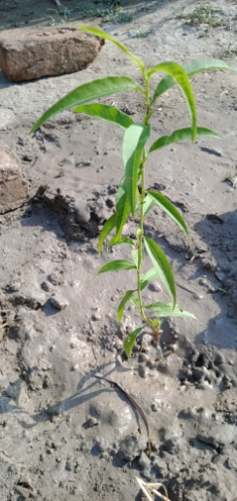
- I was bought these plants from the nursery and was planted in suitable area.
- 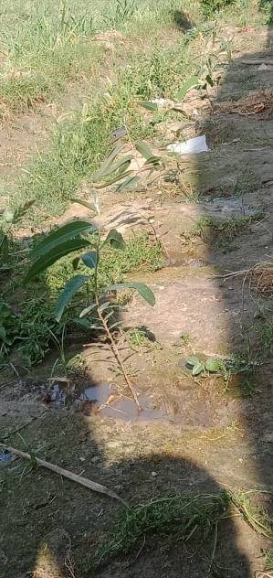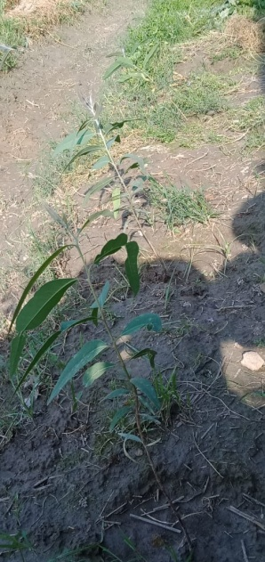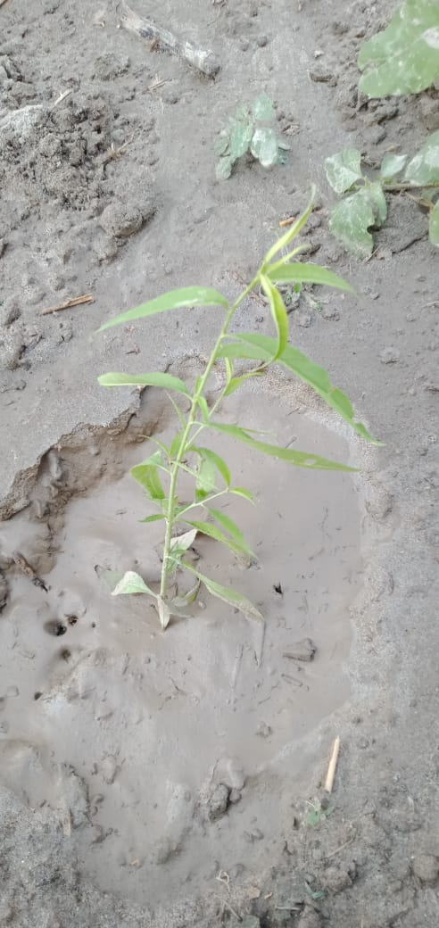

Group member 2: Tehreem Irtaza Raza
- I was planted many plants.
- I was planted 120 plants.
- 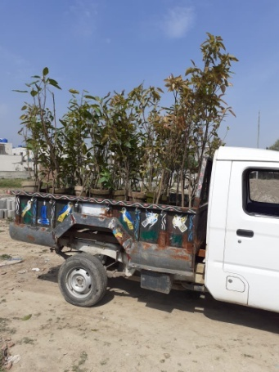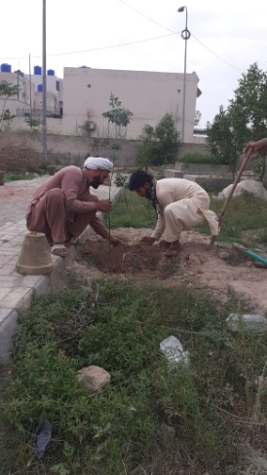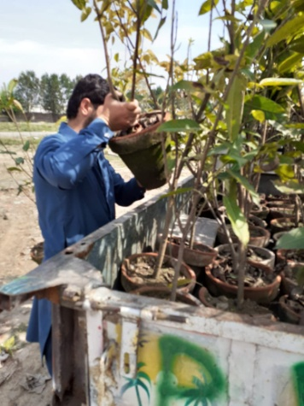
- And will daily look after all these plants.
- My father was bought the plants from the nearby nursery.
- And he was planted all plants in different area.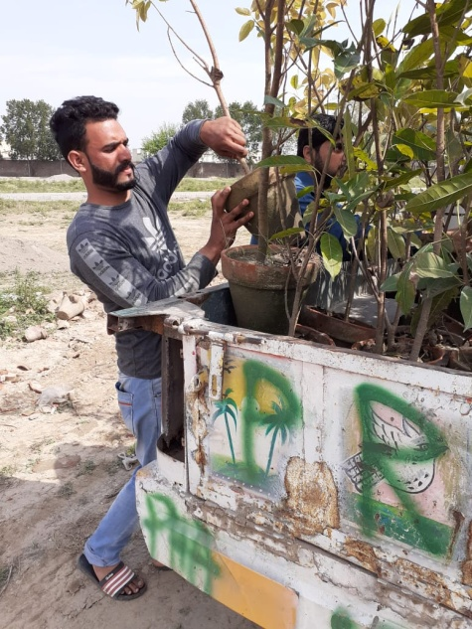 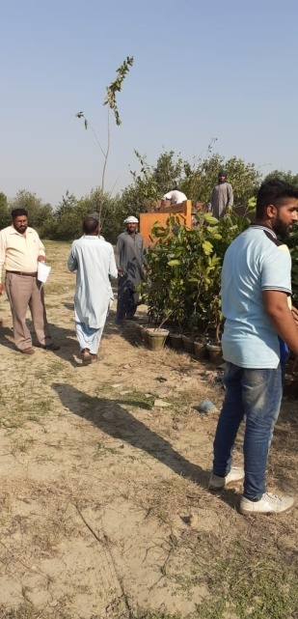
- My father was helped me also financially. (Tehreem Irtaza Raza BBTF19BM032)

- Purposed duration of the activity:
Minimum twenty (15) days were required to complete the task. But lockdown and article-144 can hinder the path. So, we were accomplished the project in 20 days. (Tehreem Irtaza Raza BBTF19BM032 and Zia-ullah BBTF19BM002)

- How will you evaluate your project from possible outcomes?
We were hopeful for desire outcomes. We asked to the people that what they getting from plantation, then they said that these plants cleanup our environment. They said these plants help to overcome the pollution, and many other soil diseases.
They said that these plants help to make the barren land fertile. These plants increase the fertility of soil. They said that when these plants will become stronger and become a young tree these provide shadow and oxygen. By their wording we were assured that our plantation project were helped them in their life. (Zia-ullah BBTF19BM002 and Tehreem Irtaza Raza BBTF19BM032)

Project:
Support PM Program of Ehsas Relief Fund:

- Introduction:
- Background of the problem:
Numerous families are influenced by the corona virus. 12 million families will get Rs12, 000 each under the activity. A spending plan of Rs144 billion was endorsed for the arrangement. The families will be given Rs12, 000 money after biometric check through 18,065 deal focuses or retail shops of Habib Bank Constrained and Bank Al-Falah the nation over. In a previous breakdown, the everyday breadwinners influenced by the pandemic were the administration's top need. (http://www.pass.gov.pkh)

- Present situation:
Head ministrator Imran Khan has propelled a program called Ehsas Relief Fund. In which each resident of Pakistan can give 20 rupees for Ehsas Relief Fund for COVID-19. These 20 rupees is for meriting individuals. In this manner every individual ought to give 20 rupees to Ehsas relief fund. In any case, there are scarcely any individual which give 20 rupees since mindfulness is required. Cash that Imran khan has circulated to poor people; we can likewise contribute cash through Ehsas Relief Fund. (http://www.pass.gov.pkh)

- Justification of the project:
- Importance of project activity:

Due to corona, the national and economic situation has deteriorated. People do not have enough information about the disease to protect themselves and their families. This COVID-19 is killing thousands of people all over the world. It not only kills people, but also the economy of a state. Many families have nothing to eat. Therefore Imran khan announced to distribute 12000 rupees to all deserving people. By our project we are support PM Imran khan’s program Ehsas relief fund. (Tehreem Irtaza Raza, BBTF19BM032)

- Practical Implications (Who will get benefits to the activity?):

We were gave awareness to the people about the Prime minister’s program Ehsas relief fund. By this project deserving people were got benefits. And because of the lockdown people, who Work on a daily basis, is affected. They can't afford their families, and many families have nothing to eat. With the help of this, people will be able to spend a few days in lockdown without work, so we were hopeful that public will get benefit through this project. (Tehreem Irtaza Raza, BBTF19BM032)
- Objectives of the Activity:
- To reduce inequality,
- To invest in people,
- To lift lagging district,
- To motivate the people to play their role.
- To make each and every citizen responsible.

- Plan of action:

- How will you do this activity?
We will complete our project through these steps;
- We wanted to make people aware of this Ehsas relief fund. We were informed our friends, relatives and neighbors to donate 20 rupees to ehsas relief fund. We were also told how to donate 20 rupees to ehsas relief fund.
- We were informed people by social media including what’s app group and by own self.

- Needed resources and the source of generation (financial and human resources):

- To accomplish this project we were worked as a unit.
- Our family members were supported us financially and to aware people.

Each person’s role in the project:

Group member 1: Tehreem Irtaza Raza
- I was informed my friends, relatives and also my neighbors to donate 20 rupees to ehsas relief fund.
- I were also told them how to donate 20 rupees.
- My mother and my brother helped me in this project.
- They were also made people aware of it.

Group member 2: Maria Ali
- I was informed people belonging to my area to donate 20 rupees and how.
- I was also told them all the procedure of donating 20 rupees to ehsas relief fund.
- My brothers was helped me in this work.
- Purposed duration of the activity:

We will continue to do this project until the university opens.

- How will you evaluate your project from possible outcomes?

We are hopeful to get desired outcomes. We are hopeful to help society in combating the deadly disease. We were tried our best to benefit as much people as possible. We hope that we were accomplished our work beautifully to help our society to get educated against the epidemic and we were got our responsibility completed. (Maria Ali BBTF19BM050 and Tehreem Irtaza Raza, BBTF19BM032)

Refrences:
- http://covid.gov.im
- covid.gov.pk
- https://www.researchgate.net/
- http://www.pass.gov.pkh
- Tehreem Irtaza Raza, BBTF19BM032, BS-Botany 2nd, Department of biological sciences, University of Sargodha sub-campus Bhakkar.
- Aaiza Maryum, BBTF19BM023, BS-Botany 2nd, Department of biological sciences, University of Sargodha sub-campus Bhakkar.
- Zia-ullah, BBTF19BM002, BS-Botany 2nd, Department of biological sciences, University of Sargodha sub-campus Bhakkar.
- Shagufta Bashir, BBTF19BM055, BS-Botany 2nd, Department of biological sciences, University of Sargodha sub-campus Bhakkar.
- Maria Ali, BBTF19BM050, BS-Botany 2nd, Department of biological sciences, University of Sargodha sub-campus Bhakkar.

