REFLECTIVE PRACTICE

INTRODUCTION
Critical thinking and reflective practice complement each other. Critical thinking on the one hand is used to describe the application of "... cognitive skills or strategies that increase the probability of a desirable outcome” and as a “purposeful, reasoned and goal directed - the kind of thinking involved in solving problems, formulating inferences, calculating likelihoods, and making decisions when the thinker is using these skills " (Halpern, 1996). Looking more closely at reflective practices, on the other hand, is a part of the process referring specifically to the processes of analyzing and making judgments about what has happened. It is an active, constant, and cautious consideration of knowledge, of the basis that support that knowledge, and the further practices to which it leads. Hence this unit will help the prospective teachers to relate critical thinking skills leading toward desirable outcomes and reflective practices that focuses on the process of making judgments about what has happened.

LEARNING OUTCOMES

After going through the unit you will be able to:

1. understand the meanings of reflection.
2. apply the meaning in the context of education.
3. differentiate among the philosophies different philosophers.
4. do the activity sheets and the self assessment work all by themselves.

4.1 REFLECTION
Reflection is a complex word with multiple meanings and shades in it. It has its purity in the subject of science when we define it as the act of reflecting of an image and casting back a light or heat. It is a word that we use in social science as well when we define it as the act of reflecting or the state of being reflected. It can also be used in fixing of the thoughts on something; careful consideration. (Miffin, 2005)
Reflective practice is the ability to reflect on action in order to keep the learning process in cycle. (Schon, 1983). After analysing and evaluating, we develop the theoretical aspects in practice. Reflection is more than merely thinking. It is planned and brainy activity that flourishes learning from experience. (Dewey, 1933)
Although development of reflection in the students is a difficult and complicated process but it's so important that it is said that actual "learning" cannot occur without reflection (Clements, 2009). It is our experience in daily life that students forget the curriculum contents very soon. It is not that they forget it, but the fact is that they memorized it for a very short period of time. The teacher covered the contents and students memorized it, most probably to appear in the examination. We must not accuse children for this forgetfulness. They in fact did not learn it. It went into the short term memory and ones the need of it was over; it vanished. Reflection is the transfer of learning from short term to long term memory. (Clements, 2009)
4.2 THEORETICAL PERSPECTIVES AND MODELS OF PROFESSIONAL DEVELOPMENT
4.2.1 John Dewey:
John Dewey, ( October 20, 1859 – June 1, 1952) was an American philosopher, psychologist, and educational reformer whose ideas have been influential in education and social reform. Dewey is one of the key figures related with the philosophy of pragmatism and is also considered one of the pioneers in the reflective teaching and reflective practices.
There is an established fact that experience, reflection and learning are correlated or at least have deep inter-related roots. We can find the work of John Dewey, particularly helpful in defining and describing the relationships among them. As a teacher we expect our students to learn. We especially expect them to learn the knowledge within their respective disciplines. For permanent learning, reflection on course readings and field experiences is essential.
John Dewey has defined what experiences are educative, according to Dewey (1933)
• Learning is cumulative and continuous process.
• Experience can be any physical movement, travelling, reading book, any mental activity; observation, recalling and remembering.
• Prior learning becomes the fodder for further understanding and insight.
In the context of learning; reflection plays a different role. Dewey defines reflection as the

" …active, persistent, and careful consideration of any belief or supposed form of knowledge in the light of the grounds that support it and the further conclusions to which it tends (Dewey, How We Think, 1933)."

According to John Dewey "The increased, enhanced and accelerated power of control is reflection. Although reflection starts with uneasiness, distress and anxiety but ultimately leads a person to balanced state. The reflective thought and process basically transforms the doubt into clarity, inconsistency into consistency and unpleasant experiences into the pleasant experiences. No doubt that it takes time to enable the thoughts to reach at the required balanced level. (Dewey, How We Think, 1933).

The reflective thought process takes time because it emerges in phases.
1. The first stage is known as "Perplexity", it starts when an individual responds to suggestion and ideas that he/she confronts with a problem.
2. "Elaboration" is the second stage. Soon after confronting problem the individual recalls the previous experiences, its pros and corns, negative and positive effects.
3. In the light of the elaboration, the person sets the "Hypotheses". What happened why and how and what best choice was at that time.
4. When a person come across with the same experience or same to some extent he then, compares the existing problem and its hypotheses with the previously learnt experience and its hypotheses. This stage of "Comparing Hypotheses" enables him to come to some better conclusion.
5. After carefully examining all the hypotheses, he is now ready for the final stage "Taking Action". This action is now a well thought of and based on reflective thinking process.

It is not enough just to have an experience. Reflection directs that experience to learning and deeper insights … Dewey affirms that these are not the rigid steps, but are the aspects of reflective activity. A person may go back and forth for more experience.

In fact, to Dewey, reflective thinking fosters the development of three attitudes that further the “habit of thinking in a reflective way.” These three attitudes are:
• Open mindedness (freedom from prejudice)
• Wholeheartedness or absorbed interest
• Responsibility in facing consequences
If we go through the above mentioned paragraph again and take its deep and comprehensive aspect, we would come to know that perhaps the whole paragraph is the aim of education in life.
If we consider the benefits of the stages of reflective thinking, which are perplexity, elaboration, hypotheses, comparing hypotheses and action we can say with any doubt that they will provide a guideline to the teachers and provide them with an opportunity to improve themselves professionally with going back and forth for any action. Each action of the teacher is linked with the future of an individual and ultimately with the future of the country. So it is strongly advisable to the teachers to go back and forth. Each action must be taken after well thought off process - Reflective Thinking Process.

4.2.2 D. A. Schön (1930-1997)
According to Schon "Professional knowledge and expertise is developed through reflective practices". Schon was basically interested in knowing as to when and how the professionals use reflection for professional development.
The basis of his work is "Espoused Theory". This is basically the mind behaviour model of an individual. What an individual thinks. What he does is known as "Theory in Use". If we ask a teacher as to how she deals with the failure students?. She will say that we do the counseling and give special attention to that particular child. In practice she calls the parents and suggest them for the extra coaching of the child. The first one is the "Espoused Theory" and the later on is "Theory in Use". Similarly some theories do make sense in the textbooks but when applied they are not effective and as useful as claimed by the theorist. Schon work is based for the newly professionals to let them know as to how the experts use "Theory in Use" in real life practices. In this regard his work is on reflection in-action and reflection on-action. Professionals reflect while they are engaged in an experience (reflection-in-action) and after an experience (reflection-on-action). In this practice of reflection, the young professionals who are inexperienced, develop the "Theory in Use" that underlie competence, knowledge, decision making skills and above all initiative practices.
Schön divided reflection into two parts: reflection “in” and “on” action. All include experience followed by reflection and the generation of hypotheses or experimental conclusions that are applied to further experience. For each, learning from experience requires shuttling back and forth from observations, to examination and reflection on those observations, and then acting on those conclusions. The more people reflect on action, the better they get at reflecting and the more they can learn about themselves…

4.2.3 David A. Kolb:
David A. Kolb (1939) was an American professor and educationalist. David Kolb bases his four stages of learning on two major opposite dimensions, namely ‘Concrete versus Abstract’ and ‘Active versus Reflective’. In practice, it appears that adults (as opposed to children) depending on experience and stage of life, first need to unlearn things before they can learn something new.
Within the dimensions, Kolb’s experiential learning theory is based on a stage theoretical model. Following is the graphical presentation of his model of learning.
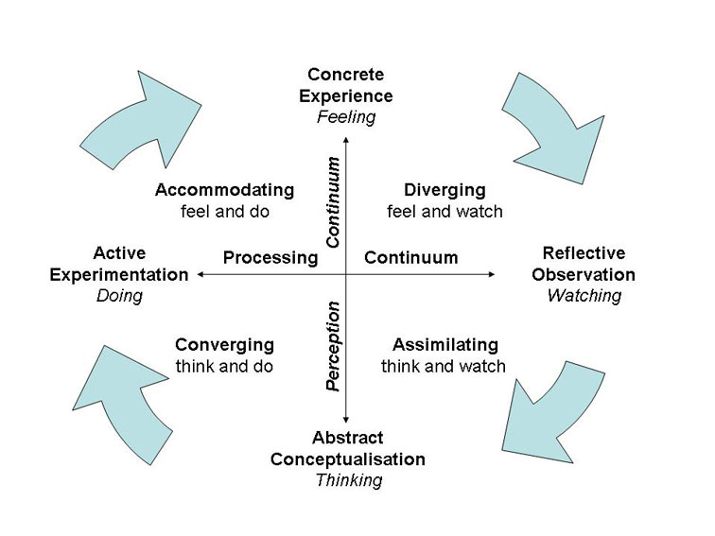
David Kolb distinguishes four learning behaviours with four learning styles:
Doers
Doers displays a combination of active experimentation and concrete experience. Doers prefer situations in which they can set to work as quickly as possible and they learn best when there is room for gaining immediate experience by doing things. Doers are open to new learning opportunities, good at solving problems and they are challenged by taking on unfamiliar tasks.
Reflectors
Reflectors have a preference for concrete experience and reflective observation. Reflectors like to think about something first and they are great at lateral problem solving. They want to consider all possible angles and implications of a problem and they never fail to see new approaches and solutions. They are dreamers that do not wish to be hurried and they want to take time before making a decision.
Thinkers
Thinkers combine reflexive observation with abstract conceptualization. They like turning their observations into coherent hypotheses and theories. They do well at verbal reasoning and they prefer to work independently. They learn best in structured learning situations with clear goals, theories and models. They would like to be able to ask questions and discuss topics.
Deciders
Deciders have a preference for abstract conceptualization and active experimentation. Deciders like trying out theories in practice. They often take the initiative, are problem solvers and they make decisions. They learn best by clear and briefly formulated rules and principles they can immediately implement in practice. They are practical people that do not like wasting time.

Four stages of the learning cycle Kolb’s four stages of learning is a cyclical process in which people must work through each of the four stages. This does not necessarily have to be from the same starting point, but preferably in the same order. According to David Kolb the learning process becomes easier by going through the four stages of learning despite people’s preference for a certain stage.
People were taught how certain things interrelate and how they can be considered in a theoretical framework. Often, little attention was paid to the accommodating learning style (experimentation and experiencing). By doing something, people gain experience (doer). Then people look back on what happened (reflector). Subsequently, people establish links between these reflections and observations and they create a theory (thinker). Finally, people think how things can (still) be improved and they will try and implement this in practice (decider). All round learners are often proficient in all of the four learning styles. (Van Vliet, 2013).
Educators should ensure that activities are designed and carried out in ways that offer each learner the chance to engage in the manner that suits them best. Also, individuals can be helped to learn more effectively by the identification of their lesser preferred learning styles and the strengthening of these through the application of the experiential learning cycle.
Ideally, activities and material should be developed in ways that draw on abilities from each stage of the experiential learning cycle and take the students through the whole process in sequence. (McLeod, 2013)

