Human Resource Management: Meaning, Objectives, Scope and Functions
Meaning:
Before we define HRM, it seems pertinent to first define the term ‘human resources’. In common parlance, human resources means the people. However, different management experts have defined human resources differently. For example, Michael J. Jucius has defined human resources as “a whole consisting of inter-related, inter-dependent and interacting physiological, psychological, sociological and ethical components”.
According to Leon C. Megginson “From the national point of view human resources are knowledge, skills, creative abilities, talents, and attitudes obtained in the population; whereas from the view-point of the individual enterprise, they represent the total of the inherent abilities, acquired knowledge and skills as exemplified in the talents and aptitude of its employees”.
Sumantra Ghosal considers human resources as human capital. He classifies human capita into three categories-intellectual capitals, social capital and emotional capital. Intellectual capital consists of specialized knowledge, tacit knowledge and skills, cognitive complexity, and learning capacity.
Social capital is made up of network of relationships, sociability, and trustworthiness Emotional capital consists of self-confidence, ambition and courage, risk-bearing ability, and resilience. Now it is clear from above definitions that human resources refer to the qualitative and quantitative aspects of employees working in an organisation.
Let us now define human resource management.
In simple words, HRM is a process of making the efficient and effective use of human resources so that the set goals are achieved. Let us also consider some important definitions of HRM.
According to Flippo “Personnel management, or say, human resource management is the planning, organising, directing and controlling of the procurement development compensation integration, 4intenance, and separation of human resources to the end that individual, organisational and social objectives are accomplished”.
The National Institute of Personnel Management (NIPM) of India has defined human resource/personnel management as “that part of management which is concerned with people at work and with their relationship within an enterprise. Its aim is to bring together and develop into an effective organisation of the men and women who make up an enterprise and having regard for the well-being of the individuals and of working groups, to enable them to make their best contribution to its success”.
According to Decenzo and Robbins “HRM is concerned with the people dimension in management. Since every organisation is made up of people, acquiring their services, developing their skills, motivating them to higher levels of performance and ensuring that they continue to maintain their commitment to the organisation are essential to achieving organisational objectives. This is true, regardless of the type of organisation-government, business, education, health, recreation, or social action”.
Thus, HRM can be defined as a process of procuring, developing and maintaining competent human resources in the organisation so that the goals of an organisation are achieved in an effective and efficient manner. In short, HRM is an art of managing people at work in such a manner that they give their best to the organisation for achieving its set goals.
Objectives:
The primary objective of HRM is to ensure the availability of right people for right jobs so as the organisational goals are achieved effectively.
This primary objective can further be divided into the following sub-objectives:
1. To help the organisation to attain its goals effectively and efficiently by providing competent and motivated employees.
2. To utilize the available human resources effectively.
3. To increase to the fullest the employee’s job satisfaction and self-actualisation.
4. To develop and maintain the quality of work life (QWL) which makes employment in the organisation a desirable personal and social situation.
5. To help maintain ethical policies and behaviour inside and outside the organisation.
6. To establish and maintain cordial relations between employees and management.
7. To reconcile individual/group goals with organisational goals.
Werther and Davis have classified the objectives of HRM into four categories as shown in table 1.2.
Table 1.2: HRM Objectives and Functions:
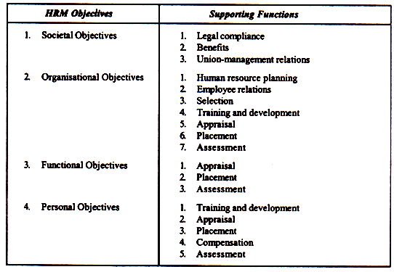
Scope:
The scope of HRM is, indeed, very vast and wide. It includes all activities starting from manpower planning till employee leaves the organisation. Accordingly, the scope of HRM consists of acquisition, development, maintenance/retention, and control of human resources in the organisation (see figure 1.1). The same forms the subject matter of HRM. As the subsequent pages unfold, all these are discussed, in detail, in seriatim.
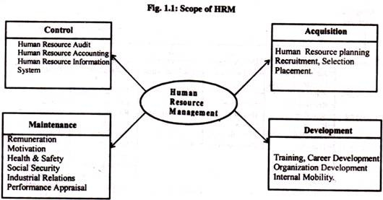
The National Institute of personnel Management, Calcutta has specified the scope of HRM as follows:
1. The Labour or Personnel Aspect:
This is concerned with manpower planning, recruitment, selection, placement, transfer, promotion, training and development, lay-off and retrenchment, remuneration, incentives, productivity, etc.
2. Welfare Aspect:
It deals with working conditions, and amenities such as canteen, creches, rest and lunch rooms, housing, transport, medical assistance, education, health and safety, recreation facilities, etc.
3. Industrial Relations Aspects:
This covers union-management relations, joint consultation, collective bargaining, grievance and disciplinary actions, settlement of disputes, etc.
Functions:
We have already defined HRM. The definition of HRM is based on what managers do. The functions performed by managers are common to all organizations. For the convenience of study, the function performed by the resource management can broadly be classified into two categories, viz.
(1) Managerial functions, and
(2) Operative functions (see fig. 1.2).
These are discussed in turn.
(1) Managerial Functions:
Planning:
Planning is a predetermined course of actions. It is a process of determining the organisational goals and formulation of policies and programmes for achieving them. Thus planning is future oriented concerned with clearly charting out the desired direction of business activities in future. Forecasting is one of the important elements in the planning process. Other functions of managers depend on planning function.
Organising:
Organising is a process by which the structure and allocation of jobs are determined. Thus organising involves giving each subordinate a specific task establishing departments, delegating authority to subordinates, establishing channels of authority and communication, coordinating the work of subordinates, and so on.
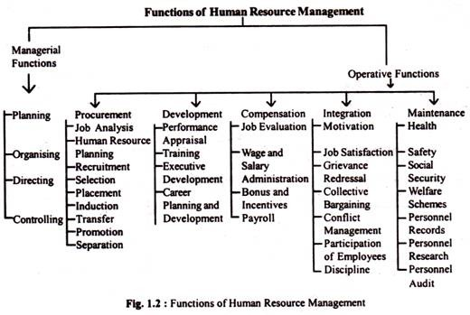
Staffing:
TOs is a process by which managers select, train, promote and retire their subordinates This involves deciding what type of people should be hired, recruiting prospective employees, selecting employees, setting performance standard, compensating employees, evaluating performance, counseling employees, training and developing employees.
Directing/Leading:
Directing is the process of activating group efforts to achieve the desired goals. It includes activities like getting subordinates to get the job done, maintaining morale motivating subordinates etc. for achieving the goals of the organisation.
Controlling:
It is the process of setting standards for performance, checking to see how actual performance compares with these set standards, and taking corrective actions as needed.
(2) Operative Functions:
The operative, also called, service functions are those which are relevant to specific department. These functions vary from department to department depending on the nature of the department Viewed from this standpoint, the operative functions of HRM relate to ensuring right people for right jobs at right times. These functions include procurement, development, compensation, and maintenance functions of HRM.
A brief description of these follows:
Procurement:
It involves procuring the right kind of people in appropriate number to be placed in the organisation. It consists of activities such as manpower planning, recruitment, selection placement and induction or orientation of new employees.
Development:
This function involves activities meant to improve the knowledge, skills aptitudes and values of employees so as to enable them to perform their jobs in a better manner in future. These functions may comprise training to employees, executive training to develop managers, organisation development to strike a better fit between organisational climate/culture and employees.
Compensation:
Compensation function involves determination of wages and salaries matching with contribution made by employees to organisational goals. In other words, this function ensures equitable and fair remuneration for employees in the organisation. It consists of activities such as job evaluation, wage and salary administration, bonus, incentives, etc.
Maintenance:
It is concerned with protecting and promoting employees while at work. For this purpose virus benefits such as housing, medical, educational, transport facilities, etc. are provided to the employees. Several social security measures such as provident fund, pension, gratuity, group insurance, etc. are also arranged.
It is important to note that the managerial and operative functions of HRM are performed in conjunction with each other in an organisation, be large or small organisations.

