Net present value (NPV):
Net present value is the difference between the present value of cash inflows and the present value of cash outflows that occur as a result of undertaking an investment project. It may be positive, zero or negative. These three possibilities of net present value are briefly explained below:

Positive NPV:
If present value of cash inflows is greater than the present value of the cash outflows, the net present value is said to be positive and the investment proposal is considered to be acceptable.

Zero NPV:
If present value of cash inflow is equal to present value of cash outflow, the net present value is said to be zero and the investment proposal is considered to be acceptable.

Negative NPV:
If present value of cash inflow is less than present value of cash outflow, the net present value is said to be negative and the investment proposal is rejected.
The summary of the concept explained so far is given below:
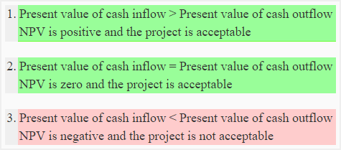

Assumptions:
The net present value method is based on two assumptions. These are:
- The cash generated by a project is immediately reinvested to generate a return at a rate that is equal to the discount rate used in present value analysis.
- The inflow and outflow of cash other than initial investment occur at the end of each period.

Advantages and Disadvantages:
The basic advantage of net present value method is that it considers the time value of money. The disadvantage is that it is more complex than other methods that do not consider present value of cash flows. Furthermore, it assumes immediate reinvestment of the cash generated by investment projects. This assumption may not always be reasonable due to changing economic conditions.
Practice Question
Question # 1
The management of Fine Electronics Company is considering to purchase an equipment to be attached with the main manufacturing machine. The equipment will cost $6,000 and will increase annual cash inflow by $2,200. The useful life of the equipment is 6 years. After 6 years it will have no salvage value. The management wants a 20% return on all investments.
Required:
- Compute net present value (NPV) of this investment project.
- Should the equipment be purchased according to NPV analysis?
Question #2
Smart Manufacturing Company is planning to reduce its labor costs by automating a critical task that is currently performed manually. The automation requires the installation of a new machine. The cost to purchase and install a new machine is $15,000. The installation of machine can reduce annual labor cost by $4,200. The life of the machine is 15 years. The salvage value of the machine after fifteen years will be zero. The required rate of return of Smart Manufacturing Company is 25%.
Should Smart Manufacturing Company purchase the machine?
Question #3
A project requires an initial investment of $225,000 and is expected to generate the following net cash inflows:
Year 1: $95,000
Year 2: $80,000
Year 3: $60,000
Year 4: $55,000
Required: Compute net present value of the project if the minimum desired rate of return is 12%.

Present value Index/ profitability index
Sometime a company may have limited funds but several alternative proposals. In such circumstances, if each alternative requires the same amount of investment, the one with the highest net present value is preferred. But if each proposal requires a different amount of investment, then proposals are ranked using an index called present value index (or profitability index). The proposal with the highest present value index is considered the best. Present value index is computed using the following formula:
Formula of present value or profitability index:
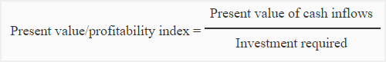
Because each investment proposal requires a different amount of investment, the most desirable investment can be found using present value index. Present value index of all three proposals is computed below:

Question # 4
Choose the most desirable investment proposal from the following alternatives using profitability index method:
