Ceramics:
A ceramic is an inorganic non-metallic solid made up of either metal or non-metal compounds that have been shaped and then hardened by heating to high temperatures. In general, they are hard, corrosion-resistant and brittle.
Defining ceramics
Dr. Ian Brown, a senior research scientist with Industrial Research Limited, explains how the term ‘ceramics’ now has a more expansive meaning. Traditional ceramics are clay-based, but high-performance or advanced ceramics are being developed from a far wider range of inorganic non-metal materials. Advanced ceramics have the properties of high strength, high hardness, high durability and high toughness.
The word 'Ceramic' comes from the Greek word meaning ‘pottery’. The clay-based domestic wares, art objects and building products are familiar to us all, but pottery is just one part of the ceramic world.
Nowadays the term ‘ceramic’ has a more expansive meaning and includes materials like glass, advanced ceramics and some cement systems as well.

Traditional ceramics – pottery
Pottery is one of the oldest human technologies. Fragments of clay pottery found recently in Hunan Province in China have been carbon dated to 17,500–18,300 years old.
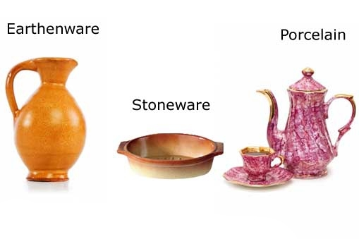
Traditional ceramics
Traditional ceramics are clay–based. The categories of pottery shown here are earthenware, stoneware and porcelain. The composition of the clays used, type of additives and firing temperatures determine the nature of the end product.
The major types of pottery are described as earthenware, stoneware and porcelain.
Earthenware is used extensively for pottery tableware and decorative objects. It is one of the oldest materials used in pottery.
The clay is fired at relatively low temperatures (1,000–1,150°C), producing a slightly porous, coarse product. To overcome its porosity, the fired object is covered with finely ground glass powder suspended in water (glaze) and is then fired a second time. Faience, Delft and majolica are examples of earthenware.
Stoneware clay is fired at a high temperature (about 1,200°C) until made glass-like (vitrified). Because stoneware is non-porous, glaze is applied only for decoration. It is a sturdy, chip-resistant and durable material suitable for use in the kitchen for cooking, baking, storing liquids and as serving dishes.
Porcelain is a very hard, translucent white ceramic. The earliest forms of porcelain originated in China around 1600BC, and by 600AD, Chinese porcelain was a prized commodity with Arabian traders. Because porcelain was associated with China and often used to make plates, cups, vases and other works of fine art, it often goes by the name of ‘fine china'.
To make porcelain, small amounts of glass, granite and feldspar minerals are ground up with fine white kaolin clay. Water is then added to the resulting fine white powder so that it can be kneaded and worked into shape. This is fired in a kiln to between 1,200–1,450°C. Decorative glazes are then applied followed by further firing.
Bone china – which is easier to make, harder to chip and stronger than porcelain – is made by adding ash from cattle bones to clay, feldspar minerals and fine silica sand.

Advanced ceramics – new materials
Advanced ceramics are not generally clay-based. Instead, they are either based on oxides or non-oxides or combinations of the two:
- Typical oxides used are alumina (Al₂O₃) and zirconia (ZrO₂).
- Non-oxides are often carbides, borides, nitrides and silicides, for example, boron carbide (B₄C), silicon carbide (SiC) and molybdenum disilicide (MoSi₂).
The space shuttle Discovery
Part of the space shuttle’s outer skin is made up of over 27,000 ceramic tiles. The tiles are designed to withstand the tremendous heat generated on re-entry into the Earth’s atmosphere.
Production processes firstly involve thoroughly blending the very fine constituent material powders. After shaping them into a green body, this is high-temperature fired (1,600–1,800°C). This step is often carried out in an oxygen-free atmosphere.
The high temperature allows the tiny grains of the individual ceramic components to fuse together, forming a hard, tough, durable and corrosion-resistant product. This process is called sintering.

Applications of advanced ceramics
Advanced ceramic materials are now well established in many areas of everyday use, from fridge magnets to an increasing range or industries, including metals production and processing, aerospace, electronics, automotive and personnel protection.
In modern medicine, advanced ceramics – often referred to as bioceramics – play an increasingly important role. Bioceramics such as alumina and zirconia are hard, chemically inert materials that can be polished to a high finish. They are used as dental implants and as bone substitutes in orthopaedic operations such as hip and knee replacement.

What are plastics?
We talk about "plastic" as though it's a single material, but there are in fact many different plastics. What they have in common is that they're plastic, which means they are soft and easy to turn into many different forms during manufacture. Plastics are (mostly) synthetic (human-made) materials, made from polymers, which are long molecules built around chains of carbon atoms, typically with hydrogen, oxygen, sulfur, and nitrogen filling in the spaces. You can think of a polymer as a big molecule made by repeating a small bit called a monomer over and over again; "poly" means many, so "polymer" is simply short for "many monomers." If you think of how a long coal train is made from many trucks coupled together, that's what polymers are like. The trucks are the monomers and the entire train, made from lots of identical trucks, is the polymer. Where a coal train might have a couple of dozen trucks, a polymer could be built from hundreds or even thousands of monomers. In other words, polymers typically have very large and heavy molecules.
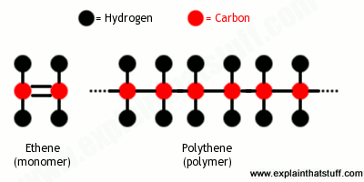
Artwork: Polymers are made from long chains of a basic unit called a monomer. Polyethylene (polythene) is made by repeating the ethene monomer over and over again.

Types of plastics
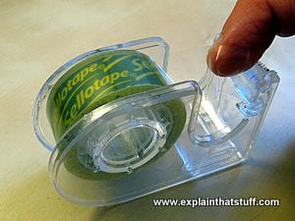
Photo: Natural plastic: Sticky tape is made from cellulose, a natural polymer found in plants. The first plastic sticky tape was developed in 1930.
There are many different plastics, so we need ways of making sense of them all by grouping similar ones together. Here are a few ways we can do that (and there are others I've not listed):
- We can split them into natural (ones easily obtained from plants and animals) and synthetic (ones artificially made by complex chemical processes in a factory or lab). Cellulose is a natural polymer used for making sticky tape (among other things), whereas nylon is a synthetic polymer made in a factory.
- We can group them according to the structure of the monomers that their polymers are made from. That's why we talk about polyesters, polyethenes, polyurethanes and so on—because they're different polymers made by repeating different monomers.
- When it comes to recycling, we need to separate plastics into different kinds that can be processed together without causing contamination. That depends on their chemical properties, physical properties, and the polymer types from which they're made, and gives us seven main kinds. (You've probably noticed seven different recycling symbols numbered 1-6 and "null" on plastic packaging, if you've looked carefully.)
- We can group by what they're made from (say bioplastics—artificially made from natural ingredients) or how they behave when they're buried in landfills (biodegradable, photodegradable, and so on).
- We can split them into two broad kinds according to how they behave when they're heated: thermoplastics (which soften when they're heated) and thermosets (thermosetting plastics, which never soften after they're initially molded).
Semiconductors:
Semiconductor, any of a class of crystalline solids intermediate in electrical conductivity between a conductor and an insulator. Semiconductors are employed in the manufacture of various kinds of electronic devices, including diodes, transistors, and integrated circuits. Such devices have found wide application because of their compactness, reliability, power efficiency, and low cost. As discrete components, they have found use in power devices, optical sensors, and light emitters, including solid-state lasers. They have a wide range of current- and voltage-handling capabilities and, more important, lend themselves to integration into complex but readily manufactural microelectronic circuits. They are, and will be in the foreseeable future, the key elements for the majority of electronic systems, serving communications, signal processing, computing, and control applications in both the consumer and industrial markets.

Semiconductor Materials
Solid-state materials are commonly grouped into three classes: insulators, semiconductors, and conductors. (At low temperatures some conductors, semiconductors, and insulators may become superconductors. Insulators, such as fused quartz and glass, have very low conductivities, on the order of 10⁻¹⁸ to 10⁻¹⁰ siemens per centimeter; and conductors, such as aluminum, have high conductivities, typically from 10⁴ to 10⁶ siemens per centimeter. The conductivities of semiconductors are between these extremes and are generally sensitive to temperature, illumination, magnetic fields, and minute amounts of impurity atoms. For example, the addition of about 10 atoms of boron (known as a dopant) per million atoms of silicon can increase its electrical conductivity a thousand fold

