Photosynthetic pigments and Photosystem

What is photosynthesis:

Photosynthesis is a biological process by which energy contained within light is converted into chemical energy of bonds between atoms that power processes within the cells. It is the reason why earth’s atmosphere and seas contain oxygen. Photosynthesis occurs within the variety of single celled organisms as well as in plant cells (in specialized organelles called chloroplast). There are two stages of photosynthesis i.e. the light reactions and dark reactions.

Pigments:
“Pigments are molecules that absorb specific wavelengths (energies) of light and reflect all others”
Pigments are colored; the color we see is the net effect of all the light reflecting back at us.
Additionally, seasonal changes in the relative synthesis of different pigments accounts for color changes in leaves during the autumn. Pigments are the vital components of the machinery of photosynthesis, the most important pigment being chlorophyll.

What is photosynthetic pigment:
“ A photosynthetic pigment(accessory pigment, chloroplast pigment, antenna pigment) is the pigment that is present in chloroplasts or photosynthetic bacteria and captures light energy necessary for photosynthesis”
OR
“ Substance or compound which absorbs visibe light spectra called as photosynthetic pigments.”

Photosynthetic pigments are the molecules responsible for absorbing electromagnetic radiation, transferring the energy of absorbed photons to the reaction centre. Photosynthetic pigments derive their name from the fact that they can absorb visible light. The molecules of photosynthetic pigments are quite ubiquitous, and are always composed of chlorophyll and carotenoids.

What should be the ideal pigment for chloroplast?
A collection of pigments that would absorb all light and thus appears black seems a logical choice. But infact we know this is not true. If plant had pigments that absorb U.V and X. rays this would mean that so much energy could be absorbed in light areas that electrons could be knocked off their orbitals and molecules destroyed.

If plant absorb infrared or radio waves, there would not be enough energy for electron transfer, just enough to warm up the molecule Pigments that absorb in the visible region gain just enough energy to boost an electron to the next level.

Classification of photosynthetic pigments:
- Principal pigments

- Chlorophyll.a
- Bacteriochlorophyll

- Acessory pigments

- Chlorophyll b,c,d,e.
- Carotenoids ( Carotene, Xanthophylls)
- Phycobilins (Phycoerythrin, Phycocyanin)

Chlorophyll:
Chlorophyll is any of several related green pigments found in the mesosomes of cyanobacteria as well as in the chloroplasts of algae and plants. It’s name is derived from the greek words khloros means pale green and phyllon means leaf. Chlorophyll is essential in photosynthesis, allowing plants to absorb energy from the light.

Chlorophyll absorb light most strongly in the blue portion of the electromagnetic spectrum as well as the red portion. Conversely it is poor absorber of green and near-green portions of the spectrum, which it reflects producing the green color of chlorophyll-containing tissues.

Chlorophyll a:

This is the most abundant pigment in the plants. Chlorophyll a absorbs light with wavelength of 430nm ( blue) and 662nm ( red). It reflects green light strongly so it appears green to us. It contains a hydrophobic phytol chain that allow it to be embedded in a lipid membrane.

The rest of the structure called a tetrapyrrolic ring rests outside of the membrane. It is the part of the pigment that absorbs the energy from light. The metal at the center of the structure, Mg hve variable oxidation states.

This means that it can accept and donate electrons readily depending of the situation. It is flexible, which is very important to the function of the molecule.

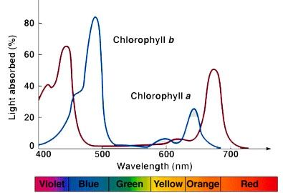

Chlorophyll a occurs in all photosynthetic organisms except photosynthetic bacteria.
Molecular structure of Chlorophyll a:
The molecular structure of chlorophyll a consist of chlorin ring, whose four nitrogen atoms surrounds a central magnesium atom. And has several other attached side chains and a hydrocarbon tail.

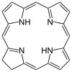(chlorin , the central ring structure of chlorophyll a)

Chlorophyll a contains a magnesium ion encased in a large ring structure known as chlorin. The chlorin ring is a heterocyclic compound derived from the pyrrole.

Side chains:
Side chains are attached to the chlorin ring of the various chlorophyll molecules. Different side chains characterize each type of chlorophyll molecule and alters the absorption spectrum of light.

Hydrocarbon tail:
Chlorophyll a has long hydrophobic tail which anchors the molecule to other hydrophobic proteins. In the thylakoid membrane of the chloroplast.

Primary electron donation:
Chlorophyll a is very important in the energy phase of photosynthesis. Two electrons need to be passed to an electron acceptor for the process of photosynthesis to proceed. Within the reaction centers of both photosystems there are a pair of chlorophyll a molecules that pass electrons on to the transport chain through redox reactions.

This photosynthetic pigment is essential for photosynthesis in eukaryotes, cyanobacteria and prochlorophytes because of its role as primary electron donor in the electron transport chain. Chlorophyll a also transfers resonance energy in the antenna complex ending in the reaction center where specific chlorophylls P680 and P700 are located.
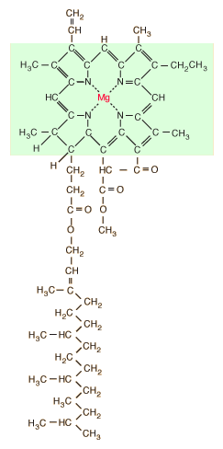

Chlorophyll b:

This molecule has structure similar to that of chlorophyll a. it absorbs light of 453nm. And 642nm maximally. It helps to increase the range of a light a plant can use for energy. The difference from chlorophyll a being the replacement of a methyl group with a CHO. It occurs in all plants, green algae and some prokaryotes. Maximum absorption at red and blue region and reflects green light.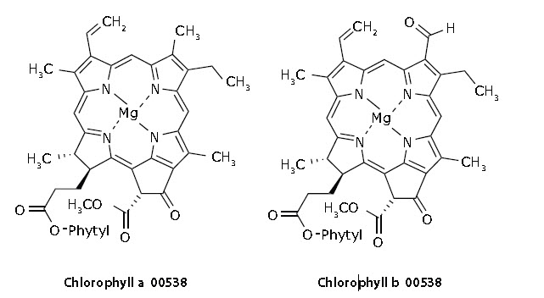

Chlorophyll a | Chlorophyll b
- Chlorophyll a is the principle pigment that captures sunlight for photosynthesis.  - Chlorophyll a absorbs the light in range of 430nm to 660nm.  - Chlorophyll a reflects blue-green in color. | - Chlorophyll b is the accessory pigment that collects sunlight and passes into chlorophyll a.  - Chlorophyll b absorbs light in range of 450nm to 650nm.  - Chlorophyll b reflects yellow-green in color.

Chlorophyll a | Chlorophyll b
- Chlorophyll a contains a methyl group in the third position of it’s chlorin ring.  - .  - The chemical for chlorophyll a is C₅₅H₇₂O₅N₄Mg.  - The molecular weight of chlorophyll a is 839.51g/mol.  - Chlorophyll a is found in all plants, algae and cyanobacteria.  - The ¾ of total chlorophyll in plants are chlorophyll a  - Solubility of chlorophyll a is low in polar solvents.  - Chlorophyll a is present at reaction center of antenna array.  - Around 1-2 micrometer size particles are ingested.  - Absorb violet blue and orange-red light from the spectrum. | - Chlorophyll b contains an aldehyde group in the third position of it’s chlorin ring.  - The chemical formula of chlorophyll b is C₅₅H₇₀MgN₄O_{6.}  - The molecular weight of a chlorophyll b is 907.49g/mol.  - Chlorophyll b is found in all plants and green algae.  - The ¼ of total chlorophyll in plants are chlorophyll b.  - Solubility of chlorophyll b is high in polar solvents.  - Chlorophyll b regulates the size of antenna.  - Around 0.1-0.2 micrometer size particles are ingested.  - Absorb orange-red light from the spectrum.

Bactriochlorophylls:
Bacteriochlorophylls are photosynthetic pigments that occur in various photosynthetic bacteria. They were discovered by C.B. vein Neil in 1932. They are related to chlorophylls which are the primary pigments in plants, algae and cyanobacteria. Groups that contains bacteriochlorophyll contain photosynthesis, but do not produce oxygen. They use wavelength of light not absorbed by plants or cyanobacteria. Replacement of Mg2+ with protons with bacteriophaeophytin; the phaeophytin form.

They include purple and green sulphur bacteria. Bacteriochlorophyll in bacteria performs the same function as chlorophyll in plants. They absorb the light of longer wavelength than chlorophyll. The position of absorption maximum is observed in the red or infra-red region and depends on the type of bacteriochlorophyll and it’s protein environment.

Carotenoids:
The color of carotenoids are familiar as the fall color of leaves. As the leaves lose their chlorophyll, the more persistant carotenoids give the pleasant red, yellow and oranges of the autumn foliage. Beta-carotenes is of the most important to carotenoids; Lycpene, the color of tomatoes is also a carotenoid.

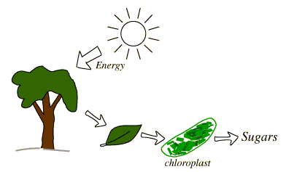
This is a class of accessory pigments that occur in all photosynthetic organisms. They are completely hydrophobic (fat soluble) and exist in lipid membranes. Carotenoids absorbs maximally between 460nm and 550nm and appear red, orange or yellow to us. The most important function of carotenoid seems to be protecting the plant. From free-radicals formed from ultra violet or other radiation. Free radicals are dangerous because they contain an extra odd electrons they do not really want to have. This means that they are constantly trying to get rid of extra electrons. They do this by attacking whatever bonds they can.

They are also called as tetraterpenoids. The only land dwelling arthropods known to produce carotenoids are aphids, spider and mites which acquired the ability and genes from fungi. It is also produced by endosymbiotic bacteria in whiteflies. Carotenoids serve two key roles in plants and algae; they absorb light energy for use in photosynthesis and they provide photoprotection via non-photochemical quenching. Carotenoids that contain unsubstituted beta-ionine rings have vitamin A activity. Carotenoid must be consumed through diet. They are best absorbed through a source of fat. Food rich in carotenoids include:
- Yams
- Kale
- Spinach
- Watermelon
- Bell papers
- Tomatoes
- Mangoes
- Oranges
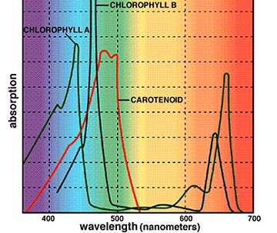

Classification of carotenoids:
Carotenoids are classified into two main groups:
- Xanthophylls
- Carotenes

- Carotenes:
Carotenes do not contain oxygen and are associated with more of an orange pigment. Carotene carotenoids play an important role in helping plant grow. Beta-carotene and lycopene fall under this category. .Foods in the carotene category includes:
- Carrots
- Sweet potatoes
- Papaya
- Pumpkins
- Winter squash
Beta-carotenes:
Beta-carotene is the most important of the carotenoids that serve as accessory pigment in photosynthesis. Measurement of the absorption of these pigments as a function of photosynthetic output makes it is clear that the chlorophylls are most important but that beta-carotenes contributes. Beta-carotene give it’s color to the carrot and also to the squash and bananas. It also appears in autumn leaf colors.

The name beta-carotene comes from the Greek beta and Latin carota. It is the yellow/orange pigment that give vegetables and fruits their rich colors. Few facts on beta-carotene
- Beta-carotene is a red or orange found in many fresh fruits and vegetables.
- Beta-carotene is converted into vitamin A, an essential vitamin.
- Vitamin A is toxic at high levels.
- Beta-carotene is a carotenoid and an antioxidant.
- Smokers with high beta-carotene intake might have an increased risk of lung cancer.
- Some evidence suggests that beta-carotene might slow cognitive decline.
- Beta-carotene might help older people retain their lung strength as they age.
Beta-carotenes chemical formula is – C₄₀H₅₆ – was discovered in 1907.
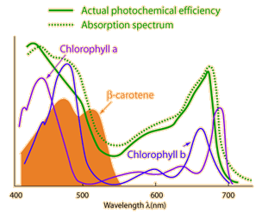

Lycopene:
Lycopene is a plant nutrient with an antioxidant properties. It’s the pigment that red and pink fruits such as tomatoes, watermelon. Lycopene has been linked to health benefits ranging from heart health to protection against sunburns and certain type of cancers.
High blood levels of lycopene may also add years to the lives of people with metabolic syndrome_ a combination of health conditions that can lead to heart diseases. Over a 10 year study, researchers noted that the individuals with metabolic disease who had the highest blood lycopene levels had up to a 39% lowing risks of dying prematurely.

- Xanthophylls:
They are essentially oxidized carotenoids and contain oxygen. They are fat soluble. They are usually red and yellow and do not absorb energy as well as carotenoids.
Xanthophyll protect you from too much sunlight. They are most associated with high health.

Molecular structure:
As both are carotenoids, xanthophylls and carotenes are similar in structure but xanthophylls contain oxygen atom while carotenes are purely hydrocarbons, which do not contain oxygen. Their content of oxygen causes xanthophylls to be more polar than carotenes and causes their separation from carotenes.
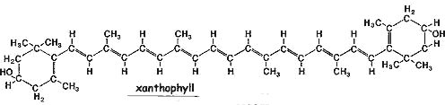

Food that fall under xanthophyll category include:
- Kale
- Spinach
- Pumpkin
- Corn
- Egg yolks

Phycobilins:
Phycobilins are water soluble pigments found in the stroma of chloroplast. Organelles that are present only in cyanobacteria and rhodophyta. The two classes of phycobilins include phycoerythrin and phycocyanin. Phycobilins are found in red algae and cyanobacteria. Inside the cells of these organisms, the phycobilins collect light energy from the sun and passes this energy to the primary pigment, which is the chlorophyll. In prokaryotes such as cyanobacteria they are found in the cytoplasm. The light energy they absorb is essential for the production of organic molecules by the process of photosynthesis. Phycobilins that are covalently linked to proteins are reffered to as phycobiliproteins which serve as chromophores. Phycobiliproteins are aggregated in a highly ordered protein complex called a phycobilisomes, making these phycobilins unique among photosynthetic pigments. Phycobilisomes are attached to the cytosol face of the thylakoid. Extending into the cytosol phycobilisomes consist of a cluster of phycobilin pigments including phycoerythrin and phycocyanin.

Phycocyanin:
Phycocyanin is found in cyanobacteria, giving them their misleading common name of blue green algae. Different species of cyanobacteria possess differing ratios of phycocyanin and phycoerythrin. They are water soluble and blue in color. Phycocyanin consist of alpha and beta subunits. Most phycocyanins are present as a trimmer.

Each polypeptide chain of phycocyanin consist of apoprotein and chromophore with a ring opening tetra-pyrrole structure.
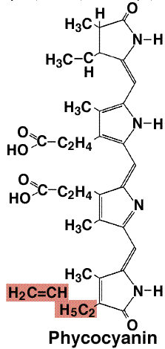
Phycoerythrin:
Phycoerythrin is a red protein pigment complex produced by the light harvesting phycobiliprotein family accessory to the main chlorophyll pigments responsible for photosynthesis. In the phycoerythrin family, the most known phycobilins are phycoerythrobilin; the typical phycoerythrin acceptor chromophore. Phycoerythrins are composed of monomers, usually organized in disk-shaped trimmer or hexamer.

Anthocyanins: Literally flower blue. They are water soluble flavonoid pigments. Color appear as red to blue. Occur in all tissues of higher plants but color not noticeable. Have purple color and are present in vegetables (onion, cabbage, potatoes), red blue and purple berries, black beans. They attract pollinators and act as seed dispersers, repel predators protect cells from damage by excess light. Improve plant tolerance to stress such as drought,UV-B. Improve night vision and other vision disorders, protect against heart diseases.

Anthocyanins are found in cell vacuoles, mostly in flowers and fruits but also in stems leaves, stems and roots. Anthocyanins may have a protective role in plants against extreme temperatures. Tomato plant protect against cold stress with anthocyanins countering reactive oxygen species, leading to a lower rate of cell death in leaves.

It’s not directly involved in the photosynthesis. At low light levels, green leaves are most efficient at photosynthesis. Anthocyanins are group of polyphenolic pigments that are ubiquitously found in the plant kingdom. In plants , anthocyanins play a role not only in reproduction by attracting pollinators and seed dispersers but also in protection against various biotic and abiotic stresses. In addition to acting as antioxidants and fighting free radicals, anthocyanins may offer anti-inflammatory, anti-viral and anti-cancer benefits. In herbal medicines, anthocyanin rich substance have long been used to treat a number of conditions (including high blood pressure, colds and urinary tract infection).

Anthocyanins protect leaves from the stress of photoinhibitory light fluxes by absorbing the excess photons otherwise be intercepted by chlorophyll b. They develop in late summer in the sap of leaf cells, resulting from complex interactions of factors outside or inside the plant. Their formation depends on the breakdown of sugars in the presence of light as the level of phosphate in the leaf is reduced. The empirical formula for flavylium ion of anthocyanin is C₁₅H₁₁O⁺

The visual function of anthocyanins in reproductive organs as an aid to pollination and seed dispersal is generally accepted. Anthocyanins may protect photosynthetic tissues against photoinhibition. Anthocyanins significantly modify both the quantity and quality of light incident on chloroplasts. The red anthocyanins present in vegetative tissues preferentially absorb green and ultraviolet light and show lower absorbance of blue light while little red light is absorbed. Absorbance of blue-green light by anthocyanins reduces light available to chlorophyll. A low level of absorbance or complete lack of it in the blue and red spectra, possible allows accumulation of pigments to high levels without interference with photoreceptors. For example phytochrome and cytochrome.

Betalins:
Betalins are class of red and yellow tyrosine derived pigments found in the plants of carryophyllales, where they replace anthocyanin pigment. Betalins also occur in some high order fungi. They are most often noticeable in the petals of flowers, but may color the fruits, leaves, stems and roots of plants they contain them. They include pigments such as those found in beets.
The name betalin from the Latin name of the common beet from which betalins were extracted. The deep red color of the beets is due to the presence of the betalin pigments. The particular shades of red to purple are distinctive and unlike to that of anthocyanin pigments found in most plants. There are two categories of betalins
- Betacyanin:
Include reddish to voilet betalin pigments. Among the betacyanins present in plants include betanin, isobetanin, probetanin, neobetanin.

- Betaxanthins:
Thos betalin pigments which appear yellow to orange. Among the betaxanthins present in plants include vulgaxanthin, miraxanthin, indicaxanthin.

Betanin also called as beetroot red after the fact that it may be extracted from red beet roots. Betanin is commercially used as a natural food dye. It can cause red feces in some people. They counter inflammation, protect the liver and have anticancer and antioxidant properties.

Photosystems
The light-harvesting complex (or antenna complex) is an array of protein and chlorophyll molecules embedded in the thylakoid membrane of plants and cyanobacteria, which transfer light energy to one chlorophyll a molecule at the reaction center of a photosystem.
The antenna pigments are predominantly chlorophyll b, xanthophylls, and carotenes. Chlorophyll a is known as the core pigment. Their absorption spectra are non-overlapping and broaden the range of light that can be absorbed in photosynthesis. The carotenoids have another role as an antioxidant to prevent photo-oxidative damage of chlorophyll molecules. Each antenna complex has between 250 and 400 pigment molecules and the energy they absorb is shuttled by resonance energy transfer to a specialized chlorophyll-protein complex known as the reaction center of each photosystem.^{[1]} The reaction center initiates a complex series of chemical reactions that capture energy in the form of chemical bonds.
For photosystem II, when either of the two chlorophyll a molecules at the reaction center absorb energy, an electron is excited and transferred to an electron acceptor molecule, pheophytin, leaving the chlorophyll a in an oxidized state. The oxidised chlorophyll a replaces the electrons by photolysis that involves the oxidation of water molecules to oxygen, protons and electrons.
Under changing light conditions, the reversible phosphorylation of light harvesting chlorophyll a/b binding proteins (LHCII) represents a system for balancing the excitation energy between the two photosystems.^{[2]}
The N-terminus of the chlorophyll a-b binding protein extends into the stroma where it is involved with adhesion of granal membranes and photo-regulated by reversible phosphorylation of its threonine residues.^{[3]} Both these processes are believed to mediate the distribution of excitation energy between photosystems I and II.
This family also includes the photosystem II protein PsbS, which plays a role in energy-dependent quenching that increases thermal dissipation of excess absorbed light energy in the photosystem.^{[4]}
.
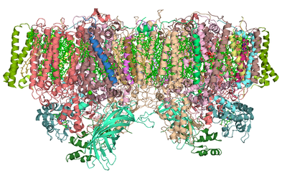
Photosystem II (or water-plastoquinone oxidoreductase) is the first protein complex in the light-dependent reactions of oxygenic photosynthesis. It is located in the thylakoid membrane of plants, algae, and cyanobacteria. Within the photosystem, enzymes capture photons of light to energize electrons that are then transferred through a variety of coenzymes and cofactors to reduce plastoquinone to plastoquinol. The energized electrons are replaced by oxidizing water to form hydrogen ions and molecular oxygen.
By replenishing lost electrons with electrons from the splitting of water, photosystem II provides the electrons for all of photosynthesis to occur. The hydrogen ions (protons) generated by the oxidation of water help to create a proton gradient that is used by ATP synthase to generate ATP. The energized electrons transferred to plastoquinone are ultimately used to reduce NADP⁺
to NADPH or are used in non-cyclic electron flow.^{[1]}
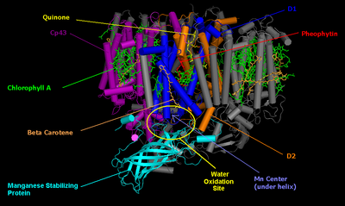
Cyanobacterial photosystem II, Monomer, PDB 2AXT.
The core of PSII consists of a pseudo-symmetric heterodimer of two homologous proteins D1 and D2.^{[2]} Unlike the reaction centers of all other photosystems in which the positive charge sitting on the chlorophyll dimer that undergoes the initial photoinduced charge separation is equally shared by the two monomers, in intact PSII the charge is mostly localized on one chlorophyll center (70−80%).^{[3]} Because of this, P680⁺ is highly oxidizing and can take part in the splitting of water.^{[2]}
Photosystem II (of cyanobacteria and green plants) is composed of around 20 subunits (depending on the organism) as well as other accessory, light-harvesting proteins. Each photosystem II contains at least 99 cofactors: 35 chlorophyll a, 12 beta-carotene, two pheophytin, two plastoquinone, two heme, one bicarbonate, 20 lipids, the Mn
₄CaO
₅ cluster (including two chloride ions), one non heme Fe²⁺
and two putative Ca²⁺
ions per monomer.^{[4]} There are several crystal structures of photosystem II.^{[5]} The PDB accession codes for this protein are 3WU2, 3BZ1, 3BZ2 (3BZ1 and 3BZ2 are monomeric structures of the Photosystem II dimer),^{[4]} 2AXT, 1S5L, 1W5C, 1ILX, 1FE1, 1IZL.

Oxygen-evolving complex (OEC)[edit]
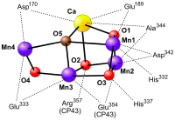
The oxygen-evolving complex is the site of water oxidation. It is a metallo-oxo cluster comprising four manganese ions (in oxidation states ranging from +2 to +4)^{[6]} and one divalent calcium ion. When it oxidizes water, producing oxygen gas and protons, it sequentially delivers the four electrons from water to a tyrosine (D1-Y161) sidechain and then to P680 itself. The first structural model of the oxygen-evolving complex was solved using X-ray crystallography from frozen protein crystals with a resolution of 3.8Å in 2001.^{[7]} Over the next years the resolution of the model was gradually increased to 2.9Å.^{[8][9][10]} While obtaining these structures was in itself a great feat, they did not show the oxygen-evolving complex in full detail. In 2011 the OEC of PSII was resolved to a level of 1.9Å revealing five oxygen atoms serving as oxo bridges linking the five metal atoms and four water molecules bound to the Mn4CaO5 cluster; more than 1,300 water molecules were found in each photosystem II monomer, some forming extensive hydrogen-bonding networks that may serve as channels for protons, water or oxygen molecules.^{[11]} At this stage, it is suggested that the structures obtained by X-ray crystallography are biased, since there is evidence that the manganese atoms are reduced by the high-intensity X-rays used, altering the observed OEC structure. This incentivized researchers to take their crystals to a different X-ray facilities, called X-ray Free Electron Lasers, such as SLAC in the USA. In 2014 the structure observed in 2011 was confirmed.^{[12]} Knowing the structure of Photosystem II did not suffice to reveal how it works exactly. So now the race has started to solve the structure of Photosystem II at different stages in the mechanistic cycle (discussed below). Currently structures of the S1 state and the S3 state's have been published almost simultaneously from two different groups, showing the addition of an oxygen molecule designated O6 between Mn1 and Mn4,^{[13][14]} suggesting that this may be the site on the oxygen evolving complex, where oxygen is produced.

Water splitting[edit]
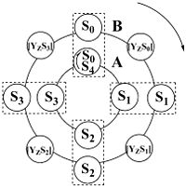
Water-splitting process: Electron transport and regulation. The first level (A) shows the original Kok model of the S-states cycling, the second level (B) shows the link between the electron transport (S-states advancement) and the relaxation process of the intermediate S-states ([YzSn], n=0,1,2,3) formation
Photosynthetic water splitting (or oxygen evolution) is one of the most important reactions on the planet, since it is the source of nearly all the atmosphere's oxygen. Moreover, artificial photosynthetic water-splitting may contribute to the effective use of sunlight as an alternative energy-source.

The mechanism of water oxidation is still not fully elucidated, but we know many details about this process. The oxidation of water to molecular oxygen requires extraction of four electrons and four protons from two molecules of water. The experimental evidence that oxygen is released through cyclic reaction of oxygen evolving complex (OEC) within one PSII was provided by Pierre Joliot et al.^{[15]} They have shown that, if dark-adapted photosynthetic material (higher plants, algae, and cyanobacteria) is exposed to a series of single turnover flashes, oxygen evolution is detected with typical period-four damped oscillation with maxima on the third and the seventh flash and with minima on the first and the fifth flash (for review, see^{[16]}). Based on this experiment, Bessel Kok and co-workers ^{[17]} introduced a cycle of five flash-induced transitions of the so-called S-states, describing the four redox states of OEC: When four oxidizing equivalents have been stored (at the S₄-state), OEC returns to its basic S₀-state. In the absence of light, the OEC will "relax" to the S₁ state; the S₁ state is often described as being "dark-stable". The S₁ state is la.

Difference Between Photosystem I and Photosystem II
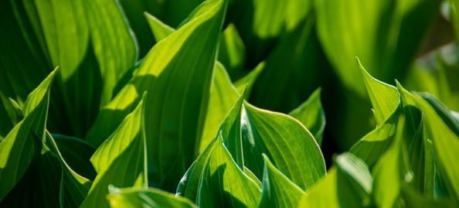
The two main multi-subunit membrane protein complexes differ in their absorbing wavelength, where the photosystem I or PS 1 absorbs the longer wavelength of light which is 700 nm while photosystem II or PS 2 absorbs the shorter wavelength of light 680 nm.
Secondly, each photosystem is replenished by the electrons, after the loss of an electron, but the sources are different where PS II gets it electrons from water while PS I gains electrons from the PS II through an electron transport chain.
The photosystems are involved in photosynthesis and are found in thylakoid membranes of algae, cyanobacteria and mainly in plants. We all know that plants and other photosynthetic organisms collect solar energy which is supported by the light-absorbing pigment molecules present in the leaves.
The absorbed solar energy or light energy in leaves is converted to chemical energy at the first stage of photosynthesis. This process undergoes a series of chemical reaction known as light-dependent reactions.
The photosynthetic pigments like chlorophyll a, chlorophyll b and carotenoids are present in the thylakoid membranes of the chloroplast. The photosystem constitutes the light-harvesting complexes, that comprises of 300-400 chlorophylls, proteins, and other pigments. These pigments get excited after absorbing the photon, and then one of the electrons is switched to higher-energy orbital.
The excited pigment passes their energy to neighbouring pigment by the resonance energy transfer, and this is the direct electromagnetic interactions. Further, in turn, the neighbouring pigment transfer energy to pigment and the process is repeated multiple times. Together these pigment molecules collect their energy and pass towards the central part of the photosystem known as reaction center.
Though the two photosystems in the light-dependent reactions got their name in the series, they were discovered, but the photosystem II (PS II) comes first in the path in the electron flow and then the photosystem I (PSI). In this content, we will explore the difference between the two types of pf photosystem and a brief description of them.

BASIS FOR COMPARISON | PHOTOSYSTEM I (PS I) | PHOTOSYSTEM II (PS II)
Meaning | Photosystem I or PS I uses light energy to convert NADP+ to NADPH2. It involves the P700, chlorophyll and other pigments. | Photosystem II or PS II is the protein complex that absorbs light energy, involving P680, chlorophyll and accessory pigments and transfer electrons from water to plastoquinone and thus works in dissociation of water molecules and produces protons (H+) and O2.
Location | It is located on the outer surface of the thylakoid membrane. | It is located on the inner surface of the thylakoid membrane.
Photocenter or reaction centre | P700 is the photo center. | P680 is the photo center.
Absorbing wavelength | The pigments in the photosystem 1 absorb longer wavelengths of light which is 700 nm (P700). | The pigments in the photosystem2 absorb shorter wavelengths of light which is 680 nm (P680).
Photophosphorylation | This system is involved in both cyclic as well as non-cyclic photophosphorylation. | This system is involved in both cyclic photophosphorylation.
Photolysis | No photolysis occur. | Photolysis occurs in this system.
Pigments | Photosystem I or PS 1 contains chlorophyll A-670, chlorophyll A-680, chlorophyll A-695, chlorophyll A-700, chlorophyll B, and carotenoids. | Photosystem II or PS 2 contains chlorophyll A-660, chlorophyll A-670, chlorophyll A-680, chlorophyll A-695, chlorophyll A-700, chlorophyll B, xanthophylls and phycobilins.
The ratio of the chlorophyll carotenoid pigments | 20-30 :1. | 3-7 :1.
Function | The primary function of the photosystem I is in NADPH synthesis, where it receives the electrons from PS II. | The primary function of the photosystem II is in the hydrolysis of water and ATP synthesis.
Core Composition | The PSI is made up of two subunits which are psaA and psaB. | The PS II is made up of two subunits made up of D1 and D2.

Definition of Photosystem I
Photosystem I or PSI is located in the thylakoid membrane and is a multisubunit protein complex found in green plants and algae. The first initial step of trapping solar energy and the then conversion by light-driven electron transport. PS I is the system where the chlorophyll and other pigments get collected and absorb the wavelength of light at 700nm. It is the series of reaction, and the reaction center is made up of chlorophyll a-700, with the two subunits namely psaA and psaB.
The subunits of PSI is larger than the subunits PS II. This system also consists of the chlorophyll a-670, chlorophyll a-680, chlorophyll a-695, chlorophyll b, and carotenoids. The absorbed photons are carried into the reaction center with the help of the accessory pigments. The photons are further released by the reaction center as high energy electrons, that undergoes a series of electron carriers and finally used by NADP+ reductase. The NADPH is produced through NADP+ reductase enzyme from such high energy electrons. NADPH is used in the Calvin cycle.
Therefore, the main aim of the integral membrane protein complex that uses light energy to produce ATP and NADPH. Photosystem I is also known as plastocyanin-ferredoxin oxidoreductase.

Definition of Photosystem II
Photosystem II or PS II is the membrane-embedded-protein-complex, consisting of more than 20 subunits and around 100 cofactors. The light is absorbed by the pigments such as carotenoids, chlorophyll, and phycobilin in the region known as antennae and further this excited energy is transferred to the reaction center. The main component is peripheral antennae which are engaged in the absorbing light along with the chlorophyll and other pigments. This reaction is done at the core complex which is the site for the initial electron transfer chain reactions.
As discussed earlier that, PS II absorbs light at 680 nm, and enters at high-energy state. The P680 donates an electron and transfer to the pheophytin, which is the primary electron acceptor. As soon as the P680 loses an electron and gains positive charge, it needs an electron for replenishment which is fulfilled by splitting of water molecules.
The oxidation of water occurs at manganese center or Mn4OxCa cluster. The manganese center oxidizes two molecules at once, extracting four electrons and thus producing a molecule of O2 and releasing four H+ ions.
There is the various contradicting mechanism of the above process in PS II, though protons and electrons extracted from water are used to reduce NADP+ and in ATP production. Photosystem II is also known as water-plastoquinone oxidoreductase and is said as the first protein complex in the light reaction.

Key Differences Between Photosystem I and Photosystem II
Given points will exhibit the variation between the photosystem I and photosystem II:
- Photosystem I or PS I and Photosystem II or PS II are the protein-mediated complex, and the main aim is to produce energy (ATP and NADPH2), which is used in Calvin cycle, the PSI uses light energy to convert NADP+ to NADPH2. It involves the P700, chlorophyll and other pigments, while PS II is the complex that absorbs light energy, involving P680, chlorophyll and accessory pigments and transfer electrons from water to plastoquinone and thus work in dissociation of water molecules and produces protons (H+) and O2.
- Photosystem I is located on the outer surface of the thylakoid membrane and is bind to the special reaction center known as P700, whereas PS II is located on the inner surface of the thylakoid membrane and the reaction center is known as P680.
- The pigments in the photosystem 1 absorb longer wavelengths of light which is 700 nm (P700), on the other hand, pigments in the photosystem2 absorb shorter wavelengths of light which is 680 nm (P680).
- Photophosphorylation in PS I is involved in both cyclic as well as non-cyclic photophosphorylation, and PS II is involved in both cyclic photophosphorylation.
- No photolysis occurs in PS I, though it happens photosystem II.
- Photosystem I or PS I contains chlorophyll A-670, chlorophyll A-680, chlorophyll A-695, chlorophyll A-700, chlorophyll B, and carotenoids in the ratio of 20-30 :1, whereas in Photosystem II or PS 2 contains chlorophyll A-660, chlorophyll A-670, chlorophyll A-680, chlorophyll A-695, chlorophyll A-700, chlorophyll B, xanthophylls and phycobilins in the ratio of 3-7 :1.
- The primary function of the photosystem I in NADPH synthesis, where it receives the electrons from PS II, and the photosystem II is in the hydrolysis of water and ATP synthesis.
- Core Composition in the PSI is made up of two subunits which are psaA and psaB, and PS II is made up of two subunits made up of D1 and D2.

Conclusion
So we can say that in plants photosynthesis encompasses two processes; the light-dependent reactions, and the carbon-assimilation reaction which is misleadingly also known as dark reactions. In the light reactions, the photosynthetic pigments and chlorophyll absorb light and convert into ATP and NADPH (energy).

Photosystem
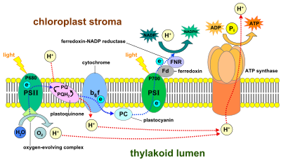
Light-dependent reactions of photosynthesis at the thylakoid membrane
Photosystems are functional and structural units of protein complexes involved in photosynthesis that together carry out the primary photochemistry of photosynthesis: the absorption of light and the transfer of energy and electrons. Photosystems are found in the thylakoid membranes of plants, algae and cyanobacteria. They are located in the chloroplasts of plants and algae, and in the cytoplasmic membrane of photosynthetic bacteria. There are two kinds of photosystems: II and I.

Reaction centers[edit]
At the heart of a photosystem lies the reaction center, which is an enzyme that uses light to reduce molecules (provide with electrons). This reaction center is surrounded by light-harvesting complexes that enhance the absorption of light.
Two families of reaction centers in photosystems exist: type I reaction centers (such as photosystem I (P700) in chloroplasts and in green-sulphur bacteria and type II reaction centers (such as photosystem II (P680) in chloroplasts and in non-sulphur purple bacteria.
Each of the photosystem can be identified by the wavelength of light to which it is most reactive (700 and 680 nanometers, respectively for PSI and PSII in chloroplasts), the amount and type of light-harvesting complex present and the type of terminal electron acceptor used.
Type I photosystems use ferredoxin-like iron-sulfur cluster proteins as terminal electron acceptors, while type II photosystems ultimately shuttle electrons to a quinone terminal electron acceptor. Both reaction center types are present in chloroplasts and cyanobacteria, and work together to form a unique photosynthetic chain able to extract electrons from water, creating oxygen as a byproduct.

Structure[edit]
A reaction center comprises several (>24 or >33) protein subunits, that provide a scaffold for a series of cofactors. The cofactors can be pigments (like chlorophyll, pheophytin, carotenoids), quinones, or iron-sulfur clusters.^{[1]}

Relationship between photosystems I and II[edit]
For oxygenic photosynthesis, both photosystems I and II are required. Oxygenic photosynthesis can be performed by plants and cyanobacteria; cyanobacteria are believed to be the progenitors of the photosystem-containing chloroplasts of eukaryotes. Photosynthetic bacteria that cannot produce oxygen have a single photosystem similar to either.
When photosystem II absorbs light, electrons in the reaction-center chlorophyll are excited to a higher energy level and are trapped by the primary electron acceptors.
Photoexcited electrons travel through the cytochrome b6f complex to photosystem I via an electron transport chain set in the thylakoid membrane. This energy fall is harnessed, (the whole process termed chemiosmosis), to transport hydrogen (H⁺) through the membrane, into the thylakoid lumen, to provide a potential energy difference between the thylakoid lumen space and the chloroplast stroma, which amounts to a proton-motive force that can be used to generate ATP. The protons are transported by the plastoquinone. If electrons only pass through once, the process is termed noncyclic photophosphorylation.
When the electron reaches photosystem I, it fills the electron deficit of the reaction-center chlorophyll of photosystem I. ATP is generated when the ATP synthase transports the protons present in the lumen to the stroma, through the membrane. The electrons may either continue to go through cyclic electron transport around PS I or pass, via ferredoxin, to the enzyme NADP⁺ reductase. Electrons and hydrogen ions are added to NADP⁺ to form NADPH. This reducing agent is transported to the Calvin cycle to react with glycerate 3-phosphate, along with ATP to form glyceraldehyde 3-phosphate, the basic building-block from which plants can make a variety of substances.

