Career Management and Career Planning
Effective HRM encompasses career planning, career development and succession planning. An organization without career planning and career development initiatives is likely to encounter the highest rate of attrition, causing much harm to their plans and programmes. Similarly without succession planning managing of vacancies, particularly at higher levels, become difficult. There are examples of many organizations that had to suffer for not being able to find a right successor for their key positions. With the increase scope for job mobility and corporate race for global headhunting of good performers, it is now a well-established fact that normal employment span for key performers remains awfully short.
The term career planning and career developments are used interchangeably in most of the organizations. It is also correct that but for their subtle difference in the definitional context, their process remains the same.
Definition of Career
Career is a sequence of attitudes and behaviours associated with the series of job and work related activities over a person’s lifetime.
Yet in another way, it may be defined as a succession of related jobs, arranged in hierarchical order, through which a person moves in an organization. As the literal definition of career focuses on an individually perceived sequence, to be more accurate, career may be either individual-centred or organizational-centred. Therefore, career is often defined separately as external career and internal career. External career refers to the objective categories used by society and organizations to describe the progression of steps through a given occupation, while internal career refers to the set of steps or stages which make up the individual’s own concept of career progression within an occupation. For such two different approaches, in organizational context, career can be identified as an integrated pace of vertical lateral movement in an occupation of an individual over his employment span.
Important Elements of Career
Analyzing definitional context, it is clear that career has following important elements-
1. It is a proper sequence of job-related activities. Such job related activities vis-a-vis experience include role experiences at diff hierarchical levels of an individual, which lead to an increasing level of responsibilities, status, power, achievements and rewards.
2. It may be individual-centered or organizational–centered, individual-centered career is an individually perceived sequence of career progression within an occupation.
3. It is better defined as an integrated pace of internal movement in an occupation of an individual over his employment span.

Overview
Career planning generally involves getting to know who you are, what you want, and how to get there. Keep in mind that career planning is a continuous process that allows you to move from one stage to another stage as your life changes. You may even find yourself going back to look at who you are again after exploring how to get there. Learning to negotiate the career planning process now is essential, considering most people will change careers several times in a lifetime.
If a career plan is to be effective, it must begin with an objective. When asked about career objectives, most managers will probably answer by saying that they want to be successful. What is success? Definition of success depends on personal aspirations, values, self-image, age, background and other different factors. Success is personally defined concept. In order to plan your career, you need to have an idea of what constitutes career success.
- Do you want to be president of the company?
- Do you want to be the senior executive in your field of expertise?
- Would you be happier as a middle manager in your area?
- Whatever the choice it must be yours.
Career management is a process by which individuals can guide, direct and influence the course of their careers.
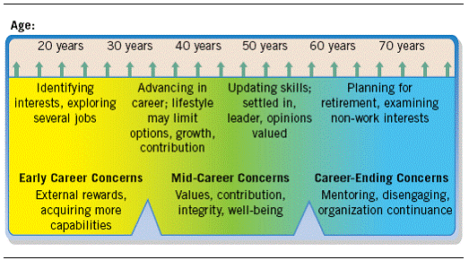
Fig.1.2 General Periods in Careers
In the course of our career we move from one stage to another setting and implementing appropriate goals at each stage. Our goals differ from getting established on job at early career stage to career reappraisal, moving away from technical areas & becoming more of a generalist. Movement form one career stage to another will require individuals to update self & to appropriate change goals. When required danger exist that individuals may too long stay in a job they don’t like or miss career opportunity
A sensible early step in career planning is to diagnose. You might answer questions:
• What types of positions and career experiences do I need to achieve my goals?
• What personal traits characteristics and behaviors require change in order for me to improve my professional effectiveness?
CAREER PLANNING IN AN ORGANIZATION
Career planning is the process by which one selects career goals and the path to these goals. The major focus of career planning is on assisting the employees achieve a better match between personal goals and the opportunities that are realistically available in the organization. Career programmers should not concentrate only on career growth opportunities. Practically speaking, there may not be enough high level positions to make upward mobility a reality for a large number of employees. Hence, career-planning efforts need to pin-point and highlight those areas that offer psychological success instead of vertical growth.
Career planning is not an event or end in itself, but a continuous process of developing human resources for achieving optimum results. It must, however, be noted that individual and organizational careers are not separate and distinct. A person who is not able to translate his career plan into action within the organization may probably quit the job, if he has a choice. Organizations, therefore, should help employees in career planning so that both can satisfy each other’s needs.
Career Planning vs. Human Resource Planning
Human Resource planning is the process of analyzing and estimating the need for and availability of employees. Through Human Resource planning, the Personnel Department is able to prepare a summary of skills and potentials available within the organization. Career planning assists in finding those employees who could be groomed for higher level positions, on the strength of their performance.
Human Resource planning gives valuable information about the availability of human resources for expansion, growth, etc. (expansion of facilities, construction of a new plant, opening a new branch, launching a new product, etc.). On the other hand, career planning only gives us a picture of who could succeed in case any major developments leading to retirement, death, resignation of existing employees.
Human Resource planning is tied to the overall strategic planning efforts of the organization. There cannot be an effective manpower planning, if career planning is not carried out properly.

Need for Career Planning
Every employee has a desire to grow and scale new heights in his workplace continuously. If there are enough opportunities, he can pursue his career goals and exploit his potential fully. He feels highly motivated when the organization shows him a clear path as to how he can meet his personal ambitions while trying to realize corporate goals.
Unfortunately, as pointed out by John Leach, organizations do not pay adequate attention to this aspect in actual practice for a variety of reasons. The demands of employees are not matched with organizational needs; no effort is made to show how the employees can grow within certain limits, what happens to an employee five years down the line if he does well, whether the organization is trying to offer mere jobs or long-lasting careers, etc. When recognition does not come in time for meritorious performance and a certain amount of confusion prevails in the minds of employees whether they are ‘in’ with a chance to grow or not, they look for greener pastures outside. Key executives leave in frustration and the organization suffers badly when turnover figures rise. Any recruitment effort made in panic to fill the vacancies is not going to be effective. So, the absence of a career plan is going to make a big difference to both the employees and the organization. Employees do not get right breaks at a right time; their morale will be low and they are always on their toes trying to find escape routes.
Organizations are not going to benefit from high employee turnover. New employees mean additional selection and training costs. Bridging the gaps through short-term replacements is not going to pay in terms of productivity. Organizations, therefore, try to put their career plans in place and educate employees about the opportunities that exist internally for talented people. Without such a progressive outlook, organizations cannot prosper.
Objectives
Career planning seeks to meet the following objectives:
i. Attract and retain talent by offering careers, not jobs.
ii. Use human resources effectively and achieve greater productivity.
iii. Reduce employee turnover.
iv. Improve employee morale and motivation.
v. Meet the immediate and future human resource needs of the organization on a timely basis
Career Planning Process
The career planning process involves the following steps:
i. Identifying individual needs and aspirations:
Most individuals do not have a clear cut idea about their career aspirations, anchors and goals. The human resource professionals must, therefore, help an employee by providing as much information as possible showing what kind of work would suit the employee most, taking his skills, experience, and aptitude into account. Such assistance is extended through workshops/seminars while the employees are subjected to psychological testing, simulation exercises, etc. The basic purpose of such an exercise is to help an employee form a clear view about what he should do to build his career within the company. Workshops and seminars increase employee interest by showing the value of career planning. They help employees set career goals, identify career paths and uncover specific career development activities (discussed later). These individual efforts may be supplemented by printed or taped information. To assist employees in a better way, organizations construct a data bank consisting of information on the career histories, skill evaluations and career preferences of its employees (known as skill or talent inventory).
ii. Analyzing career opportunities:
Once career needs and aspirations of employees are known, the organization has to provide career paths for each position. Career paths show career progression possibilities clearly. They indicate the various positions that one could hold over a period of time, if one is able to perform well. Career paths change over time, of course, in tune with employee’s needs and organizational requirements. While outlining career paths, the claims of experienced persons lacking professional degrees and that of young recruits with excellent degrees but without experience need to be balanced properly.
iii. Aligning needs and opportunities:
After employees have identified their needs and have realized the existence of career opportunities the remaining problem is one of alignment. This process consists of two steps: first, identify the potential of employees and then undertake career development programmers (discussed later on elaborately) with a view to align employee needs and organizational opportunities. Through performance appraisal, the potential of employees can be assessed to some extent. Such an appraisal would help reveal employees who need further training, employees who can take up added responsibilities, etc. After identifying the potential of employees certain developmental techniques such as special assignments, planned position rotation, supervisory coaching, job enrichment, understudy programs can be undertaken to update employee knowledge and skills.
iv. Action plans and periodic review:
The matching process would uncover gaps. These need to be bridged through individual career development efforts and organization supported efforts from time to time. After initiating these steps, it is necessary to review the whole thing every now and then. This will help the employee know in which direction he is moving, what changes are likely to take place, what kind of skills are needed to face new and emerging organizational challenges. From an organizational standpoint also, it is necessary to find out how employees are doing, what are their goals and aspirations, whether the career paths are in tune with individual needs and serve the overall corporate objectives, etc.
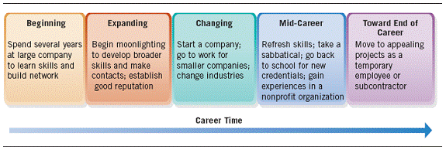
FIG.1.3 The New “Portable” Career Path
CAREER PLANNING MODELS
There are many models one may use while career planning. The two main models are
Waterloo University Model
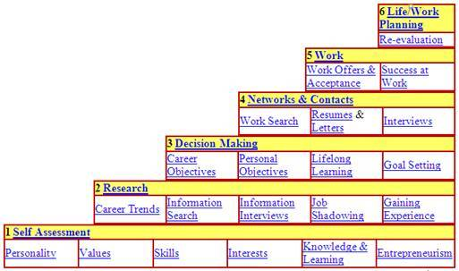
FIG.1.5 Water University Model
The SODI Career Planning Model
Given the complexity of career development and the fluidity of the world of work, we need to be able to navigate our career paths with purpose and clarity.
Law and Watts (1977) devised a simple model of career education which has stood the test of time. This model has been changed slightly to become a career planning, rather than a career education model and named the SODI model where the last element is ‘implementation’ rather than ‘transition learning’, and ‘decision learning’ becomes ‘decision making and planning’.
The model encapsulates four concepts which are:
Self-awareness – individual having knowledge about and understanding of their own personal development. Self-awareness in a careers context involves an understanding of kind of personal resources (both actual and potential) they bring to world.
Opportunity awareness – an understanding of the general structures of the world of work, including career possibilities and alternative pathways.
Decision making and planning – an understanding of how to make career decisions, and being aware of pressures, influences, styles, consequences and goal setting.
Implementing plans – having the appropriate skill level in a range of areas to be able to translate job and career planning into reality

