Pyroxene:
The pyroxenes (commonly abbreviated to Px) are a group of important rock-forming inosilicate minerals found in many igneous and metamorphic rocks. Pyroxenes have the general formula XY(Si,Al)2O6, where X represents calcium, sodium, iron (II) or magnesium and more rarely zinc, manganese or lithium, and Y represents ions of smaller size, such as chromium, aluminium, iron (III), magnesium, cobalt, manganese, scandium, titanium, vanadium or even iron (II). Although aluminium substitutes extensively for silicon in silicates such as feldspars and amphiboless, the substitution occurs only to a limited extent in most pyroxenes. They share a common structure consisting of single chains of silica tetrahedra. Pyroxenes that crystallize in the monoclinic system are known as clinopyroxenes and those that crystallize in the orthorhombic system are known as orthopyroxenes.

The name pyroxene is derived from the Ancient Greek words for fire (πυρ) and stranger (ξένος). Pyroxenes were so named because of their presence in volcanic lavas, where they are sometimes seen as crystals embedded in volcanic glass; it was assumed they were impurities in the glass, hence the name "fire strangers". However, they are simply early-forming minerals that crystallized before the lava erupted.

The upper mantle of Earth is composed mainly of olivine and pyroxene. Pyroxene and feldspar are the major minerals in basalt and gabbro.

General Consideration:

Pyroxenes are the most significant and abundant group of rock-forming ferromagnesian silicates. They are found in almost every variety of igneous rock and also occur in rocks of widely different compositions formed under conditions of regional and contact metamorphism. The name pyroxene is derived from the Greek pyro, meaning “fire,” and xenos, meaning “stranger,” and was given by Haüy to the greenish crystals found in many lavas which he considered to have been accidentally included there.

Pyroxenes crystallize in both the orthorhombic and monoclinic crystal systems. Typically pyroxenes occur as stubby prismatic crystals. They are chemically analogous to the amphiboles except that, as discussed above, hydroxyls are absent in the pyroxene structure. They are similar in colour, lustre, and hardness to the amphiboles but have slightly higher densities owing to the absence of hydroxyls. Pyroxenes have two distinctive planes of cleavage with intersecting angles of about 87° and 93°. Perpendicular to their cleavage planes, pyroxenes have nearly square cross sections, which, together with the cleavage directions, are diagnostic properties.
Chemical Composition
The chemical composition of minerals of the pyroxene group can be expressed by the general formula XYZ2O6, in which X= Na+, Ca2+, Mn2+, Fe2+, Mg2+, Li+; Y= Mn2+, Fe2+, Mg2+, Fe3+, Al3+, Cr3+, Ti4+; and Z= Si4+, Al3+. The range of possible chemical substitutions in pyroxene is constrained by the sizes of the available sites in the structure and the charge of the substituting cations. The Xcation sites in general are larger than the Ycation sites. Extensive atomic substitution occurs between the ideal end-member compositions. Most pyroxenes have only limited substitution of aluminum for silicon in the Z(tetrahedral) site. When a substituting ion differs in charge, electrical neutrality is maintained by coupled substitutions. For example, the pair consisting of Na+ and Al3+ substitutes for 2 Mg2+.
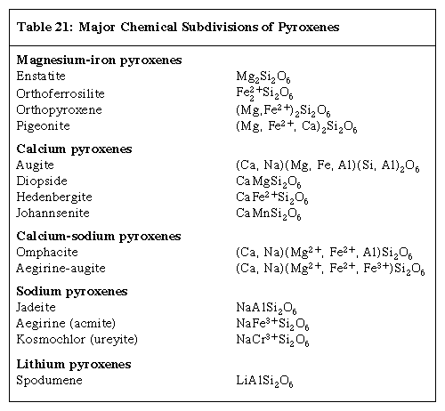
Table shows the five major chemical subdivisions of pyroxenes.

The most common pyroxenes can be represented as part of the chemical system CaSiO3 (wollastonite, a pyroxenoid), MgSiO3 (enstatite), and FeSiO3 (ferrosilite). Since no true pyroxenes exist with calcium contents greater than that of the diopside-hedenbergite join, the part of this system below this join is known as the pyroxene quadrilateral. Ferrous iron and magnesium substitute freely since they have similar ionic sizes and identical charges. Complete substitution exists between enstatite (Mg2Si2O6) and ferrosilite (Fe2Si2O6), and complete solid solution of iron for magnesium exists between diopside (CaMgSi2O6) and hedenbergite (CaFeSi2O6). Augite, subcalcic augite, and pigeonite lie within the interior of the pyroxene quadrilateral. Compositionally, augite is related to members of the diopside-hedenbergite series with limited substitution of Na+ for Ca2+, Al3+ for Mg2+ and Fe2+, and Al3+ for Si4+ in the Z(tetrahedral) site. Augites with substantial aluminum or sodium cannot be strictly represented in the quadrilateral plane. Monoclinic pigeonite encompasses a field of magnesium-iron solid solution with a slightly higher calcium content than the orthorhombic enstatite-orthoferrosilite series.

Coupled substitutions involving Na+, Li+, or Al3+ for Mg2+in the enstatite structure yield pyroxenes that lie outside the quadrilateral compositional field. The coupled substitution of Na+ and Al3+ for 2 Mg2+ in enstatite produces the pyroxene jadeite. The coupled substitution of Na+ and Fe3+ for 2 Mg2+ produces the pyroxene aegirine (acmite). Substitution of Li+ and Al3+ for 2 Mg2+ yields spodumene. The substitution of Al3+ for Mg2+ and Al3+ for Si4+ yields the ideal tschermakite component MgAlSiAlO6.

Other less common pyroxenes with compositions outside the pyroxene quadrilateral include johannsenite [CaMnSi2O6], and kosmochlor (ureyite) [NaCrSi2O6]. Johannsenite involves the substitution of manganese for iron in hedenbergite. Kosmochlor has chromium (Cr) in place of iron or aluminum in a sodic pyroxene.

The nature of aluminum substitution in pyroxenes varies significantly from one pyroxene to another. In the magnesium-iron pyroxene group, aluminum is usually present in only small amounts. In both jadeite and spodumene, which contain essential aluminum in the Y site, the substitution of silicon by aluminum in the Z tetrahedral site is almost negligible. In augite there can be extensive substitution of aluminum for tetrahedral silicon.

At high temperatures, pyroxenes have more extensive fields of solid solution than they do at lower ones. Consequently, as temperatures decrease, the pyroxene adjusts its composition in the solid state by exsolving a separate phase in the form of lamellae within the host pyroxene grain. The lamellae are exsolved along specific crystallographic directions, producing oriented intergrowths with parallel and herringbone texture. There are five principal combinations of exsolution pairs: (1) augite with enstatite lamellae, (2) augite with pigeonite lamellae, (3) augite with both pigeonite and enstatite lamellae, (4) pigeonite with augite lamellae, and (5) enstatite with augite lamellae.

The pyroxenes differ compositionally from the amphiboles in two major respects. Pyroxenes contain no essential water in the form of hydroxyls in their structure, whereas amphiboles are considered to be hydrous silicates. The second key chemical difference between the two is the presence of the Asite in amphiboles which contains the large alkali elements, typically sodium and at times potassium; the pyroxenes do not have an equivalent site that can accommodate potassium. Hydroxyl groups in the amphibole structure decrease their thermal stability relative to the more refractory pyroxenes. At high temperatures amphiboles decompose to anhydrous minerals.

Crystal Structure

The pyroxene group includes minerals that form in both the orthorhombic and monoclinic crystal systems. Orthorhombic pyroxenes are referred to as orthopyroxenes, and monoclinic pyroxenes are called clinopyroxenes. The essential feature of all pyroxene structures is the linkage of the silicon-oxygen (SiO4) tetrahedrons by sharing two of the four corners to form continuous chains. The chains, which extend indefinitely parallel to the ccrystallographic axis, have the composition of (SiO3)n(Figure 1). A repeat distance of approximately 5.3 Å along the length of the chain defines the caxis of the unit cell. The SiO3chains are bonded to a layer of octahedrally coordinated cation bands which also extend parallel to the caxis. The octahedral layer contains two distinct cation sites called M1 and M2. The size and charge of the cations that occupy the M2 site chiefly determine the structural type of a pyroxene. Large, singly or doubly charged cations give rise to a diopside (monoclinic) structure, whereas small, singly or doubly charged cations result in an enstatite (orthorhombic) structure

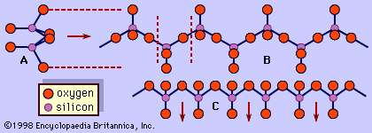
Figure 1: Single pyroxene chain, (SiO3)n, in three projections: (A) along the c axis direction, (B) on (100), a plane that intersects the a axis and is parallel to the b and c axes, and (C) along the b axis direction.

In most pyroxenes the chains are not exactly straight as shown in Figure 1, but are rotated or kinked so that more than one type of chain is possible. The diopside, jadeite, augite, protoenstatite, and spodumene structures consist of only one chain type. Pigeonite, clinoenstatite, and omphacite have two symmetrically distinct types of tetrahedral chains. Orthopyroxenes also have two distinct types of tetrahedral chains and an octahedral stacking sequence that leads to a doubling of the a axis.
A representative pyroxene structure that illustrates the tetrahedral and octahedral chains in jadeite is shown in Figure 2. The octahedral strips consist of M1 and M2 octahedrons sandwiched between two oppositely pointing tetrahedral chains. The M1 sites are occupied by smaller cations such as magnesium, iron, aluminum, and manganese, which are coordinated to six oxygen atoms to form a regular octahedron. In monoclinic pyroxenes, the M2 site is a large irregular polyhedron occupied by the larger calcium and sodium cations which are in eightfold coordination. In the low-calcium orthorhombic pyroxenes, M2 contains magnesium and iron, and the polyhedron takes on a more regular octahedral shape. The M1 cation strip is bonded to oxygen atoms of two oppositely pointing tetrahedral chains. Together, these form a tetrahedral-octahedral-tetrahedral (t-o-t) strip. A schematic projection of the pyroxene structure perpendicular to the caxis and the relationship of the pyroxene cleavage to the t-o-t strips or I beams is shown in Figure 3.

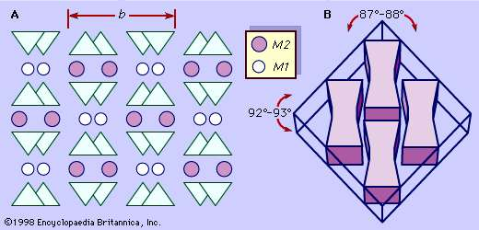
Figure 3: (A) Schematic projection of the monoclinic pyroxene structure perpendicular to the c axis. (B) Control of cleavage angles by the I beams in the pyroxene structure.
Pyroxenes in the quadrilateral with compositions near the diopside-hedenbergite join exist only in the monoclinic form. Those with compositions near the enstatite-orthoferrosilite join containing less than about 5 percent CaSiO3 can be subdivided into two structural types, clinopyroxene or orthopyroxene. Those with approximately 5–20 percent CaSiO3 are monoclinic at high temperatures (pigeonite) and invert to an orthorhombic structure at low temperatures (enstatite). Those with less than 50 percent FeSiO3 can exist as clinoenstatite (monoclinic) or enstatite (orthorhombic) polymorphic structures. Those with more than 50 percent FeSiO3 are clinoferrosilite (monoclinic) or ferrosilite (orthorhombic) polymorphic structures. Pyroxenes outside the quadrilateral all have monoclinic pyroxene structures similar to that of diopside.

The inversion of high-temperature structures to low-temperature structures is often accompanied by the exsolution of lamellae of either a separate calcium-rich or magnesium-iron-rich phase. For example, as high-temperature monoclinic pigeonite slowly cools, it exsolves calcium ions to form augite lamellae and inverts to the orthorhombic enstatite structure. Consequently, the presence of the exsolution lamellae is evidence of a previous monoclinic structure.
Physical Properties
Within hand specimens, pyroxene can generally be identified by the following characteristics: two directions of cleavage intersecting at roughly right angles (approximately 87° and 93°), stubby prismatic crystal habit with nearly square cross sections perpendicular to cleavage directions, and a Mohs hardness between 5 and 7. Specific gravity values of the pyroxenes range from about 3.0 to 4.0. Unlike amphiboles, pyroxenes do not yield water when heated in a closed tube. Characteristically, pyroxenes are dark green to black in colour, but they can range from dark green to apple-green and from lilac to colourless, depending on the chemical composition. Diopside ranges from white to light green, darkening in colour as the iron content increases. Hedenbergite and augite are typically black. Pigeonite is greenish brown to black. Jadeite (see photograph) is white to apple-green to emerald-green or mottled white and green. Aegirine (acmite) forms long, slender prismatic crystals that are brown to green in colour. Enstatite is yellowish or greenish brown and sometimes has a submetallic bronzelike lustre. Iron-rich ferrosilite orthopyroxenes range from brown to black. Spodumene is colourless, white, gray, pink, yellow, or green. The two gem varieties are a clear lilac-coloured type called kunzite, while the clear emerald-green type is known as hiddenite.
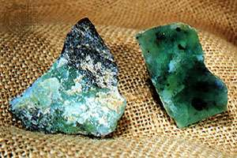

Uncut (left) and cut jadeite.
In thin sections, monoclinic pyroxenes are distinguished by two directions of cleavage at approximately 87° and 93°, eight-sided basal cross sections, and light brown or green colour. Orthorhombic pyroxenes differ from monoclinic pyroxenes in that they have parallel extinction.
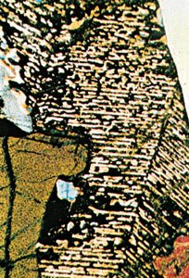
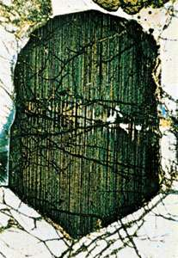

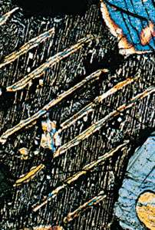
Microscopically, many igneous pyroxenes show exsolution textures of thin lamellae of one pyroxene in a host of a different composition. The lamellae occur as oriented intergrowths that display parallel and herringbone textures. These lamellae result from the exsolution of a separate pyroxene phase from a host grain due to subsolidus re-equilibration (that occurs while the mineral is in the solid state) during slow cooling.

Physical Properties of Pyroxenes
Chemical Classification | Silicate
Color | Usually dark green to dark brown or black. Some, such as jadeite and spodumene, occur in a range of colors.
Streak | White
Luster | Vitreous to dull
Diaphaneity | Semi-translucent to opaque
Cleavage | Most pyroxene minerals exhibit two directions of cleavage that intersect at approximately 87º and 93º. Cleavage fragments often have a nearly square cross-section.
Mohs Hardness | 5 to 7
Specific Gravity | 3 to 4
Diagnostic Properties | Stubby prismatic crystals. Angle of cleavage plane intersection.
Chemical Composition | A generalized composition of XYZ₂O₆, as described in the accompanying sections.
Crystal System | Monoclinic or orthorhombic
Uses | Most pyroxenes have no regular use as industrial minerals. Pyroxene minerals are minor to secondary components of some rocks that are used as crushed stone and dimension stone. A few pyroxene minerals are used as gem materials, but only in rare instances when they have attractive color and clarity. Jadeite, diopside, and spodumene are the most important pyroxene gem materials. Spodumene was once an important source of lithium.

Origin And Occurrence
Minerals in the pyroxene group are abundant in both igneous and metamorphic rocks. Their susceptibility to both chemical and mechanical weathering makes them a rare constituent of sedimentary rocks. Pyroxenes are classified as ferromagnesian minerals in allusion to their high content of magnesium and iron. Their conditions of formation are almost exclusively restricted to environments of high temperature, high pressure, or both. Characteristically the more common pyroxenes are found in mafic and ultramafic igneous rocks where they are associated with olivine and calcium-rich plagioclase and in high-grade metamorphic rocks such as granulites and eclogites. Enstatite, clinoenstatite, and kosmochlor occur in meteorites.

Igneous rocks
Magnesium-rich orthopyroxenes and calcium-rich clinopyroxenes are important constituents of basalts, gabbros, peridotites, and norites. They are the major minerals in pyroxenites. Magnesium-rich orthopyroxenes occur in the earlier-formed rocks of layered ultramafic complexes.

Uninverted pigeonites (monoclinic) are common as phenocrysts in high-temperature, rapidly cooled lavas and in some intrusives such as diabases. In slowly cooled mafic intrusive rocks, pigeonite inverts to an orthorhombic pyroxene and undergoes exsolution.

Augite is the most common pyroxene and is found primarily in mafic igneous rocks. It occurs in basalts, gabbros, andesites, diorites, and peridotites. The augites in layered ultramafic intrusions show compositional trends of increasing iron and decreasing magnesium contents with fractionation. Augite is also known to occur in lunar basalts. Although more common in metamorphic rocks, diopside is found in some mafic and ultramafic rocks.

Aegirine (acmite) and aegirine-augite occur most commonly as products of the late crystallization of alkaline magmas. They are found in alkalic rocks such as nepheline syenites and phonolites, wherein they are associated with orthoclase, feldspathoids, augite, and sodium-rich amphiboles.

Spodumene is found almost exclusively in lithium-rich granite pegmatites. Some of the world’s largest known crystals are spodumene. Single crystals of spodumene exceeding 13 metres (43 feet) in length were mined for their lithium content in the Black Hills of South Dakota, U.S. Spodumene is typically associated with microcline, albite, quartz, muscovite, lepidolite, beryl, and tourmaline.

Metamorphic rocks
Iron-rich orthopyroxenes are found in metamorphosed iron formations in association with the amphibole grunerite. At higher grades of regional metamorphism, the amphibole anthophyllite breaks down to form magnesium-iron orthopyroxenes. The orthopyroxene enstatite occurs in high-temperature and high-pressure granulite facies rocks such as quartz-rich, garnet-bearing granulites.

Diopside results from the thermal metamorphism of siliceous limestones or dolomites according to the following decarbonation reaction:

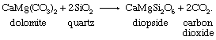

Chemical equation.

In calc-silicate skarns produced by contact metamorphism, diopside is associated with wollastonite, vesuvianite, grossular, and tremolite. Diopside also forms under conditions of regional metamorphism by the breakdown of tremolite. Hedenbergite is a product of thermal metamorphism of iron-rich sediments where its formation is probably due to the breakdown of actinolite with increasing temperature. Augite can be found in quartz-free, aluminum-rich skarns associated with spinel, calcite, vesuvianite, garnet, clintonite, and diopside. Johannsenite is associated with rhodonite, bustamite, sphalerite, chalcopyrite, galena, pyrite, and magnetite in metasomatized limestones adjacent to igneous intrusions.

Aegirine (acmite) is associated with glaucophane or riebeckite in some metamorphic rocks. Jadeite is found only in metamorphic rocks. It either occurs as monomineralic veins or is associated with albite, glaucophane, aragonite, lawsonite, and quartz in high-pressure, low-temperature metamorphic rocks of blueschist facies. In some localities, jadeite is associated with serpentine in glaucophane-bearing metamorphic rocks.

Omphacite is restricted in occurrence to the high-pressure and high-temperature rocks called eclogites. Eclogites represent the most deep-seated conditions of metamorphism and are characterized by an assemblage of omphacite and magnesium-rich pyrope garnet. Omphacite-bearing eclogite nodules are associated with peridotites in the kimberlite pipes of South Africa. It can also be found in subduction zones that have been exhumed.

