So

Soil water holding capacity

Definitions:

The retention of water by soil is called water holding capacity.

OR

Simply defined soil water holing capacity is the amount of water that a given soil can hold for crop use.

Explanation:

Soil water holing capacity is a term that all farms should know to optimize crop production. Soil is fertile because it has humus(Partially decomposed organic matter in the upper layer of Earth crust.
Soil:

The whither upper layer of Earth crust which influence by animals.

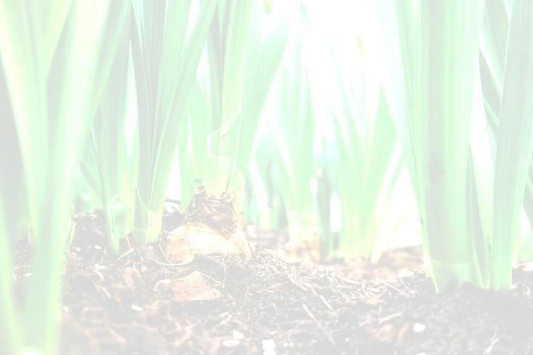
Soil water is made up of plant available and plant unavailable water. Plant available water is the water in thesoilprofilebetweenthefullpointandpermanentwiltingpoint(whentheplantcannolongerberevived by irrigation or rainfall). Within plant available water is readily available water (RAW). This is the water thecropcaneasilyaccess.WhentheRAWhasbeenusedupthesoilisregardedasbeingattherefillpoint.
Irrigation scheduling aims to replace the RAW. But before scheduling decisions can be made the amount of RAW in the root zone needs to be known.
To determine the RAW you need to know:

- The effective rooting depth – how much of the soil profile are rootsaccessing?

- The soil texture – soil texture influences the soil’s water holdingcapacity.

- The soil tension where crops begin to stress – for sugarcane this is about -100kPa.

Effective rooting depth:

The best way to determine the effective rooting depth is to dig a hole in the crop row and measure how far down the majority of the roots go.
Soil texture:

Many soil tests now report soil texture. If the test doesn’t have soil texture then it can be determined by hand texturing.
If there are different soil layers within the effective rooting zone the soil texture for each layer needs to be determined.

Calculating RAW:

The rooting depth and soil texture are known the RAW in the root zone can be calculated by multiplying the depth of the root zone (m) by the typical RAW (mm/m) at a given soil tension (Table ).
For example: Rooting depth is 40 cm; soil texture is a sandy loam; soil tension for irrigation is -100 kPa. From Table 1 the RAW (mm/m of soil) at -100 kPa is 70 mm. RAW in the root zone is then 70 mm × 0.4 m = 28 mm.
Using RAW for scheduling:

WhentheRAWisknown,cropwaterusenumberscanbeusedtocalculatewhenthecropwillagainrequire irrigation. If the RAW is 28 mm and the crop is using 14 mm per week; it will need to be irrigated in two weekstime.
Table 1: Typical Raw for a range of soil types, sugar cane experience stress at -100 kPa.

Readily available water(mm water per m soil) between field capacity and different stress level
Soil texture | Crop stress level
 | -20kPa | -40kPa | -60kPa | -100kPa | -200kPa
Sandy | 30 | 35 | 35 | 40 | 45
Loamy sand | 45 | 50 | 55 | 60 | 650
Loam | 45 | 65 | 75 | 85 | 105

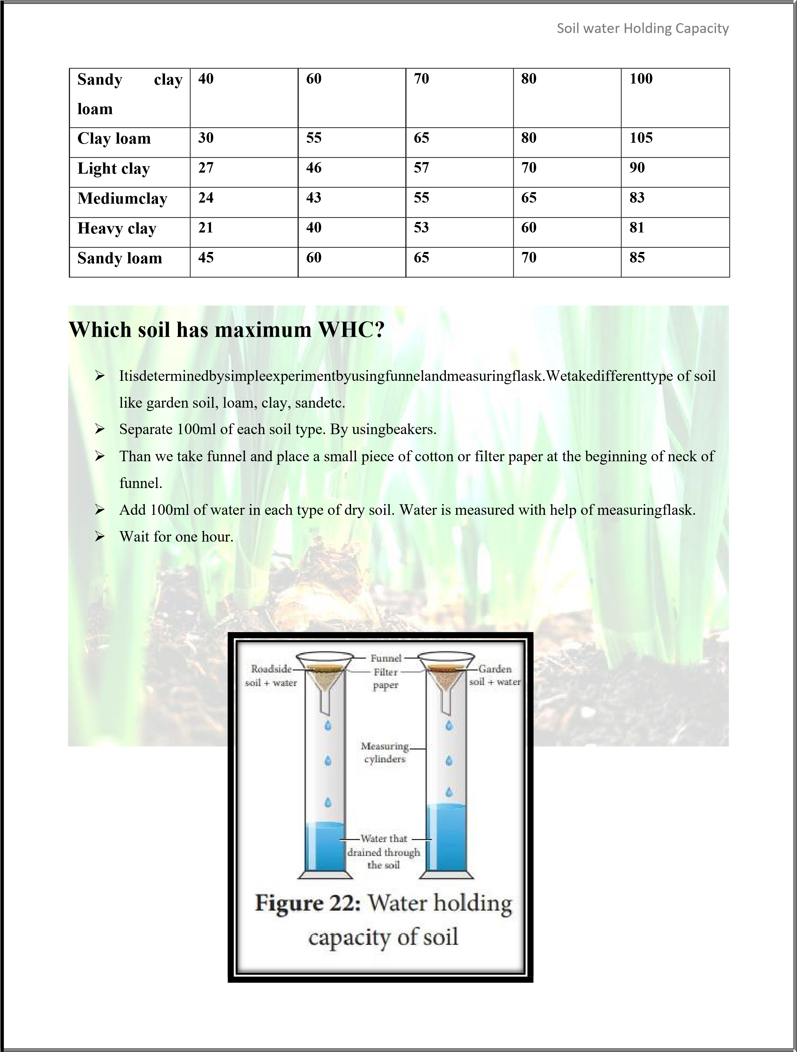
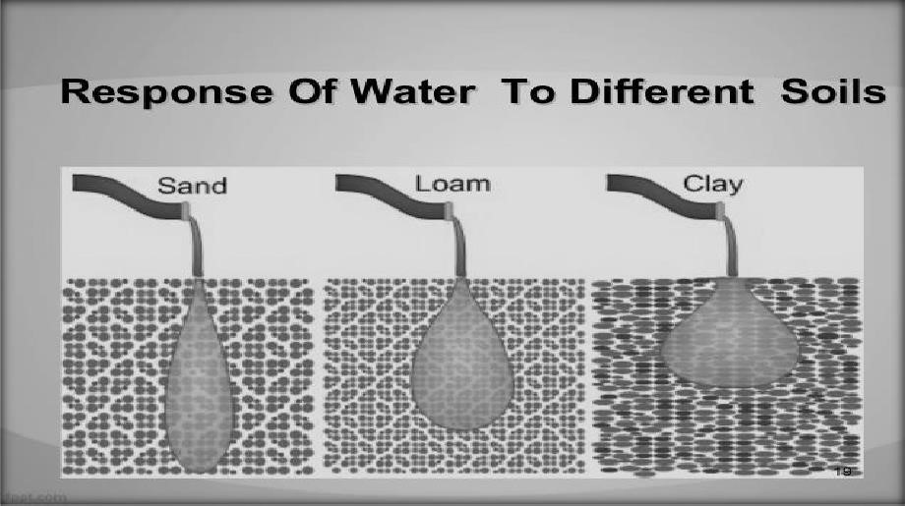
Soil water Holding Capacity

Observation:

❖

Field capacity of clay soil rich inorganic matter on volume basis 59% (59
mL of water retain in
soil and 41 mlcollected).

❖

Field capacity of loam soil rich inorganic matter on volume basis 46% (46 mL of water retain in
soil and 54 mlcollected).

❖

Field capacity of sand soil rich inorganic matter on volume basis 27% (27 mL of
water retain in
soil and 73 mlcollected).

Result
:

Clay soil has maximum water holding capacity.

Water field capacity

Definitions:

Weight of water retained in soil after gravitational water has been drained out.

OR

Field capacity is the point where the soil water holding capacity has reached its maximum for the entire
field.

OR

Field capacity is the amount of water in soil held by capillary force.

OR

FC is the amount of soil moisture or water content held in soil after excess water has drained away and rate of downward movement .This usually takes place in 2-3 days after rain or irrigation .
Difference between water holding capacity and water field capacity

Gravitational water | Capillary water | Hygroscopic water

Water holding capacity

Water
field capacity

Total amount of water a soil can hold at field
capacity.

This may be retain by hygroscopic force or
capillary force.

This may or may not readily available for plant
growth.

Maximum amount of water the soil can hold.

This is
because of capillary force.

It is available for plant growth.

When we see the chemistry of water in relation to soil. We found water stick in soil because of different
forces. Based upon these forces there are three types of water found in
soil.

Types of water

Volume of water which is drained out under the influence of gravity to join ground water table.  It is not available for plant growth. | Volume of water which is retained against gravity due to surface tension.  It is helpful for plant growth. | Volume of water absorbed on soil surface as a very thin film and strongly bind or stick to soil grain.  It is not helpful for plant growth.

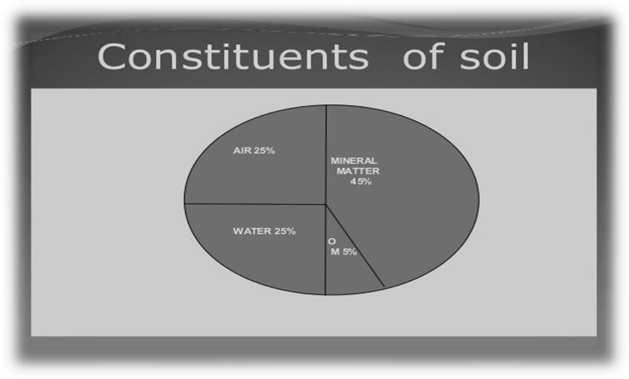
Since the roots move denser close to surface hence pressure applied to extract water will be less so water can be easily extracted close to surface. Root hairs are the organs of plants which provide greater surface area for contact to soil. So these root hairs move the root denser close to surface and water is extracted. But the roots that are much deeper and close to permanent wilting point; they cannot extract water but they are much helpful for absorption of organic matter and minerals.
Moisture extraction level in root zone:

Saturation:

The saturation capacity is the level of water content when soil is saturated and all pores fill with water. At saturation some water is under the effect of gravity more than under attraction of soil particles. Saturation capacity = ^{weight of water} weight of soil

Wilting point:

It is the point where plant can no longer extract the water from the soil.

Wilting is the loss of rigidity of non woody parts of plants. This occur when turgor pressure in non lignified plants cells falls zero , as a result of diminished water in cells. The rate of loss of water from the plant is greater than the absorption of water in plant.
When the water is applied over the agricultural field then certain fraction of it infiltrate and directly join the ground water table . Where as certain fraction get started in the voids of soil which is known as soil moisture. Gravity water takes 2-5 days to join ground water table during which degree of saturation in root zone is one.
S=Degree of saturation = 1

Permanent wilting point:

If the moisture content in root zone goes below permanent wilting point then water is not available for roots and plant may wilt up.
Readily available water:

It is portion of available water which can be easily extracted by crops.

Optimum moisture content:

It is that moisture content below which water can be easily extracted by crops and with the practice of irrigation the moisture content is maintained between optimum moisture content and yield capacity. If moisture content in root zone falls below optimum moisture content then ultimate productivity at the =

Expression for field capacity:

As we know

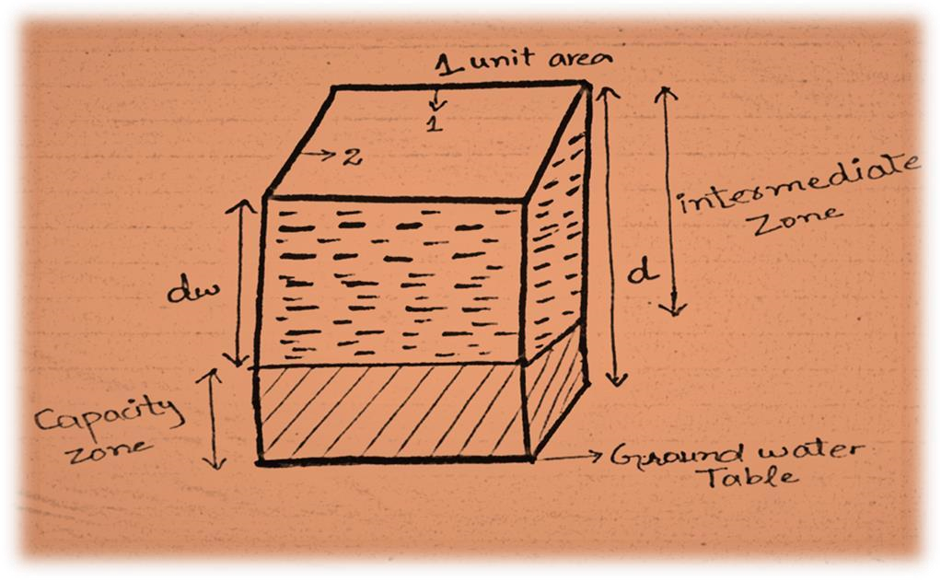
S = Degree of saturation = 1

1

=
V
W

V
v

=

voulme of water
volume of soil

V
W
=
1 X 1 x
d
w
Area = 1 unit
area
VS = 1 x 1 x
d W
t.
ƴ
=
w
xV
W

F.C = Moisture content in root
zone when all rards are filled with water.

F.C =
w
t
ofwater

W
t
ofwater

F.C= unit W_{t}of water ×volume of water
Wt of soil

F.C = γ^{W×}VW

γW ×Vsoil

Pressure Plates Apparatus:

In lab we need equipment to determine FC of certain soil also PWP and PAWC, such as the pressure plate apparatus. If you don’t have this equipment FC can be estimated based upon soil texture, structure, organic matter content. Also there is many indirect ways to calculate FC in lab. One of them is soil saturation methods that describe above.
Field capacity of different soils:

Soil water field capacity is controlled by the soil texture and soil organic matter content.

Silt Loam:
The soil has that 30% san
d and 60% silt and 10 % clay sized particles. The smaller particle have
much larger surface area than the larger sand particles. The larger surface the easier it is for the
soil to hold on the water so it has high field capacity.

Sand:

Sand in
contrast has larger particles which results smaller surface area. Therefore field capacity
of sand is low.

Clay:

Clay has smaller particles so it has higher water field capacity.

Factors that control FC:

Following factors control water field
capacity;

1.

Soil texture

2.

Organic mattercontent

Soil texture:

The soil which has smaller grain particles has more surface area for absorption. While the soil which has larger particles has low field capacity.
Organic matter:

When the amount of organic content increases in the soil the water holding capacity also increases.

