SOMATIC EMBRYOGENESIS
What is somatic embryogenesis?
It is the process of a single cell or a group of cells initiating the developmental pathways that lead to reproductive regeneration of non zygotic embryos capable of germinating to form complete plants.

Embryogeneic cultures are compact dry, amorphous, and white in colour as compared to non embryogenic cultures which are watery dirty white to light brown in colour and soft in nature.
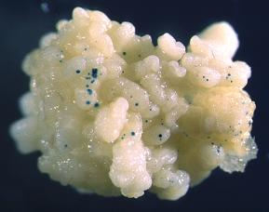

SOMATIC EMBRYOGENESIS

Indirect somatic embryogeneisi
Direct somatic embryogensis

In direct embryogenesis the embryo is formed directly from a cell or group of cells without the production of an intervening callus
In indirect somatic embryogenesis callus is first produced from the explant. Embryos are then produced from the callus

Embryoid
It is a small well organized structure comparable of the sexual embryo, which is produced in tissue culture of dividing somatic cells.which are embryogenically potential,
Embryogenic potential
The capability of the somatic plant cell of a culture to produce embryoids is known as embryogenic potential
Embryogenic callus (EC)
In somatic embryogenesis small compact cells divide asymemetrically and their daughter cells stick together to produce cell masses called proembryogenic masses or embryogenic clumps

Characters of somatic embryo
1.the origin is single cell
2.bipolar i.e., both shoot and root primordia present
3.vascular connection between the somatic embryos and the explant is absent
4. the somatic embryos are easily separated from the explant tissue

explants for initiation of SE
1.embryonic or young seedling tissues
2.excised small tissues from young inflorescence
3.scutellum
4.young roots
5.petioles
6.immature leaf
7.immature hypocotyls
Distinct stages in development of Somatic Embryogenesis
- .single cells
- .group of cells
- globular stage
- .heart shaped embryo
- .torpedo stage embryo
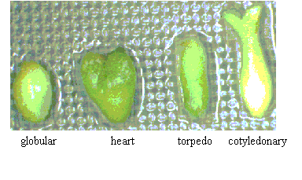
DRAW THE DIAGRAM

somatic embryogenesis may develop from single cells or from a small group of cells. Repeated cell divisions lead to the production of a group of cells that develop into an organized structure known as “globulin”stage embryo. Further development results in heart and torpedo stage embryos from which plants can be regenerated Signs of tissue differentiation become apparent at the globular stage and apical meristem are apparent in heart shaped embryo.

Somatic embryogenesis usually proceeds in two distinct stages. In the initial stage (embryo initiation) , a high concentration of 2,4 D is used. In the second stage (embryo production) embryos are produced in a medium with no or very low level of 2,4D In many systems it has been found that somatic embryogenesis is improved by supplying a source of reduced nitrogen, such as specific amino acids or casein hydrolysate.
Suspension culture
protoplast

callus
Somatic embryogenesis

organogenesis
Somatic embryogenesis

explant

Direct organogenesis

Indirect somatic embryogenesis in carrot
A callus can be established from explants from a wide range of carrot tissues by placing the explants on solid medium containing 2,4D 91 mg)/lit) . This callus can be used to produce a cell suspension by placing it in agitated liquid MS medium containing 2,4D (1mg/lit). this cell suspension can be maintained by repeated subculturing into 2,4D containing medium. Removal of old 2,4D containing
medium and replacement with fresh medium containing absicic acid (0.025 mg / lit) results in the production of embryos
Direct somatic embryogenesis form alfalfa
Young trifoliate leaves are used as the explant . These are removed from the plant and chopped into small pieces. The pieces are washed in a plant growth regulator free medium and placed in liquid medium (B5) supplemented with 2,4D (4mg / lit) , kinetin (0.2 mg /lit) , adenine (1mg / lit) and glutarthione (10mg /lit) . The cultures are maintained in agitated liquid medium for about 10 – 15 days . Transferring the culture to maltose and PEG supplemented media results in the development of somatic embryos. These somatic embryos mature on solid medium containing absicic acid.
Importance of somatic embryogenesis
1.clonal propagation:- the mass production of adventitious embryos in cell culture is one of the ways of clonal propagation
2.for genetic transformation
3.raising somaclonal variation in tree species with the help of mutation
4synthesis of artificial seeds
5.synthesis of metabolites

Differences / comparison between organogenesis and embryogenesis

Charactersistc | Organogenesis | embryogenesis
Origin | Many cells , usually superficial | Single cell, usually superficial
Polarity | Unipolar | Bipolar
Vascular connection with callus / explant | Present; vascular strands connected with those present in callus / explant | Absent; there is no vascular connection with callus/ explant
Separation from callus/ explant | Not easity separated unless cut off | Easily separated since the radicular end is cutinized
Applications of somatic embryogenesis
- somatic embryogenesis provides potential plantlets in the form of somatic seeds. These are available in enormous number once the culture is established. The somatic embryos can be used for the production of synthetic seeds for direct sowing in the field.
- somatic embryo provides organized culture system comparable to intact plant in sterile liquid cultures. Such cultures produce organ specific or differentiation related compounds in higher amount compared to cell culture of the species

